Programmable Materials (2020), 0, 1–12 doi:10.1017/langcog.2020.13

RESEARCH ARTICLE

Harnessing Length and Height Changes in thermoresponsive Programmable Materials
Dilip Chalissery1, Tobias Rümmler1, Fabian Ziervogel2, Chris Eberl3 and Thorsten Pretsch1
1Fraunhofer Institute for Applied Polymer Research IAP, Geiselbergstraße 69, 14476 Potsdam, Germany.
2Fraunhofer Institute for Machine Tools and Forming Technology IWU, Nöthnitzer Straße 44, 01187 Dresden, Germany.
3Fraunhofer Institute for Mechanics of Materials IWM, Wöhlerstraße 11, 79108 Freiburg, Germany.
Received: 27 March 2023; Revised: XX April 2023; Accepted: XX May 2023

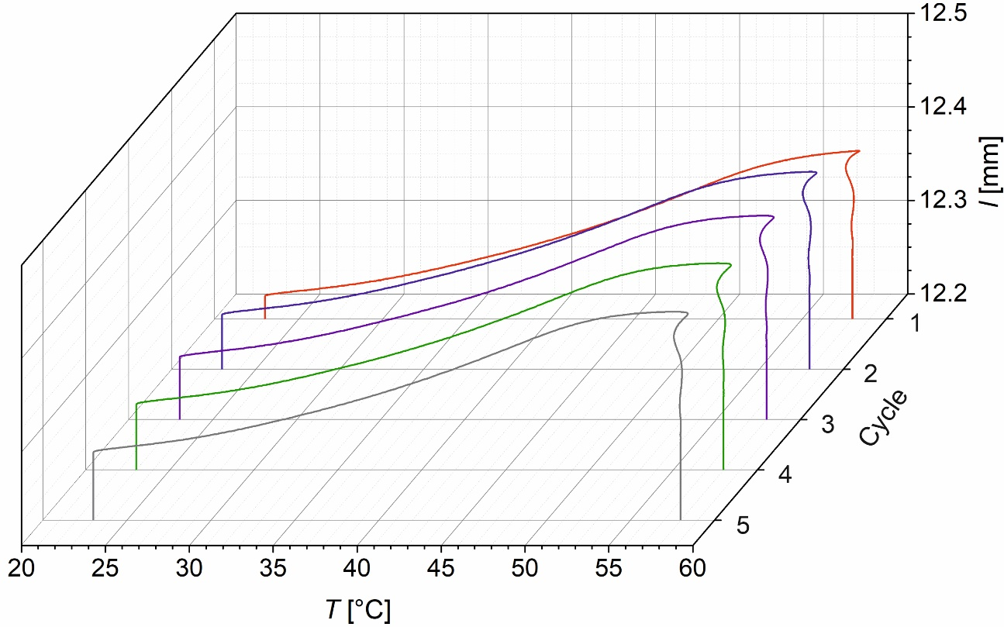
Figure S1. Thermal expansion of untreated PDA-based PEU under a weak external load of 0.001 N. Evolution of object length l above temperature T for cycles one to five.

