Supplementary file 1: Decision-aid for identifying symptomatic UTI vs. Asymptomatic Bacteriuria
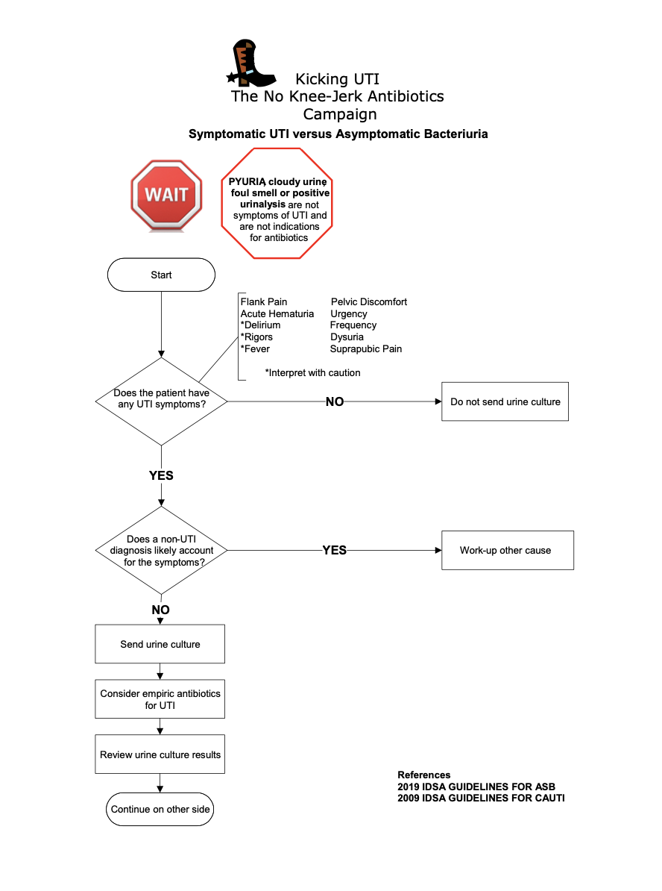
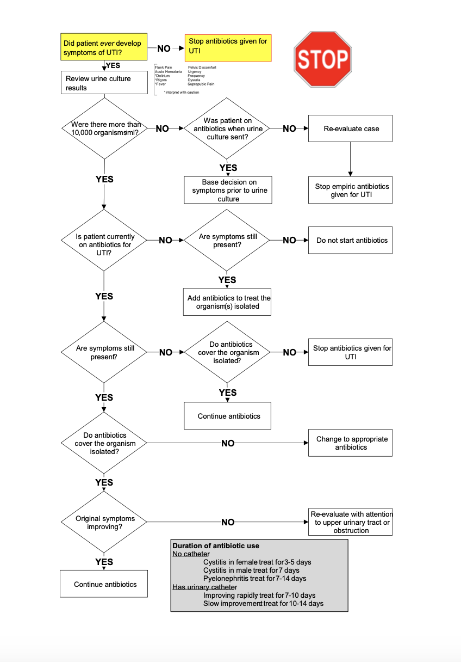

Supplementary File 2: Intervention Time Log

Appendix E: Time Log
Responder Initials: _______________
Site Name:__________________________________
Week of: :_______________
Please enter all time in minutes:
 | Local Administration and Logistics | Intervention Delivery | Implementation Activities*
Monday
Tuesday
Wednesday
Thursday
Friday
Saturday
Sunday
Definitions:
Local Administration and Logistics: Record any time you spent at your site in meetings regarding this project, on emails or project-related communications, creating awareness about the project in staff meetings, etc.
Intervention Delivery: Record how much time you spent delivering education or audit and feedback for the intervention. Any teaching setting is relevant—grand rounds, medicine team rounds, educational conferences, etc.
Implementation Activities: *These differ for the two arms. For the virtual learning collaborative arm, this definition will read: Implementation activities include time spent in training webinars, learning collaborative meetings, or office hours; time spent using the listserv; time spent accessing and reviewing project materials; time spent communicating with other sites in the project; and time spent working directly with the coordinating site.
For the technical assistance arm, this definition will read: Implementation activities include time spent in training webinars, time spent accessing and reviewing project materials, and time spent working directly with the coordinating site.

Supplemental file 3: Intervention Activity Log

Appendix C: Intervention Activity Log
Your name: _____________________
Teaching Case Number presented (if used): ___________________

Type of activity:
Grand Rounds Teaching Conference Team Rounds
In-service E-consults Staff Meetings Phone Calls
Other (please describe: ____________________)
Date of activity: ____/____/_____

Number of participants in attendance:_____________

Time spent in delivery in minutes: _______________

Composition of Audience:
Staff physicians/providers Residents in training Infection Preventionists
Nurses Certified Nursing Assistants
Pharmacists Fellows
Other (please describe: ____________________)
Comments: __________________________________________________________________
____________________________________________________________________________

