Supplemental Material
Nomogram to Predict Probability of Subsequent Infection Caused by ESBL-Positive E. coli or K. pneumoniae
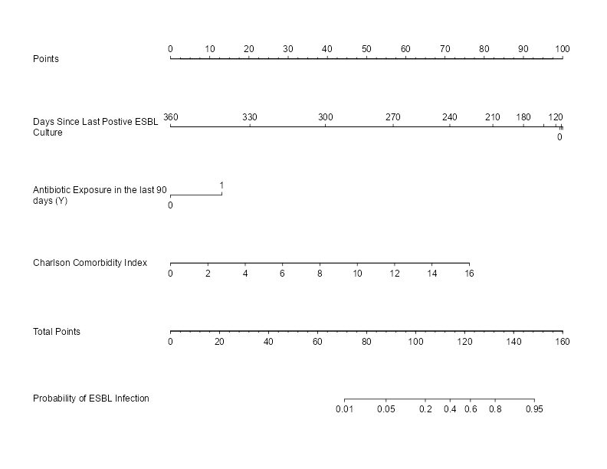
Use of this nomogram is intended for patients who present with suspected bacterial infection and have a history of culture growing ESBL-positive E. coli or K. pneumoniae.
Nomogram instructions:
- The top line (Points) is to be used to assign points to the three variables below it.
- Variable 1: Determine time in days since historical culture growing ESBL-positive E. coli or K. pneumoniae. Assign points based on this result using ‘Points’ line above.
- Variable 2: Determine if the patient has received an antibiotic in the previous 90 days. If no, assign 0 points. If yes, assign 12 points.
- Variable 3: Calculate the patient’s Charlson Comorbidity Index score. Assign points based on this result using the ‘Points’ line above.
- Sum the assigned points for the three variables, and mark the result on the ‘Total Points’ line.
- Match the mark on the Total Points line with the location on the line below. This is the probability the infection is caused by ESBL-positive E. coli or K. pneumoniae.
An online calculator for this nomogram may be found at www.ESBLrisk.com.

