Figure S1. Flowchart of urine culture isolates included in the study.

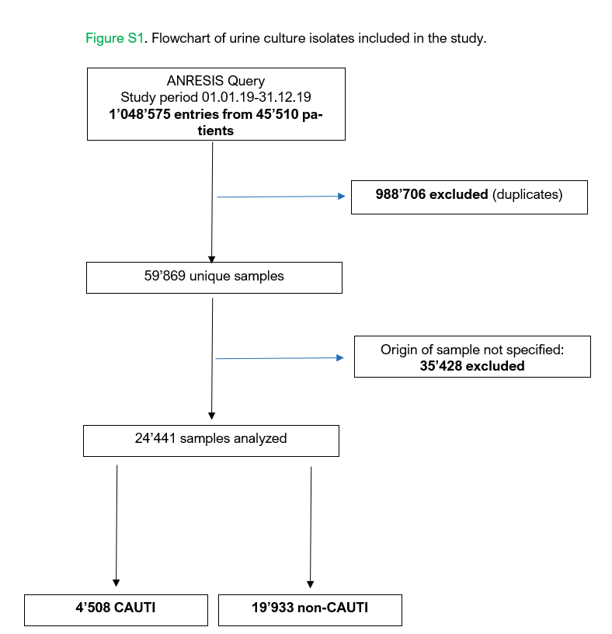

Table S1 Resistance Pattern, CAUTI vs non-CAUTI

 |  | E. coli |  |  | K. pneumoniae |  |  | P. mirabilis |  |  | P. aeruginosa
 |  | CAUTI | non-CAUTI | p-value | CAUTI | non-CAUTI | p-value | CAUTI | non-CAUTI | p-value | CAUTI | non-CAUTI | p-value
C3G (%) | n | 1316 | 9678 |  | 436 | 1601 |  | 208 | 663
 | R | 153 (11.6) | 789 (8.2) | <0.001 | 39 (8.9) | 103 (6.4) | 0.086 | 5 (2.4) | 9 (1.4) | 0.465
CIP (%) | n | 1183 | 9075 |  | 370 | 1399 |  | 172 | 599 |  | 350 | 528
 | R | 307 (26.0) | 1533 (16.9) | <0.001 | 66 (17.8) | 160 (11.4) | 0.001 | 37 (21.5) | 92 (15.4) | 0.074 | 51 (14.6) | 57 (10.8) | 0.118
NOR (%) | n | 1257 | 7369 |  | 399 | 1264 |  | 186 | 470
 | R | 353 (28.1) | 140 (19.1) | <0.001 | 64 (16.0) | 149 (11.8) | 0.033 | 40 (21.5) | 62 (13.2) | 0.011
TMP-SMX (%) | n | 1423 | 10500 |  | 451 | 1675 |  | 219 | 699
 | R | 390 (27.4) | 2619 (24.9) | 0.048 | 59 (13.1) | 215 (12.8) | 0.953 | 67 (30.6) | 221 (31.6) | 0.841
FFM (%) | n | 1405 | 10444 |  | 341 | 1291 |  | 154 | 494
 | R | 32 (2.3) | 148 (1.4) | 0.018 | 98 (28.7) | 398 (30.8) | 0.496 | 34 (22.1) | 88 (17.8) | 0.287
AMC (%) | n | 1403 | 10790 |  | 458 | 1708 |  | 216 | 690
 | R | 408 (29.1) | 2586 (24.0) | <0.001 | 75 (16.4) | 222 (13.0) | 0.073 | 15 (6.9) | 46 (6.7) | 1
NIT (%) | n | 1276 | 9641 |  | 305 | 1077 |  | 159 | 518
 | R | 25 (2.0) | 154 (1.6) | 0.401 | 206 (67.5) | 720 (66.9) | 0.875 | 159 (100.0) | 512 (98.8) | 0.379
CEF (%) | n |  |  |  |  |  |  |  |  |  | 329 | 481
 | R |  |  |  |  |  |  |  |  |  | 45 (13.7) | 39 (8.1) | 0.015
PIP (%) | n |  |  |  |  |  |  |  |  |  | 344 | 521
 | R |  |  |  |  |  |  |  |  |  | 50 (14.5) | 51 (9.8) | 0.043
CAZ (%) | n |  |  |  |  |  |  |  |  |  | 369 | 507
 | R |  |  |  |  |  |  |  |  |  | 39 (10.6) | 41 (8.1) | 0.254
IMI (%) | n |  |  |  |  |  |  |  |  |  | 313 | 495
 | R |  |  |  |  |  |  |  |  |  | 43 (13.7) | 52 (10.5) | 0.201

C3G = Ceftriaxone; CIP = Ciprofloxacin; NOR = Norfloxacin; TMP-SMZ = trimethoprim-sulfamethoxazole; FFM = fosfomycin; NIT = Nitrofurantoin; AMC = Amoxicillin/clavulanic acid; CEF = cefepime; PIP = piperacillin-tazobactam; CAZ = ceftazidime; IMI = Imipenem

Table S2 Resistance profile, CAUTI samples, Hospital category

- Escherichia coli

 |  | Primary | Secondary | Tertiary | P value
C3G (%) | n | 709 | 374 | 233
 | R | 79 (11.1) | 34 (9.1) | 40 (17.2) | 0.009
CIP (%) | n | 647 | 333 | 203
 | R | 160 (24.7) | 81 (24.3) | 66 (32.5) | 0.064
NOR (%) | n | 712 | 303 | 237
 | R | 207 (28.9) | 83 (27.4) | 63 (26.6) | 0.757
TMP-SMX (%) | n | 712 | 405 | 306
 | R | 181 (25.4) | 108 (26.7) | 101 (33.0) | 0.042
FFM (%) | n | 685 | 412 | 308
 | R | 16 (2.3) | 9 (2.2) | 7 (2.3) | 0.987
NIT (%) | n | 679 | 392 | 205
 | R | 14 (2.1) | 4 (1.0) | 7 (3.4) | 0.129
AMC (%) | n | 707 | 384 | 312
 | R | 166 (23.5) | 121 (31.5) | 121 (38.8) | <0.001

- Klebsiella pneumonia

 |  | Primary | Secondary | Tertiary | P value
C3G (%) | n | 213 | 139 | 84
 | R | 16 (7.5) | 10 (7.2) | 13 (15.5) | 0.065
CIP (%) | n | 187 | 113 | 70
 | R | 29 (15.5) | 17 (15.0) | 20 (28.6) | 0.033
NOR (%) | n | 208 | 100 | 91
 | R | 37 (17.8) | 15 (15.0) | 12 (13.2) | 0.576
TMP-SMX (%) | n | 199 | 137 | 115
 | R | 20 (10.1) | 17 (12.4) | 22 (19.1) | 0.068
FFM (%) | n | 153 | 113 | 75
 | R | 30 (19.6) | 45 (39.8) | 23 (30.7) | 0.001
NIT (%) | n | 164 | 85 | 56
 | R | 115 (70.1) | 54 (63.5) | 37 (66.1) | 0.555
AMC (%) | n | 200 | 138 | 120
 | R | 29 (14.5) | 23 (16.7) | 23 (19.2 | 0.547

- Proteus mirabilis
 |  | Primary | Secondary | Tertiary | P value
C3G (%) | n | 96 | 65 | 47
 | R | 1 (1.0) | 0 (0.0) | 4 (8.5) | 0.007
CIP (%) | n | 84 | 49 | 39
 | R | 21 (25.0) | 8 (16.3) | 8 (20.5) | 0.494
NOR (%) | n | 99 | 44 | 43
 | R | 25 (25.3) | 7 (15.9) | 8 (18.6) | 0.396
TMP-SMX (%) | n | 97 | 63 | 59
 | R | 27 (27.8) | 18 (28.6) | 22 (37.3) | 0.424
FFM (%) | n | 70 | 46 | 38
 | R | 20 (28.6) | 9 (19.6) | 5 (13.2) | 0.162
NIT (%) | n | 98 | 38 | 23
 | R | 98 (100.0) | 38 (100.0) | 23 (100.0) | NA
AMC (%) | n | 95 | 61 | 60
 | R | 7 (7.4) | 3 (4.9) | 5 (8.3) | 0.743

- Pseudomonas aeruginosa

 |  | Primary | Secondary | Tertiary | P value
CEF (%) | n | 142 | 100 | 87
 | R | 21 (14.8) | 17 (17.0) | 7 (8.0) | 0.181
CIP (%) | n | 148 | 123 | 79
 | R | 26 (17.6) | 17 (13.8) | 8 (10.1) | 0.305
PIP (%) | n | 126 | 130 | 88
 | R | 21 (16.7) | 20 (15.4) | 9 (10.2) | 0.396
CAZ (%) | n | 152 | 129 | 88
 | R | 18 (11.8) | 14 (10.9) | 7 (8.0) | 0.635
IMI (%) | n | 139 | 90 | 84
 | R | 20 (14.4) | 13 (14.4) | 10 (11.9) | 0.85

C3G = Ceftriaxone; CIP = Ciprofloxacin; NOR = Norfloxacin; TMP-SMZ = trimethoprim-sulfamethoxazole; FFM = fosfomycin; NIT = Nitrofurantoin; AMC = Amoxicillin/clavulanic acid; CEF = cefepime; PIP = piperacillin-tazobactam; CAZ = ceftazidime; IMI = Imipenem

Table S3 Pathogen Distribution: comparison between geographical regions

 | German speaking | French speaking
n | 4310 | 881
Species (%)
E.coli | 1334 (31.0) | 323 (36.7)
Others | 595 (13.8) | 116 (13.2)
E.faecalis | 491 (11.4) | 119 (13.5)
P.aeruginosa | 453 (10.5) | 66 (7.5)
P.mirabilis | 225 (5.2) | 52 (5.9)
Enterobacter spp. | 154 (3.6) | 25 (2.8)
E.faecium | 80 (1.9) | 35 (4.0)
Enterococcus spp.  (not identified to species level) | 116 (2.7) | 0 (0.0)
K.oxytoca | 131 (3.0) | 13 (1.5)
not specified | 69 (1.6) | 27 (3.1)

Table S4 Resistance profile, CAUTI samples, Region

- Escherichia coli
 |  | German speaking | French speaking | P value
C3G (%) | n | 1020 | 271
 | R | 124 (12.2) | 25 (9.2) | 0.217
CIP (%) | n | 916 | 247
 | R | 250 (27.3) | 52 (21.1) | 0.057
NOR (%) | n | 354 | 37
 | R | 52 (14.7) | 9 (24.3) | 0.194
TMP-SMX (%) | n | 1145 | 255
 | R | 309 (27.0) | 74 (29.0) | 0.561
FFM (%) | n | 1160 | 224
 | R | 23 (2.0) | 8 (3.6) | 0.221
NIT (%) | n | 1014 | 255
 | R | 19 (1.9) | 6 (2.4) | 0.81
AMC (%) | n | 1133 | 247
 | R | 350 (30.9) | 49 (19.8) | 0.001

- Klebsiella pneumoniae
 |  | German speaking | French speaking | P value
C3G (%) | n | 363 | 64
 | R | 28 (7.7) | 7 (10.9) | 0.536
CIP (%) | n | 303 | 58
 | R | 46 (15.2) | 17 (29.3) | 0.016
NOR (%) | n | 354 | 37
 | R | 52 (14.7) | 9 (24.3) | 0.194
TMP-SMX (%) | n | 386 | 57
 | R | 44 (11.4) | 12 (21.1) | 0.067
FFM (%) | n | 298 | 39
 | R | 89 (29.9) | 9 (23.1) | 0.490
NIT (%) | n | 279 | 24
 | R | 187 (67.0) | 19 (79.2) | 0.320
AMC (%) | n | 389 | 61
 | R | 60 (15.4) | 12 (19.7) | 0.513

- Proteus mirabilis
 |  | German speaking | French speaking | P value
C3G (%) | n | 160 | 46
 | R | 3 (1.9) | 1 (2.2) | 1.00
CIP (%) | n | 128 | 43
 | R | 28 (21.9) | 9 (20.9) | 1.00
NOR (%) | n | 156 | 29
 | R | 34 (21.8) | 6 (20.7) | 1.00
TMP-SMX (%) | n | 173 | 45
 | R | 55 (31.8) | 11 (24.4) | 0.439
FFM (%) | n | 127 | 26
 | R | 29 (22.8) | 5 (19.2) | 0.886
NIT (%) | n | 126 | 32
 | R | 126 (100.0) | 32 (100.0) | NA
AMC (%) | n | 175 | 39
 | R | 11 (6.3) | 3 (7.7) | 1.00

- Pseudomonas aeruginosa
 |  | German speaking | French speaking | P value
CEF (%) | n | 44 | 280
 | R | 6 (13.6) | 38 (13.6) | 1
PIP (%) | n | 43 | 295
 | R | 5 (11.6) | 44 (14.9) | 0.734
CAZ (%) | n | 44 | 320
 | R | 3 (6.8) | 35 (10.9) | 0.565
IMP (%) | n | 42 | 266
 | R | 12 (28.6) | 30 (11.3) | 0.005
CIP (%) | n | 46 | 298
 | R | 9 (19.6) | 39 (13.1) | 0.341

C3G = Ceftriaxone; CIP = Ciprofloxacin; NOR = Norfloxacin; TMP-SMZ = trimethoprim-sulfamethoxazole; FFM = fosfomycin; NIT = Nitrofurantoin; AMC = Amoxicillin/clavulanic acid; CEF = cefepime; PIP = piperacillin-tazobactam; CAZ = ceftazidime; IMI = Imipenem

Table S5 Resistance profile, CAUTI samples, nosocomial vs community-acquired (CA)

- Escherichia coli

 |  | CA | Nosocomial | P value
C3G | n | 446 | 346
 | r | 45 (10.1) | 43 (12.4) | 0.355
CIP | n | 397 | 322
 | r | 99 (24.9) | 80 (24.8) | 1
FFM | n | 502 | 378
 | r | 140 (27.9) | 102 (27.0) | 0.825
NIT | n | 501 | 370
 | r | 11 (2.2) | 6 (1.6) | 0.721
NOR | n | 435 | 281
 | r | 114 (26.2) | 79 (28.1) | 0.635
TMP-SMX | n | 502 | 378
 | r | 140 (27.9) | 102 (27.0) | 0.825
AMC | n | 482 | 364
 | r | 129 (26.8) | 101 (27.7) | 0.81

- Klebsiella pneumoniae

 |  | CA | Nosocomial | P value
C3G | n | 147 | 120
 | r | 11 (7.5) | 8 (6.7) | 0.985
CIP | n | 116 | 103
 | r | 14 (12.1) | 15 (14.6) | 0.731
FFM | n | 162 | 117
 | r | 15 (9.3) | 12 (10.3) | 0.942
NIT | n | 126 | 78
 | r | 71 (56.3) | 51 (65.4) | 0.258
NOR | n | 134 | 92
 | r | 16 (11.9) | 8 (8.7) | 0.577
TMP-SMX | n | 162 | 117
 | r | 15 (9.3) | 12 (10.3) | 0.942
AMC | n | 164 | 124
 | r | 19 (11.6) | 21 (16.9) | 0.259

- Proteus mirabilis

 |  | CA | Nosocomial | P value
C3G | n | 60 | 76
 | r | 0 | 0 | NA
TMP-SMX | n | 67 | 75
 | r | 18 (26.9) | 21 (28.0) | 1
NOR | n | 55 | 54
 | r | 13 (23.6) | 15 (27.8) | 0.783
NIT | n | 50 | 55
 | r | 50 (100.0) | 55 (100.0) | NA
FFM | n | 67 | 75
 | r | 18 (26.9) | 21 (28.0) | 1
CIP | n | 49 | 63
 | r | 10 (20.4) | 18 (28.6) | 0.441
AMC | n | 67 | 71
 | r | 4 (6.0) | 6 (8.5) | 0.816

- Pseudomonas aeruginosa

 |  | CA | Nosocomial | P value
CIP | n | 109 | 130
 | r | 14 (12.8) | 15 (11.5) | 0.913
PIP | n | 96 | 112
 | r | 10 (10.4) | 13 (11.6) | 0.959
CEF | n | 95 | 103
 | r | 9 (9.5) | 13 (12.6) | 0.633
IMP | n | 92 | 97
 | r | 12 (13.0) | 14 (14.4) | 0.947
CAZ | n | 108 | 126
 | r | 7 (6.5) | 10 (7.9) | 0.861

C3G = Ceftriaxone; CIP = Ciprofloxacin; NOR = Norfloxacin; TMP-SMZ = trimethoprim-sulfamethoxazole; FFM = fosfomycin; NIT = Nitrofurantoin; AMC = Amoxicillin/clavulanic acid; CEF = cefepime; PIP = piperacillin-tazobactam; CAZ = ceftazidime; IMI = Imipenem

