Supplementary Appendix 1. Search terms and strategies

Covid 19 | Vaccine efficacy | Long term symptoms
MeSH  COVID-19  SARS-CoV-2  Coronavirus Infections (no explode) | MeSH  Vaccine efficacy  Covid-19 Vaccines  RNA, Messenger  Vaccines  Immunization (inc vaccination)  AND  Treatment outcome | MeSH  Complications subheading  Post acute covid 19 syndrome  Chronic disease
Keywords  Covid  Covid 19  Corona virus  Coronavirus  2019-nCoV  SARS-CoV-2  2019-nCoV | Keywords  Vaccine(s)  Vaccination(s)  Vaccinated  Pfizer  Bnt162b2  Moderna  immunization(s)  variolation(s)  Immunologic stimulation  Immunostimulation  Immunotherap (y,ies)  mRNA-1273  ChAdOx1-S  AZD1222  AstraZeneca/Oxford  Janssen  Johnson&Johnson  Ad26COVS1  JNJ-78436735  Gamaleya  Sputnik V  Sinovac  Corona Vac  Novavax  Covaxin  sinopharm  AND  Effectiveness  Efficacy  Effective  Antibody response  Antibody levels  IgG  Neutralizing antibodies  Success | Keywords  Long hauler  Long term  Long haul  Post acute  Chronic  Expanded  extended  recurr*  sustain*  persist*  prolong*  continu*  Debilitating  AND  effect*  symptom*  impact*  outcome*  recover*  suffer*  sequela*  impair*

MEDLINE via Ovid 4/27/22
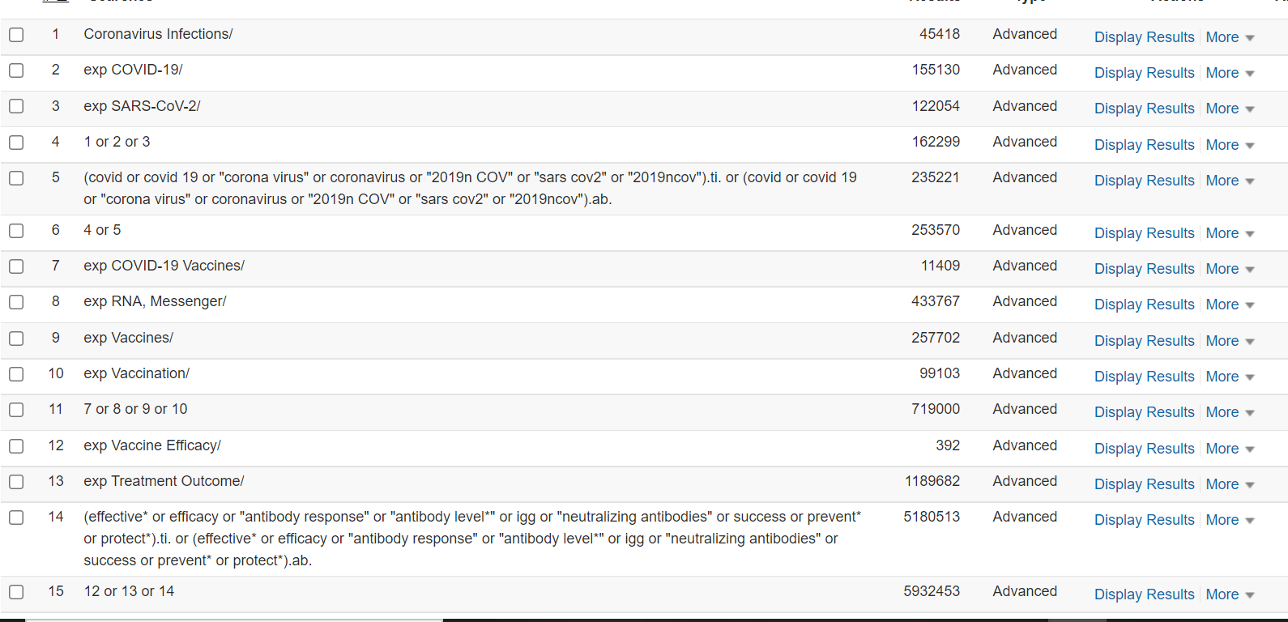
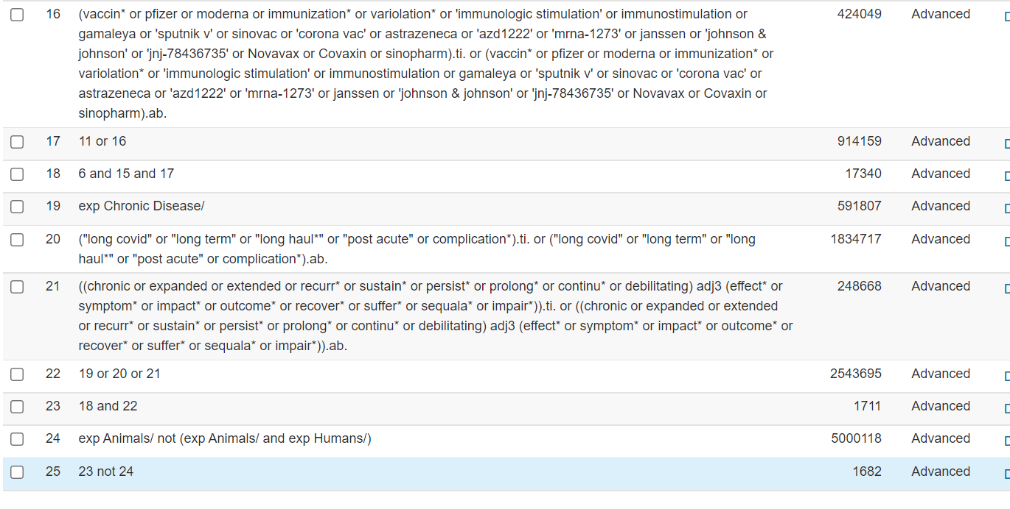
Embase 4/27/22
#1
'long covid'/exp
OR
'long haul':ab,ti OR 'long hauler':ab,ti OR 'long term':ab,ti OR 'long covid':ab,ti OR 'post acute':ab,ti
OR
((chronic OR expanded OR extended OR recurr* OR sustain* OR persist* OR prolong* OR continu* OR debilitating) NEAR/2 (effect* OR symptom* OR impact* OR outcome* OR recover* OR suffer* OR sequala* OR impair*)):ti,ab

#2
'coronavirus disease 2019'/exp OR 'coronavirus infection'/de OR covid:ab,ti OR 'covid 19':ab,ti OR 'corona virus':ab,ti OR coronavirus:ab,ti OR 'sars-cov-2':ab,ti OR '2019-ncov':ab,ti

#3
'messenger rna'/exp OR 'vaccine'/exp OR 'vaccination'/exp OR 'immunization'/exp OR vaccine*:ab,ti OR vaccination*:ab,ti OR pfizer:ab,ti OR moderna:ab,ti OR immunization*:ab,ti OR variolation*:ab,ti OR 'immunologic stimulation':ab,ti OR immunostimulation:ab,ti OR gamaleya:ab,ti OR 'sputnik v':ab,ti OR sinovac:ab,ti OR 'corona vac':ab,ti OR astrazeneca:ab,ti OR 'azd1222':ab,ti OR 'mrna-1273':ab,ti OR janssen:ab,ti OR 'johnson & johnson':ab,ti OR 'jnj-78436735':ab,ti OR Novavax:ab,ti OR Covaxin:ab,ti OR sinopharm:ab,ti

#4
'drug efficacy'/exp OR 'treatment outcome'/exp OR effectiveness:ti,ab OR efficacy:ti,ab OR effective:ti,ab OR 'antibody response':ab,ti OR 'antibody levels':ab,ti OR igg:ab,ti OR 'neutralizing antibodies':ab,ti OR success:ti,ab OR prevent:ti,ab OR prevention:ti,ab OR protect:ti,ab OR protection:ti,ab OR protecting:ti,ab OR 'sars-cov-2 antibody'/exp

#1 AND #2 AND #3 AND #4=1253

CINAHL 4/27/22
#1
(MH "RNA, Messenger" OR MH "Vaccines+" OR MH "Immunization" OR Vaccine* OR Vaccination* OR Pfizer OR Moderna OR immunization* OR variolation* OR “immunologic stimulation" OR Immunostimulation OR Gamaleya OR "Sputnik V" OR Sinovac OR "Corona Vac" OR AstraZeneca OR Janssen OR "AZD1222" OR "mRNA-1273" OR Janssen OR "Johnson & Johnson" OR "JNJ-78436735") AND (MH "Coronavirus Infections" OR MH "COVID-19" OR MH "SARS-CoV-2" OR Covid OR "Covid 19" OR "Corona virus" OR Coronavirus OR "2019-nCoV" OR "SARS-CoV-2" OR "2019-nCoV")
OR
MH "COVID-19 Vaccines"

#2
"long haul" OR "long hauler" OR "long term" OR "long covid" OR "post acute"
OR
(chronic OR expanded OR extended OR recurr* OR sustain* OR persist* OR prolong* OR continu* OR debilitating) N2 (effect* OR symptom* OR impact* OR outcome* OR recover* OR suffer* OR sequala* OR impair*)

#3
(MH "Drug Efficacy") OR (MH "Treatment Outcomes+")
OR
TI ( Effective* OR efficacy OR “antibody response'” OR “antibody levels” OR igg OR “neutralizing antibodies” OR success OR prevent OR prevention OR protect* OR “sars-cov-2 antibody” ) OR AB ( Effective* OR efficacy OR “antibody response'” OR “antibody levels” OR igg OR “neutralizing antibodies” OR success OR prevent OR prevention OR protect* OR “sars-cov-2 antibody” )

#1 AND #2 AND #3=580

Scopus 4/27/22

#1
TITLE-ABS-KEY ( vaccine* OR vaccination* OR pfizer OR moderna OR immunization* OR variolation* OR "immunologic stimulation"OR immunostimulation OR gamaleya OR "Sputnik V" OR sinovac OR "Corona Vac" OR astrazeneca OR janssen OR "AZD1222" OR "mRNA-1273" OR janssen OR "Johnson & Johnson" OR "JNJ-78436735") AND TITLE-ABS-KEY ( covid OR "Covid 19" OR "Corona virus" OR coronavirus OR 2019ncov OR sarscov2 OR 2019-ncov)

#2
(chronic OR expanded OR extended OR recurr* OR sustain* OR persist* OR prolong* OR continu* OR debilitating) W/2 (effect* OR symptom* OR impact* OR outcome* OR recover* OR suffer* OR sequala* OR impair*)
OR
TITLE-ABS-KEY "long haul" OR "long hauler" OR "long term" OR "long covid" OR "post acute"

#3
TITLE (effective* OR efficacy OR "antibody response'" OR "antibody levels" OR igg OR "neutralizing antibodies" OR success OR prevent OR prevention OR protect* OR "sars-cov-2 antibody") OR ABS (effective* OR efficacy OR "antibody response'" OR "antibody levels" OR igg OR "neutralizing antibodies" OR success OR prevent OR prevention OR protect* OR "sars-cov-2 antibody")

#1 AND #2 AND #3=1540, without reviews=1068

Web of Science 4/27/22

TS=(vaccine* OR vaccination*OR pfizer OR moderna OR immunization* OR variolation* OR "immunologic stimulation"OR immunostimulation OR gamaleya OR "Sputnik V" OR sinovac OR "Corona Vac" OR astrazeneca OR janssen OR "AZD1222" OR "mRNA-1273" OR janssen OR "Johnson & Johnson" OR "JNJ-78436735") AND TS=(covid OR "Covid 19" OR "Corona virus" OR coronavirus OR 2019ncov OR sarscov2 OR 2019-ncov)

#2
TS=(chronic OR expanded OR extended OR recurr* OR sustain* OR persist* OR prolong* OR continu* OR debilitating) NEAR/2 (effect* OR symptom* OR impact* OR outcome* OR recover* OR suffer* OR sequala* OR impair*)
OR
TS=("long haul" OR "long hauler" OR "long term" OR "long covid" OR "post acute" )

#3
TI=(effective* OR efficacy OR "antibody response'" OR "antibody levels" OR igg OR "neutralizing antibodies" OR success OR prevent OR prevention OR protect* OR "sars-cov-2 antibody") OR AB=(effective* OR efficacy OR "antibody response'" OR "antibody levels" OR igg OR "neutralizing antibodies" OR success OR prevent OR prevention OR protect* OR "sars-cov-2 antibody")

#1 AND #2 AND #3=934

Cochrane 4/27/22
