Supplement 1. Flow diagram of study population
7,736 calls placed to the COVID-19 Call Center from December 28, 2020 to April 29, 2021

69 calls with a timing concern (e.g., test order date >7 days after call date, symptom onset >7 days after or >14 days before call date)

7,667 calls

232 repeat calls within 3 days from the same employee

7,435 calls

2,494 calls without a positive or negative SARS-CoV-2 test result (testing was not indicated based on Call Center evaluation for the majority of these calls)

4,941 calls

675 calls in which the employee was 0-13 days from his/her first COVID-19 dose

4,266 calls

27 calls in which the two COVID-19 vaccine doses were <17 days apart

4,239 calls were included in the final study cohort

Supplement 2. Epidemiologic curve of employees testing positive for SARS-CoV-2 by vaccination status and percent positivity for SARS-CoV-2 among employees calling the COVID-19 Occupational Health Call Center from December 28, 2020 to April 29, 2021
Supplement 3. Epidemiologic curve of positive SARS-CoV-2 cases in the St. Louis Metropolitan Statistical Area (MSA), February 17, 2020 to August 18, 2021
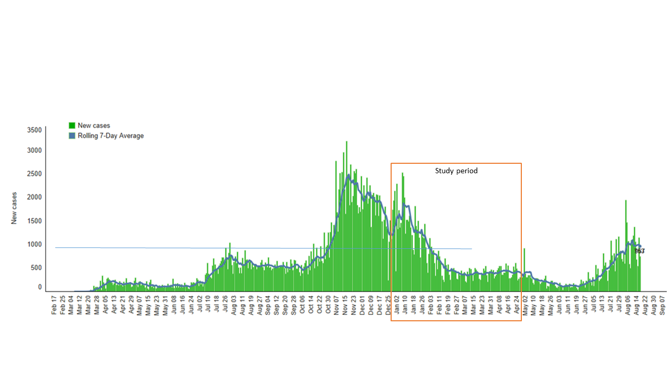
Citation: data from the BJC analytics team, per an internal dashboard, accessed 8/27/2021.

