Supplementary Material

for

Improving antimicrobial prescribing for upper respiratory infections in the emergency department: implementation of peer comparison with behavioral feedback
George F. Jones, BS^{1,2}, Valeria Fabre, MD¹, Jeremiah Hinson, MD, PhD³, Scott Levin, PhD³, Matthew Toerper, MSc³, Jennifer Townsend, MD⁴, Sara E. Cosgrove, MD¹, Mustapha Saheed, MD³, Eili Y. Klein, PhD^{3,5}
¹Department of Medicine, Division of Infectious Diseases, Johns Hopkins University School of Medicine, Baltimore, Maryland, USA
²Eastern Virginia Medical School, Norfolk, Virginia, USA
³Department of Emergency Medicine, Johns Hopkins University School of Medicine, Baltimore, Maryland, USA
⁴Division of Infectious Diseases, Greater Baltimore Medical Center, Towson, Maryland, USA
⁵Center for Disease Dynamics, Economics & Policy, Washington DC, USA

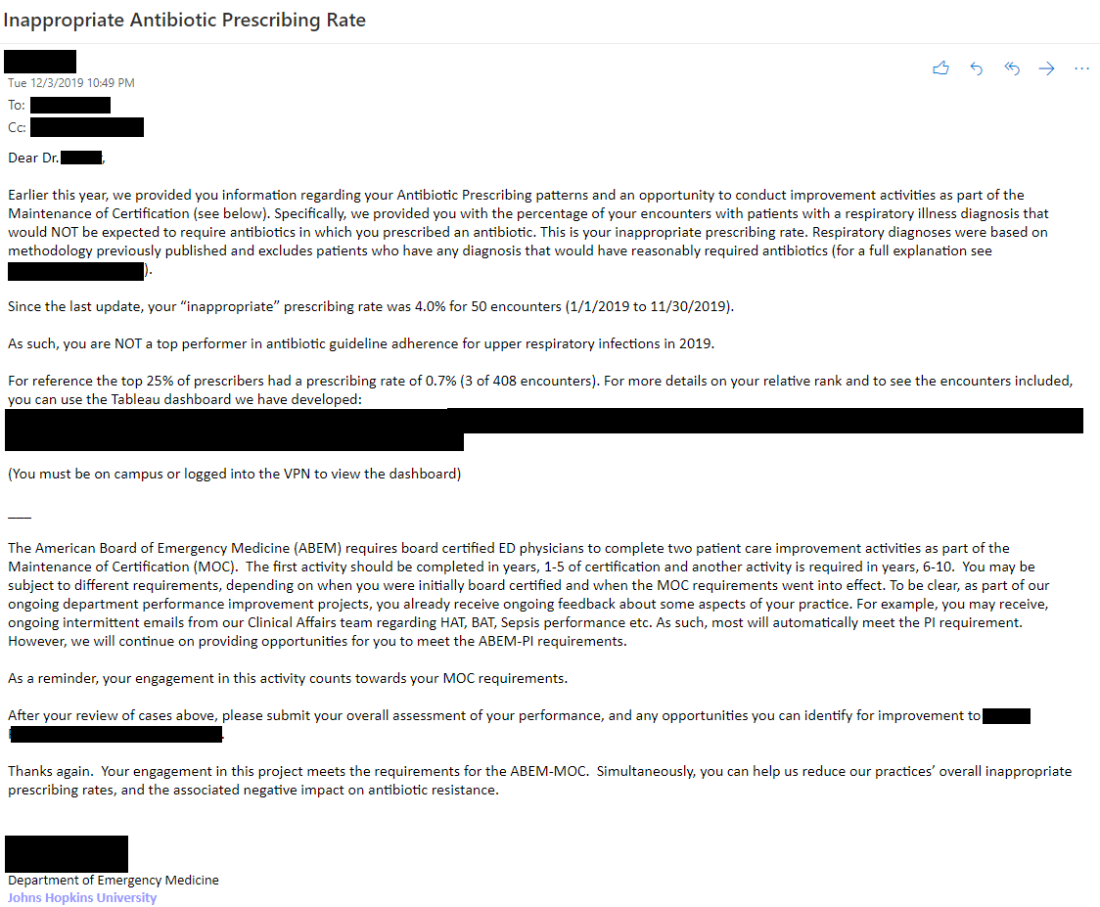
Supplementary Figure 1. Example feedback email.
Example email sent to providers on an approximately biannual basis providing them with feedback on their inappropriate prescribing rate. Provider-specific information has been redacted to maintain confidentiality.

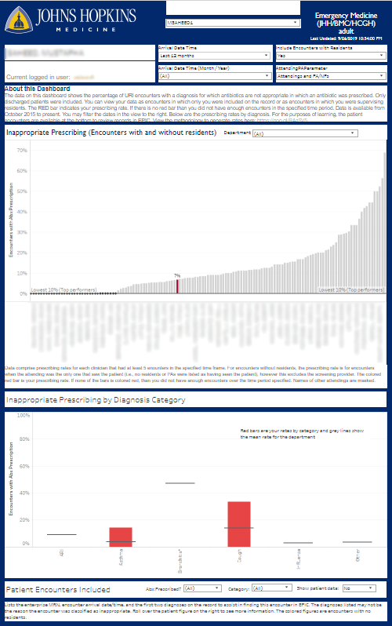
Supplementary Figure 2. Provider feedback dashboard.
Providers in the top 10% are shown for peer comparison. Rolling over each column shows the percentage for each provider and the number of encounters on which the rate of inappropriate prescribing is based. Filters allow the provider to compare data over different timelines and across departments.

Supplementary Table 1. Diagnosis codes used to categorize respiratory condition encounters where antibiotics are inappropriate.
ICD-10 Diagnosis Code | Diagnosis | Category
J00 | Acute nasopharyngitis [common cold] | AURI
J04.0 | Acute laryngitis | AURI
J04.2 | Acute laryngotracheitis | AURI
J06.0 | Acute laryngopharyngitis | AURI
J06.9 | Acute upper respiratory infection, unspecified | AURI
J09.X2 | Influenza due to identified novel influenza A virus | Influenza
J10.1 | Influenza due to other identified influenza virus | Influenza
J10.2 | Influenza due to other identified influenza virus | Influenza
J11.1 | Influenza due to unidentified influenza virus with other resp manifest | Influenza
J11.2 | Influenza due to unidentified influenza virus with GI manifest | Influenza
J11.89 | Influenza due to unidentified influenza virus with other manifest | Influenza
J20.3 | Acute bronchitis due to coxsackievirus | Bronchitisª
J20.4 | Acute bronchitis due to parainfluenza virus | Bronchitisª
J20.5 | Acute bronchitis due to respiratory syncytial virus | Bronchitisª
J20.6 | Acute bronchitis due to rhinovirus | Bronchitisª
J20.7 | Acute bronchitis due to echovirus | Bronchitisª
J20.8 | Acute bronchitis due to other specified organisms | Bronchitisª
J20.9 | Acute bronchitis, unspecified | Bronchitisª
J21.0 | Acute bronchiolitis due to respiratory syncytial virus | Bronchitisª
J21.1 | Acute bronchiolitis due to human metapneumovirus | Bronchitisª
J21.8 | Acute bronchiolitis due to other specified organisms | Bronchitisª
J21.9 | Acute bronchiolitis, unspecified | Bronchitisª
J40 | Bronchitis, not specified as acute or chronic | Bronchitisª
J30.0 | Vasomotor rhinitis | Other
J30.1 | Allergic rhinitis due to pollen | Other
J30.2 | Other seasonal allergic rhinitis | Other
J30.5 | Allergic rhinitis due to food | Other
J30.81 | Allergic rhinitis due to animal (cat) (dog) hair a | Other
J30.89 | Other allergic rhinitis | Other
J30.9 | Allergic rhinitis, unspecified | Other
J31.0 | Chronic rhinitis | Other
J31.1 | Chronic nasopharyngitis | Other
J33.0 | Polyp of nasal cavity | Other
J33.1 | Polypoid sinus degeneration | Other
J33.8 | Other polyp of sinus | Other
J33.9 | Nasal polyp, unspecified | Other
J34.1 | Cyst and mucocele of nose and nasal sinus | Other
J34.2 | Deviated nasal septum | Other
J34.3 | Hypertrophy of nasal turbinates | Other
J34.81 | Nasal mucositis (ulcerative) | Other
J34.89 | Other specified disorders of nose and nasal sinuse | Other
J34.9 | Unspecified disorder of nose and nasal sinuses | Other
J35.01 | Chronic tonsillitis | Other
J35.02 | Chronic adenoiditis | Other
J35.03 | Chronic tonsillitis and adenoiditis | Other
J35.1 | Hypertrophy of tonsils | Other
J35.2 | Hypertrophy of adenoids | Other
J35.3 | Hypertrophy of tonsils with hypertrophy of adenoid | Other
J35.8 | Other chronic diseases of tonsils and adenoids | Other
J35.9 | Chronic disease of tonsils and adenoids, unspecifi | Other
J37.0 | Chronic laryngitis | Other
J37.1 | Chronic laryngotracheitis | Other
J38.00 | Paralysis of vocal cords and larynx, unspecified | Other
J38.01 | Paralysis of vocal cords and larynx, unilateral | Other
J38.02 | Paralysis of vocal cords and larynx, bilateral | Other
J38.1 | Polyp of vocal cord and larynx | Other
J38.2 | Nodules of vocal cords | Other
J38.3 | Other diseases of vocal cords | Other
J38.4 | Edema of larynx | Other
J38.5 | Laryngeal spasm | Other
J38.6 | Stenosis of larynx | Other
J38.7 | Other diseases of larynx | Other
J39.2 | Other diseases of pharynx | Other
J39.3 | Upper respiratory tract hypersensitivity reaction, site unsp | Other
J39.8 | Other specified diseases of upper respiratory tract | Other
J39.9 | Disease of upper respiratory tract, unspecified | Other
B34.9 | Viral infection, unspecified | Other
R09.81 | Nasal congestion | Other
R09.82 | Postnasal drip | Other
B97.4 | Respiratory syncytial virus as the cause of disease classified elsewhere | Other
J12.9 | Viral pneumonia, unspecified | Pneumonia
J45.20 | Mild intermittent asthma, uncomplicated | Asthma
J45.21 | Mild intermittent asthma with (acute) exacerbation | Asthma
J45.30 | Mild persistent asthma, uncomplicated | Asthma
J45.31 | Mild persistent asthma with (acute) exacerbation | Asthma
J45.40 | Moderate persistent asthma, uncomplicated | Asthma
J45.41 | Moderate persistent asthma with (acute) exacerbation | Asthma
J45.901 | Unspecified asthma with (acute) exacerbation | Asthma
J45.909 | Unspecified asthma, uncomplicated | Asthma
J45.998 | Other asthma | Asthma
R05 | Cough | Cough
ª No COPD indication either in current visit or prior visit (ICD-10 code: J44).

Supplementary Table 2. Diagnosis codes for respiratory infections for which antibiotics are or may be appropriate.
ICD-10 Diagnosis Code | Diagnosis | Category
J20.0 | Acute bronchitis due to Mycoplasma pneumoniae | Bacterial Bronchitis
J20.1 | Acute bronchitis due to Hemophilus influenzae | Bacterial Bronchitis
J20.2 | Acute bronchitis due to streptococcus | Bacterial Bronchitis
J22 | Unspecified acute lower respiratory infection | Bacterial Bronchitis
J41.0 | Simple chronic bronchitis | Chronic Bronchitis
J41.1 | Mucopurulent chronic bronchitis | Chronic Bronchitis
J41.8 | Mixed simple and mucopurulent chronic bronchitis | Chronic Bronchitis
J42 | Unspecified chronic bronchitis | Chronic Bronchitis
J44.0 | Chronic obstructive pulmon disease w acute lower resp infct | COPD
J44.1 | Chronic obstructive pulmonary disease w (acute) exacerbation | COPD
J44.9 | Chronic obstructive pulmonary disease, unspecified | COPD
J09.X1 | Influenza due to ident novel influenza A virus w pneumonia | Influenza with Pneumonia
J09.X9 | Flu due to ident novel influenza A virus w oth manifest | Influenza with Pneumonia
J10.00 | Flu due to oth ident flu virus w unsp type of pneumonia | Influenza with Pneumonia
J10.01 | Flu due to oth ident flu virus w same oth ident flu virus pn | Influenza with Pneumonia
J10.08 | Influenza due to oth ident influenza virus w oth pneumonia | Influenza with Pneumonia
J10.81 | Influenza due to oth ident influenza virus w encephalopathy | Influenza with Pneumonia
J10.82 | Influenza due to oth ident influenza virus w myocarditis | Influenza with Pneumonia
J10.83 | Influenza due to oth ident influenza virus w otitis media | Influenza with Pneumonia
J10.89 | Influenza due to oth ident influenza virus w oth manifest | Influenza with Pneumonia
J11.00 | Flu due to unidentified flu virus w unsp type of pneumonia | Influenza with Pneumonia
J11.08 | Flu due to unidentified flu virus w specified pneumonia | Influenza with Pneumonia
J11.81 | Flu due to unidentified influenza virus w encephalopathy | Influenza with Pneumonia
J11.82 | Influenza due to unidentified influenza virus w myocarditis | Influenza with Pneumonia
J11.83 | Influenza due to unidentified influenza virus w otitis media | Influenza with Pneumonia
J04.10 | Acute tracheitis without obstruction | Other ARI
J04.11 | Acute tracheitis with obstruction | Other ARI
J04.30 | Supraglottitis, unspecified, without obstruction | Other ARI
J34.0 | Abscess, furuncle and carbuncle of nose | Other ARI
J39.0 | Retropharyngeal and parapharyngeal abscess | Other ARI
J39.1 | Other abscess of pharynx | Other ARI
J02.0 | Streptococcal pharyngitis | Pharyngitis
J02.8 | Acute pharyngitis due to other specified organisms | Pharyngitis
J02.9 | Acute pharyngitis, unspecified | Pharyngitis
J03.00 | Acute streptococcal tonsillitis, unspecified | Pharyngitis
J03.01 | Acute recurrent streptococcal tonsillitis | Pharyngitis
J31.2 | Chronic pharyngitis | Pharyngitis
J13 | Pneumonia due to Streptococcus pneumoniae | Pneumonia
J14 | Pneumonia due to Hemophilus influenzae | Pneumonia
J15.0 | Pneumonia due to Klebsiella pneumoniae | Pneumonia
J15.1 | Pneumonia due to Pseudomonas | Pneumonia
J15.20 | Pneumonia due to staphylococcus, unspecified | Pneumonia
J15.21 | Pneumonia due to staphylococcus aureus | Pneumonia
J15.211 | Pneumonia due to methicillin suscep staph | Pneumonia
J15.212 | Pneumonia due to Methicillin resistant Staphylococcus aureus | Pneumonia
J15.29 | Pneumonia due to other staphylococcus | Pneumonia
J15.3 | Pneumonia due to streptococcus, group B | Pneumonia
J15.4 | Pneumonia due to other streptococci | Pneumonia
J15.5 | Pneumonia due to Escherichia coli | Pneumonia
J15.6 | Pneumonia due to other aerobic Gram-negative bacteria | Pneumonia
J15.7 | Pneumonia due to Mycoplasma pneumoniae | Pneumonia
J15.8 | Pneumonia due to other specified bacteria | Pneumonia
J15.9 | Unspecified bacterial pneumonia | Pneumonia
J16.0 | Chlamydial pneumonia | Pneumonia
J16.8 | Pneumonia due to other specified infectious organisms | Pneumonia
J17 | Pneumonia in diseases classified elsewhere | Pneumonia
J18.0 | Bronchopneumonia, unspecified organism | Pneumonia
J18.1 | Lobar pneumonia, unspecified organism | Pneumonia
J18.2 | Hypostatic pneumonia, unspecified organism | Pneumonia
J18.8 | Other pneumonia, unspecified organism | Pneumonia
J18.9 | Pneumonia, unspecified organism | Pneumonia
J01.00 | Acute maxillary sinusitis, unspecified | Sinusitis
J01.01 | Acute recurrent maxillary sinusitis | Sinusitis
J01.10 | Acute frontal sinusitis, unspecified | Sinusitis
J01.11 | Acute recurrent frontal sinusitis | Sinusitis
J01.20 | Acute ethmoidal sinusitis, unspecified | Sinusitis
J01.21 | Acute recurrent ethmoidal sinusitis | Sinusitis
J01.30 | Acute sphenoidal sinusitis, unspecified | Sinusitis
J01.31 | Acute recurrent sphenoidal sinusitis | Sinusitis
J01.40 | Acute pansinusitis, unspecified | Sinusitis
J01.41 | Acute recurrent pansinusitis | Sinusitis
J01.80 | Other acute sinusitis | Sinusitis
J01.81 | Other acute recurrent sinusitis | Sinusitis
J01.90 | Acute sinusitis, unspecified | Sinusitis
J01.91 | Acute recurrent sinusitis, unspecified | Sinusitis
J32.0 | Chronic maxillary sinusitis | Sinusitis
J32.1 | Chronic frontal sinusitis | Sinusitis
J32.2 | Chronic ethmoidal sinusitis | Sinusitis
J32.3 | Chronic sphenoidal sinusitis | Sinusitis
J32.4 | Chronic pansinusitis | Sinusitis
J32.8 | Other chronic sinusitis | Sinusitis
J32.9 | Chronic sinusitis, unspecified | Sinusitis
J03.80 | Acute tonsillitis due to other specified organisms | Tonsillitis
J03.81 | Acute recurrent tonsillitis due to other specified organisms | Tonsillitis
J03.90 | Acute tonsillitis, unspecified | Tonsillitis
J03.91 | Acute recurrent tonsillitis, unspecified | Tonsillitis
J36 | Peritonsillar abscess | Tonsillitis

Supplementary Table 3. Diagnosis codes for non-respiratory infections for which antibiotics are/may be appropriate.
ICD-10 Diagnosis Code | Diagnosis
A04 | Other bacterial intestinal infections
A05 | Other bacterial foodborne intoxications, not elsewhere classified
A06.2 | Amoebic nondysenteric colitis
A09 | Infectious gastroenteritis and colitis, unspecified
A15 | Respiratory tuberculosis
A17 | Tuberculosis of nervous system
A18 | Tuberculosis of other organs
A19 | Miliary tuberculosis
A20 | Plague
A21 | Tularemia
A22 | Anthrax
A23 | Brucellosis
A24 | Glanders and melioidosis
A25 | Rat-bite fevers
A26 | Erysipeloid
A27 | Leptospirosis
A28 | Other zoonotic bacterial diseases, not elsewhere classified
A30 | Leprosy [Hansen's disease]
A31 | Infection due to other mycobacteria
A32 | Listeriosis
A33 | Tetanus neonatorum
A34 | Obstetrical tetanus
A35 | Other tetanus
A36 | Diphtheria
A37 | Whooping cough
A38 | Scarlet fever
A39 | Meningococcal meningitis
A40 | Streptococcal sepsis
A41 | Other sepsis
A42 | Actinomycosis
A43 | Nocardiosis
A44 | Bartonellosis
A46 | Erysipelas
A48 | Other bacterial diseases, not elsewhere classified
A49 | Bacterial infection of unspecified site
A50 | Congenital syphilis
A51 | Early syphilis
A52 | Late syphilis
A53 | Other and unspecified syphilis
A54 | Gonococcal infection
A55 | Chlamydial lymphogranuloma (venereum)
A56 | Other sexually transmitted chlamydial diseases
A57 | Chancroid
A58 | Granuloma inguinale
A59 | Trichomoniasis
A64 | Unspecified sexually transmitted disease
A65 | Nonvenereal syphilis
A66 | Yaws
A67 | Pinta [carate]
A68 | Relapsing fevers
A69 | Other spirochetal infections
A70 | Chlamydia psittaci infections
A71 | Trachoma
A74 | Other diseases caused by chlamydiae
A75 | Typhus fever
A77 | Spotted fever [tick-borne rickettsioses]
A78 | Q fever
A79 | Other rickettsioses
B58.2 | Toxoplasma meningoencephalitis
B95 | Streptococcus, Staphylococcus, and Enterococcus as the cause of diseases classified elsewhere
B96 | Other bacterial agents as the cause of diseases classified elsewhere
G00 | Bacterial meningitis, not elsewhere classified
G01 | Meningitis in bacterial diseases classified elsewh
G02 | Meningitis in other infectious and parasitic disea
G03 | Meningitis due to other and unspecified causes
G04 | Encephalitis, myelitis and encephalomyelitis
G05 | Encephalitis, myelitis and encephalomyelitis in diseases classified elsewhere
G06 | Intracranial and intraspinal abscess and granuloma
H00.03 | Abscess of eyelid
H05.01 | Cellulitis of orbit
H05.02 | Osteomyelitis of orbit
H05.03 | Periostitis of orbit
H60 | Otitis externa
H65 | Nonsuppurative otitis media
H66 | Suppurative and unspecified otitis media
I00 | Rheumatic fever without heart involvement
I01 | Rheumatic fever with heart involvement
I02 | Rheumatic chorea
I33 | Acute and subacute endocarditis
I96 | Gangrene, not elsewhere classified
J47 | Bronchiectasis
J95.851 | Ventilator associated pneumonia
K02 | Dental caries
K04.4 | Acute apical periodontitis of pulpal origin
K04.6 | Chronic apical periodontitis
K04.6 | Periapical abscess with sinus
K04.7 | Periapical abscess without sinus
K05.2 | Aggressive periodontitis
K05.3 | Chronic periodontitis
K05.4 | Periodontosis
K11.2 | Sialoadenitis
K12.2 | Cellulitis and abscess of mouth
K35 | Acute appendicitis
K50 | Crohn's disease
K52.1 | Toxic gastroenteritis and colitis
K57.2 | Diverticulitis of large intestine with perforation
K57.3 | Diverticulitis of large intestine without perforat
K61 | Abscess of anal and rectal regions
K65.0 | Generalized (acute) peritonitis
K65.1 | Peritoneal abscess
K65.2 | Spontaneous bacterial peritonitis
K65.9 | Peritonitis, unspecified
K68.1 | Retroperitoneal abscess
K75.0 | Abscess of liver
K80.0 | Calculus of gallbladder with acute cholecystitis
K80.18 | Calculus of gallbladder with other cholecystitis w
K80.19 | Calculus of gallbladder with other cholecystitis w
K80.42 | Calculus of bile duct with acute cholecystitis wit
K80.44 | Calculus of bile duct with chronic cholecystitis w
K81.0 | Acute cholecystitis
K83.0 | Cholangitis
K91.850 | Pouchitis
L00 | Staphylococcal scalded skin syndrome
L01.00 | Impetigo, unspecified
L01.09 | Other impetigo
L02 | Cutaneous abscess, furuncle and carbuncle
L03 | Cellulitis and acute lymphangitis
L04 | Acute lymphadenitis
L05.01 | Pilonidal cyst with abscess
L05.91 | Pilonidal cyst without abscess
L08.89 | Other specified local infections of the skin and s
L08.9 | Local infection of the skin and subcutaneous tissu
M00 | Pyogenic arthritis
M01 | Direct infections of joint in infectious and parasitic diseases classified elsewhere
M46.20 | Osteomyelitis of vertebra, site unspecified
M46.30 | Infection of intervertebral disc (pyogenic), site
M60.0 | Infective myositis
M86 | Osteomyelitis
N10 | Acute pyelonephritis
N12 | Tubulo-interstitial nephritis, not specified as ac
N28.84 | Pyelitis cystica
N30.0 | Acute cystitis
N30.20 | Other chronic cystitis without hematuria
N30.80 | Other cystitis without hematuria
N30.90 | Cystitis, unspecified without hematuria
N34.1 | Nonspecific urethritis
N34.2 | Other urethritis
N35.111 | Postinfective urethral stricture, not elsewhere cl
N39.0 | Urinary tract infection, site not specified
N41.0 | Acute prostatitis
N41.1 | Chronic prostatitis
N41.9 | Inflammatory disease of prostate, unspecified
N43.1 | Infected hydrocele
N45.1 | Epididymitis
N51 | Disorders of male genital organs in diseases class
N61 | Inflammatory disorders of breast
N72 | Inflammatory disease of cervix uteri
N73.0 | Acute parametritis and pelvic cellulitis
N73.3 | Female acute pelvic peritonitis
N73.9 | Female pelvic inflammatory disease, unspecified
N75.0 | Cyst of Bartholin's gland
N75.1 | Abscess of Bartholin's gland
N76.0 | Acute vaginitis
N76.4 | Abscess of vulva
N77.1 | Vaginitis, vulvitis and vulvovaginitis in diseases
O23 | Infections of genitourinary tract in pregnancy
O41.1010 | Infection of amniotic sac and membranes, unspecifi
O41.1090 | Infection of amniotic sac and membranes, unspecifi
O85 | Puerperal sepsis
O86 | Other puerperal infections
O91 | Infections of breast associated with pregnancy, the puerperium and lactation
P36 | Bacterial sepsis of newborn
P39.0 | Neonatal infective mastitis
P39.2 | Intra-amniotic infection affecting newborn, not el
P39.3 | Neonatal urinary tract infection
P39.4 | Neonatal skin infection
P39.8 | Other specified infections specific to the perinatal period
P39.9 | Infection specific to the perinatal period, unspecified
P77 | Necrotizing enterocolitis of newborn
R09.1 | Pleurisy
R50.81 | Fever presenting with conditions classified elsewh
R50.9 | Fever, unspecified
R78.81 | Bacteremia
R82.71 | Bacteriuria
S01 | Open wound of head
S11 | Open wound of neck
S21 | Open wound of thorax
S31 | Open wound of abdomen, lower back, pelvis and external genitals
S41 | Open wound of shoulder and upper arm
S51 | Open wound of elbow and forearm
S61 | Open wound of wrist, hand and fingers
S71 | Open wound of hip and thigh
S81 | Open wound of knee and lower leg
S91 | Open wound of ankle, foot and toes
T80.2 | Infections following infusion, transfusion and therapeutic injectio
W54.0XXA | Bitten by dog, initial encounter
Z20.1 | Contact with and (suspected) exposure to tuberculosis
Z20.2 | Contact with and (suspected) exposure to infections with a predominantly sexual mode of transmission
Z20.81 | Contact with and (suspected) exposure to other bacterial communicable diseases
Z20.89 | Contact with and (suspected) exposure to other communicable diseases
Z20.9 | Contact with and (suspected) exposure to unspecified communicable disease
Z22.3 | Carrier of other specified bacterial diseases
Z22.8 | Carrier of other infectious diseases
Z22.9 | Carrier of infectious disease, unspecified
Z76.0 | Encounter for issue of repeat prescription

Supplementary Table 4. Demographics of all acute respiratory infection encounters
Characteristic | Pre-intervention |  | Post-intervention
 | Control | Intervention | Control | Intervention
ARI encounters (n=51,928) | 10,620 | 20,531 | 7,911 | 12,866
Age (mean) | 50.8 | 42.3 | 49.8 | 42.7
Female (%) | 61.1 | 58.7 | 61.2 | 57.9
ARI prescribing rate (%) | 39.4 | 35.0 | 40.8 | 30.6
ARI encounters where antibiotics are inappropriate (%)ª | 62.9 | 63.9 | 58.8 | 62.7
ARI encounters where antibiotics are or may be appropriate (%)ª | 33.1 | 31.2 | 36.2 | 32.9
ADI (mean) | 3.4 | 6.9 | 3.6 | 6.7
Number of attending physicians | 41 | 116 | 45 | 114
ADI: Area depravation index^{19,20}; ARI: Acute respiratory infection.
ª These rows do not sum to 100% in a given column because encounters with a secondary exclusion code listed in Supplementary Table 3 were excluded.

