Table 1: Number of total prescriptions and prescriptions per 1000 visits per provider (pre and post-intervention)
Provider ID | Number of Prescriptions (pre-intervention) | Number of visits (pre-intervention) | Prescriptions per 1000 visits | Number of prescriptions (post-intervention) | Number of visits (post-intervention) | Prescriptions per 1000 visits (post-intervention)
Provider A | 112 | 1069 | 105 | 87 | 903 | 96
Provider B | 72 | 1337 | 54 | 58 | 1226 | 47
Provider C | 51 | 732 | 70 | 25 | 657 | 38
Provider D | 45 | 870 | 52 | 25 | 761 | 33
Provider E | 19 | 596 | 32 | 16 | 566 | 28
Provider F | 17 | 684 | 25 | 28 | 636 | 44
Provider G | 18 | 667 | 27 | 18 | 706 | 25
Provider H | 15 | 361 | 42 | 16 | 359 | 44
Provider I | 8 | 374 | 21 | 5 | 368 | 14

Table 2: Institutional Antibiotic Duration Recommendations
Indication | Goal Duration of therapy (days)
Acute exacerbation of chronic bronchitis | 5
Pneumonia | 5
Sinusitis | 5
Skin and skin structure infection | 5
Otitis | 7
Urinary tract infection | 7

Figure 1: Use of different antibiotics: pre and post-intervention

Image 1: Viral Prescription Pad distributed in clinic
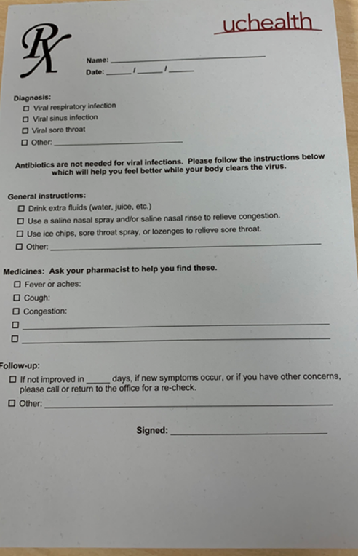

Image 2: Poster in patient waiting area
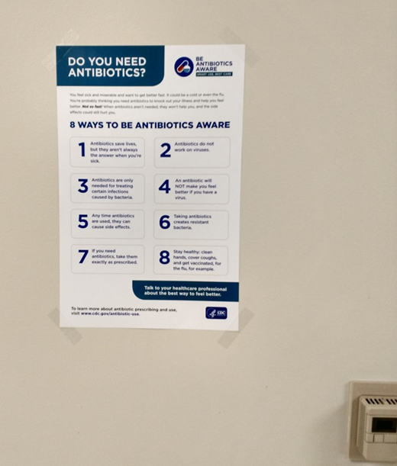

Image 3: Poster in patient waiting area

