Supplementary Table 1: Antibiotic Stewardship Survey Linked to CFIR Domains and Constructs
Question Theme | Question | CFIR Construct | CFIR Domain
About ASPs | Academic literature confirms that ASPs are an effective way to improve antibiotic prescribing | Evidence Strength & Quality | Intervention Characteristics
 | Clinical experience confirms that ASPs are an effective way to improve antibiotic prescribing. | Evidence Strength & Quality | Intervention Characteristics
 | ASPs add value to our organization. | Relative Advantage | Intervention Characteristics
 | ASPs appear to have more advantages than disadvantages for our patients. | Relative Advantage | Intervention Characteristics
ASPs in this setting | Our hospital primarily started the ASP because it was mandated. | Leadership Engagement | Inner Setting
 | There was an internal push from hospital leadership to establish an ASP. | Leadership Engagement | Inner Setting
 | There was an ASP-champion on the clinical staff who actively promoted the implementation of the ASP. | Leadership Engagement | Inner Setting
 | Knowing that other peer hospitals were instituting an ASP was a factor in deciding to implement one here. | Peer Pressure | Outer Setting
 | Talking to other organizations with ASPs helped us develop our ASP. | Cosmopolitanism | Outer Setting
 | Hospital leadership was involved in the initial development of the ASP. | Readiness for Implementation: Leadership Engagement | Inner Setting
 | Hospital leadership provided adequate resources to establish the ASP. | Readiness for Implementation: Leadership Engagement | Inner Setting
 | When the ASP was initially developed, roles and responsibilities were clearly identified. | Planning | Process
 | A realistic time schedule was developed for implementation of the ASP when the program was initially implemented. | Planning | Process
 | The original plan for implementing the ASP acknowledged clinicians’ input and opinions. | Planning | Process
 | The original plan for implementing the ASP was unnecessarily complex. | Planning | Process
 | This ASP had the support of the key opinion leaders in the hospital. | Engaging: Opinion Leaders | Process
Leadership’s perspective on Local ASP | Hospital leadership sets a high priority on the success of the ASP. | Relative Priority | Inner Setting
 | Clinical leadership has endorsed the project in visible ways. | Leadership Engagement | Inner Setting
 | Clinical leadership gives the antibiotic steward the authority to enforce the ASP policies. | Leadership Engagement | Inner Setting
 | The Antibiotic steward(s) has protected time to implement the ASP. | Leadership Engagement | Inner Setting
 | The ASP has been easily integrated into the Electronic Health Record (EHR) system. | Compatibility | Inner Setting
 | The EHR provides helpful reports about antibiotic use within the hospital. | Access to knowledge & info | Inner Setting
 | The ASP has considerable visibility within the hospital system. | Engaging | Process
 | Hospital leadership receives regular feedback on progress of ASP activities and resource needs. | Reflecting & Evaluating | Process
Staff’s perspective on local ASP | At my hospital…
 | Clinicians and hospital staff have received enough education and training on the ASP. | Access to Knowledge & Info | Inner Setting
 | The ASP is integrated into new provider training. | Access to Knowledge & Info | Inner Setting
 | The staff was receptive to the ASP. | Knowledge & Beliefs about the Intervention | Characteristics of the Individual
 | Nursing and other support staff understand the importance of the ASP policies. | Knowledge & Beliefs about the Intervention | Characteristics of the Individual
 | ASP policies put a heavy burden on the nursing staff. | Knowledge & Beliefs about the Intervention | Characteristics of the Individual
 | Nurses are actively engaged in the ASP activities. | Executing | Process
 | Clinical Pharmacists who provide patient care on the inpatient wards understand the importance of the ASP policies. | Knowledge & Beliefs about the Intervention | Characteristics of the Individual
 | ASP policies put a heavy burden on Clinical Pharmacists who provide patient care on inpatient wards. | Knowledge & Beliefs about the Intervention | Characteristics of the Individual
 | Clinical Pharmacists who provide patient care on the inpatient wards are actively engaged in ASP activities. | Executing | Process
 | Clinicians do not like the ASP because they feel it limits their ability to treat patients the way they think is best. | Knowledge & Beliefs about the Intervention | Characteristics of the Individual
 | Clinicians think the ASP delays antibiotic therapy too much. | Knowledge & Beliefs about the Intervention | Characteristics of the Individual
 | Clinicians think the ASP restricts too many antibiotics. | Knowledge & Beliefs about the Intervention | Characteristics of the Individual
 | The ASP involves too many steps for clinicians to adhere to in prescribing antibiotics. | Knowledge & Beliefs about the Intervention | Characteristics of the Individual
 | The ASP is strongly supported within the organization. | Engaging | Process
 | Feedback from clinicians related to proposed and implemented changes of the ASP is collected regularly. | Reflecting and Evaluating | Process
 | Clinicians at my facility view ASPs as one of the more important interventions the hospital can adopt compared to other interventions. | Implementation Climate: Compatibility | Inner Setting
Opinions of the Steward | As an antibiotic steward…
 | I work well with the interdisciplinary medical teams. | Engaging: Formally Appointed Internal Implementation Leaders | Process
 | I work well with individual clinicians. | Engaging: Formally Appointed Internal Implementation Leaders | Process
 | I have a lot of authority in the antibiotic decisions made in my facility. | Self-Efficacy | Characteristics of the Individual
 | I provide options to clinicians in antibiotic decisions in my facility. | Self-Efficacy | Characteristics of the Individual
 | I accept responsibility for the outcomes of this program. | Self-Efficacy | Characteristics of the Individual
 | I feel like I can effect change in my setting. | Self-Efficacy | Characteristics of the Individual
 | I feel like I have the skills to function effectively in my role. | Self-Efficacy | Characteristics of the Individual
 | I am able to carry out the mission of the ASP in my hospital. | Self-Efficacy | Characteristics of the Individual
 | I am empowered to continue to improve the ASP. | Self-Efficacy | Characteristics of the Individual
 | I am invested in the success of the ASP. | Self-Efficacy | Characteristics of the Individual
 | It is important to me that my hospital does not have substantially higher antibiotic use compared to other hospitals. | Individual Identification with Organization | Characteristics of the Individual
About the Hospital | In this hospital, clinical staff’s opinions are solicited regarding decisions about patient care. | Networks & Communication | Inner Setting
 | In this hospital, clinical staff’s opinions are solicited regarding innovative, new programs. | Learning Climate | Inner Setting
 | Communication within the hospital is effective. | Networks & Communication | Inner Setting
 | Clinical innovation and creativity to improve patient care are rewarded in my hospital. | Learning Climate | Inner Setting
 | Staff at the hospital have a sense of personal responsibility for improving patient care and outcomes. | Culture | Inner Setting
 | Staff at the hospital cooperate to maintain and improve effectiveness of patient care. | Culture | Inner Setting
 | Staff at the hospital are receptive to change in clinical processes. | Culture | Inner Setting
 | Clinical leadership at the hospital provides staff with information on hospital performance measures and guidelines. | Reflecting & Evaluating | Process
 | Clinical leadership at the hospital establishes clear goals for patient care processes and outcomes. | Reflecting & Evaluating | Process
 | Clinical leadership at the hospital provides staff with feedback/data on effects of clinical decisions. | Reflecting & Evaluating | Process
 | Clinical leadership at the hospital hold staff accountable for achieving results. | Reflecting & Evaluating | Process
Demographic/  Personal Questions | Are you trained as a: 1) pharmacist; 2) physician
 | How long have you worked at this hospital?
 | In what year were you first licensed as a physician/pharmacist?
 | Where did you attend pharmacy or medical school?
 | If applicable, where did you complete residency training?
 | If applicable, did you receive specialized Infectious Disease or Antibiotic Training? (y/n)
 | People sometimes volunteer to be the Antibiotic Steward within a hospital, and other times they are assigned by hospital management. Which answer best fits how you think it worked in your setting?
On a scale of 1 (very low) to 5 (very high), when you first started this antibiotic stewardship position, how much interest did you have in antibiotic stewardship?
(Place a mark on the scale above)
What is your involvement in the ASP?
- I’m the primary leader
- I co-lead the ASP with [open response]
- I do a lot of the work, but I’m not in charge
- Other, please reply: [open response]
 | Would you be willing to have us contact you to discuss these topics more? If so, please leave your name, and phone number and/or email address.
 | Name
 | Phone and/or email address
 | if you do NOT want to be contacted in the future, please indicate by selecting “Do not Contact.”

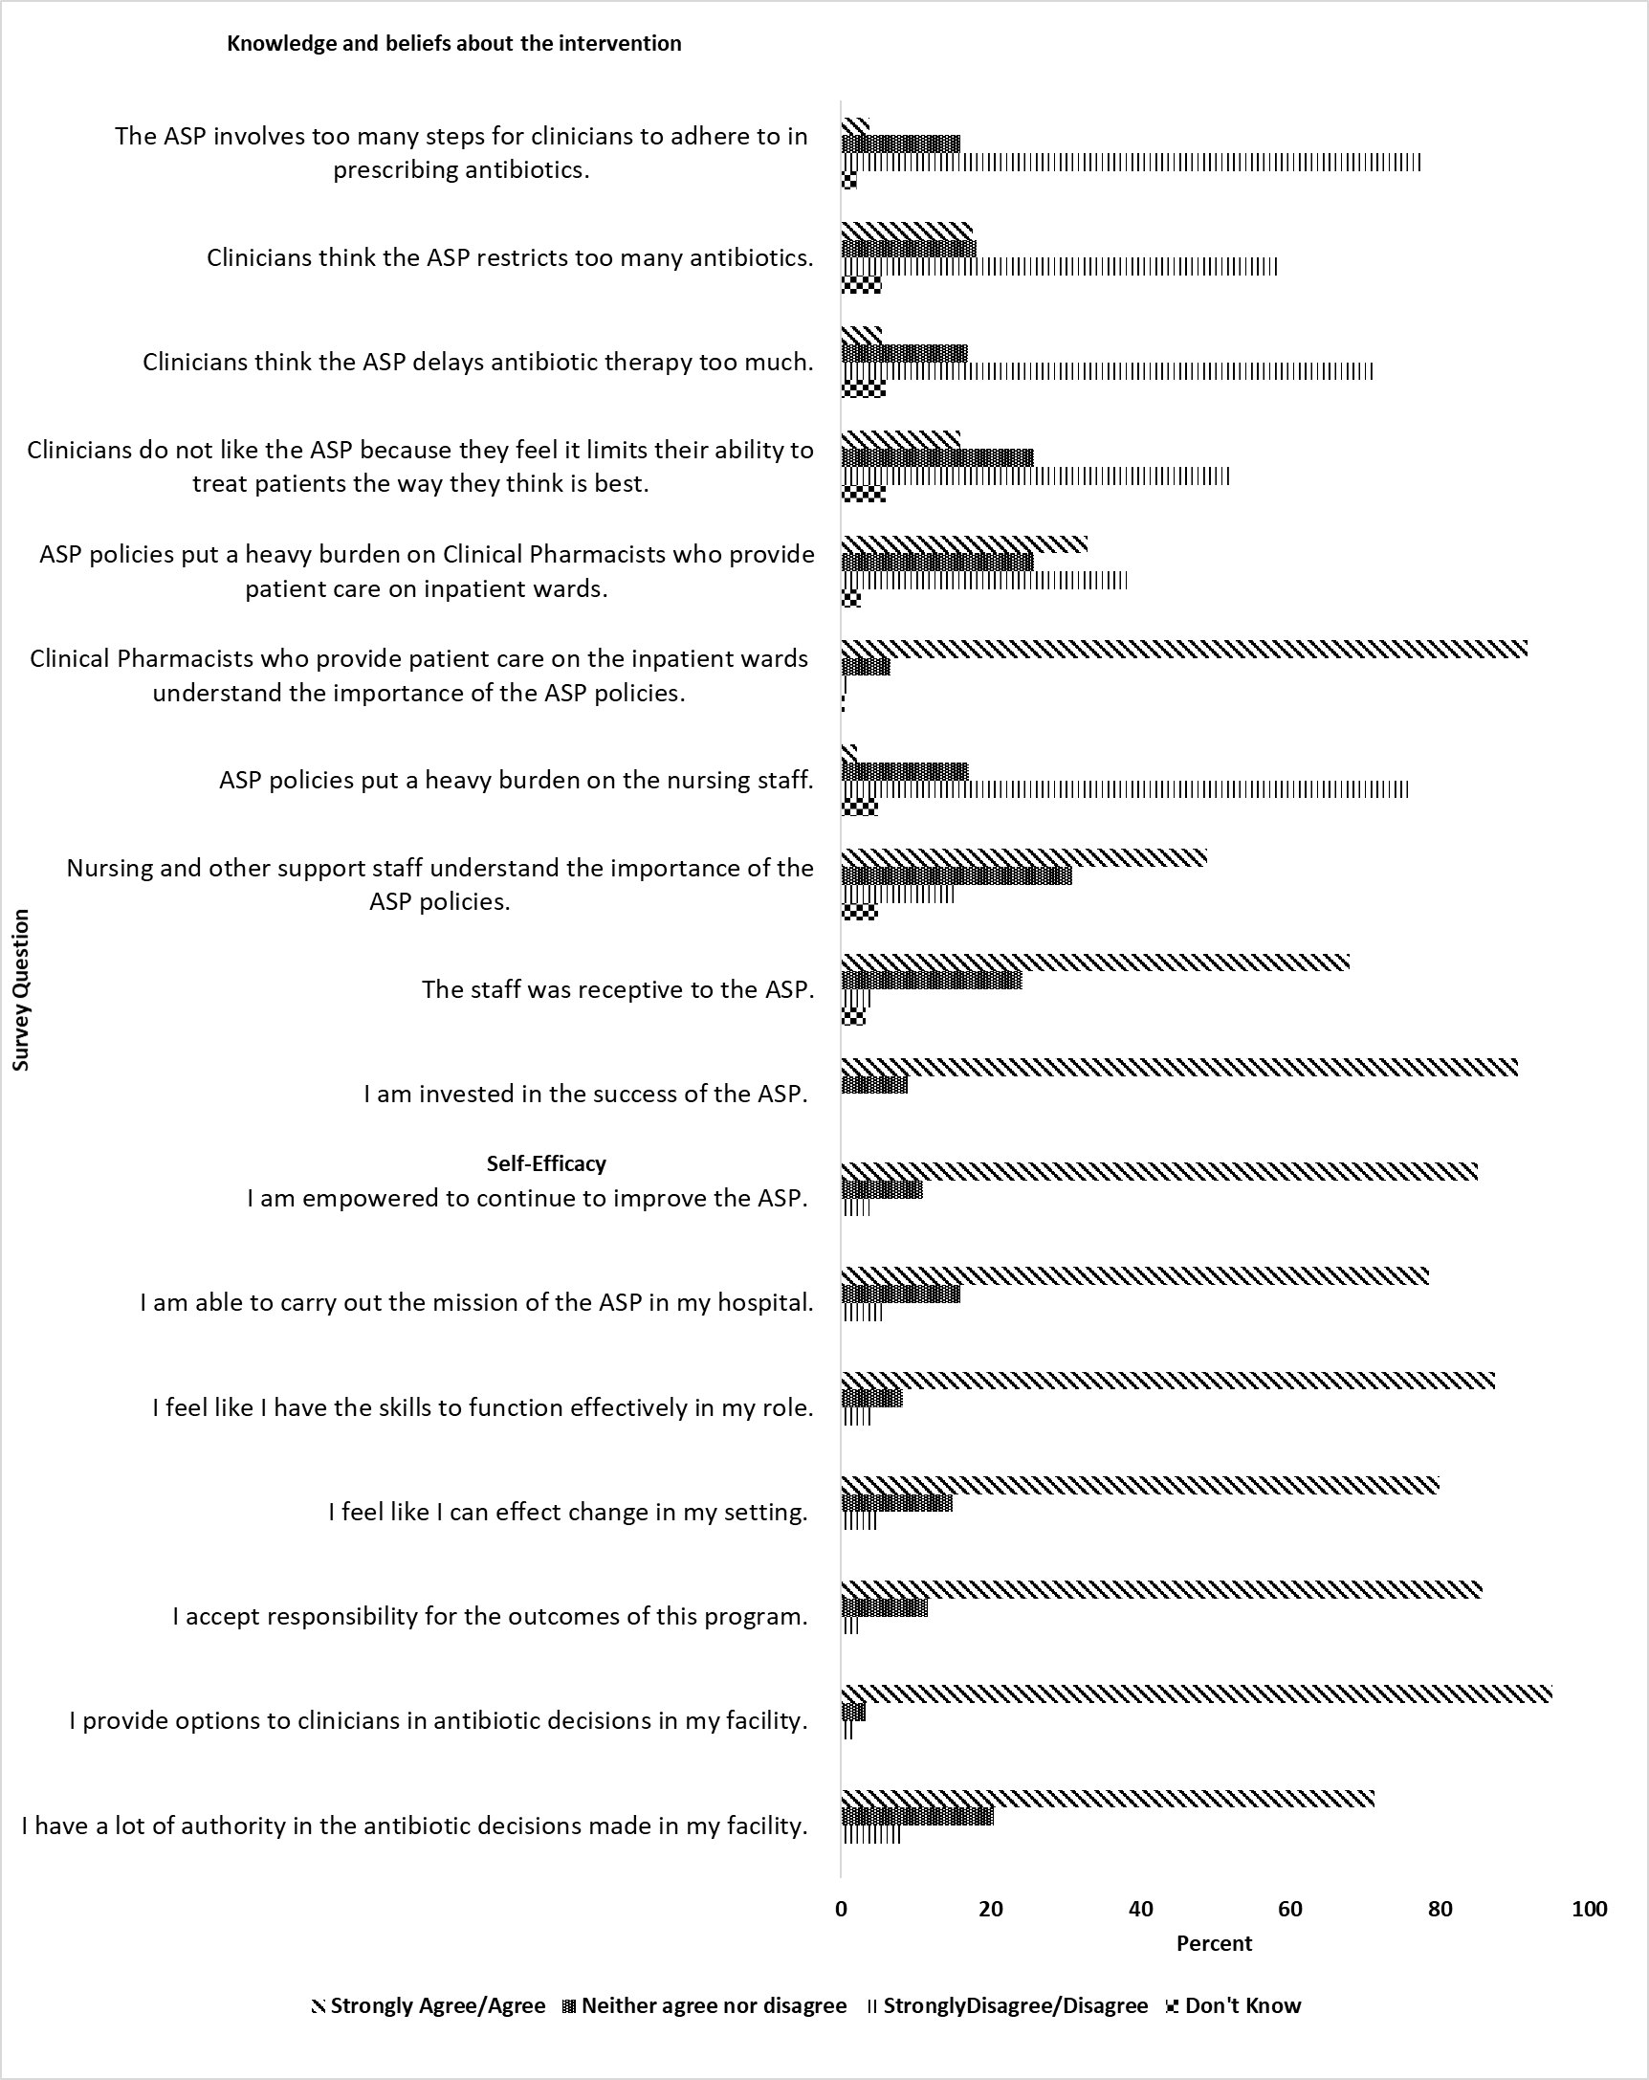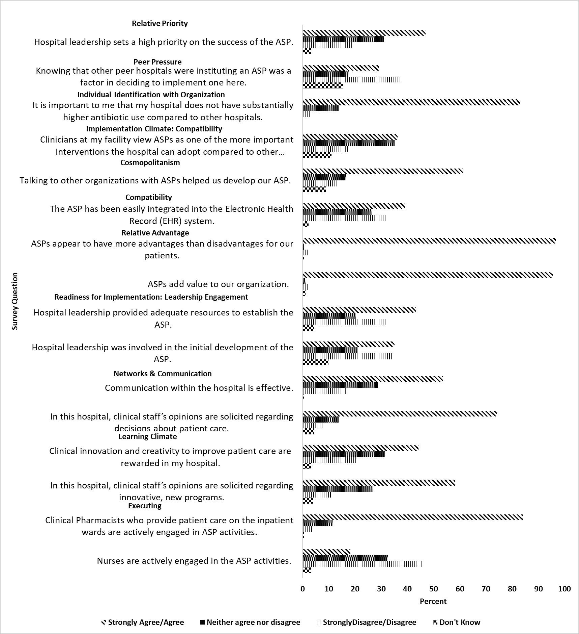
b
a
Supplementary Figure 1: Distribution of responses to all survey questions

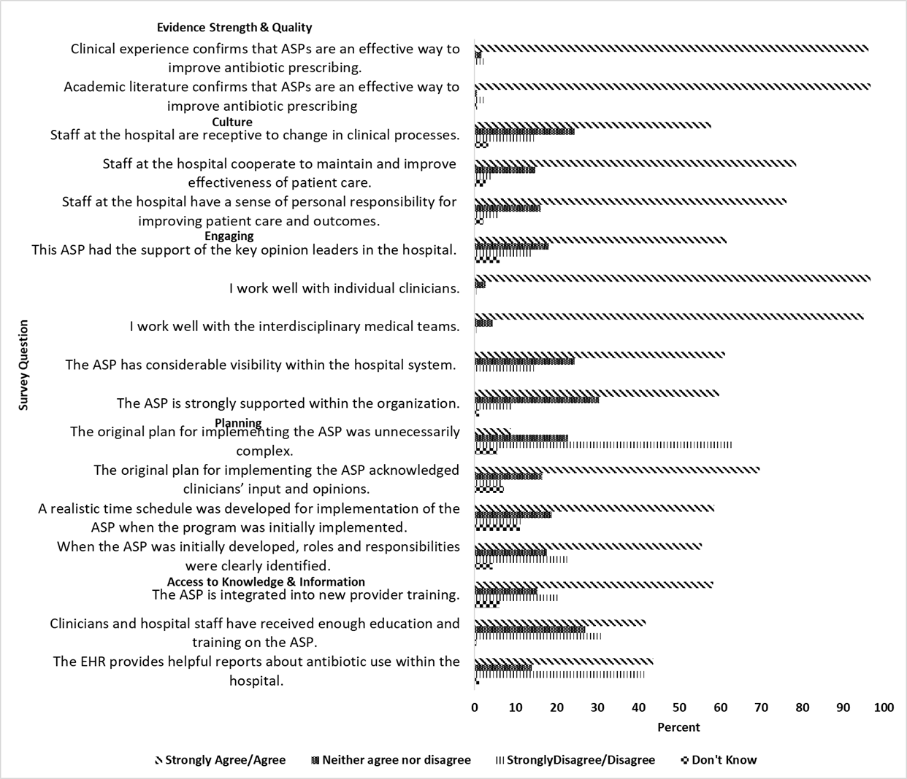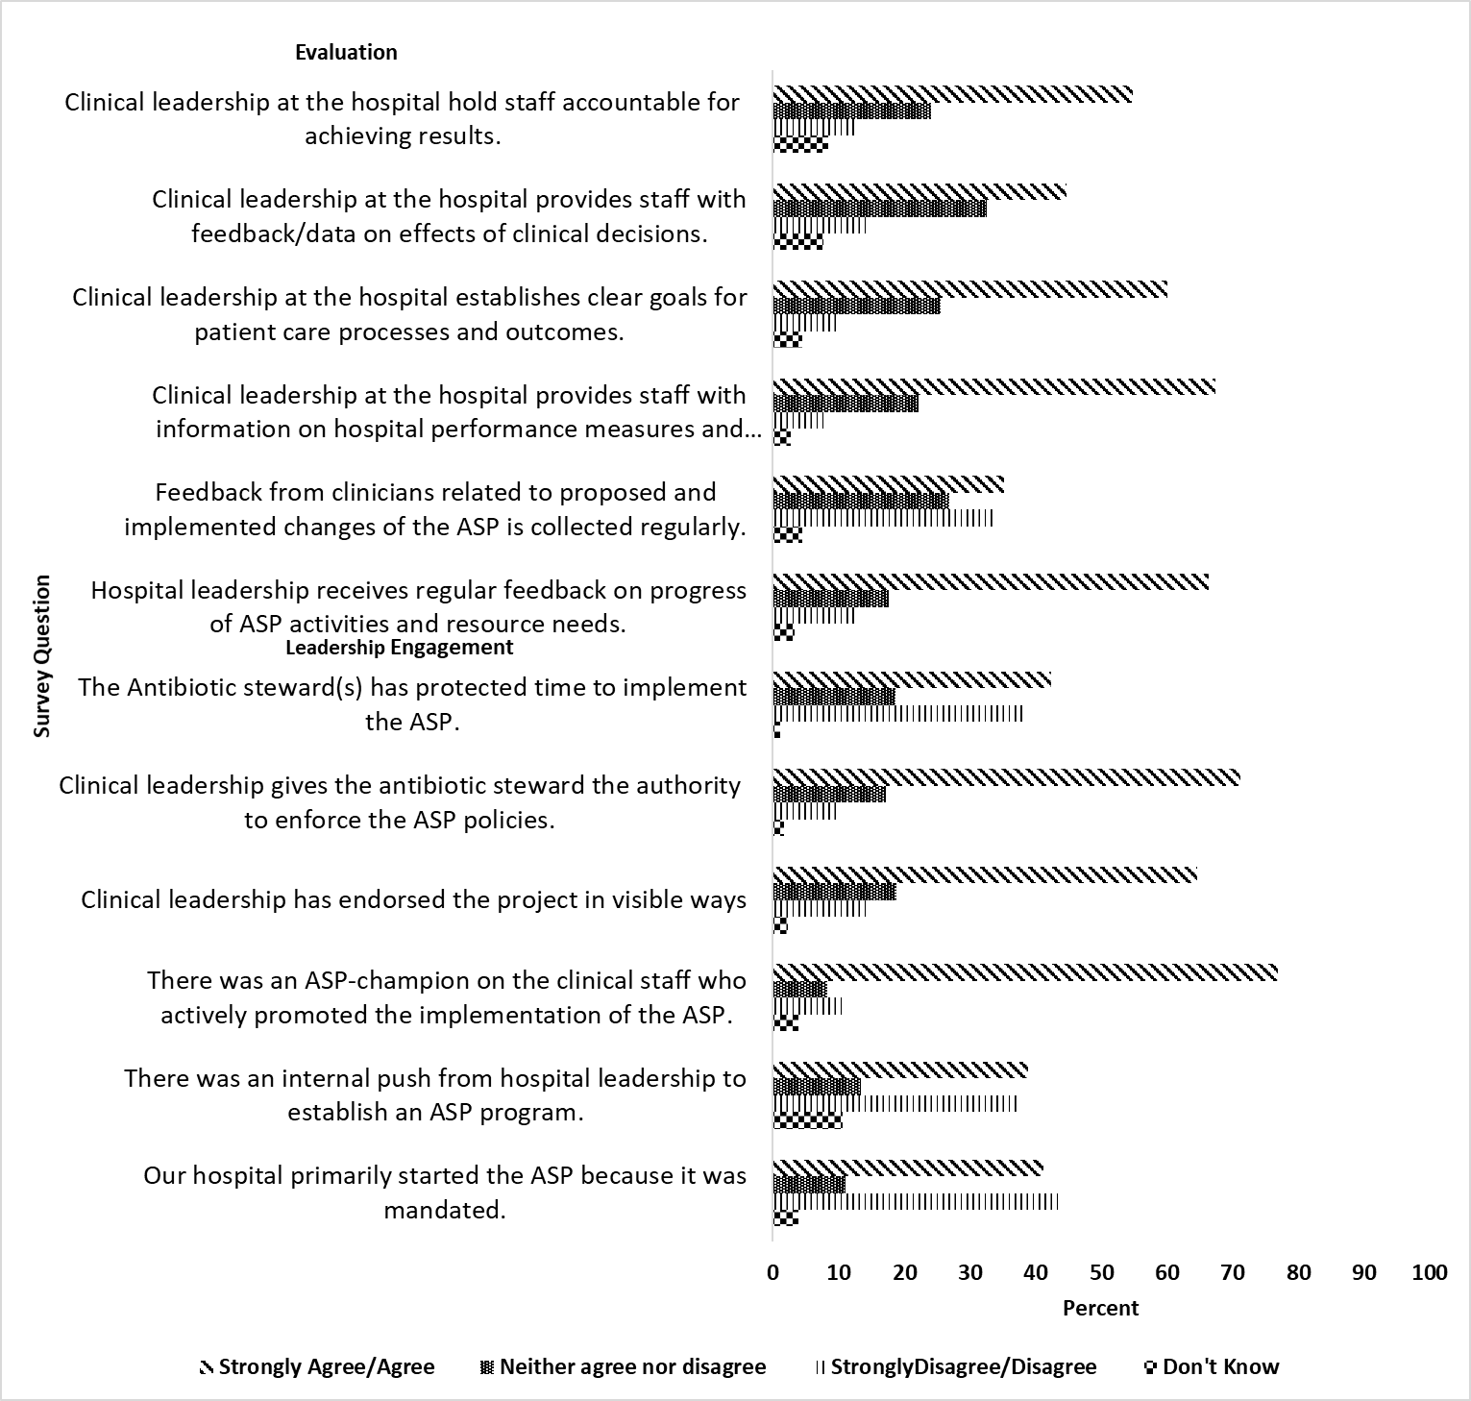
d
c

