Supplementary

ClusterAlign: A fiducial tracking and tilt series alignment tool for thick sample tomography

Shahar Seifer, Michael Elbaum

File name | Rotation  axis | Max  number fiducials | Cluster  radius | Fiducial  size, locations | Track | CNR  fiducials | Figures
DM126_  2_LT_Cell_1_3 | ϕ=90° | 800 | 400 pix | 7.5 pix  ±30%,  200% tolerance | 59 fids | 1.0 | Main text: Figs 4-9
DM101_  1_Cell1_7 | ϕ=90° | 2000 | 400 pix | 6 pix ±50%,  200% tolerance | 36 fids | 3.2 | Here: Fig.S1
DM127_  SUN1_2_1_2 | ϕ=90° | 800 | 400 pix | 6 pix ±50%,  200%  tolerance | 53 fids | 1.5 | Here: Fig.S2
AD66_  1_A-pt60a | ϕ=90° | 2000 | 400 pix | 6.5 pix ±30%,  200%  Tolerance | 369 fids | 2.8 | Main text: Fig.10  Here: Fig.S3
DM124_  1_B_3_1a,b | Dual axis | 1500 | 1000 pix | 7 pix ±50%,  250%  Tolerance | 93, 116  fids | 1.2 | Here: Figs.S4-6
ETDB/3c3f9c | ϕ=102° | 500 | 2800 | 25 pix ±40%,  250%  Tolerance | 16 fids | 5.0 | Here: Figs S7-10,15
ETDB/91e5cd | ϕ=12° | 500 | 2500 | 25 pix ±40%,  250%  Tolerance | 11  fids | 3.0 | Here: Figs S11-15

Relation between difference in z and distance between fiducials in the x-y plane
Figure S1. (36 tracked fiducial points)
Figure S2. (53 tracked fiducial points)
Figure S3. (369 tracked fiducial points)

Dual axis reconstruction
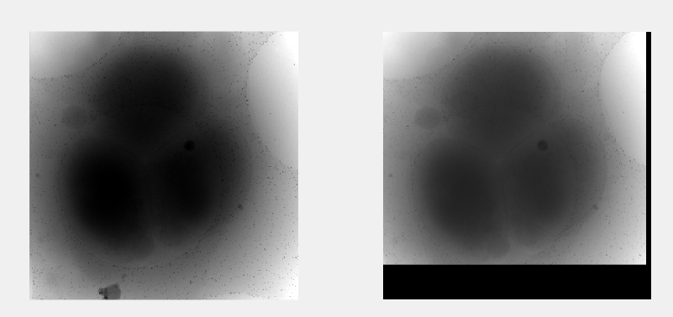
Figure S4. Matching center slices of the two tilt series. The information is used to shift the argument of detector location (relative to the center of reconstructed volume) that is passed to Astra toolbox with each projection.
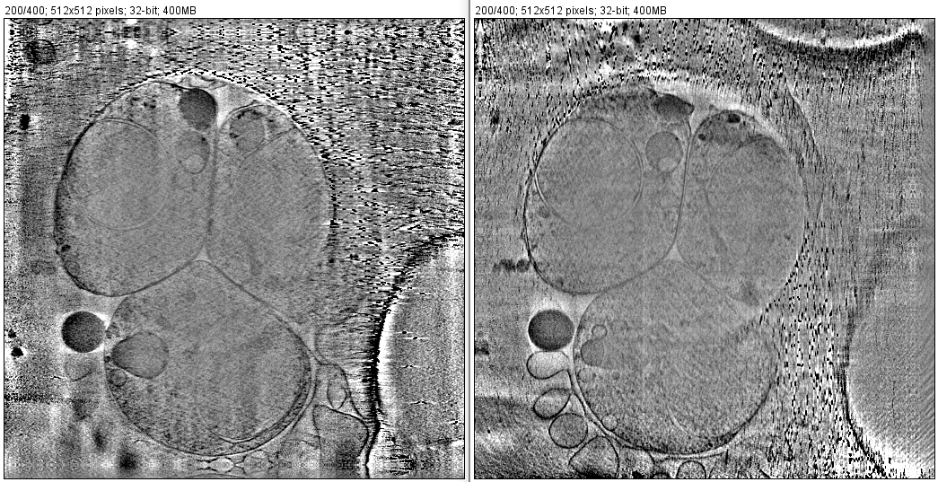
Figure S5. Separate single axis reconstruction of the two tilt-series (scale bar is 400nm).
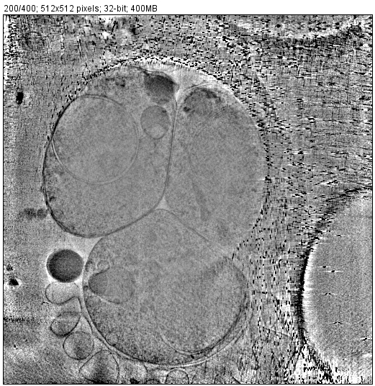
Figure S6. Dual axis reconstruction using the Matlab script.
Performance with published TEM datasets
Data source: https://etdb.caltech.edu/tomogram/3c3f9c published by Yiwei Chang 2016.
Analysis without pre-rotation: rotation axis found by software: phi=102. First iteration found 26 tracked fiducials, second iteration found 14 tracked fiducials (alignment result in Fig.S8).
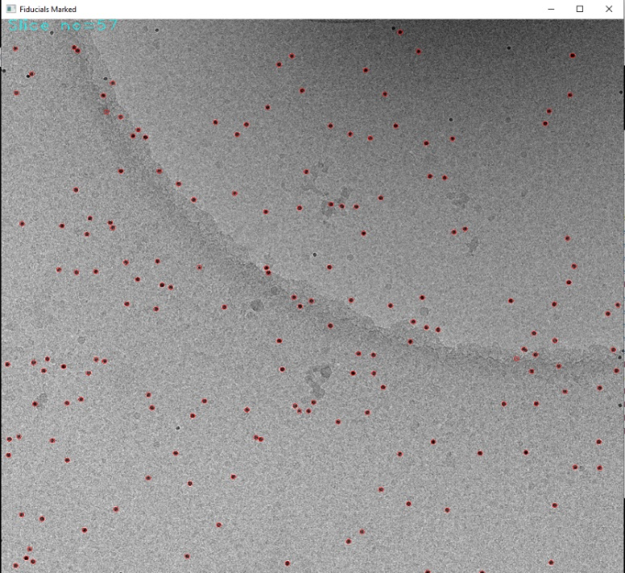
Figure S7. Detection of fiducials (circled in red)
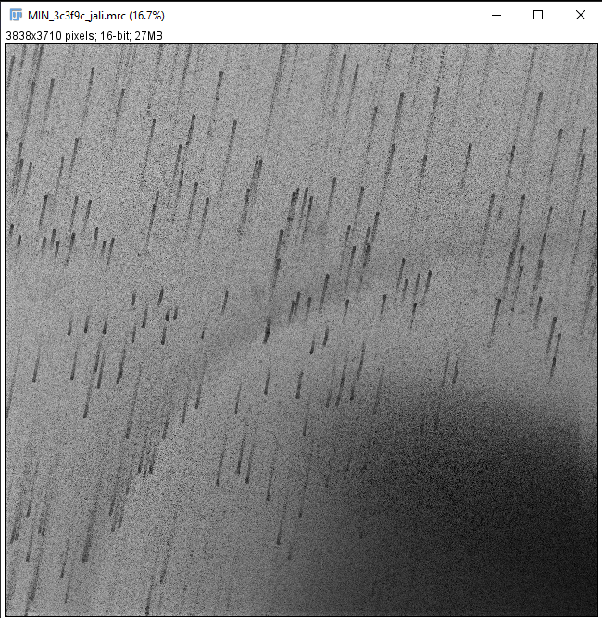
Figure S8. Z-projection of aligned stack without pre-rotation.
Analysis after 102⁰ pre-rotation: rotation axis found by software: phi=0. First iteration found 80 tracked fiducials, second iteration found 16 tracked fiducials (alignment results in Figs.S9-10).
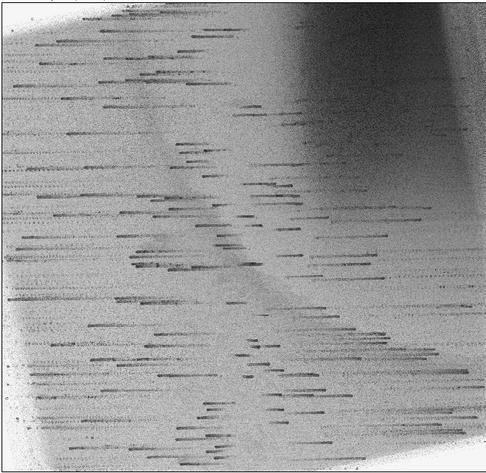
Figure S9. Z-projection of aligned stack after pre-rotation.
Figure S10. Global alignment errors calculated using Matlab code clusteralign_test.m (note the discussion on sample warping, particle size of 25 pix and initial alignment error of up to 300 pix).

Data source: https://etdb.caltech.edu/tomogram/91e5cd published by Rasika Ramdasi 2014.
Analysis without pre-rotation: rotation axis found by software: phi=12. First iteration found 2 tracked fiducials (alignment result in Fig.S11).
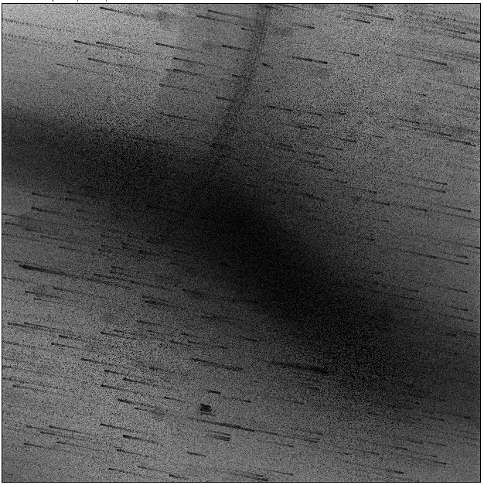
Figure S11. Z-projection of aligned stack without pre-rotation.
Analysis after 12⁰ pre-rotation: rotation axis found by software: phi=0. First iteration found 25 tracked fiducials (Fig.S12), second iteration found 11 tracked fiducials (alignment result in Figs.S13-14).
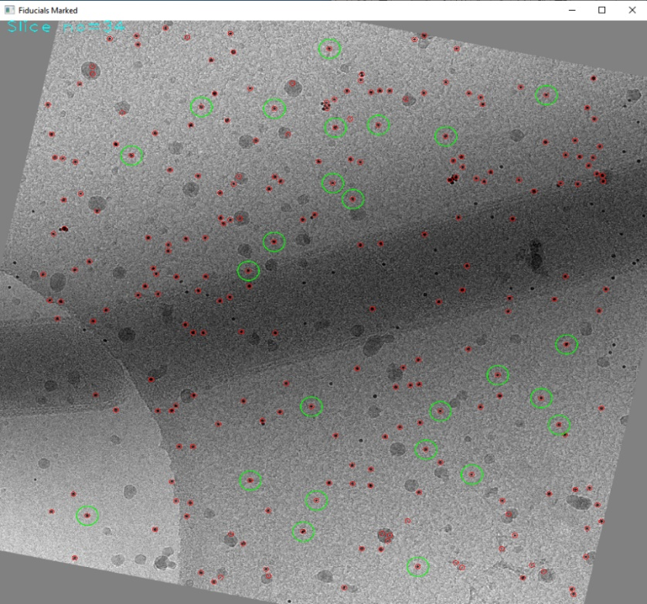
Figure S12. Detected particles (red) and tracked fiducials (green)

Figure S13. Z-projection of aligned stack after pre-rotation.
Figure S14. Global alignment errors calculated using Matlab code clusteralign_test.m (note the discussion on sample warping, the particle size of 25 pix and initial alignment errors of up to 100 pix).
Sample warping due to beam exposure or charging causes deviations from pure rigid body rotation, which cannot be corrected by simple image translations. Further refinement beyond the global translational alignment can be achieved by exporting the fiducial model file generated by ClusterAlign to tomoalign. For example, exporting the fiducial locations file nogaps.fid.txt of ETDB/91e5cd to tomoalign, the reported mean residual error reduces from 4.5 pix to 1.46 pix owing to the warping model. In the case of ETDB/3c3f9c the reported mean residual error reduces from 4.6 pix to 1.4 pix. The local alignment compensates for deformation in the sample during TEM acquisition. The final alignment residues are shown in Fig.S15, which demonstrate the effectiveness of combining our cluster-based fiducial tracking with analysis of other software. Explanation of the local alignment method in tomoalign can be found in J.-J. Fernandez, S. Li, T. A. M. Bharat, & D. A. Agard, Journal of Structural Biology, 202 (2018).

Figure S15. Reported residual errors by tomoalign after fitting the ClusterAlign fiducial tracking data to a local alignment model. Sub-pixel accuracy appears in 80-88% of the tilt views.

