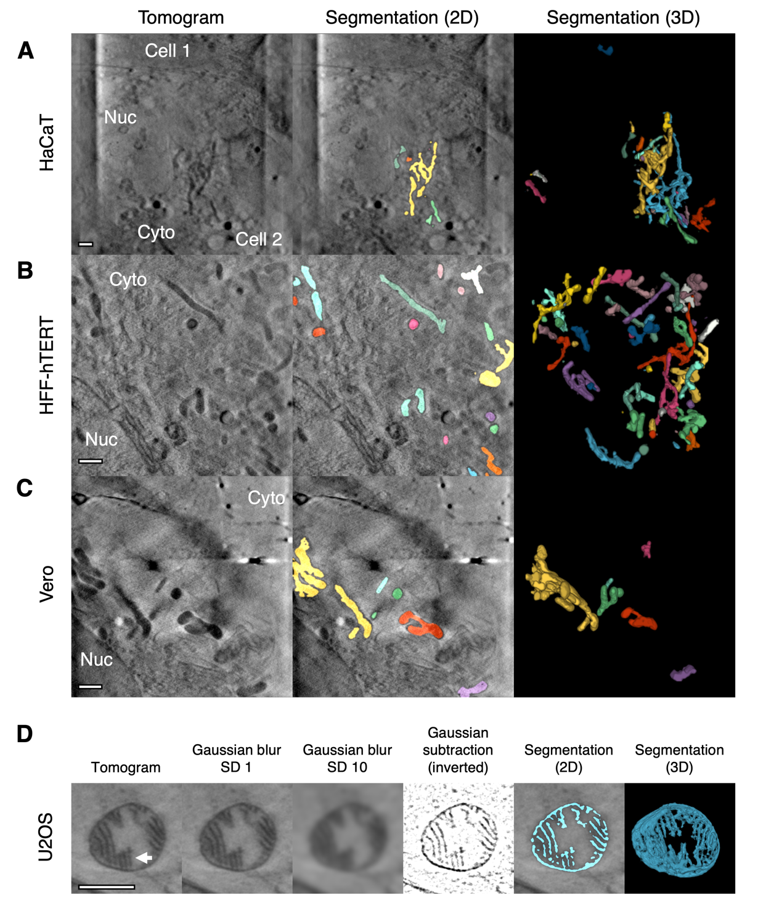
Supplementary Figure 1. Segmentation of pleomorphic mitochondria from multiple cell types. (A) Mitochondria were segmented from a cultured human keratinocyte (HaCaT cell) captured using a 40 nm zone plate objective. (B) Mitochondria were segmented from a human foreskin fibroblast immortalised by a human telomerase reverse transcriptase (HFF-hTERT cell) using a 25 nm zone plate objective. (C) Mitochondria were segmented from a green monkey kidney epithelial cell (Vero cell) using a 25 nm zone plate objective. (D) Segmentation of detectable cristae (arrow) in a swollen mitochondrion with a light lumen from a U2OS cell captured using a 25 nm zone plate objective. Although it is possible to segment cristae using Contour, a few additional steps are needed to compensate for the narrow widths of the cristae. Using Fiji, a 200×200 voxel section was cropped from a tomogram and scaled up in the XY plane by 2.5× to increase the number of voxels along the width of the cristae so that a width restriction could be effectively used during segmentation. Gaussian blurs with 1 and 10 standard deviations (SD) were applied and the SD 1 Z stack was subtracted from the SD 10 Z stack to digitally increase the signal-to-background ratio⁽³¹⁾. The subtracted image was inverted and local segmentations were run in Contour using a width restriction of 3 voxels. Here, the 2D segmentation is overlayed onto the original section from the tomogram, rather than the subtracted image used to create it. A smoothing factor of 3 and a Gaussian blur with an SD of 1 was applied to the segmented volume in Contour and a 3D rendering was produced using 3D Viewer in Fiji⁽²⁾. Scale bars = 1μm. Nuc, nucleus. Cyto, cytoplasm.

Supplementary Table 1. Timetable of processes in Contour. Most processes are rapid but local segmentations may take up to 2 hours depending on the number of features that need to be segmented. Under these circumstances, local segmentations will still be faster than manual segmentation tools.
Process | Estimated Time | Factors affecting length of time
Global segmentation | 5–10 minutes | - Number of image projections in the Z stack  - Number of structures that will be segmented
Local segmentation | 0.5–2 hours | - Number of elements that will be segmented  - Whether global segmentation was skipped
Differentiate elements | 5-10 minutes | - Number of segmented elements
Quantitate volumes (automatic) | Seconds
Quantitate widths (optional) | 0.5–2 hours | - Number of segmented elements  - Number of surface voxels for each segmented element
Filter elements | 5–10 minutes | - Threshold volume  - Number of elements with a volume below the threshold
Smoothing | Seconds
Gaussian blur | Seconds

