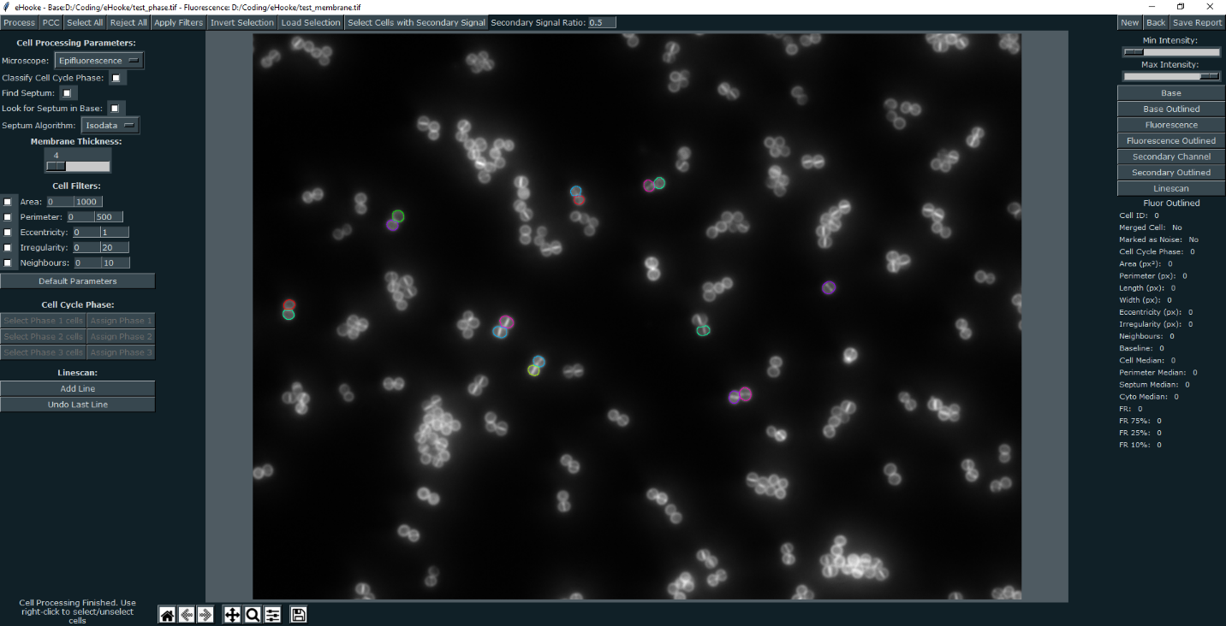

**Supplementary Figure 1 – Screenshot of eHooke’s graphical interface.**



**Supplementary Figure 2 – Comparison of manual classification of cell cycle phases by different users.** Users, members of the Pinho laboratory, were asked to classify cells according to the cell cycle stage (Phase 1-3) and discard cells thought to be incorrectly segmented by eHooke or for which they could not confidently decide on the classification. Users with the same number correspond to the same person; all users were given the same collection of cell images.(A)User classification of 945 individual *S. aureus* JE2 cells imaged by widefield microscopy. (B)User classification of 536 *S. aureus* JE2 cells imaged by SIM.

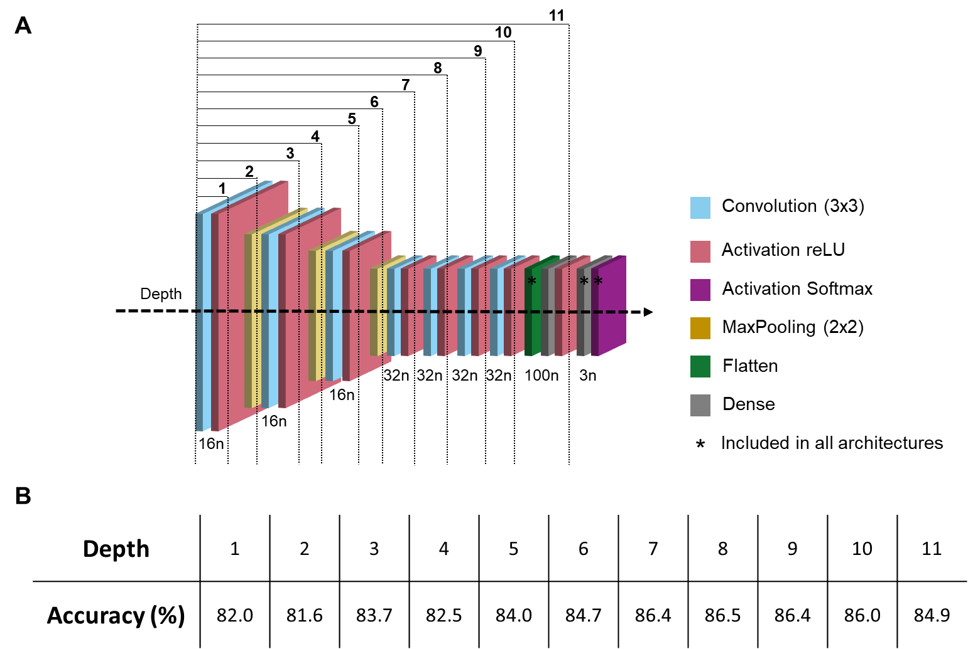

**Supplementary Figure 3 – Neural network architecture and ablation studies.** (A) Schematic representation of the artificial neural network. The network was separated in 11 depth levels for the purpose of performing ablation studies. The final dense layer with 3 neurons and the SoftMax activation layer are kept in every architecture. Each depth level contains all the layers of the previous depths. When the dense layer from depth 11 is removed, the flatten layer is added before the final dense layer with 3 neurons for every other architecture. (B) Classification accuracies of the test dataset (see Figure 2) obtained with artificial neural networks corresponding to each depth level.

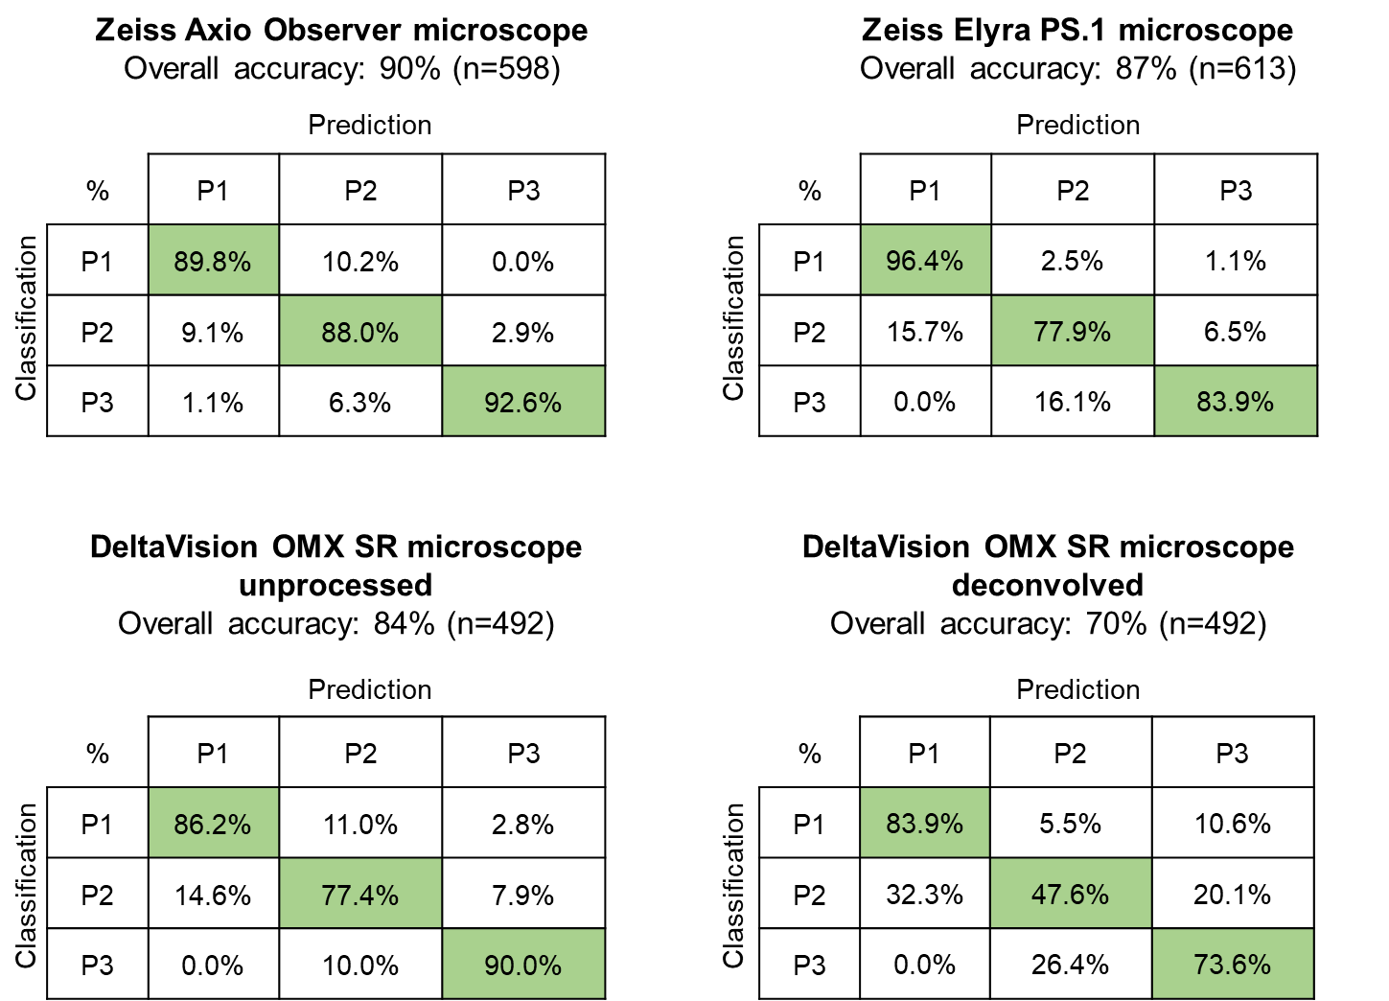

**Supplementary Figure 4 – Accuracy of automated cell cycle classification by ANN for images obtained in different microscopes.** Confusion matrices of the automated cell cycle classification by the artificial neural network (ANN) for images of a culture of *S. aureus* JE2, acquired using different microscopes. Green indicates true positives.

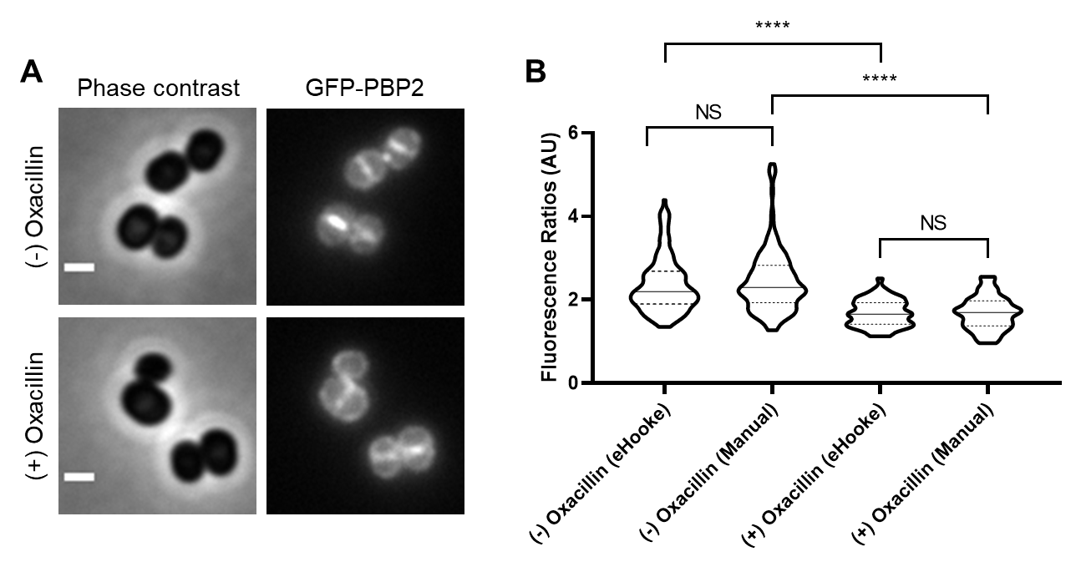

**Supplementary Figure 5 – Calculation of fluorescence ratios (FRs) of septal versus peripheral membrane fluorescence.** (A) *S. aureus* strain BCBPM090, expressing a fluorescent derivative of PBP2, was imaged by widefield microscopy. Bottom images correspond to cells incubated for 15 min with 0.5 µg mL-1 oxacillin prior to imaging. Scale bars 1 μm. (B) Quantification of the fluorescence ratio (FR) value for cells as those depicted in panel B. Manual quantification ((-) Oxacillin: n=149, (+) Oxacillin: n=56) was performed using ImageJ by doing a linescan analysis, extracting the maximum values corresponding to the septum and membrane and subtracting the background value prior to calculating FR; automated analysis ((-) Oxacillin: n=168, (+) Oxacillin: n=58) was performed using eHooke, considering only the 25% brightest pixels of septum for the calculation of the FR (FR25). Both methods generated similar data showing that PBP2 delocalizes from the septum in the presence of oxacillin. Median is represented by full line and quartiles by dashed lines. Statistical analysis was performed using a two-sided Mann–Whitney U test. NS, not significant; **** P < 0.0001.



**Supplementary Figure 6 - Analysis of cytoplasmic fluorescence using an internal control to normalize fluorescence values.** (A)*S. aureus* RNpGEreporter Pspac-GFP cells were incubated with either 0.025 or 0.25 mM IPTG and mixed with control cells of the same strain incubated with 0.25 mM IPTG. These control cells were also stained with the DNA dye Hoechst 33342. White arrows in the GFP image point to control cells; white overlay in fluorescence images indicates cell outline. Scale bars 1 μm. (B)Quantification of cytoplasmic fluorescence signal for 0.025 mM IPTG (n=214) and 0.25 mM IPTG (n=275) test cultures normalized using the control culture. As expected, when both test and control cultures were incubated with the same IPTG concentration (0.25mM), this ratio was close to 1 (0.92) and decreased (to 0.72) when test cells were incubated in the presence of lower concentration of IPTG (0.025mM) than control cells. Median is represented by full line and quartiles by dashed lines. Statistical analysis was performed using a two-sided Mann–Whitney U test. **** P < 0.0001.

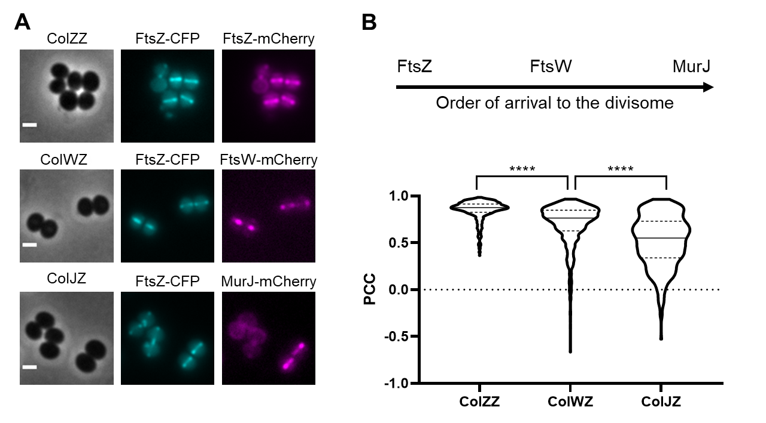

**Supplementary Figure 7 – Establishing the order of arrival of proteins to the divisome using Pearson’s Correlation Coefficient (PCC).** (A)Widefield microscopy images of strains expressing two fluorescent derivatives of divisome proteins: ColZZ expressing FtsZ-CFP and FtsZ-mCherry; ColWZ expressing FtsZ-CFP and FtsW-mCherry; ColJZ expressing FtsZ-CFP and MurJ-mCherry. Scale bars 1 μm. (B)Schematic representation of the order of arrival of FtsZ, FtsW and MurJ to the divisome (top panel), which correlates with the calculated PCC values for images of CFP and mCherry channels of the three strains mentioned in panel A: CollZZ (0.88, n=450), ColWZ (0.76 n=695) and ColJZ (0.55, n=380) (bottom panel). Median is represented by full line and quartiles by dashed lines. Statistical analysis was performed using a two-sided Mann–Whitney U test. **** P < 0.0001.

**Supplementary Table 1 –** Test dataset classification accuracy of tested models with ANNs with increasing layer depth levels (see Supplementary Figure 3 for network architecture)

|  |  |  |  |  |  |
| --- | --- | --- | --- | --- | --- |
| **Model Depth** | **Microscope** | **Phase** | **Phase Accuracy** | **Microscope Accuracy** | **Overall Accuracy** |
| Depth 1 | Widefield | Phase 1 | 86.8% | 84.4% | 82.0% |
| Phase 2 | 75.0% |
| Phase 3 | 91.2% |
| SIM | Phase 1 | 85.1% | 79.8% |
| Phase 2 | 66.3% |
| Phase 3 | 91.0% |
| Depth 2 | Widefield | Phase 1 | 88.1% | 85.0% | 81.6% |
| Phase 2 | 76.3% |
| Phase 3 | 90.3% |
| SIM | Phase 1 | 81.3% | 78.2% |
| Phase 2 | 66.3% |
| Phase 3 | 92.4% |
| Depth 3 | Widefield | Phase 1 | 87.7% | 84.8% | 83.7% |
| Phase 2 | 77.1% |
| Phase 3 | 88.9% |
| SIM | Phase 1 | 83.2% | 82.6% |
| Phase 2 | 76.5% |
| Phase 3 | 92.4% |
| Depth 4 | Widefield | Phase 1 | 88.7% | 85.3% | 82.5% |
| Phase 2 | 78.0% |
| Phase 3 | 88.5% |
| SIM | Phase 1 | 81.8% | 79.8% |
| Phase 2 | 71.6% |
| Phase 3 | 89.6% |
| Depth 5 | Widefield | Phase 1 | 91.7% | 85.6% | 84.0% |
| Phase 2 | 76.3% |
| Phase 3 | 87.1% |
| SIM | Phase 1 | 82.9% | 82.5% |
| Phase 2 | 75.8% |
| Phase 3 | 93.8% |
| Depth 6 | Widefield | Phase 1 | 89.7% | 86.2% | 84.7% |
| Phase 2 | 79.7% |
| Phase 3 | 88.5% |
| SIM | Phase 1 | 87.3% | 83.3% |
| Phase 2 | 75.8% |
| Phase 3 | 86.8% |
| Depth 7 | Widefield | Phase 1 | 91.4% | 87.2% | 86.4% |
| Phase 2 | 80.1% |
| Phase 3 | 88.9% |
| SIM | Phase 1 | 85.9% | 85.6% |
| Phase 2 | 80.7% |
| Phase 3 | 93.8% |
| Depth 8 | Widefield | Phase 1 | 91.7% | 87.3% | 86.5% |
| Phase 2 | 77.5% |
| Phase 3 | 91.7% |
| SIM | Phase 1 | 87.0% | 85.7% |
| Phase 2 | 79.9% |
| Phase 3 | 93.1% |
| Depth 9 | Widefield | Phase 1 | 91.1% | 87.5% | 86.4% |
| Phase 2 | 81.4% |
| Phase 3 | 89.4% |
| SIM | Phase 1 | 85.9% | 85.2% |
| Phase 2 | 79.9% |
| Phase 3 | 93.1% |
| Depth 10 | Widefield | Phase 1 | 88.4% | 85.6% | 86.0% |
| Phase 2 | 81.8% |
| Phase 3 | 85.7% |
| SIM | Phase 1 | 89.4% | 86.4% |
| Phase 2 | 78.8% |
| Phase 3 | 92.4% |
| Depth 11 | Widefield | Phase 1 | 88.1% | 83.6% | 84.9% |
| Phase 2 | 74.2% |
| Phase 3 | 87.6% |
| SIM | Phase 1 | 86.4% | 86.2% |
| Phase 2 | 81.4% |
| Phase 3 | 94.4% |