Supplementary Material

We apply a data clustering methodology based on nonstationary multivariate autoregressive factor (VARX) models, along with a bounded variation, finite element (FEM-BV) clustering procedure to characterize the interaction between small-scale nonturbulent motions and turbulence. Here, we briefly review the mathematical framework of FEM-BV-VARX used to classify the flow regimes in terms of their scale-interaction properties. However, for full details of the mathematical framework, readers are referred to Horenko (2010), and for further details on its application to flow-regime classification, to Vercauteren and Klein (2015).
For the cluster analysis, our intention is to test the influence of nonturbulent motions on turbulence, and therefore we apply additional prefiltering of the turbulence data; the prefiltered data will be used as an external factor in the clustering procedure. Unfortunately, the separation between nonturbulent and turbulent motions is ambiguous under stable conditions and so we proceed with a crude separation of scales of motion. Motions of scales between 1 and 30 min are typically dominated by wavelike motions, microfronts, and other complex structures (Mahrt 2011), and these are the scales whose influence on the fast vertical velocity fluctuations we will investigate. Therefore, we perform further averaging of the 1-min data records inside our pre-processed 30-min data windows, and these 1-min-averaged data will be considered in the cluster analysis. The vertical velocity fluctuations considered in the cluster analysis are the fluctuations resulting from scales of motion faster than 1 min.
As already mentioned, large-scale structures will interact with small-scale structures such that the flow regime will change according to the degree of interaction. From the analysis of the friction velocities due to different scale structures at the three sites, we know that the average friction velocity of turbulence changes least from the mountain to the flat seashore (0.22 m s⁻¹ to 0.16 m s⁻¹), while those of the other two scale structures both change from 0.31 m s⁻¹ to 0.12 m s⁻¹ because they are in some way produced by the complex terrain. As suggested by Mahrt and Bou-Zeid (2020), gusts and large-scale structures can influence turbulent vortices. Here, according to the influence of such motions with a scale of 1–30 min, i.e., gusts, on turbulence with a scale less than 1 min, the flow is divided into four regimes. The influence of external factors, u_{gust} = ū_{1min} − ū_{30min}, on the friction velocity u* of a small-scale turbulent vortex is analysed using the FEM-BV-VARX method. Figures S1–S3 show an analysis of the scale interaction of the three observation positions. Figures S1a, S2a and S3a show the whole friction velocity for the four regimes. Figures S1b–g, S2b–g and S3b–g show the friction velocity, wind speed, wind direction, average WCC, and C_{D} for the four regimes during the six processes.
The friction velocities obtained at the different observation sites are different. The roof and tower are located at different heights at the same location, so the friction velocity is similar, but the Gulf is located at another observation site. There was a strong wind on 21–22 September, in which the friction velocity increased significantly. However, the flow can all be divided into four regimes. Regime one corresponds to weak turbulence pulsation with small friction velocity and weak wind. In this regime, there is little turbulence and the flow is stable, but, occasionally, when the flow is disturbed, the wind speed decreases and the wind direction changes, meaning coherent structures will appear with large coherence coefficients and drag coefficients (Figs. S2d and S3c). Regime two reflects the transition of turbulent motion when the wind speed and friction velocity increase from a stable to unstable regime. This regime is usually full of coherent structures, and when the coherence coefficient is negative, i.e., the type of flow is ejection or sweep, the flux is convergent. For example, Figs. S1d and e demonstrate that when the flow passes over a hill it exchanges upper-level high-speed wind with lower-level low-speed wind. When the coherence coefficient is positive, i.e., the flow type is outward or inward, the flux is divergent. For example, Figs. S3b and d show that when the flow passes over the flat sea surface it exchanges upper-level low-speed wind with bottom-level high-speed wind. Regimes three and four are both developed-turbulence flow, in which the structure usually consists mainly of turbulence (Figs. S1g and S3g). The intensity of turbulence in regime three is slightly less than that in regime four. During the observation period, the wind speeds and friction velocities at the roof and tower were larger than those at the Gulf (Fig. 2), and the intensity of regimes three and four at the roof and tower were also higher than those at the Gulf (Figs. S1a, S2a and S3a).
(a)
(b)
(c)
(d)
(e)
(f)
(g)
Fig. S1. Analysis of the turbulence regime by FEM-BV-VARX at the roof site: (a) friction velocities of four regimes; (b–g) friction velocity, wind speed, wind direction, WCC and C_{D} for four regimes during six weather processes.
The friction velocity was large at 1300 LT on 10 September at the roof, and there was mainly small-scale turbulence as the flow was in regime three and four under most times. The coherence coefficients were negative regardless of whether the vortex scale larger than 1 min (gusts) or less than 1 min (turbulence) reflected that the situation was full of coherent structures that exchanged momentum flux. However, the C_{D} was small, which showed that the momentum exchange was not effective during the see-breeze process. The coherence of gusts (pink line) was consistent with the coherence of turbulence (light blue line) during the process because the large-scale structures interacted with the small-scale structures (Fig. S1b). When the land-wind appeared on 11 September, the flow just translated from stable to unstable, being in regime one most of the time but sometimes in regime two. The coherence of gusts was weakened and the coherence of turbulence was not obvious. Although the friction velocity was small, the C_{D} was large for the land-wind, which showed that the exchange of momentum flux was effective (Fig. S1c). At 1500 LT on 13 September, the sea-breeze changed to a land-wind, and the gusts were strongly negatively coherent (Fig. S1d). In the process of land-wind conversion to sea-breeze at 0600 LT on 15 September, the coherence of gusts was gradually enhanced, and this was mainly negative coherence (Fig. S1e). During the transition, the momentum flux was exchanged effectively and C_{D} was large (Fig. S1d and S1e). At 2300 LT on 18 September, the gusts were still dominated by negative coherence (Fig. S1f); and at 0500 LT on 21 September, there was a strong positive correlation. At this time, the turbulence was fully developed (Fig. S1g).
(a)
(c)
(b)
(d)
(e)
(f)

Fig. S2. Analysis of the turbulence regime by FEM-BV-VARX at the tower site: (a) friction velocities in four regimes; (b–g) friction velocity, wind speed, wind direction, WCC and C_{D} for the four regimes during six weather processes.
(g)
The friction velocity was large at 1300 LT on 10 September at the tower, and the regime was almost always three or four. The coherence coefficients were positive for gusts and near-zero for turbulence (Fig. S2b), reflecting that there was divergence of momentum flux. At 1500 LT on 13 September, the sea-breeze changed to a land-wind, and coherent structures appeared occasionally when the flow was disturbed, the wind speed decreased, and the wind direction changed, and the C_{D} was large in that moment (Fig. S2d). At 0500 LT on 21 September, when strong winds blew, the C_{D} was small (Fig. S2g). Because of the complex hilly terrain, the flow was almost unstable, almost always in regime two accompanying by regimes three and four, and the C_{D} was large (Figs. S2c, S2e and S2f).
(a)
(b)
(c)
(d)

(e)
(f)
(g)
Fig. S3. Analysis of the turbulence regime by FEM-BV-VARX at the Gulf: (a) friction velocities in four regimes; (b–g) friction velocity, wind speed, wind direction, WCC and C_{D} for the four regimes during six weather processes.
At the flat underlying surface of the beach, except for strong winds at 0500 LT on 21 September, the regime could be classified as three and four and the type of turbulence was developed turbulence (Fig. S3g). There were occasional coherent structures when the land-wind appeared on 11 September (Fig. S3c), and the other processes could all be classified as developing turbulence under regime two. However, when there was a sea-breeze, due to positive coherence, the C_{D} was small (Figs. S3b and d), and during land-winds the C_{D} was large (Figs. S3c, e and f).
We calculated the ratios of first two regimes and last two regimes for each process and found that, when the ratio was more than 0.5, it was a developing-turbulence process and full of coherent structures that all contributed flux. When the ratio was less than 0.5, it was a developed-turbulence process and full of turbulence (Table S1). Because the WCC of turbulence is small, the transition of flux is not effective. Although the friction velocity is large, the C_{D} is small, such as during processes 1 and 6 at the roof (Figs. S1b and g), processes 1, 4 and 6 at the tower (Figs. S2b, e and g), and process 6 at the Gulf (Fig. S3g).
Table S1. Ratios of regimes at the three sites during six weather processes.
Roof |  | Tower |  | Gulf
Process |  | Process |  | Process
1 |  | 1 |  | 1
2 |  | 2 |  | 2
3 |  | 3 |  | 3
4 |  | 4 |  | 4
5 |  | 5 |  | 5
6 |  | 6 |  | 6

Figures S4a–c show the coherence coefficients of the three observation positions at the scales between 1 s and 30 min during the six weather processes. Figure S4d shows the coherence coefficients of the three observation positions at scales between 1 min and 5 d. From the analysis above, we know that the structures at the tower were more chaotic and the coherence coefficients of different scales were nearly the same owing to the complex terrain. We can also see this here in Figs. S4b and d. In the former, the coherence coefficients of the six processes change irregularly with scale; and in the latter, the coherence coefficients of the structures at the tower (red line) were almost zero. Also, the coherence coefficients of the structures at the roof and gulf changed during different processes. At the roof, it increased negatively except during strong wind periods (Fig S4a); and at the Gulf, it was nearly zero for structures less than 1 min, except during the sea-breeze at 1300 LT on 10 September and 1500 LT on 13 September (Fig S4c). From Fig. S4d, we can see that at the roof the coherence coefficients increased negatively from 1 min to 5 d, which means there was interaction between large-scale and small-scale structures. However, the coherence coefficients of structures less than 30 min increased slowly, and then quickly increased negatively with the period at the Gulf. This means that the large-scale structures did not have a relationship with the small-scale structures. The small-scale coherence coefficient at the roof was larger than that of the other two positions.
From the above analysis, we know that different scale structures all contribute momentum fluxes in the coastal marine atmospheric boundary layer. Also, the coherence characteristics of the structures are important for the flux transformation. When turbulence is developing, which is analogous to the transition of turbulence in wall-bounded turbulence processes, different scale structures – hereinto separated into turbulence, gusts and large-scale structures – can be invoked. Furthermore, in certain suitable situations, such as in the log-region or constant flux layer, a not very smooth underlying surface, like the sea surface, not very close to the top of the mountain, which is affected by weather processes, and here, on the roof, large-scale structures can interact with small-scale structures and each scale can contribute flux to almost the same degree. Also, by the degree of interaction, we can describe the flow regime as a developing-turbulence regime and developed-turbulence regime. For the latter, it is mainly turbulence that contributes flux. Although the flux is large, the C_{D} is small, which means the transition of flux is not effective.
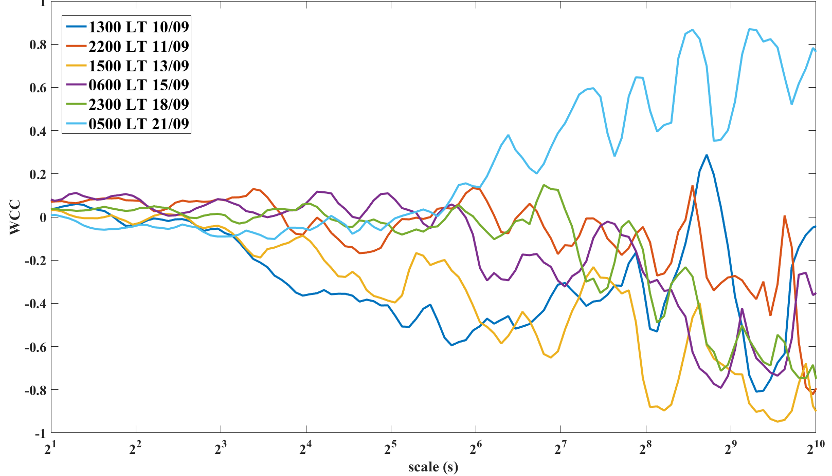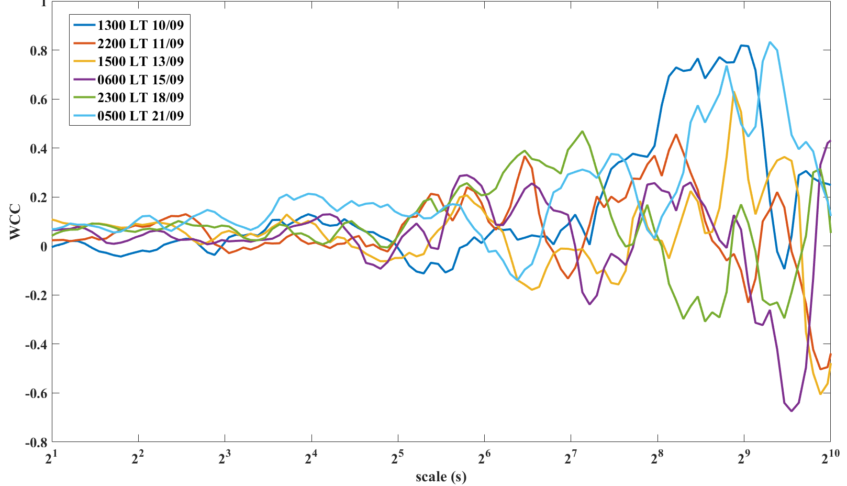
(a)
(b)
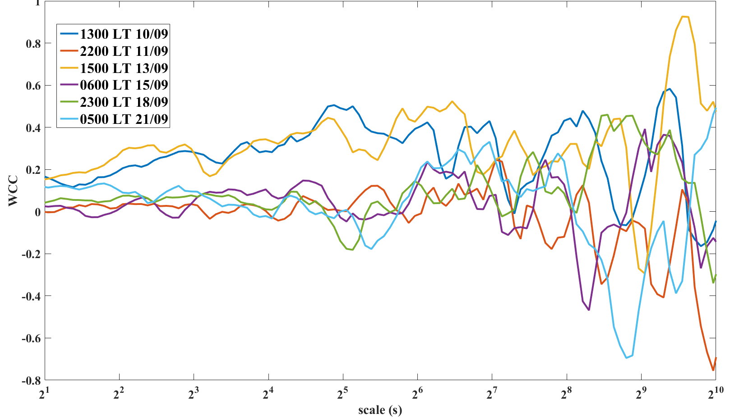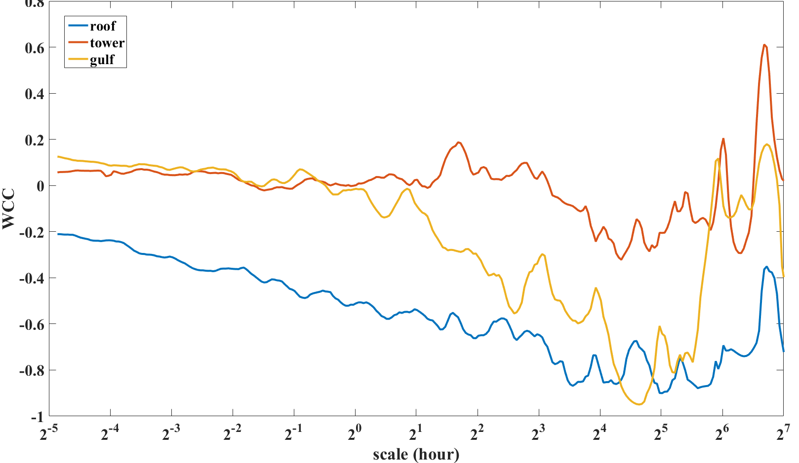
(c)
(d)
Fig. S4. Wavelet coherence coefficient from 1 s to 30 min between vertical and horizontal velocities at the (a) roof, (b) tower and (c) Gulf sites, and (d) from 1 min to 5 d at the three sites.
References
Horenko I (2010) On the identification of nonstationary factor models and their application to atmospheric data analysis. J Atmos Sci 67(5):1559–1574
Vercauteren N, Klein R (2015) A clustering method to characterize intermittent bursts of turbulence and interaction with submeso motions in the stable boundary layer. J Atmos Sci 72(4):1504–1517
Mahrt L (2011) The near-calm stable boundary layer. Boundary-Layer Meteor 140:343–360
Mahrt L, Bou-Zeid E (2020) Non-stationary boundary layers. Boundary-Layer Meteorol 176:13–33

