Supporting Information for

Stream lamination and mixing in a microfluidic jet for X-ray detection

Diego A. Huyke,^{1,*} Alexandre S. Avaro,^{1,*} Thomas Kroll,² and Juan G. Santiago^{1,**}

¹ Department of Mechanical Engineering, Stanford University, Stanford, CA 94305, USA
² Stanford Synchrotron Radiation Lightsource, SLAC National Accelerator Laboratory, Stanford University, Menlo Park, CA 94025, USA

* Equal contribution.
** To whom correspondence should be addressed. E-mail: juan.santiago@stanford.edu.

Contents
S1 Theta device fabrication
S2 Custom theta device interface
S3 1D diffusion model solution
S4 Approximate integration of the quenched intensity ratio $β$
S5 Determination of the free jet cross-sectional area and velocity
S6 Uncertainty propagation on the measure of the quenched intensity ratio
S7 Practical considerations regarding $Q_{sa}/Q_{ca}$
S8 Epifluorescence image of the dual-nozzle aperture of the theta device

S1 Theta device fabrication
This section describes the equipment and procedures to fabricate the theta device.

S1.1 Pulling of glass capillaries
We purchased theta glass capillaries with 1.0/1.5 mm (ID/OD) diameters (TG150-4, Warner Instruments, USA). The sintered portion of these capillaries were pulled on a laser-based micropipette puller (figure S1a, P-2000, Sutter Instrument, USA) with the settings described in table S1. To this end, capillaries were secured on the puller holders using thumb screws (figures S1b and S1c). The procedure produces two opposing pulled capillary tips (figure S1d). Figure S1e shows a close-up image of one pulled tip. Other protocols for use with this micropipette puller are available online (Adair Oesterle, 2018; Sutter instrument, 2020). In one 30 min session, it was possible to produce around 60 pulled capillaries. Pulled capillaries were stored and transported in a pipette storage box (BX10, Sutter Instrument, USA).
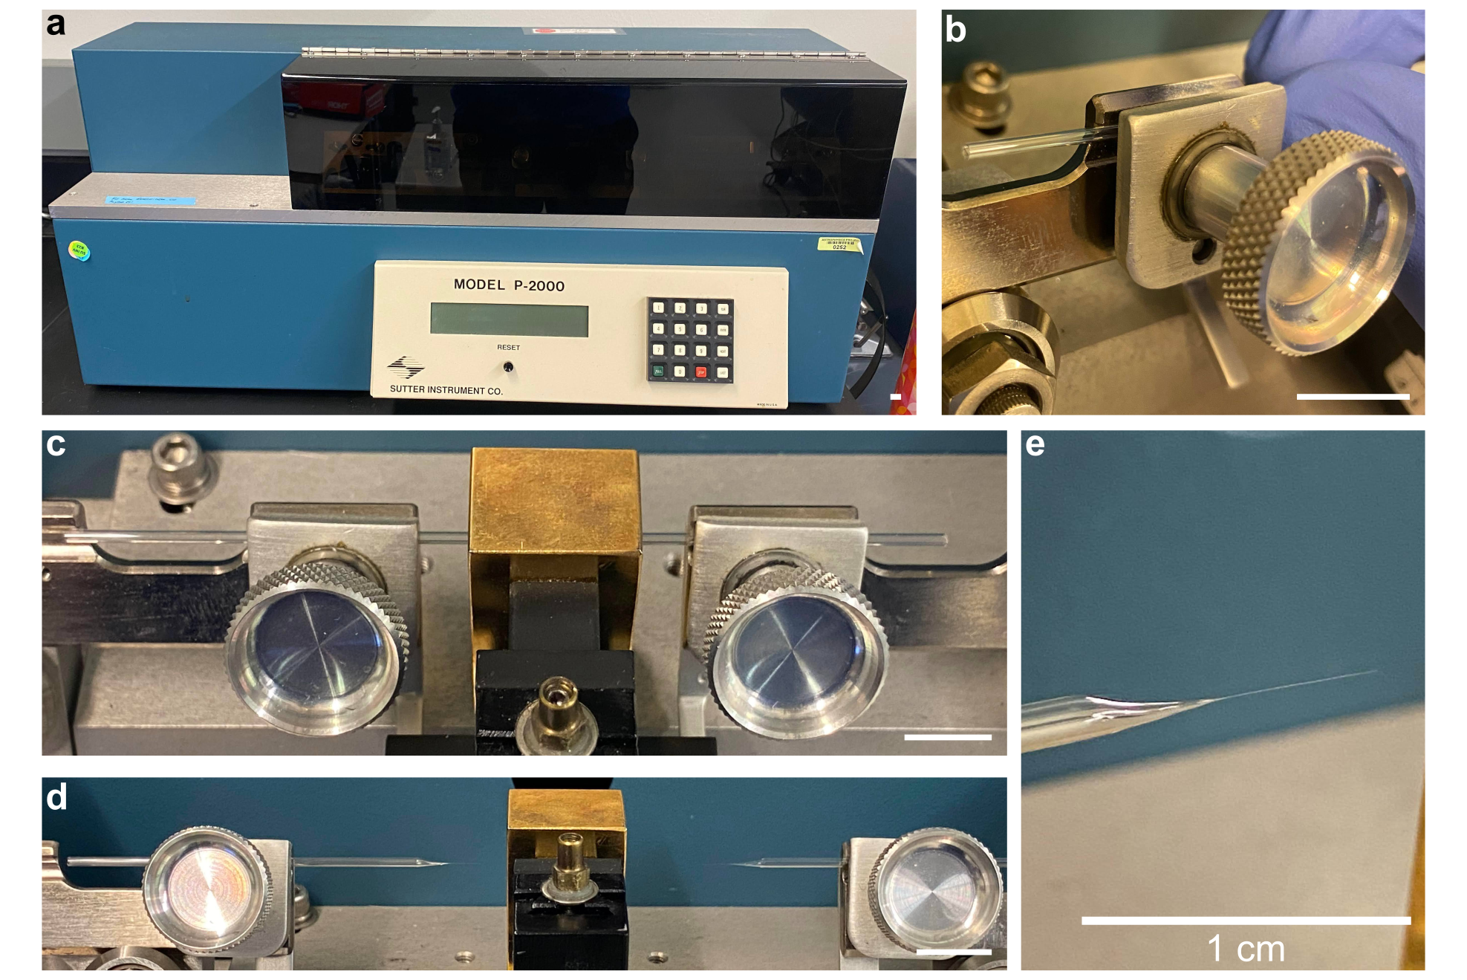Figure S1. Use of a micropipette puller to taper theta capillaries. a P-2000 instrument used to fabricate theta devices. b The capillary was secured inside the holder using the thumbscrews. c Capillary secured on both ends. d Result after pulling the capillary (two tips are achieved). e Zoomed in view of pulled capillary.

Table S1. Summary of the settings used to produce the pulled-tip theta capillaries on a P-2000 micropipette puller. Development of these settings required some preliminary work, including variation of parameters such as the position of the capillary with respect to the machine’s laser, the heat setting, and the rate of pull. The machine allows for multiple protocol steps but we here used a single step process.
Step | Heat | Fil | Vel | Del | Pul
1 | 480 | 10 | 20 | 5 | 10
S1.2 Attachment of fluidic connections
We attached fluidic connections to the pulled theta capillaries using a commercially available kit for interfacing and mounting theta capillaries (THP-15, Warner Instruments, USA). The kit contains flexible, fused silica capillaries (350 µm OD) bonded to a female Luer port (figure S2a). (Warner Instruments terms these latter capillaries flexible-fill tubes.) The flexible-fill tubes were first cut to a length of 5 cm (figure S2b) and then attached to the pulled capillaries with hot glue (figure S2c). The hot glue was allowed to cool for 30 mins before introducing liquids. The latter attachment concludes the theta device fabrication process (figure S2d).
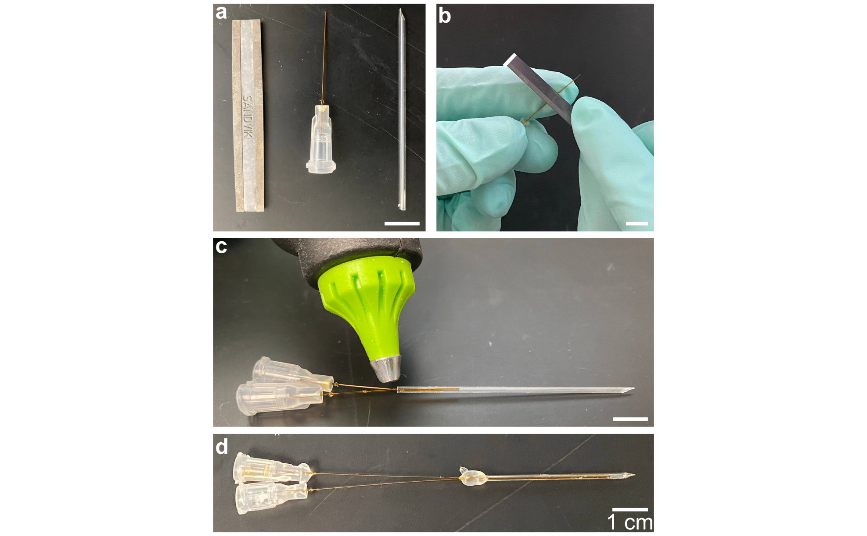
Figure S2. Images summarizing process of interfacing fluidic connections with the pulled theta capillaries. a Required components for the attachment of fluidic connections include (from left to right) Sandvik scoring blade, flexible-fill tube with female Luer connection, and pulled theta capillary. b The scoring blade was used to score and then flick off the length of the fused silica capillary in the flexible-fill tube. c Cut flexible-fill tubes were inserted into each channel of the pulled theta capillary and sealed in place using hot glue. d Finished theta device after the hot glue was allowed to cool for 30 min.
S2 Custom theta device interface
This section describes the mounting of the theta device on a custom interface for experimental visualization. The body of the custom interface (figure S3a) was composed of a standard laser-cut acrylic sheet with mounted optical components (Thorlabs, USA) and two microfluidic tees (F-300, IDEX, USA). The main axis of the interface consisted of a long optical post parallel to the theta device streamwise direction. Attached to this main axis was the purchased theta holder (part of the THP-15 kit) which featured a trough and thumb screw to secure the theta device (figure S3a). Soft tubes, along with microfluidic and Luer fittings (figure S3b), were connected to the microfluidic tees (figure S3c). A separate soft tube was connected to a Luer barbed fitting and also mounted on the main axis of the interface (figure S3c).
Prior to use, the fluidic connections which exited the microfluidic tees were first connected to the theta device Luer ports (figure S3d). Then, the theta device was secured on the holder using the thumb screw (inset figure S3d). Finally, the jet exit line and the theta device were arranged in parallel. Note that, since the exit line and device were parallel, the main axis of the interface can be rotated while jetting. The microfluidic tees were supplied liquid flow using high-pressure liquid chromatography (HPLC) pumps (LC-20AD, Shimadzu, Japan) at operating pressures between 1,000 and 1,500 PSI.
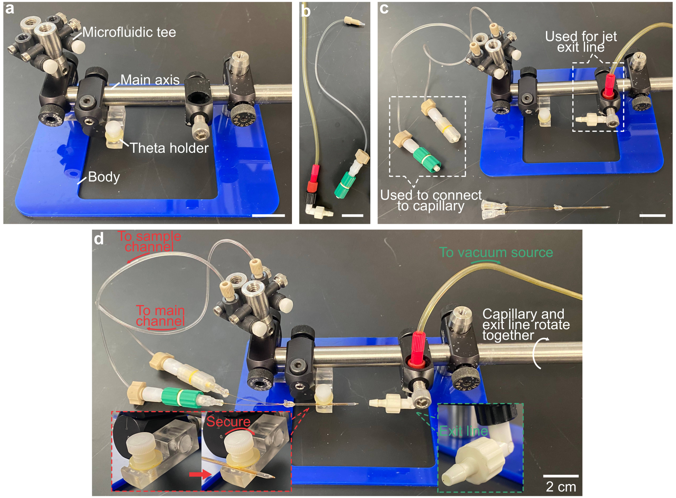
Figure S3. Mounting of the theta device in a custom interface. a Main body of interface consisted of a laser-cut acrylic sheet, optical components, and two microfluidic tees. b Flexible tubing with microfluidic and Luer connectors. c The flexible tubing and connections were first mounted on the main body of the custom interface. d The theta device was mounted on the holder and secured using the thumbscrew (see left inset). The theta device and exit line were parallel, and so the main axis of the interface could be rotated while jetting.
S3 1D diffusion model solution
This section presents more details of the analytical solution of the one-dimensional (1D) diffusion model presented in §3.1 of the main manuscript. Using the assumptions listed in section §3.1, the advection-diffusion problem is approximated by the following unidimensional unsteady diffusion problem:
 | $$\frac{∂c_{sa}}{∂t}=D_{sa}\frac{∂^{2}c_{sa}}{∂ξ^{2}},$$ | (S1)
 | $$\frac{∂c_{ca}}{∂t}=D_{ca}\frac{∂^{2}c_{ca}}{∂ξ^{2}},$$ | (S2)
 | $$c_{sa}\left(t=0,ξ\right)=c_{sa,0}\left(1-H\left(ξ-s\right)\right),$$ | (S3)
 | $$c_{ca}\left(t=0,ξ\right)=c_{ca,0}H\left(ξ-s\right).$$ | (S4)
The free surface at the top of the jet acts like an impenetrable wall for the diffusion of both species. Using Green’s function analysis (i.e., a convolution of the heat kernel) to solve respectively for $c_{sa}$ and $c_{ca}$, we find:
 | $$c_{sa}\left(ξ,t\right)=\int_{-s}^{s}{\frac{c_{sa,0}}{\sqrt{4D_{sa}t}}\exp\left(-\frac{{\left(ξ-ξ^{'}\right)}^{2}}{4D_{sa}t}\right)dξ^{'}}.$$ | (S5)
Using the change of variable $η=\frac{ξ-ξ^{'}}{\sqrt{4D_{sa}t}}$, it comes:
 | $$c_{sa}\left(ξ, t\right)=-\frac{c_{sa,0}}{\sqrt{π}}\int_{\frac{ξ+s}{\sqrt{4D_{sa}t}}}^{\frac{ξ-s}{\sqrt{4D_{sa}t}}}{e^{-η^{2}}dη}.$$ | (S6)
Finally,
 | $$c_{sa}\left(ξ,t\right)=\frac{c_{sa,0}}{2}\left[\operatorname{erf}\left(\frac{ξ+s}{\sqrt{4D_{sa}t}}\right)-\operatorname{erf}\left(\frac{ξ-s}{\sqrt{4D_{sa}t}}\right)\right].$$ | (S7)
The same integration yields a similar result for $c_{ca}$:
 | $$c_{ca}\left(ξ,t\right)=\frac{c_{ca,0}}{2}\left[2+\operatorname{erf}\left(\frac{ξ-s}{\sqrt{4D_{ca}t}}\right)-\operatorname{erf}\left(\frac{ξ+s}{\sqrt{4D_{ca}t}}\right)\right].$$ | (S8)
We now introduce the following non-dimensional quantities:
 | $$δ=\sqrt{4D_{sa}t}, α=\sqrt{\frac{D_{sa}}{D_{ca}}}, γ=\frac{s}{δ}, η=\frac{ξ}{δ}.$$ | (S9)
The solutions for $c_{sa}$ and $c_{ca}$ respectively become $c_{s}=c_{sa}/c_{sa,0}$ and $c_{q}=c_{ca}/c_{ca,0}$, where:
 | $$c_{s}=\frac{1}{2}\left[\operatorname{erf}\left(η+γ\right)-\operatorname{erf}\left(η-γ\right)\right],$$ | (S10)
And
 | $$c_{q}=1+\frac{1}{2}\left[\operatorname{erf}\left(α\left(η-γ\right)\right)-\operatorname{erf}\left(α\left(η+γ\right)\right)\right].$$ | (S11)

S4 Approximate integration of the quenched-intensity ratio $β$
In this section, we derive an approximate integration for the quenched intensity ratio $β$, in order to identify the relevant time scales of the 1D diffusion model we developed in section §3.1 of the main manuscript and S3 of the current Supplementary Information (SI). Let $I_{unquen}$ (resp. $I_{quen}$) be the measured intensity in the unquenched (resp. quenched) case, such that:
 | $$I_{unquen}=ω\int_{0}^{+∞}{c_{sa}\left(ξ,t\right)dξ},$$ | (S12)
 | $$I_{quen}=ω\int_{0}^{+∞}{\frac{c_{sa}(ξ, t)}{1+K_{sv}c_{ca}(ξ,t)}dξ}.$$ | (S13)
Here, $ω$ is the proportionality factor between intensity and integrated concentration, and $K_{sv}$ is the Stern-Volmer constant ($K_{sv}=7.29$ M⁻¹ in our study (Huyke et al., 2020)). Integration is performed from 0 to $+∞$ under the assumptions $s≪2R_{j}$ (lamination of the sample stream) and $\sqrt{4\max\left(D_{ca},D_{sa}\right)t}≪R_{j}$ (small times). Let $χ=K_{sv}c_{ca,0}$. We define the following non-dimensional intensities $\tilde{I_{u}}=\frac{I_{unquen}}{ωc_{sa,0}δ}$ and $\tilde{I_{q}}=\frac{I_{quen}}{ωc_{sa,0}δ}$, such that the quenched-to-unquenched intensity ratio $β$ is:
 | $$β=\frac{I_{quen}}{I_{unquen}}=\frac{\tilde{I_{q}}}{\tilde{I_{u}}}=\frac{\int_{0}^{+∞}{\frac{c_{sa}\left(ξ, t\right)}{1+K_{sv}c_{ca}\left(ξ,t\right)}dξ}}{\int_{0}^{+∞}{c_{sa}\left(ξ,t\right)dξ}}.$$ | (S14)
We first integrate:
 | $$\tilde{I_{u}}=\int_{0}^{+∞}{c_{s}\left(η\right)dη}=γ.$$ | (S15)
To our knowledge, there exists no analytical solution to the integration of $\tilde{I_{q}}$. However, we show below an approximate integration that serves the identification of the characteristic time scales of the problem. We define $f(η)$, such that:
 | $$\tilde{I_{q}}=\int_{0}^{+∞}{\frac{c_{s}\left(η\right)}{1+χc_{q}(η)}dη}=\int_{0}^{+∞}{f\left(η\right)dη}.$$ | (S16)
The function $f(η)$ is well approximated by the sigmoid function $g(η)$:
 | $$f\left(η\right)≈g\left(η\right)=\frac{\operatorname{erf}\left(γ\right)}{1+χ\left(1-\operatorname{erf}\left(αγ\right)\right)}\frac{1+e^{-\frac{γ-1}{1-α^{2}}}}{1+e^{\frac{η-\left(γ-1\right)}{1-α^{2}}}}.$$ | (S17)
Figure S4a shows examples of profiles for $f(η)$ (transparent lines), obtained with numerical integration, and $g(η)$ (opaque lines), for $γ$ varying between 0 and 9. It shows good agreement between $f(η)$ and the corresponding sigmoid approximation. In turn, $\tilde{I_{q}}$ may be approximated by:
 | $$\tilde{I_{q}}≈\int_{0}^{+∞}{g\left(η\right)}dη=\frac{\operatorname{erf}\left(γ\right)\left(1+e^{\frac{1-γ}{1-α^{2}}}\right)}{1+χ\left(1-\operatorname{erf}\left(αγ\right)\right)}\left(1-α^{2}\right)\ln\left(1+e^{\frac{γ-1}{{1-α}^{2}}}\right).$$ | (S18)
We show in figure S4b the relative error $u(γ)$ on the integration of $\tilde{I_{q}}$ induced by $g(η)$ for $γ∈\left[0, 15\right]$. Here, $u(γ)$ is computed by:
 | $$u\left(γ\right)=\frac{\left|\int_{0}^{+∞}{f\left(η\right)}dη-\int_{0}^{+∞}{g\left(η\right)}dη\right|}{\int_{0}^{+∞}{f\left(η\right)}dη}.$$ | (S19)
$u(γ)$ is confined below 15% for all values of $γ$ and tends to 0 as $γ$ increases. Finally, the quenched intensity ratio is:
 | $$β=\frac{I_{q}}{I_{u}}=\frac{\tilde{I_{q}}}{\tilde{I_{u}}}=\frac{\operatorname{erf}\left(γ\right)\left(1+e^{\frac{1-γ}{1-α^{2}}}\right)}{1+χ\left(1-\operatorname{erf}\left(αγ\right)\right)}\frac{\left(1-α^{2}\right)}{γ} \ln\left(1+e^{\frac{γ-1}{{1-α}^{2}}}\right).$$ | (S20)
Or, in dimensional form:
 | $$β=\frac{\frac{\sqrt{4D_{sa}t}}{s}\operatorname{erf}\left(\frac{s}{\sqrt{4D_{sa}t}}\right)\left(1-\frac{D_{sa}}{D_{ca}}\right)}{1+K_{sv}c_{ca,0}\left(1-\operatorname{erf}\left(\frac{s}{\sqrt{4D_{ca}t}}\right)\right)} \left(1+e^{\frac{1-\frac{s}{\sqrt{4D_{sa}t}}}{1-\frac{D_{sa}}{D_{ca}}}}\right)ln\left(1+e^{\frac{\frac{s}{\sqrt{4D_{sa}t}}-1}{1-\frac{D_{sa}}{D_{ca}}}}\right).$$ | (S21)
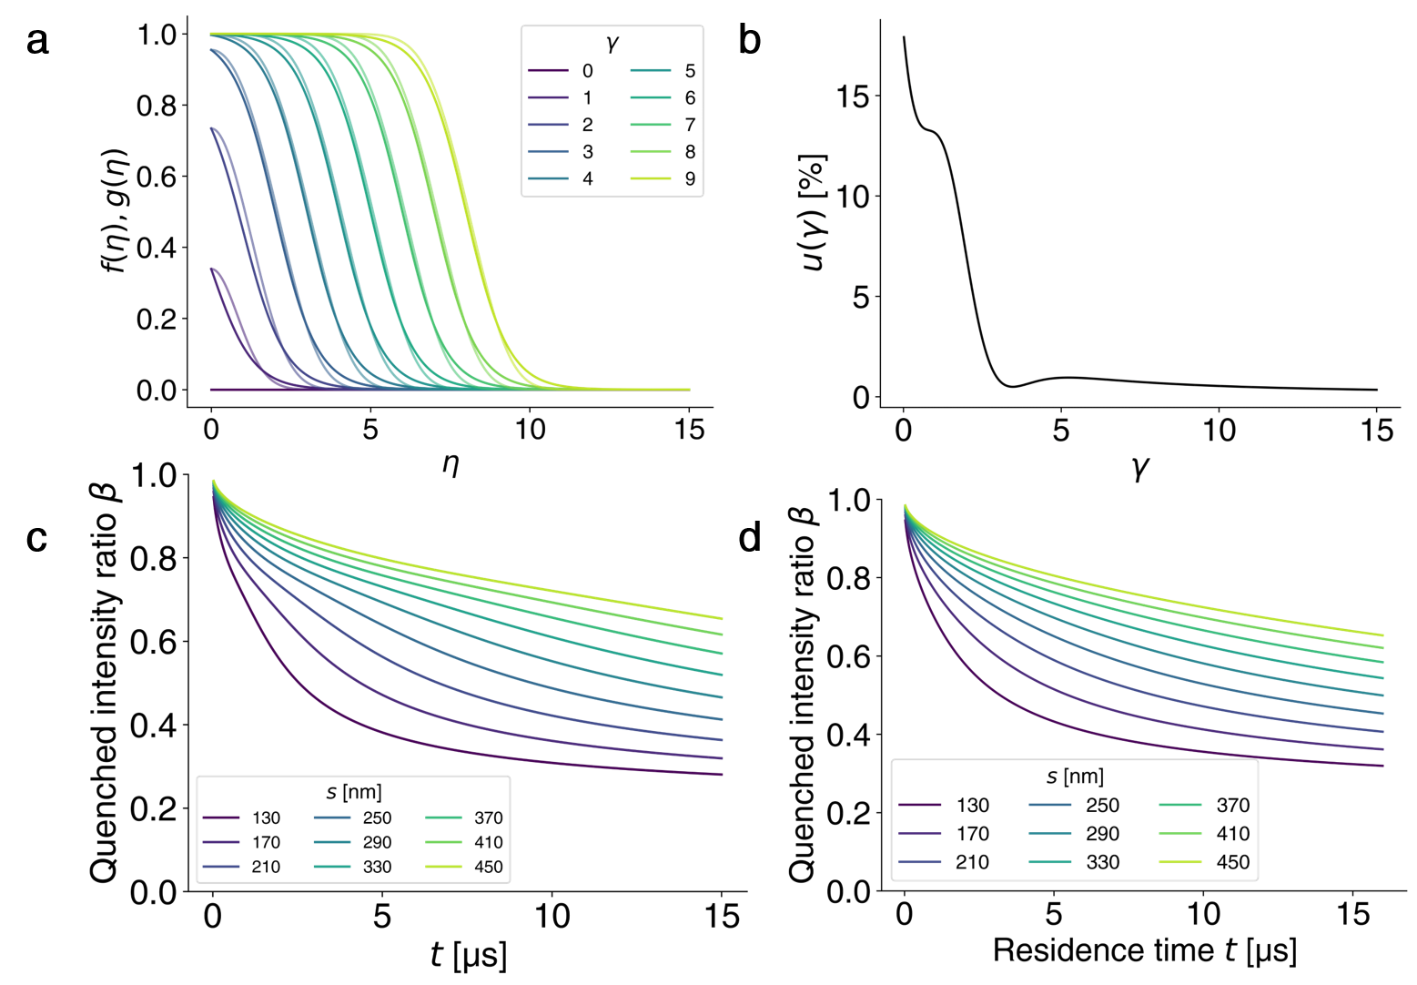
Figure S4c shows different profiles for $β$ versus time $t$ using this approximate analytical integration. Figure S4d shows the same profiles for $β$ using numerical integration for $\tilde{I_{q}}$.
Figure S4. Approximate integration of the quenched intensity ratio $β$. a Approximation of the quenched integrand $f(η)$ by the sigmoid $g(η)$. Shown are varying profiles of $f(η)$ for varying $γ$ (transparent lines) and the corresponding profiles of $g(η)$ (opaque lines). Profiles corresponding to the same value of $γ$ are shown in the same color. b Relative integration error $u\left(γ\right)$ due to the replacement of the quenched integrand $f(η)$ by $g(η)$. c Analytical, approximated profiles for the quenched intensity ratio $β$ versus residence time for various values of the model parameter $s$. These profiles were computed using equation (S21). d Numerically-integrated profiles for the quenched intensity ratio $β$ versus residence time for various values of the model parameter $s$. These profiles are also shown in figure 2c of the main manuscript.
S5 Determination of the free jet cross-sectional area and velocity
In this section, we derive the cross-sectional area of the free jet and velocity. First, we derive the velocity $U_{j}$ of the free jet based on a control volume analysis. The cross-section at the exit of the theta capillary is shown in figure S5a. The corresponding fully-developed Poiseuille flow through each semi-circular channel is given as equations (S22a) and (S22b) (White, 2006), for $0<r<R_{c}$ and $-\frac{π}{2}<θ<\frac{π}{2}$:
 | $$u_{x}\left(r,θ\right)=U_{0}\left[{\left(\frac{r}{R_{c}}\right)}^{2}\left(1+\cos\left(2θ\right)\right)-\frac{16}{π}\sum_{n=1, 3, 5, …}^{∞}{{\left(-1\right)}^{\frac{n+1}{2}}{\left(\frac{r}{R_{c}}\right)}^{n}\frac{\cos\left(nθ\right)}{n\left(n+2\right)\left(n-2\right)}}\right],$$ | (S22a)
 | $$U_{0}=\frac{Q}{πR_{c}^{2}}{\left(\frac{1}{4}+\frac{32}{π^{2}}\sum_{k=1, 3, 5, …}^{∞}{\frac{1}{k^{2}{\left(k+2\right)}^{2}\left(k-2\right)}}\right)}^{-1}=\frac{Q}{R_{c}^{2}}\frac{2π}{8-π^{2}}.$$ | (S22b)
Here, $Q=Q_{sa}$ or $Q_{ca}$ is the flow rate going through one semi-circular section, and $R_{c}$ is the radius of the theta capillary. An example solution for the velocity profile is shown in figure S5b. We note:
 | $$ψ\left(r,θ\right)={\left(\frac{r}{R_{c}}\right)}^{2}\left(1+\cos\left(2θ\right)\right)-\frac{16}{π}\sum_{n=1, 3, 5, …}^{∞}{{\left(-1\right)}^{\frac{n+1}{2}}{\left(\frac{r}{R_{c}}\right)}^{n}\frac{\cos\left(nθ\right)}{n\left(n+2\right)\left(n-2\right)}}=\frac{u_{x}\left(r,θ\right)}{U_{0}}.$$ | (S22c)
Note that $ψ\left(r,θ\right)=ψ\left(-r, θ+π\right)$, so that the two solutions for the two semi-circular domains have similar expressions for the velocity and:
 | $$\iint_{sa}^{ }{ψ\left(r,θ\right)rdθdr}=\iint_{ca}^{ }{ψ\left(r,θ\right)rdθdr},$$ | (S23a)
 | $$\iint_{sa}^{ }{ψ^{2}\left(r,θ\right)rdθdr}=\iint_{ca}^{ }{ψ^{2}\left(r,θ\right)rdθdr}.$$ | (S23b)
Mass and $x$-momentum conservation in the control volume (CV) shown in figure S5d yield the following conservation equations, where the subscripts “$sa$” and “$ca$” respectively refer to the sample and carrier streams:
 | $$I_{1}=\iint_{sa}^{ }{u_{x,sa}\left(r,θ\right)rdθdr}+\iint_{ca}^{ }{u_{x,ca}\left(r,θ\right)rdθdr}=πR_{j}^{2}U_{j},$$ | (S24)
 | $$I_{2}=\iint_{sa}^{ }{u_{x,sa}^{2}\left(r,θ\right)rdθdr}+\iint_{ca}^{ }{u_{x,ca}^{2}\left(r,θ\right)rdθdr}=πR_{j}^{2}U_{j}^{2}.$$ | (S25)
It comes:
 | $$I_{1}=Q_{sa}+Q_{ca},$$ | (S26)
 | $$I_{2}={\left(\frac{2π}{8-π^{2}}\right)}^{2}\frac{Q_{sa}^{2}+Q_{ca}^{2}}{R_{c}^{4}}\iint_{sa}^{ }{ψ^{2}\left(r,θ\right)rdθdr}.$$ | (S27)
We provide below the integration of equation (S25). Let:
 | $$I_{3}=\frac{1}{R_{c}^{2}}\iint_{sa}^{ }{ψ^{2}\left(r,θ\right)rdθdr}.$$ | (S28)
 | $$I_{3}=\int_{0}^{1}{\int_{-\frac{π}{2}}^{\frac{π}{2}}{{\left(r^{2}\left(1+\cos\left(2θ\right)\right)-\frac{16}{π}\sum_{n=1, 3, 5, …}^{∞}{{\left(-1\right)}^{\frac{n+1}{2}}r^{n}\frac{\cos\left(nθ\right)}{n\left(n+2\right)\left(n-2\right)}}\right)}^{2}rdθdr}}.$$ | (S29)
 | $$I_{3}=I_{31}+I_{32}+I_{33}.$$ | (S30)
Here,
 | $$I_{31}=\int_{0}^{1}{\int_{-\frac{π}{2}}^{\frac{π}{2}}{r^{5}{\left(1+\cos\left(2θ\right)\right)}^{2}dθdr}}=\frac{π}{4},$$ | (S31)
 | $$I_{32}={\left(\frac{16}{π}\right)}^{2}\int_{0}^{1}{\int_{-\frac{π}{2}}^{\frac{π}{2}}{ {\left(\sum_{n=1, 3, 5, …}^{∞}{{\left(-1\right)}^{\frac{n+1}{2}}r^{n}\frac{\cos\left(nθ\right)}{n\left(n+2\right)\left(n-2\right)}}\right)}^{2}rdθdr}},$$ | (S32)
 | $$I_{32}={\left(\frac{16}{π}\right)}^{2}\int_{0}^{1}{\int_{-\frac{π}{2}}^{\frac{π}{2}}{ \sum_{p=0, 1, 2, …}^{∞}{r^{4p+3}\frac{\cos^{2}\left(\left(2p+1\right)θ\right)}{{\left(\left(2p+1\right)\left(2p+3\right)\left(2p-1\right)\right)}^{2}}}dθdr}}+{\left(\frac{16}{π}\right)}^{2}\int_{0}^{1}{\int_{-\frac{π}{2}}^{\frac{π}{2}}{ \sum_{j=0, 1, 2, …}^{∞}{\sum_{i=0}^{j-1}{{\left(-1\right)}^{i+j+1}}\frac{r^{2\left(i+j\right)+2}}{\left(4i^{2}-1\right)\left(4j^{2}-1\right)\left(2i+3\right)\left(2j+3\right)}\cos\left(\left(2i+1\right)θ\right)\cos\left(\left(2j+1\right)θ\right)}dθdr}},$$ | (S33)
 | $$I_{32}={\left(\frac{16}{π}\right)}^{2}\frac{π}{2}\sum_{n=1, 3, 5, …}^{∞}{\frac{1}{{\left(n\left(n+2\right)\left(n-2\right)\right)}^{2}\left(2n+2\right)}},$$ | (S34)
 | $$I_{32}=\frac{5π}{12}+\frac{40}{9π}-\frac{64}{9π}\ln\left(2\right),⁡$$ | (S35)
And
 | $$I_{33}=-\frac{32}{π}\int_{0}^{1}{\int_{-\frac{π}{2}}^{\frac{π}{2}}{\sum_{n=1, 3, 5, …}^{∞}{{\left(-1\right)}^{\frac{n+1}{2}}r^{n+3}\frac{\cos\left(nθ\right)\left(1+\cos\left(2θ\right)\right)}{n\left(n+2\right)\left(n-2\right)}}dθdr}},$$ | (S36)
 | $$I_{33}=-\frac{256}{π}\sum_{n=1, 3, 5, …}^{∞}{\frac{1}{n\left(n+2\right)\left(n-2\right)\left(n+4\right)\left(n^{3}-4n\right)}},$$ | (S37)
 | $$I_{33}=-\frac{5π}{6}+\frac{64}{27π}.$$ | (S38)
Finally, it comes:
 | $$\frac{1}{R_{c}^{2}}\iint_{sa}^{ }{ψ^{2}\left(r,θ\right)rdθdr}=\frac{184}{27π}-\frac{π}{6}-\frac{64}{9π}\ln\left(2\right),$$ | (S39)
 | $$I_{2}={\frac{Q_{sa}^{2}+Q_{ca}^{2}}{R_{c}^{2}}\left(\frac{2π}{8-π^{2}}\right)}^{2}\left(\frac{184}{27π}-\frac{π}{6}-\frac{64}{9π}\ln\left(2\right)\right).$$ | (S40)
Then:
 | $$U_{j}=\frac{I_{2}}{I_{1}}= {\frac{1}{R_{c}^{2}}\frac{Q_{sa}^{2}+Q_{ca}^{2}}{Q_{sa}+Q_{ca}}\left(\frac{2π}{8-π^{2}}\right)}^{2}\left(\frac{184}{27π}-\frac{π}{6}-\frac{64}{9π}\ln\left(2\right)\right),$$ | (S41)
And
 | $$R_{j}=\frac{I_{1}}{\sqrt{πI_{2}}}=R_{c}\frac{Q_{sa}+Q_{ca}}{\sqrt{Q_{sa}^{2}+Q_{ca}^{2}}}\frac{π^{2}-8}{2π\sqrt{\frac{184}{27}-\frac{π^{2}}{6}-\frac{64}{9}\ln\left(2\right)}}.$$ | (S42)
Figure S6 shows the values of $U_{j}$ and $R_{j}$ for the conditions explored experimentally. These values of $U_{j}$ and $R_{j}$ are consistent with the ones obtained by the numerical integration of equations (S24) and (S25).

In the limit where $Q_{sa}≪Q_{sh}$, we can further simplify equations (S40) and (S41) such that:
 | $$U_{j}≈{\frac{Q_{ca}}{R_{c}^{2}}\left(\frac{2π}{8-π^{2}}\right)}^{2}\left(\frac{184}{27π}-\frac{π}{6}-\frac{64}{9π}\ln\left(2\right)\right),$$ | (S43)
 | $$R_{j}≈\frac{R_{c}}{2}\frac{π^{2}-8}{π\sqrt{\frac{184}{27}-\frac{π^{2}}{6}-\frac{64}{9}\ln\left(2\right)}}.$$ | (S44)
The contraction of the free jet in this limit is therefore about:
$$R_{j}≈0.606 R_{c}.$$

Lastly, we detail how we compute the characteristic diffusion length scale $s'$. As summarized in §3.2 of the main manuscript, we assume that the fully developed free jet has a circular cross-section. The sample stream has the shape of a circular segment, and this segment is a part of the circular jet, as shown in figure S5c. We then assume that the chord $w$ of this circular segment is equal to the in-plane, spanwise width of the sample stream (i.e., in the $z$-direction, as shown in figure S5c). This chord length is measured experimentally on the epifluorescence images of the unquenched mixing experiments (e.g., see figure 3b) for each value of the sample flowrate. The sagitta $s'$ of the sample circular segment is then deduced from this measurement using the following geometrical formula:
 | $$s^{'}=R_{j}\left(1-\sqrt{1-\frac{w^{2}}{4R_{j}^{2}}}\right).$$ | (S45)
This sagitta $s'$ serves as one estimate of the transverse (i.e., in the $y$-direction) thickness of the sample stream. For the values of $Q_{sa}/Q_{ca}$ considered, the sagitta values obtained from this approximation ranged from 0.3 to 0.6 µm.

The simple one-dimensional diffusion model developed in §3.1 of the main manuscript does not, of course, capture the highly three-dimensional convection diffusion effects of the physical problem. For this reason, we applied a simple heuristic to relate our estimated sagitta $s'$ to an effective initial sample transverse thickness, $s$, applicable to the one-dimensional diffusion model. We assume a proportional relation of the form $s=λs'$. Here, $λ$ is an empirical constant of proportionality between the two lengths $s$ and $s'$. We determine this constant by comparing the experimental values of the quenched intensity ratio $β$ to the one-dimensional model predictions, again assuming a fully-developed jet with uniform velocity. In this comparison, we determined the best-fit (single) value for $λ$ for all experiments; i.e., for all of the experimental values of $Q_{sa}/Q_{ca}$. The best-fit value is $λ=0.2$. Note that this fit uses a numerical integration of $f(η)$ rather than the analytical estimation presented in equation (10) to obtain a more accurate solution of the 1D diffusion problem. The effective length $s$ is then a second useful estimate of the transverse thickness of the sample stream. For the conditions explored in the current study, $s$ ranges from about 0.1 to 0.2 µm.

We use this estimated thickness and scale the streamwise coordinate $x$ by the product $s Pe_{s}$, where $Pe_{s}=\frac{sU_{j}}{D_{ca}}$ is a Péclet number based on $s$. This scaling shows very good collapse of the quenching distribution as shown in figure 4b of the main manuscript.
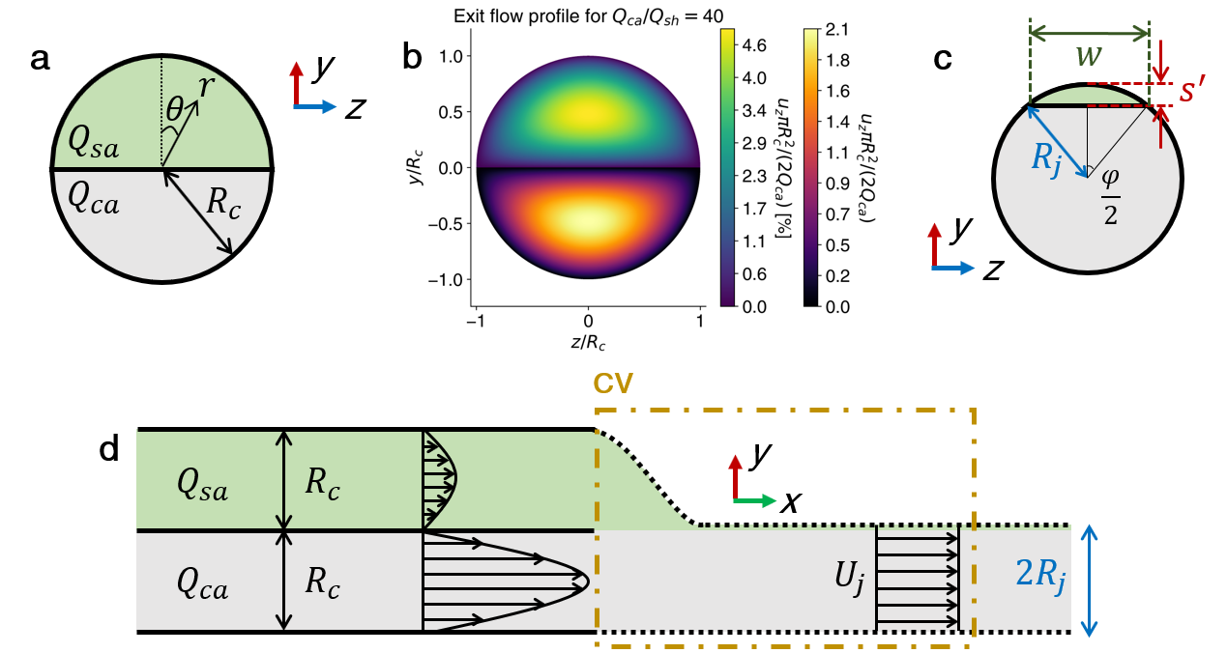
Figure S5. Geometry of the exiting free jet. a Geometry of the exiting stream. The two-nozzle device consists of two semi-circular domains with the same radius $R_{c}$ (capillary radius, $R_{c}=15$ µm for the quenching experiments), forming the characteristic “theta” shape. b Fully-developed (internal) laminar flow solution for the $x$-direction velocity fields is given by equations (S22a) and (S22b). c Model for the geometry of the free jet. The fluorescent stream occupies a circular segment of sagitta $s'$, chord $w$, and central angle $φ$. d Control volume analysis to determine the free jet velocity $U_{j}$ and radius $R_{j}$. The developed free jet cross-sectional area is then $A_{j}=πR_{j}^{2}$.
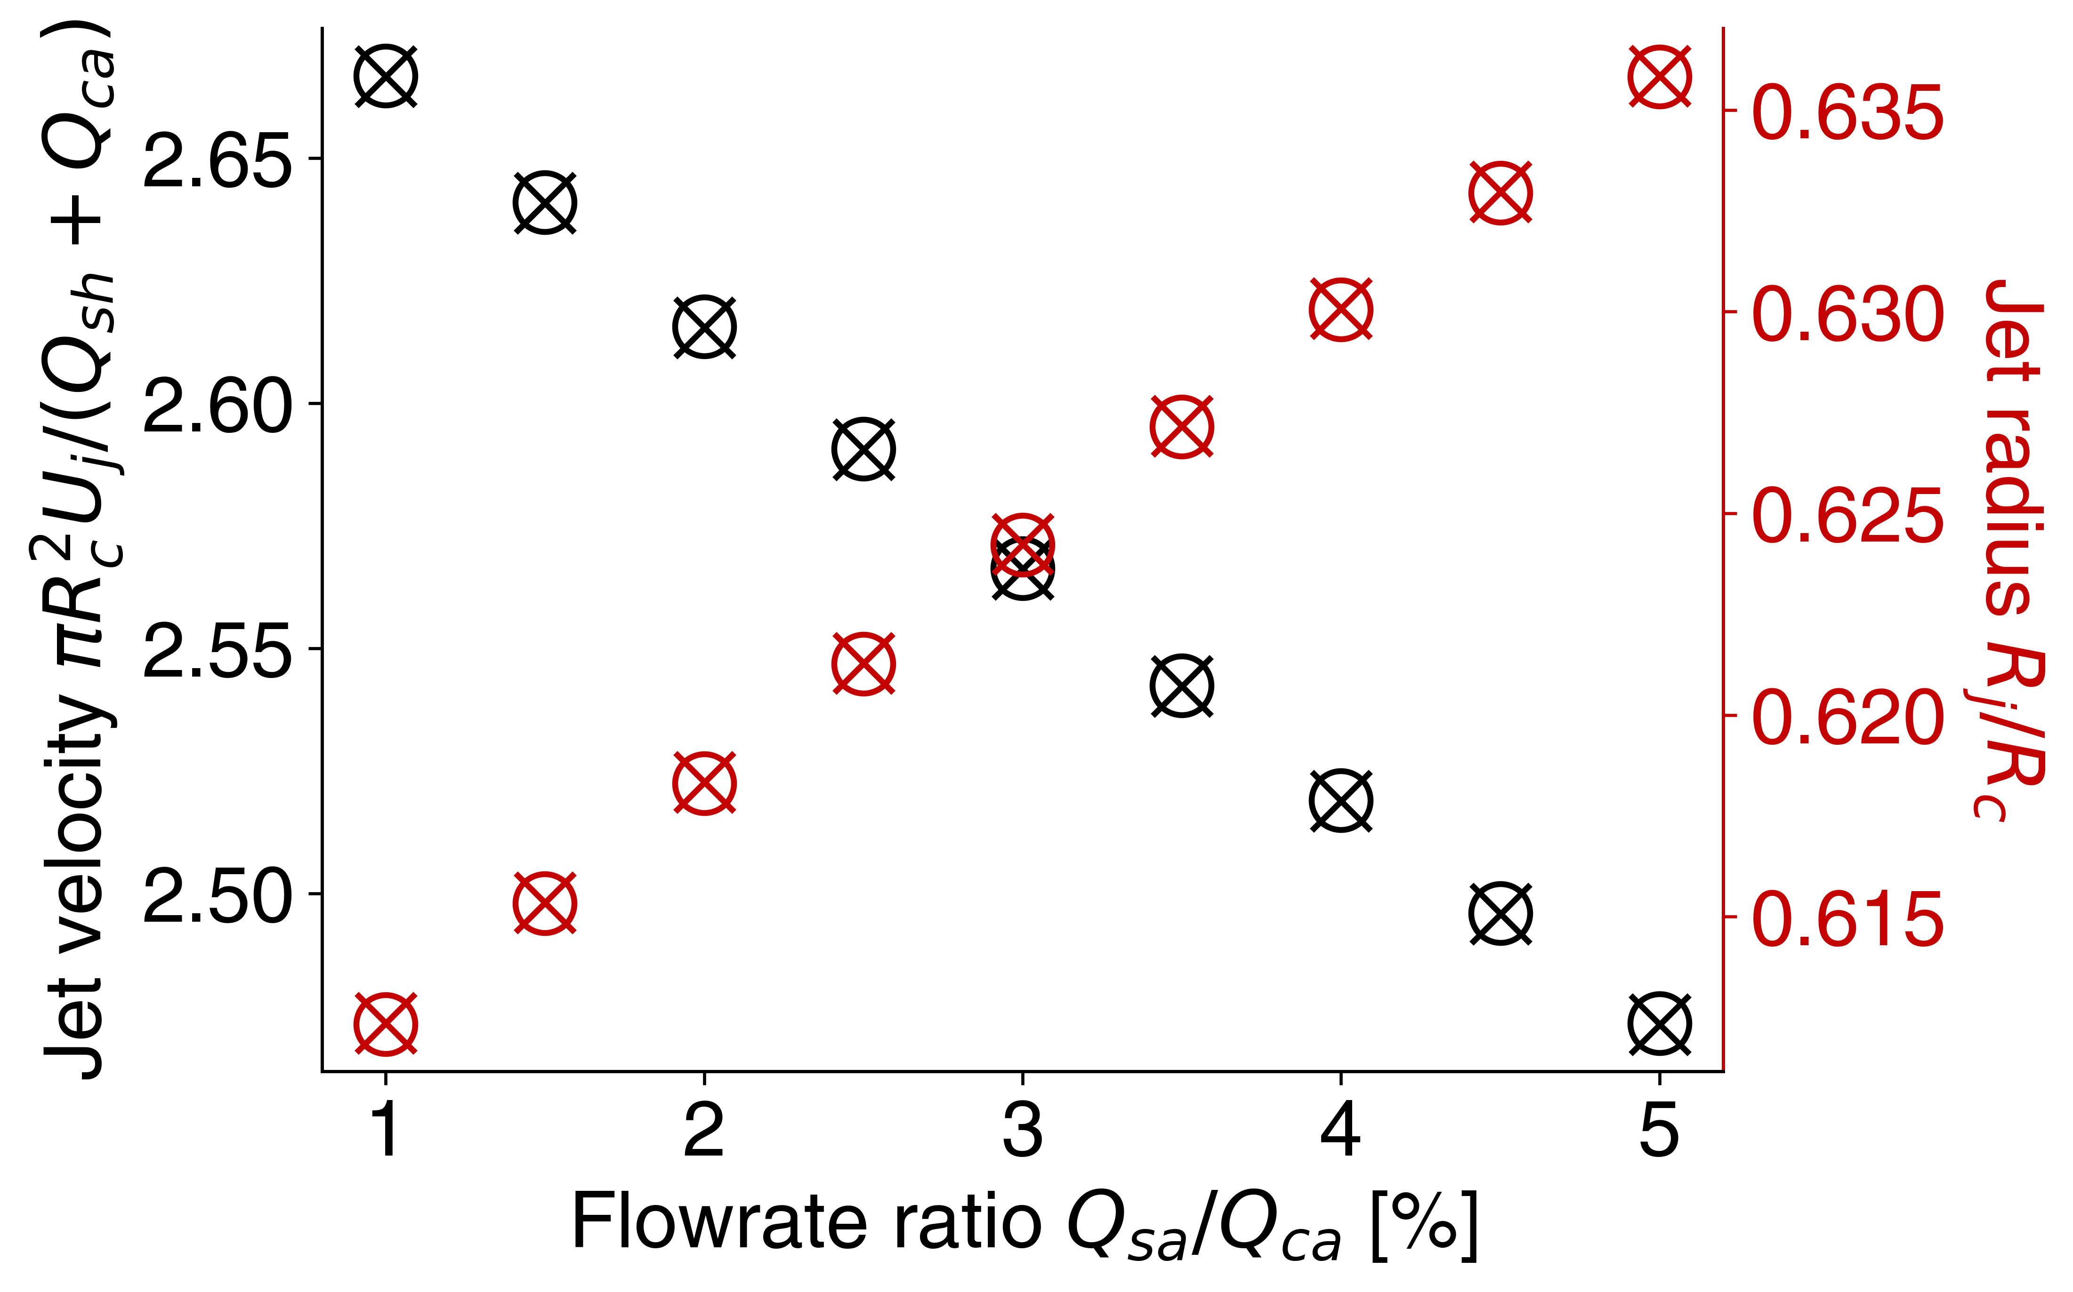
Figure S6. Free jet velocity and radius vs. flowrate ratio for the experimentally explored conditions. Normalized values for the free jet velocity (resp. free jet radius) are shown with black (resp. red) symbols. The solution from equations (S41) and (S42) is shown with cross symbols. We also report similar values obtained by the numerical integration of equations (S24) and (S25) with circles.
S6 Uncertainty propagation on the measure of the quenched intensity ratio
This section presents an uncertainty quantification on the measured quenched intensity ratio $β$. This ratio is defined as:
 | $$β=\frac{I_{quen}}{I_{unquen}}.$$ | (S46)
Here, $I_{quen}$ and $I_{unquen}$ are respectively the transverse-integrated fluorescence intensities, averaged over the two realizations of each experimental condition. Note that all quantities in equation (S46) depend on the streamwise position $x$. We denote each realization of the jet (i.e., each different image of the free jet) by subscripts 1 and 2. The uncertainty on the mean of $β$, $P_{β}$, is then approximated as:
 | $$P_{β}^{2}={\left(\frac{∂β}{∂I_{quen}}σ_{I_{quen}}\right)}^{2}+{\left(\frac{∂β}{∂I_{unquen}}σ_{I_{unquen}}\right)}^{2}=\frac{1}{{\hat{I}}_{unquen}^{2}}\left(σ_{I_{quen}}^{2}+β^{2}σ_{I_{unquen}}^{2}\right).$$ | (S47)
Here, we defined:
 | $$σ_{I_{i}}^{2}={\left(I_{i,1}-{\hat{I}}_{i}\right)}^{2}+{\left(I_{i,2}-{\hat{I}}_{i}\right)}^{2},$$ | (S48)
 | $${\hat{I}}_{i}=\frac{I_{i,1}+I_{i,2}}{2}.$$ | (S49)
Here, $i$ refers to either quenched (“quen”) and unquenched (“unquen”) cases, and the subscripts 1 refer to the two realizations. We then plot $β±P_{β}$ in figure 4a, for each value of the sample flowrate $Q_{sa}$.
S7 Practical considerations regarding $Q_{sa}/Q_{ca}$
In this section, we review some practical considerations regarding the experimental variation of the sample-to-carrier flowrate ratio $Q_{sa}/Q_{ca}$. In this work, we explored values of $Q_{sa}/Q_{ca}$ of order 0.01 to 0.05. We will discuss how lower and higher values of $Q_{sa}/Q_{ca}$ are difficult to achieve with the mixer system presented in this work.

A first practical limit to $Q_{sa}/Q_{ca}$ is governed by spatial extent of the mixing region. The values of $Q_{sa}/Q_{ca}$ explored in this work enabled mixing which was sufficiently rapid to be analyzed within the field of view of our optics. More importantly, this range of flowrate ratios also enabled mixing to occur upstream of the Rayleigh-Plateau-type breakup of the liquid jet into droplets. Substantial increases in the ratio $Q_{sa}/Q_{ca}$ would mean that jet break-up occurs before the two streams can significantly mix. Following the work of, for example, Ismail et al. (Ismail, Yao, Xia, & Stark, 2018), we can assume a scaling for the stable jet length, $L_{b}$, as follows: $L_{b} \sim U_{j}R_{j}\sqrt{\frac{6ρR_{j}}{γ}}$. Here, $U_{j}$ and $R_{j}$ are respectively the jet velocity and radius, consistent with the variables in equations (11) and (12) of the main manuscript. $ρ$ and $γ$ are respectively the water density and surface tension. Increasing $Q_{sa}/Q_{ca}$ to, say, 0.1 by increasing $Q_{sa}$ would result in breakup length $L_{b}$ on the order of 1 mm. However, the characteristic diffusion time scales as $s^{2}/D_{ca}$, where $D_{ca}$ is the diffusion coefficient of the quencher species in water and $s$ is the characteristic transverse thickness of the sample stream. Increasing the flowrate ratio from 0.01 to 0.1 would also increase the characteristic transverse jet thickness $s$ about 10-fold. Note, for this approximation, we here choose $D_{ca}$ instead of $D_{sa}$ (diffusion coefficient of the sample species) since $D_{ca}$is approximately three times larger than $D_{sa}$. The mixing time of order of $s^{2}/D_{ca}$ would then require a stable jet length of order 10 cm, which would not be possible using the current mixer configuration.

A second important limitation on extending values of $Q_{sa}/Q_{ca}$ are practical limitations associated with controlling and pumping these flow streams. Note our system is intended to be compatible with high energy X-ray facilities. This includes the use of (fairly portable, benchtop) HPLC pumps compatible with experiments in X-ray spectroscopy facilities, supply capillaries with inner diameters of 125 or 500 µm (to minimize liquid dead volume and save on potentially expensive reagents), and fittings that enable quick exchange of the dual-nozzle system (e.g., during a scheduled X-ray facility time). These features leverage our previous experience in such facilities (Huyke et al., 2020, 2021). For the conditions we explored, the sample flowrate $Q_{sa}$ varied between 20 and 100 µL/min. These flowrates can be repeatedly controlled with an HPLC pump with an accuracy of order 0.5 µL/min or greater. Larger values of $Q_{ca}$ are also difficult to achieve. This results in maximum required source pressures of over 10,000 kPa, and dynamic pressure of the free jet over 8,000 kPa. An order of magnitude increase in this source pressure would be difficult to control, would require a new type of pump, and may require new fluidic connections. Further, leaks near the pump of such a system could also yield potentially lethal jets (e.g., sufficient to cut through human flesh and bone).
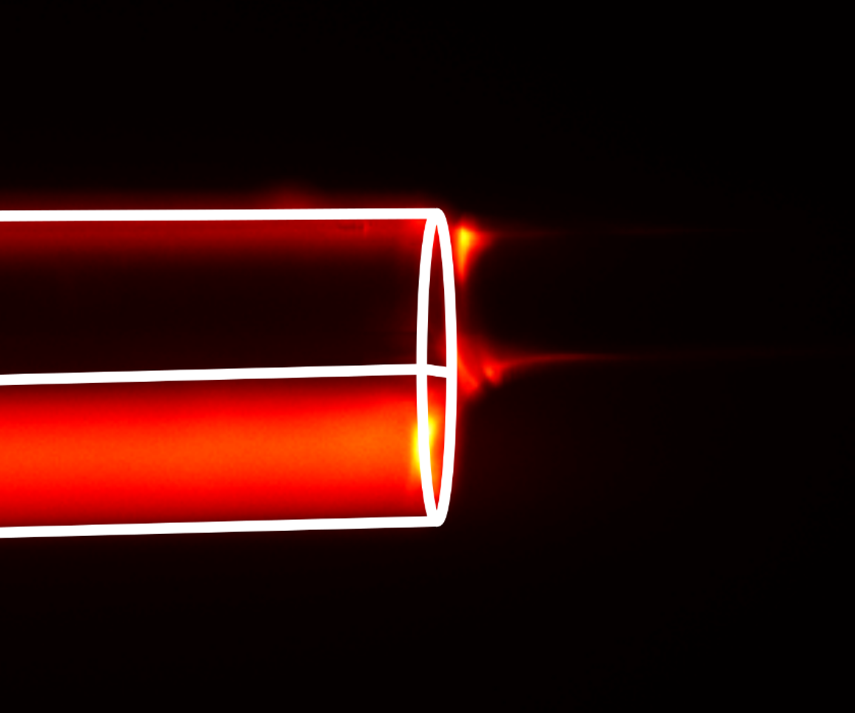
S8 Epifluorescence image of the dual-nozzle aperture of the theta device
Figure S7. Epifluorescence image of the theta device’s dual-nozzle during operation. Shown is a side-view image of the two-nozzle output of the theta mixer device. The white lines are added as a visual aid highlighting the outer walls and the wall separating the two nozzles. The flow is left to right and the jet exits to the right-side of the image. The fluorescent reagent solution (i.e., the sample stream) is flowing through the bottom channel and the unlabeled “carrier solution” flows through the top channel. The sample stream is rapidly accelerated, predominantly by viscous stresses imposed by the carrier channel stream, and laminates into a thin stream. The high image intensity regions near the top of the top nozzle and the top of the emerging streams are artifacts due to light scatter. That is, these are capillary and jet areas which elastically scatter photons emitted by the bottom stream into the collection optics, and are captured by the camera.

REFERENCES
Adair Oesterle. (2018). Pipette Cookbook 2018. Sutter Instrument.
Huyke, D. A., Ramachandran, A., Oyarzun, D. I., Kroll, T., DePonte, D. P., & Santiago, J. G. (2020). On the competition between mixing rate and uniformity in a coaxial hydrodynamic focusing mixer. Analytica Chimica Acta, 1103, 1–10.
Huyke, D. A., Ramachandran, A., Ramirez-Neri, O., Guerrero-Cruz, J. A., Gee, L. B., Braun, A., … Santiago, J. G. (2021). Millisecond timescale reactions observed via X-ray spectroscopy in a 3D microfabricated fused silica mixer. Journal of Synchrotron Radiation, 28, 1100–1113.
Ismail, A. S., Yao, J., Xia, H. H., & Stark, J. P. W. (2018). Breakup Length of Electrified Liquid Jets: Scaling Laws and Applications. Physical Review Applied, 10, 064010.
Sutter instrument. (2020). P-2000 Laser-Based Micropipette Puller System Operation Manual. Sutter Instrument.
White, F. M. (2006). Viscous Fluid Flow (Third Edition). McGraw-Hill.

