Dynamics of cavity structures and wall-pressure fluctuations associated with shedding mechanism in unsteady sheet/cloud cavitating flows

Changchang Wang^{1*}, Mindi Zhang¹

¹ Beijing Institute of Technology, Beijing, China

¹ wangchangchang026@vip.163.com

Supplementary Materials

1. Methodology

1.1. Visualization techniques and mPOD analysis
The cavitation phenomena are documented by a high-speed digital camera (HG-LE, by Redlake), up to a rate of 10⁵ frames per second (fps). In order to maintain desirable spatial resolutions, the images acquisition frequency 3000 Hz at 0.23 megapixels is used in this study depending on the focus of the investigation. The illumination is provided by two dysprosic lamps. The image resolution was 752×312 with an optical magnification of 0.27 mm px⁻¹, and the image depth was 8 bit. For all series of images obtained by the visualization method, camera settings for brightness and contrast were kept constant and equal. According to the study by Bilus et al. ^{S1}, the gray level value is proportion to void fraction in a wide void fraction range. So in the current study, firstly, the cavitation images are converted from RGB true color images to gray images. Then, the cavitation structure analysis is conducted based on gray level images. It should be noted that under cloud cavitation regimes, the interactions between cavity structures with RJ and SW are different, which cause variability of void fraction along cavity thickness direction especially for RJ conditions. For example, the RJ is usually beneath the cavity and changes local void fraction, enhancing the variability of void fraction along cavity thickness direction. Furthermore, when the RJ shows 3D structures, the local void fraction change is very small and we can just identify the RJ from the movement of cavity structures driven by the RJ motion. Consequently, it is efficient to identify cavity structures using the variability of void fraction along cavity thickness direction. To quantitatively analyze the cavity structures, cavity structures identification functions based on variability of void fraction along cavity thickness direction are defined based on gray levels in high-speed imaging, i.e., gray level average ($\overline{g}$) and gray level variance ($\hat{g}$). The normalized gray level is used in the analysis
g(x,y)=I(x,y)/255 (S1)
The gray level average function ($\overline{g}$) is
(S2)
where N_{ypixel} is the number of non-zero pixel in the y direction at fixed streamwise location.
The gray level variance function ($\hat{g}$) is defined as follows
(S3)
here, ave(g(x,y)) is the time averaged gray level values.
Fig. S1 shows the gray level profiles at typical cavity evolution instances, i.e., in the process of reentrant jet development and shockwave propagation, respectively. The gray level average and gray level variance functions present the similar evolution trend corresponding to the cavity structures, and both can predict the cavity structures well, including the reentrant jet and shockwave dynamics. These gray level profiles for unsteady flow structure analysis have been described and evaluated by Wang et al. ^{S2}. In the present work, we further extend this method to analyze the cavity structures and fluctuating wall-pressure signals from the statistical viewpoint.

FIG. S1 Typical gray level profiles along with the corresponding high-speed images in the process of (a) reentrant jet development at σ=0.75, and (b) shockwave propagation at σ=0.71. Re=7.8×10⁵.

FIG. S2 Outline of the temporally–spatially resolved cavity structure analysis approach based on both gray level and gray level functions defined in the current study, and the mPOD algorithm.
Fig. S2 shows the schematic of image processing used in the present work to analyze the unsteady cavitation behaviors and extract the coherent cavity structures. The gray level image matrix and spatial-temporal (s-t) gray level function matrix are formulated based on gray level images and gray level functions. Then, the s-t diagram of gray levels is obtained by stacking the gray level profiles where the evolution of transient cavity structures, including cavity growth, reentrant jet/shockwave development, cavity shedding, and so on, can be well illustrated. The Multiscale Proper Orthogonal Decomposition (mPOD) method which has the advantages of frequency-based separation of flow structures, minimizing the frequency-overlapping of different modes, is applied to the gray level matrix. The resulting mPOD modes and eigenvalues are then used to identify the coherent structures and the corresponding frequency contents as well. The modes obtained by mPOD are featured by a well-defined and non-overlapping range of frequencies. As for any data-driven decomposition, the mPOD firstly assembles the data matrix. N snapshots obtained by an experiment can be written in the form $\left\{I_{1}, I_{2}, {⋯, I}_{N}\right\}$, and the fluctuating parts of I is $\left\{I_{1}^{'}, I_{2}^{'}, ⋯, I_{N}^{'}\right\}$. The snapshot at the ith instant can be expressed as a column vector I_{i}, and the time interval between two consecutive snapshots is given as Δt. The mean part of I is calculated using
(S4)
and $I^{'}$ denotes the fluctuating part. For the clarity of the gray level values statistically converged, the average image $\overline{I}$ is first removed, and the mPOD is based on fluctuating fields $I^{'}$
(S5)
The purpose of the mPOD is to extract a set of spatial orthogonal basis and represent the fluctuating parts as follows:
(S6)
where, σ_{mr} is the amplitude coefficient, representing the spatial coherent structures, ψ_{mr} is the temporal coefficient, and the subscript ‘m’ represents the multiscale approach. In order to find the orthogonal basis, the temporal correlation matrix K and its Fourier transform $\hat{K}$ are firstly calculated
(S7)
(S8)
where $I^{'T}$ represents the transpose of matrix $I^{'}$, and Ψ_{F} is the symmetric and orthogonal Fourier matrix used to the inverse transformation of the filtered spectra. In the standard POD method ^{S3, S4}, firstly the temporal correlation matrix K is decomposed to obtain the temporal basis, and then the flow fields are projected to the temporal basis using the snapshot method ^{S5}, resulting in the spatial coherent structures of POD modes. Details about the standard POD algorithm can be found in references ^{S3, S5}. Compared with the standard POD, in the mPOD algorithm, the temporal basis will be computed by setting frequency constraints to the classical POD, and mainly consists of three steps. Firstly, the correlation matrix K is split into the contributions of different scales (K_{m}) by the multi-resolution analysis (MRA) for further analysis as follows
(S9)
where, M is the number of scaling interval, ‘$°$’ is the Hadamard product, H_{m} is the transfer function of the filter to separate the scale m, n_{m} is the characterized value in the scale m, and λ is the eigenvalue. Secondly, the orthonormal temporal basis $Ψ_{m}$ corresponding to each scale can be obtained by diagonalizing each of these contributions as in the standard POD algorithm ^{S5}
$K_{m}=Ψ_{m}\sum_{m}^{2}{Ψ_{m}^{T}}$ (S10)
Thirdly, the spatial basis $Φ_{M}$ is calculated by the projection of the dataset $I^{'}$ on the temporal basis $Ψ_{m}$ of each scale, and then the bases of each scale are merged into the final temporal basis, leading to the decomposition of flow fields
$Φ_{M}=I^{'}Ψ_{m}\sum_{m}^{-1}{Ψ_{m}^{T}}$ (S11)
Finally, sort the results in descending order of energy contribution.
It is worth noting that the above cavity structures analysis is based on cavitation images where 2D assumptions of cavity structures are used. However, cavitating flows always present 3D structures in nature as well as due to the side walls effects, especially the small-scale and large-scale shedding cavity cluster/cloud structures, resulting in the overlaps of different flow structures in cavitation images. Fig. S3 presents the illustrations of 3D effects (i.e., flow structures A, B and C) on 2D cavitation images where due to the side wall effects the dimensions of A and B are smaller than that of B, and the corresponding uncertainties sources. As shown in Fig. S3 (b) and Fig. S3 (c), flow structures (i.e., A, B, C) in different spanwise (Δz) and streamwise (Δx) locations could cause uncertainties in streamwise direction (Δx′) on the cavitation images, respectively. These two kinds of uncertainties are analyzed as follows:
(1) As for uncertainty caused by flow structures at different spanwise locations (Δz) but the same streamwise location in Fig. S3 (b), such as flows structures A and B, ideally, A and B should locate at the same streamwise location on cavitation images, but owing to the 3D effects, it would have streamwise difference Δx′ on cavitation images. For a Nikon 60 mm/F2.8 lens, the CMOS size of 36 mm × 24 mm, the maximum spanwise distance of Δz=70 mm, and the imaging region of 230 mm × 95 mm, the maximum streamwise error (ε) using the current imaging system has ε=Δx′/(x₁-Δx′)= 8.4%. This error would cause difficulties for the identification of flow structures with the size less than 8.4% cavity dimensions, i.e., small-scale structures. However, considering the relative low intensity level caused by flows structures behind the front window, this cavity length variance has little effect for the transient global cavity evolution which is the focus of the current study.
(2) As for uncertainty caused by flow structures at different spanwise locations (Δz) and different streamwise location (Δx) in Fig. S3 (c), an interesting phenomenon could occur that the flow structures at different Δz and Δx when they are in line with the lens focus will locate at the same streamwise location Δx′ on cavitation image. In this case, the image intensity would be enhanced. However, the energy gained from the illumination system by flow structures behind the front window is always low and the intensity variance attenuates with the increasing Δz. So, this kind of uncertainty could be ignored compared with intensity induced by cavity evolution in cavity cycles.

Fig. S3 Illustration of 3D effects on uncertainties using the current 2D cavitating flow imaging system. CMOS: Complementary Metal-Oxide-Semiconductor, A: flow structures near back wall of the channel, B: flow structure at the center of the channel, and C: flow structure near front wall of the channel.

Above all, 3D effects could cause overlapping of different cavity flow structures on cavitation images, altering the intensity distribution, and bring difficulties for the cavity structure identification especially the small-scale cavity structures. In the current study, we focus on the large-scale cavity structures, which are not largely influenced by these 3D effects. Furthermore, these intensity uncertainties caused by 3D effects can be ignored when compared with the intensity evolution by the transient cavity structure evolution in cavity cycles. Consequently, the current visualization techniques and image analysis approach (i.e., gray level profiles, mPOD) are satisfactory for our current study.

1.2. Unsteady pressure measurement techniques
Wall-pressure fluctuations generated by the cavity evolution were measured within a region extending from the wedge throat to 16% L_{divergent}. Four 5.5 mm diameter flush-mounted dynamic pressure sensors (PCB 102A05) were located within the centerline of the divergent section from ξ/H = 0.11, with a step of 0.26 H (where ξ=10 mm, 35 mm, 60 mm, 85 mm ξ denotes the streamwise coordinate from the front stagnation, i.e., the wedge throat, along the divergent channel wall surface). The sensors connected to an ICP Sensor 428C16 signal conditioner were located to be within the cavitation region and flush-mounted with the wall surface. The resonance frequency of the transducers is more than 250 kHz, and the calibration of the sensors was carried out by using the on-site calibrator of PCB Piezotronics, Inc., as the reference. A 16 bit 16-channel NI DAQ data acquisition system (National Instruments PCI-6133 card) whose largest sampling rate is 2.5 M per channel was used to amplify, filter, and transform the output of transducers into digital values, and depending on the focus of the investigation, 1.024 MHz is used, and the sampling length is 10 s in the present study. The raw pressure signals were first preconditioned with a median filter to remove the background noise during the cavitation experiment in the water tunnel. Then, time series and statistical analysis are conducted based on the filtered and clear signals.
To correlate the pressure fluctuations with the transient cavity behaviors, high-speed imaging, and pressure fluctuation signals from four pressure transducers were acquired simultaneously by a 5 V TTL signal controller, which is a single-shot waveform generator. When the controller is triggered, the voltage signal will jump to a higher value above the threshold value (20 mV is used in the present work), and the cavitation images and wall-pressure signals will be captured simultaneously at each sampling rate. Considering that the sampling rate of the high-speed camera (3,000 fps) was far less than that of the unsteady pressure transducers (1.024 MHz), which means that three pictures correspond to 1024 pressure samples, the synchronism of the cavitation images and the pressure signal is approximately 3 μs, and the time difference can be negligible compared with the unsteady sheet/cloud cavitation behaviors, the time scale of which is on the order of approximately 1 ms. The simultaneous measurement system has been used in the experiment studies of cavity dynamics and its induced pressure fluctuations in recent years ^{S2}.

2. Results and discussion
As shown in Fig. S4, cavitation inception occurs at a cavitation number around σ = 1.11, where vapor grows downstream the wedge throat. The cavity structures are characterized by stable sheet cavity attached on the wall and separated bubble or tube cavities in the streamwise secondary vortices in the shear region. The attached sheet cavity covers the transducer #1 and #2. There are mainly two types of inception cavity structures within shear layer, i.e., inception bubble and vortex tube bubble as shown in the snapshots in Fig. S4 (a) and (b) respectively. Owing to the strong interactions with local vortex structures in the shear region, inception bubbles and vortex tube bubbles present the growth, breakup, merge, and collapse unsteady behaviors. Based on observations of high-speed images, generally, the life cycle of inception bubble is longer than that of vortex tube bubble. From the statistical analysis, for a period of around 76 ms, there is about 13 inception bubbles, while for a period of around 131 ms, only 10 vortex tube bubbles. There is about 2.4 inception bubbles and 1 vortex tube bubble. The occurrence frequency of inception bubble formation is higher than the vortex tube bubble. This observation of inception cavity structures in shear layer is consistent with Gopalan et al. ⁵, Iyer & Ceccio ^{S6}, and Ganesh et al. ^{S7}. Shedding cavity clusters are not observed at the rear of sheet cavity, indicating the relatively stable state inside the sheet cavity.
With a reduction in σ, cavity length increases and cavity closure fluctuates a lot along with the cavity structures shedding. Fig. S5 presents the evolution process of small-scale cavity cluster shed at the closure region of sheet cavitation and large-scale cavity cloud at the cloud cavitation. At σ = 0.85 under sheet cavitation in Fig. S5 (a), the attached sheet cavity length increases to cover all the four pressure transducers and the shear layer cavitates more. Vapor was observed to fill the vortices in the shear layer region and no trailing bubbles are observed, as shown in Fig. S5 (a). With the shear layer changing from separated trailing bubbles to fully cavitated cavity structures, the attached sheet cavity closure becomes unstable and small-scale cavity cluster (S-S cavity) are shed intermittently at the rear of the sheet cavity as observed in the snapshots in Fig. S5 (a) which is different from the relatively stable and closed type sheet cavity under inception cavitation in Fig. S4. With the cavity cluster being shed downstream into high pressure region, the size and vapor content of the cavity decreases, and the cavity topology changes from cloud shape to vortex tube as shown at instant t₄ in Fig. S5 (a). At the same time, the vortex tube is connected with the channel wall and moves downstream near the wall until disappears at instant t₅ and t₆. With a further reduction in cavitation number to σ = 0.75, cavity becomes unstable with increasing cavity length, and cavity regime transitions to cloud cavitation. Different from the relatively stable sheet cavitation with intermittently shedding small-scale cavity clusters (S-S cavity), cloud cavitation is characterized by the periodic large-scale cavity cloud shedding (L-S cavity) as shown in Fig. S5 (b). At σ = 0.75 under cloud cavitation, in the process of large-scale cavity cloud shedding in cloud cavitation in Fig. S5 (b), the shedding cloud is far away from the wall and moves downstream. With the collapse of cavity cloud, the U-shape cavitation cloud forms at t₄ in Fig. S5 (b) with low vapor structure around the U-shape cavity. With the cavity cloud being shed further downstream, both the U-shape cavity cloud and the vapor structures around begin to collapse at instant t₅ and t₆ in Fig. S5 (b).

FIG. S4 The typical inceptions bubbles in the shear layer region across the sheet cavity interface at σ = 1.11.

FIG. S5 Evolution process of shedding cavity structures for (a) small-scale cavity cluster at sheet cavity regime, σ=0.85, and (b) large-scale cavity cloud at cloud cavity regime, σ=0.75. Dashed green lines show the sheet cavity closure and the dashed white lines show the locations of shedding cavity structures.

To illustrate the instabilities associated with the cloud cavity shedding mechanism, the reentrant jet and shockwave dynamics are studied. Fig. S6 shows the unsteady evolution process of the reentrant jet under cloud cavitation with reentrant jet mechanism at σ=0.75. As shown in the snapshots, a reverse flow layer beneath the attached cavity, namely the re-entrant jet (RJ), is observed to move upstream. At t=t₀+6 ms, the head of reentrant jet develops to approximately #3 transducer, and at t=t₀+17 ms to approximately #2 transducer. With the development of reentrant jet, at t=t₀+25 ms, the reentrant jet arrives at the cavity leading edge, and the interactions between the attached sheet cavity and reentrant jet causes the cavity to breakup. Under the convective effects of main flows, the broken sheet cavity is rolled up into a large cavity cloud (L-S cavity), shedding downstream, named as reentrant jet mechanism. With a further reduction in cavitation number to σ = 0.71, cavity length further increases, and the size of both attached sheet cavity and shedding cloud cavity increases. The cavity content is mainly composed of vapor where the void fraction increases. According to the study by Brennen ¹ and Franc ³, the sound speed in bubbly flows will drop drastically to even 3-5 m/s where local flow could be supersonic, and at certain flow conditions there could be shockwave. In the current experiment, a propagating low void fraction structure occurs within attached cavity starting from cavity closure to cavity leading edge as shown in Fig. S7. Based on our current high-speed imaging, it is found that when this low void fraction front arrives at the cavity leading edge, it will cause the attached cavity breakup accompanying with the large-scale cavity cloud formation and shedding shown from instant t=t₀ to instant t=t₀+37 ms in Fig. S7. This shockwave structure has been observed in our previous work using both experimental measurements ⁴³ and numerical methods ^{S8, S9}, and effects of air injection on shockwave dynamics was also discussed ^{S2}. It is worth noting that the current high-speed visualization agrees well with the observation of bubbly shockwave by x-ray densitometry technique ^{S10}. So, in the current study, this low void fraction front is named as shockwave, and this cavity regime is termed as shockwave mechanism which is different from the reentrant jet mechanism in Fig. S6. It is worth noting that although some of the features of re-entrant jet mechanism and shock wave mechanism in cloud cavitation have been studied, there are still lots of work need to do to gain further insight into these two mechanisms and their transition, such as how the interactions between re-entrant jet and shockwave when both two structures exist determines the cloud cavitation breakup and shedding are unknown and requires more sophisticated measurements.

FIG. S6 The unsteady evolution process of cavity structures in the process of reentrant jet movement in reentrant jet dominated cloud cavitation stage at σ=0.75, and Re=7.8×10⁵.

FIG. S7 The unsteady evolution process of cavity structures in the process of shockwave propagation in shockwave dominated cloud cavitation at σ=0.71, and Re=7.8×10⁵.
FIG. S8 The variation of convective velocity of typical cavity structures including sheet cavity growth (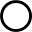, and black region), RJ/SW motion ( and red region), and cloud cavity shedding ( and green region) normalized by U_{t} with σ at Re=7.8×10⁵. The shadow region indicated the region of standard derivations along with mean value of the convective velocities.

Fig. 8 presents the variation of convective velocities of typical cavity structures as a function of σ based on cavitation images in cloud cavitation. The convective velocity is calculated from the s-t diagram of gray level variance, and for each flow condition, at least 10 cavity cycles are measured to ensure the statistic convergence. We find that the convective velocities almost stay and only decreases slightly with decreasing σ. Across the range of σ studied, the cloud cavity shedding velocity is the largest with almost 0.44 ± 0.04 U_{t} shown in the green shadow region, and the sheet cavity growth velocity is the smallest with approximately 0.25 ± 0.02 U_{t} shown in the black shadow region. The RJ/SW motion velocity is larger than the sheet cavity growth velocity with approximately 0.35 ± 0.04 U_{t} shown in the red shadow region.
To identify the flow physics responsible for the secondary frequency (f_{s}), here we analyze the characteristic frequency associated with the typical cavity structures in cloud cavitation. In Fig. S8, the transport velocity of typical cavity structures (i.e., sheet cavity growth, RJ/SW motion and cloud shedding) of typical cloud cavitation with RJ mechanism and SW mechanism is presented and agrees with the measures in Fig. 5 in Section. A. As listed in Tab. 1, the characteristic frequency for RJ (f_{RJ}) is approximately 1/(L_{c}/u_{re})=18.0 Hz for reentrant jet movement (u_{re} is the reentrant jet movement velocity), which is near its secondary frequency f_{s}=23.1 Hz (relative error approximately 22%), and for shockwave (f_{SW}) is approximately 1/(L_{c}/u_{sh})=13.4 Hz for shockwave propagation (u_{sh} is the shockwave propagation velocity), which is close to its secondary frequency f_{s}=14.3 Hz (relative error approximately 22%). Shown in Fig. S8, the cavity shedding frequency is about 2.41 ± 0.19 f_{RJ} or f_{SW} where this relation shows agreement with the that between f_{d} and f_{s} obtained from wall-pressure signals, St_{d}=2.00 ± 0.14 St_{s} (relative error approximately 20%). It should be noted that in the process of reentrant jet movement and shockwave propagation, the RJ/SW front motion varies, potentially resulting in overestimation or underestimation of RJ/SW frequency. Additionally, the uncertainties involved in the environmental variability during the tests and the estimation of RJ and SW velocities from cavitation images, also contribute to overestimation or underestimation of RJ/SW frequency. Consequently, our observations on cavity structures and double-peak behaviors show that flows at secondary frequency are closely related with the reentrant jet dynamics and shockwave dynamics.

FIG. S9 Time series of average gray level lines (i.e., gray level average and gray level variance) and the corresponding simultaneously acquired pressure fluctuations at #2 pressure transducer for (a) reentrant jet mechanism at σ=0.75 and (b) shockwave mechanism at σ=0.71, respectively. Re=7.8×10⁵.

Time series of average gray level lines (i.e., gray level average and gray level variance) over a 20 × 1 pixel window, centered over the transducer effective surface, have been extracted from the high-speed imaging for comparison with wall-pressure fluctuation measurements. Samples of the simultaneously recorded gray level lines and wall-pressure fluctuations for different cavity regimes, i.e., inception cavity, sheet cavity, cloud cavity with reentrant jet mechanism and shockwave mechanism, are shown in Fig. S9. Based on the assumption that the gray level value is in proportion to the vapor fraction ^{S1}, a low average gray level corresponds to the clear water and a high average gray level corresponds to the white vapor cloud. Generally, the gray level average and gray level variance show the similar evolution trend. As shown in Fig. S9, in accord to the observations of transient cavity behaviors, the fluctuating pressure signals present the intermittent features in inception and sheet cavitation, and the periodicity in cloud cavitation. Specifically, at inception cavitation in Fig. S9 (a), both the gray level lines and wall-pressure signals present the high frequency fluctuations. The average gray level value is in the range of 0~0.4, and the average gray level variance is in the range of 0~0.3. At inception cavitation in Fig. S9 (b), compared with that in inception cavitation, the evolution frequency of gray level and wall-pressure fluctuation signals decrease. The average gray level increases and is in the range of 0~0.8, while the average gray level variance is almost the constant and is in the range of 0~0.3. At cloud cavitation with reentrant jet mechanism in Fig. S9 (c) and shockwave mechanism in Fig. S9 (d), the evolution of both average gray level and wall-pressure fluctuations presents the low frequency and periodic features. Due to the strong unsteadiness in cloud cavitation, both the average gray level and average gray level variance increase. Corresponding the unsteady cavity structures, the fluctuating wall-pressure fluctuations present periodic evolutions. Strong correlation between pressure fluctuations and image intensity is found. However, a delay between the average gray level lines and the wall-pressure fluctuations is found. The phase difference between the average gray level and wall-pressure fluctuation may be attributed to the alternating reentrant jet/shockwave movement and sheet cavity growth. The same delay between light intensity and surface pressure signals is also reported by Graaf et al. ²¹ in cloud cavitation around a sphere.
The comparisons of frequency contents calculated by cavitation area from cavitation images using the Morlet wavelet analysis ^{S11} and measured pressure signals using Fast Fourier Transform (FFT) method in cloud cavitating regimes are presented in Fig. S10 and Fig. S11. Both the time-frequency spectrum by cavity structures and frequency spectrogram obtained from the sampled pressure signals show similar overall structure especially the double-peak behaviors, indicating the close correlation between the wall-pressure signals and cavity structures. Specifically, the dominated frequency (f_{d}) in cloud cavitation with reentrant jet mechanism calculated by cavity area in Fig. S10 (a) is about 11.7 Hz and by sampled pressure signals about 12.4 Hz (relative error about 6.0%) in Fig. S10 (b). According to the previous work ^{17, 43}, the dominant frequency (f_{d}) obtained from cavity volume and pressure signals is the same as the cavity shedding frequency, representing the cavity shedding period. The secondary frequency (f_{s}) is about 23.1 Hz for cavity area in Fig. S10 (a) and 24.4 Hz for sampled pressure signals (relative error about 5.6%) in Fig. S10 (b). The lower dominated frequency in shockwave mechanism is consistent with the measures that in shockwave mechanism, the cavity length is longer than that in reentrant jet mechanism, while the shockwave propagation velocity is smaller than the reentrant jet, resulting in a longer time required for the cavity breakup and longer shedding cycle. The correlation between secondary frequencies obtained from cavity aera and measured pressure signals in both RJ and SW mechanism verifies that, different from the dominant frequency which is associated with the large-scale cavity shedding process, another interesting cavity structure is responsible for this secondary frequency content.
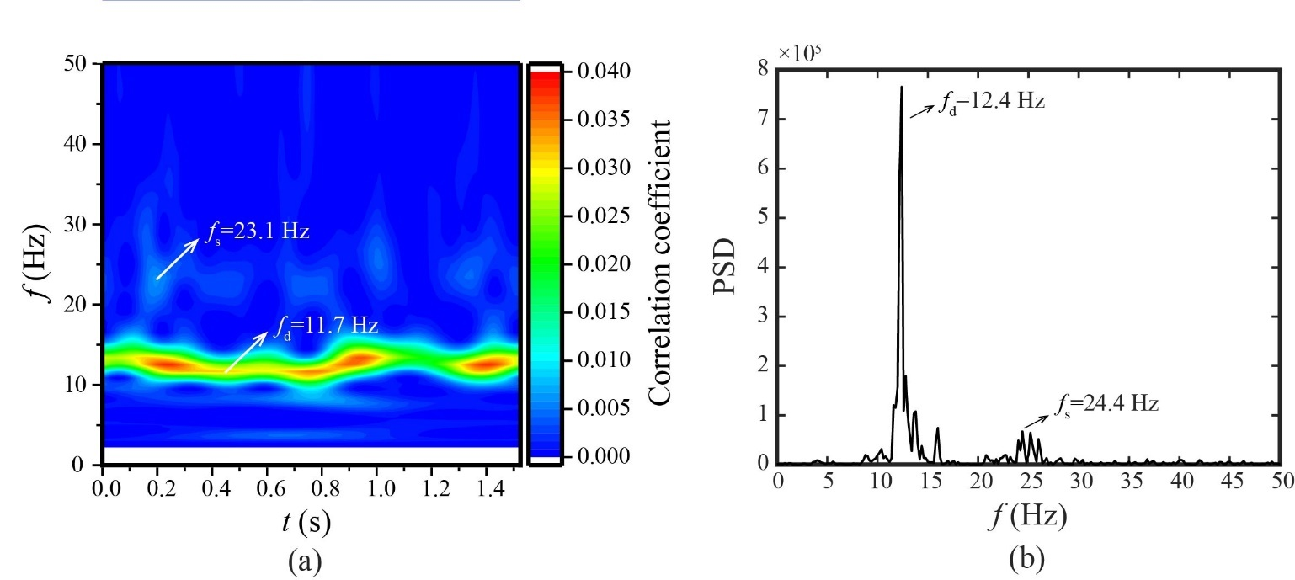
FIG. S10 Spectral contents of cavitating flows calculated by (a) wavelet analysis based on cavity volume obtained from experimentally observed images and (b) wall-pressure fluctuations on pressure transducer #2 (x/H=0.37) calculated by FFT for σ=0.75 at U_{t}=8.3 m/s, Re=7.8×10⁵ under the reentrant jet dominant cloud cavity shedding mechanism.

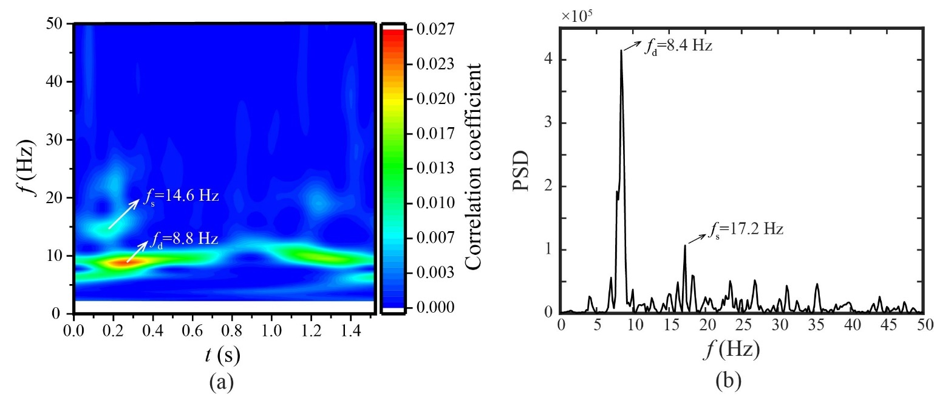
FIG. S11 Spectral contents of cavitating flows calculated by (a) wavelet analysis based on cavity volume obtained from experimentally observed images and (b) wall-pressure fluctuations on pressure transducer #2 (x/H=0.37) calculated by FFT σ=0.71 at U_{t}=8.3 m/s, Re=7.8×10⁵ under the shockwave dominant cloud cavity shedding mechanism.

FIG. S12 Distribution of temporally average gray level variance during 1.5 s based on experimentally observed images for (a) σ=1.11, (b) σ=0.85, (c) σ=0.75 and (d) σ=0.71 at U_{t}=8.3 m/s, Re=7.8×10⁵. Vertical dashed lines show the locations of four pressure transducers, respectively. White lines ($\hat{g}$=15) indicate the mean cavity outlines used to determine the mean cavity length (L_{c}).

To quantitatively analyze the cavity structures and dynamics, Fig. S12 shows the time-average cavitation fields corresponding to the observations in Fig. S4 ~ Fig. S7. The mean cavity structures in Fig. S12 are calculated using the standard deviation of gray level values at each pixel based on the normalized gray level function defined in Eq. (S1), where high gray level value indicates large vapor fraction. As shown in Fig. S12, independent of the transient cavity behaviors, the mean cavity structure presents the semi-ellipse shape for all cavity regimes, i.e., inception cavitation, sheet cavitation, reentrant jet dominated cloud cavitation and shockwave dominated cavitation. This mean cavity shape is in accord with the x-ray densitometry observations by Ganesh et al. ¹⁷ A large portion of high void fraction regions indicated by the black arrows are shown in the center of the cavity. With increasing σ, the cavitation region extends further downstream with the size (length, thickness) of cavity increase. At inception cavitation in Fig. S13 (a), the cavity length is at the transducer #2, where the transducer #1 and #2 are inside the cavity, and transducer #3 and #4 are outside the cavity. At sheet cavitation in Fig. S13 (b), the cavity length just locates at the transducer #4, showing all the transducers are inside the cavity. At cloud cavitation for both reentrant jet and shock wave mechanisms in Fig. S13 (c) and Fig. S13 (d), all the four transducers are inside the cavity. Moreover, all the transducers are beneath the high vapor fraction region. This mean cavity structure shows that the statistics of the cavitation flow fields have the self-similarity independent of cavity regimes, especially inside the cavitation region.

FIG. S13 High order moments of the gray level variance (×-times) and the corresponding pressure fluctuations (ᵒ-circle) at four pressure transducer locations as a function of normalized distance (ξ/L_{c}) for (a) standard deviation values (Std), (b) kurtosis values (Ku) and (c) skewness values (Sk). Note that the shadow region indicates cavitation region.

To quantitatively analyze the statistics of cavitation flow structures, Fig. S13 presents the high-order moments distribution calculated from both gray level variance and wall-pressure fluctuations as a function of ξ/L_{c} for all the cavity regimes with 16 data points in total. It is found that inside the cavity, the statistics of gray level variance and wall-pressure fluctuations show the similar trend. Both the standard deviations of gray level variance and wall-pressure fluctuations arrive their maximum value near cavity closure at ξ/L_{c}=1. Ku>3 for both gray level variance and wall-pressure fluctuations is observed, showing the non-Gaussian behaviors of these parameters. Moreover, the Sk>0 is observed, showing the positive skewness, which is in accord to the PDFs shapes in Fig. 19. However, Sk<0 is also observed for the skewness values obtained from the gray level variance at around ξ/L_{c}=0.4, showing there could be discrepancy between the wall-pressure fluctuations and cavity structures. And this negative skewness (Sk<0) is only observed in cloud cavitation with shockwave mechanism. It is worth noting that owing to the rare cavity structures outside cavity, the wall-pressure fluctuations is mainly influenced by the pure liquid flows, not the cavity structures, and thus the statistics of gray level variance outside cavity show significant discrepancies from that of the wall-pressure fluctuations. Furthermore, Fig. S14 presents the 3D evolution of the Sk and Ku along the streamwise direction as a function of σ including different cavity regimes (i.e., inception cavity, sheet cavity, cloud cavity with reentrant jet mechanism and cloud cavitation with shockwave mechanism). In general, low Ku and Sk values are observed inside the cavitation region. Interestingly, a negative skewness around 0.1~0.2 L_{c}/H is also observed in the flow conditions under cloud cavitation with shockwave mechanism which is consistent with the calculations in Fig. S13 under shockwave mechanism. This negative Sk could be related with the shockwave induced cavity collapses, which causes the local void fraction reduction. The physics responsible for the differences in the PDF features in cloud cavitation with reentrant jet mechanism and shockwave mechanism could be related with the interactions between the cavity structures and shockwave/reentrant jet where there exist complex physics, i.e., shockwave/cavity interactions, mass transfer., the mechanism of which requires further investigation.

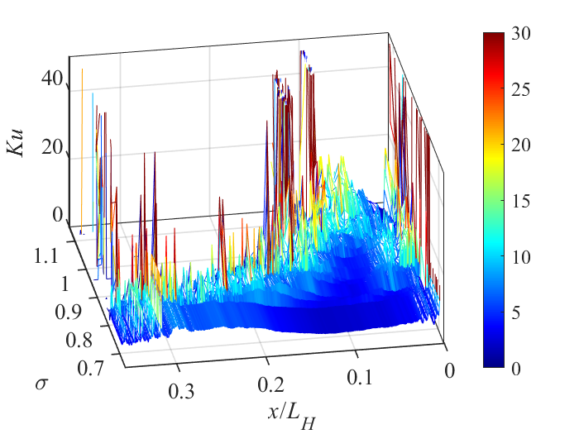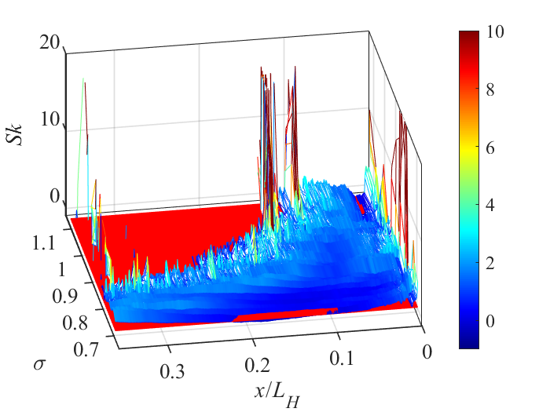
Cavitation region
σ
Cavitation region
ξ/L_{H}
Cavitation region
Sk=0
SW
σ

ξ/L_{H}
(a) | (b)
FIG. S14 3D evolution of (a) Ku and (b) Sk distribution along the streamwise direction based on gray level variances extracted from cavitation images as a function of σ.

References:
S1. I. Bilus, G. Bombek, M. Hocevar, et al., “The experimental analysis of cavitating structure fluctuations and pressure pulsations in the cavitation station,” J. Mech. Eng. 60 (3): 147–157 (2014).
S2. C. Wang, B. Huang, G. Wang, et al., “Unsteady pressure fluctuation characteristics in the process of breakup and shedding of sheet/cloud cavitation,” Int. J. Heat Mass Trans, 114: 769-785 (2017).
S3. J.L. Lumley, ‘‘The structure of inhomogeneous turbulent flows,’’ In Atmospheric Turbulence and Radio Wave Propagation, edited by A. M. Yaglom and V.I. Tararskym, Nauka, Moscow, 166–178 (1967).
S4. P.J. Schmid, “Dynamic mode decomposition of numerical and experimental data,” J. Fluid Mech. 656: 5-28 (2010).
S5. L. Sirovich, ‘‘Turbulence and the dynamics of coherent structures. Part III: Dynamics and scaling,’’ Q. Appl. Math. 45, 583 (1987).
S6. C.O. Iyer & S.L. Ceccio, “The influence of developed cavitation on the flow of a turbulent shear layer,” Phys. Fluids 14: 3414-3431 (2002).
S7. H. Ganesh, J. Schot & S.L. Ceccio, “Stationary cavitation bubbles forming on a delta wing vortex,” Phys. Fluids 26: 127102 (2014).
S8. C. Wang, Q. Wu, B. Huang, et al., “Numerical investigation of cavitation vortex dynamics in unsteady cavitating flow with shock wave propagation,” Ocean Eng. 156: 424-434 (2018).
S9. C. Wang, G. Wang & B. Huang, “Dynamics of unsteady compressible cavitating flows associated with the cavity shedding,” Ocean Eng. 209: 107025 (2020).
S10. J. Wu, L. Deijlen, A. Bhatt, et al., “Cavitation dynamics and vortex shedding in the wake of a bluff body,” J. Fluid Mech. 917: A26 (2021).
S11. A. Teolis, “Computational Signal Processing with Wavelets,” Applied and Numerical Harmonic Analysis, 85 (5): 358–362 (1998).

