**Experimental Investigation of Performance of High Shear Atomizer with Discrete Radial-Jet Fuel Nozzle: Mean and Dynamic Characteristics**

Sonu Kumar a, Darshan D Rathod a, Saptarshi Basu a, b*

a Interdisciplinary Centre for Energy Research, Indian Institute of Science,

Bangalore-560012

b Mechanical Engineering, Indian Institute of Science, Bangalore-560012

*\*Corresponding author - sbasu@iisc.ac.in*

# **Supplementary Materials**

# **S1**. **Introduction**

The high shear atomizer consists of multiple radial or axial air swirlers (known as swirl cup) and fuel nozzles. The swirlers are usually named as primary swirler, secondary swirler and so on. The fuel atomization and mixing with an oxidizer in such atomizers totally depends upon the air swirlers. Different types of fuel nozzle like simplex pressure-swirl nozzle, duplex nozzle and discrete jet fuel nozzle, as shown in **Figure S1**, are used with such atomizers. The fuel nozzle injects the fuel on the pre-filming surface of the swirler and forms a thin film of liquid which gets sheared by the highly turbulent swirling air. Liquid at the exit of the prefilter further undergoes atomization by swirling air issuing from the secondary swirler and subsequently forms an air-fuel mixture. This mixture enters the combustor dome by passing through a diverging section known as a flare. The complex aerodynamic nature and presence of two-phase flow make it a challenging task to understand the liquid atomization process inside the swirl cup.

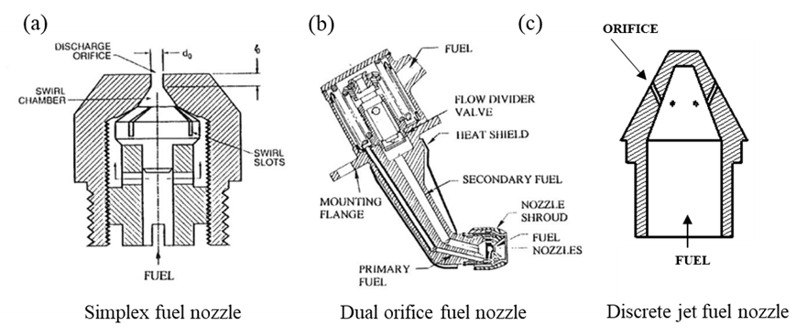

**Figure S1:** Schematic of different types of fuel nozzle, a) simplex pressure-swirl fuel nozzle, b) Dual orifice (duplex) fuel nozzle (Lefebvre 2000) and c) discrete jet fuel nozzle.

The swirl cup of atomizer employed in the present study is a common form that finds application in the gas turbine combustion engines (Wang et al., 2005)(Xiao & Huang, 2016). The geometrical specification of the atomizer is given in **Table S1**. The primary swirler is kept at a high swirl with an increased air flow rate compared to the secondary to enhance atomization and fuel-air mixing. Besides this, the larger diameter of prefilmer at the beginning provides enough surface area and time to achieve relatively uniform film thickness before the film reaches the lip of the prefilmer.

**Table S1:** Atomizer detail of the base case**.**

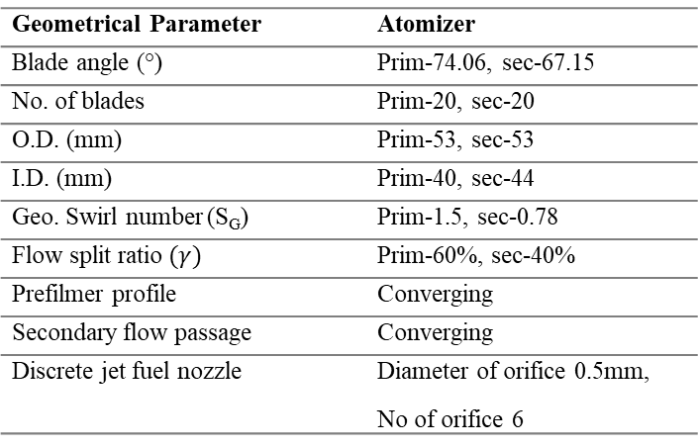

## 

## **S 2. Experimental Methodology**

S 2.*1 High shear atomizer design and description*

The swirl cup is a compound radial entry swirler with vanes. The swirlers are named as primary and secondary swirlers. The primary swirler is connected with a converging passage known as prefilmer/venturi. The prefilmer converges to achieve a more uniform film thickness around the periphery of the lip of the venturi. The fuel nozzle plugged concentrically into the swirler has six holes to inject the fuel onto the surface of the prefilmer. The orifice diameter of the fuel nozzle is 0.5 mm each. Air entering the primary swirler receives the swirl momentum, which interacts with liquid jets and promotes the formation of a liquid film on the surface of prefilmer. At the lip of the prefilmer, a non-uniform liquid rim usually undergoes intense shearing action from both sides by the primary and secondary swirling flow and subsequently gets atomized. The mixture of air droplets exits through a diverging component known as flare, at the exit of the swirl cup.

The geometric swirl number is derived from the empirical formula (Sheen et al., 1996) given in equation 2. This is analogous to the swirl number(Gupta et al., 1984) given by equation 1, which is the ratio between the axial flux of azimuthal momentum and axial flux of axial momentum divided by a characteristic length scale.

$$\begin{aligned}SN= \frac{\int_{0}^{R_{o}}{{ρU}_{y} U_{θ} 2πr^{2} dr}}{R\int_{0}^{R_{o}}{{{ρU}^{2}}_{y}} 2πr dr}\#\left(1\right)\end{aligned}$$

Where R is the characteristic radius, $R_{o}$ is the outer radius of flow at the location, $U_{y}$ is axial velocity, $U_{θ}$ is tangential velocity.

$$\begin{aligned}{SN}_{geo}= 0.28.\left( \frac{1}{1-β}\right).\left(\frac{\tan{∅}}{1+\tan{∅}.\tan\left(π/N\right)}\right)\#\left(2\right)\end{aligned}$$

where, $∅$ is the swirler vane angle; $N$ is the number of vanes; $β$ is the blockage factor.

Blockage factor ($β$) can be written as

$$\begin{aligned}β=\frac{N.t}{2.π.R_{inner}.\cos{∅}}\#\left(3\right)\end{aligned}$$

Where, $t$ is vane/blade thickness (mm); $R_{inner}$ is the swirler inner radius

**Table S2**: Geometrical parameters of various swirl-cup.



The high shear atomizer employed in the present study combines a discrete radial jet fuel nozzle and a swirl cup. The design parameters of the swirl cup considered in the present study are listed below:

1. Split ratio ($γ$)
2. Mixing length ($η$)
3. Flare exit angle ($θ$)
4. Swirler configuration: Co- Rotation (COR) & Counter-Rotation (CR).

The first parameter, split-ratio, is defined as the ratio of the primary swirler inlet area to that of the secondary swirler inlet area. The split ratio determines the flow rate of the air passing through both primary and secondary swirlers. The second and third parameters belong to the flare. Mixing length is a linear section over which the primary air and secondary air initially get merged before expanding by the flare's diverging section. The Flare exit angle is angle of the diverging section of the flare. Swirl configuration represents the relative swirl direction or vane orientation of the primary and secondary swirlers. The opposite sense of rotation is called counter-rotation, while the same sense of rotation is called co-rotation swirl configuration. It should be noted here that the fuel nozzle is kept unchanged across the test cases.

## S *2.2.* *Experimental set-up*

The experiments were conducted in an open chamber at ambient temperature and pressure conditions. The experimental set-up utilized to conduct experiments is shown in **Figure S2**. The set-up consists of an air plenum and a liquid pipeline at the center of the plenum. The high shear atomizer was connected at one end of the air plenum. The plenum was connected with a high-pressure compressed air line to deliver the air through atomizers. A mass flow controller (Alicat made MCR series with accuracy ±0.8% of displayed reading + 0.2% of full scale) was employed to control the air flow rate through the atomizer. A liquid supply pipeline attached with fuel nozzle was housed concentrically to the atomizer. Water was utilized as a substitute for hydrocarbon fuel. The water delivery unit contains a water tank connected with a centrifugal pump, inline rotameter (Telelin-made) and inline filter. The rotameter had a measuring range of 0-0.5 lpm. The flow rate of water was calibrated up to ~ ±1 mlpm through the collection method. The set-up had a provision to interchange the atomizer. Furthermore, the relative position of the fuel nozzle with respect to the venturi exit was kept unchanged. The fuel nozzle had six holes at a certain angle to the nozzle axis. The flow rates of air and water were 3000 slpm and 250 mlpm, respectively for all the cases. The experiments were performed with spray for all the cases and for a few cases with seeded air only. The seeding unit was disconnected from the main unit while experimenting with spray. Diagnostic techniques such as high-speed PIV, phase doppler interferometry (PDI), and mechanical patternator were employed to capture the relevant information.

## *2.3 High-Speed PIV*

The instantaneous flow field of the spray were captured by employing nonintrusive measuring techniques known as particle image velocimetry (PIV). The PIV system consists of a Photonics Ind. made dual-pulsed high-speed laser (ND: YAG, 532nm, 30mJ) having an acquisition frequency of 10kHZ in single pulse mode and a Photron-made SA-5 high-speed camera. A combination of optics was used to convert the cylindrical laser beam into a thin sheet (~1mm) to illuminate the field of interest. The camera was positioned in such a way that the optical axis of the camera lens (Tokino lens f = -100mm) lies orthogonal to the laser sheet. A programmable tuning unit was used to synchronize the laser and camera. The raw Mie-scattered instantaneous images were captured in dual frame mode at an acquisition rate of 3.5 kHz, corresponding to 2000 raw images for approximately 0.57 sec. A field of view of 110mm x 110mm with a camera sensor resolution of 1024 X 1024 pixels provided a spatial resolution of ~9 px/mm. The raw instantaneous images were processed using LaVision DaVis software version 8.4. The post-process steps to construct vector field were cross-correlation technique and multi-pass decreasing window size. Initial interrogation window (IW) size of 64 x 64 pixels and final IW size of 48 x 48 pixels with 50 % overlap in each pass. An adaptive PIV cross-correlation method was used to improve the spatial resolutions of vectors. The uncertainties in the velocity values were calculated using the correlation statistics method (Wieneke, 2015), and in the present study, it is found to be ±1-2 % of the local velocity value. Further, the spurious vectors present in the data were removed by using a median filter.



**Figure S2:** Illustration of experimental set-up

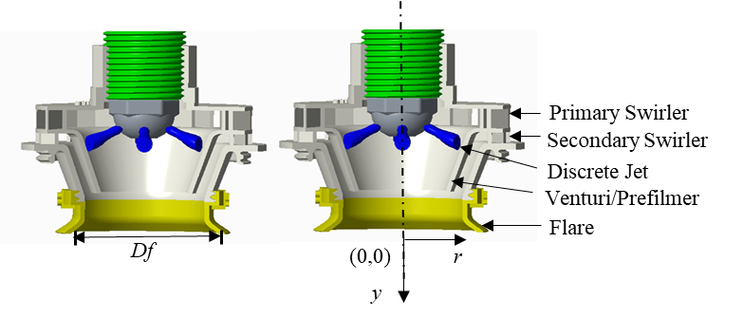

**Figure S3:** Illustration of high shear injector characteristics length and origin. Note: Origin is taken at 2 mm down from the flare exit.

In the present experiment, while doing spray PIV, droplets generated in the spray were used as a scattering medium in a longitudinal plane, and no seeding particles were introduced into the air. **Figure S5** shows PDF and cumulative sum of the droplets size distribution of the spray at the center and edge for one case, respectively. The peak of the droplet size count is around 7micronmeter at the centre and 9-micron meters at the spray edge. The cumulative sum plot (green line) shows that majority of droplet (~80%) have sizes less than 13 µm. Consequently, the calculated maximum value of stokes number is found to be within 0.8 for a major spray droplet population. Further, the flow fields obtained with the alumina particles with a diameter of approximately ~2-3 µm seeded as tracers in air and with the droplets exhibit similar flow topology, (see **Figure S4** ), indicate that the tracing accuracy of spray droplets is comparable in comparison to the seeding particles and the spray flow field closely follow the true air flow field. This is due to the extremely small size of most droplets (~5-12µm) generated by the high shear injectors.

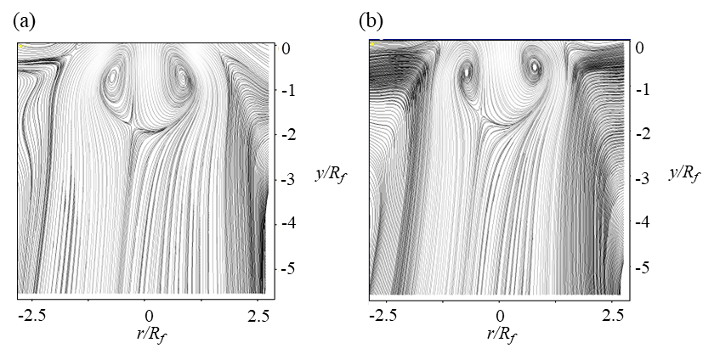

**Figure S4:** Illustration of streamlines of the flow field with a) with spray, b) with alumina seeded air.

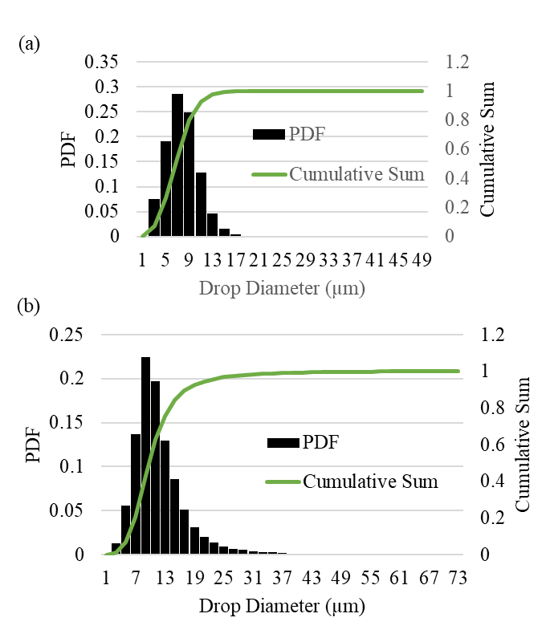

**Figure S5:** Droplet size distribution at; a) centre, b) edge of the spray.

## *2.4 Phase Doppler Interferometry*

The droplet size distribution and its three components of velocity were measured by utilizing a 3D PDI (Artium-made) system. The two transmitters and a receiver were mounted on an automated computer-controlled traverse system with three-axis movement. One transmitter was equipped with two laser beam pairs with wavelengths of 532 nm and 473 nm. The other transmitter was equipped with a 561nm wavelength laser beam. Optics with a focal length of 750mm were mounted on both transmitters and a receiver. The forward off scattering mode of the PDI technique was employed to record the information. Both the transmitters were aligned at 30 degrees to the central axis of the intersection of the laser beams to capture the maximum Mie-scattered light as shown in **Figure S6** a. The intersection point of the laser beam was considered as the probe location. The signal-to-noise ratio (SNR) of the sample data was monitored using an oscilloscope connected with the PDI acquisition unit. The measured SNR was maintained above 85% at all locations. Further the phase validation rate was above 89 percent. The data were recorded for 30 seconds providing sufficient data points (>90000, in general) for meaningful statistical calculation of droplet size. The uncertainty in droplet diameter size measurement is 0.5µm. Further care has taken that base plate which was 30 mm upstream from the flare exit remain clean to avoid crossing of any large drop from the surface to probe region.

The longitudinal mid-plane passing through the center of the atomizer was divided into grids that acted as sampling locations of the spray to measure the droplet size and their velocity components. The sampling location started at 5 mm (*y/Rf* =0.25) downstream of the flare exit and extended up to 50 mm (*y/Rf* = 2.5) along the axis of the atomizer. The interval between the second row onward is 10mm (*y/Rf* =0.5) in the axial direction. Sampling in the radial direction starts from the central axis (*r/Rf* =0) and goes to the spray's edge at intervals of 10mm (*r/Rf* =0.5) see **Figure S6** b. The PDI set-up was mounted on a computer-controlled 3-axis movement traverse unit such that the probe location could be moved precisely. For a given axial position, the measurements in the radial direction are carried out till a significant decrease in data rate is observed (edge or boundary of the spray). This radial position of the edge of the spray varies from case to case depending upon the size of CTRZ.



**Figure S6:** a)Representation of PDI set up and b) drop measurement locations .

## *S 2.5 Spray patternation*

The spray patternation to measure the azimuthal volume distribution in spray was carried out using a mechanical patternator, see **Figure S7**. The patternator consisted of a 12 x 12 grid of cells with a cell size of 20mm x 20mm x 50mm. A 45-degree chamfer was made on the edges of each cell to minimize the bouncing back of the droplet after impact. Each cell was connected to a measuring cylinder (with an accuracy of 0.2 ml) via a silicon tube. The spray volume was collected for 10 minutes in each cylinder using a stopwatch. The total volume collected in 10 minutes was divided by the total volume of sprayed liquid to calculate the collection efficiency (see equation 4). The total volume of liquid sprayed was computed using the liquid flow rate (250 mlpm).

$$\begin{aligned}Collection efficiency =\frac{actual volume collected }{total volume sprayed}\#\left(4\right)\end{aligned}$$

The collection efficiency recorded lies in the range of ~ 60-70 percent.



**Figure S7:** Illustration of mechanical patternator grid and methodology.

## *S 2.6 Flow parameters and test conditions*

In addition to the geometric swirl number of both swirlers, Reynolds number is also calculated as given in **Table S3**. Reynolds numbers of primary and secondary swirler Reynolds number $\{{\left(Re\right)}_{P },{\left(Re\right)}_{S }\}$ are evaluated using equations given in literatures (Kumar.et al., 2020) (Rajamanickam et al., 2019)**.**

**Table S3: Experimental test cases.**

|  |  |  |  |  |  |  |  |
| --- | --- | --- | --- | --- | --- | --- | --- |
| Test cases | Configuration | (*SN5*) |  | | [x10^5]  ±1% | [x10^5]  ±1% | *MR* (for a single jet)  ±2.8% |
| ***W/Df*** | ***L/Df*** |
| C1 | *(BASE, γ=60:40*  *Θ=50°, η=0mm)* | 0.66 | 0.835 | 1.045 | 0.264 | 0.261 | 3346.1 |
| C2 | *(CR, γ=50:50*  *Θ=50°, η=0mm)* | 0.66 | 0.997 | 1.249 | 0.253 | 0.290 | 3346.1 |
| C3 | *(CR, γ=40:60*  *Θ=50°, η=0mm)* | 0.74 | 1.230 | 1.642 | 0.238 | 0.314 | 3346.1 |
| C4 | *(CR, γ=60:40 Θ=45°,η=5mm)* | 0.51 | 0.613 | 0.735 | 0.264 | 0.261 | 3346.1 |
| C5 | *(CR, γ=60:40 Θ=50°, η=5mm)* | 0.31 | 0.511 | 0.571 | 0.264 | 0.261 | 3346.1 |
| C6 | *(COR, γ=60:40 Θ=50°, η=0mm)* | 0.89 | 0.778 | 2.6832 | 0.264 | 0.261 | 3346.1 |
| C7 | *(COR, γ=60:40 Θ=45°, η=5mm)* | 0.67 | 0.605 | 2.183 | 0.264 | 0.261 | 3346.1 |
| C8 | *(COR, γ=60:40 Θ=50°, η=5mm)* | 0.65 | 0.551 | 2.069 | 0.264 | 0.261 | 3346.1 |

**S3. Results and discussion**

*S3.1 Global flow field*

The experimental test case is given in Table S3. Further, the relationship between axial *W/Df* and radial length *L/Df* scales with swirl number *SN5* for the counter and co-rotational configuration cases is shown in **Figure S8**. It shows that with the increase in swirl number, the *W/Df* and *L/Df* increase and are linearly varied with swirl number. As discussed in the main manuscript, **Figure S8** clearly shows that by switching from counter- rotation (C1) to co- rotation (C6), swirl number increases; however, radial length (*W/Df*) does not alter noticeably. This trend with discrete radial jet matches the atomizer housing the simplex pressure-swirl fuel nozzle reported in our previous literature (Kumar et al., 2020).

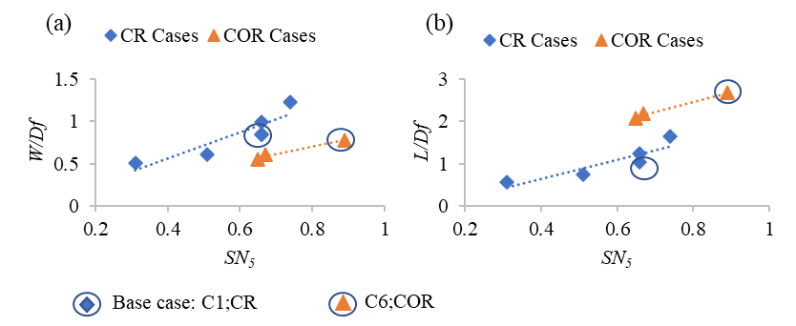

**Figure S8:** Functional relationship of radial (W/Df) and axial length scale (L/Df) of CTRZ with swirl number.

*S3.2 Droplet size distribution*

The volume flux distribution across all the test cases at various axial and radial positions for ALR ~14.1 and ALR 4-10 are shown in **Figure S9** and **Figure S10**, respectively.

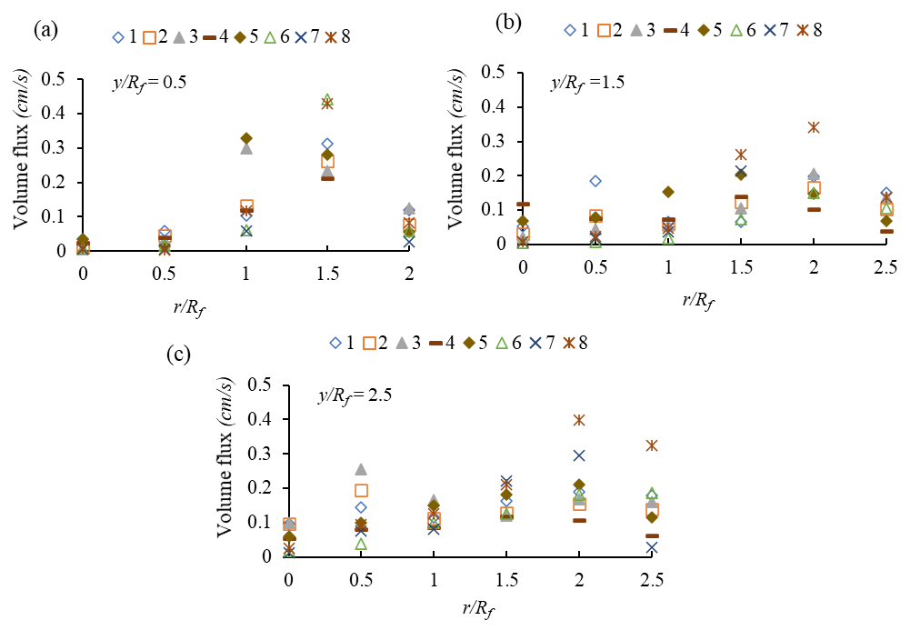

**Figure S9:** Volume flux at ALR ~14.1 across all the test cases C1:C8 for axial positions; a) y/Rf =0.5, b) y/Rf =1.5 and c) y/Rf =2.5.

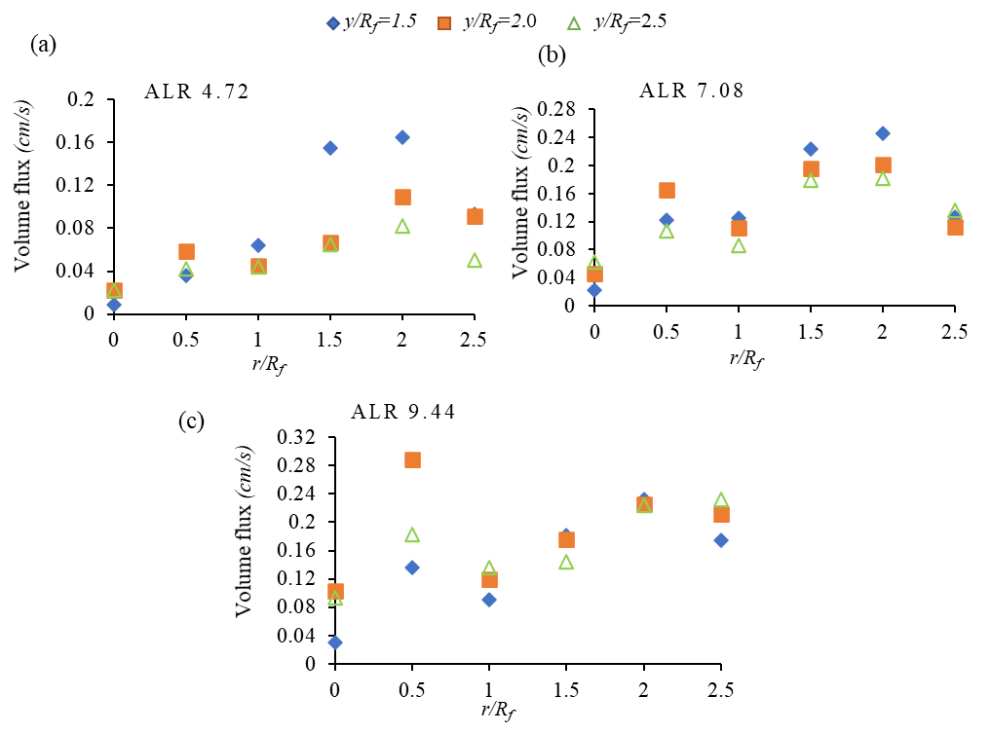

**Figure S10**: Volume flux at for base case C1 at axial positions, y/Rf =0.5, y/Rf =1.5, y/Rf =2.5 for a) ALR ~ 4.72, b) ALR ~7.08 and c) ALR ~9.44.

The GSMD value of all the test cases at ALR ~14.1 is given in **Table S4,** and for the case C1 at various ALR is given in **Table S5.**

**Table S4:** GSMD for all the cases at a ALR ~14.1

|  |  |  |  |  |  |  |  |  |
| --- | --- | --- | --- | --- | --- | --- | --- | --- |
|  | GSMD (µm) @ ALR ~14.1 | | | | | | | |
| y/d | C1 | C2 | C3 | C4 | C5 | C6 | C7 | C8 |
| 1.65 | 18.72 | 17.95 | 19.43 | 14.78 | 19.47 | 18.97 | 15.95 | 21.20 |
| 2.09 | 19.36 | 19.06 | 18.52 | 17.82 | 20.67 | 16.15 | 17.30 | 20.76 |
| 2.52 | 20.3 | 18.42 | 16.24 | 17.46 | 21.27 | 16.56 | 16.45 | 20.82 |

**Table S5:** GSMD at various ALR for case C1.

|  |  |  |  |  |
| --- | --- | --- | --- | --- |
| Case C1 | GSMD (µm) | | | |
|  | ALR | | | |
| y/d | ~4.72 | ~7.08 | ~9.44 | ~14.1 |
| 1.65 | 65.4983 | 38.2098 | 24.1609 | 18.72 |
| 2.09 | 55.9066 | 32.7636 | 22.8921 | 19.36 |
| 2.52 | 48.3461 | 34.0345 | 25.1909 | 20.3 |

*S3.3 Spray patternation*

Before conducting the patternation, the flow rate through each orifice is measured to determine the inherent discrepancies due to manufacturing capability. The nozzle has six holes at an equal angle in the azimuthal plane. The standard deviation among the orifices is 7.44 %, as given in **Table S6.**

**Table S6**: Liquid flow distribution across the six holes of the discrete radial-jet fuel nozzle.

|  |  |  |  |  |  |
| --- | --- | --- | --- | --- | --- |
|  | No. of readings | | |  |  |
| Nozzle holes | 1 (% of total flow) | 2 (% of total flow) | 3(% of total flow) | Mean of readings | Std. Dev. |
| 1 | 18.08 | 18.24 | 18.12 | 18.15 | 0.08 |
| 2 | 15.63 | 16.09 | 15.57 | 15.76 | 0.29 |
| 3 | 17.70 | 17.81 | 17.48 | 17.67 | 0.17 |
| 4 | 15.07 | 14.81 | 14.93 | 14.93 | 0.13 |
| 5 | 18.08 | 17.60 | 17.70 | 17.79 | 0.25 |
| 6 | 15.44 | 15.45 | 16.20 | 15.70 | 0.44 |
| Total | 100 | 100 | 100 | 100 |  |
| Mean | 16.67 | 16.67 | 16.67 | 16.67 |  |
| Std. Dev | 1.30 | 1.29 | 1.18 | 1.24 |  |
| % Std. Dev. w.r.t Mean | 7.82 | 7.71 | 7.06 | 7.44 |  |

# **S4. Spray Patternation and Calculations**

The patternator employed to collect the spray is an array of size 12 by 12 cells as represented in **Figure S11**. The volume of liquid passing through each square cell was collected in respected measuring cylinders connected to each cell. To calculate the spray symmetry quantitatively, each cell was given a position value x and y. Further calculations are explained below:

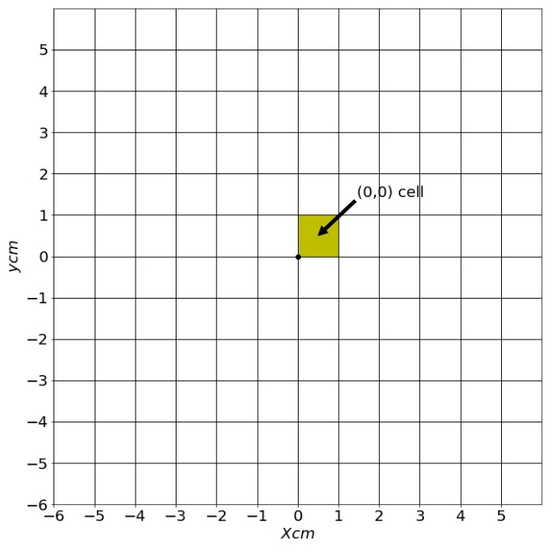

**Figure S11: Representation of patternation cell as cell matrix**

The cell location x, y is at the lower left of the cell. The volume collected in each cell is recorded.

$q_{x,y}$ = Volume of spray collected in x, y cell; from $x$ = -6 to 5 and y = -6 to 5

The volume collected in each cell is divided by the total volume of spray collected to get the normalized volume.

$$\begin{aligned}q_{total}= \sum_{x,y}{q_{x,y}} \#\left(14\right)\end{aligned}$$

$$\begin{aligned}{\hat{q}}_{x,y}=\frac{q_{x,y}}{q_{total}}\#\left(15\right)\end{aligned}$$

${\hat{q}}_{x,y}$ = normalized volume of spray collected in x, y cell

$\sum_{x,y}{ }$ = sum over all x, y i.e., all cells.

The polar coordinate is a better choice to represent better the spatial distribution of spray in the azimuthal plane. For this, circular sectors are projected on cartesian coordinate as shown in **Figure S12** and ${\hat{q}}_{x,y}$ is converted into ${\hat{q}}_{r,θ}$ as given in below:

$$\begin{aligned}{\hat{q}}_{r,θ}=\sum_{x,y}{{\hat{q}}_{x,y}×M_{x,y}}\#\left(16\right)\end{aligned}$$

${\hat{q}}_{r,θ}$ = volume under sector at $θ \& Δθ, r \& Δr$.

$M_{x,y}$ = fractional area matrix, the calculation of which is shown below.

$M_{x,y}$ is obtained by finding the area intersection of x, y cell with the sector.

$$\begin{aligned}M_{x,y}=\frac{\left( intersecting area of sector and x,y cell\right)}{\left(area of x,y cell\right)}\#\left(17\right)\end{aligned}$$

Normalized volume flux through a given sector

$$\begin{aligned}{\hat{f}}_{r,θ}=\frac{{\hat{q}}_{r,θ}}{{\hat{Ar}}_{r,θ}}\#\left(18\right)\end{aligned}$$

Where, ${\hat{Ar}}_{r,θ}$ = area of sector

**Figure S12:** Illustration of projection of circular sector and cells.

Two approaches are better considered to represent the spatial azimuthal distribution of spray volume. First, sector-wise normalized fluxes are calculated to represent the azimuthal symmetry of spray dispersion. The circular region is subdivided into thirty-six sectors of the equal angle of 10o, see **Figure S13** for illustration. The sector flux of each sector is calculated by using equation 18. Further, the mean and standard deviation across all the sectors is calculated to represent the azimuthal symmetry. The percentage std. deviation about the mean is calculated by dividing the absolute std. dev. Value Over mean value as shown in equation 19

% Std. Dev = $\frac{Absolute Std. Dev.}{Mean value}*100$ $\left(19\right)$

= $\frac{1.1}{21}*100$

= 5.23

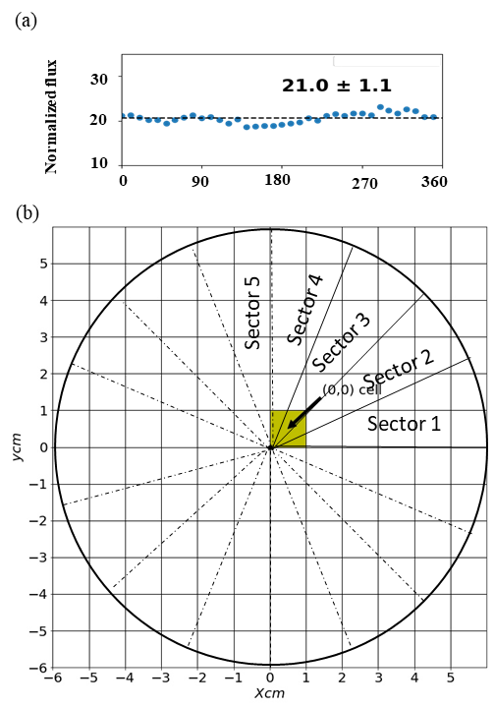



**Figure S13:** a) Sector-wise normalized flux b) Illustration of sector-wise normalized flux evaluation

Since the former way of representation does not reflect the local spray dispersion and symmetry, therefore in the second method, the local normalized spray volume flux variation in the radial direction and corresponding azimuthal symmetry at a given radial location is represented as shown in Figure **S14**.

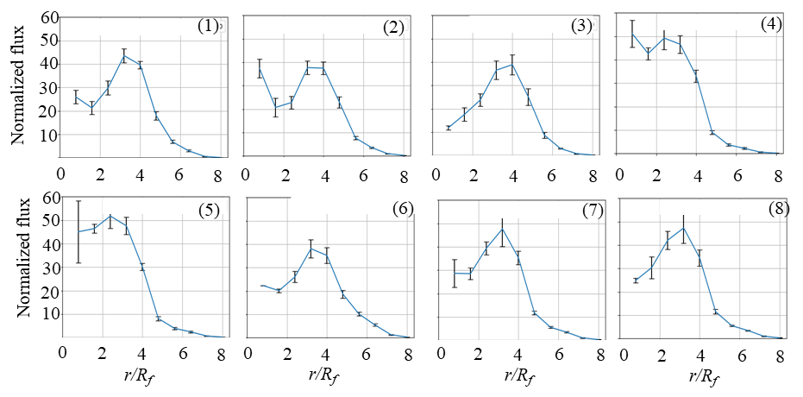

**Figure S14**: Spray volume/mass flux variation in the radial direction for 1) Base Case; $γ=60:40$, 2) $C2:γ=50:50$, 3)C3: $γ=40:60$ 4) C4: CR:Θ=45°, η=5, 5) C5: CR:Θ=50°, η=5, 6)C6: COR:Θ=50°, η=0, 7) C7: COR:Θ=45°, η=5 and 8) C8: COR:Θ=50°,η=5. The error bar shows the standard deviation in the azimuthal direction at the given radius.

The whole array of cells is subdivided into numbers of circular strips to calculate the local normalized volume flux at a given radius. For instance, as shown in **Figure S15**, the radial strip at radius **r**, shown in dark circles with delta r thickness, is selected and its volume flux, ${\hat{f}}_{r,θ}$, is calculated. To get the total value of the selected annular region, all the sector values are summed up. The radial strip is further subdivided into the thirty-six sectors to calculate local the azimuthal symmetry of this selected annular region, see **Figure S15**. The sector in blue color is normalized volume flux in one sector.

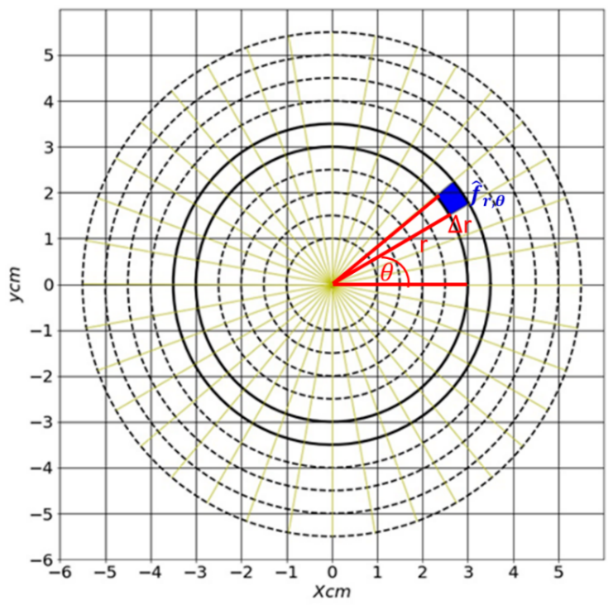

**Figure S15:** Illustration of evaluating the local flux in annular region at given radius.

# **S5. Series of stages to conduct the experiments**

The approach and various measurements to perform the current study are illustrated pictorially in **Figure S16**.



**Figure S16**: Illustration of the approach to conduct the experiment.

# **S6. Performance comparison of high shear atomizer housing simplex pressure-swirl fuel nozzle and discrete radial jet fuel nozzle**

The simplex pressure-swirl fuel nozzle is known to produce uniform azimuthal spray distribution associated with its hollow continuous film sheet, as shown in **Figure 1 a** (main manuscript). Whereas the discrete radial fuel jet nozzle has an inherent discontinuity in the azimuthal direction; see **Figure 1 b**. However, the proper performance of the simplex fuel nozzle is limited to a certain power range as mentioned in the introduction. The sheet gets collapsed beyond a certain value of discharge rate. This limitation is not associated with a discrete jet fuel nozzle. Hence, the high shear atomizer equipped with a discrete fuel nozzle has the potential to avoid this limitation related to the simplex fuel nozzle, but at the same time, the high shear atomizer mounted with a discrete fuel nozzle should be able to generate drop size and spray distribution close to that produced by high shear atomizer mounted with simplex fuel nozzle. In this section, we have compared the performance of high shear atomizer housing the discrete fuel nozzle and simplex fuel nozzle. As we know, the shear injector comprises a series of swirlers and a fuel nozzle. For comparison, the swirler is kept same and only the fuel nozzle is interchanged. The comparison is made at a single value of ALR~14.01. Spray characteristics like velocity profile, droplet size and spray distribution are shown in **Figure S17**. The streamline contours show similarity in the velocity field. However, the size of CTRZ, *W/Df* & *L/Df* is relatively smaller for the discrete jet fuel nozzle. On the other hand, droplet size variation in radial direction has a similar trend for both cases. However, the discrete jet fuel nozzle witnessed a slight droplet size increase. This change is within 5%, which could be considered negligible. Furthermore, the spatial distribution of spray volume in the azimuthal plane for the discrete jet is reasonably close to that for the simplex pressure swirl fuel nozzle. The percentage standard deviation for discrete jet and simplex fuel nozzle is within 5% of the mean.

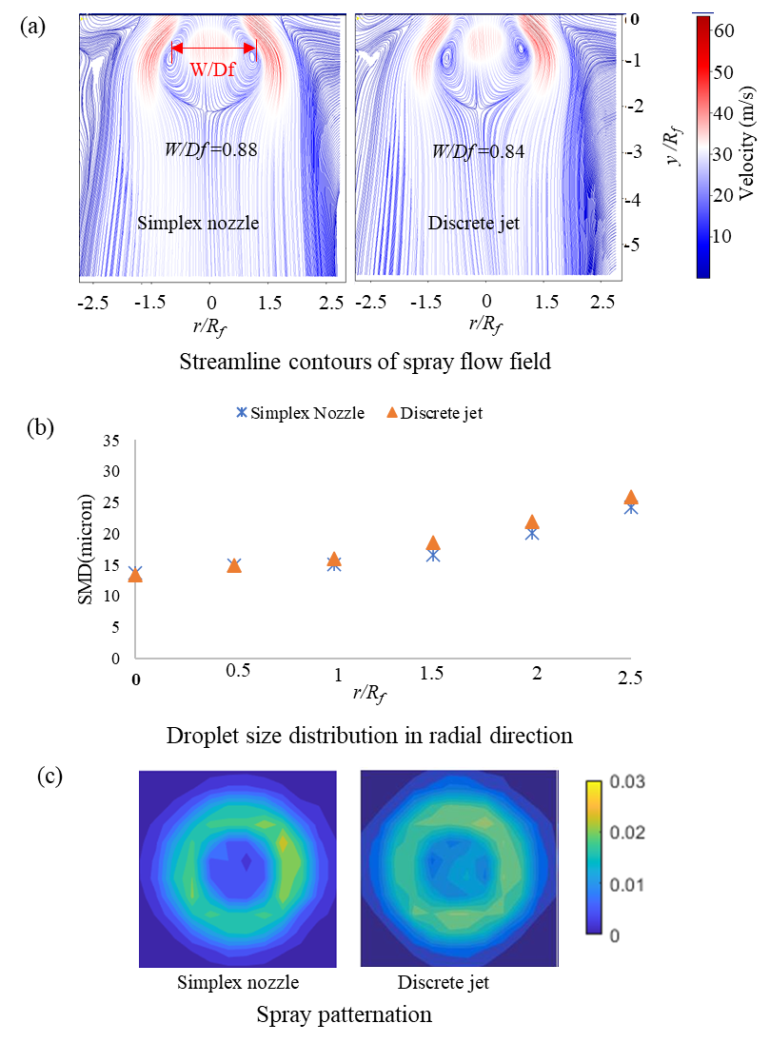

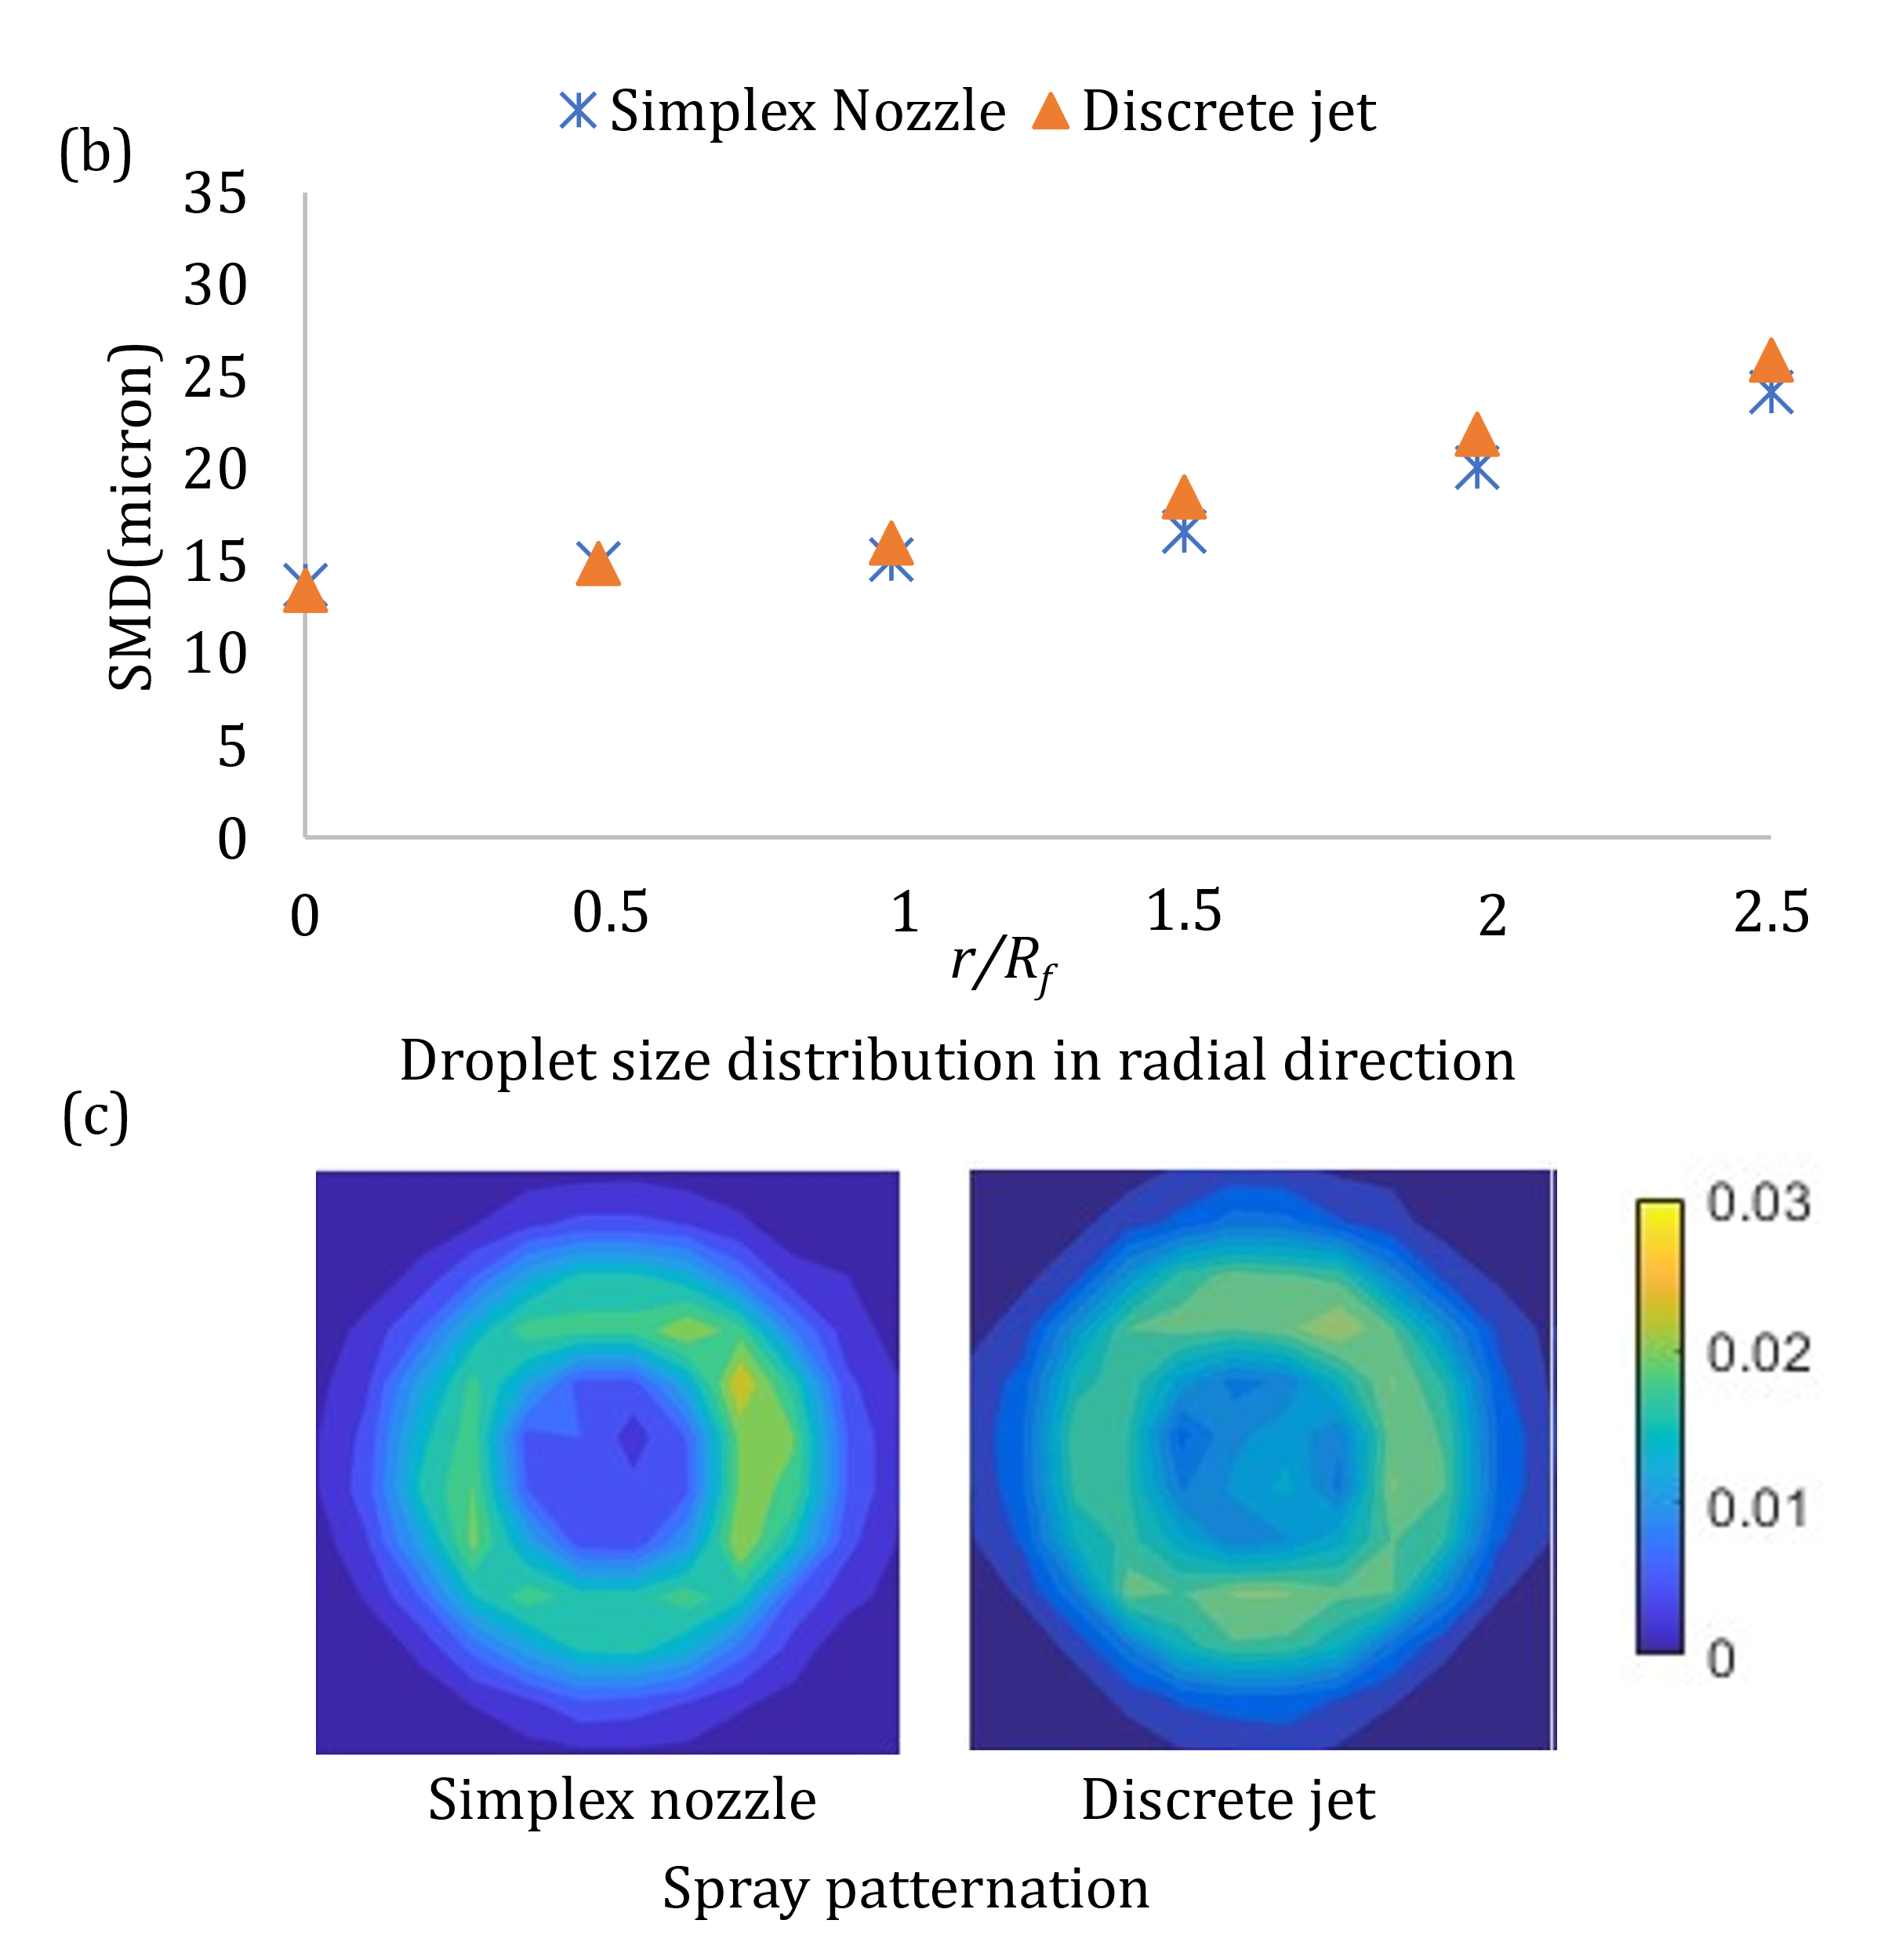

**Figure S17**: Comparison of spray characteristic of atomizer equipped with a simplex fuel nozzle and a discrete radial-jet fuel nozzle.

**References**

Gupta, A. K., Lilley, D. G., Syred, N., Gupta, A. K., Lilley, D. G., & Syred, N. (1984). Swirl flows. *Tw*.

Kumar, S., Malavalli, S., Chaudhuri, S., & Basu, S. (2020). Spray Characteristics and Flow Topologies of High Shear Injector at High Primary Swirl. *International Journal of Multiphase Flow*, *131*, 103393. https://doi.org/10.1016/j.ijmultiphaseflow.2020.103393

Rajamanickam, K., Potnis, A., Sakthi Kumar, K. R., Sivakumar, D., & Basu, S. (2019). On the influence of geometrical parameters on the spray characteristics of high shear injectors. *Experimental Thermal and Fluid Science*, *109*(July), 109872. https://doi.org/10.1016/j.expthermflusci.2019.109872

Sheen, H. J., Chen, W. J., Jeng, S. Y., & Huang, T. L. (1996). Correlation of Swirl Number for a Radial-Type Swirl Generator. *Experimental Thermal and Fluid Science*, *12*(4), 444–451. https://doi.org/10.1016/0894-1777(95)00135-2

Wang, S., Hsieh, S. Y., & Yang, V. (2005). Unsteady flow evolution in swirl injector with radial entry. I. Stationary conditions. *Physics of Fluids*, *17*(4). https://doi.org/10.1063/1.1874892

Wieneke, B. (2015). PIV uncertainty quantification from correlation statistics. *Measurement Science and Technology*, *26*(7). https://doi.org/10.1088/0957-0233/26/7/074002

Xiao, W., & Huang, Y. (2016). Lean blowout limits of a gas turbine combustor operated with aviation fuel and methane. *Heat and Mass Transfer/Waerme- Und Stoffuebertragung*, *52*(5), 1015–1024. https://doi.org/10.1007/s00231-015-1622-3