Supplementary Information
Fluidic Shaping of Optical Components
Valeri Frumkin and Moran Bercovici

Materials and Methods
Immersion liquid: The immersion liquid was prepared by mixing water with glycerol in varying concentrations. This combination allows to reach any density between 0.997 g/mL for water at room temperature, to 1.263 g/mL for pure glycerol. The precise density can be measured directly by weighing a known volume of the immersion liquid. The simplest way to verify neutral buoyancy conditions is by injecting a small volume of the lens liquid directly into the immersion liquid, without any bounding frame. If the immersion liquid is indeed at neutral buoyancy, the injected lens liquid will take the shape of a spherical drop and will remain stationary, without floating to the surface or sinking to the bottom.
Lens liquids and curing conditions: In principle, any curable liquid can be used to form a lens, provided that an appropriate immersion liquid can be identified. In this work, we demonstrate curing of PDMS (Sylgard 184, Dow, MI), and UV adhesive (NOA61, NOA63, NOA81, Norland, NJ) lenses. The PDMS lenses are cured by incubating them at 80 C for 1.5 hr, at 60 C for 4 hr, or at room temperature for 24 hr. The UV adhesive is cured by exposure to light at 365 nm (a 36 W consumer grade nail lamp) for 2-5 min, depending on the thickness of the lens and the specific adhesive chosen. Since both PDMS and Norland adhesives are immiscible in water and have densities between ~1.03 (PDMS) g/mL and ~1.12 g/mL (Norland), the water\glycerol-based immersion liquid allowed us to precisely control the density difference. Since preparation of PDMS involves intense mixing of the base resin with a cross-linker, we degassed the PDMS mixture for 20 minutes before injecting it into the bounding surface, in order to eliminate any bubbles trapped in the fluid due to the mixing.

Varying the shape of the bounding surface
Figure S1 presents a schematic illustration of several configuration of bounding surfaces used in this work. The central configuration considered here is that of a ring-shaped bounding surface (Fig S1a,b). For this shape allows to obtain convex, concave, and meniscus type spherical lenses, while for Bessel-shaped aspheric lenses can be obtained.
The fluidic shaping method can also be used to produce non-axisymmetric optical components. For example, a bounding surface in the shape of a rectangular pad with two sidewalls can be used to produce a cylindrical lens (Fig. S1c). The injected lens-liquid wets the pad and the sidewalls, and the boundary conditions are set by the pinning of the contact line at the edges of the pad. The cylindrical shape is obtained for the corresponding volume of the injected lens-liquid. If the injected volume is less than that required by for a cylindrical lens, the same boundary conditions result in a saddle (toroidal) lens. This is of course only a subset of the possible components achievable by this method and combining more general boundary conditions with variation of the Bond number, can produce a very wide range of optical shapes.

Surface roughness
Surface profile measurements were obtained using reflective digital holographic microscopy, (DHM-R, LynceeTec) with a 10X objective, of a spherical lens produced from NOA 81 UV adhesive. The measured profile shows excellent agreement with a least square fit of a circular section, with a maximum deviation of 15 nm over an area of 500x500 microns (Fig. S2). To obtain precise measurements of surface roughness we sent several samples for measurement by atomic force microscopy, and measured each at several locations. The measurements indicated roughness values of RMS=1.15 nm and Ra=0.84 nm for the best sample, and RMS=3.16 nm and Ra=1.89 nm for the worst ones. All measurements were performed over a 20x20 micron area.
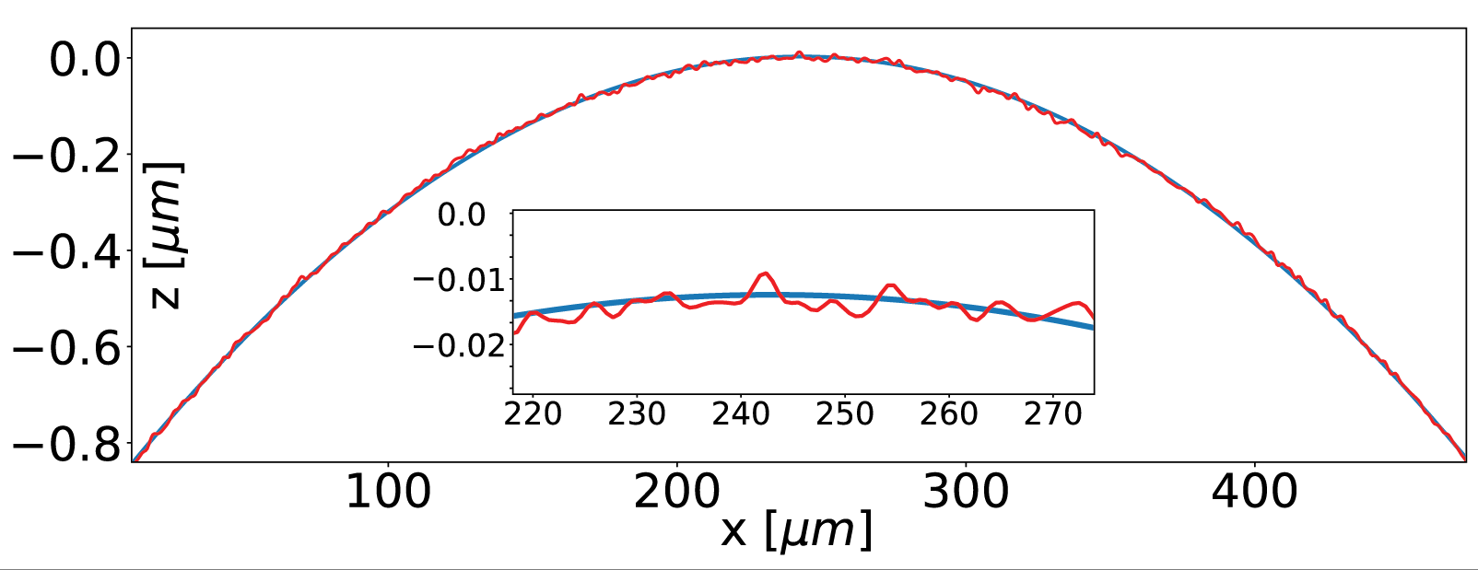

Fig. S1. A surface profile measurement of a spherical lens, obtained by reflective digital holographic microscopy (red), compared to a least square fit of a circular section (blue). The maximum deviation is 15 nm.

Supplementary Videos

Video S1. Injection of the lens liquid into a ring-shaped bounding frame.

Video S2. Simulations of spherical and meniscus-type lenses, for varying values of the lens volume and the enclosed volume.

Video S3. Simulations of Bessel-shaped aspheric lenses, for varying values of the Bond number and lens volume.

Video S4. Stability of Bessel-type aspheric lenses in their liquid form.

