Supplementary Information

Sulfur-mediated chalcogen versus hydrogen bonds in proteins:
a seesaw effect in the conformational space

Vishal Annasaheb Adhav¹, Sanket Satish Shelke¹, P. Balanarayan²,
Kayarat Saikrishnan^{1*}
¹Department of Biology, Indian Institute of Science Education and Research, Pune, 411008, India.
²Department of Chemical Sciences, Indian Institute of Science Education and Research, Mohali, 140306, India.

*Correspondence and requests for materials should be addressed to K.S. (email: saikrishnan@iiserpune.ac.in)

Figure S1. Definition of ζ along with some of the representative examples where ζ value was greater than 240° or less than 120°, which indicated that the respective H were pointing away from lone-pair region of S.

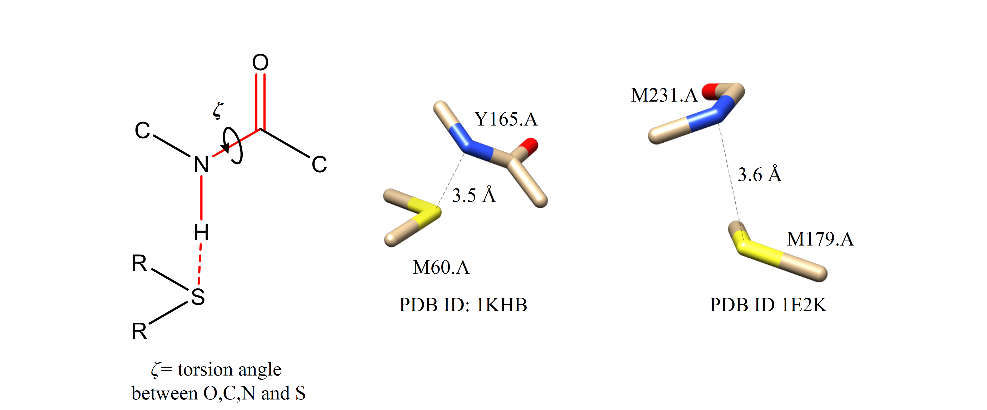

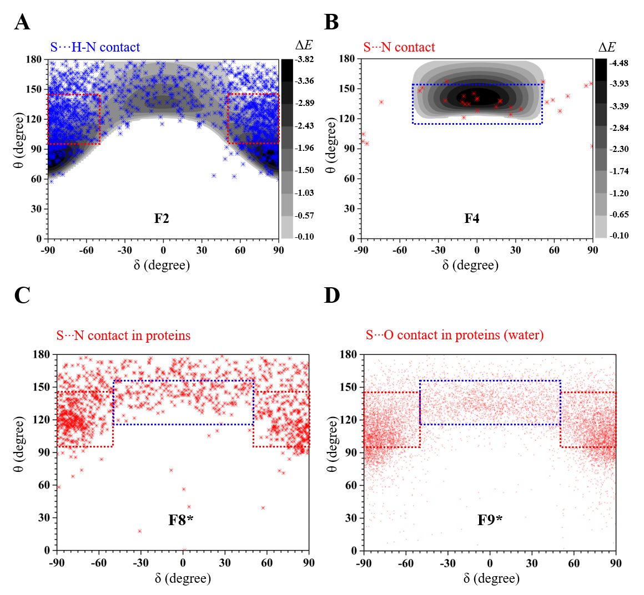
Figure S2. (A) Mapping of θ and δ values of S···H-N contacts in fragment F2 with computationally calculated ΔEs in the background. (B) Mapping of θ and δ values of S···N contacts in fragment F4 with computationally calculated ΔEs in the background. (C) S···N and (D) S···O contacts formed by methionine and cystine in fragments F8 and F9, respectively. In case of proteins, interacting atoms were separated by at least 6 covalent bonds.

Figure S3. (A) Representative examples of H- and Ch-bond in F1-F5 with their CSD ID. In case of fragment F5, d_{S···H} is marked by an asterisk. Note that H-O/N groups that formed Ch-bond with S in F5 could form H-bond with a neighboring acceptor atom (B) Representative example of outliers for S···H-O contacts in F1 (C) Representative example of outliers of S···O contacts in F3 from those clustered around at θ =75˚ and δ =90˚ or -90˚ (refer Figure 1e) and (d) Representative examples of outliers of S···O contacts in fragment F3. All the examples are shown with their CSD ID.

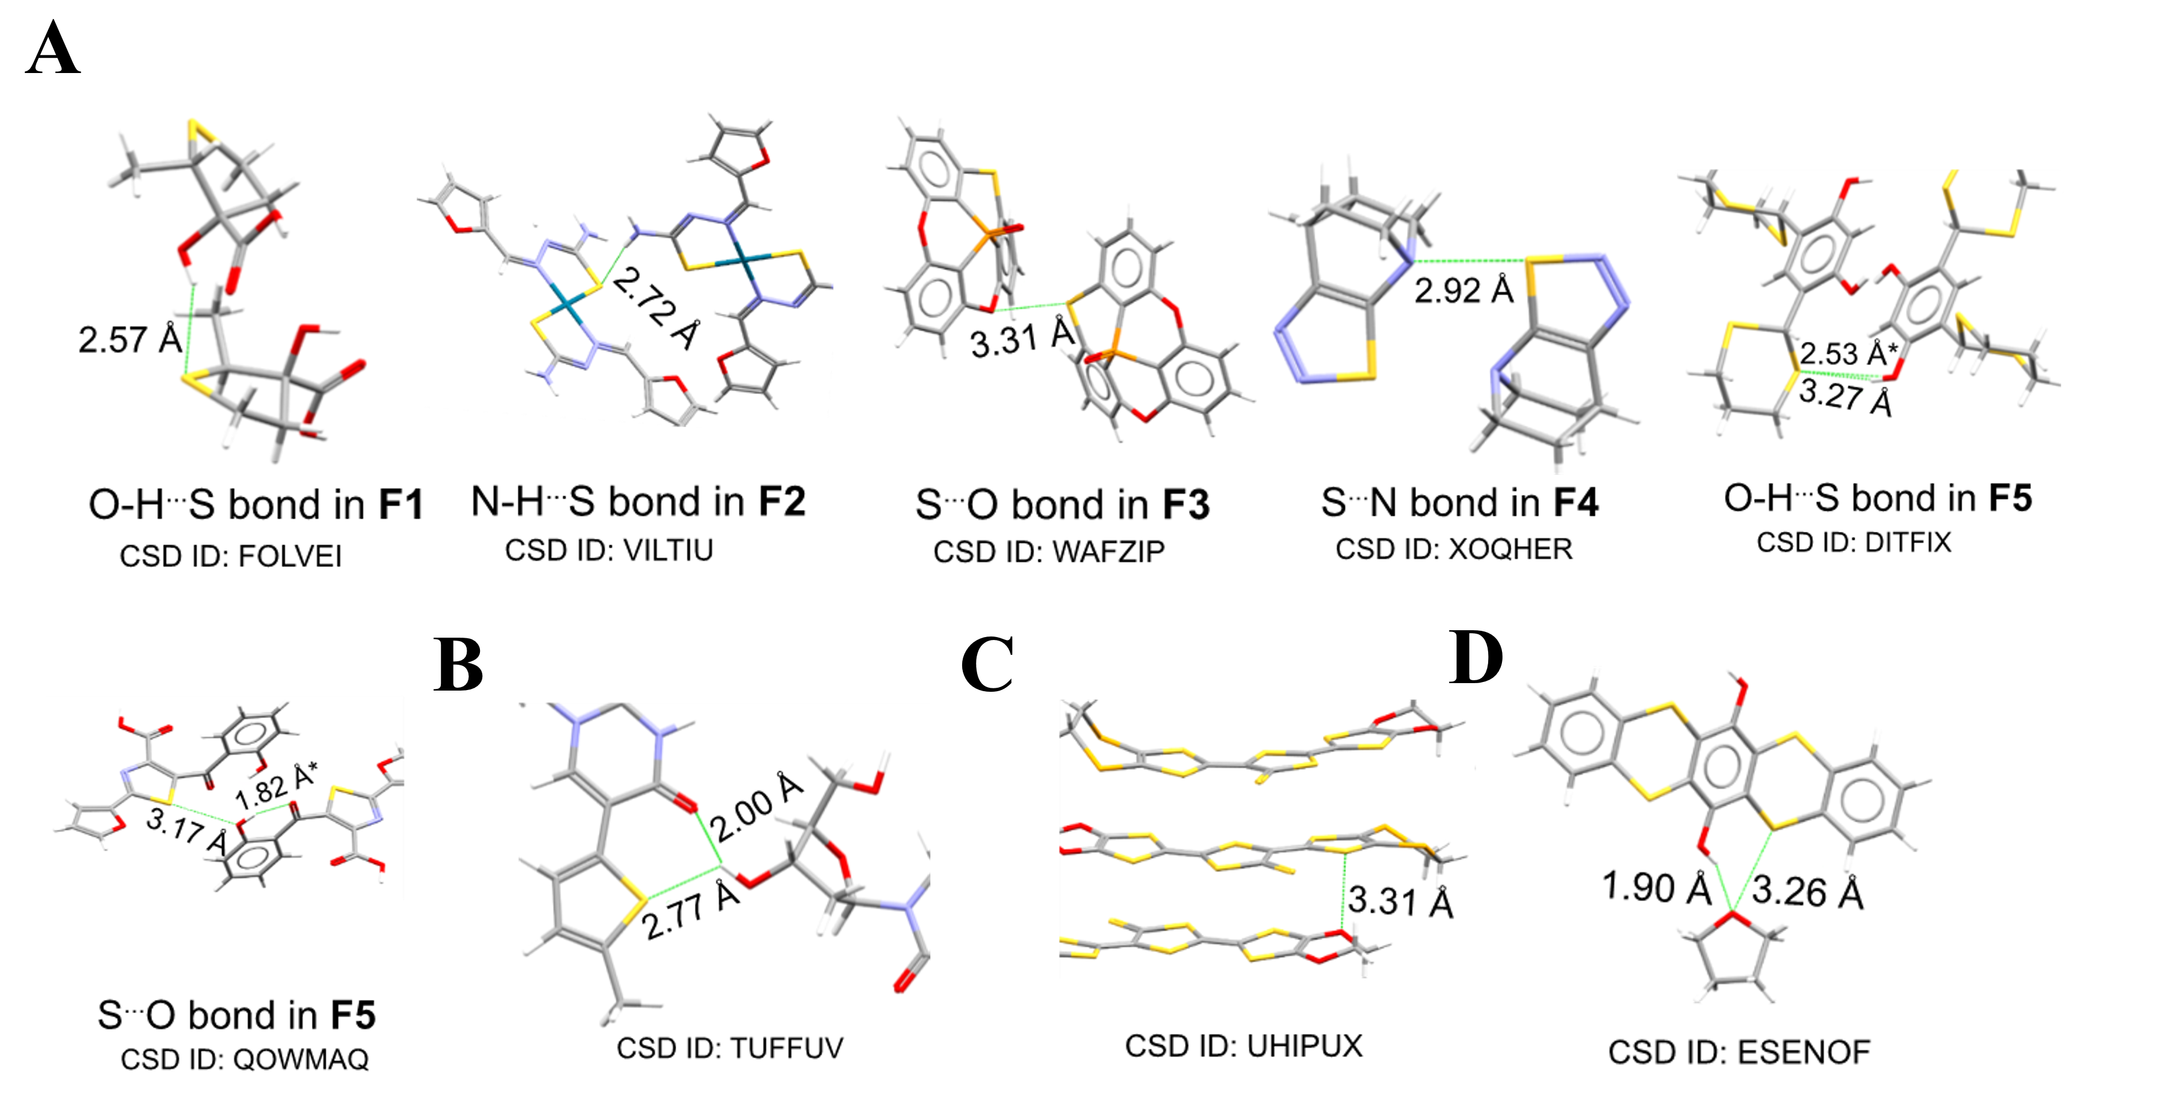

Figure S4. Representative examples of methionine-mediated (A) Ch-bond (B) H-bond in fragment F7. Representative examples of cystine-mediated (C) Ch-bond (D) H-bond. Potential coexisting H-bonds are also illustrated. Representative examples of methionine-mediated (E) Ch-bond (F) H-bond in fragment F8 (G) Representative example of cystine-mediated Ch-bond in F8. All structures are shown with their PDB IDs.
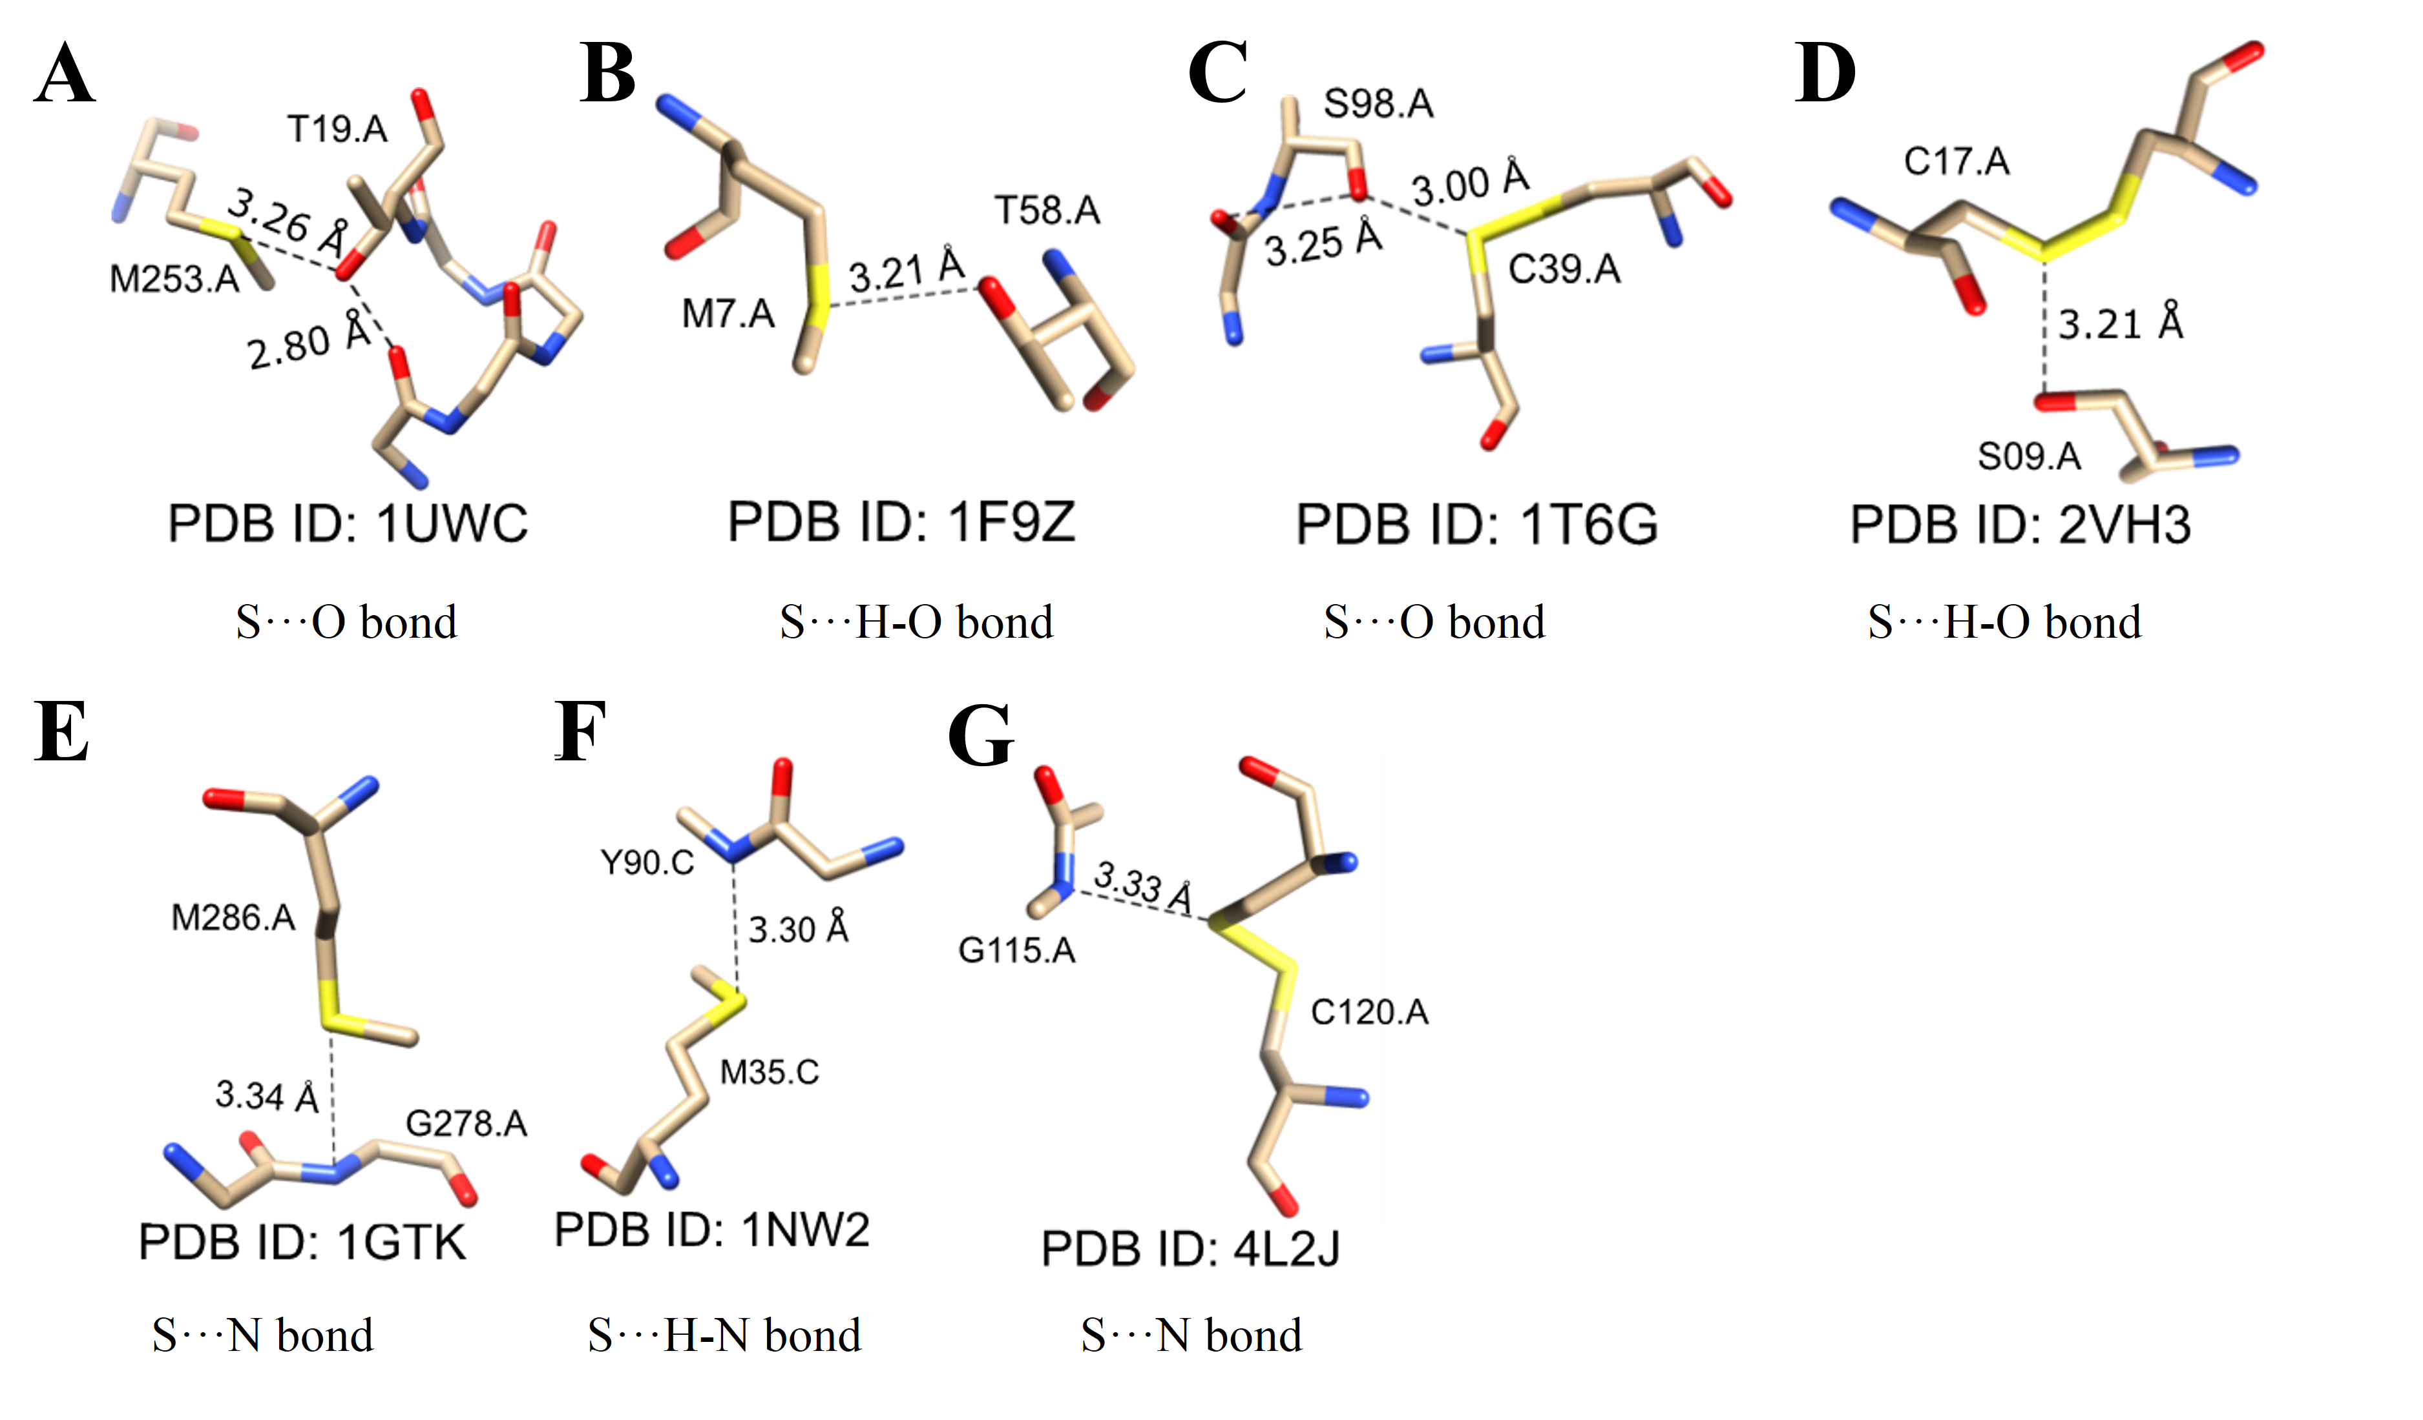
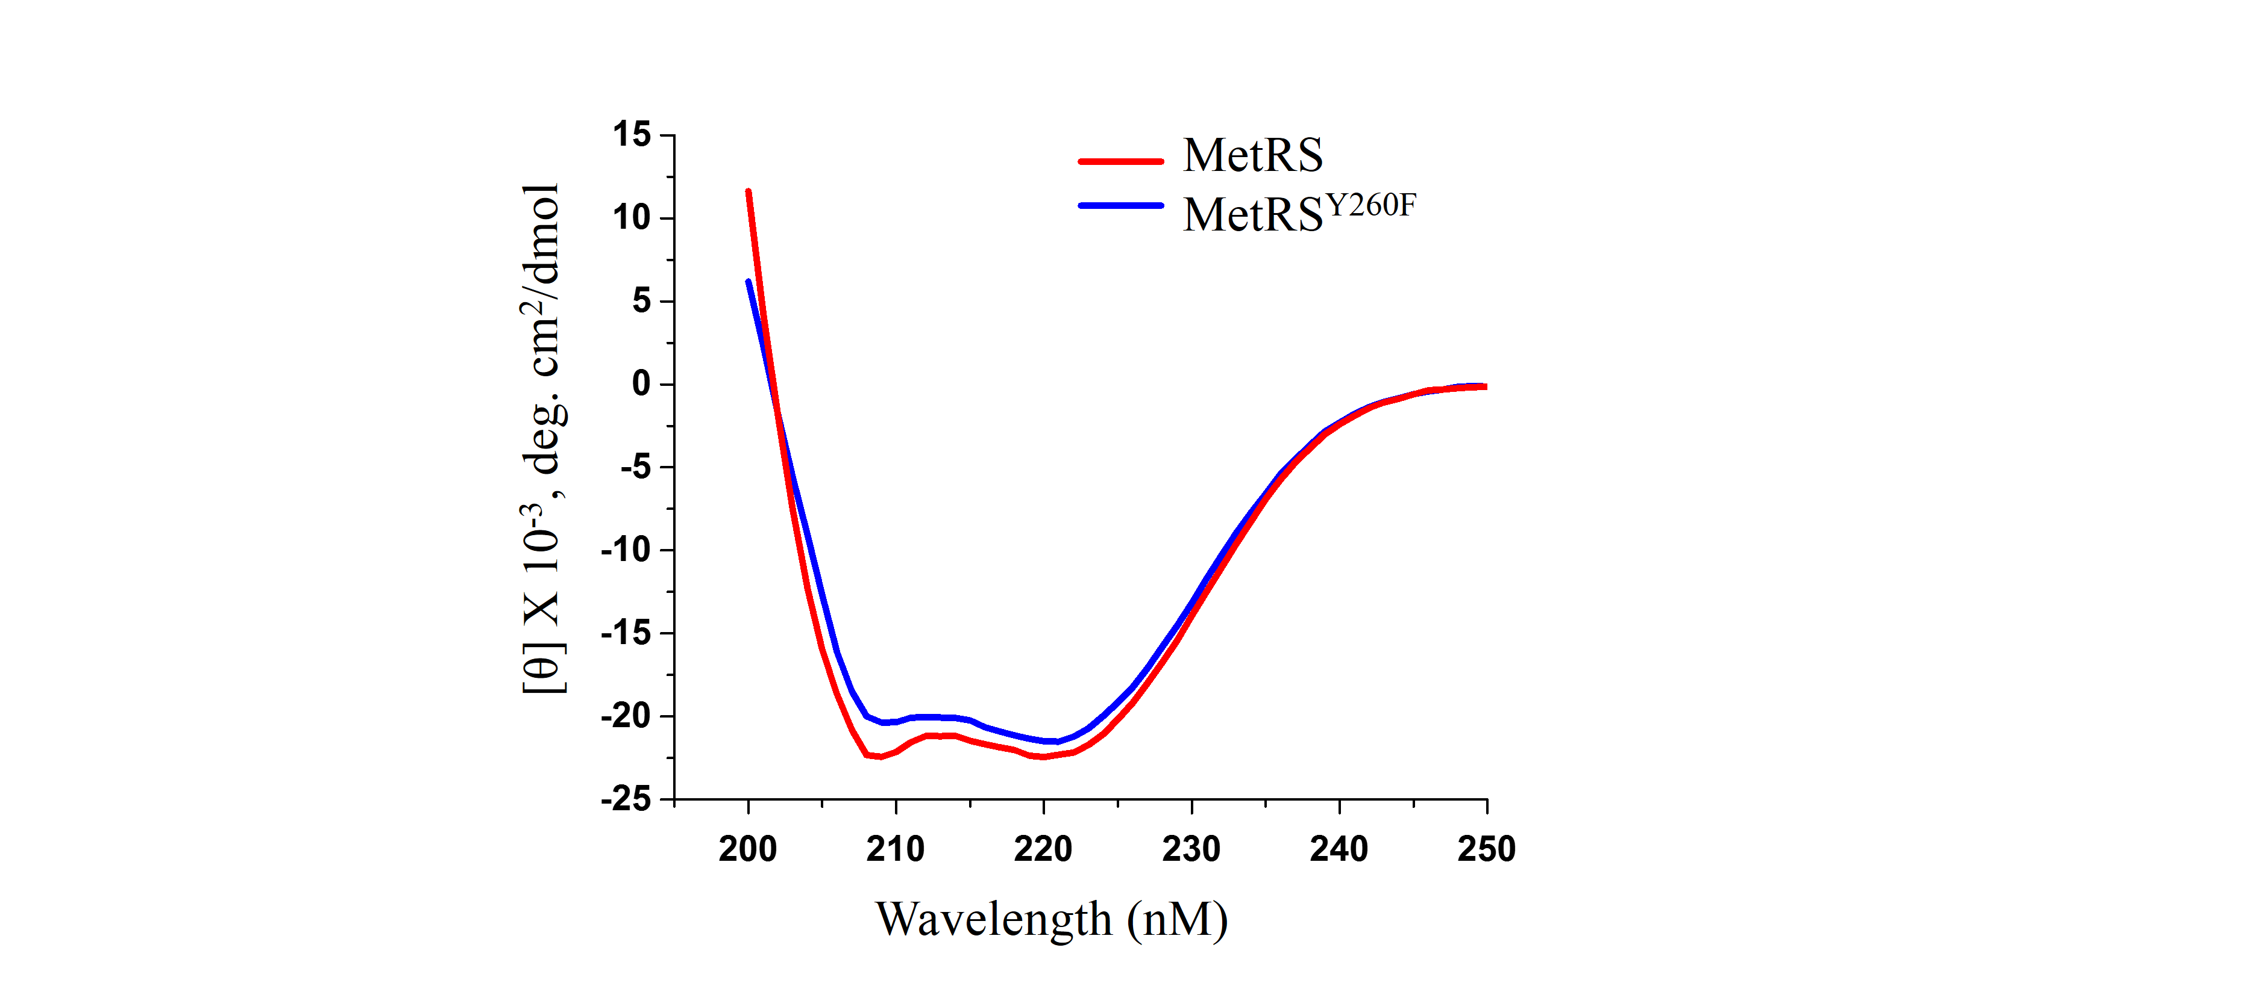
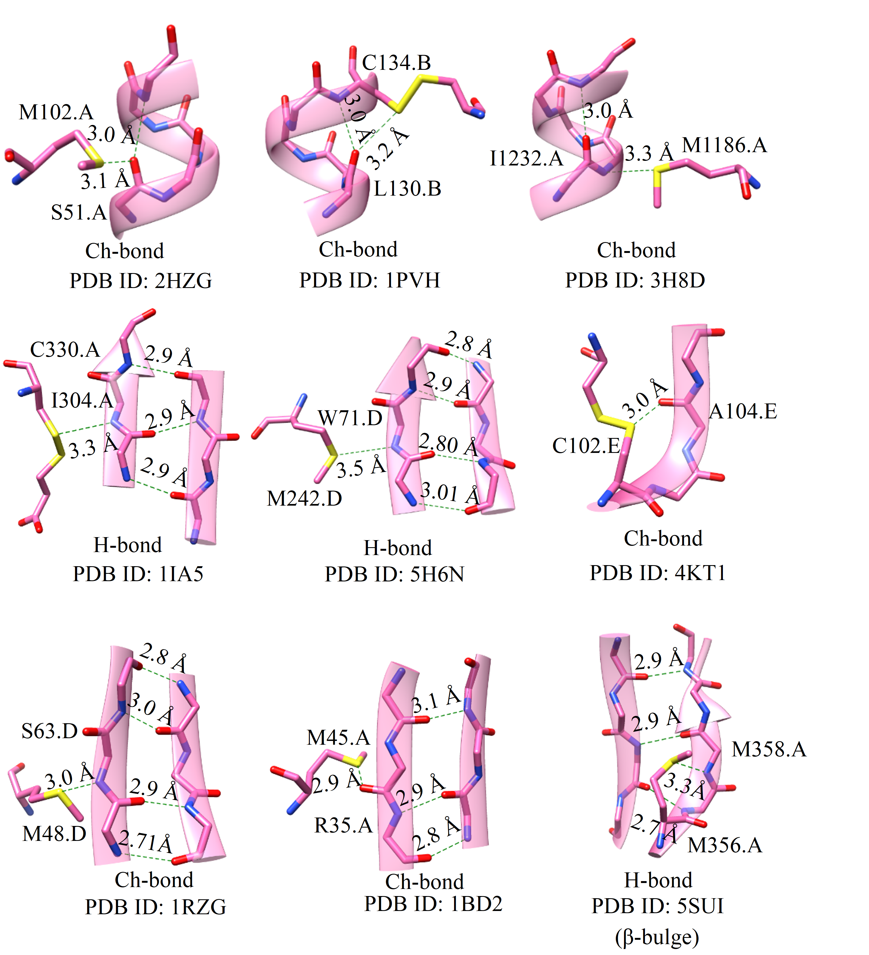
Figure S5. Representative examples of H-bonds and Ch-bonds formed by Met-S^{δ} and Cys-S^{γ} with residues in α-helix and β-sheet. Also, an example of H-bond formed by Met-S^{δ} introducing β-bulge (PDB ID: 5SUI).

Table S1. Classification of the CSD data based on electronic nature of S. S-mediated H-bonds and Ch-bonds were identified using distance (d) and angular criteria (θ and δ) defined in the text.
Fragment | S···H-O contacts (N_{c}) | S···H-N contacts (N_{c}) | S···O contacts (N_{c}) | S···N contacts (N_{c}) | Total Fragments  (N_{f})
M-S-M | 49 | 158 | 1 | 0 | 208
M-S-Y | 253 | 507 | 17 | 3 | 780
R-S-R | 48 | 41 | 71 | 12 | 172
E-S-Y | 60 | 56 | 302 | 18 | 436
S (Ar) | 17 | 32 | 318 | 26 | 393
Total | 427 | 794 | 709 | 59 | 1989

Table S2. A summary of the number of contacts seen in PDB where d_{S···O} and d_{S···N} were below 3.32 Å and 3.35 Å, respectively.
Interaction | Interacting residues | Number of contacts (N_{c})
S···O contact | S(Ar) and Peptide backbone | 98
 | S(Ar) and Glu/Gln/Asn/Asp | 31
 | S(Ar) and Ser/Thr/Tyr | 46
 | S(Ar) and H₂O | 147
 | Cystine and Peptide backbone | 2074
 | Cystine and Glu/Gln/Asn/Asp | 245
 | Cystine and Ser/Thr/Tyr | 285
 | Cystine and H₂O | 980
 | Methionine and Peptide backbone | 2666
 | Methionine and Glu/Gln/Asn/Asp | 727
 | Methionine and Ser/Thr/Tyr | 1320
 | Methionine and H₂O | 8737
 | Metal-chelated cysteine and Peptide backbone | 69
 | Metal-chelated cysteine and Glu/Gln/Asn/Asp | 148
 | Metal-chelated cysteine and Ser/Thr/Tyr | 369
 | Metal-chelated cysteine and H₂O | 1552
S···N contact | S(Ar) and Peptide backbone | 13
 | S(Ar) and Arg/His/Lys | 45
 | S(Ar) and Trp/Asn/Gln | 16
 | Cystine and Peptide backbone | 228
 | Cystine and Arg/His/Lys | 212
 | Cystine and Trp/Asn/Gln | 100
 | Methionine and Peptide backbone | 1005
 | Methionine and Arg/His/Lys | 1163
 | Methionine and Trp/Asn/Gln | 719
 | Metal-chelated cysteine and Peptide backbone | 1803
 | Metal-chelated cysteine and Arg/His/Lys | 630
 | Metal-chelated cysteine and Trp/Asn/Gln | 90

Table S3. Classification of the PDB data based on electronic nature of S. H-bonds and Ch-bonds were identified using the angular range of θ and δ defined in the text.
Fragment | S···H-O contacts (N_{c}) | S···H-N contacts (N_{c}) | S···O  contacts (N_{c}) | S···N  contacts (N_{c}) | Total Fragments  (N_{f})
M-S-C | 1057 | 1351 | 186 | 98 | 2692
C-S-C | 5354 | 1263 | 4281 | 750 | 11648
C-S-S | 295 | 132 | 2277 | 106 | 2810
S (Ar) | 30 | 41 | 198 | 18 | 287
Total | 6736 | 2787 | 6942 | 972 | 17437

Table S4. A summary of the results of the PDB analysis performed to identify H-bond and Ch-bond formed by Cys-S^{γ} or Met-S^{δ} that cap α-helices in proteins.
Fragment  (residue) | Total Number of α- helix capping contacts (N_{T}) ^{[a]} | N-terminal α-helix capping  contacts (N_{N}) ^{[b]} | C-terminal α-helix capping  contacts (N_{C}) ^{[c]}
C-S-S  (cystine) | 164 | 42 (25) | 123 (75)
C-S-C  (Methionine) | 249 | 138 (37) | 232 (63)
C-S-M  (Metal-chelated cysteine) | 1069 | 1068 (100) | 1 (0)
^{[a]}Total number of S···O/ S···H-N contacts found capping α-helices. ^{[b]}Total number of S···H-N contacts found capping the N-termini of α-helices. ^{[c]}Number of S···O contacts found capping the C-termini of α-helices. The percentage in parenthesis was calculated using [(N_{N/C}/ N_{T}) x100].

Table S5. A summary of the results of PDB analysis performed to identify H-bond and Ch-bond formed by Cys-S^{γ} or Met-S^{δ} with residues in α-helix (only internal residues) and β-sheets.
Fragment (residue) | S···H-N interaction |  | S···O interaction |  | S···N interaction
 | α-helix | β- strand | α-helix | β- strand | α-helix | β- strand
C-S-S  (Cystine) | 0 | 7 | 297 | 42 | 0 | 3
C-S-C  (Methionine) | 1 | 335 | 156 | 229 | 34 | 34

