Comparing 2 crystal structures and 12 AlphaFold2-predicted human membrane glucose transporters and their water-soluble QTY variants

Eva Smorodina¹, Fei Tao², Rui Qing², David Jin³, Steve Yang⁴ and Shuguang Zhang⁵*

¹Laboratory for Computational and Systems Immunology, Department of Immunology, University of Oslo, Norway
²Laboratory of Food Microbial Technology, State Key Laboratory of Microbial Metabolism, School of Life Sciences and Biotechnology, Shanghai Jiaotong University, Shanghai 200240, China.
³Avalon GloboCare Corp. Freehold, New Jersey 07728, USA
⁴PT Metiska Farma, Daerah Khusus Ibukota Jakarta 12220, Indonesia
⁵Laboratory of Molecular Architecture, Media Lab, Massachusetts Institute of Technology, 77 Massachusetts Avenue, Cambridge, MA, 02139, USA

*To whom the correspondence should be addressed.
Email: Shuguang@MIT.EDU
Telephone: +1-617-258-7514

Eva Smorodina, ribes.ev@gmail.com, ORCID: 0000-0002-5457-5163
Fei Tao taofei@sjtu.edu.cn, ORCID: 0000-0002-5997-8770
Rui Qing, ruiqing.br@sjtu.edu.cn, ORCID: 0000-0002-7952-2295
David Jin david@avalon-globocare.com, ORCID: 0000-0002-3061-4228
Steve Yang, steve.yang@metiska.co.id, ORCID: 0000-0002-5346-0321
Shuguang Zhang, Shuguang@MIT.EDU, ORCID: 0000-0002-3856-3752

Supplementary Materials

Table S1. Prediction confidence for GLUT1^{native}, GLUT1^{QTY}, GLUT3^{native}, and GLUT3^{QTY}. “Protein” column represents native and QTY versions of GLUT1 and GLUT3. “Model” column defines the model ID (PDB-files of all models have the names as mentioned in this column). “Rank” column shows how good the model is (the better pLDDT score is, the higher the model rank is). Models are sorted by their rank. We use the models with the highest rank (rank 1). Confidence in models based on pLDDT values: very low (pLDDT < 50), low (pLDDT = 60), OK (pLDDT = 70), confident (pLDDT = 80), very high (pLDDT > 90).
Protein | Model | Rank | pLDDT | pTMscore
GLUT1 native | 3 | 1 | 89.45 | 0.8859
GLUT1 native | 5 | 2 | 89.31 | 0.8937
GLUT1 native | 2 | 3 | 87.44 | 0.8507
GLUT1 native | 4 | 4 | 86.64 | 0.8632
GLUT1 native | 1 | 5 | 86.54 | 0.8383
GLUT1 QTY | 3 | 1 | 88.24 | 0.8670
GLUT1 QTY | 5 | 2 | 87.45 | 0.8716
GLUT1 QTY | 1 | 3 | 86.91 | 0.8516
GLUT1 QTY | 2 | 4 | 86.15 | 0.8399
GLUT1 QTY | 4 | 5 | 86.12 | 0.8523
GLUT3 native | 5 | 1 | 89.71 | 0.8972
GLUT3 native | 3 | 2 | 88.69 | 0.8849
GLUT3 native | 1 | 3 | 87.39 | 0.8445
GLUT3 native | 2 | 4 | 86.87 | 0.8481
GLUT3 native | 4 | 5 | 86.50 | 0.8726
GLUT3 QTY | 3 | 1 | 86.42 | 0.8573
GLUT3 QTY | 1 | 2 | 86.32 | 0.8407
GLUT3 QTY | 5 | 3 | 84.97 | 0.8528
GLUT3 QTY | 2 | 4 | 83.27 | 0.8089
GLUT3 QTY | 4 | 5 | 81.34 | 0.7756

Table S2. Prediction confidence for native glucose transporters, GLUT2^{QTY}, and GLUT4^{QTY}-14^{QTY}. “Protein” column represents native and QTY versions of GLUT2 and GLUT4-14. “Model” column defines the model ID (PDB-files of all models have the names as mentioned in this column). Confidence in models based on pLDDT values: very low (pLDDT < 50), low (pLDDT = 60), OK (pLDDT = 70), confident (pLDDT = 80), very high (pLDDT > 90). You can find information about other models in the GitHub Repository: https://github.com/eva-smorodina/glucose-transporters.
Protein | Model | pLDDT | pTMscore
GLUT2 native | 5 | 86.01 | 0.8658
GLUT2 QTY | 3 | 85.01 | 0.8256
GLUT4 native | 5 | 87.86 | 0.8770
GLUT4 QTY | 3 | 84.95 | 0.8423
GLUT5 native | 3 | 89.39 | 0.8960
GLUT5 QTY | 3 | 87.63 | 0.8799
GLUT6 native | 3 | 82.12 | 0.8231
GLUT6 QTY | 3 | 82.03 | 0.8173
GLUT7 native | 3 | 87.99 | 0.8655
GLUT7 QTY | 3 | 86.84 | 0.8513
GLUT8 native | 3 | 81.88 | 0.8293
GLUT8 QTY | 3 | 83.85 | 0.8365
GLUT9 native | 1 | 83.30 | 0.8137
GLUT9 QTY | 1 | 81.94 | 0.8009
GLUT10 native | 3 | 74.64 | 0.7586
GLUT10 QTY | 3 | 74.08 | 0.7429
GLUT11 native | 3 | 88.51 | 0.8772
GLUT11 QTY | 3 | 87.85 | 0.8665
GLUT12 native | 3 | 73.04 | 0.7404
GLUT12 QTY | 1 | 72.98 | 0.7193
GLUT13 native | 3 | 80.02 | 0.7751
GLUT13 QTY | 3 | 79.70 | 0.7733
GLUT14 native | 5 | 87.30 | 0.8700
GLUT14 QTY | 3 | 84.25 | 0.8344

Figure S1. 14 human glucose transporter and their water-soluble QTY variants:

protein sequences, predicted 2D structures, and hydrophobic profiles

GTR1=GLUT1=SLC2A1= facilitated glucose transporter member 1, P11166, 492aa
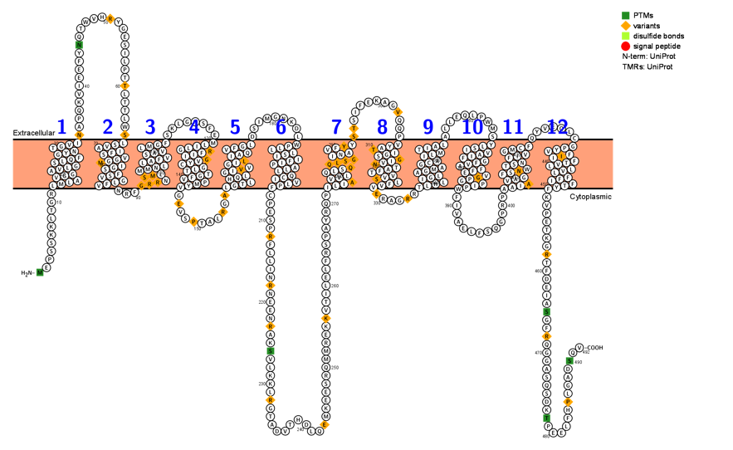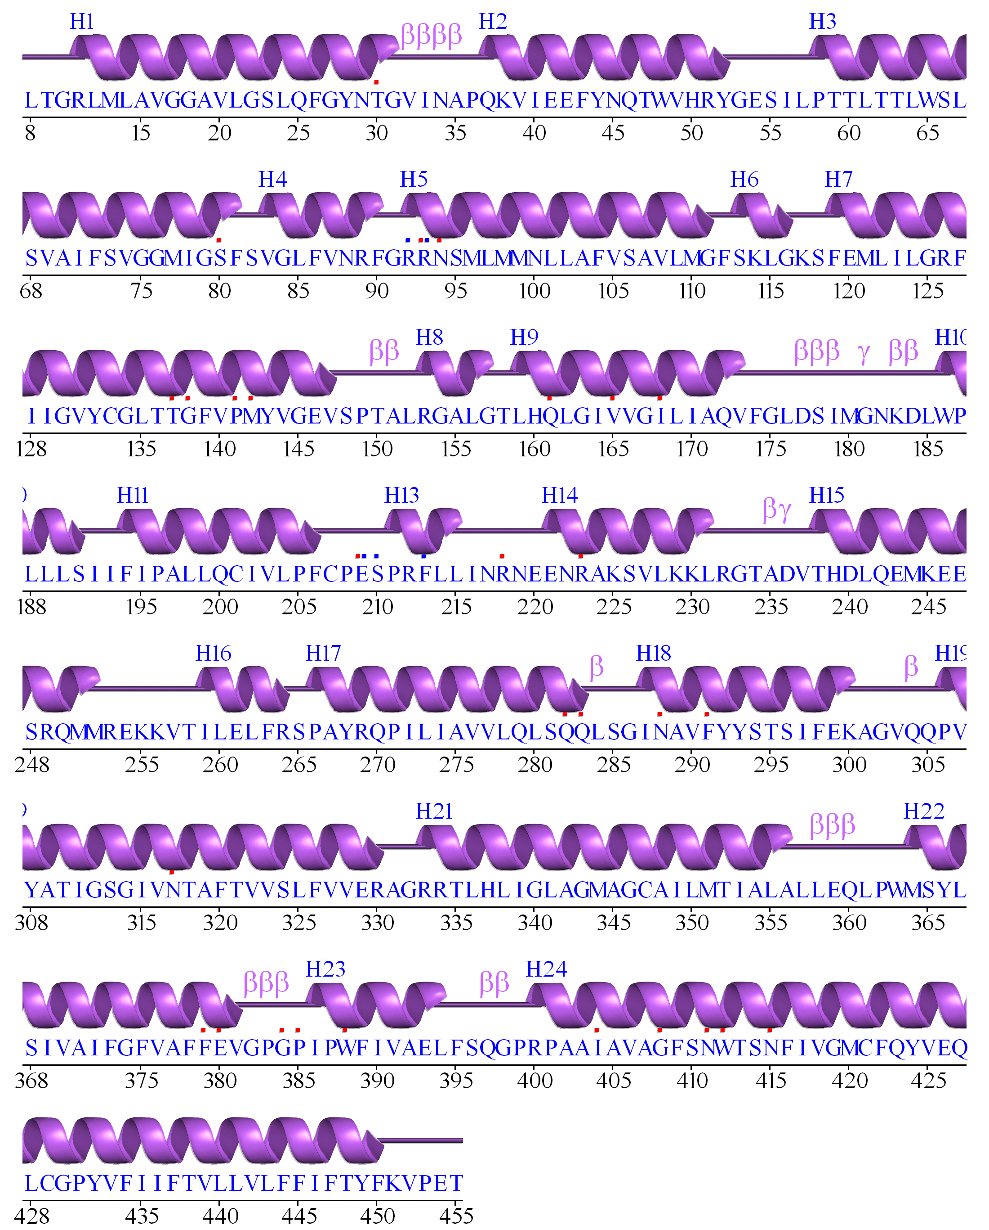

>sp|P11166| GTR1=GLUT1 Solute carrier family 2, facilitated glucose transporter member 1
MEPSSKKLTGRLMLAVGGAVLGSLQFGYNTGVINAPQKVIEEFYNQTWVHRYGESILPTT
LTTLWSLSVAIFSVGGMIGSFSVGLFVNRFGRRNSMLMMNLLAFVSAVLMGFSKLGKSFE
MLILGRFIIGVYCGLTTGFVPMYVGEVSPTALRGALGTLHQLGIVVGILIAQVFGLDSIM
GNKDLWPLLLSIIFIPALLQCIVLPFCPESPRFLLINRNEENRAKSVLKKLRGTADVTHD
LQEMKEESRQMMREKKVTILELFRSPAYRQPILIAVVLQLSQQLSGINAVFYYSTSIFEK
AGVQQPVYATIGSGIVNTAFTVVSLFVVERAGRRTLHLIGLAGMAGCAILMTIALALLEQ
LPWMSYLSIVAIFGFVAFFEVGPGPIPWFIVAELFSQGPRPAAIAVAGFSNWTSNFIVGM
CFQYVEQLCGPYVFIIFTVLLVLFFIFTYFKVPETKGRTFDEIASGFRQGGASQSDKTPE
ELFHPLGADSQV

The QTY variant GTR1^{QTY}
MEPSSKKLTGRQMQATGGATQGSQQFGYNTGTTNAPQKVIEEFYNQTWVHRYGESILPTT
LTTLWSQSTATYSTGGMTGSYSTGQYTNRFGRRNSMQMMNQQAYTSATQMGYSKLGKSFE
MQQQGRYTTGTYCGQTTGYTPMYTGEVSPTALRGAQGTQHQQGTTTGTQTAQTYGQDSIM
GNKDQWPQQQSTTYTPAQQQCTTQPYCPESPRFLLINRNEENRAKSVLKKLRGTADVTHD
LQEMKEESRQMMREKKVTILELFRSPAYRQPTQTATTQQQSQQQSGTNATYYYSTSIFEK
AGVQQPTYATTGSGTTNTAYTTTSQYTTERAGRRTQHQTGQAGMAGCATQMTTAQAQQEQ
LPWMSYQSTTATYGYTAYYETGPGPTPWYTTAELFSQGPRPAATATAGYSNWTSNYTTGM
CYQYVEQLCGPYTYTTYTTQQTQYYTYTYYKVPETKGRTFDEIASGFRQGGASQSDKTPE
ELFHPLGADSQV

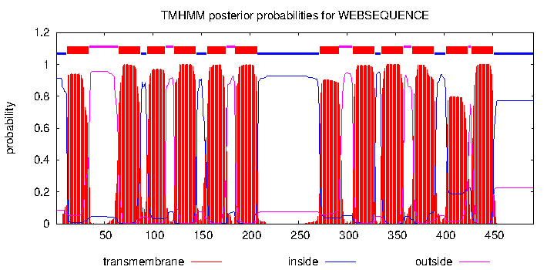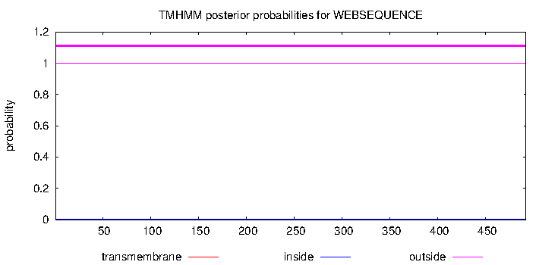
Native GTR1 GTR1^{QTY}

GTR2=Glut2=SLC2A2= facilitated glucose transporter member 2, P11168, 524aa
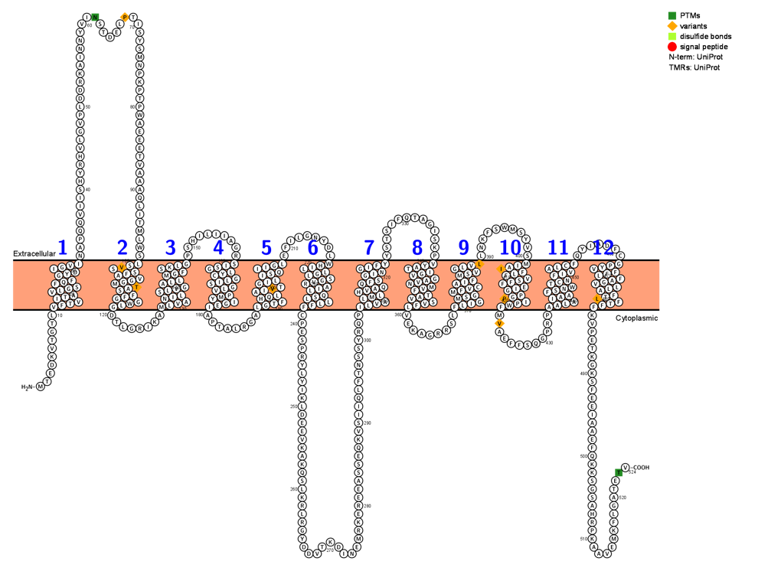

P11168|GTR2 Solute carrier family 2, facilitated glucose transporter member 2
GTR2=GLUT2
MTEDKVTGTLVFTVITAVLGSFQFGYDIGVINAPQQVIISHYRHVLGVPLDDRKAINNYV
INSTDELPTISYSMNPKPTPWAEEETVAAAQLITMLWSLSVSSFAVGGMTASFFGGWLGD
TLGRIKAMLVANILSLVGALLMGFSKLGPSHILIIAGRSISGLYCGLISGLVPMYIGEIA
PTALRGALGTFHQLAIVTGILISQIIGLEFILGNYDLWHILLGLSGVRAILQSLLLFFCP
ESPRYLYIKLDEEVKAKQSLKRLRGYDDVTKDINEMRKEREEASSEQKVSIIQLFTNSSY
RQPILVALMLHVAQQFSGINGIFYYSTSIFQTAGISKPVYATIGVGAVNMVFTAVSVFLV
EKAGRRSLFLIGMSGMFVCAIFMSVGLVLLNKFSWMSYVSMIAIFLFVSFFEIGPGPIPW
FMVAEFFSQGPRPAALAIAAFSNWTCNFIVALCFQYIADFCGPYVFFLFAGVLLAFTLFT
FFKVPETKGKSFEEIAAEFQKKSGSAHRPKAAVEMKFLGATETV
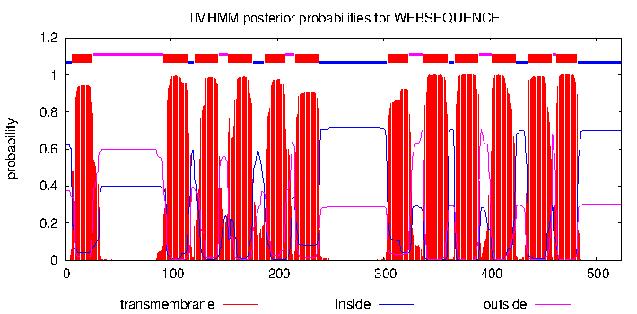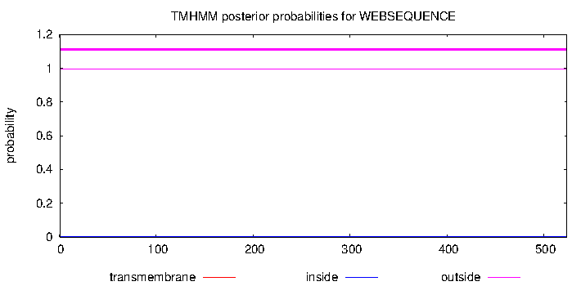

GLUT2^{QTY}
MTEDKVTGTLTYTTTTATQGSYQYGYDTGTTNAPQQVIISHYRHVLGVPLDDRKAINNYV
INSTDELPTISYSMNPKPTPWAEEETVAAAQLITMLWSQSTSSYATGGMTASYYGGWQGD
TLGRIKAMQTANTQSQTGAQQMGYSKQGPSHILIIAGRSTSGQYCGQTSGQTPMYTGETA
PTALRGAQGTYHQQATTTGTQTSQTTGQEFILGNYDQWHTQQGQSGTRATQQSQQQYYCP
ESPRYLYIKLDEEVKAKQSLKRLRGYDDVTKDINEMRKEREEASSEQKVSIIQLFTNSSY
RQPTQTAQMQHTAQQYSGTNGTYYYSTSIFQTAGISKPTYATTGTGATNMTYTATSTYQT
EKAGRRSLYQTGMSGMYTCATYMSTGQTQQNKFSWMSYVSMTATYQYTSYYETGPGPTPW
YMVAEFFSQGPRPAAQATAAYSNWTCNYTTAQCYQYIADFCGPYTYYQYAGTQQAYTQYT
YYKVPETKGKSFEEIAAEFQKKSGSAHRPKAAVEMKFLGATETV

GTR3=GLUT3=SLC2A3= facilitated glucose transporter member 3, P11169, 496aa
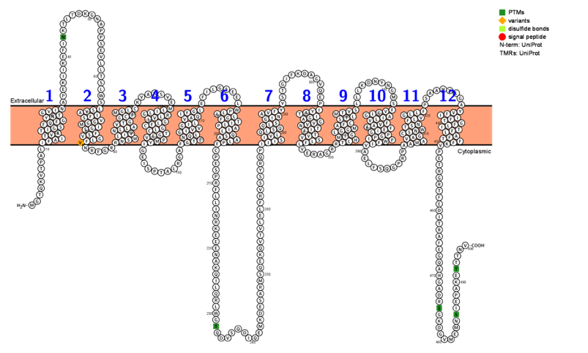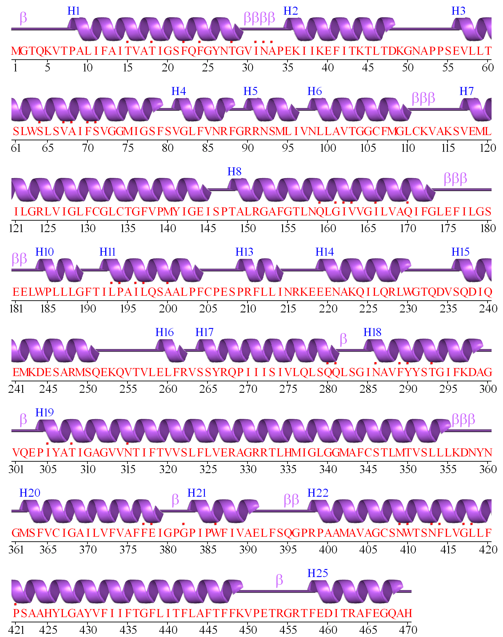
TM8-9
GTR3=GLUT3
P11169|GTR3 HUMAN Solute carrier family 2, facilitated glucose transporter member 3
MGTQKVTPALIFAITVATIGSFQFGYNTGVINAPEKIIKEFINKTLTDKGNAPPSEVLLT
SLWSLSVAIFSVGGMIGSFSVGLFVNRFGRRNSMLIVNLLAVTGGCFMGLCKVAKSVEML
ILGRLVIGLFCGLCTGFVPMYIGEISPTALRGAFGTLNQLGIVVGILVAQIFGLEFILGS
EELWPLLLGFTILPAILQSAALPFCPESPRFLLINRKEEENAKQILQRLWGTQDVSQDIQ
EMKDESARMSQEKQVTVLELFRVSSYRQPIIISIVLQLSQQLSGINAVFYYSTGIFKDAG
VQEPIYATIGAGVVNTIFTVVSLFLVERAGRRTLHMIGLGGMAFCSTLMTVSLLLKDNYN TM8-9
GMSFVCIGAILVFVAFFEIGPGPIPWFIVAELFSQGPRPAAMAVAGCSNWTSNFLVGLLF
PSAAHYLGAYVFIIFTGFLITFLAFTFFKVPETRGRTFEDITRAFEGQAHGADRSGKDGV
MEMNSIEPAKETTTNV
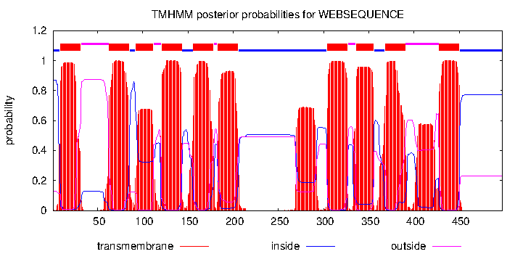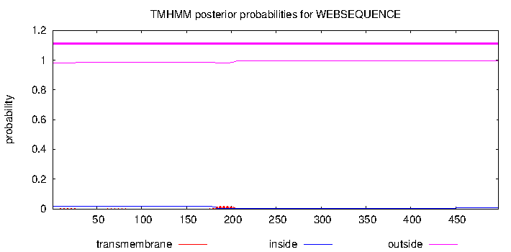

GLUT3^{QTY}
MGTQKVTPALTYATTTATTGSYQYGYNTGTTNAPEKIIKEFINKTLTDKGNAPPSEVLLT
SLWSQSTATYSTGGMTGSYSTGQYTNRFGRRNSMQTTNQQATTGGCYMGQCKVAKSVEMQ
TQGRQTTGQYCGQCTGYTPMYTGEISPTALRGAYGTQNQQGTTTGTQTAQTYGQEFILGS
EELWPQQQGYTTQPATQQSAAQPYCPESPRFLLINRKEEENAKQILQRLWGTQDVSQDIQ
EMKDESARMSQEKQVTVLELFRVSSYRQPTTTSTTQQQSQQQSGTNATYYYSTGIFKDAG
VQEPTYATTGAGTTNTTYTTTSQYQTERAGRRTQHMTGQGGMAYCSTQMTTSQQQKDNYN TM8-9
GMSYTCTGATQTYTAYYETGPGPTPWYTTAELFSQGPRPAAMATAGCSNWTSNYQTGQQY
PSAAHYLGAYTYTTYTGYQTTYQAYTYYKTPETRGRTFEDITRAFEGQAHGADRSGKDGV
MEMNSIEPAKETTTNV

GTR4=GLUT4=SLC2A4= facilitated glucose transporter member 4, P14672, 509aa

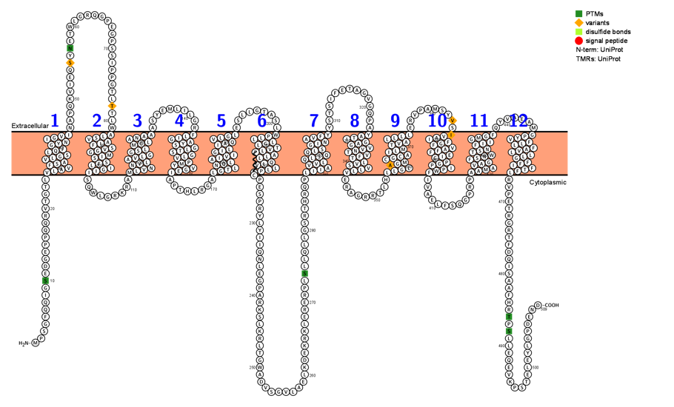
GTR4=GLUT4
P14672|GLUT4 HUMAN Solute carrier family 2, facilitated glucose transporter member 4
MPSGFQQIGSEDGEPPQQRVTGTLVLAVFSAVLGSLQFGYNIGVINAPQKVIEQSYNETW
LGRQGPEGPSSIPPGTLTTLWALSVAIFSVGGMISSFLIGIISQWLGRKRAMLVNNVLAV
LGGSLMGLANAAASYEMLILGRFLIGAYSGLTSGLVPMYVGEIAPTHLRGALGTLNQLAI
VIGILIAQVLGLESLLGTASLWPLLLGLTVLPALLQLVLLPFCPESPRYLYIIQNLEGPA
RKSLKRLTGWADVSGVLAELKDEKRKLERERPLSLLQLLGSRTHRQPLIIAVVLQLSQQL
SGINAVFYYSTSIFETAGVGQPAYATIGAGVVNTVFTLVSVLLVERAGRRTLHLLGLAGM
CGCAILMTVALLLLERVPAMSYVSIVAIFGFVAFFEIGPGPIPWFIVAELFSQGPRPAAM
AVAGFSNWTSNFIIGMGFQYVAEAMGPYVFLLFAVLLLGFFIFTFLRVPETRGRTFDQIS
AAFHRTPSLLEQEVKPSTELEYLGPDEND

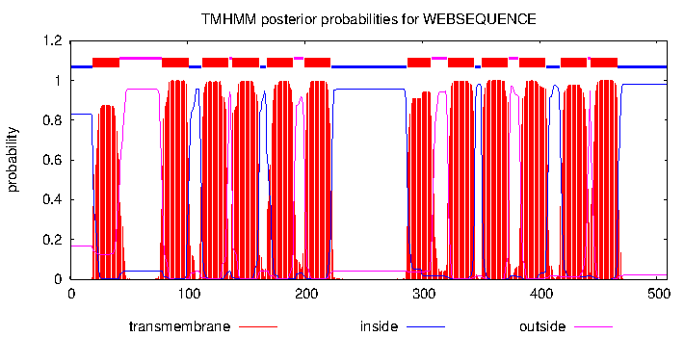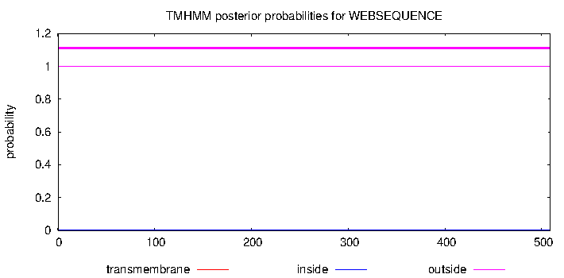

GLUT4^{QTY}
MPSGFQQIGSEDGEPPQQRVTGTLTQATYSATQGSQQYGYNTGTTNAPQKVIEQSYNETW
LGRQGPEGPSSIPPGTLTTLWAQSTATYSTGGMTSSYQTGTTSQWLGRKRAMQTNNTQAT
QGGSQMGQANAAASYEMLILGRYQTGAYSGQTSGQTPMYTGETAPTHLRGAQGTQNQQAT
TTGTQTAQTQGQESLLGTASLWPQQQGQTTQPAQQQQTQQPYCPESPRYLYIIQNLEGPA
RKSLKRLTGWADVSGVLAELKDEKRKLERERPLSLLQLLGSRTHRQPQTTATTQQQSQQQ
SGTNATYYYSTSIFETAGVGQPAYATTGAGTTNTTYTQTSTQQTERAGRRTLHQQGQAGM
CGCATQMTTAQQQQERVPAMSYVSTTATYGYTAYYETGPGPTPWYIVAELFSQGPRPAAM
ATAGYSNWTSNYTTGMGYQYVAEAMGPYTYQQYATQQQGYYTYTYQRVPETRGRTFDQIS
AAFHRTPSLLEQEVKPSTELEYLGPDEND

GTR5=GLUT5=SLC2A5= facilitated glucose transporter member 5, P22732, 501aa

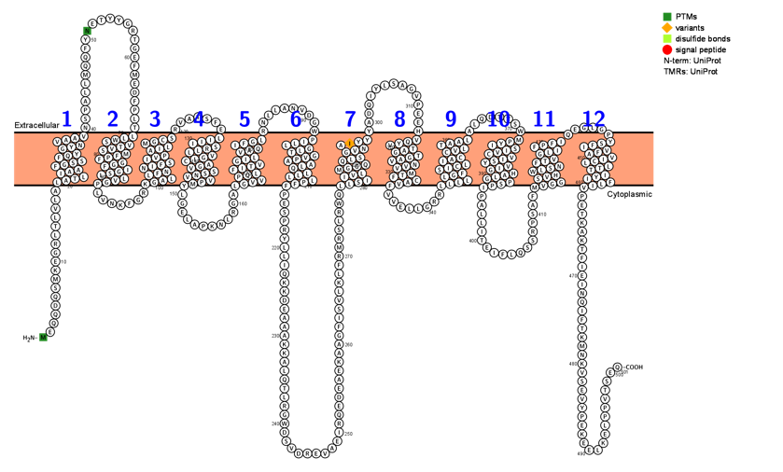

P22732| GTR5=GLUT5 Solute carrier family 2, facilitated glucose transporter member 5
MEQQDQSMKEGRLTLVLALATLIAAFGSSFQYGYNVAAVNSPALLMQQFYNETYYGRTGE
FMEDFPLTLLWSVTVSMFPFGGFIGSLLVGPLVNKFGRKGALLFNNIFSIVPAILMGCSR
VATSFELIIISRLLVGICAGVSSNVVPMYLGELAPKNLRGALGVVPQLFITVGILVAQIF
GLRNLLANVDGWPILLGLTGVPAALQLLLLPFFPESPRYLLIQKKDEAAAKKALQTLRGW
DSVDREVAEIRQEDEAEKAAGFISVLKLFRMRSLRWQLLSIIVLMGGQQLSGVNAIYYYA
DQIYLSAGVPEEHVQYVTAGTGAVNVVMTFCAVFVVELLGRRLLLLLGFSICLIACCVLT
AALALQDTVSWMPYISIVCVISYVIGHALGPSPIPALLITEIFLQSSRPSAFMVGGSVHW
LSNFTVGLIFPFIQEGLGPYSFIVFAVICLLTTIYIFLIVPETKAKTFIEINQIFTKMNK
VSEVYPEKEELKELPPVTSEQ

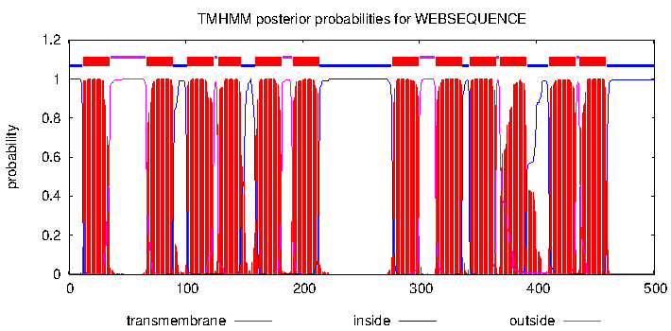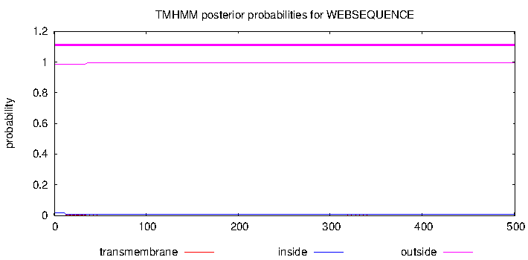

GLUT5^{QTY}
MEQQDQSMKEGRLTLVLAQATQTAAYGSSYQYGYNTAATNSPALLMQQFYNETYYGRTGE
FMEDFPLTQQWSTTTSMYPYGGYTGSQQTGPLVNKFGRKGAQQYNNTYSTTPATQMGCSR
VATSFEQTTTSRQQTGTCAGTSSNTTPMYLGELAPKNLRGAQGTTPQQYTTTGTQTAQTY
GQRNLLANVDGWPTQQGQTGTPAAQQQQQQPYYPESPRYLLIQKKDEAAAKKALQTLRGW
DSVDREVAEIRQEDEAEKAAGFISVLKLFRMRSLRWQQQSTTTQMGGQQQSGTNATYYYA
DQIYLSAGVPEEHTQYTTAGTGATNTTMTYCATYVVELLGRRQQQQQGFSTCQTACCTQT
AAQALQDTVSWMPYTSTTCTTSYTTGHAQGPSPTPALLITEIFLQSSRPSAFMTGGSTHW
QSNYTTGQTYPYTQEGLGPYSYTTYATTCQQTTTYTYQTTPETKAKTFIEINQIFTKMNK
VSEVYPEKEELKELPPVTSEQ

GTR6=GLUT6=SLC2A6= facilitated glucose transporter member 6, Q9UGQ3, 507aa

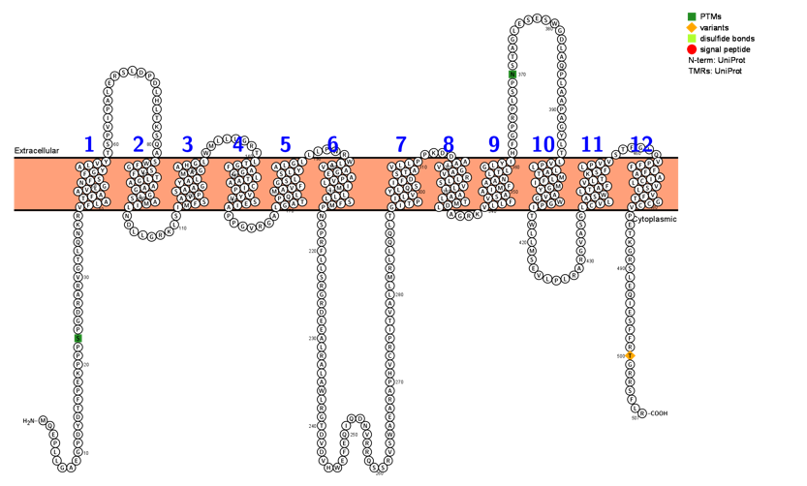

Q9UGQ3| GTR6=GLUT6 Solute carrier family 2, facilitated glucose transporter member 6
MQEPLLGAEGPDYDTFPEKPPPSPGDRARVGTLQNKRVFLATFAAVLGNFSFGYALVYTS
PVIPALERSLDPDLHLTKSQASWFGSVFTLGAAAGGLSAMILNDLLGRKLSIMFSAVPSA
AGYALMAGAHGLWMLLLGRTLTGFAGGLTAACIPVYVSEIAPPGVRGALGATPQLMAVFG
SLSLYALGLLLPWRWLAVAGEAPVLIMILLLSFMPNSPRFLLSRGRDEEALRALAWLRGT
DVDVHWEFEQIQDNVRRQSSRVSWAEARAPHVCRPITVALLMRLLQQLTGITPILVYLQS
IFDSTAVLLPPKDDAAIVGAVRLLSVLIAALTMDLAGRKVLLFVSAAIMFAANLTLGLYI
HFGPRPLSPNSTAGLESESWGDLAQPLAAPAGYLTLVPLLATMLFIMGYAVGWGPITWLL
MSEVLPLRARGVASGLCVLASWLTAFVLTKSFLPVVSTFGLQVPFFFFAAICLVSLVFTG
CCVPETKGRSLEQIESFFRTGRRSFLR

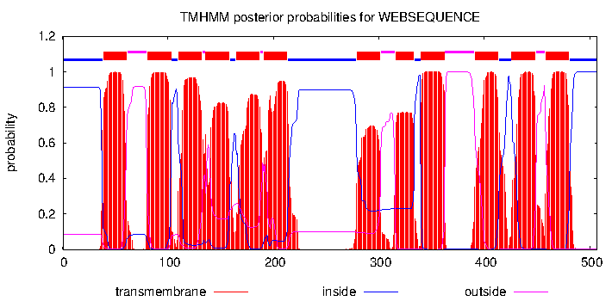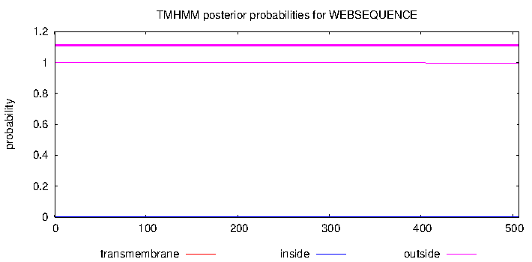

GLUT6^{QTY}
MQEPLLGAEGPDYDTFPEKPPPSPGDRARVGTLQNKRTYQATYAATQGNYSYGYAQTYTS
PVIPALERSLDPDLHLTKSQASWYGSTYTQGAAAGGQSAMTQNDLLGRKLSTMYSATPSA
AGYAQMAGAHGQWMLLLGRTQTGYAGGQTAACTPTYTSETAPPGVRGAQGATPQQMATYG
SQSQYAQGQLLPWRWQATAGEAPTQTMTQQQSYMPNSPRFLLSRGRDEEALRALAWLRGT
DVDVHWEFEQIQDNVRRQSSRVSWAEARAPHVCRPITVALLMRLLQQLTGTTPTQTYQQS
TYDSTATQQPPKDDAATTGATRQQSTQTAAQTMDQAGRKTQQYTSAATMYAANQTQGQYT
HFGPRPLSPNSTAGLESESWGDLAQPLAAPAGYLTQTPQQATMQYTMGYATGWGPTTWLL
MSEVLPLRARGVASGQCTQASWQTAYTQTKSYQPTTSTFGLQVPYYYYAATCQTSQTYTG
CCTPETKGRSLEQIESFFRTGRRSFLR

GTR7=GLUT7=SLC2A7= facilitated glucose transporter member 7, Q6PXP3, 512aa
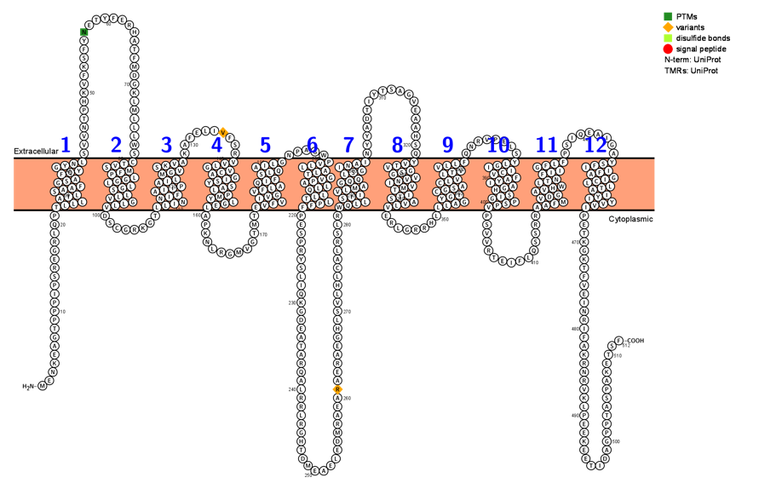

Q6PXP3| GTR7=GLUT7 Solute carrier family 2, facilitated glucose transporter member 7
MENKEAGTPPPIPSREGRLQPTLLLATLSAAFGSAFQYGYNLSVVNTPHKVFKSFYNETY
FERHATFMDGKLMLLLWSCTVSMFPLGGLLGSLLVGLLVDSCGRKGTLLINNIFAIIPAI
LMGVSKVAKAFELIVFSRVVLGVCAGISYSALPMYLGELAPKNLRGMVGTMTEVFVIVGV
FLAQIFSLQAILGNPAGWPVLLALTGVPALLQLLTLPFFPESPRYSLIQKGDEATARQAL
RRLRGHTDMEAELEDMRAEARAERAEGHLSVLHLCALRSLRWQLLSIIVLMAGQQLSGIN
AINYYADTIYTSAGVEAAHSQYVTVGSGVVNIVMTITSAVLVERLGRRHLLLAGYGICGS
ACLVLTVVLLFQNRVPELSYLGIICVFAYIAGHSIGPSPVPSVVRTEIFLQSSRRAAFMV
DGAVHWLTNFIIGFLFPSIQEAIGAYSFIIFAGICLLTAIYIYVVIPETKGKTFVEINRI
FAKRNRVKLPEEKEETIDAGPPTASPAKETSF
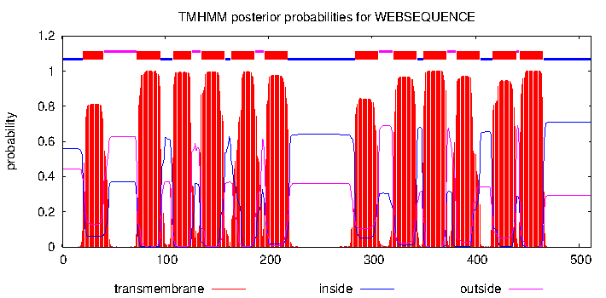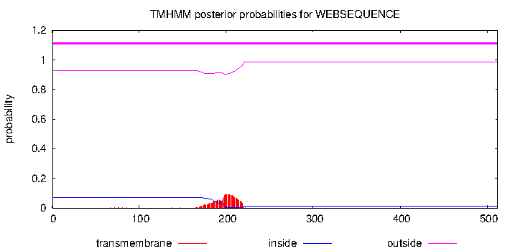

GLUT7^{QTY}
MENKEAGTPPPIPSREGRLQPTQQQATQSAAYGSAYQYGYNQSVVNTPHKVFKSFYNETY
FERHATFMDGKLMLLLWSCTTSMYPQGGQQGSQQTGQQTDSCGRKGTQQTNNTYATTPAT
QMGTSKTAKAFELIVFSRTTQGTCAGTSYSAQPMYQGEQAPKNLRGMVGTMTETYTTTGT
YQAQTYSQQATQGNPAGWPTQQAQTGTPAQQQQQTQPYYPESPRYSLIQKGDEATARQAL
RRLRGHTDMEAELEDMRAEARAERAEGHLSVLHLCALRSLRWQQQSTTTQMAGQQQSGTN
ATNYYADTIYTSAGVEAAHSQYTTTGSGTTNTTMTTTSATQTERLGRRHLQQAGYGTCGS
ACQTQTTTQQYQNRVPELSYQGTTCTYAYTAGHSTGPSPTPSVVRTEIFLQSSRRAAYMT
DGATHWQTNYTTGYQYPSIQEAIGAYSYTTYAGTCQQTATYTYTTTPETKGKTFVEINRI
FAKRNRVKLPEEKEETIDAGPPTASPAKETSF

GTR8=GLUT8= SLC2A8= facilitated glucose transporter member 8, Q9NY64, 477aa

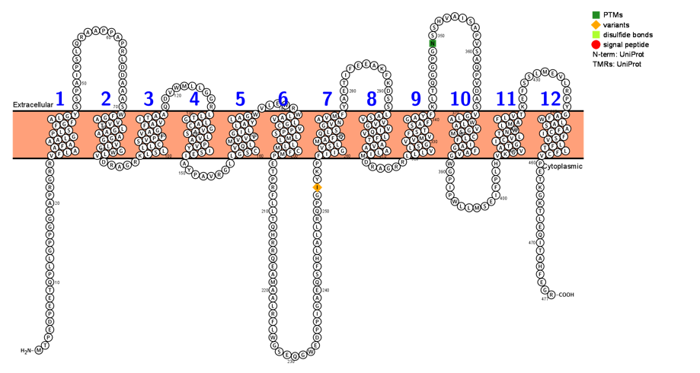

Q9NY64|GTR8=GLUT8 Solute carrier family 2, facilitated glucose transporter member 8, 477aa
MTPEDPEETQPLLGPPGGSAPRGRRVFLAAFAAALGPLSFGFALGYSSPAIPSLQRAAPP
APRLDDAAASWFGAVVTLGAAAGGVLGGWLVDRAGRKLSLLLCSVPFVAGFAVITAAQDV
WMLLGGRLLTGLACGVASLVAPVYISEIAYPAVRGLLGSCVQLMVVVGILLAYLAGWVLE
WRWLAVLGCVPPSLMLLLMCFMPETPRFLLTQHRRQEAMAALRFLWGSEQGWEDPPIGAE
QSFHLALLRQPGIYKPFIIGVSLMAFQQLSGVNAVMFYAETIFEEAKFKDSSLASVVVGV
IQVLFTAVAALIMDRAGRRLLLVLSGVVMVFSTSAFGAYFKLTQGGPGNSSHVAISAPVS
AQPVDASVGLAWLAVGSMCLFIAGFAVGWGPIPWLLMSEIFPLHVKGVATGICVLTNWLM
AFLVTKEFSSLMEVLRPYGAFWLASAFCIFSVLFTLFCVPETKGKTLEQITAHFEGR

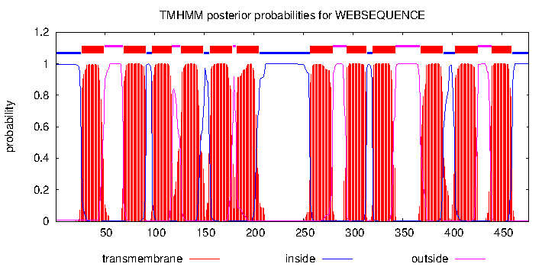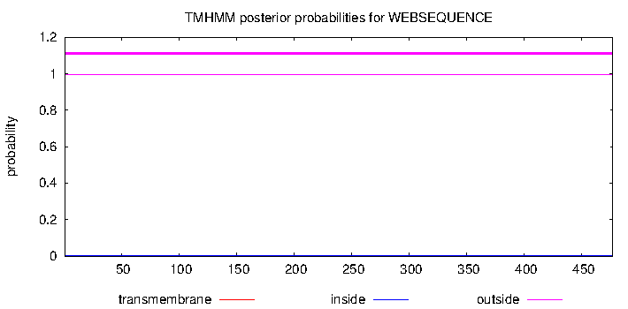

GLUT8^{QTY}
MTPEDPEETQPLLGPPGGSAPRGRRTYQAAYAAAQGPQSYGYAQGYSSPAIPSLQRAAPP
APRLDDAAASWYGATTTQGAAAGGTQGGWQTDRAGRKQSQQQCSTPYTAGYATTTAAQDV
WMLLGGRQQTGQACGTASQTAPTYTSETAYPAVRGLQGSCTQQMTTTGTQQAYQAGWTLE
WRWQATQGCTPPSQMQQQMCYMPETPRFLLTQHRRQEAMAALRFLWGSEQGWEDPPIGAE
QSFHLALLRQPGIYKPYTTGTSQMAYQQQSGTNATMYYAETIFEEAKFKDSSQASTTTGT
TQTQYTATAAQTMDRAGRRQQQTQSGTTMTYSTSAYGAYYKLTQGGPGNSSHVAISAPVS
AQPVDASTGQAWQATGSMCQYTAGYATGWGPIPWLLMSEIFPLHTKGTATGTCTQTNWQM
AYQTTKEFSSLMEVLRPYGAYWQASAYCTYSTQYTQYCTPETKGKTLEQITAHFEGR

GTR9=GLUT9=SLC2A9= facilitated glucose transporter member 9, Q9NRM0, 540aa

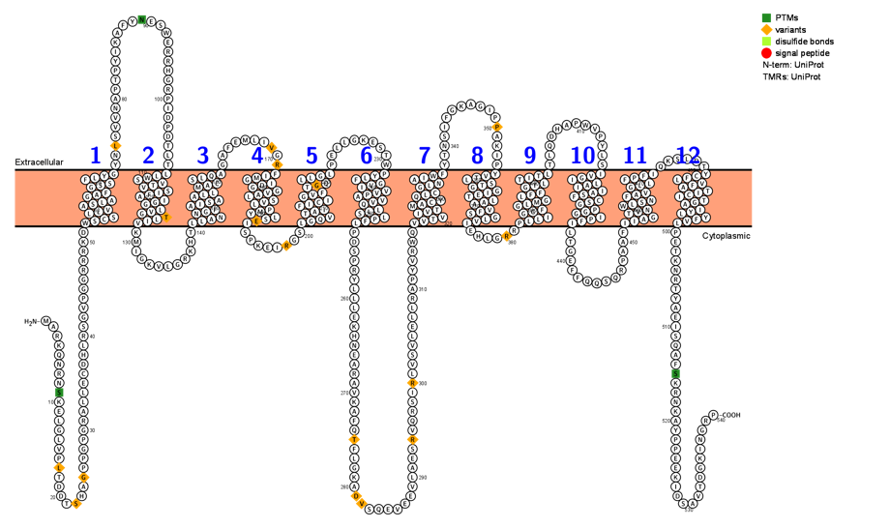

Q9NRM0 | GTR9=GLUT9 Solute carrier family 2, facilitated glucose transporter member 9
MARKQNRNSKELGLVPLTDDTSHAGPPGPGRALLECDHLRSGVPGGRRRKDWSCSLLVAS
LAGAFGSSFLYGYNLSVVNAPTPYIKAFYNESWERRHGRPIDPDTLTLLWSVTVSIFAIG
GLVGTLIVKMIGKVLGRKHTLLANNGFAISAALLMACSLQAGAFEMLIVGRFIMGIDGGV
ALSVLPMYLSEISPKEIRGSLGQVTAIFICIGVFTGQLLGLPELLGKESTWPYLFGVIVV
PAVVQLLSLPFLPDSPRYLLLEKHNEARAVKAFQTFLGKADVSQEVEEVLAESRVQRSIR
LVSVLELLRAPYVRWQVVTVIVTMACYQLCGLNAIWFYTNSIFGKAGIPPAKIPYVTLST
GGIETLAAVFSGLVIEHLGRRPLLIGGFGLMGLFFGTLTITLTLQDHAPWVPYLSIVGIL
AIIASFCSGPGGIPFILTGEFFQQSQRPAAFIIAGTVNWLSNFAVGLLFPFIQKSLDTYC
FLVFATICITGAIYLYFVLPETKNRTYAEISQAFSKRNKAYPPEEKIDSAVTDGKINGRP

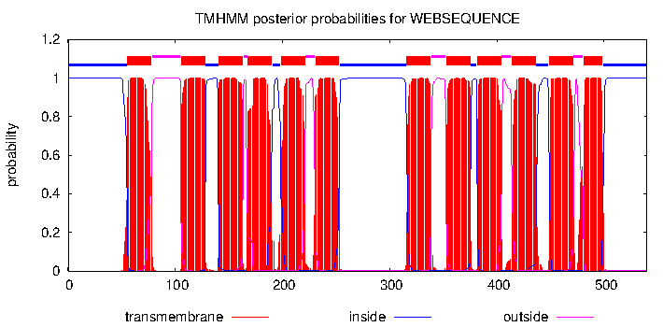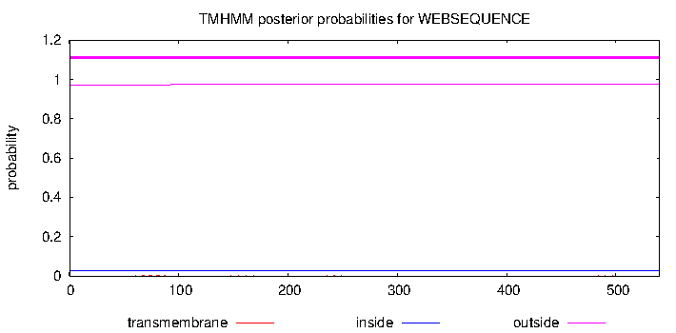

GLUT9^{QTY}
MARKQNRNSKELGLVPLTDDTSHAGPPGPGRALLECDHLRSGVPGGRRRKDWSCSQQTAS
QAGAYGSSYQYGYNLSVVNAPTPYIKAFYNESWERRHGRPIDPDTLTQQWSTTTSTYATG
GQTGTQTTKMIGKVLGRKHTQQANNGYATSAAQQMACSQQAGAFEMLIVGRYTMGTDGGT
AQSTQPMYQSETSPKEIRGSQGQTTATYTCTGTYTGQQQGQPELLGKESTWPYQYGTTTT
PATTQQQSQPYQPDSPRYLLLEKHNEARAVKAFQTFLGKADVSQEVEEVLAESRVQRSIR
LVSVLELLRAPYVRWQTTTTTTTMACYQQCGQNATWYYTNSIFGKAGIPPAKIPYTTQST
GGTETQAATYSGQTTEHLGRRPQQTGGYGQMGQYYGTQTTTQTLQDHAPWVPYLSTTGTQ
ATTASYCSGPGGTPYTQTGEFFQQSQRPAAFTTAGTTNWQSNYATGQQYPYTQKSLDTYC
YQTYATTCTTGATYQYYTQPETKNRTYAEISQAFSKRNKAYPPEEKIDSAVTDGKINGRP

GTR10=GLUT10=SLC2A10= facilitated glucose transporter member 10, O95528, 541aa

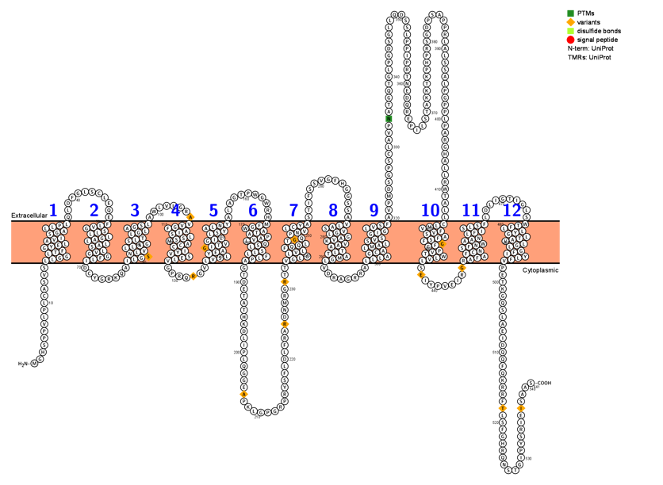

O95528| GTR10=GLUT10 Solute carrier family 2, facilitated glucose transporter member 10
MGHSPPVLPLCASVSLLGGLTFGYELAVISGALLPLQLDFGLSCLEQEFLVGSLLLGALL
ASLVGGFLIDCYGRKQAILGSNLVLLAGSLTLGLAGSLAWLVLGRAVVGFAISLSSMACC
IYVSELVGPRQRGVLVSLYEAGITVGILLSYALNYALAGTPWGWRHMFGWATAPAVLQSL
SLLFLPAGTDETATHKDLIPLQGGEAPKLGPGRPRYSFLDLFRARDNMRGRTTVGLGLVL
FQQLTGQPNVLCYASTIFSSVGFHGGSSAVLASVGLGAVKVAATLTAMGLVDRAGRRALL
LAGCALMALSVSGIGLVSFAVPMDSGPSCLAVPNATGQTGLPGDSGLLQDSSLPPIPRTN
EDQREPILSTAKKTKPHPRSGDPSAPPRLALSSALPGPPLPARGHALLRWTALLCLMVFV
SAFSFGFGPVTWLVLSEIYPVEIRGRAFAFCNSFNWAANLFISLSFLDLIGTIGLSWTFL
LYGLTAVLGLGFIYLFVPETKGQSLAEIDQQFQKRRFTLSFGHRQNSTGIPYSRIEISAAS

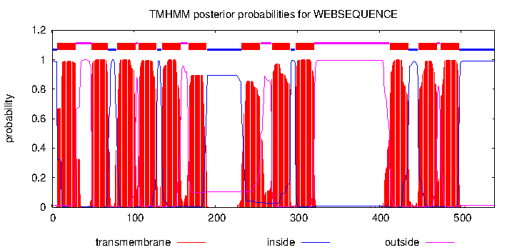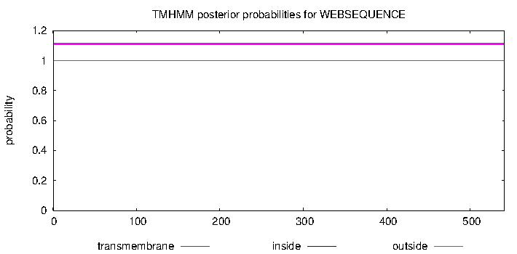

GLUT10^{QTY}
MGHSPPVLPLCASVSQQGGQTYGYEQATTSGAQQPQQLDFGLSCLEQEYQTGSQQQGAQQ
ASQTGGYQTDCYGRKQATQGSNQTQQAGSQTQGQAGSQAWLVLGRATTGYATSQSSMACC
TYTSEQTGPRQRGVQTSQYEAGTTTGTQQSYAQNYALAGTPWGWRHMYGWATAPATQQSQ
SQQYQPAGTDETATHKDLIPLQGGEAPKLGPGRPRYSFLDLFRARDNMRGRTTTGQGQTQ
YQQQTGQPNTQCYASTIFSSVGFHGGSSATQASTGQGATKTAATQTAMGQVDRAGRRAQQ
QAGCAQMAQSVSGTGQTSYAVPMDSGPSCLAVPNATGQTGLPGDSGLLQDSSLPPIPRTN
EDQREPILSTAKKTKPHPRSGDPSAPPRLALSSALPGPPLPARGHALLRWTAQQCQMTYT
SAYSYGYGPTTWQTQSEIYPVEIRGRAYAYCNSYNWAANQYTSQSYQDLIGTIGLSWTYQ
QYGQTATQGQGYTYQYTPETKGQSLAEIDQQFQKRRFTLSFGHRQNSTGIPYSRIEISAAS

GTR11=GLUT11=SLC2A11=, facilitated glucose transporter member 11, Q9BYW1, 496aa

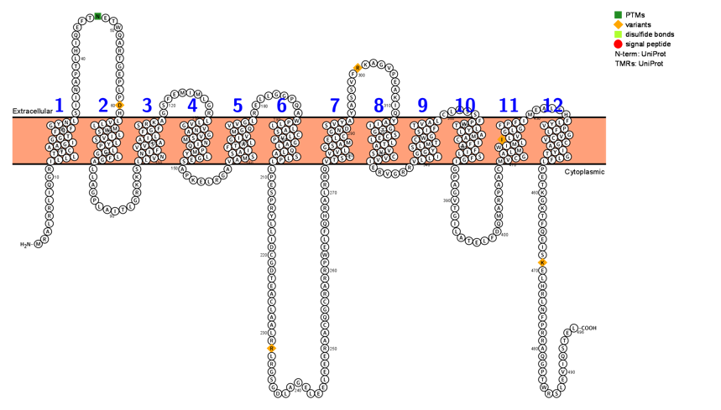

Q9BYW1| GTR11=GLUT11 Solute carrier family 2, facilitated glucose transporter member 11
MRALRRLIQGRILLLTICAAGIGGTFQFGYNLSIINAPTLHIQEFTNETWQARTGEPLPD
HLVLLMWSLIVSLYPLGGLFGALLAGPLAITLGRKKSLLVNNIFVVSAAILFGFSRKAGS
FEMIMLGRLLVGVNAGVSMNIQPMYLGESAPKELRGAVAMSSAIFTALGIVMGQVVGLRE
LLGGPQAWPLLLASCLVPGALQLASLPLLPESPRYLLIDCGDTEACLAALRRLRGSGDLA
GELEELEEERAACQGCRARRPWELFQHRALRRQVTSLVVLGSAMELCGNDSVYAYASSVF
RKAGVPEAKIQYAIIGTGSCELLTAVVSCVVIERVGRRVLLIGGYSLMTCWGSIFTVALC
LQSSFPWTLYLAMACIFAFILSFGIGPAGVTGILATELFDQMARPAACMVCGALMWIMLI
LVGLGFPFIMEALSHFLYVPFLGVCVCGAIYTGLFLPETKGKTFQEISKELHRLNFPRRA
QGPTWRSLEVIQSTEL

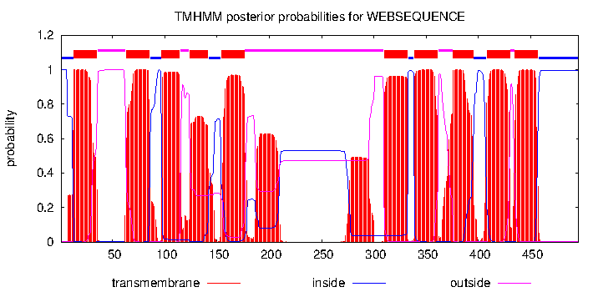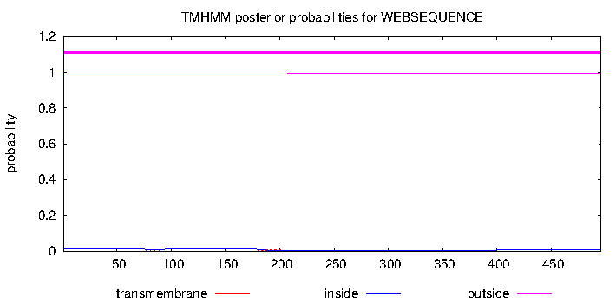

GLUT11^{QTY}
MRALRRLIQGRTQQQTTCAAGTGGTYQYGYNQSIINAPTLHIQEFTNETWQARTGEPLPD
HQTQQMWSQTTSQYPQGGQYGALLAGPLAITLGRKKSQQTNNTYTTSAATQYGYSRKAGS
FEMIMLGRQQTGTNAGTSMNTQPMYQGESAPKELRGATAMSSATYTAQGTTMGQTTGQRE
LLGGPQAWPLLLASCLVPGALQLASLPLLPESPRYLLIDCGDTEACLAALRRLRGSGDLA
GELEELEEERAACQGCRARRPWELFQHRALRRQTTSQTTQGSAMEQCGNDSTYAYASSVF
RKAGVPEAKIQYATTGTGSCEQQTATTSCTTTERVGRRTQQTGGYSQMTCWGSTYTTAQC
LQSSYPWTQYQAMACTYAYTQSYGTGPAGVTGILATELFDQMARPAACMTCGAQMWTMQT
QTGQGYPYTMEALSHYQYTPYQGTCTCGATYTGQYQPETKGKTFQEISKELHRLNFPRRA
QGPTWRSLEVIQSTEL

GLUT12=GTR12=SLC2A12= facilitated glucose transporter member 12, Q8TD20, 617aa

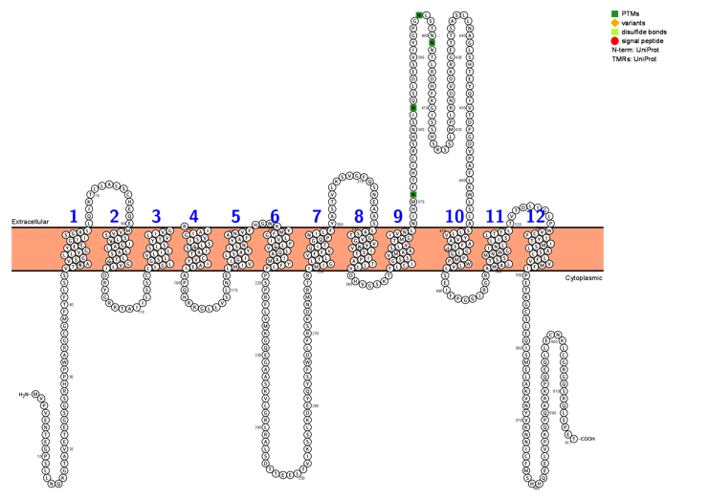

Q8TD20| GLUT12=GTR12 Solute carrier family 2, facilitated glucose transporter member 12
MVPVENTEGPSLLNQKGTAVETEGSGSRHPPWARGCGMFTFLSSVTAAVSGLLVGYELGI
ISGALLQIKTLLALSCHEQEMVVSSLVIGALLASLTGGVLIDRYGRRTAIILSSCLLGLG
SLVLILSLSYTVLIVGRIAIGVSISLSSIATCVYIAEIAPQHRRGLLVSLNELMIVIGIL
SAYISNYAFANVFHGWKYMFGLVIPLGVLQAIAMYFLPPSPRFLVMKGQEGAASKVLGRL
RALSDTTEELTVIKSSLKDEYQYSFWDLFRSKDNMRTRIMIGLTLVFFVQITGQPNILFY
ASTVLKSVGFQSNEAASLASTGVGVVKVISTIPATLLVDHVGSKTFLCIGSSVMAASLVT
MGIVNLNIHMNFTHICRSHNSINQSLDESVIYGPGNLSTNNNTLRDHFKGISSHSRSSLM
PLRNDVDKRGETTSASLLNAGLSHTEYQIVTDPGDVPAFLKWLSLASLLVYVAAFSIGLG
PMPWLVLSEIFPGGIRGRAMALTSSMNWGINLLISLTFLTVTDLIGLPWVCFIYTIMSLA
SLLFVVMFIPETKGCSLEQISMELAKVNYVKNNICFMSHHQEELVPKQPQKRKPQEQLLE
CNKLCGRGQSRQLSPET
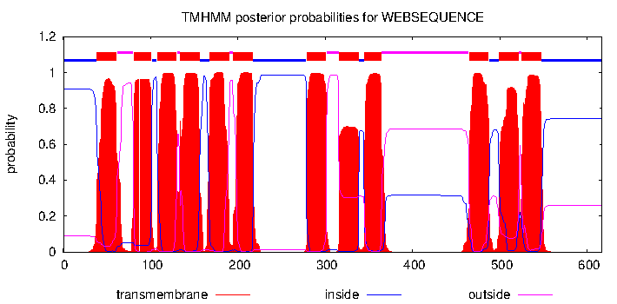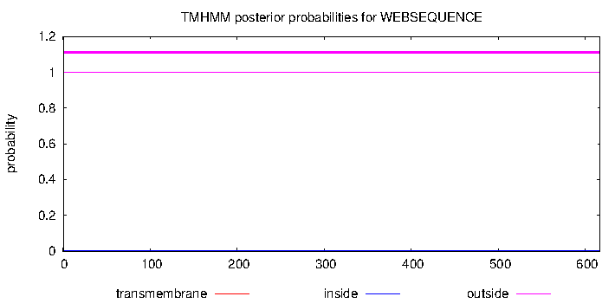

GLUT12^{QTY}
MVPVENTEGPSLLNQKGTAVETEGSGSRHPPWARGCGMFTFLSSTTAATSGQQTGYEQGT
TSGAQQQIKTLLALSCHEQEMTTSSQTTGAQQASQTGGTQTDRYGRRTAIILSSCQQGQG
SQTQTQSQSYTTQTTGRTATGTSTSQSSTATCTYTAEIAPQHRRGLLVSLNEQMTTTGTQ
SAYTSNYAYANTYHGWKYMYGQTTPQGTQQATAMYYQPPSPRFLVMKGQEGAASKVLGRL
RALSDTTEELTVIKSSLKDEYQYSFWDLFRSKDNMRTRTMTGQTQTYYTQTTGQPNTQYY
ASTVLKSVGFQSNEAASQASTGTGTTKTTSTTPATQQTDHVGSKTYQCTGSSTMAASQTT
MGTTNQNIHMNFTHICRSHNSINQSLDESVIYGPGNLSTNNNTLRDHFKGISSHSRSSLM
PLRNDVDKRGETTSASLLNAGLSHTEYQIVTDPGDVPAFLKWLSLASQQTYTAAYSTGQG
PMPWQTQSEIFPGGIRGRAMAQTSSMNWGTNQQTSQTYQTVTDLIGLPWTCYTYTTMSQA
SQQYTTMYTPETKGCSLEQISMELAKVNYVKNNICFMSHHQEELVPKQPQKRKPQEQLLE
CNKLCGRGQSRQLSPET

GLUT13=SLC2A13=MYCT=HMIT, Q96QE2, 648aa

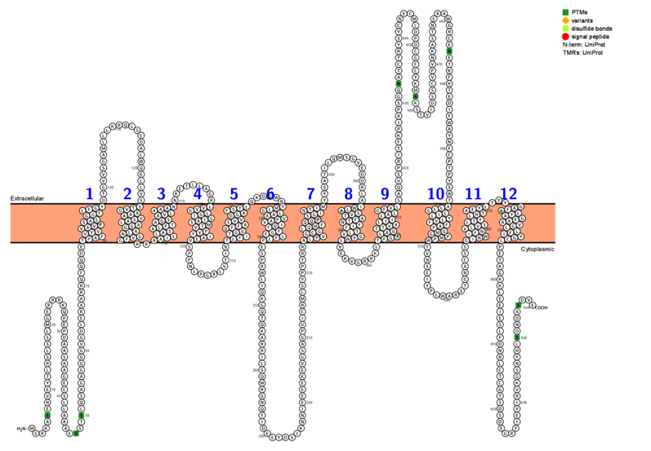

>sp|Q96QE2|MYCT=GLUT13=SLC2A13 Proton myo-inositol cotransporter
MSRKASENVEYTLRSLSSLMGERRRKQPEPDAASAAGECSLLAAAESSTSLQSAGAGGGG
VGDLERAARRQFQQDETPAFVYVVAVFSALGGFLFGYDTGVVSGAMLLLKRQLSLDALWQ
ELLVSSTVGAAAVSALAGGALNGVFGRRAAILLASALFTAGSAVLAAANNKETLLAGRLV
VGLGIGIASMTVPVYIAEVSPPNLRGRLVTINTLFITGGQFFASVVDGAFSYLQKDGWRY
MLGLAAVPAVIQFFGFLFLPESPRWLIQKGQTQKARRILSQMRGNQTIDEEYDSIKNNIE
EEEKEVGSAGPVICRMLSYPPTRRALIVGCGLQMFQQLSGINTIMYYSATILQMSGVEDD
RLAIWLASVTAFTNFIFTLVGVWLVEKVGRRKLTFGSLAGTTVALIILALGFVLSAQVSP
RITFKPIAPSGQNATCTRYSYCNECMLDPDCGFCYKMNKSTVIDSSCVPVNKASTNEAAW
GRCENETKFKTEDIFWAYNFCPTPYSWTALLGLILYLVFFAPGMGPMPWTVNSEIYPLWA
RSTGNACSSGINWIFNVLVSLTFLHTAEYLTYYGAFFLYAGFAAVGLLFIYGCLPETKGK
KLEEIESLFDNRLCTCGTSDSDEGRYIEYIRVKGSNYHLSDNDASDVE

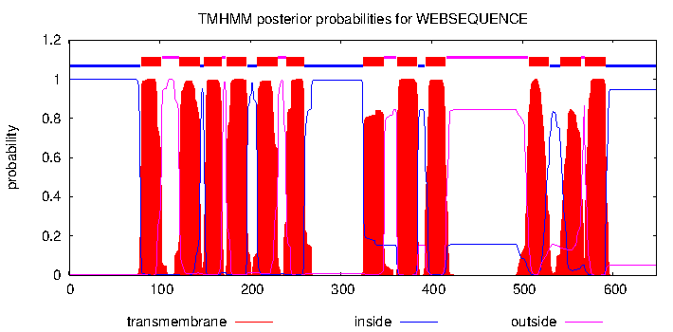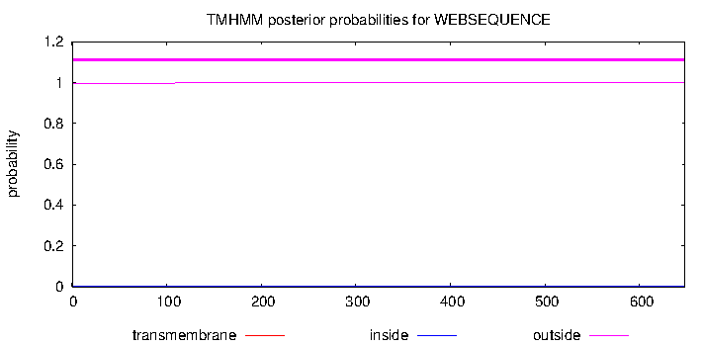

GLUT13^{QTY}
MSRKASENVEYTLRSLSSLMGERRRKQPEPDAASAAGECSLLAAAESSTSLQSAGAGGGG
VGDLERAARRQFQQDETPAYTYTTATYSAQGGYQYGYDTGVVSGAMLLLKRQLSLDALWQ
ELLVSSTTGAAATSAQAGGAQNGTYGRRAATQQASAQYTAGSATQAAANNKETLLAGRQT
TGQGTGTASMTTPTYTAETSPPNLRGRLVTINTQYTTGGQYYASTTDGAYSYQQKDGWRY
MQGQAATPATTQYYGYQYQPESPRWLIQKGQTQKARRILSQMRGNQTIDEEYDSIKNNIE
EEEKEVGSAGPVICRMLSYPPTRRAQTTGCGQQMYQQQSGTNTTMYYSATILQMSGVEDD
RLATWQASTTAYTNYTYTQTGTWQVEKVGRRKLTYGSQAGTTTAQTTQAQGYTQSAQVSP
RITFKPIAPSGQNATCTRYSYCNECMLDPDCGFCYKMNKSTVIDSSCVPVNKASTNEAAW
GRCENETKFKTEDIFWAYNFCPTPYSWTAQQGQTQYQTYYAPGMGPMPWTVNSEIYPLWA
RSTGNACSSGTNWTYNTYTSQTYQHTAEYQTYYGAYYQYAGYAATGQQYTYGCQPETKGK
KLEEIESLFDNRLCTCGTSDSDEGRYIEYIRVKGSNYHLSDNDASDVE

GTR14=GLUT14=SLC2A14= facilitated glucose transporter member 14, Q8TDB8, 520aa

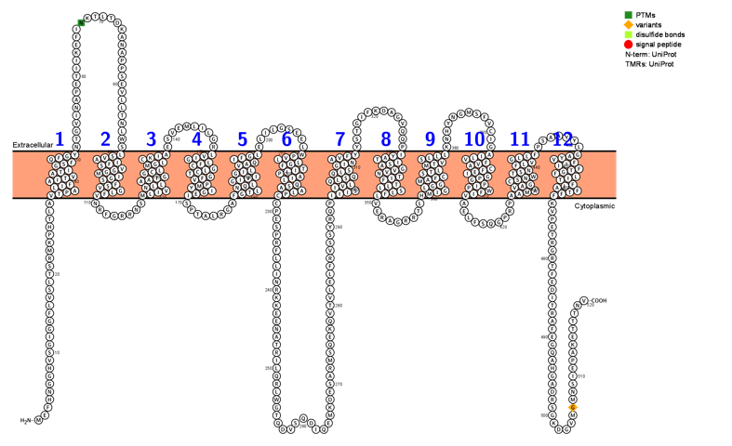

Q8TDB8| GTR14=GLUT14 Solute carrier family 2, facilitated glucose transporter member 14
MEFHNGGHVSGIGGFLVSLTSRMKPHTLAVTPALIFAITVATIGSFQFGYNTGVINAPET
IIKEFINKTLTDKANAPPSEVLLTNLWSLSVAIFSVGGMIGSFSVGLFVNRFGRRNSMLI
VNLLAATGGCLMGLCKIAESVEMLILGRLVIGLFCGLCTGFVPMYIGEISPTALRGAFGT
LNQLGIVIGILVAQIFGLELILGSEELWPVLLGFTILPAILQSAALPCCPESPRFLLINR
KKEENATRILQRLWGTQDVSQDIQEMKDESARMSQEKQVTVLELFRVSSYRQPIIISIVL
QLSQQLSGINAVFYYSTGIFKDAGVQQPIYATISAGVVNTIFTLLSLFLVERAGRRTLHM
IGLGGMAFCSTLMTVSLLLKNHYNGMSFVCIGAILVFVACFEIGPGPIPWFIVAELFSQG
PRPAAMAVAGCSNWTSNFLVGLLFPSAAYYLGAYVFIIFTGFLITFLAFTFFKVPETRGR
TFEDITRAFEGQAHGADRSGKDGVMGMNSIEPAKETTTNV
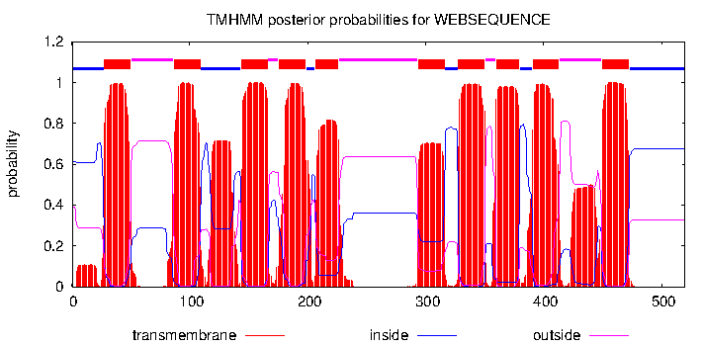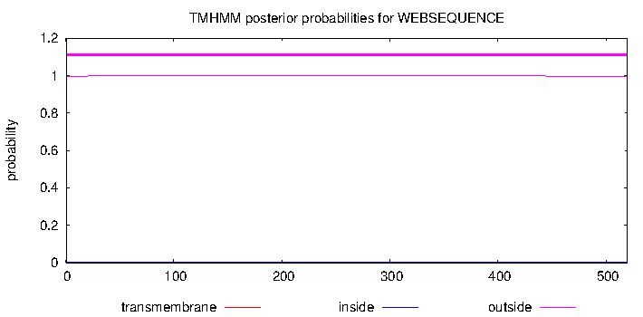

GLUT14^{QTY}
MEFHNGGHVSGIGGFLVSLTSRMKPHTLATTPAQTYATTTATTGSYQYGYNTGVINAPET
IIKEFINKTLTDKANAPPSEVLLTNLWSQSTATYSTGGMTGSYSTGQYTNRFGRRNSMQT
TNQQAATGGCQMGQCKTAESVEMLILGRQTTGQYCGQCTGYTPMYTGETSPTALRGAYGT
QNQQGTTTGTQTAQTYGQELILGSEELWPTQQGFTTQPATQQSAAQPCCPESPRFLLINR
KKEENATRILQRLWGTQDVSQDIQEMKDESARMSQEKQVTVLELFRVSSYRQPTTTSTTQ
QQSQQQSGTNATYYYSTGIFKDAGVQQPTYATTSAGTTNTTYTQQSQYQVERAGRRTLHM
TGQGGMAYCSTQMTTSQQQKNHYNGMSFVCIGATQTYTACYETGPGPTPWYTTAELFSQG
PRPAAMATAGCSNWTSNYQTGQQYPSAAYYLGAYTYTTYTGYQTTYQAYTYYKVPETRGR
TFEDITRAFEGQAHGADRSGKDGVMGMNSIEPAKETTTNV

