Supplemental Information - Resolving the Fine Structure in the EnergyLandscapes of Repeat Proteins
Murilo N. Sanches,†,‡ R. Gonzalo Parra,^{†,fj} Rafael G. Viegas,§,‡ Antonio B. Oliveira Jr.,^{ǁ} Peter G. Wolynes,^{ǁ} Diego U. Ferreiro,∗,⊥ and Vitor B. P. Leite∗,‡
†These authors contributed equally to this work
‡Department of Physics, S˜ao Paulo State University (UNESP), Institute of Biosciences, Humanities and Exact Sciences, S˜ao Jos´e do Rio Preto, SP, 15054-000, Brazil fjEuropean Molecular Biology Laboratory (EMBL), Heidelberg, 69117, Germany
§Federal Institute of Education, Science and Technology of S˜ao Paulo (IFSP), Catanduva,
SP, 15.808-305, Brazil
ǁCenter for Theoretical Biological Physics, Rice University, Houston, TX, USA
⊥Instituto de Qu´ımica Biol´ogica de la Facultad de Ciencias Exactas y Naturales, C1428EGA Buenos Aires, Argentina

E-mail: ferreiro@qb.fcen.uba.ar; vitor.leite@unesp.br

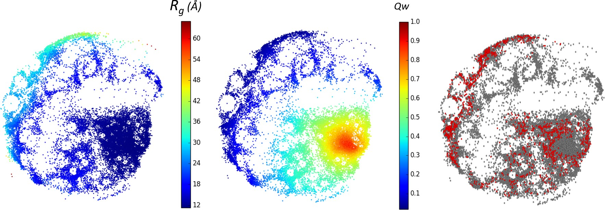

Figure S1: ELViM 2D projection of the conformational phase space of 3ANK as (A) a func- tion of the radius of gyration and (b) a function of Qw coordinate. (C) Projection showing the conformations obtained with two different simulations: the unbiased conformations in red, and the biased conformations in grey.

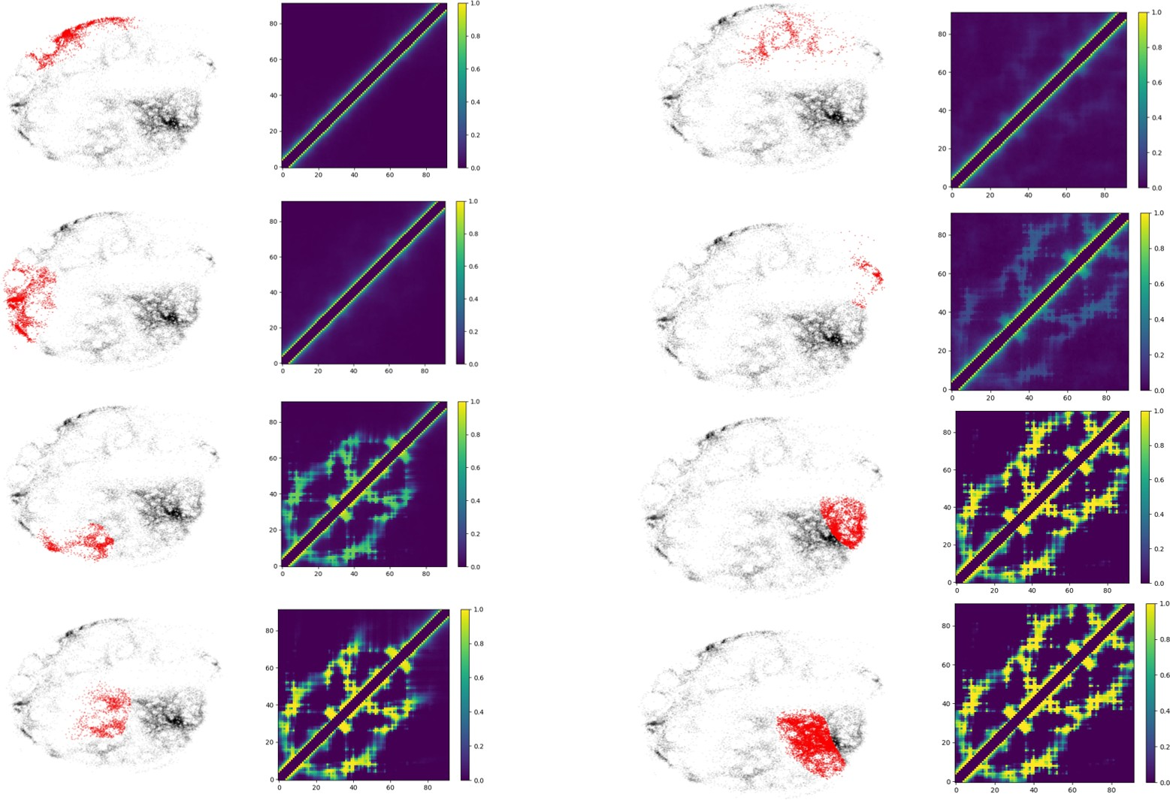

Figure S2: Mean contact maps of the 3ANK structures corresponding to the different regions of the ELViM projection (highlighted in red).

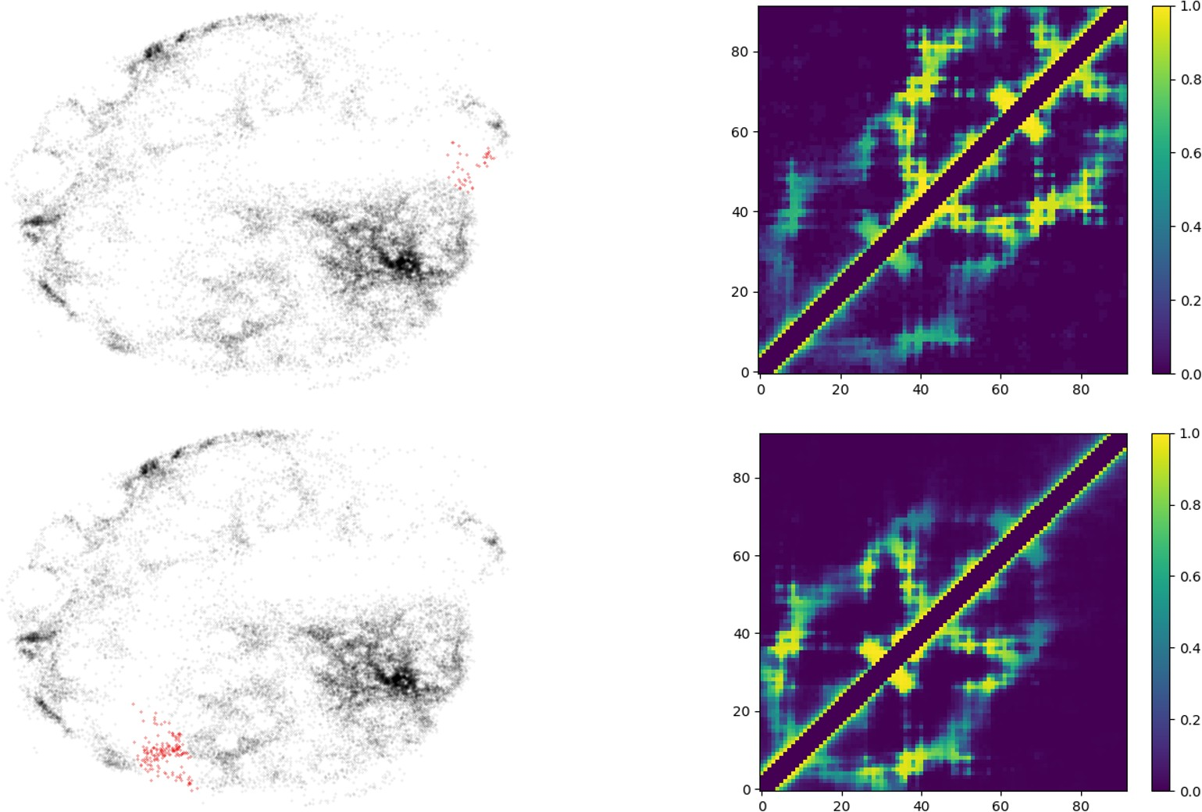

Figure S3: Mean contact maps of the 3ANK transition states with the same values of global Qo. The difference between these conformations combined with the fact that they have similar Qo values is the reason behind the apparent backtracking.

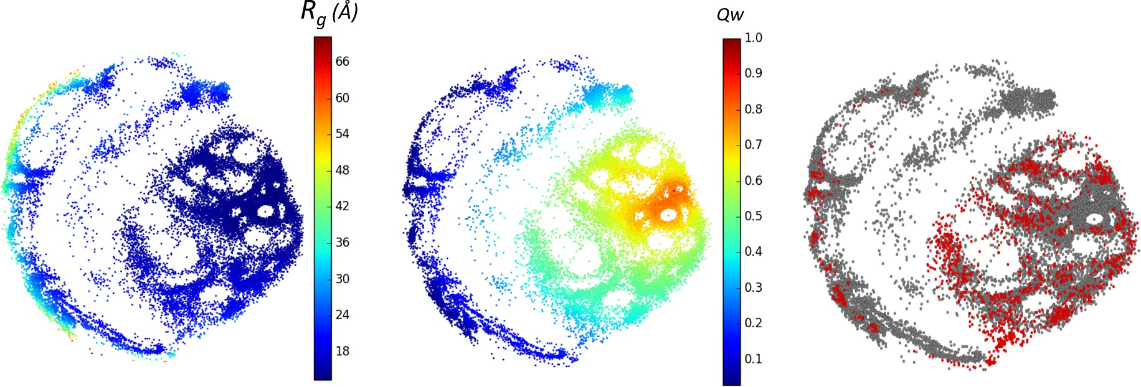

Figure S4: ELViM 2D projection of the conformational phase space of 4ANK as (A) a function of the radius of gyration and (b) a function of Qw coordinate. (c) Projection showing the conformations obtained with two different simulations: the unbiased conformations in red, and the biased conformations in grey.

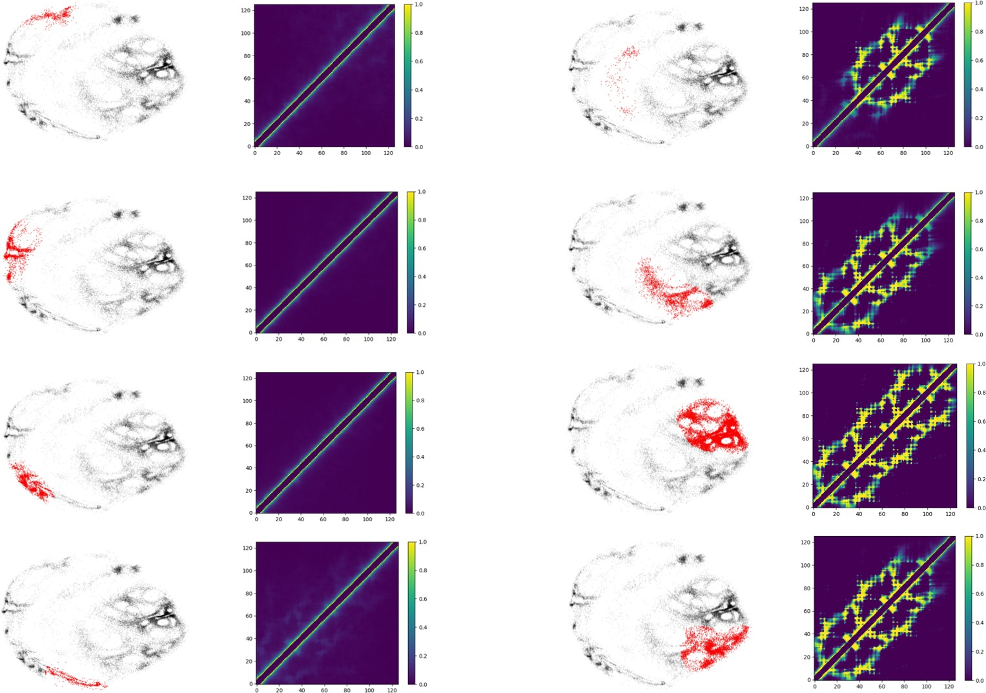

Figure S5: Mean contact maps of the 4ANK structures corresponding to the different regions of the ELViM projection (highlighted in red).

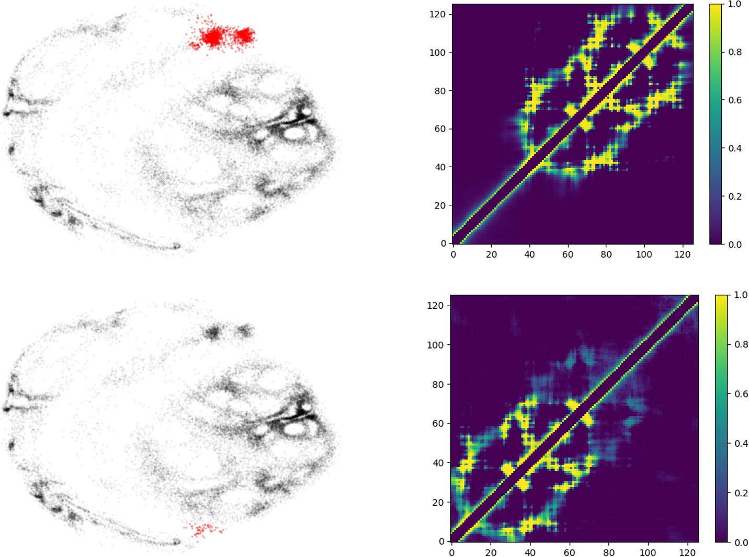

Figure S6: Mean contact maps of the 4ANK transition states with the same values of global Qo. The difference between these conformations combined with the fact that they have similar Qo values is the reason behind the apparent backtracking.

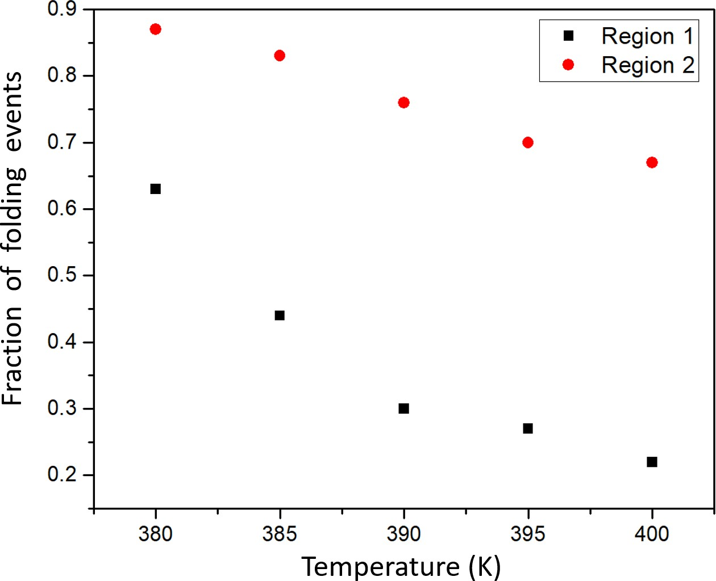

Figure S7: Fraction of folding events for region 1 and region 2 of the 4ANK for each different temperature.

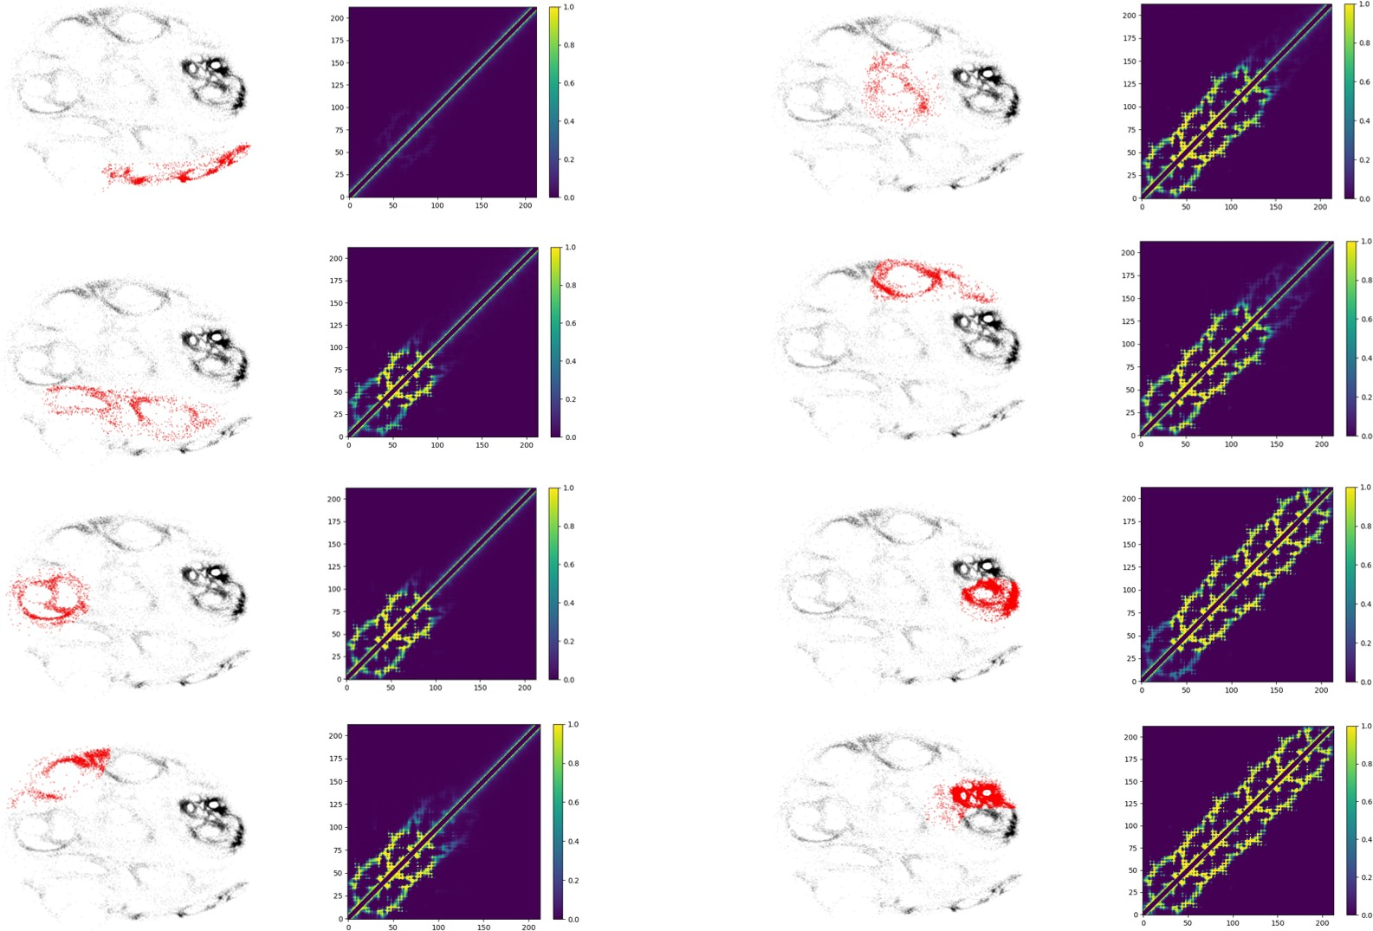

Figure S8: Mean contact maps of the 6ANK structures corresponding to the different regions of the ELViM projection (highlighted in red).

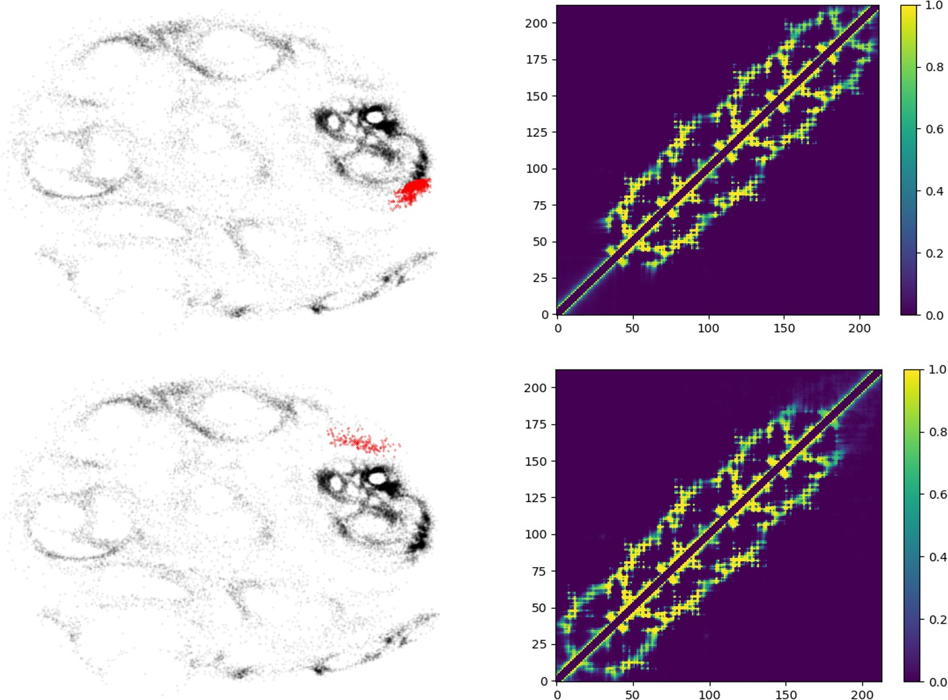

Figure S9: Mean contact maps of the 6ANK transition states with the same values of global Qo. The difference between these conformations combined with the fact that they have similar Qo values is the reason behind the apparent backtracking.

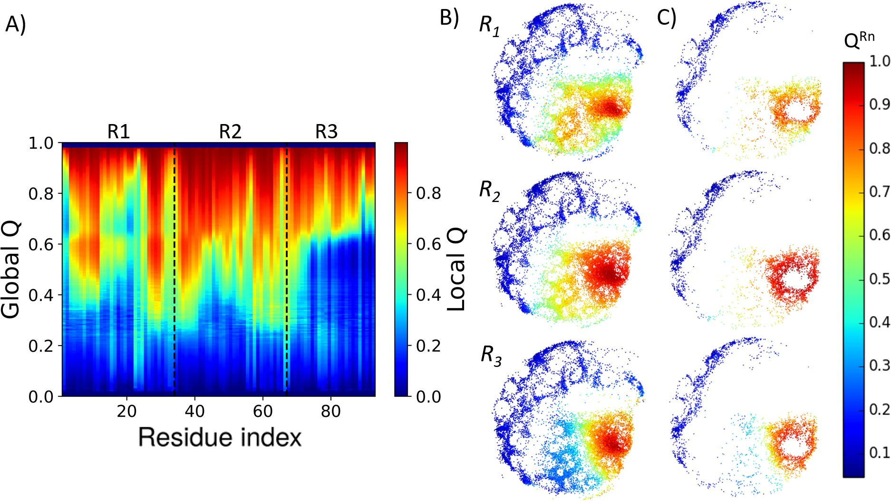

Figure S10: (a) Degree of folding of each residue as a function of Qo. The color indicates the average local Qo^{i} for a specific residue i over the entire set of structures of a given global Qo for 3ANK. (b) 2-dimensional ELViM projections for 3ANK biased trajectories, as a function of Qo^{Rn} for each repeat. (c) 2-dimensional ELViM projections for 3ANK unbiased trajectories, as a function of Qo^{Rn} for each repeat

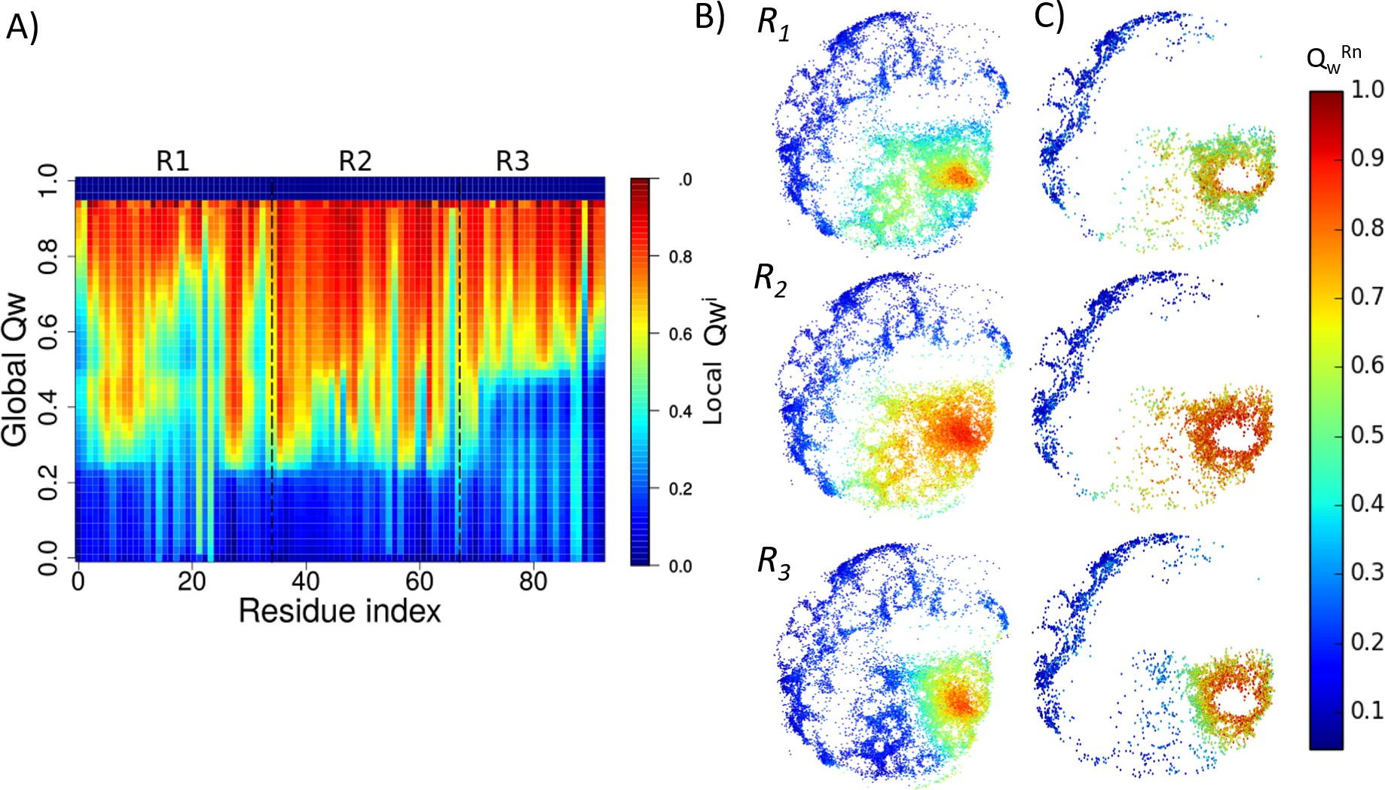

Figure S11: (a) Degree of folding of each residue as a function of Qw. The color indicates the average local Qw^{i} for a specific residue i over the entire set of structures of a given global Qw for 3ANK. (b) 2-dimensional ELViM projections for 3ANK biased trajectories, as a function of Qw^{Rn} for each repeat. (c) 2-dimensional ELViM projections for 3ANK unbiased trajectories, as a function of Qw^{Rn} for each repeat.

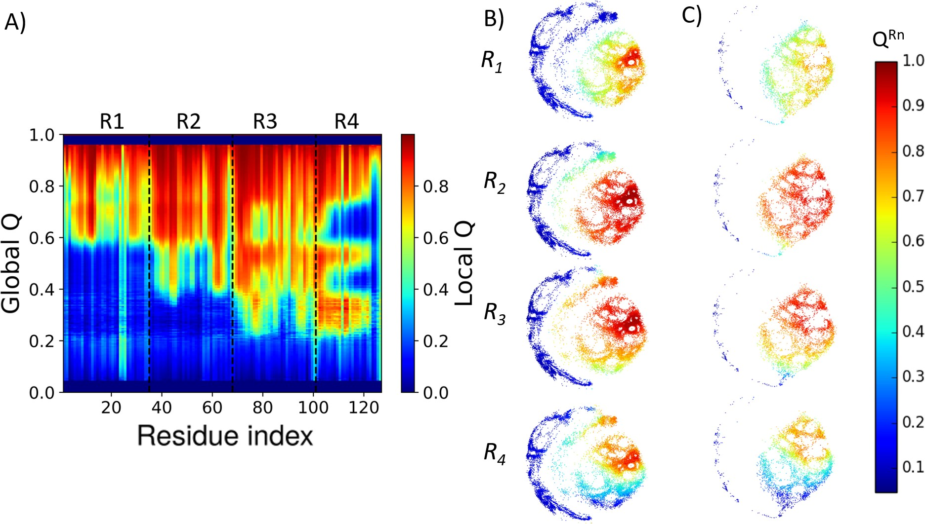

Figure S12: Analyses of the 4ANK repeats formation. (a) Degree of folding of each residue as a function of Qo. The color indicates the average local Qo^{i} for a specific residue i over the entire set of structures of a given global Qo for 4ANK. (b) 2-dimensional ELViM projections for 4ANK biased trajectories, as a function of Qo^{Rn} for each repeat. (c) 2-dimensional ELViM projections for 4ANK unbiased trajectories, as a function of Qo^{Rn} for each repeat.

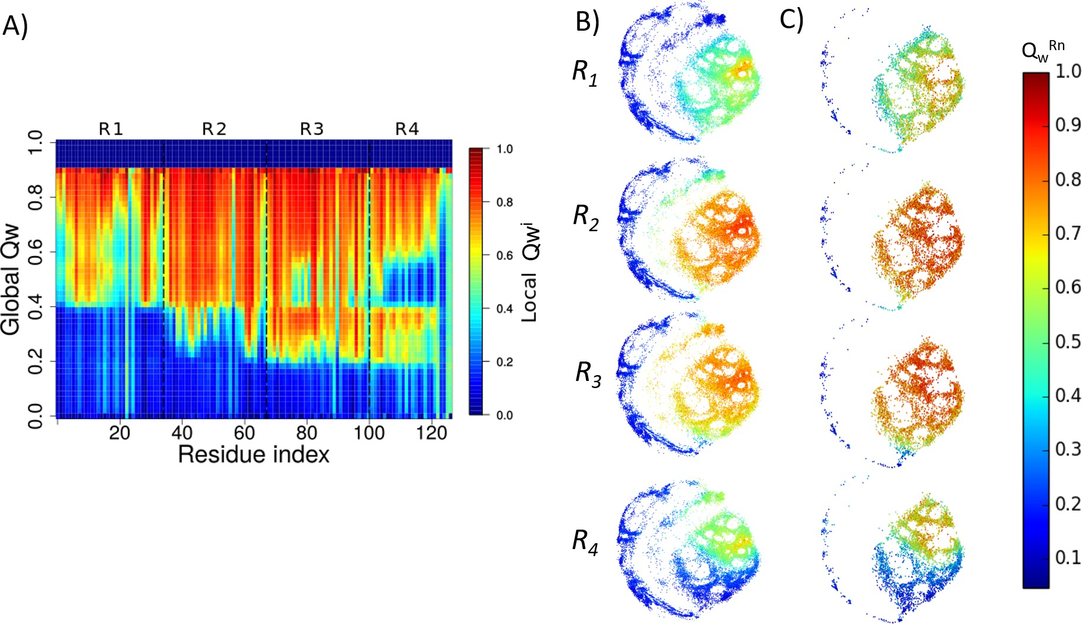

Figure S13: Analyses of the 4ANK repeats formation. (a) Degree of folding of each residue as a function of Qw. The color indicates the average local Qw^{i} for a specific residue i over the entire set of structures of a given global Qw for 4ANK. (b) 2-dimensional ELViM projections for 4ANK biased trajectories, as a function of Qw^{Rn} for each repeat. (c) 2- dimensional ELViM projections for 4ANK unbiased trajectories, as a function of Qw^{Rn} for each repeat

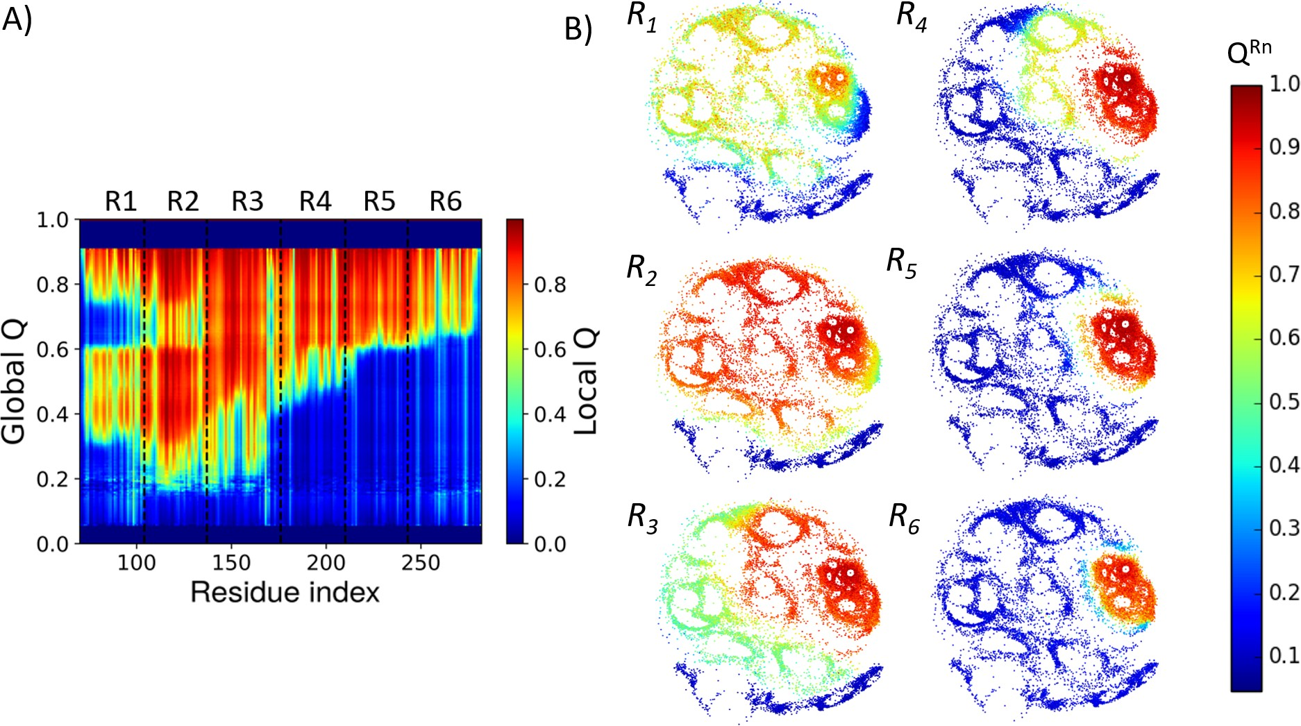

Figure S14: (a) Degree of folding of each residue as a function of Qo. The color indicates the average local Qo^{i} for a specific residue i over the entire set of structures of a given global Qo for 6ANK. (b) 2-dimensional ELViM projections of 6ANK biased trajectories, as a function of Qo^{Rn} for each repeat.

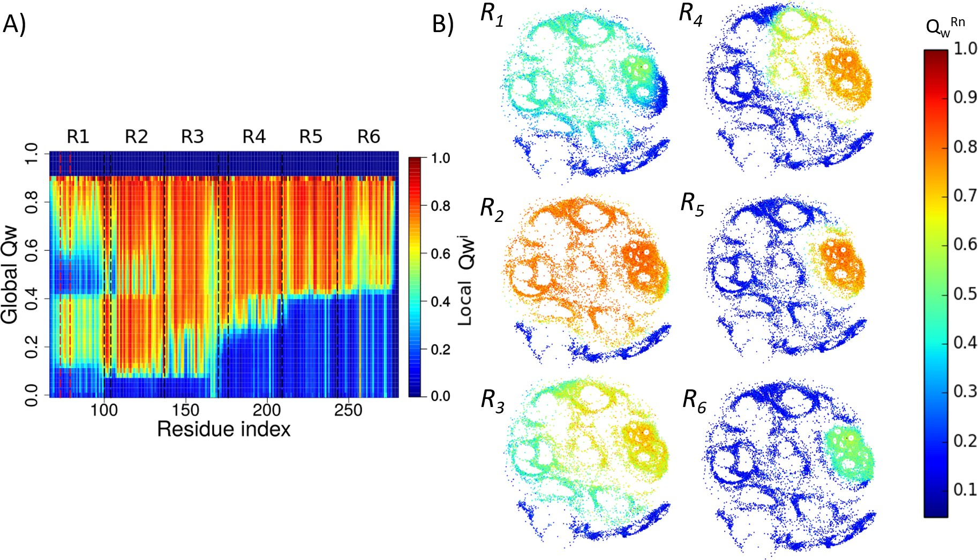

Figure S15: (a) Degree of folding of each residue as a function of Qw. The color indicates the average local Qw^{i} for a specific residue i over the entire set of structures of a given global Qw for 6ANK. (b) 2-dimensional ELViM projections of 6ANK biased trajectories, as a function of Qw^{Rn} for each repeat.

