Supplementary Information

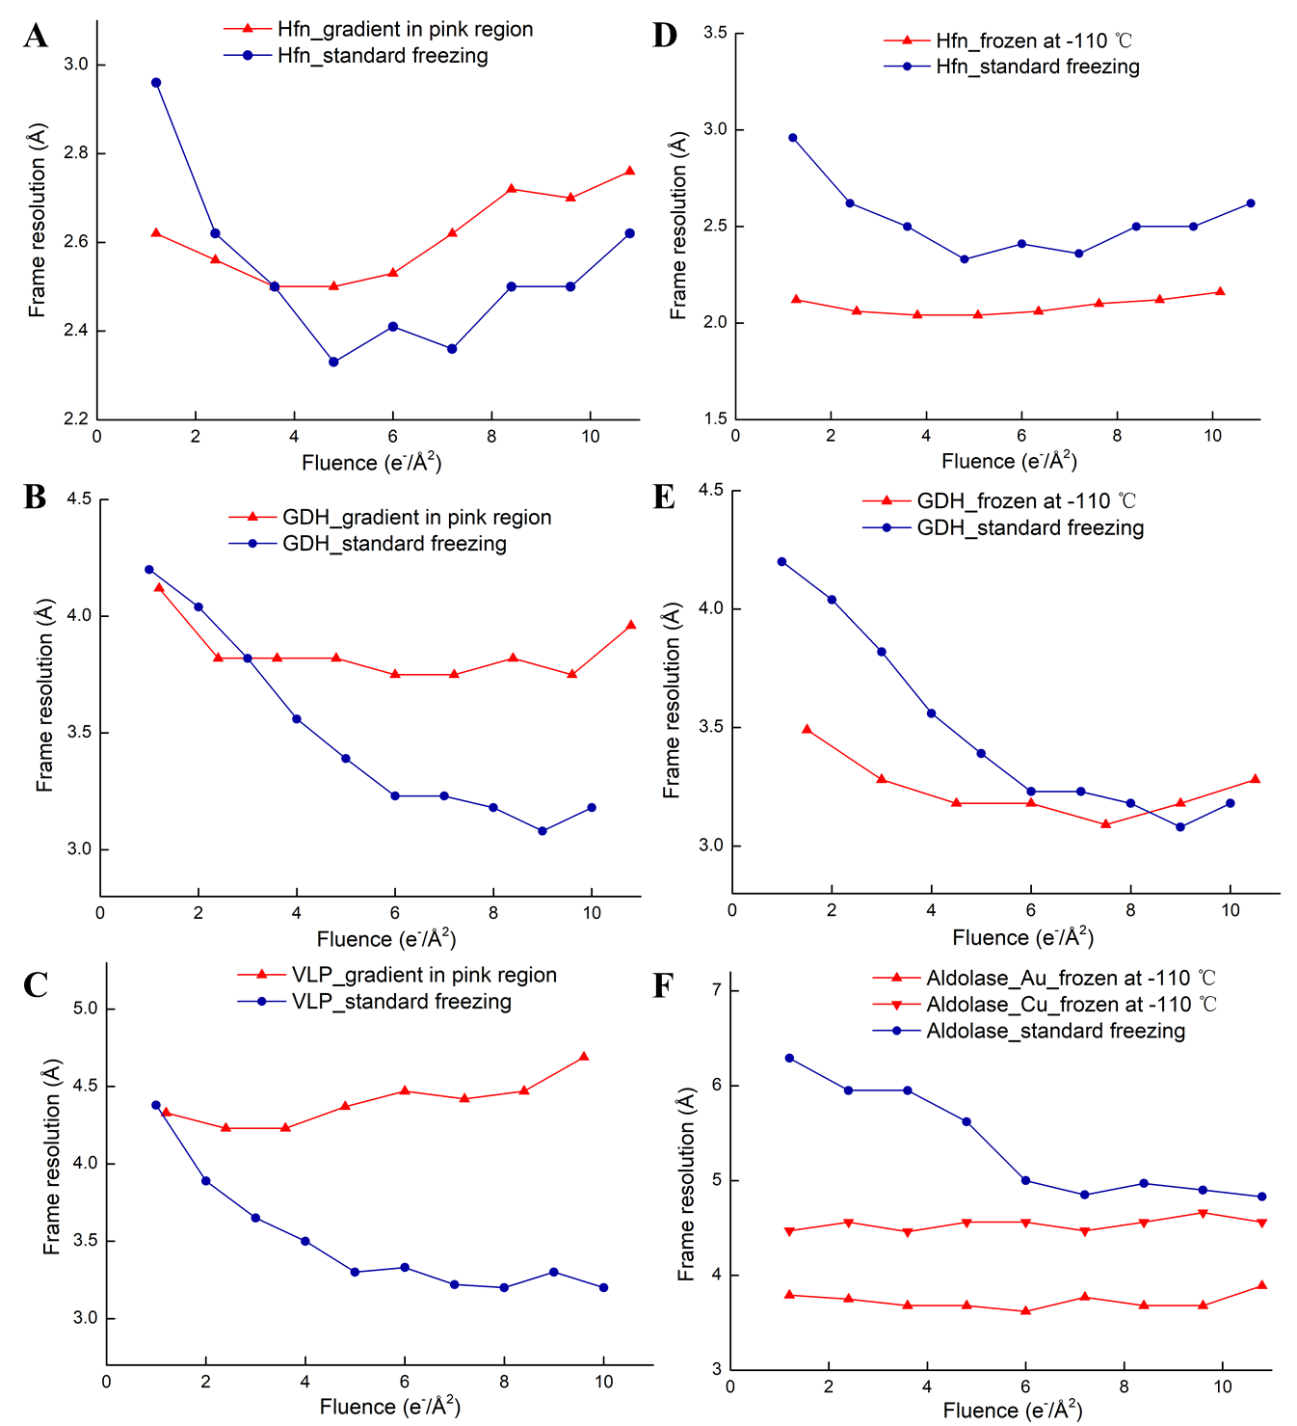
Figure S1. Comparison of resolution of per-frame reconstruction of various samples frozen under different freezing conditions. A-C. The comparison of per-frame reconstructions of datasets collected in pink region (red curves) and that collected in grid frozen at -183 ℃ in conventional conditions (blue curves) without intentionally moving the tweezers towards the center of grid. D-E. The comparison of per-frame reconstructions of datasets frozen at -110 ℃ (red curves) and frozen at -183 ℃ in conventional freezing conditions (blue curves).

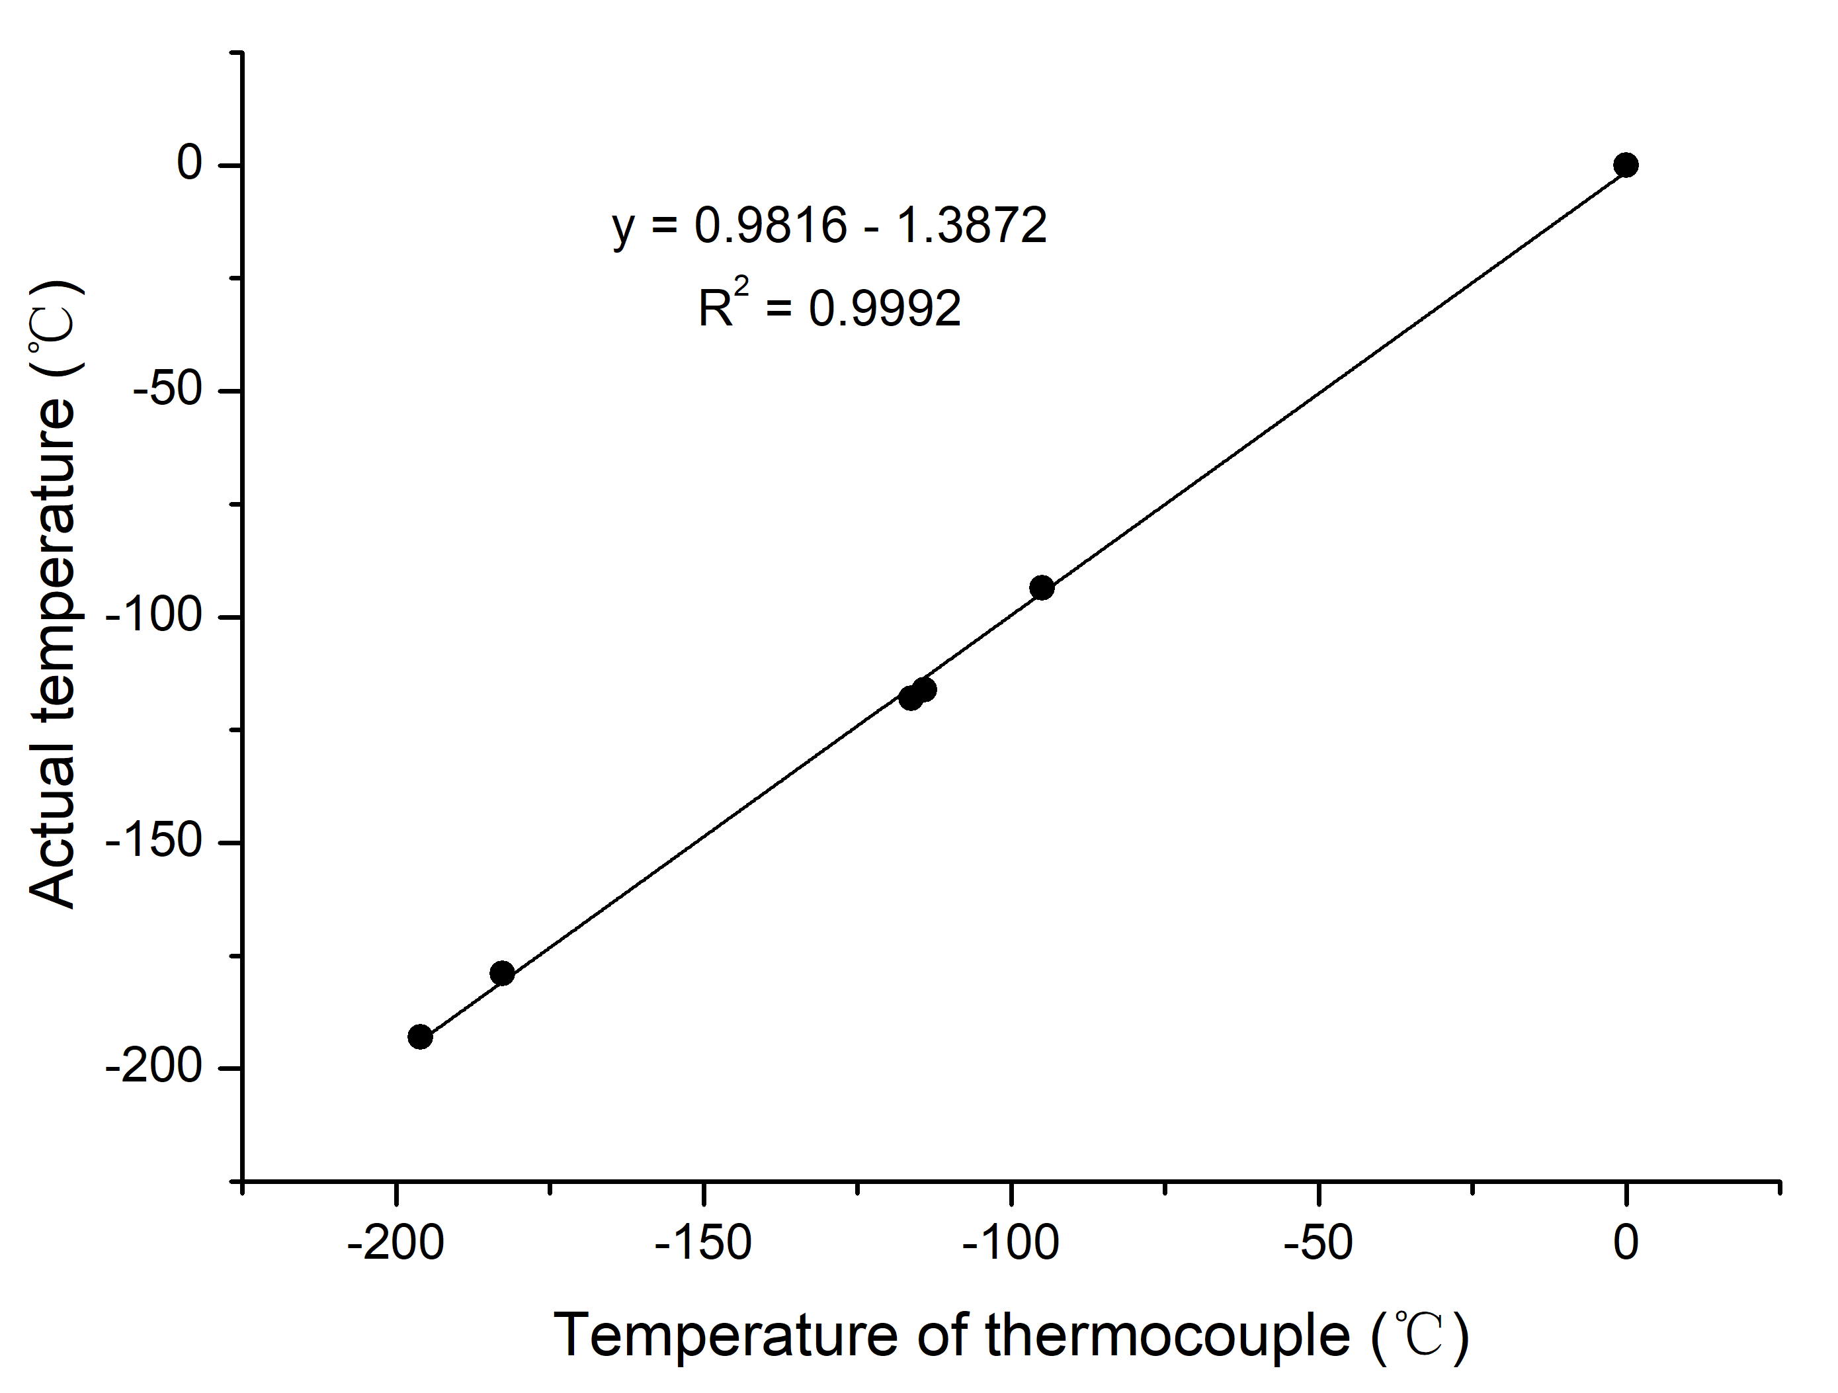
Figure S2. The calibration curve and fitting formula of the thermocouple. The actual temperature was measured from the liquid nitrogen (-196 °C) and the solid liquid phase of pure water (0 °C), acetone (-95 °C), ethanol (-114 °C), diethyl ether (-116 °C) and ethane (-183 °C) at an atmospheric pressure, respectively. Six data points were well fitted to an exponential function (black).

Figure S3. Samples including apo-ferritin, GDH aldolase and β-galactosidase embedded in vitreous ice frozen at −110 °C.

Samples | T (℃) | Grid | Device  of  plunge | Electron microscope | M ª | Binned pixel size  (Å/pixel) | Dose rate  (e⁻/Å²/s) | Total  dose  (e⁻/Å²) | BIS ^{b} (Y/N) | Energy filter  (eV) | Images number | Particles number | Resolution  (Å)
apo-  ferritin | -183 | NiTi film  on Au grid | Gatan CP3 | Titan Krios | 165000 | 0.82 | 12 | 60 | N | N | 287 | 68501 | 2.2
GDH | -183 | carbon film  on Cu grid | Gatan CP3 | Titan Krios G3 | 165000 | 0.82 | 12 | 60 | Y | 20 | 58 | 6363 | 3.3
VLP | -183 | NiTi film  on Au grid | Leica EMGP | Titan Krios G2 | 165000 | 0.82 | 12 | 60 | N | 20 | 54 | 1148 | 3.6
apo-  ferritin | -150 | NiTi film  on Au grid | Gatan CP3 | Titan Krios G2 | 165000 | 0.82 | 12 | 60 | N | 20 | 382 | 76573 | 2.4
apo-  ferritin | -110 | NiTi film  on Au grid | Gatan CP3 | Titan Krios G2 | 265000 | 0.515 | 25.1 | 60 | N | 20 | 1370 | 296695 | 1.9
aldolase | -110 | NiTi film  on Au grid | Gatan CP3 | Titan Krios | 165000 | 0.82 | 12 | 60 | N | N | 313 | 46253 | 3.1
aldolase | -110 | carbon film  on Cu grid | Gatan CP3 | Titan Krios G2 | 165000 | 0.82 | 12 | 60 | N | 20 | 592 | 158416 | 4.0
GDH | -110 | carbon film  on Cu grid | Gatan CP3 | Titan Krios G2 | 165000 | 0.82 | 12 | 60 | N | 20 | 285 | 49665 | 3.0
apo-  ferritin | standard | NiTi film  on Au grid | VitroBot | Titan Krios G2 | 165000 | 0.82 | 12 | 60 | N | 20 | 560 | 103770 | 2.1
GDH | standard | carbon film  on Cu grid | Gatan CP3 | Titan Krios G2 | 165000 | 0.82 | 12 | 60 | N | 20 | 790 | 83207 | 2.8
VLP | standard | carbon film  on Cu grid | Leica EMGP | Titan Krios G2 | 130000 | 1.04 | 9.2 | 60 | N | 20 | 587 | 18882 | 3.0
aldolase | standard | NiTi film  on Au grid | Gatan CP3 | Titan Krios G2 | 165000 | 0.82 | 12 | 60 | N | 20 | 295 | 55989 | 4.0
Table S1. Information on cryo-EM specimen preparation, data collection and structure determination for all samples.
ª Magnification.
^{b} BIS is beam-image shift data collection (Wu, Huang, Cheng, Zhu, & Zhang, 2019).

Table S2. The temperature calibration of EMGP and CP3 using the temperature thermocouple.
EMGP |  |  | CP3
Readings of EMGP/°C | Actual temperatures /°C | The differences between EMGP and actual temperature/°C | Readings of CP3/°C | Actual temperatures /°C | The differences between CP3 and actual temperature/°C
-180 | -181 | -1 | -180 | -186 | 6
-170 | -171 | -1 | -170 | -176 | 6
-160 | -160 | 0 | -160 | -166 | 6
-150 | -150 | 0 | -150 | -156 | 6
-140 | -140 | 0 | -140 | -146 | 6
-130 | -130 | 0 | -130 | -136 | 6
-120 | -120 | 0 | -120 | -125 | 5
-110 | -110 | 0 | -110 | -115 | 5
-100 | -100 | 0 | -100 | -105 | 5
-90 | -90 | 0 | -90 | -95 | 5
-80 | -80 | 0 | -80 | -85 | 5

Wu, C., Huang, X., Cheng, J., Zhu, D., & Zhang, X. (2019). High-quality, high-throughput cryo-electron microscopy data collection via beam tilt and astigmatism-free beam-image shift. Journal of structural biology.

