Supplementary Information

Ultrafast Enzymatic Digestion of Deoxyribonucleic Acid in Aqueous

Microdroplets for Sequence Discrimination and Identification

Xiaoqin Zhong1,2, Hao Chen3, Richard N. Zare1,4*

1Department of Chemistry, Fudan University, Shanghai 200438, China

2Department of Environment and Chemical Engineering, Shanghai University, Shanghai 200444, China
3Department of Chemistry & Environmental Science, New Jersey Institute of

Technology, Newark, NJ, 07102, USA

4Department of Chemistry, Stanford University, Stanford, California 94305, USA

*Corresponding authors:

Richard N. Zare, E-mail: rnz@stanford.edu
Supplementary Table S1: Digestion extent of different DNA sequences by DNase I
with ESSI-MS. A positive voltage of 3 kV was applied for the digestion and detection.

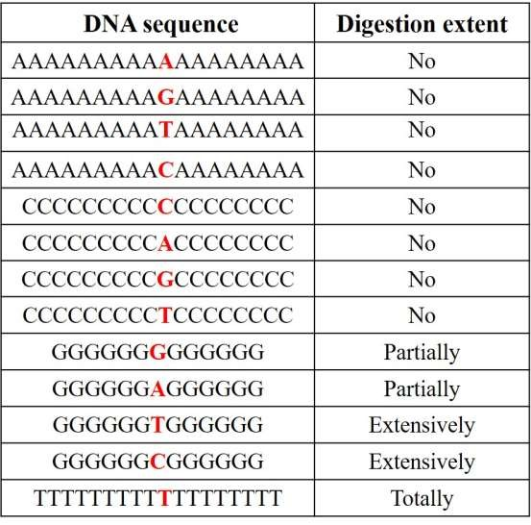
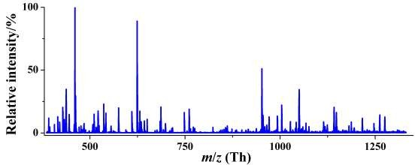
Supplementary Figure S1: Mass spectrum of fragments identified from digests of
DNA sequence containing pure T by ESSI-MS applied with a positive voltage (+3 kV).
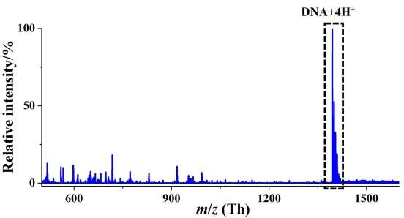
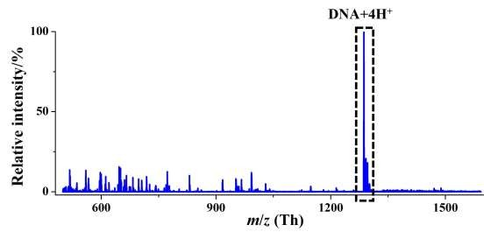
Supplementary Figure S2: Mass spectrum of fragments identified from digests of DNA sequence containing pure A incubated in bulk phase overnight at room temperature. ESSI-MS was applied with a positive voltage (+3 kV) for detection.

Supplementary Figure S3: Mass spectrum of fragments identified from digests of DNA sequence containing pure C incubated in bulk phase overnight at room temperature. ESSI-MS was applied with a positive volta

