Supplementary data for
NCodR: A multi-class SVM classification to distinguish non-coding RNAs in Viridiplantae

Chandran Nithin^{1,2+}, Sunandan Mukherjee^{1,3+}, Jolly Basak⁴ and Ranjit Prasad Bahadur^{1,}*

¹Computational Structural Biology Lab, Department of Biotechnology, Indian Institute of Technology Kharagpur, 721302, India
²Laboratory of Computational Biology, Faculty of Chemistry, Biological and Chemical Research Centre, University of Warsaw, Warsaw 02-089, Poland
³Laboratory of Bioinformatics and Protein Engineering, International Institute of Molecular and Cell Biology in Warsaw, ul. Ks. Trojdena 4, PL-02-109 Warsaw, Poland
⁴Department of Biotechnology, Visva-Bharati, Santiniketan, 731235, India
⁺These authors have contributed equally and should be considered joint first authors.
*Corresponding author
Corresponding author: Ranjit Prasad Bahadur

Figure S1 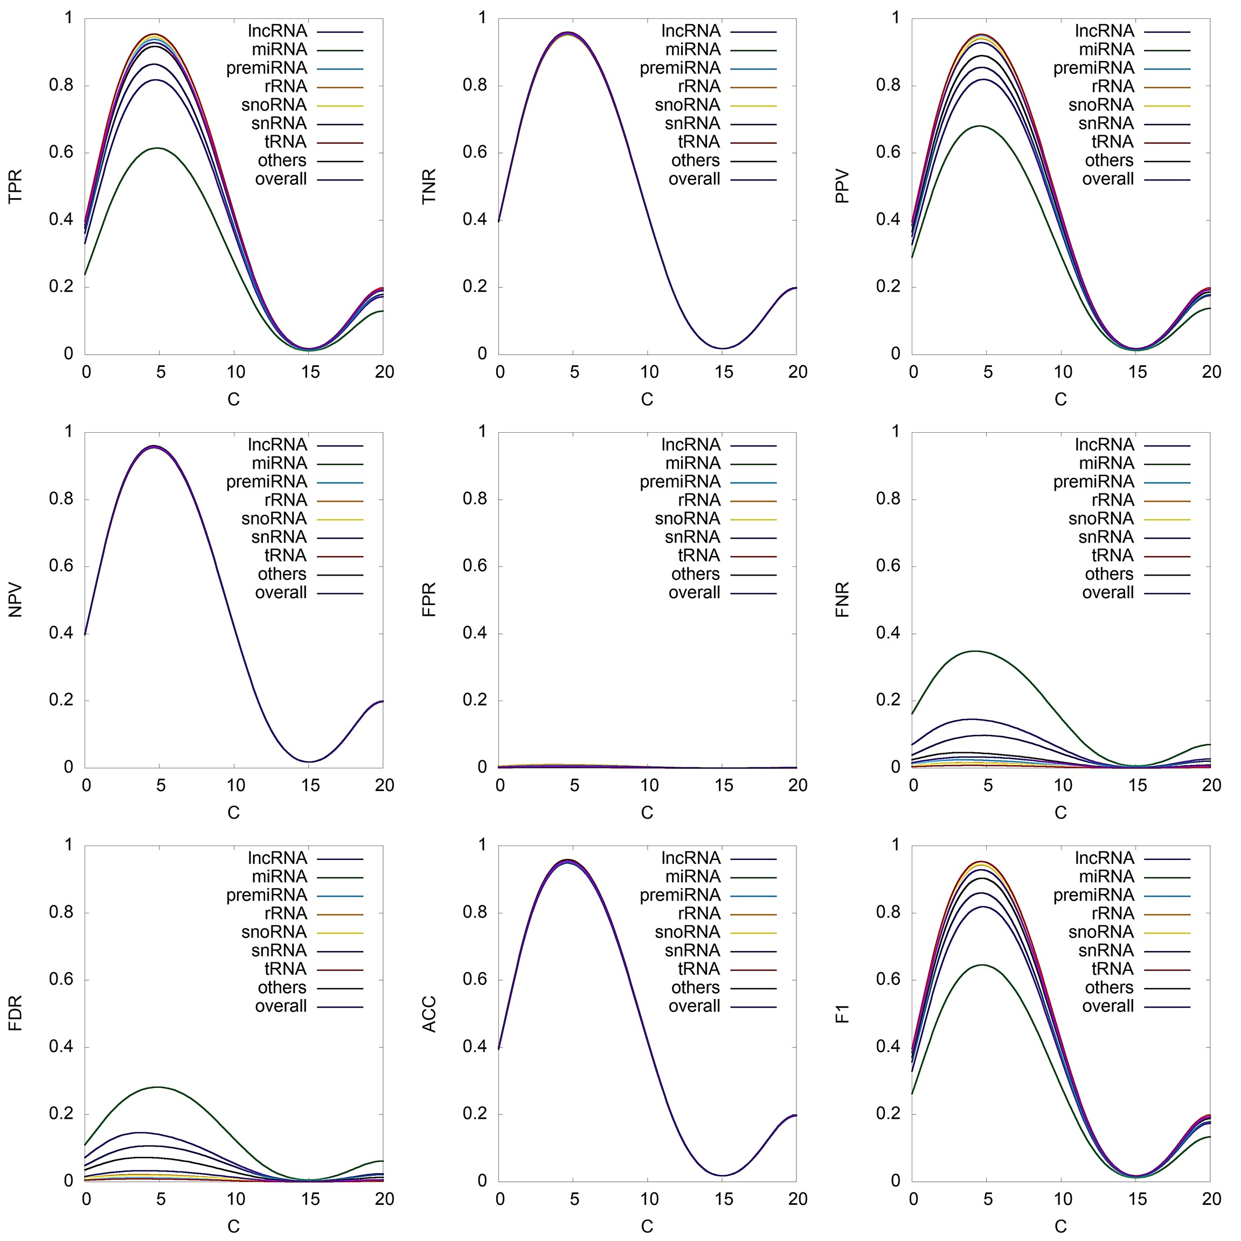
Figure S1: Performance measures of the SVM-RBF classifier for different values of C. For a constant value of hyperparameter gamma (gamma=0.003), the SVM-RBF classifier was trained for different values of C. The curves were smoothened using Gaussian kernel density estimates in the gnuplot program.

Figure S2
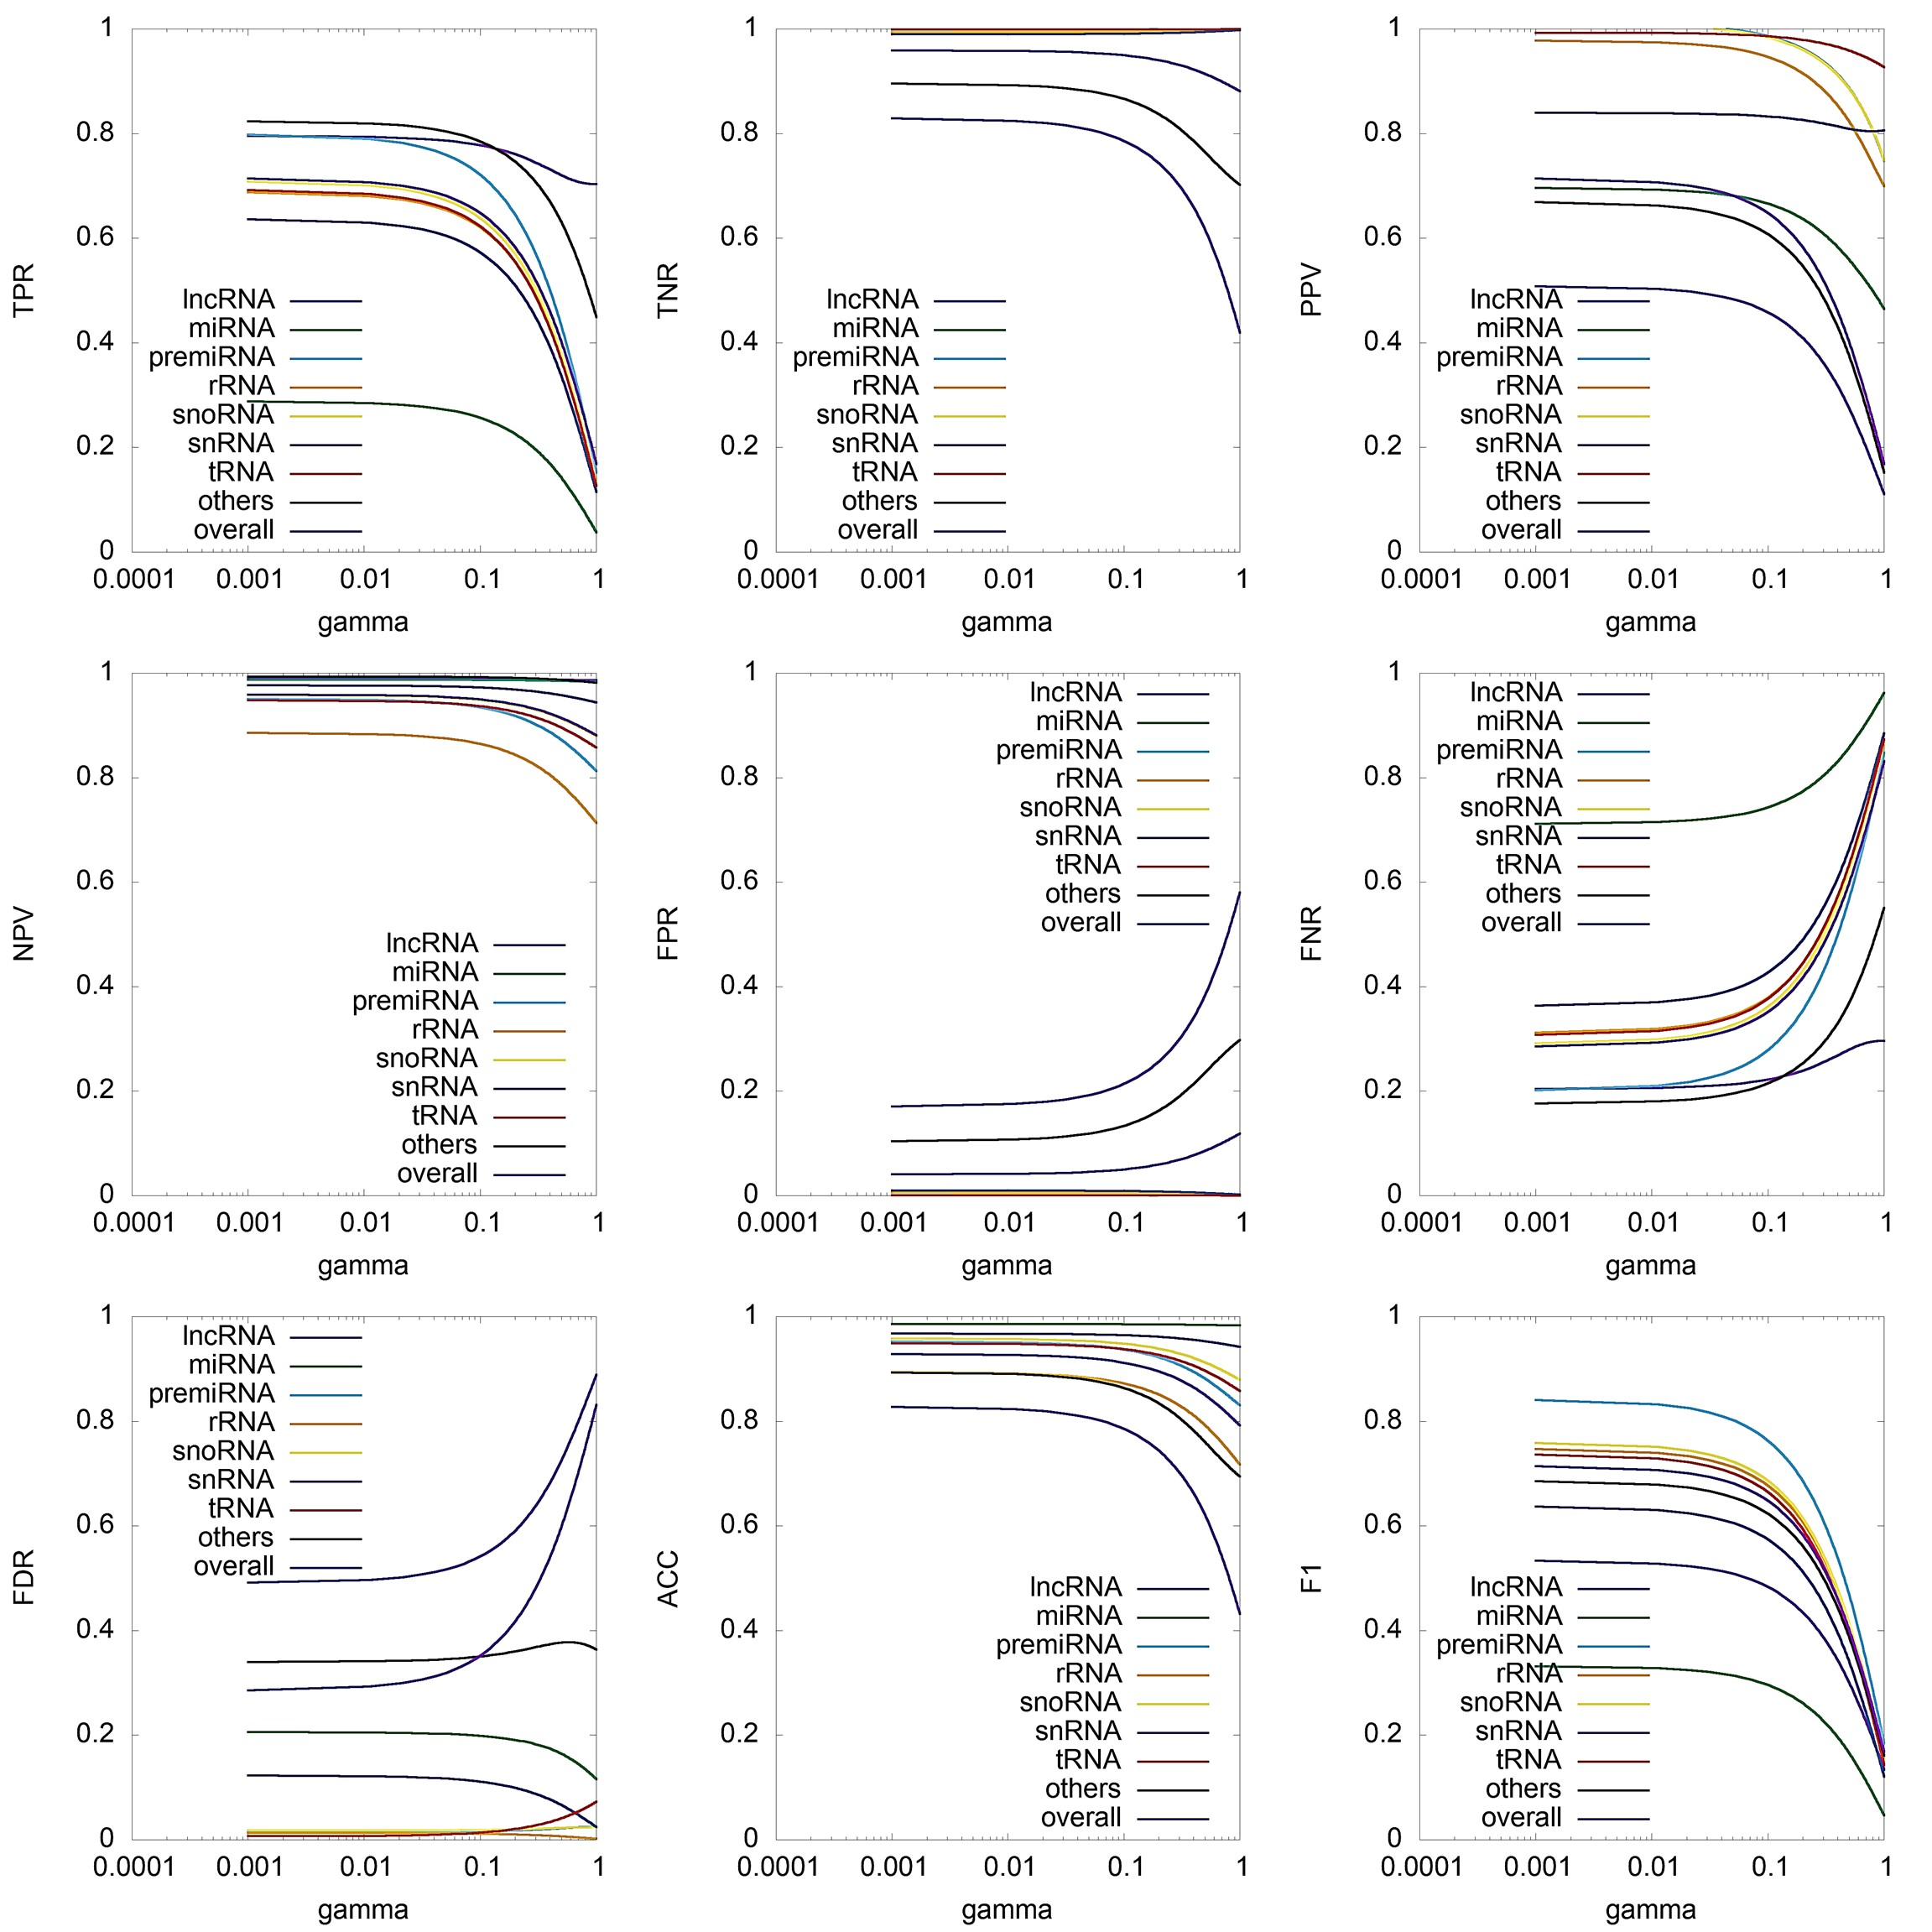
Figure S2: Performance measures of the SVM-RBF classifier for different values of gamma. For a constant value of hyperparameter C (C=8), the SVM-RBF classifier was trained for different gamma values. The curves were smoothened using acspline interpolation in the gnuplot program.

