Appendix A: Eigenvectors for each source and target wall type studied in section 5.
Table 5. Eigenvectors for ${0.2}_{source}→{0.2}_{target}$
 | Source (SSM)  0.2m, red brick |  | Target (DMD)  0.2m, red brick |  |  | Target (POD)  0.2m, red brick
 | $$V_{s1}$$ | $$V_{s2}$$ | $$V_{t1}$$ | $$V_{t2}$$ |  | $$V_{t1}$$ | $$V_{t2}$$
$$x$$ | 0.985 | 0.172 | -0.837 |  | 0.011 | -0.687 | -0.727
$$y$$ | -0.172 | 0.985 | -0.419 |  | -0.106 | -0.727 | 0.687

Table 6. Eigenvectors for ${0.6}_{source}→{0.2}_{target}$
 | Source (SSM)  0.6m, red brick |  | Target (DMD)  0.2m, red brick |  |  | Target (POD)  0.2m, red brick
 | $$V_{s1}$$ | $$V_{s2}$$ | $$V_{t1}$$ | $$V_{t2}$$ |  | $$V_{t1}$$ | $$V_{t2}$$
$$x$$ | 0.998 | 0.060 | -0.837 |  | 0.011 | -0.687 | -0.727
$$y$$ | 0.060 | 0.998 | -0.419 |  | -0.106 | -0.727 | 0.687

Table 7. Eigenvectors for ${0.8}_{source}→{0.3}_{target}$
 | Source (SSM)  0.8m, red brick |  | Target (DMD)  0.3m, concrete |  |  | Target (POD)  0.3m, concrete
 | $$V_{s1}$$ | $$V_{s2}$$ | $$V_{t1}$$ | $$V_{t2}$$ |  | $$V_{t1}$$ | $$V_{t2}$$
$$x$$ | 0.999 | 0.045 | -0.823 |  | -0.487 | -0.690 | -0.724
$$y$$ | -0.045 | 0.999 | -0.025 |  | -0.192 | -0.724 | 0.690

Appendix B: Plots for other forecast studies.
Note that for the cross-domain generalisation scenarios in Figure 17 and Figure 12, we assume 3000 hours of training data (vs 2000hours in previous studies) to demonstrate the effect of increased training data on the accuracy of longer-time forecast.

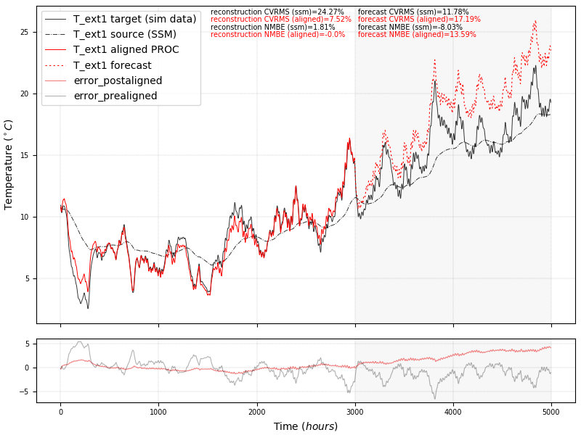
Figure 11. Cross-domain generalization scenario: 0.6m wall SSM (source) to 0.2m wall data (target). The target subspace was derived via POD (orthogonal eigenvectors).
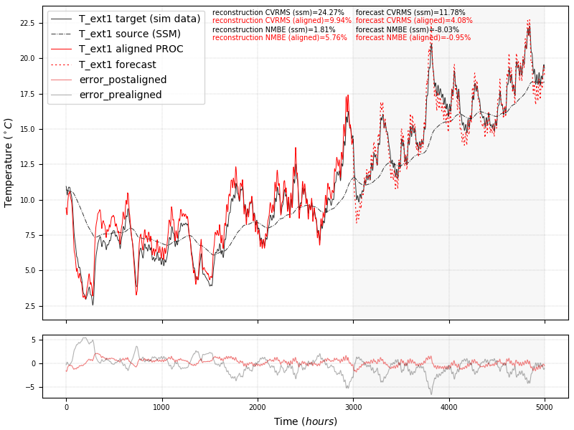
Figure 12. Cross-domain generalization scenario: 0.6m wall SSM (source) to 0.2m wall data (target). The target subspace was derived via DMD (nonorthogonal eigenvectors).
Appendix C: Noisy target measurement data.
We introduce noise sampled from a random distribution with a mean of 0.5 and a standard deviation of 0.9, to the measurement data from the scenario discussed in section 5.2. Figure 13 and Figure 14 demonstrate the subspace alignment results in the subspace-embedded and the lifted space, respectively. We can observe how the Physics-based SDA approach is able to learn a transformation between the source and a noise-filtered target signal that generalises successfully beyond measured timesteps. This is largely due to the SVD decomposition of the noisy signal when applying POD to the target data where the SVD acts as a noise filter (Epps & Krivitzky, 2019; Shin et al., 1999).

Figure 13. Alignment of source to noisy target signal in embedded space.
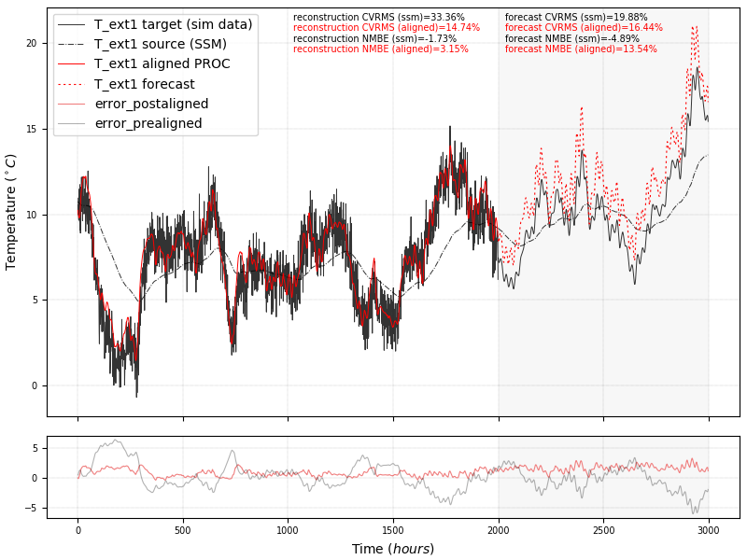
Figure 14. Alignment of source to noisy target signal in lifted space.
Appendix D: Phase portrait plots comparatives between state Physics-derived and data-derived state space geometric structures. Note the geometric similarity between the physics and data.
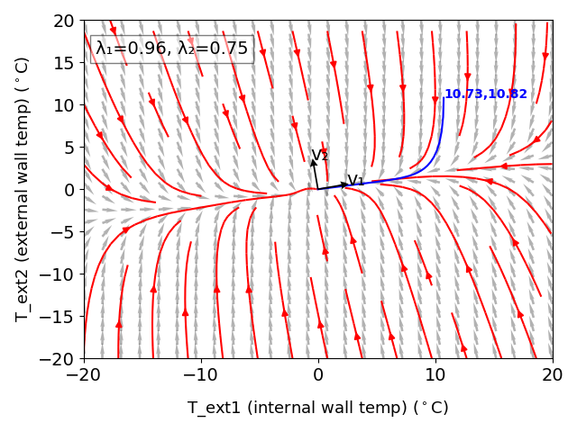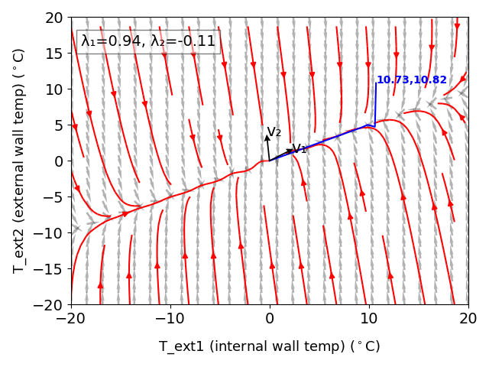
Figure 15. a) Physics-derived state space for 0.2m wall (orthogonal), b) Data-derived state space for 0.2m wall e via DMD (non-orthogonal).
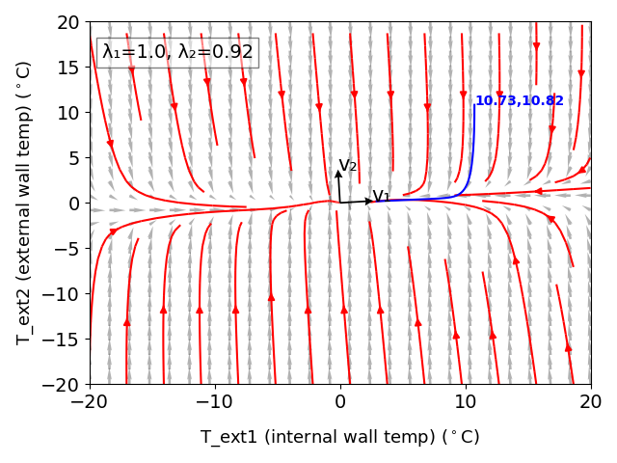
Figure 16. a) Physics-derived state space for 0.6m wall (orthogonal), b) Data-derived state space for 0.2m wall via DMD (non-orthogonal).
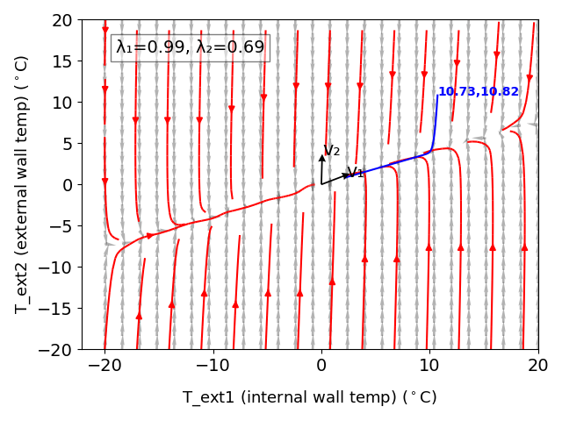

Figure 17. a) Physics-derived state space for 0.2m wall (orthogonal), b) Data-derived state space for 0.9m wall via DMD (non-orthogonal).

Cite this article: Xuereb Conti, Z., Choudhary, R., Magri, L. 2022. A Physics-based Domain Adaptation framework for modelling and forecasting building energy systems. Data-Centric Engineering 1: e1, 1–6. https://doi.org/10.1017/
dce.2019.2

