Intelligent Vehicle Drive Mode Which Predicts the Driver Behaviour Vector to augment
Engine Performance in Real-time
Srikanth Kolachalama*, Hafiz Malik
Electrical and Computer Engineering, University of Michigan, Dearborn 48128, USA
Corresponding author: skola@umich.edu; Co-author: hafiz@umich.edu

Supplementary Material - Figures
- Prediction of [EOP, CATOP] - NARX and LSTM methods
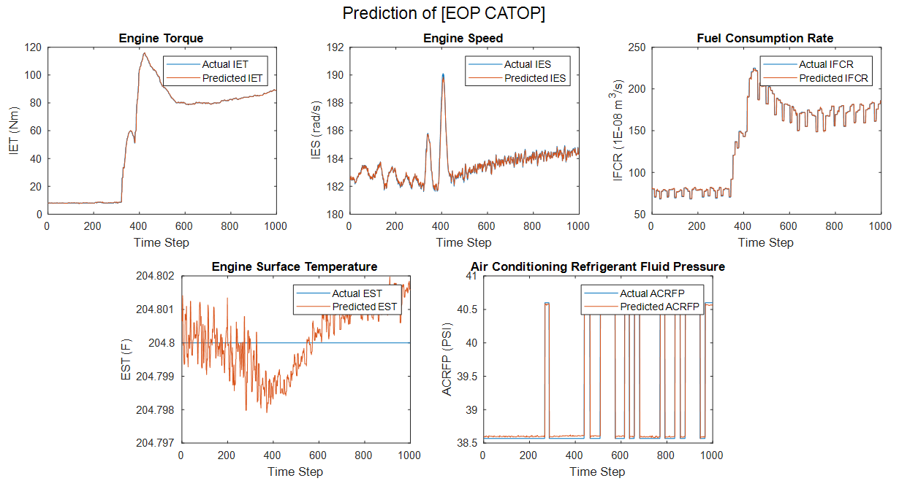
Figure S1: NARX Prediction of EOP and CATOP - Cadillac XT6, Dataset 1
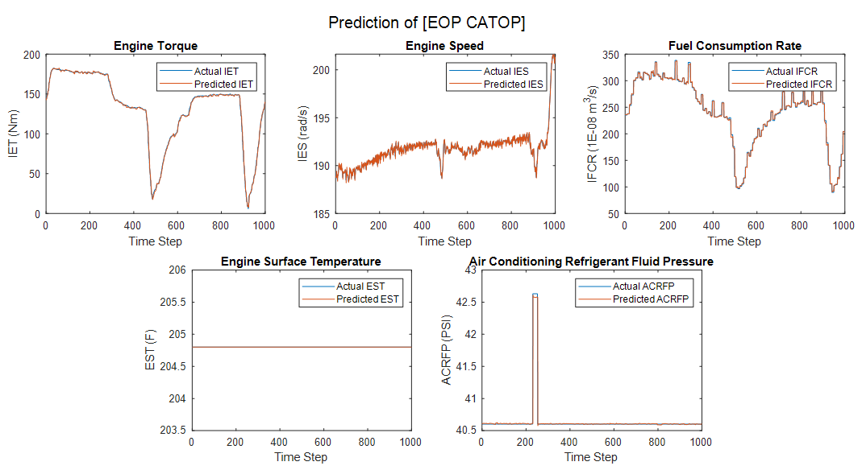
Figure S2: NARX Prediction of EOP and CATOP - Cadillac XT6, Dataset 2
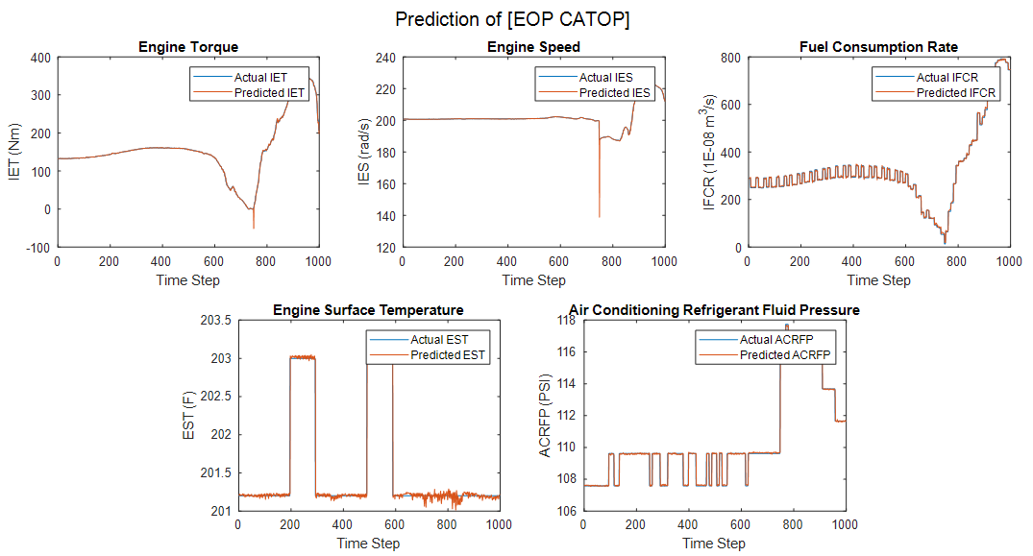Figure S3: NARX Prediction of EOP and CATOP - Cadillac CT4, Dataset 1
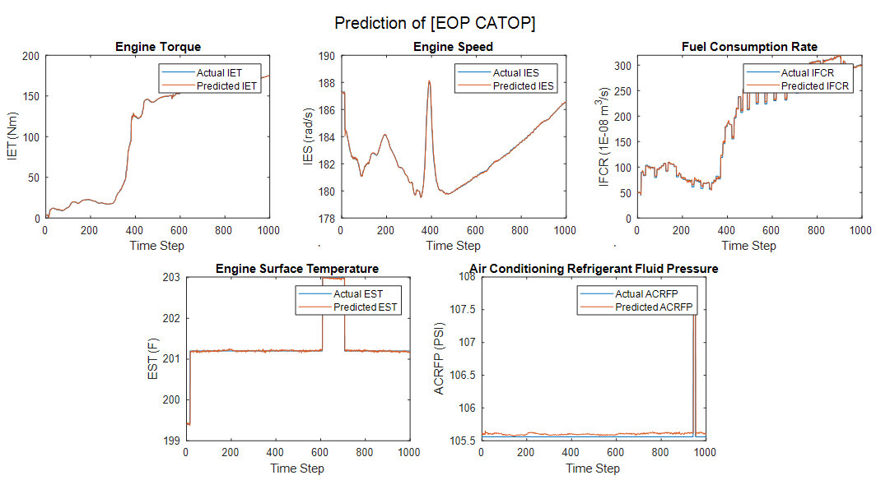Figure S4: NARX Prediction of EOP and CATOP - Cadillac CT4, Dataset 2
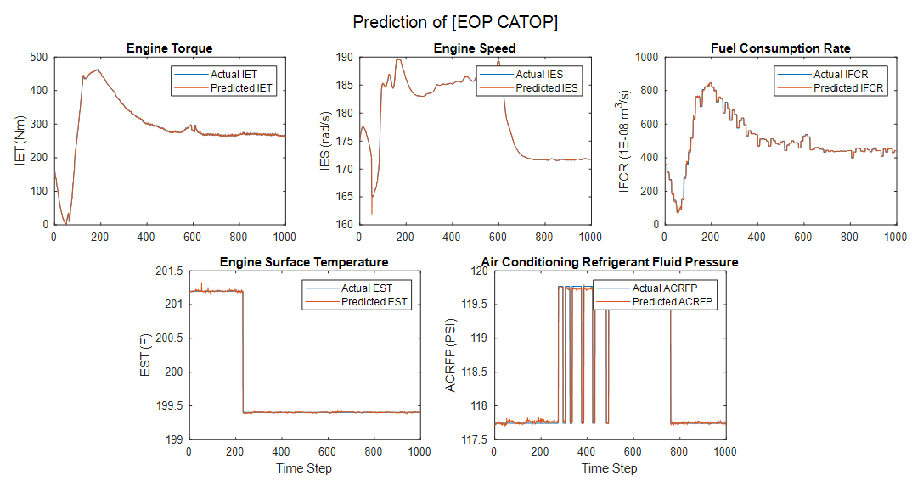 Figure S5: NARX Prediction of EOP and CATOP - Cadillac Escalade ESV, Dataset 1
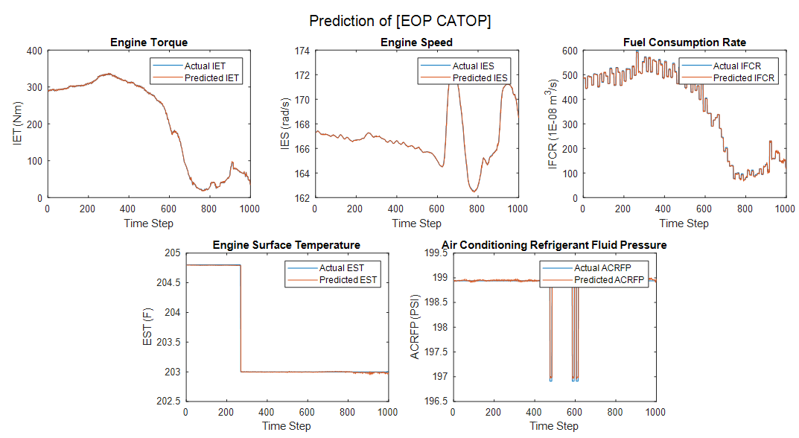Figure S6: NARX Prediction of EOP and CATOP - Cadillac Escalade AWD ESV, Dataset 2
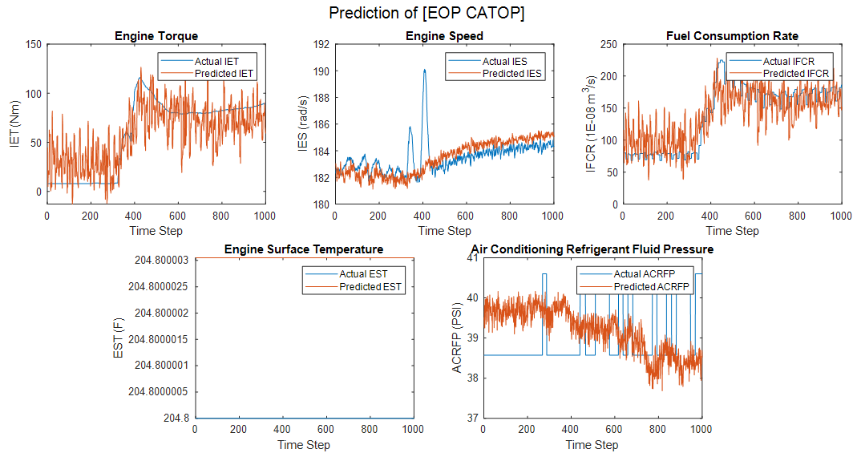Figure S7: LSTM Prediction of EOP and CATOP - Cadillac XT6, Dataset 1
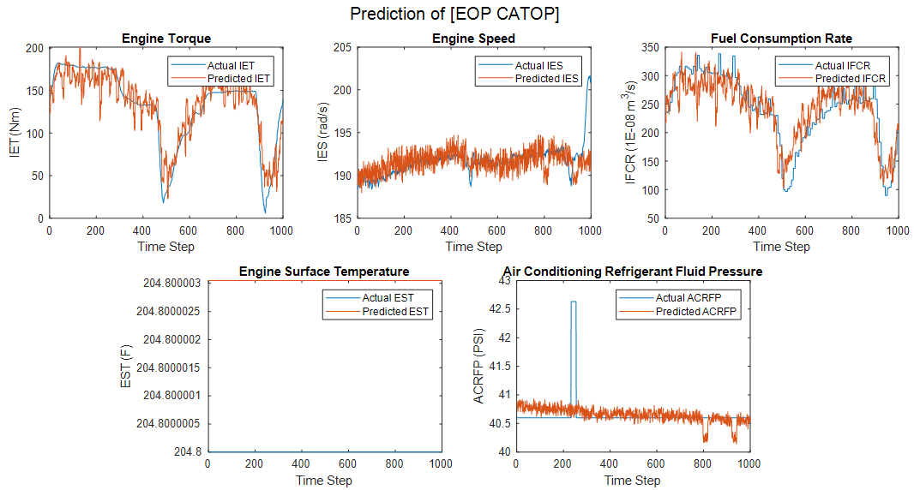Figure S8: LSTM Prediction of EOP and CATOP - Cadillac XT6, Dataset 2
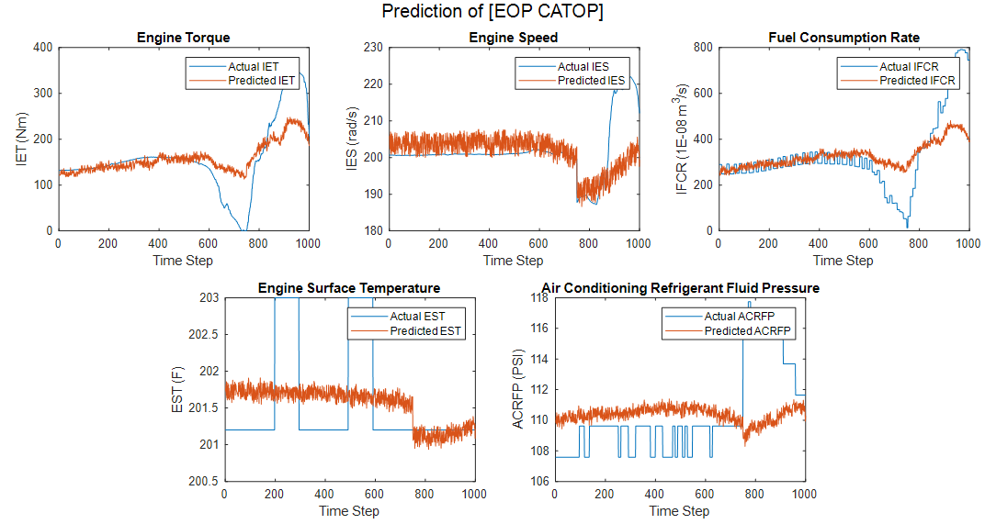Figure S9: LSTM Prediction of EOP and CATOP - Cadillac CT4, Dataset 1
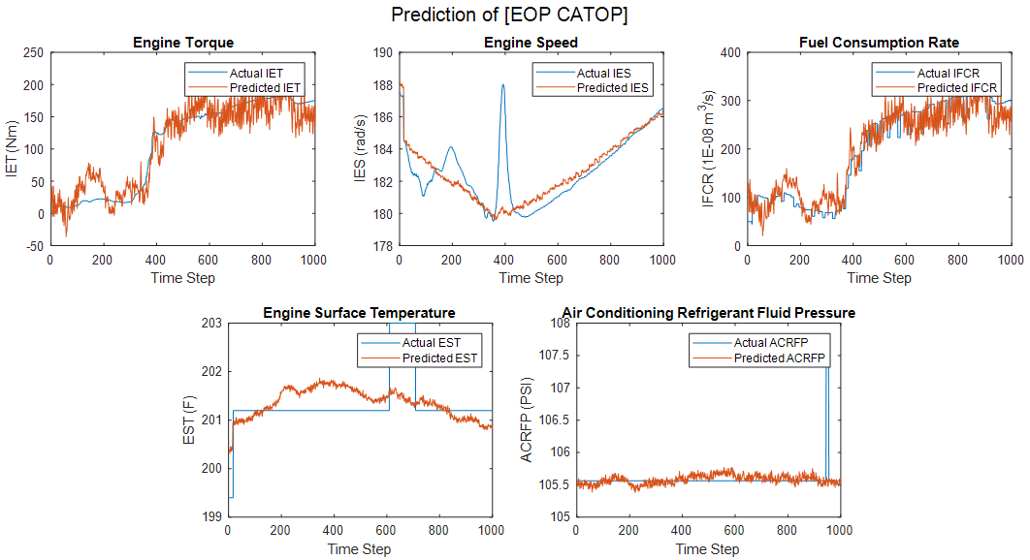Figure S10: LSTM Prediction of EOP and CATOP - Cadillac CT4, Dataset 2
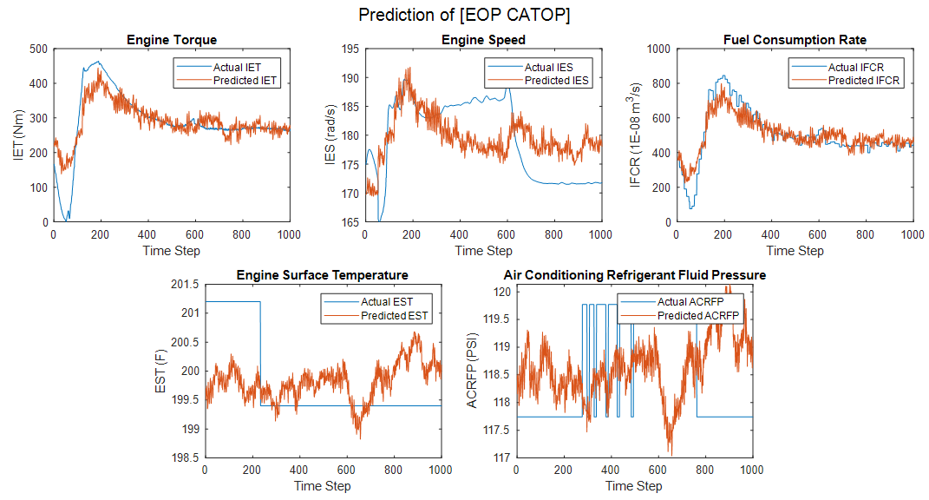Figure S11: LSTM Prediction of EOP and CATOP - Cadillac Escalade ESV, Dataset 1
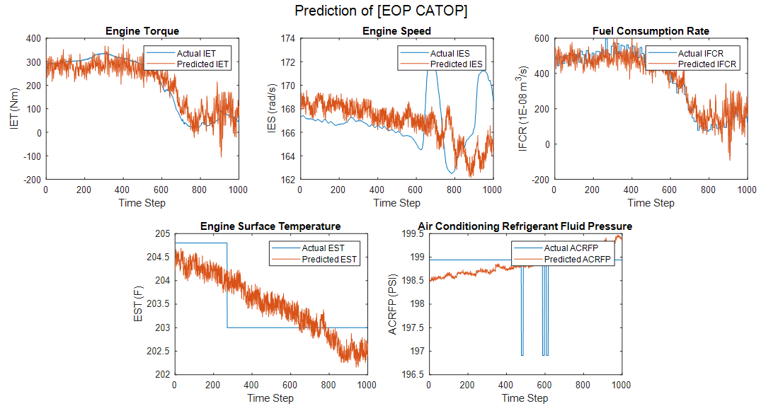Figure S12: LSTM Prediction of EOP and CATOP - Cadillac Escalade AWD, Dataset 2

- Prediction of EOP - 2020 Cadillac CT5
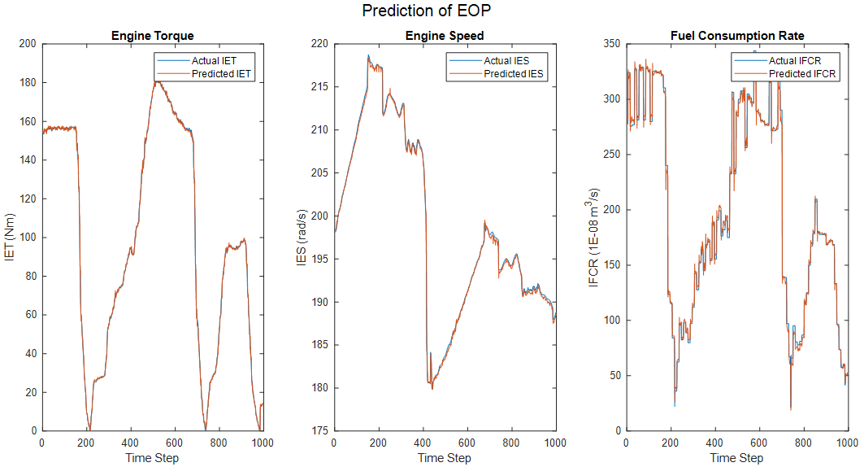Figure S13: EOP-ACCSSP = 30 MPH
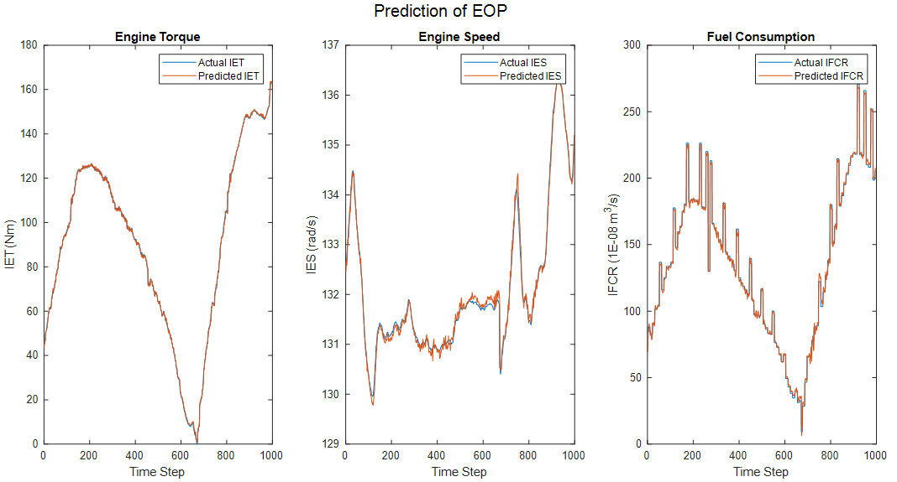Figure S14: EOP-ACCSSP = 40 MPH
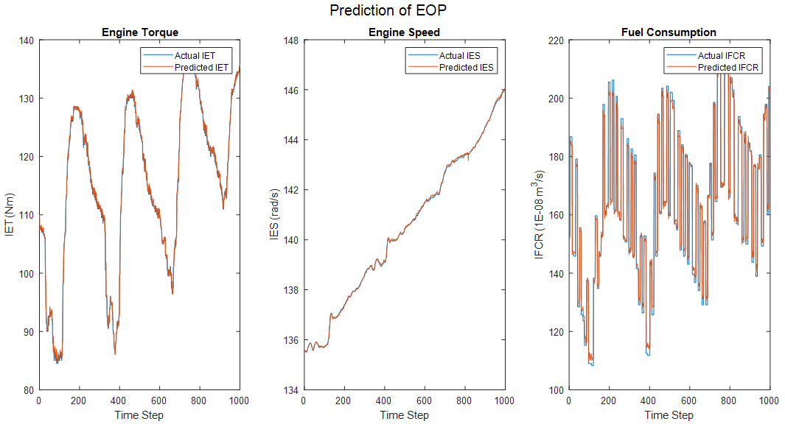Figure S15: EOP-ACCSSP = 50 MPH
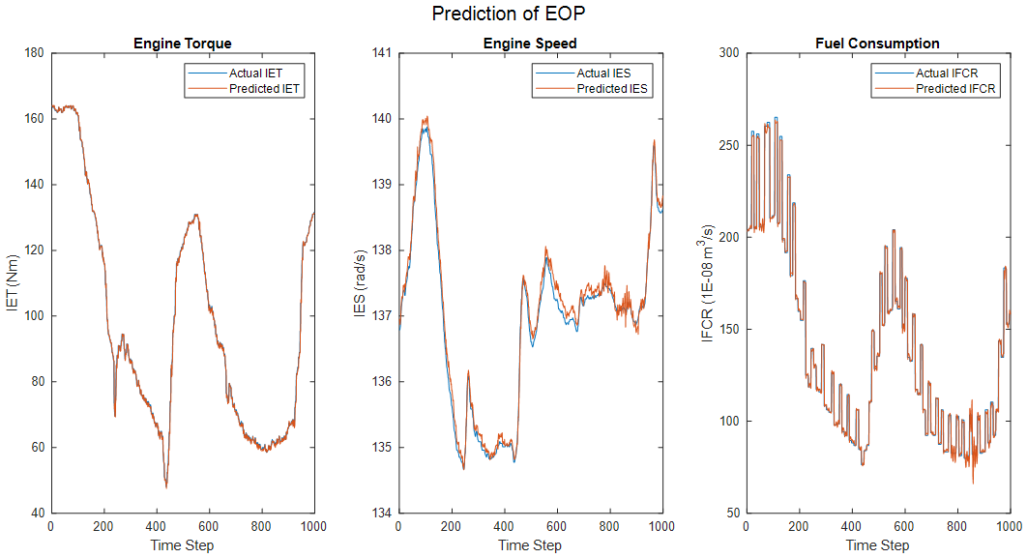Figure S16: EOP-ACCSSP = 60 MPH
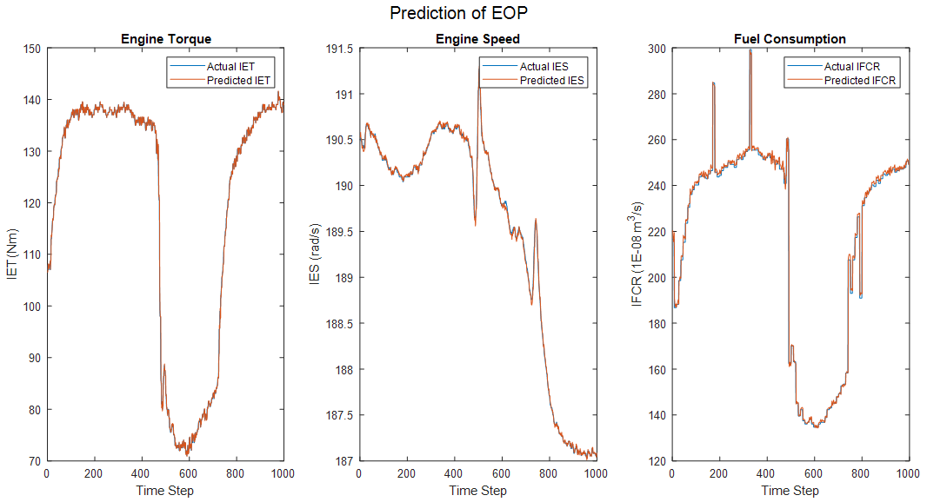
Figure S17: EOP-ACCSSP = 70 MPH

- Prediction of CATOP - 2020 Cadillac CT5 (EAT > 65 ℉)

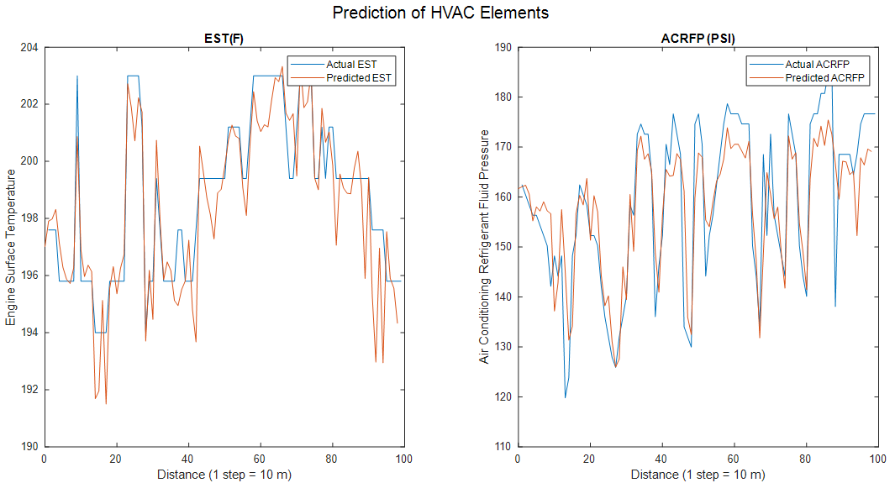Figure S18: ACCSSP = 35 MPH, CAT=67 ℉, EAT=83.3℉
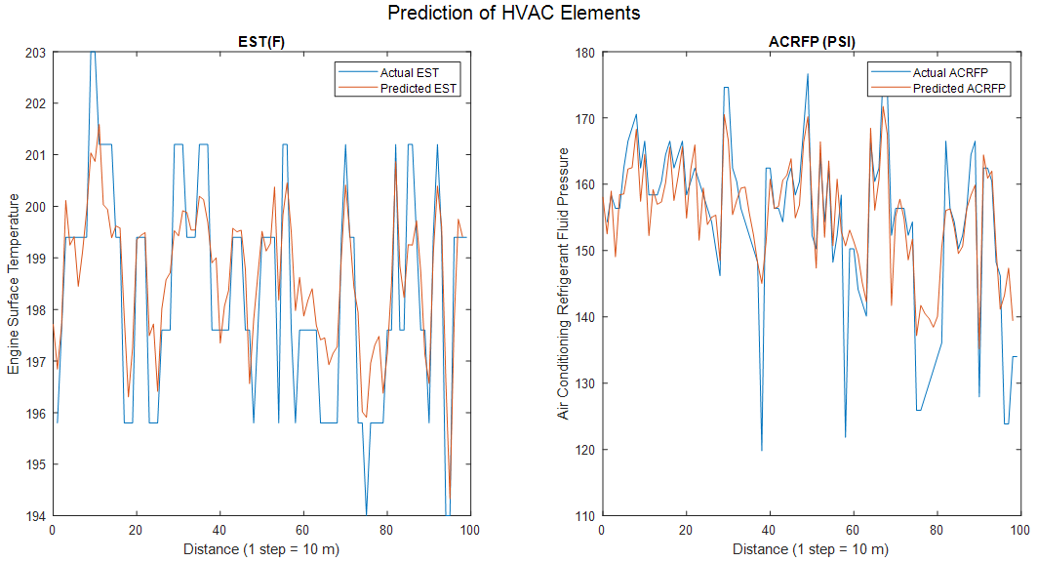Figure S19: ACCSSP = 45 MPH, CAT=65 ℉, EAT=80.3℉
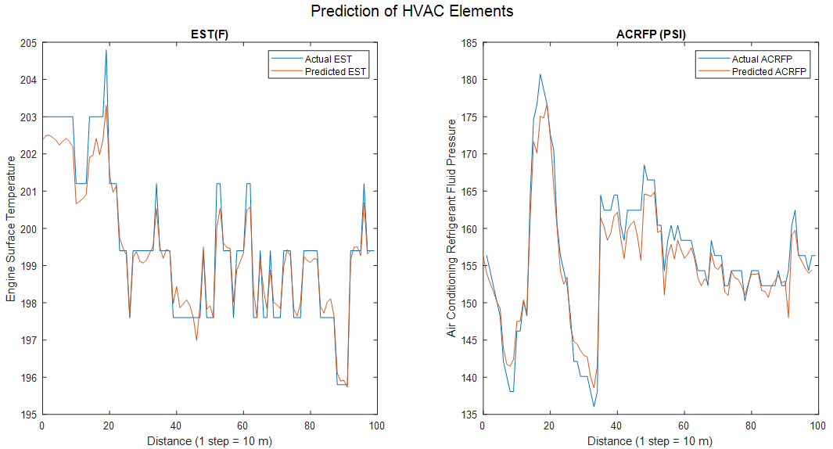Figure S20: - ACCSSP = 55 MPH, CAT=66 ℉, EAT=70.2℉
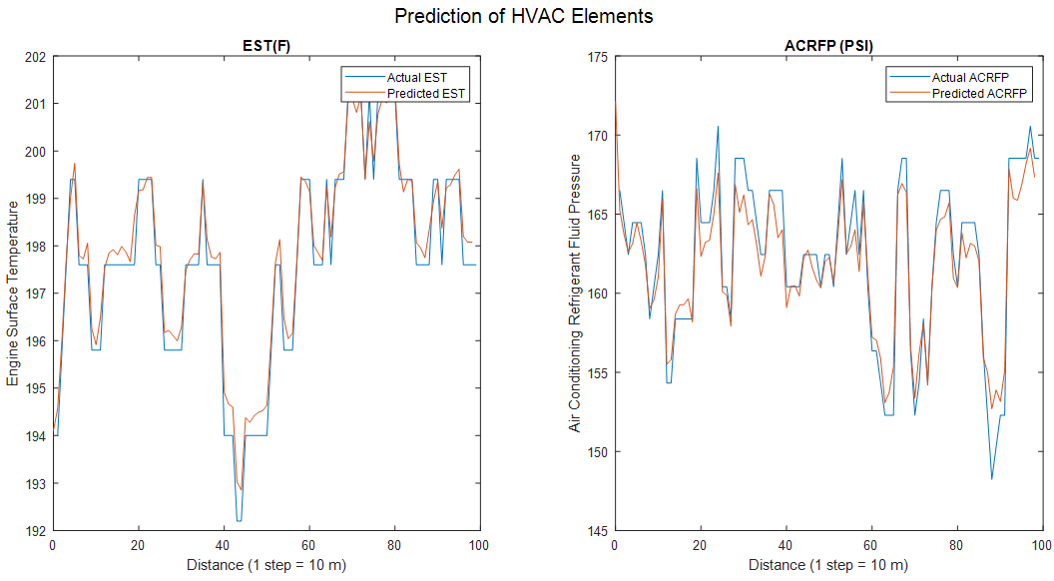Figure S21: ACCSSP = 65 MPH, CAT=68 ℉, EAT=80.9℉
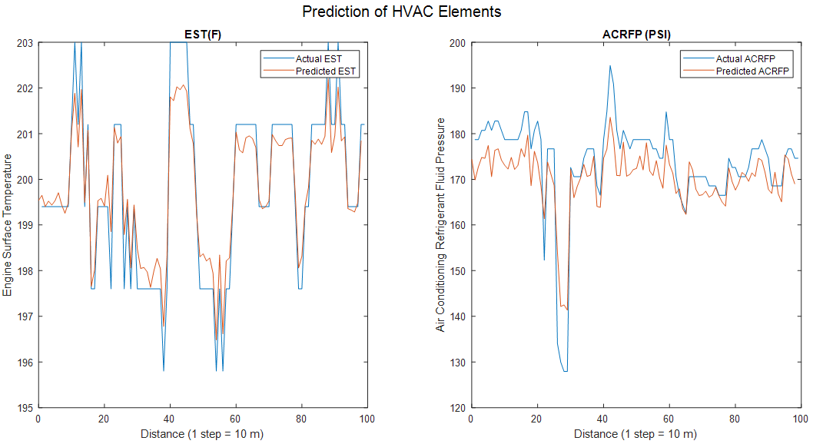
Figure S22: ACCSSP = 75 MPH, CAT = 69 ℉, EAT = 84.62 ℉

- Prediction of CATOP - 2020 Cadillac CT5 (EAT < 45 ℉)
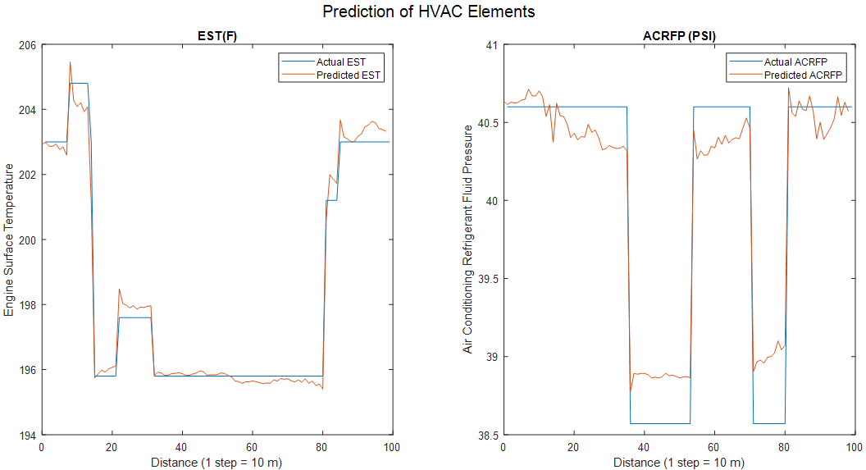Figure S23: ACCSSP = 35 MPH, CAT = 76 ℉,
EAT=36.4 ℉
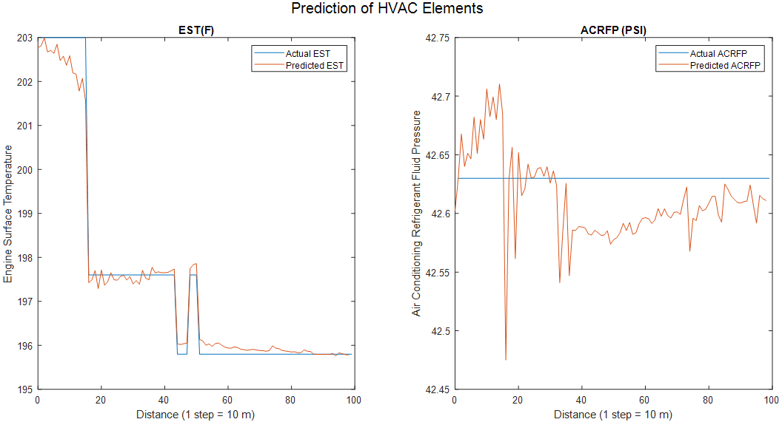Figure S24: ACCSSP = 45 MPH, CAT = 71 ℉,
EAT=39.1 ℉
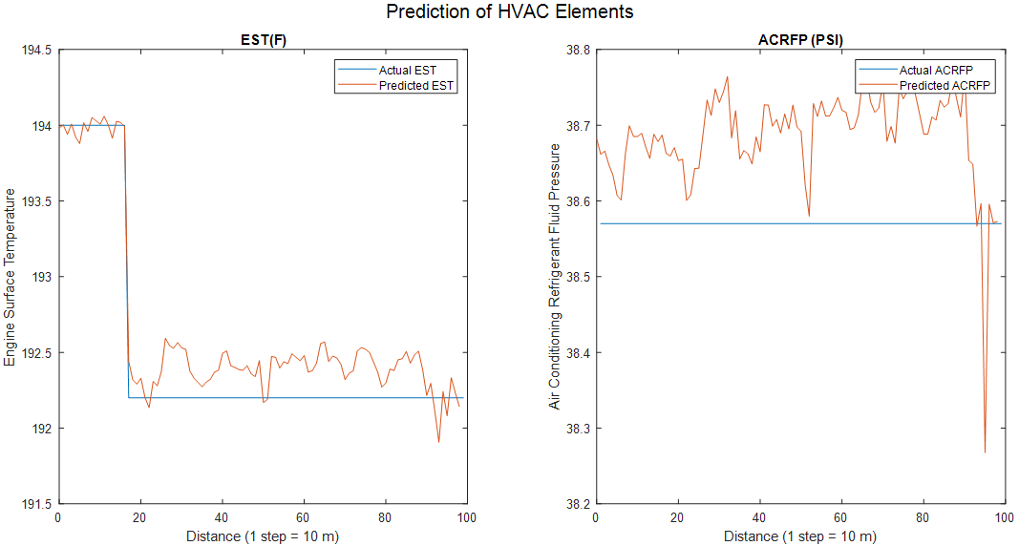Figure S25: ACCSSP = 55 MPH, CAT = 85 ℉,
EAT=34.7 ℉
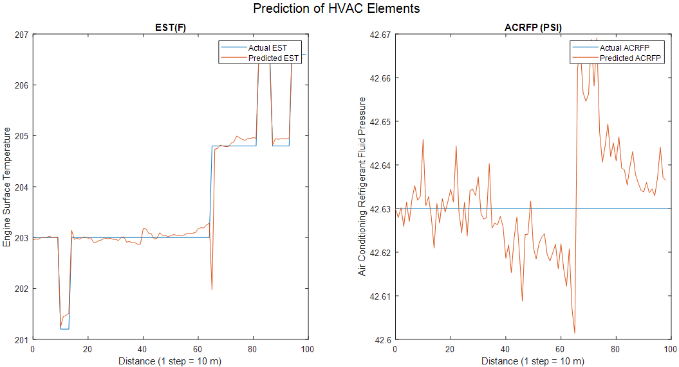Figure S26: ACCSSP =65 MPH, CAT = 80 ℉,
EAT=38.9 ℉
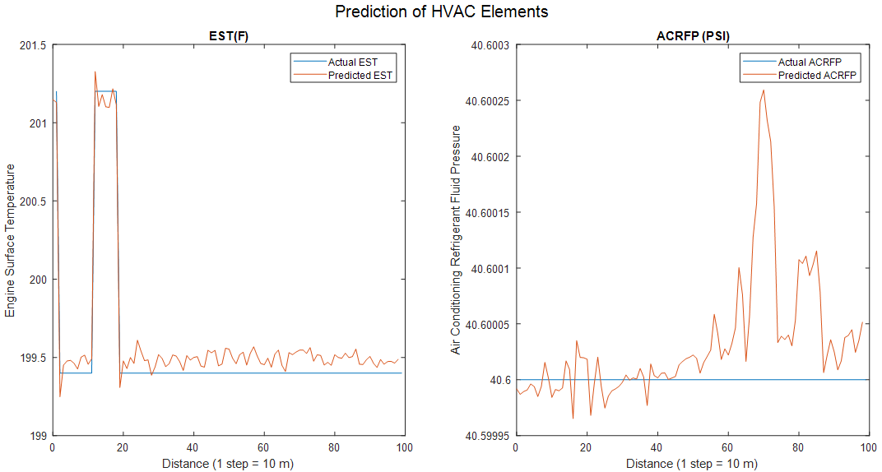
Figure S27: ACCSSP = 75 MPH, CAT = 75 ℉, EAT = 37.4 ℉

- Prediction of ACCSSP - 2020 Cadillac CT5

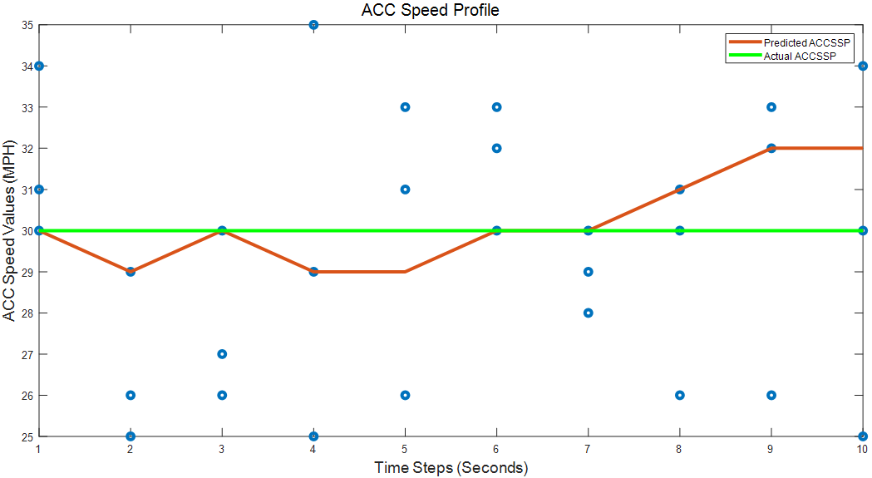
Figure S28: Predicted ACCSSP—Initial ACC Speed = 30 MPH.

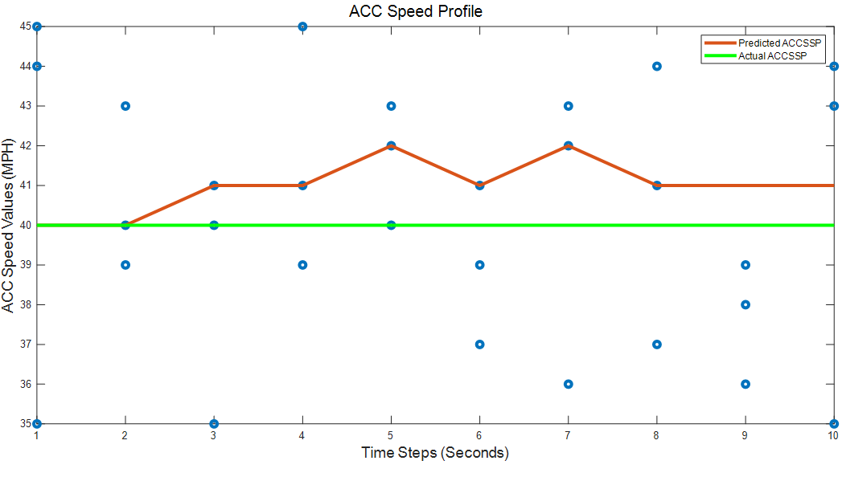
Figure S29: Predicted ACCSSP—Initial ACC Speed = 40 MPH.

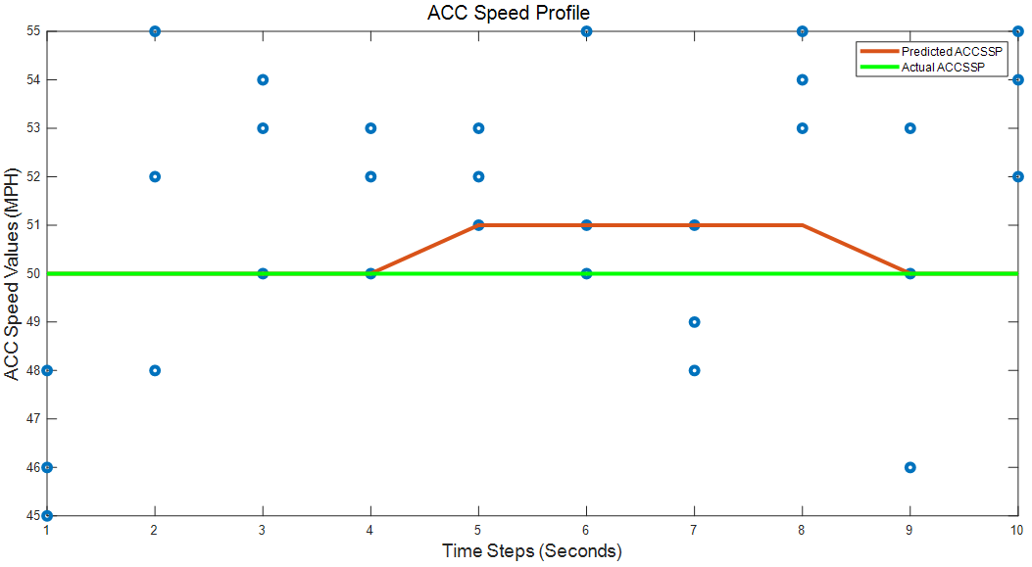
Figure S30: Predicted ACCSSP—Initial ACC Speed = 50 MPH.

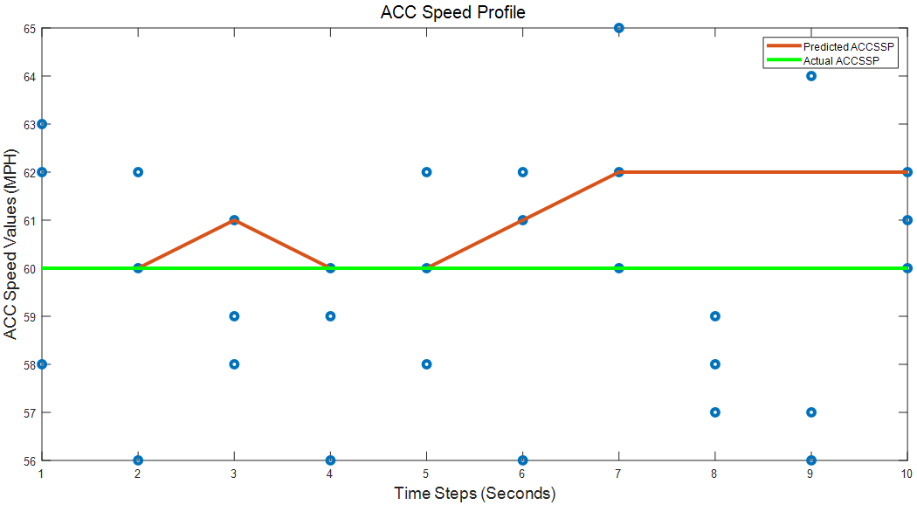
Figure S31: Predicted ACCSSP—Initial ACC Speed = 60 MPH.

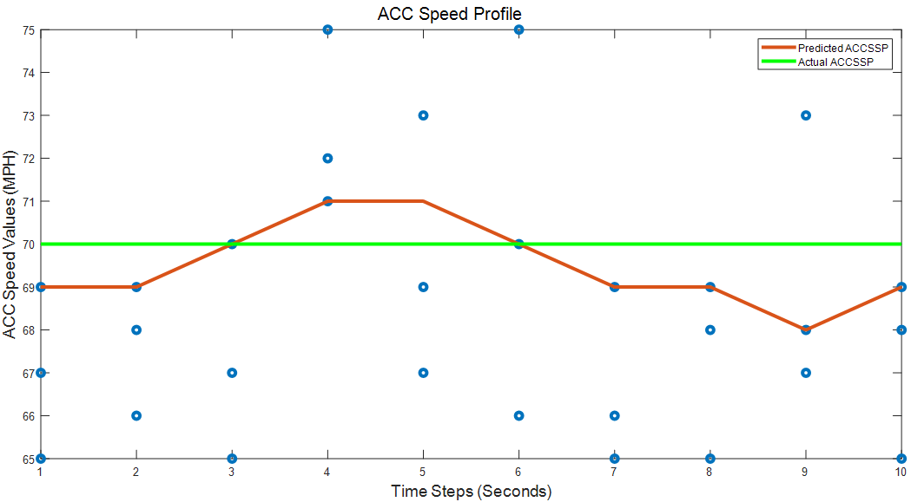
Figure S32: Predicted ACCSSP—Initial ACC Speed = 70 MPH.

- Prediction of CATSP - 2020 Cadillac CT5
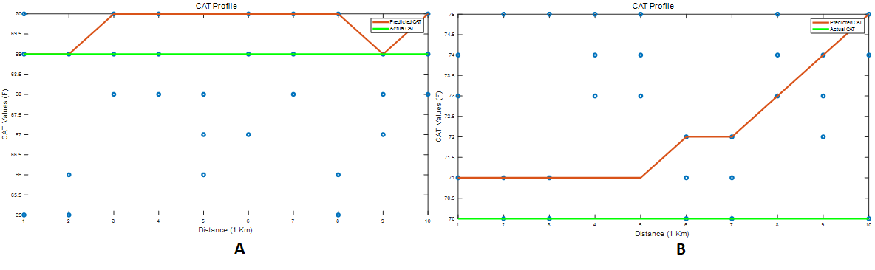
Figure S33: CATSP: (A) ICAT = 69 ℉; EAT = 82.07 ℉; (B) ICAT = 70 ℉; EAT = 37.98 ℉—ACCSSP = 30 MPH.

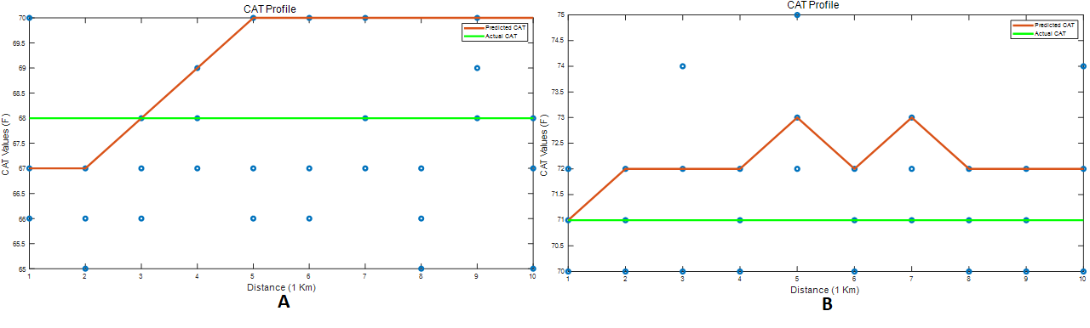
Figure S34: CATSP: (A) ICAT = 68 ℉; EAT = 85.29 ℉; (B) ICAT = 71 ℉; EAT = 37.63 ℉—ACCSSP = 40 MPH.
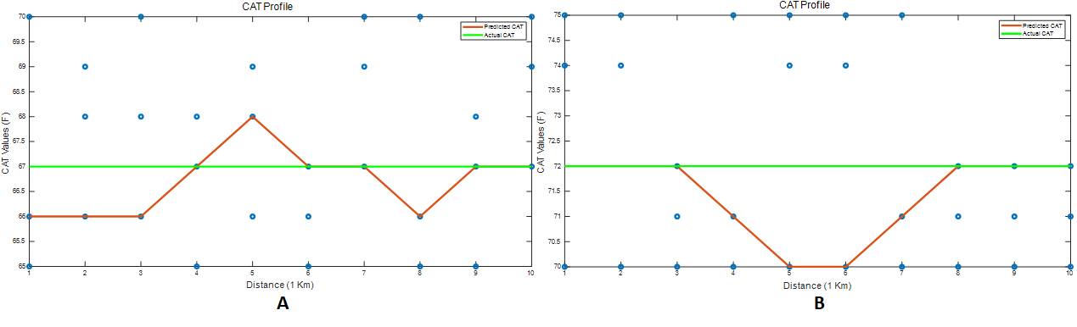
Figure S35: CATSP: (A) ICAT = 66 ℉; EAT = 80.726 ℉; (B) ICAT = 72 ℉; EAT = 40.1 ℉—ACCSSP = 50 MPH.

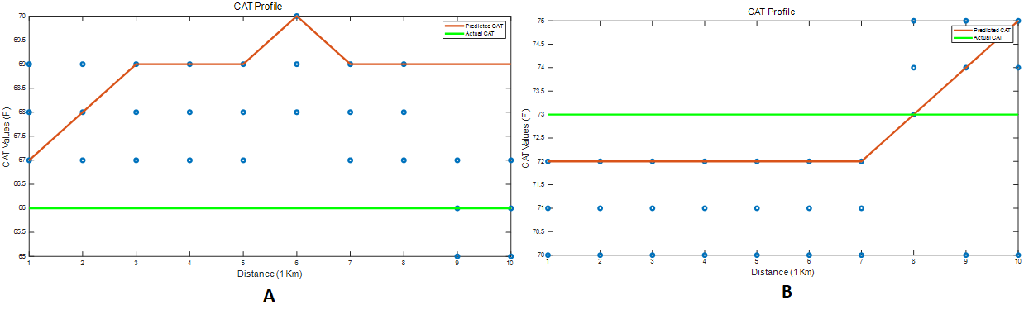
Figure S36: CATSP: (A) ICAT = 66 ℉; EAT = 79.44 ℉; (B) ICAT = 73 ℉; EAT = 38.86 ℉—ACCSSP = 60 MPH.

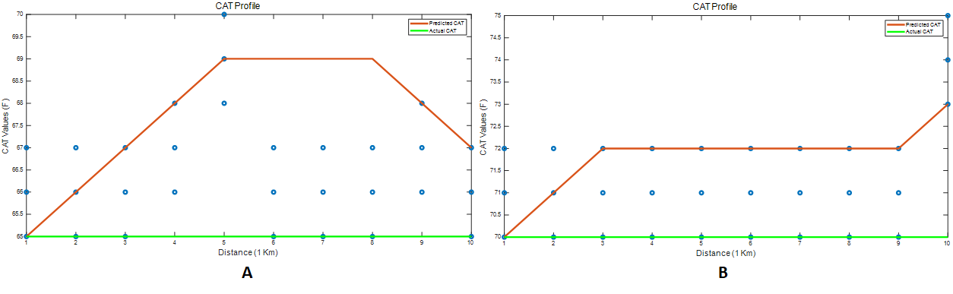
Figure S37: CATSP: (A) ICAT = 65 ℉; EAT = 76.1℉; (B) ICAT = 70 ℉; EAT = 36.518 ℉—ACCSSP = 70 MPH.

- Quantification of [IEE, IEM] - 2020 Cadillac CT5
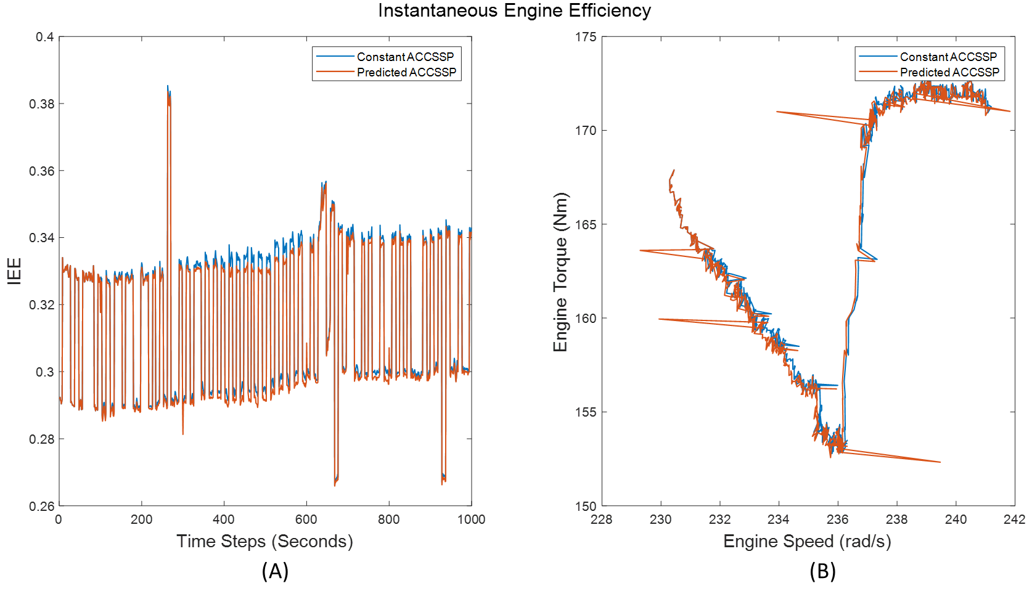Figure S38: Validation: (A) IEE; (B) IEM—ACCSSP = 70 MPH.
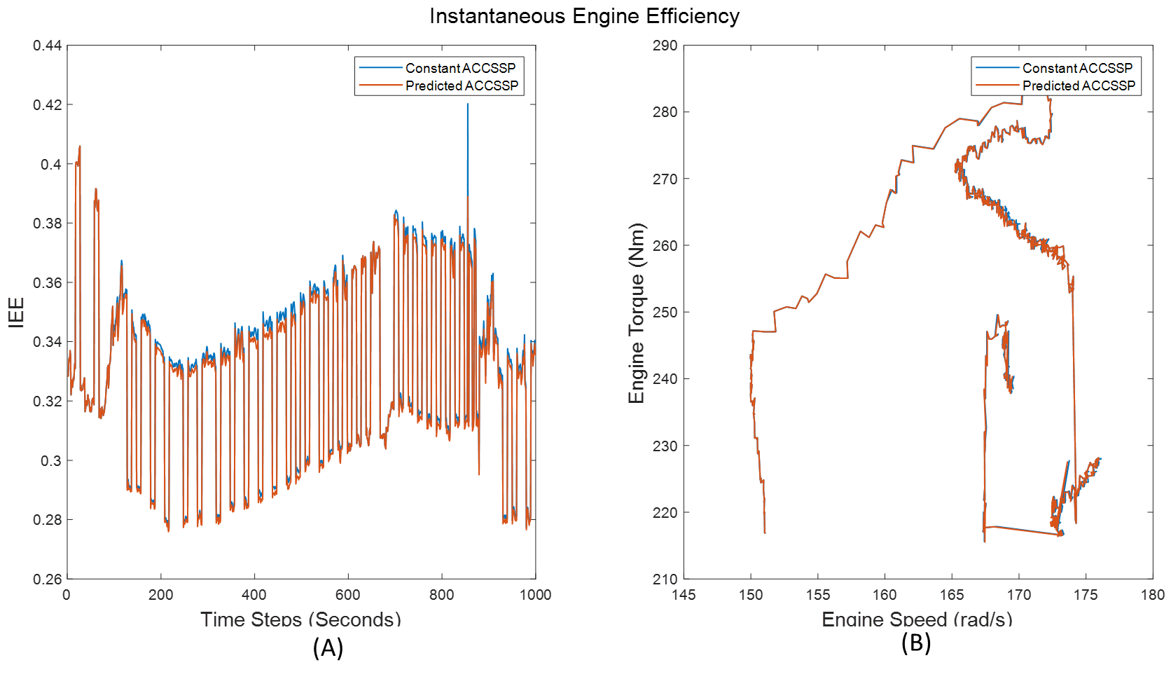
Figure S39: Validation: (A) IEE; (B) IEM—ACCSSP = 60 MPH.
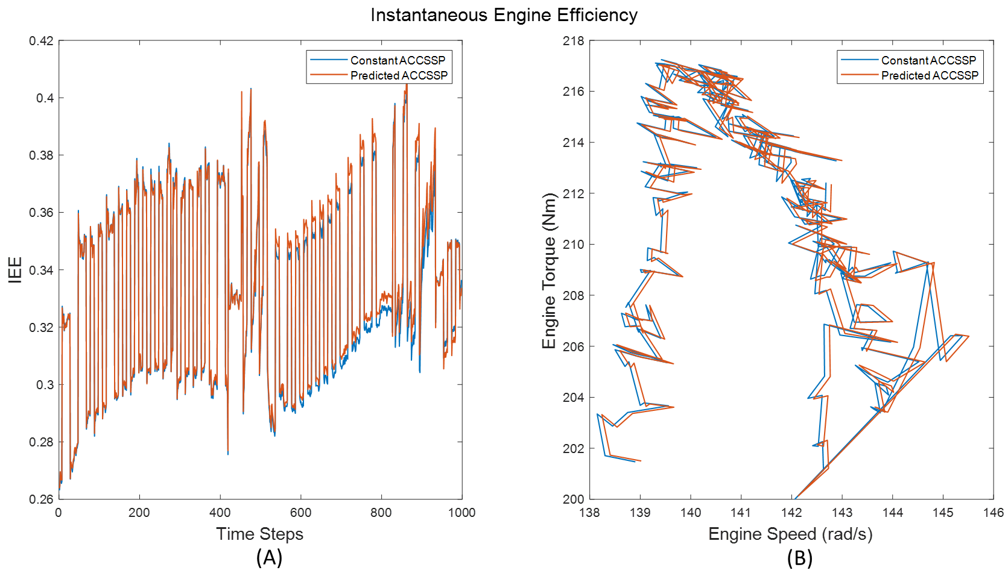
Figure S40: Validation: (A) IEE; (B) IEM—ACCSSP = 50 MPH.
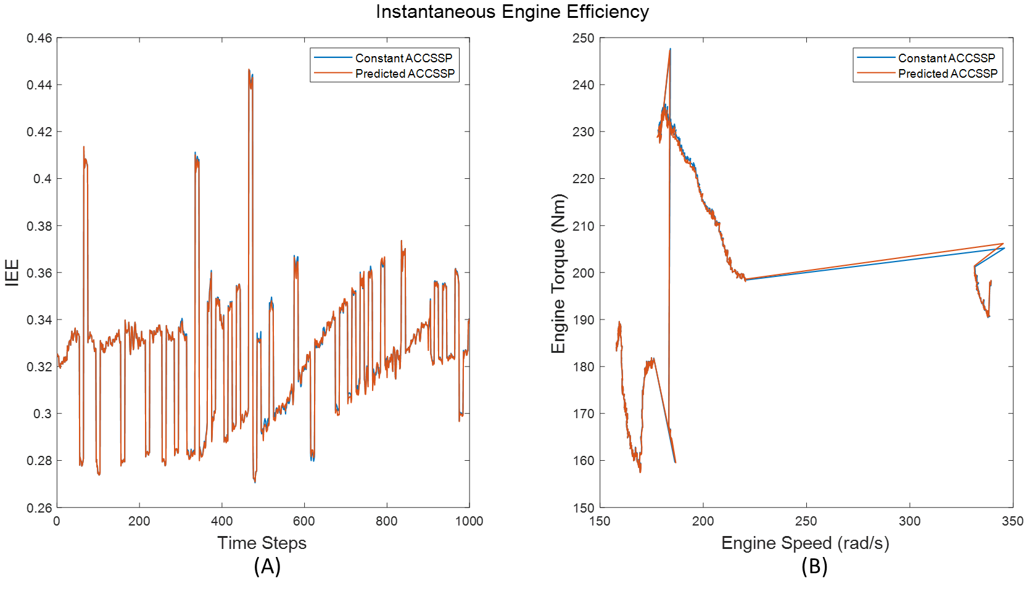
Figure S41: Validation: (A) IEE; (B) IEM—ACCSSP = 40 MPH.
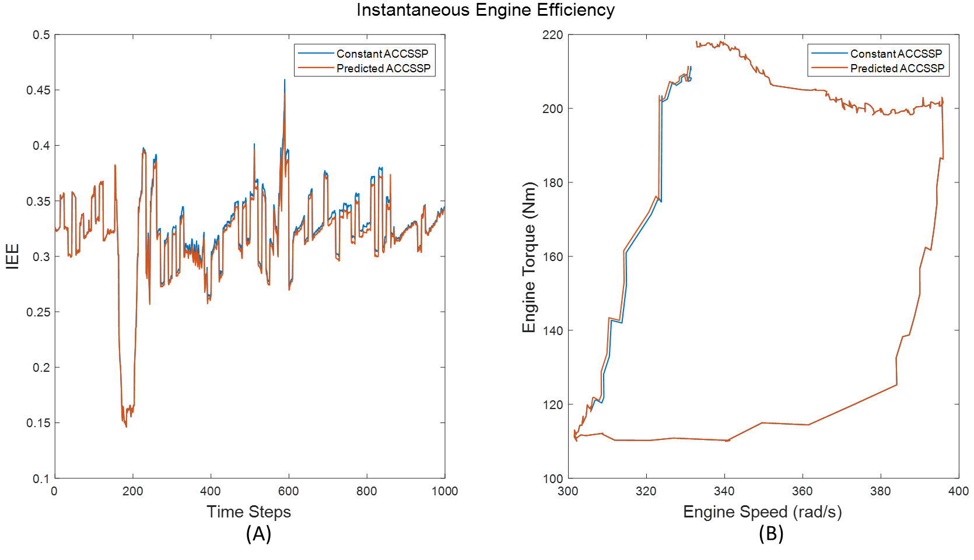
Figure S42: Validation: (A) IEE; (B) IEM—ACCSSP = 30 MPH.

