Socio-spatial aspects of creativity and their role in the planning and design of university campuses public spaces: a practitioners’ perspective

Supplementary Materials
Isabelle Soares*, Thai Nguyen, Claudia Yamu, Gerd Weitkamp
Corresponding author: i.c.soares@rug.nl

The propositions: Research-generated evidence on socio-spatial aspects of creativity

The evidence presented to practitioners were generated through the following data collection and analysis procedures. Data were collected through Public Participatory GIS (PPGIS) which represent the mapped perceptions of users in public spaces, Space Syntax analysis, secondary GIS data (Basisregistratie Grootschalige Topografie, Top10.NL and Open Street Map) and content analysis of photography. PPGIS data were collected from students, university employees, companies’ employees, and campus visitors. For this research, ‘creativity’ or ‘creative encounters’ were represented by the act of sharing knowledge and the exchange of ideas with others. Survey respondents were approached on-site by the researchers to answer a web-based questionnaire (maptionnaire.com) and were asked to draw polygons on the campus map to indicate on the campus map indoor and/or outdoor public space(s) where they have shared knowledge or exchanged ideas with people in the past year. The first round of PPGIS data collection was an in-class experiment by Bachelor’s students of the ‘Methods for Academic Research’ course unit at the UG. The second round of PPGIS data collection was conducted by the researchers on campuses open and semi-public spaces (details in Soares, Yamu, and Weitkamp 2020; Soares, Weitkamp, and Yamu 2020; Soares et al. 2021).
The collected polygon data were aggregated into 100x100m cells (Curtis et al. 2014; Soares et al. 2020a) and combined with secondary data that represent built environment features (Campus’ buildings, restaurants, café and canteens, streets and sidewalks, spaces between buildings, green areas, sitting opportunities, water features and vegetation) theorized as important to influence creativity on campus (See presentation and illustrations in Appendix B).
For the Space Syntax analysis, the measure normalised angular choice measure (NACH) was used to calculate the ‘potential through-movement’ (Hillier 2012; Hillier & Iida 2005) of the Zernike Campus Groningen (See Chapter 1). Angular choice has the strongest and the most consistent correlation with pedestrian movement compared to any other syntactic measure, such as integration (Al-Sayed et al. 2012; Hillier 2012; Sharmin & Kamruzzaman 2018), since humans tend to estimate the angular distance to reach destinations while walking through the environment (Hillier 2009; Van Nes & Yamu 2018; Vaughan 2007). Furthermore, to understand the interplay between the spatial configuration of the campus and people’s mapped perceptions, we combined and categorised the space syntax results with the PPGIS data (collected in 2018), representing peoples’ perceptions regarding the public spaces where they meet people from outside the campus.
Content analysis of photography addressed the main differences and similarities between inner-city campuses and SPs. Photography was used to visualize and exemplify differences and similarities between the creative public spaces, such as campus open public spaces (streets, plazas and green areas) and semi-public spaces (indoor and outdoor areas).

Table 1: Propositions of research evidence on socio-spatial aspects of creativity.
 | Proposition Title | Procedures used for data collection and analysis | Summary of key findings
1 | ‘Campus Design’, ‘Urban Design’ and ‘Public Spaces’ guidelines might not be suitable for every campus. Context and individualities matter. | Data collection | The results showed that natural features such as green areas, water and vegetation, which were theorized as important for life on campuses (e.g relaxation and restoration), were not significant for the specific act of ‘creativity’ through knowledge sharing and exchange of ideas. With our empirical findings, it was clear that urban designers and planners tend to generalize characteristics of the built environment without taking into consideration context and individualities (Dober 1992, 2014; Strange et al., 2001; Strange and Banning 2015; Kenney et al., 2005; Hajrasouliha 2015, 2017; Lau and Yang 2009; Zeng et al. 2020). Therefore, Proposition 1 supports this claim, through empirical findings. With this, we were able to prove to what extent features that are theorized as fundamental for campuses were not after all fundamental for creativity.
PPGIS (Representing people’s perceptions on creativity on campuses public spaces) of the six study cases (inner-city campus and science parks of Amsterdam, Utrecht and Groningen)
Secondary GIS data that represent built environment (BE) features
(Campus’ buildings, restaurants, café and canteens, streets and sidewalks, spaces between buildings, green areas, sitting opportunities, water features and vegetation).
 |  | Data analysis
 |  | Distance from every cell was calculated to every BE feature. Negative binomial regression of the relationship between frequency of creativity and locations of BE features. For this research, ‘creativity’ or ‘creative encounters’ were represented by the act of sharing knowledge and the exchange of ideas with others.
2 | The locations of built environment features can influence or inhibit creative encounters. | Data collection | The locations of BE features influence peoples’ perceptions regarding creative encounters in public spaces. They also influence what happens ‘in between’ actions of a creative individual and his or her environment. The evidence of our empirical research, which measured the influence of the built environment on the frequency of creative encounters, shows that the array and location of urban functions and physical features create a possibility for spatially guided creativity (Soares et al. 2020a; 2021). For instance, certain locations on campus, perceived with a high frequency of creative encounters, are close by a cluster and mix of built environment features (urban functions and physical features). Such composition can make people feel welcome to interact with others, and therefore, higher opportunities for creative encounters might emerge (See examples on Appendix B).
PPGIS (Representing peoples’ perceptions on creativity on campuses public spaces) of the six study cases (inner-city campus and science parks of Amsterdam, Utrecht and Groningen)
Secondary GIS data that represent built environment features
(Campus’ buildings, restaurants, café and canteens, streets and sidewalks, spaces between buildings, green areas, sitting opportunities, water features and vegetation).
 |  | Data analysis
 |  | Distances from every cell were calculated as the locations of every built environment feature. We picked the 10 cells with the highest frequency of creativity and checked how distance to each built environment feature play a role in those cells.
3 | High accessibility high availability of spaces to walk does not mean high possibilities of creative encounters, and low accessibility does not mean low possibilities of creative encounters. | Data collection | For this proposition, two examples of findings were presented. Firstly, it was presented results of the statistical model, where we calculated the relationship between frequency of creativity and location of built environment features. The variable that represents the distance to Streets and Sidewalks (DIST_StreetsSidewalk) is not significant. This means that the availability of roads and sidewalks are not per se determinant for the ‘act of creativity’. Secondly, it was presented the network analysis model, called space syntax analysis, to measure the walkability of the campus – the potential for walking – and we combined this data with data that represented peoples’ perceptions at the campus (Soares et al. 2020b). When the VGI perceptual data was combined with space syntax, it was possible to visualize spaces with low accessibility but high potential for creativity, high accessibility and high creativity and high accessibility and low creativity.  In summary, this proposition claims that accessibility and availability of movement spaces per se, do not hinder interactions and are not determinants for creativity to occur. And at the same time, the ‘easy access’ to amenities does not guarantee creative encounters and interactions. The opposite can also occur, and spaces in low accessibility areas can provide high engagement between people and the built environment. In other words, people will often feel attracted to places that they can have ‘easy access’ to, but at the same time places that they are familiar with.
- PPGIS (Representing the places where people shared knowledge and exchange ideas) of the 6 study cases.
- PPGIS (Representing peoples’ perceptions of where they meet people from outside the campus) of the Zernike campus.
Space syntax model (involving car, pedestrian and cycling movement)
Photography to understand spaces with high/low potential for movement and potential for meeting people.

 |  | Data analysis
a) Distance from every cell was calculated to every built environment feature. Negative binomial regression of the relationship between frequency of creativity and locations of BE features. For this proposition, we focused on the variable ‘DIST_RoadsSidewalks’
b) Space syntax analysis (Normalized angular choice, 800m)
The interface between space syntax and frequency of encounter on campus
And analysis of photography of the relationship between people and the built environment.
4 | Campuses and Public spaces typology matter for creative encounters between people | Data collection | - Campuses’ typology matter  For this research, we had the hypothesis that creativity at inner-city campuses would be spatially distributed throughout the whole city centre. And that in SPs, creativity would occur only within the campus masterplan. This is since inner-city campuses are located in the city centre and have access to a higher diversity of land use. In other words, people that circulate at the inner-city campuses public spaces have the potential to mix with tourists, day-trippers, workers and residents. However, empirical evidence contradicted the hypothesis. The following evidence was found:  - Creativity seems to depend on buildings in inner-city campuses, more than depends on Science Parks. In Science parks, creativity is spread throughout the campus, involving indoor and outdoor locations. Even though SPs masterplan design has a car-based logic, they provide a more ‘open’ atmosphere, where people can circulate between public spaces and buildings without feeling that they ‘don’t belong’.  - We noticed during the data collection that accessing inner-city campus buildings and public spaces was harder because of the physical configuration of buildings and lack of connectivity with the city. Buildings are often reformed houses, that have changed their interior to accommodate academic activities, and therefore have a private character. It seems that ‘strangers’ are invading the buildings while trying to visit;  - Public space typology matter  The other hypothesis that we had was that creativity occur differently depending on the type of public space: neighbourhood parks, streets, walking paths, passages, terraces, yards, backyards, plazas and semi-public passages. Evidence confirmed this hypothesis, and the empirical research showed that the physical characteristics of the masterplan and open and semi-public spaces make a difference in how people interact with spaces and with each other. Evidence showed that public spaces typology should be taken into account when planning and designing campuses.
 |  | Photography of all types of public spaces, according to the results of the PPGIS and space syntax data.
 |  | Data analysis:
 |  | Content analysis of photography, on how people interact with space and with each other, considering the differences and similarities of the campuses and the public spaces typologies in each campus.

A2. On-street survey interviewees – Public space users

Data on perceived creativity (VGI) were collected through on-street surveys (details can be found in Soares et al. 2020a; 2020b; 2021). The surveys were responded to by public spaces users using a web-based questionnaire (maptionnaire.com). There were two rounds of VGI data collection; for Soares et al. (2020b) the survey was conducted as an in-class experiment by Bachelor’s students of the ‘Methods for Academic Research’ course unit at the University of Groningen (UG). For Soares et al. (2020a; 2021), the researcher collected the data in the inner-city campuses and science parks of Amsterdam, Utrecht and Groningen with a student assistant. Data were collected from students, university employees, companies’ employees, and campus visitors. For Chapter 3, 224 polygon responses were collected. For Soares et al. (2020a), 511 polygon responses were collected and for Soares et al. (2021), 744 polygon responses were collected. This was a research-led participatory process.
The ‘perceived creativity’ was represented by the acts of socialization, spontaneous encounters and meeting people from outside the campus (MPFOC) (Soares et al. 2020b) and the act of sharing knowledge and the exchange of ideas with others (Soares et al. 2020a; 2021). The perceptual data considered outdoor and indoor campuses’ public spaces.

B. Power Point presentation provided to practitioners during the interview

- We presented the study area and showed how the interview questions would be conducted (Slides 1 and 2). The power point presentation was used after the Introduction questions of the interview (see Table 2)

B1. Proposition 1: ‘Campus Design’, ‘Urban Design’ and ‘Public Spaces’ guidelines might not be suitable for every campus. Context and individualities matter.

- Let’s take Amsterdam Science Park as an example.
- We collected data on users’ perceptions and related to the built environment features available on campuses.
- We asked people where they shared knowledge and exchanged ideas with others in the past year. Sharing knowledge and exchanging ideas for this research represent the ‘creativity’ or ‘creative encounters’ in public spaces (Slide 4).
- The respondents could draw polygons to represent the indoor and outdoor public spaces that they were creative in the past year.
- We aggregated the polygons into 100x100m cells, which are in the same scale of buildings and public spaces (Slide 5).
- For every cell, we calculated distance to key built environment features.
- These key features were selected according to the literature review on ‘campus design’, ‘urban design’ and ‘public spaces’ guidelines, the majority of the sources are Anglo-American. We followed those guidelines to develop our data collection and analysis (Slide 6).
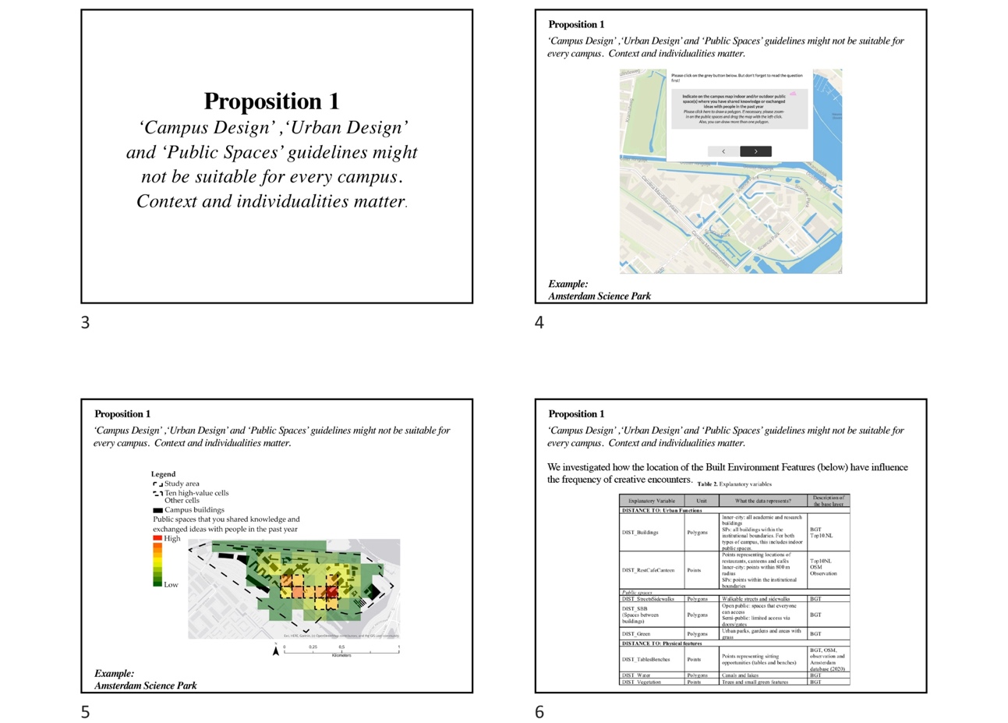

- We have found in those guidelines that a mix of land use could provide encounters between people in public spaces, and in this research, we made these guidelines tangible/measurable for practitioners. We empirically tested them (Slide 7).
- If you see, the community garden of the ASP is located within the cells with the highest frequency of creativity. So just by visualising it, we assume that green areas play a role in creative encounters at the Amsterdam Science Park (Slide 8).

- However, we ran a regression model of all 6 campuses – 1132 cells – to investigate the relationship between the frequency of creative encounters and distance to built environment features. For the model that contains all cells of all 6 study cases, Green areas are not significant for Creativity (Slide 8 and 9).
- Because we knew that science parks have a great number of green areas that could be significant for creativity, we thus ran a regression, separating the campuses typologies, and green areas were still not significant for the model (Slide 11).
- This result contradicts the literature and shows that green areas Afterall all are not so fundamental for the ‘act of creativity’ on inner-city campuses and science parks. In other words, natural features such as green areas, water and vegetation are important for other activities on campuses (for instance relaxation and restoration).
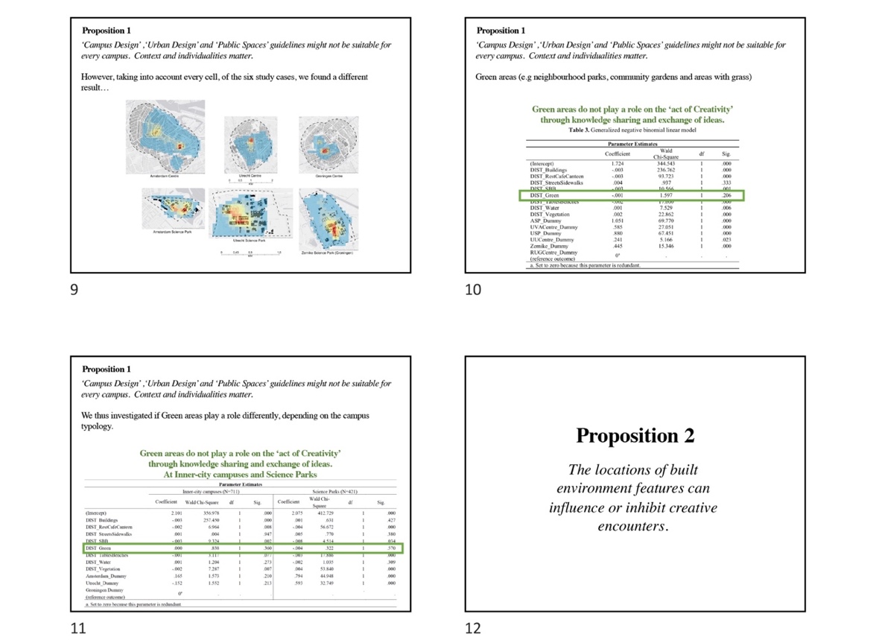

B2. Proposition 2: The locations of built environment features can influence or inhibit creative encounters.

- Let's take Utrecht Science Park as an example. As you can see, the map shows the 10 cells with the highest frequency of creativity at this campus (Slide 13).
- We measured the influence of the built environment on the frequency of creative encounters (Slides 14 and 15).
- In this image it is possible to visualize the 10 cells with the highest frequency of creative encounters and that those 10 cells contain or are located near of multiple urban functions (Slide 16).
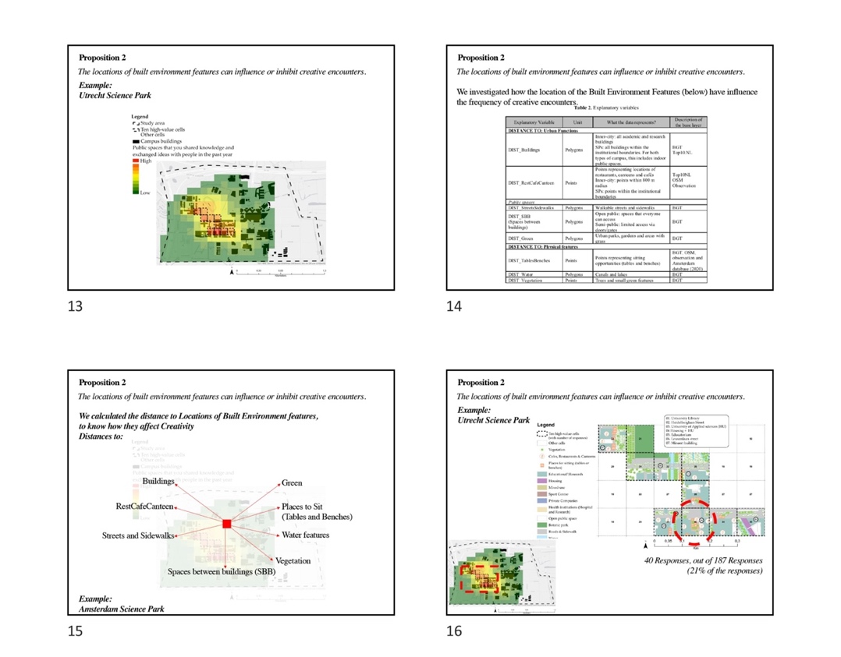

- As aforementioned, we have found in theory that a mix of land-use could provide encounters between people on campuses, but in this research, we empirically tested this affirmation (Slide 17).
- We found that the location of urban functions and physical features create a possibility for spatially guided creativity. For instance, certain locations on campus, perceived with a high frequency of creative encounters, are close by a cluster and mix of built environment features (urban functions and physical features). Such composition can make people feel welcome to interact with others, and therefore, higher opportunities for creative encounters might emerge (Slide 18).

B3. Proposition 3: High accessibility or high availability of spaces to walk does not mean high possibilities of creative encounters. Low accessibility does not mean low possibilities of creative encounters.

- For this proposition, we will show two examples of findings.
- These are the 6 study areas, showing the frequency of creativity in each campus (Slide 20)
- Now we will focus on the variable ‘DIST_StreetsSidewalks’ that represent the distance from a 100x100m cell to a road or sidewalks (Slide 21).
- As you can see, the maximum distance from a cell to a road or sidewalk was 80m. Super short. On the model, that calculated the relationship between frequency of creative encounter with the location of built environment features – this variable is not significant. This means that the availability of roads and sidewalks are not per se determinant for the ‘act of creativity’. Naturally, without them, we couldn’t circulate in outdoor public spaces (Slide 22).
- The second example is about Zernike Campus Groningen.
- We used a network analysis model, called space syntax analysis, to measure the walkability of the campus – the potential for walking – and we combined this data with data that represented peoples’ perceptions at the campus (Slide 23).
- We then concluded that spaces with low accessibility can provide high engagement between people and the built environment, depending on the activity that it can provide.

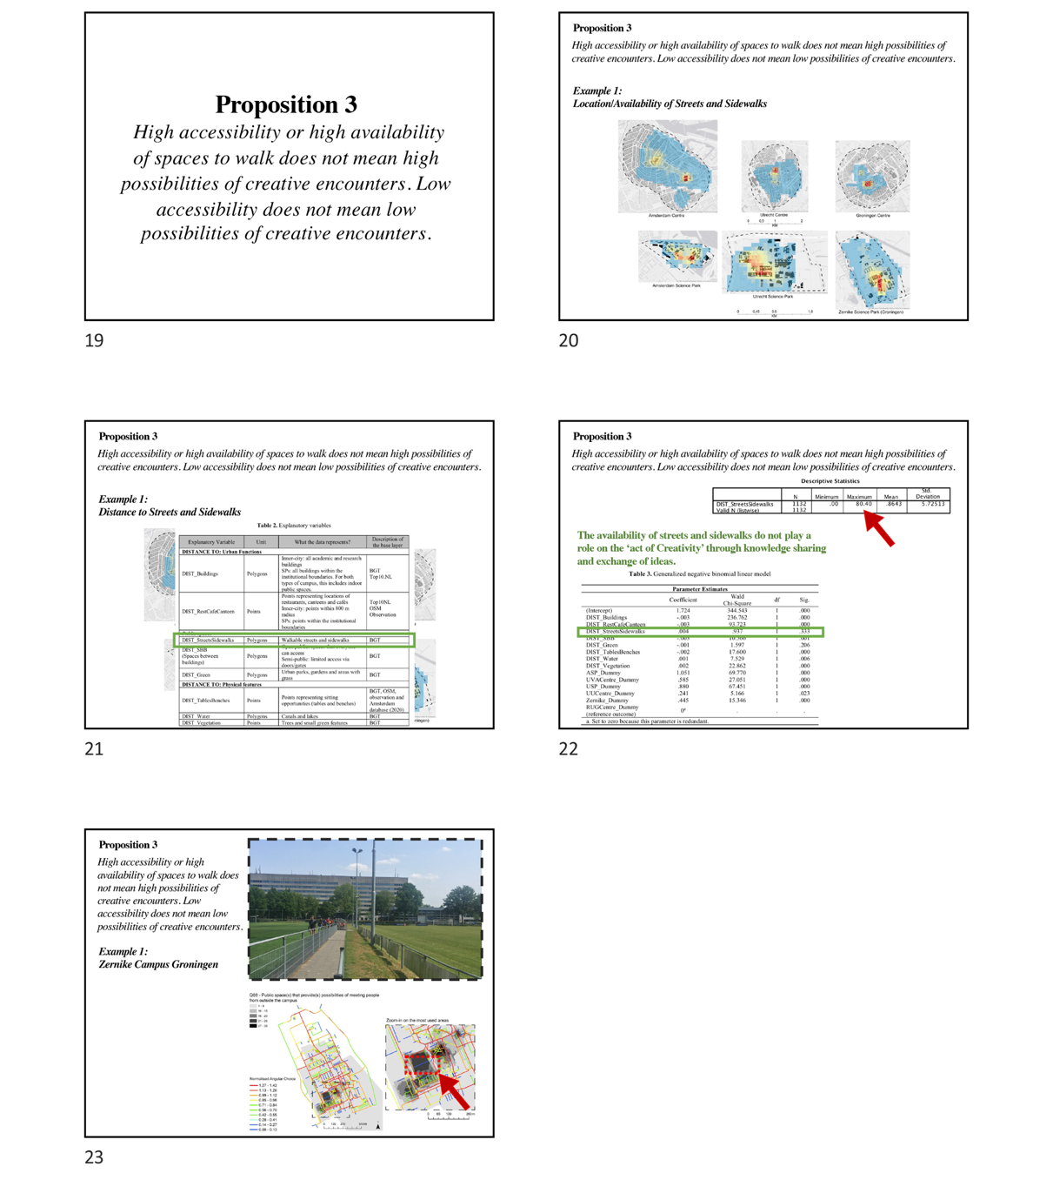

B4. Proposition 4: Campus and Public spaces typology matter for creative encounters between people.

- This proposition is divided into two parts: a) Creativity occurs differently according to campus typology, and b) creativity also occurs differently according to public spaces typology.
- For this part, we used observations and photography to check spaces with a high frequency of creative encounters.

- Campuses typologies matter
- For this research, we had the hypothesis that creativity at inner-city campuses would be spatially distributed throughout the whole city centre. And that in SPs, creativity would occur only within the campus masterplan.
- This is since inner-city campuses are located in the city centre and have access to a higher diversity of land use. In other words, people that circulate at the inner-city campuses public spaces have the potential to mix with tourists, day-trippers, workers and residents.

- Public spaces typologies matter
- Another hypothesis that we had was that creativity occur differently depending on the type of public space: neighbourhood parks, streets, walking paths, passages, terraces, yards, backyards, plazas and semi-public passages.

Regarding ‘a) Campus typology matter’

- Empirical evidence contradicted the hypothesis. We noticed during the data collection that accessing inner-city campus buildings and public spaces was harder because of the physical configuration of buildings and lack of connectivity with the city. Buildings are often reformed houses, that have changed their interior to accommodate academic activities, and therefore have a private character. It seems that ‘strangers’ are invading the buildings while trying to visit (Slide 27).
- Example of City of Groningen and Inner-city campus (Slide 28)

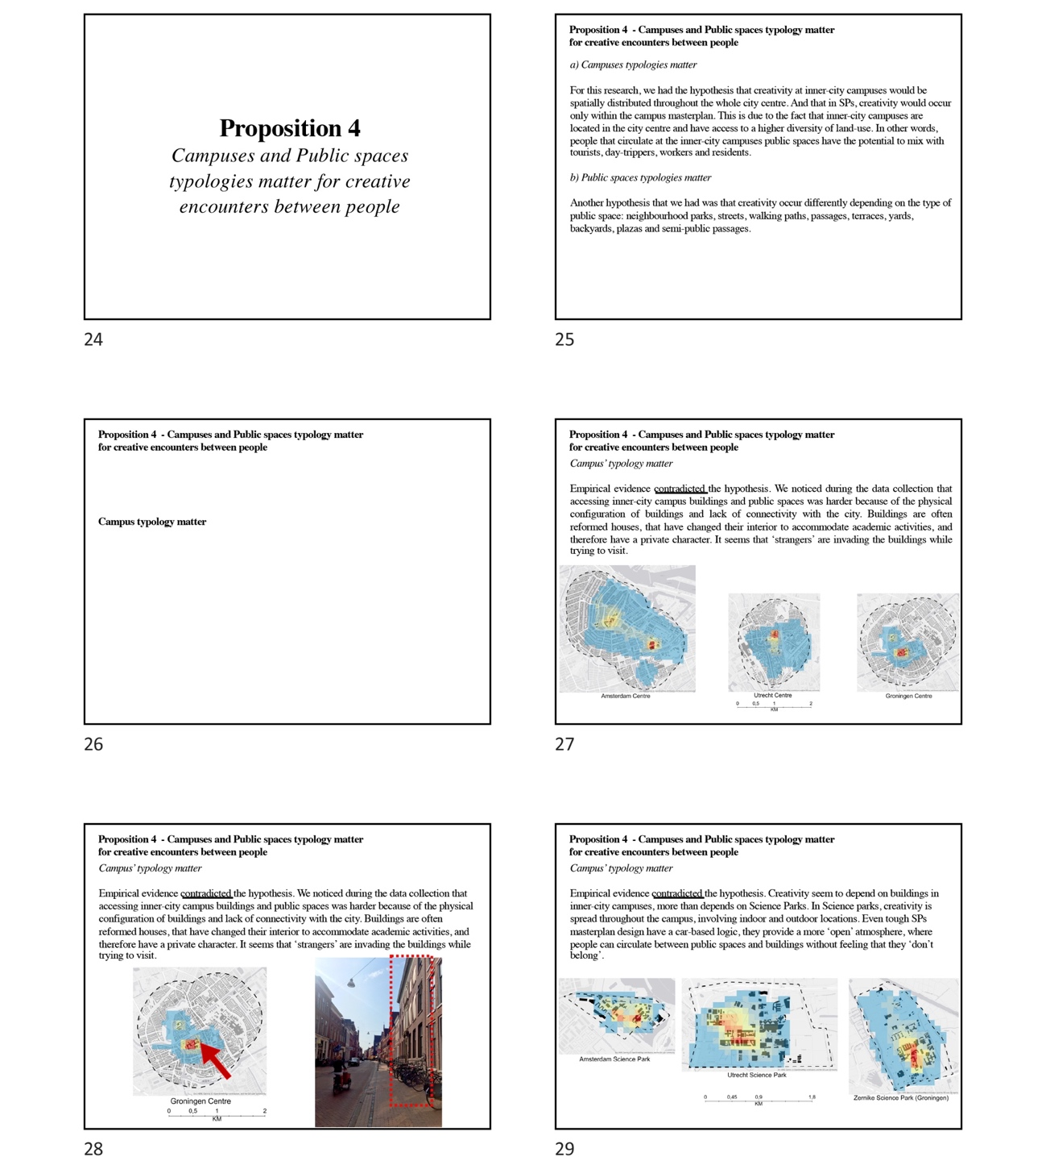

- Empirical evidence thus contradicted the hypothesis for the Science Parks (Slide 29). We noticed during the data collection that accessing inner-city campus buildings and public spaces was harder because of the physical configuration of buildings and lack of connectivity with the city. Buildings are often reformed houses, that have changed their interior to accommodate academic activities, and therefore have a private character. It seems that ‘strangers’ are invading the buildings while trying to visit.
- Example city of Amsterdam Science Park (Slide 30)

Regarding ‘b) Public spaces typologies matter’

- Evidence confirmed this hypothesis, and the empirical research showed that the physical characteristics of the masterplan, open and semi-public spaces make a difference in how people interact with spaces and with each other. Evidence showed that public spaces typology should be taken into account when planning and designing campuses.

C. Interview Guide and Questions

- Introduce yourself.
- Explain the concept of ‘spatial affordances for creativity’ (for interview: the value of spatial and perceptual aspects of creativity).
- Explain the study areas.
- Explain the structure of the Interview and what are the Propositions (Evidence of empirical research).

Table 2: Interview Questions
Propositions | Interview question
Introduction | - What is your position? And how does it relate to the planning and design of public spaces?
 | - What is your opinion on the value of public spaces for a city?
- Does your institution/organization have any goals to achieve regarding the quality of public spaces?

If yes, which ones? Examples?
If not, do you see the necessity of it?
 | - To what extent the public spaces are taken into account in the decision-making of the masterplan development or redevelopment of campuses?
 | - To what extent are opportunities for creative encounters, knowledge sharing between people taken into account for the decision-making of campuses public spaces?
- In your practice or the process of decision-making, do you use any type of data that captures peoples’ perceptions, feelings or experiences?

If not… would you like to explore this? Do you see it as important?
If yes… can you explain a little bit how was the process? Were policies or decision-making done based on this data?
- ‘Campus Design’,‘Urban Design’ and ‘Public Spaces’ guidelines might not be suitable for every campus. Context and individualities matter. | Credibility
 | - Do you feel that the evidence presented in Proposition 1 and the arguments provided are reliable to understand creativity in campuses public spaces?
 | Do you use any type of ‘campus design’, ‘urban design’ or ‘public spaces guidelines in your practice? How do you feel about them?
 | Relevance
 | - To what extent Proposition 1 is relevant and useful for decision-making on campuses and public spaces?
 | Applicability
 | - To what extent the insights provided in Proposition 1 can be applicable for the improvement of Campuses and Public Spaces? Could this evidence be helpful for decision-making?
- The locations of built environment features can influence or inhibit creative encounters. | Credibility
- According to your experience in practice, do you think the procedures used and the evidence provided in Proposition 2 is reliable to understand creativity in public spaces?

If yes. Can you explain why?
If no. What makes you think the information provided is not reliable?
 | Relevance
- According to your experience in practice, what is your opinion on the influence of the built environment on peoples’ interactions on campus?

Prob: For instance, the extent to which the location of urban functions, physical features, activities, furniture play a role in peoples’ interactions on campus.
 | Applicability
 | - Now, thinking about projects of development or re-development of public spaces of campuses: To what extent the evidence presented in Proposition 2 could be applicable and usable for decision making?
- High accessibility high availability of spaces to walk does not mean high possibilities of creative encounters, and low accessibility does not mean low possibilities of creative encounters. | Credibility
 | - According to your experience in practice, do you think the procedures used and the evidence provided in Proposition 3 is reliable? Do they relate to your practice?
 | Relevance
 | - To what extent is Proposition 3 Relevant to your practice?
 | Applicability
- Do you think the evidence presented in Proposition 3 could be applied to your practice, to solve public spaces problems?

If yes. How would you link this evidence to your practice?
If no. How it could be adapted or improved to be applicable?
- Campus and Public spaces typology matter for creative encounters between people. | Credibility
- To what extent presented procedures in Proposition 4 - of separating and specifying campuses and public spaces are valid to your practice?

Prob: Do you think this procedure is reliable to understand creative interactions in public spaces?
Relevance
(Openness/connectivity between campus and city)
- Are there any strategies/policies to promote connectivity/openness between campus and the city? For instance, making sure that public spaces and campuses are well integrated with the rest of the city?

If yes. Can you give examples?
If not. How do you think the city and campuses should communicate – in a spatial way?
Relevance
(Interface between public (public space) and Private (university buildings)
- To what extent do distinctions between public and private-public spaces affect decision making on the development or re-development of campuses?

Prob: For instance, are there Dilemmas or Positive aspects on the management of public and private parties? How to manage the parties in the public spaces decision-making?
 | Applicability
- Do you think this evidence could be applied to your practice? And can you link this evidence to your practice?

If no. How it could be adapted or improved to be applicable?
Closing | - Taking a general overview of the presented Propositions. Are there any propositions that are relevant to your practice but not applicable? Is there anything regarding the propositions that you would like to add?  - Anything you want to add?  - Can you recommend someone?  - Can I contact you if I have any additional questions?

D. Codebook

D1. Codebook - Research Question 01

Table 2: Indicators of codes, for research question 1
Code (level) name | Indicators
Not applied | Socio-spatial aspects of creativity are not mentioned as an aspect considered in decision-making, planning and design.
Partly applied | Socio-spatial aspects of creativity are acknowledged as important, however, are not yet applied in decision-making, planning and design.
Applied | Socio-spatial aspects of creativity are acknowledged as important and are applied in either decision-making or planning or design.

Table 3: Indicators of sub-codes, for research question 1
Sub-code (reason) Name | Indicators
CA.01 Buildings are often the priority | For the university as an institution, their main priority is the buildings and interior. The institutions located on campuses focus (or cares) about their building, and often neglects the public spaces as an important asset for a university.
CA.02 Public spaces for circulation | This sub-code represents quotations that explain that decision-making, planning and design of public spaces refer to public spaces as spaces for circulation (e.g availability of cycling paths or connectivity with bus systems)
CA.03 Managing public spaces | This sub-code represents quotations which explain that decision-making, planning and design of public spaces refer to public spaces from the management perspective. It highlights and specifies opinions of practitioners based on their roles in the public spaces projects (e.g to promote safety, spaces for bike parking, maintenance, promoting the location of garbage bins, location of furniture).
CA.04 Public spaces as places for meeting and all types of encounters (not specifically creative encounters) | This sub-code represents quotations that explain that decision-making, planning and design of public spaces take into account public spaces as spaces to meet, and do not specify which kind of encounter they can or should promote.
CA.05 Events complement the physical characteristics of public spaces, for creative encounters | This sub-code represents quotations that explain that the physical environment is not enough to enable creative encounters, that the promotion of events on campus plays a fundamental role in creative encounters.
CA.06 Socio-spatial aspects of creativity is applied | This represents the quotations that show that the socio-spatial aspects of creativity are somehow addressed in the planning, design and decision-making of campuses public spaces.

D2. Codebook - Research Question 02

Table 4: Indicators of codes (Part 2)
Code name | Indicators
Low | The code ‘No’ represents quotations that explain why the practitioner does not perceive or doubts that the research evidence (propositions) is/are credible OR relevant OR applicable to their practice.
Medium | The code ‘moderate’ represents quotations that explain why the practitioner perceives that the research evidence (propositions) is ‘in between’ yes or no regarding its credibility OR relevance OR applicability for practice.
High | The code ‘Yes’ represents quotations that explain why the practitioner perceives that the research evidence (propositions) is/are credible OR relevant OR applicable to their practice.

Table 5: Indicators of sub-codes, for research question 2
Discussion points  extracted from propositions |  | Indicators
01 | The impact of natural features in group or individual creativity | The sub-code represents quotations that refer to the perceptions of practitioners regarding Proposition 1, which discussed to what extent research evidence that argues that natural features might not play a role in the specific act of ‘knowledge sharing and exchange of ideas’ on campuses public spaces.
02 | Land-use mix, activities and short distances can enable creative encounters | The sub-code represents quotations that refer to practitioners’ perceptions regarding the research evidence presented in Proposition 2 (see Appendix A), which stated that (creative) encounters are enabled by the location of built environment features.
03 | Aspects such as weather and season can influence socio-spatial aspects of creativity | This code represents the quotations that say that the built environment features presented in the propositions are not enough to explain creativity, according to the practitioner’s perspective. It was argued that other aspects also play a role in creative encounters in public spaces, such as weather and season of the year. Additionally, the built environment is not enough to promote encounters, and practitioners argued that you need for instance to promote events to enhance encounters.
04 | Spatial accessibility between built environment features facilitate creative encounters | This code represents perceptions of professionals about public spaces that can enhance or hinder creativity through spatial accessibility. It was argued that the masterplan of a campus should be planned and design in a way that balances flows of movement and land-use. With that, campus managers do not need to put effort in organizing events and other external activities to promote peoples’ engagement with each other.
05 | City-campus integration | The sub-code represents quotations that refer to the socio-spatial relationships between the campus area (as a neighbourhood) and the host city (the surrounding areas). Oftentimes, such relationships are simplified to accessibility, mobility or connectivity. This also relates to the ‘interface between inside and outside’, which regards the interactions between the inside of university buildings and inside/outside public spaces.
06 | Campus typology plays a role in Creativity | The sub-code represents quotations that refer to the extent to which socio-spatial aspects of creativity differ depending on the campus typology, namely inner-city campuses and science parks.
07 | Public spaces management | This sub-code represents quotations that are focused on the management of public spaces, from the decision-making perspective. Quotations that represent the role that the multiple stakeholders play (e.g. planners, designers, decision-makers, project managers) in public spaces projects and how they deal with multiple managerial decisions regarding public spaces.

References
Al-Sayed, K., A. Turner & S. Hanna, 2012. Generative structures in cities, 8th International Space Syntax Symposium 1–18.
Curtis, J.W., E. Shiau, B. Lowery, D. Sloane, K. Hennigan & A. Curtis, 2014. The prospects and problems of integrating sketch maps with geographic information systems to understand environmental perception: A case study of mapping youth fear in Los Angeles gang neighborhoods, Environment and Planning B: Planning and Design 41(2), 251–71.
Dober, R.P., 1992. Campus Design. New York, N.Y: J. Wiley.
Dober, R.P., 2014. Campus Landscape : Functions, Forms, Features[Reprint]. New York: John Wiley & Sons, INC.
Hajrasouliha, A., 2015.
Hajrasouliha, A., 2017. Master-planning the American campus: Goals, actions, and design strategies, Urban Design International 22(4), 363–81.
Hillier, B., 2009. Spatial Sustainability in Cities Organic Patterns and Sustainable Forms, in Symposium A Quarterly Journal In Modern Foreign Literatures, 1–20.
Hillier, B., 2012. Studying cities to learn about minds: Some possible implications of space syntax for spatial cognition, Environment and Planning B: Planning and Design 39(1), 12–32.
Hillier, B. & S. Iida, 2005. Network and psychological effects in urban movement, Lecture Notes in Computer Science (including subseries Lecture Notes in Artificial Intelligence and Lecture Notes in Bioinformatics) 3693 LNCS, 475–90.
Kenney, D.R., R. Dumont & G. Kenney, 2005. Mission and Place : Strengthening Learning and Community through Campus Design LK - Https://Rug.on.Worldcat.Org/Oclc/814879176. Westport, CT SE - x, 286 p. : ill. ; 26 cm.: Praeger.
Lau, S.S.Y. & F. Yang, 2009. Introducing healing gardens into a Compact University Campus: Design natural space to create healthy and sustainable campuses, Landscape Research 34(1), 55–81.
Sharmin, S. & M. Kamruzzaman, 2018. Meta-analysis of the relationships between space syntax measures and pedestrian movement, Transport Reviews 38(4), 524–50.
Soares, I., V. Venhorst, G. Weitkamp & C. Yamu, 2021. The impact of the built environment on creativity in public spaces of Dutch university campuses and science parks, Journal of Urban Design 1–19.
Soares, I., G. Weitkamp & C. Yamu, 2020a. Public spaces as knowledgescapes: Understanding the relationship between the built environment and creative encounters at dutch university campuses and science parks, International Journal of Environmental Research and Public Health 17(20), 1–30.
Soares, I., C. Yamu & G. Weitkamp, 2020b. The Relationship between the Spatial Configuration and the Fourth Sustainable Dimension Creativity in University Campuses: The Case Study of Zernike Campus, Groningen, The Netherlands, Sustainability 12(21), 9263.
Strange, C.C., J.H. Banning & U. Delworth, 2001. Educating by Design : Creating Campus Learning Environments That Work. San Francisco: Jossey-Bass.
Strange, C.C. & J.H.T.A.-T.T.- Banning, 2015.
Van Nes, A. & C. Yamu, 2018. Space Syntax: a Method To Measure Urban Space Related To Social, Economic and Cognitive Factors, The Virtual and the Real in Urban Planning and Design: Perspectives, Practices and Application (January), 136–50.
Vaughan, L., 2007. The spatial syntax of urban segregation, Progress in Planning 67(3), 205–94.
Zeng, C., B. Lyu, S. Deng, Y. Yu, N. Li, W. Lin, D. Li & Q. Chen, 2020. Benefits of a three-day bamboo forest therapy session on the physiological responses of university students, International Journal of Environmental Research and Public Health 17(9), .

