Supplementary Material

Supplementary Figures

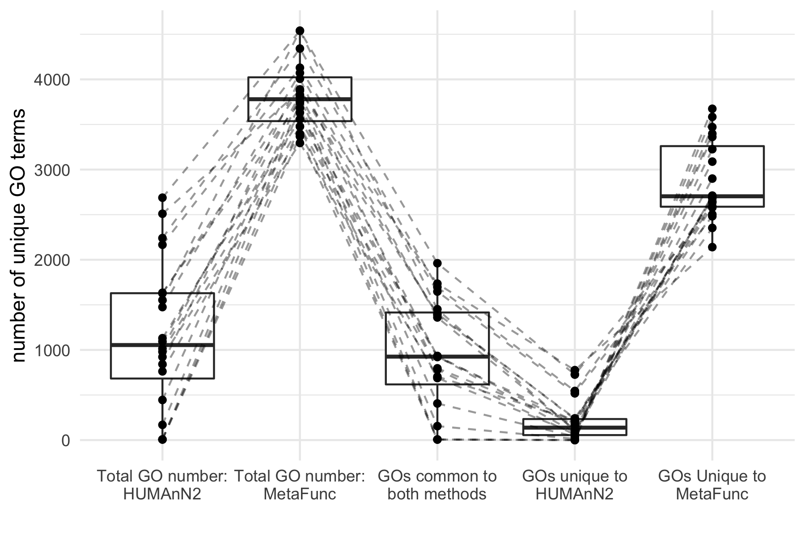
Supplementary Figure S1. Comparison of the number of unique microbial GO terms between MetaFunc and HUMAnN2 from the analysis of the PRJNA413956 cohort. We compared the number of GO terms from Bacteria and Viruses from MetaFunc with the number of microbial GO terms from HUMAnN2 that have been classified to a taxonomy. Dashed lines connect one sample from the PRJNA413956 cohort.

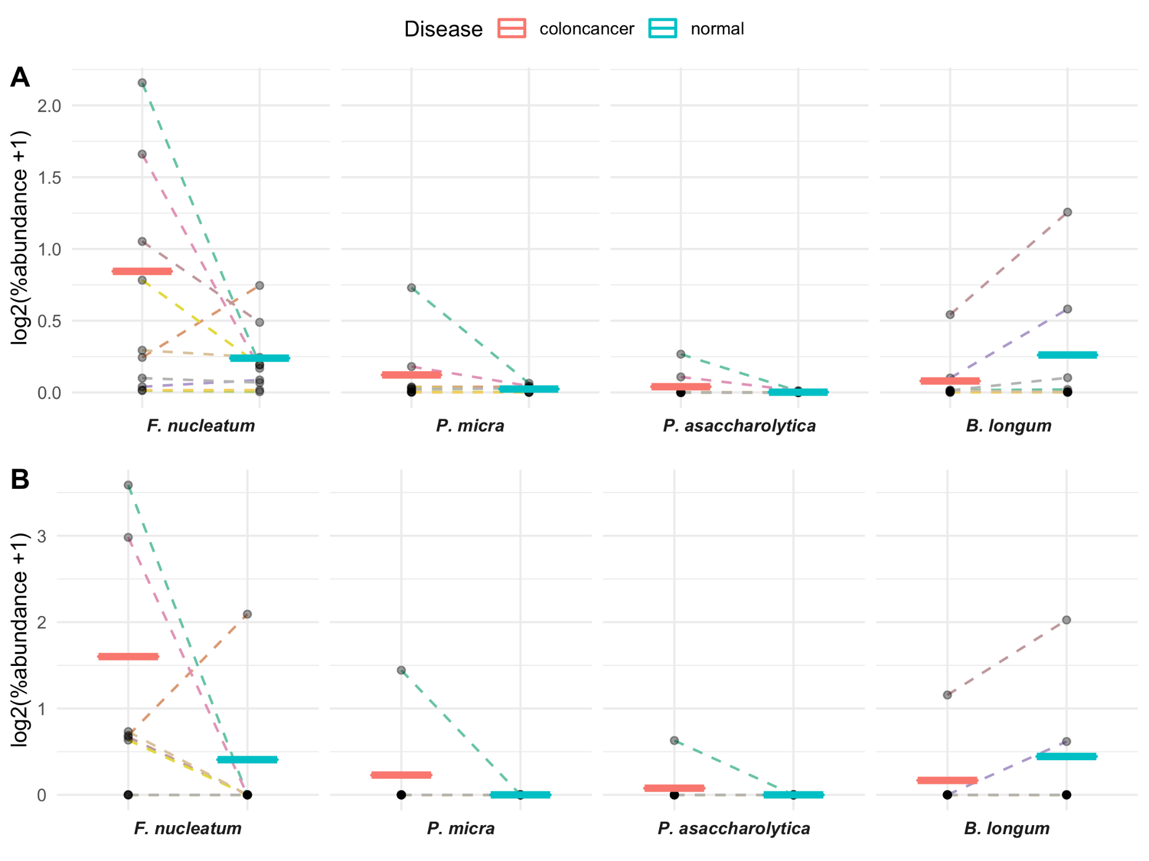
Supplementary Figure S2. Average percent abundance of selected bacterial species in CRC tissue compared to matched non-tumor (normal) samples as measured by A. MetaFunc (top) or B. HUMAnN2 (bottom). We plotted the percent abundances of selected bacteria in CRC and matched normal samples. Raw values were first log₂ transformed, with prior addition of 1 as a pseudocount to account for 0 values. Individual points represent individually transformed sample values. Per group means are represented as horizontal lines and colored according to disease state. Dashed lines connect matched CRC and normal values. Line colors correspond to individual patients.

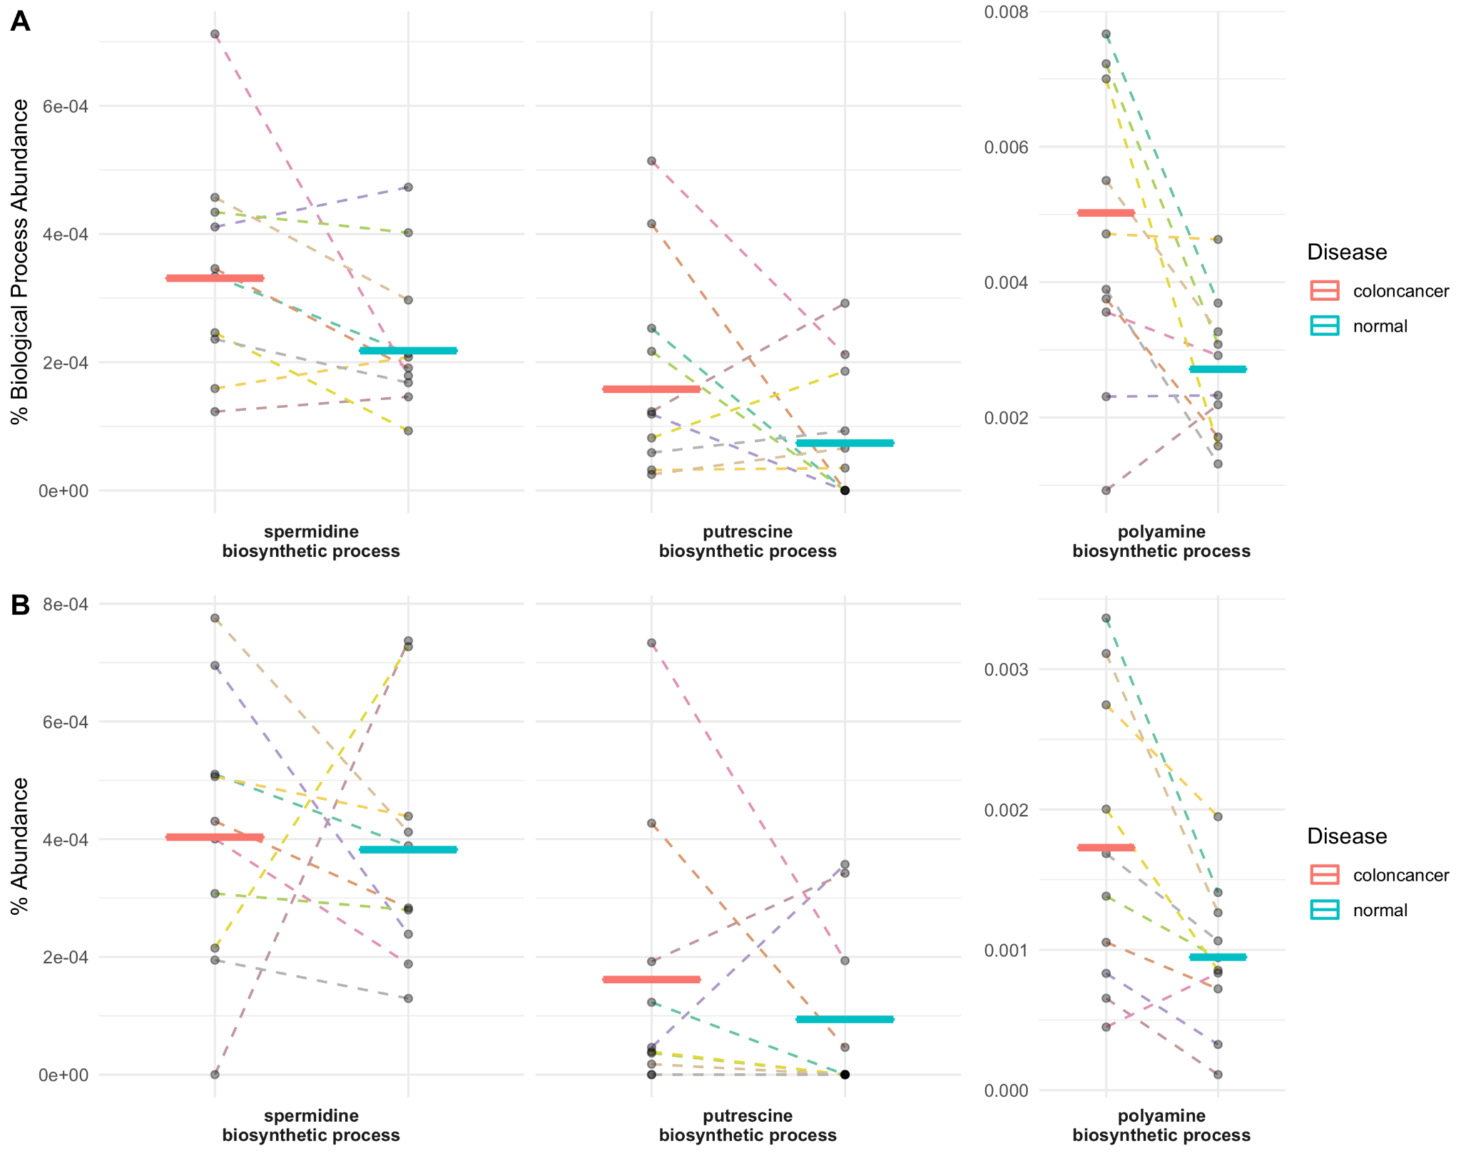
Supplementary Figure S3. Polyamine biosynthetic process GO terms compared between CRC (red) and normal (blue) samples. A. As measured by MetaFunc. Percent abundance of specific polyamine biosynthetic process GO terms among all biological process GOs in a sample/group. Values were calculated as described in section 2.3.2.4 Gene Ontology: Protein Annotation, and output in MetaFunc tables or in the R Shiny application. These values were plotted, overlaying group means (horizontal lines) and individual values (data points). Line colors depict samples from a single patient. Lines connect paired CRC and normal samples. B. As measured by HUMAnN2. Percent abundance of specific polyamine biosynthetic process GO terms. HUMAnN2 outputted read counts as reads-per-kilobase (RPKs), which was then converted to counts per million (CPM) by dividing the RPK of a gene family by the total RPK in a sample. From CPM, percent abundance was obtained.

Supplementary Tables
Supplementary Table S1. Top 25 Gene Sets Enriched in CRC Samples from PRJNA413956 Dataset as Measured by Normalized Enrichment Scores.
GO ID | GO Term | |NES| | p.adjust
GO:0042254 | GO_RIBOSOME_BIOGENESIS | 2.54 | 0.0021
GO:0000779 | GO_CONDENSED_CHROMOSOME_CENTROMERIC_REGION | 2.50 | 0.0021
GO:0034660 | GO_NCRNA_METABOLIC_PROCESS | 2.49 | 0.0021
GO:0000793 | GO_CONDENSED_CHROMOSOME | 2.47 | 0.0021
GO:0006260 | GO_DNA_REPLICATION | 2.47 | 0.0021
GO:0098687 | GO_CHROMOSOMAL_REGION | 2.47 | 0.0021
GO:0140014 | GO_MITOTIC_NUCLEAR_DIVISION | 2.46 | 0.0021
GO:0022613 | GO_RIBONUCLEOPROTEIN_COMPLEX_BIOGENESIS | 2.46 | 0.0021
GO:0034470 | GO_NCRNA_PROCESSING | 2.46 | 0.0021
GO:0016072 | GO_RRNA_METABOLIC_PROCESS | 2.45 | 0.0021
GO:0006261 | GO_DNA_DEPENDENT_DNA_REPLICATION | 2.45 | 0.0021
GO:0007059 | GO_CHROMOSOME_SEGREGATION | 2.45 | 0.0021
GO:0000819 | GO_SISTER_CHROMATID_SEGREGATION | 2.45 | 0.0021
GO:0000775 | GO_CHROMOSOME_CENTROMERIC_REGION | 2.44 | 0.0021
GO:0000070 | GO_MITOTIC_SISTER_CHROMATID_SEGREGATION | 2.44 | 0.0021
GO:0071103 | GO_DNA_CONFORMATION_CHANGE | 2.43 | 0.0021
GO:0098813 | GO_NUCLEAR_CHROMOSOME_SEGREGATION | 2.39 | 0.0021
GO:0000776 | GO_KINETOCHORE | 2.38 | 0.0021
GO:0030684 | GO_PRERIBOSOME | 2.37 | 0.0021
GO:0051983 | GO_REGULATION_OF_CHROMOSOME_SEGREGATION | 2.37 | 0.0021
GO:0048285 | GO_ORGANELLE_FISSION | 2.37 | 0.0021
GO:0006405 | GO_RNA_EXPORT_FROM_NUCLEUS | 2.36 | 0.0021
GO:0000075 | GO_CELL_CYCLE_CHECKPOINT | 2.36 | 0.0021
GO:0051783 | GO_REGULATION_OF_NUCLEAR_DIVISION | 2.35 | 0.0021
GO:0034728 | GO_NUCLEOSOME_ORGANIZATION | 2.34 | 0.0021
GO:0032200 | GO_TELOMERE_ORGANIZATION | 2.33 | 0.0021

Supplementary Table S2. Top 25 Gene Sets Enriched in CMS1 Dataset as Measured by Normalized Enrichment Scores against CMS2.
GO ID | GO Term | |NES| | p.adjust
GO:0034341 | GO_RESPONSE_TO_INTERFERON_GAMMA | 2.62 | 0.0022
GO:0060333 | GO_INTERFERON_GAMMA_MEDIATED_SIGNALING_PATHWAY | 2.53 | 0.0022
GO:0002250 | GO_ADAPTIVE_IMMUNE_RESPONSE | 2.49 | 0.0022
GO:0007159 | GO_LEUKOCYTE_CELL_CELL_ADHESION | 2.40 | 0.0022
GO:0051607 | GO_DEFENSE_RESPONSE_TO_VIRUS | 2.39 | 0.0022
GO:0042110 | GO_T_CELL_ACTIVATION | 2.38 | 0.0022
GO:0045088 | GO_REGULATION_OF_INNATE_IMMUNE_RESPONSE | 2.37 | 0.0022
GO:0001909 | GO_LEUKOCYTE_MEDIATED_CYTOTOXICITY | 2.37 | 0.0022
GO:0001906 | GO_CELL_KILLING | 2.36 | 0.0022
GO:0034340 | GO_RESPONSE_TO_TYPE_I_INTERFERON | 2.36 | 0.0022
GO:0031341 | GO_REGULATION_OF_CELL_KILLING | 2.36 | 0.0022
GO:0050863 | GO_REGULATION_OF_T_CELL_ACTIVATION | 2.36 | 0.0022
GO:0002449 | GO_LYMPHOCYTE_MEDIATED_IMMUNITY | 2.35 | 0.0022
GO:0002228 | GO_NATURAL_KILLER_CELL_MEDIATED_IMMUNITY | 2.34 | 0.0022
GO:1903039 | GO_POSITIVE_REGULATION_OF_LEUKOCYTE_CELL_CELL_ADHESION | 2.33 | 0.0022
GO:0002703 | GO_REGULATION_OF_LEUKOCYTE_MEDIATED_IMMUNITY | 2.32 | 0.0022
GO:0042098 | GO_T_CELL_PROLIFERATION | 2.32 | 0.0022
GO:0002697 | GO_REGULATION_OF_IMMUNE_EFFECTOR_PROCESS | 2.32 | 0.0022
GO:0032609 | GO_INTERFERON_GAMMA_PRODUCTION | 2.32 | 0.0022
GO:0009615 | GO_RESPONSE_TO_VIRUS | 2.31 | 0.0022
GO:0001818 | GO_NEGATIVE_REGULATION_OF_CYTOKINE_PRODUCTION | 2.30 | 0.0022
GO:0098542 | GO_DEFENSE_RESPONSE_TO_OTHER_ORGANISM | 2.30 | 0.0022
GO:0002237 | GO_RESPONSE_TO_MOLECULE_OF_BACTERIAL_ORIGIN | 2.30 | 0.0022
GO:0050852 | GO_T_CELL_RECEPTOR_SIGNALING_PATHWAY | 2.30 | 0.0022
GO:0001819 | GO_POSITIVE_REGULATION_OF_CYTOKINE_PRODUCTION | 2.30 | 0.0022

Supplementary Table S3. Top 25 Gene Sets Enriched in CMS1 Dataset as Measured by Normalized Enrichment Scores against CMS3.
GO ID | GO Term | |NES| | p.adjust
GO:0051607 | GO_DEFENSE_RESPONSE_TO_VIRUS | 2.38 | 0.0024
GO:0034341 | GO_RESPONSE_TO_INTERFERON_GAMMA | 2.34 | 0.0024
GO:0009615 | GO_RESPONSE_TO_VIRUS | 2.32 | 0.0024
GO:0098542 | GO_DEFENSE_RESPONSE_TO_OTHER_ORGANISM | 2.28 | 0.0024
GO:0071216 | GO_CELLULAR_RESPONSE_TO_BIOTIC_STIMULUS | 2.28 | 0.0024
GO:0045088 | GO_REGULATION_OF_INNATE_IMMUNE_RESPONSE | 2.26 | 0.0024
GO:0048002 | GO_ANTIGEN_PROCESSING_AND_PRESENTATION_OF_PEPTIDE_ANTIGEN | 2.25 | 0.0024
GO:0034340 | GO_RESPONSE_TO_TYPE_I_INTERFERON | 2.25 | 0.0024
GO:0030199 | GO_COLLAGEN_FIBRIL_ORGANIZATION | 2.24 | 0.0024
GO:0032611 | GO_INTERLEUKIN_1_BETA_PRODUCTION | 2.23 | 0.0024
GO:0019882 | GO_ANTIGEN_PROCESSING_AND_PRESENTATION | 2.22 | 0.0024
GO:0042590 | GO_ANTIGEN_PROCESSING_AND_PRESENTATION_OF_EXOGENOUS_PEPTIDE_ ANTIGEN_VIA_MHC_CLASS_I | 2.22 | 0.0024
GO:0032612 | GO_INTERLEUKIN_1_PRODUCTION | 2.21 | 0.0024
GO:0060333 | GO_INTERFERON_GAMMA_MEDIATED_SIGNALING_PATHWAY | 2.20 | 0.0024
GO:0002474 | GO_ANTIGEN_PROCESSING_AND_PRESENTATION_OF_PEPTIDE_ANTIGEN_ VIA_MHC_CLASS_I | 2.18 | 0.0024
GO:0005201 | GO_EXTRACELLULAR_MATRIX_STRUCTURAL_CONSTITUENT | 2.18 | 0.0024
GO:0043062 | GO_EXTRACELLULAR_STRUCTURE_ORGANIZATION | 2.18 | 0.0024
GO:0001819 | GO_POSITIVE_REGULATION_OF_CYTOKINE_PRODUCTION | 2.18 | 0.0024
GO:0050663 | GO_CYTOKINE_SECRETION | 2.18 | 0.0024
GO:0005581 | GO_COLLAGEN_TRIMER | 2.17 | 0.0024
GO:0032635 | GO_INTERLEUKIN_6_PRODUCTION | 2.17 | 0.0024
GO:0070555 | GO_RESPONSE_TO_INTERLEUKIN_1 | 2.17 | 0.0024
GO:0071706 | GO_TUMOR_NECROSIS_FACTOR_SUPERFAMILY_CYTOKINE_PRODUCTION | 2.15 | 0.0024
GO:0071887 | GO_LEUKOCYTE_APOPTOTIC_PROCESS | 2.15 | 0.0024
GO:0031349 | GO_POSITIVE_REGULATION_OF_DEFENSE_RESPONSE | 2.12 | 0.0024

Supplementary Table S4. Top 25 Gene Sets Enriched in CMS2 Dataset as Measured by Normalized Enrichment Scores against CMS1.
GO ID | GO Term | |NES| | p.adjust
GO:0042273 | GO_RIBOSOMAL_LARGE_SUBUNIT_BIOGENESIS | 2.10 | 0.0042
GO:0140053 | GO_MITOCHONDRIAL_GENE_EXPRESSION | 2.04 | 0.0056
GO:0032543 | GO_MITOCHONDRIAL_TRANSLATION | 1.97 | 0.0052
GO:0042788 | GO_POLYSOMAL_RIBOSOME | 1.93 | 0.0035
GO:0008033 | GO_TRNA_PROCESSING | 1.93 | 0.0052
GO:0044391 | GO_RIBOSOMAL_SUBUNIT | 1.92 | 0.006
GO:0042254 | GO_RIBOSOME_BIOGENESIS | 1.92 | 0.0079
GO:0000462 | GO_MATURATION_OF_SSU_RRNA_FROM_TRICISTRONIC_RRNA_TRANSCRIPT_  SSU_RRNA_5_8S_RRNA_LSU_RRNA | 1.92 | 0.0037
GO:0030490 | GO_MATURATION_OF_SSU_RRNA | 1.90 | 0.0063
GO:0034660 | GO_NCRNA_METABOLIC_PROCESS | 1.90 | 0.0116
GO:0006400 | GO_TRNA_MODIFICATION | 1.90 | 0.0044
GO:0016072 | GO_RRNA_METABOLIC_PROCESS | 1.90 | 0.0063
GO:0006399 | GO_TRNA_METABOLIC_PROCESS | 1.89 | 0.0059
GO:0000184 | GO_NUCLEAR_TRANSCRIBED_MRNA_CATABOLIC_PROCESS_NONSENSE_  MEDIATED_DECAY | 1.88 | 0.0051
GO:0006270 | GO_DNA_REPLICATION_INITIATION | 1.88 | 0.0060
GO:0003735 | GO_STRUCTURAL_CONSTITUENT_OF_RIBOSOME | 1.88 | 0.0056
GO:0030684 | GO_PRERIBOSOME | 1.88 | 0.0042
GO:0042274 | GO_RIBOSOMAL_SMALL_SUBUNIT_BIOGENESIS | 1.88 | 0.004
GO:0070129 | GO_REGULATION_OF_MITOCHONDRIAL_TRANSLATION | 1.87 | 0.0097
GO:0034470 | GO_NCRNA_PROCESSING | 1.85 | 0.0097
GO:0005736 | GO_RNA_POLYMERASE_I_COMPLEX | 1.84 | 0.0087
GO:0001510 | GO_RNA_METHYLATION | 1.84 | 0.0043
GO:0098798 | GO_MITOCHONDRIAL_PROTEIN_COMPLEX | 1.84 | 0.0073
GO:0015934 | GO_LARGE_RIBOSOMAL_SUBUNIT | 1.82 | 0.005
GO:0022626 | GO_CYTOSOLIC_RIBOSOME | 1.81 | 0.005

Supplementary Table S5. Top 25 Gene Sets Enriched in CMS2 Dataset as Measured by Normalized Enrichment Scores against CMS3.
GO ID | GO Term | |NES| | p.adjust
GO:0034660 | GO_NCRNA_METABOLIC_PROCESS | 2.48 | 0.0029
GO:0042254 | GO_RIBOSOME_BIOGENESIS | 2.46 | 0.0029
GO:0034470 | GO_NCRNA_PROCESSING | 2.45 | 0.0029
GO:0022613 | GO_RIBONUCLEOPROTEIN_COMPLEX_BIOGENESIS | 2.44 | 0.0029
GO:0016072 | GO_RRNA_METABOLIC_PROCESS | 2.43 | 0.0029
GO:0030684 | GO_PRERIBOSOME | 2.41 | 0.0029
GO:0006270 | GO_DNA_REPLICATION_INITIATION | 2.40 | 0.0029
GO:0032543 | GO_MITOCHONDRIAL_TRANSLATION | 2.31 | 0.0029
GO:0006399 | GO_TRNA_METABOLIC_PROCESS | 2.29 | 0.0029
GO:0032040 | GO_SMALL_SUBUNIT_PROCESSOME | 2.28 | 0.0029
GO:0140053 | GO_MITOCHONDRIAL_GENE_EXPRESSION | 2.28 | 0.0029
GO:0042273 | GO_RIBOSOMAL_LARGE_SUBUNIT_BIOGENESIS | 2.21 | 0.0029
GO:0008033 | GO_TRNA_PROCESSING | 2.20 | 0.0029
GO:0006415 | GO_TRANSLATIONAL_TERMINATION | 2.16 | 0.0029
GO:0007143 | GO_FEMALE_MEIOTIC_NUCLEAR_DIVISION | 2.14 | 0.0029
GO:0120114 | GO_SM_LIKE_PROTEIN_FAMILY_COMPLEX | 2.11 | 0.0029
GO:0000313 | GO_ORGANELLAR_RIBOSOME | 2.09 | 0.0029
GO:0044391 | GO_RIBOSOMAL_SUBUNIT | 2.08 | 0.0029
GO:0003688 | GO_DNA_REPLICATION_ORIGIN_BINDING | 2.08 | 0.0029
GO:0070126 | GO_MITOCHONDRIAL_TRANSLATIONAL_TERMINATION | 2.08 | 0.0029
GO:0140101 | GO_CATALYTIC_ACTIVITY_ACTING_ON_A_TRNA | 2.08 | 0.0029
GO:0071826 | GO_RIBONUCLEOPROTEIN_COMPLEX_SUBUNIT_ORGANIZATION | 2.02 | 0.0029
GO:0000375 | GO_RNA_SPLICING_VIA_TRANSESTERIFICATION_REACTIONS | 2.02 | 0.0029
GO:0015934 | GO_LARGE_RIBOSOMAL_SUBUNIT | 2.02 | 0.0029
GO:0000184 | GO_NUCLEAR_TRANSCRIBED_MRNA_CATABOLIC_PROCESS_NONSENSE_  MEDIATED_DECAY | 2.02 | 0.0029

Supplementary Table S6. Top 25 Gene Sets Enriched in CMS3 Dataset as Measured by Normalized Enrichment Scores against CMS1.
GO ID | GO Term | |NES| | p.adjust
GO:0009812 | GO_FLAVONOID_METABOLIC_PROCESS | 2.22 | 0.0032
GO:0072329 | GO_MONOCARBOXYLIC_ACID_CATABOLIC_PROCESS | 2.22 | 0.0037
GO:0009062 | GO_FATTY_ACID_CATABOLIC_PROCESS | 2.19 | 0.0037
GO:0006805 | GO_XENOBIOTIC_METABOLIC_PROCESS | 2.17 | 0.0037
GO:0034440 | GO_LIPID_OXIDATION | 2.16 | 0.0037
GO:0006635 | GO_FATTY_ACID_BETA_OXIDATION | 2.14 | 0.0035
GO:0003707 | GO_STEROID_HORMONE_RECEPTOR_ACTIVITY | 2.11 | 0.0034
GO:0006631 | GO_FATTY_ACID_METABOLIC_PROCESS | 2.07 | 0.0047
GO:0044242 | GO_CELLULAR_LIPID_CATABOLIC_PROCESS | 2.06 | 0.0043
GO:0006063 | GO_URONIC_ACID_METABOLIC_PROCESS | 2.04 | 0.0032
GO:0034308 | GO_PRIMARY_ALCOHOL_METABOLIC_PROCESS | 2.04 | 0.0035
GO:0016408 | GO_C_ACYLTRANSFERASE_ACTIVITY | 1.99 | 0.0032
GO:0005903 | GO_BRUSH_BORDER | 1.99 | 0.0037
GO:0045277 | GO_RESPIRATORY_CHAIN_COMPLEX_IV | 1.99 | 0.0032
GO:0001972 | GO_RETINOIC_ACID_BINDING | 1.93 | 0.0064
GO:0016614 | GO_OXIDOREDUCTASE_ACTIVITY_ACTING_ON_CH_OH_GROUP_OF_DONORS | 1.92 | 0.0037
GO:0034754 | GO_CELLULAR_HORMONE_METABOLIC_PROCESS | 1.92 | 0.0036
GO:0032787 | GO_MONOCARBOXYLIC_ACID_METABOLIC_PROCESS | 1.91 | 0.0060
GO:0071280 | GO_CELLULAR_RESPONSE_TO_COPPER_ION | 1.91 | 0.0081
GO:0004879 | GO_NUCLEAR_RECEPTOR_ACTIVITY | 1.90 | 0.0052
GO:0016042 | GO_LIPID_CATABOLIC_PROCESS | 1.90 | 0.0050
GO:0033559 | GO_UNSATURATED_FATTY_ACID_METABOLIC_PROCESS | 1.90 | 0.0035
GO:0015701 | GO_BICARBONATE_TRANSPORT | 1.89 | 0.0068
GO:0033293 | GO_MONOCARBOXYLIC_ACID_BINDING | 1.89 | 0.0055
GO:0033540 | GO_FATTY_ACID_BETA_OXIDATION_USING_ACYL_COA_OXIDASE | 1.88 | 0.0093

Supplementary Table S7. Top 25 Gene Sets Enriched in CMS3 Dataset as Measured by Normalized Enrichment Scores against CMS2.
GO ID | GO Term | |NES| | p.adjust
GO:0006063 | GO_URONIC_ACID_METABOLIC_PROCESS | 2.09 | 0.0029
GO:0071294 | GO_CELLULAR_RESPONSE_TO_ZINC_ION | 2.07 | 0.0029
GO:0015020 | GO_GLUCURONOSYLTRANSFERASE_ACTIVITY | 2.06 | 0.0029
GO:0009812 | GO_FLAVONOID_METABOLIC_PROCESS | 2.05 | 0.0029
GO:0071276 | GO_CELLULAR_RESPONSE_TO_CADMIUM_ION | 1.98 | 0.0029
GO:0010043 | GO_RESPONSE_TO_ZINC_ION | 1.96 | 0.0029
GO:0006805 | GO_XENOBIOTIC_METABOLIC_PROCESS | 1.96 | 0.0029
GO:0034754 | GO_CELLULAR_HORMONE_METABOLIC_PROCESS | 1.96 | 0.0029
GO:0004745 | GO_RETINOL_DEHYDROGENASE_ACTIVITY | 1.94 | 0.0029
GO:0005496 | GO_STEROID_BINDING | 1.92 | 0.0029
GO:0030258 | GO_LIPID_MODIFICATION | 1.91 | 0.0029
GO:0016042 | GO_LIPID_CATABOLIC_PROCESS | 1.91 | 0.0029
GO:0006635 | GO_FATTY_ACID_BETA_OXIDATION | 1.91 | 0.0029
GO:0034440 | GO_LIPID_OXIDATION | 1.89 | 0.0029
GO:0006654 | GO_PHOSPHATIDIC_ACID_BIOSYNTHETIC_PROCESS | 1.87 | 0.0029
GO:0007586 | GO_DIGESTION | 1.86 | 0.0029
GO:0006066 | GO_ALCOHOL_METABOLIC_PROCESS | 1.85 | 0.0029
GO:0042572 | GO_RETINOL_METABOLIC_PROCESS | 1.83 | 0.0047
GO:0001972 | GO_RETINOIC_ACID_BINDING | 1.82 | 0.0047
GO:0016408 | GO_C_ACYLTRANSFERASE_ACTIVITY | 1.81 | 0.0078
GO:0032411 | GO_POSITIVE_REGULATION_OF_TRANSPORTER_ACTIVITY | 1.81 | 0.0029
GO:0005319 | GO_LIPID_TRANSPORTER_ACTIVITY | 1.81 | 0.0029
GO:0044242 | GO_CELLULAR_LIPID_CATABOLIC_PROCESS | 1.80 | 0.0029
GO:0008028 | GO_MONOCARBOXYLIC_ACID_TRANSMEMBRANE_TRANSPORTER_ACTIVITY | 1.79 | 0.0062
GO:0042445 | GO_HORMONE_METABOLIC_PROCESS | 1.79 | 0.0029

