Supplementary material

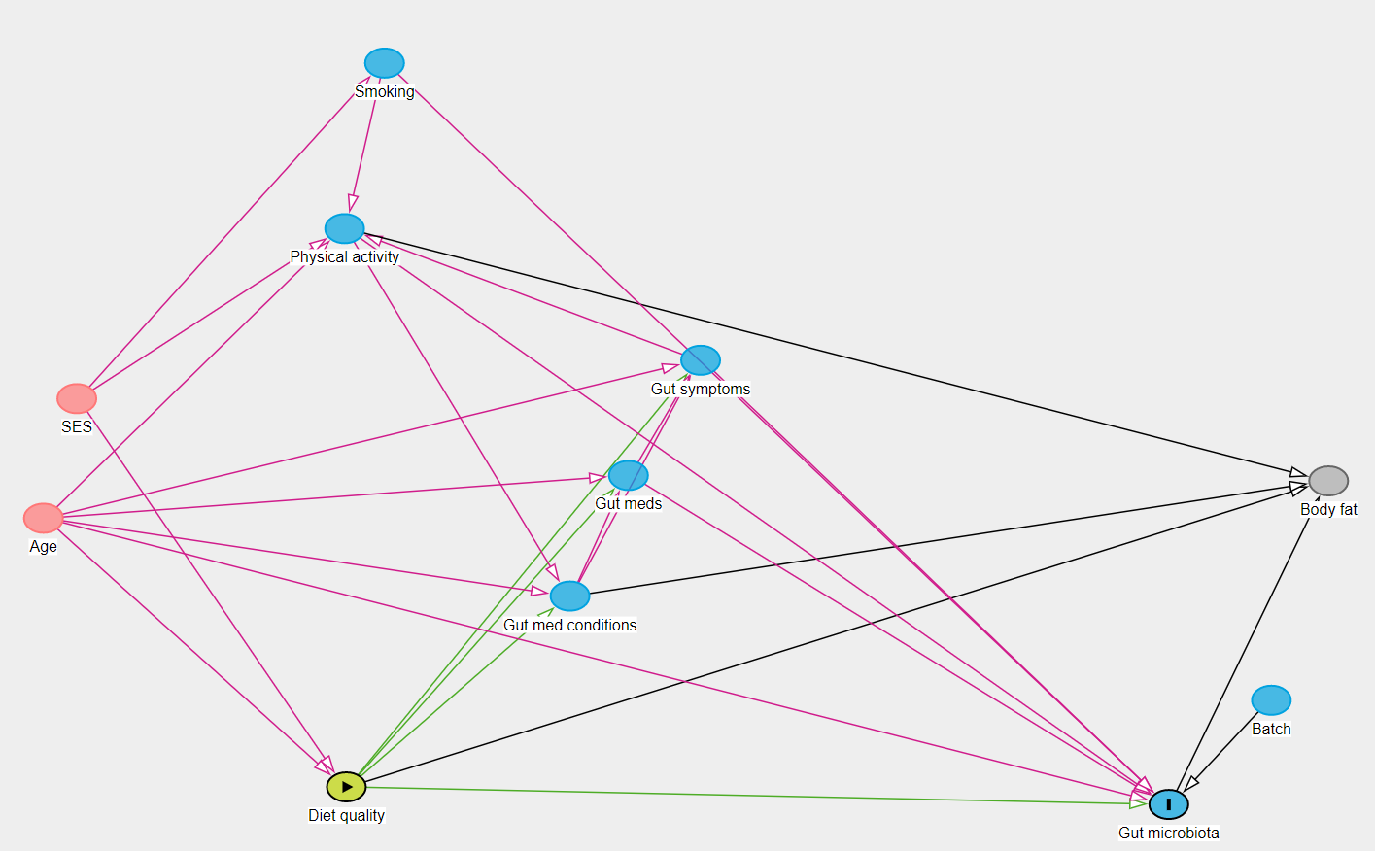
Supplementary Figure 1. Directed Acyclic Graph depicting the relationships between diet quality, the gut microbiome, and potential covariates. The minimal adjustment set included age, smoking, medications which may impact the gut, intestinal symptoms, and physical activity.

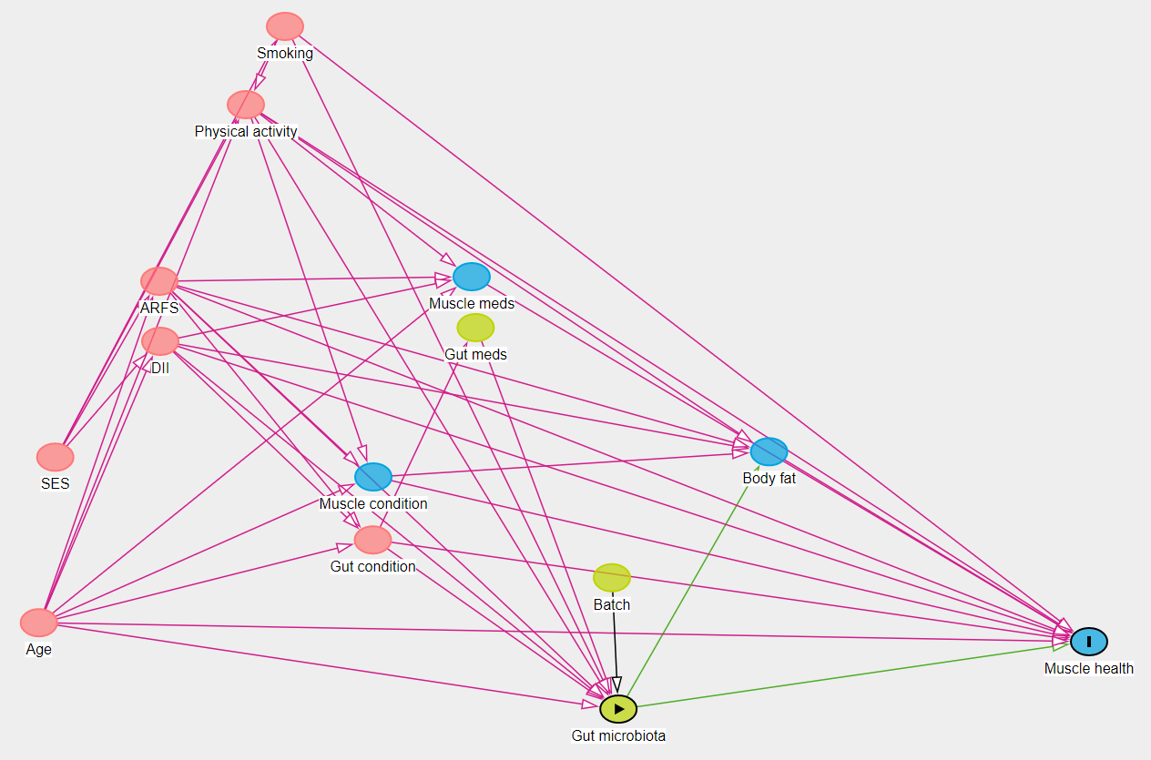
Supplementary Figure 2. Directed Acyclic Graph depicting the relationships between the gut microbiome, measures of muscle health, and potential covariates. The minimal adjustment set included age, smoking, the Australian Recommended Food Score, The Dietary Inflammatory Index, medical conditions which may impact the gut, medical conditions which may impact muscle health, and physical activity.

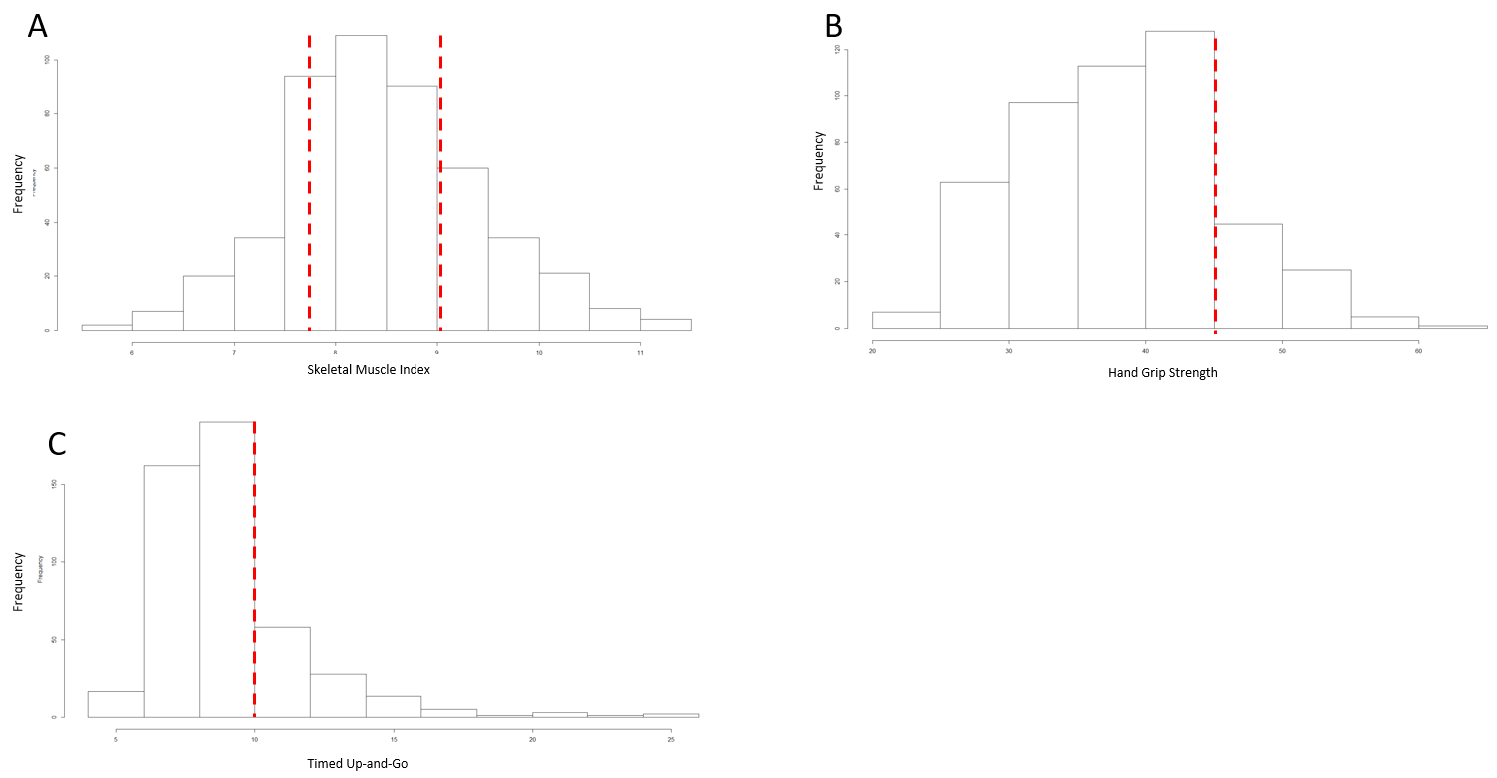
Supplementary Figure 3. Data-derived cut-offs for exploratory analyses. Cut-offs for Skeletal muscle index tertiles were 7.8 kg/m² and 9.0kg/m² (A), the cut-off for high/low handgrip strength was 45kg (B), and the cut-off for high/low Timed Up-and-Go was 10 seconds (C).

Supplementary Table 1. Associations of measures of alpha diversity with age, skeletal muscle index, timed up-and-go, and handgrip strength.
Age | B | 95%CI | p value
Shannon | -0.287 | -2.361, 1.788 | 0.786
Observed | 0.008 | -0.005, 0.021 | 0.226
Skeletal Muscle Index
Shannon | -0.026 | -0.172, 0.119 | 0.724
Observed | -0.001 | -0.001, 0.000 | 0.251
Timed Up-and-Go
Shannon | -0.133 | -0.543, 0.277 | 0.524
Observed | 0.001 | -0.001, 0.004 | 0.377
Handgrip Strength
Shannon | 0.803 | -0.287, 1.892 | 0.148
Observed | 0.001 | -0.006, 0.008 | 0.784

Supplementary Figure 4. Associations of alpha diversity with age, Skeletal Muscle Index, Timed Up-and-Go, and Handgrip Strength. No associations were observed between either Observed or Shannon measures of alpha diversity and skeletal muscle index (A), handgrip strength (B), or timed up-and-go (C).

Supplementary Figure 5. Principal coordinates analysis from unweighted and weighted UniFrac distances. No significant differences were observed between participants in low and high categories for: (A) Skeletal muscle index (Unweighted UniFrac distance, PERMANOVA, p=0.213, Weighted UniFrac distance, PERMANOVA, p=0.448), (B) handgrip strength (Unweighted UniFrac distance, PERMANOVA, p=0.081, Weighted UniFrac distance, PERMANOVA, p=0.173), or (C) timed up-and-go (Unweighted UniFrac distance, PERMANOVA, p=0.253, Weighted UniFrac distance, PERMANOVA, p=0.266).

Supplementary Figure 6. Age stratified associations between butyrate-producing bacteria and muscle mass, strength, and function. No interaction with age was observed for handgrip strength or Timed Up-and-Go.

Supplementary Table 2. Correlation matrix for muscle mass, strength, and function, and important contributing factors.
 | SMI | TUG | HGS | ARFS | DII | Butyrate | Age | IRSAD | Education | Marital  status | Employment
SMI | 1 | -0.232** | 0.356** | 0.116* | -0.148* | 0.187** | -0.362** | 0.171** | 0.142* | -0.041 | -0.291**
TUG | -0.231** | 1 | -0.443** | -0.059 | 0.088 | -0.133* | 0.525** | -0.125* | -0.273** | 0.108** | 0.366**
HGS | 0.356** | -0.443** | 1 | 0.116* | -0.179** | 0.092* | -0.583** | 0.122* | 0.227** | -0.104* | -0.433**
ARFS ^ | 0.116* | -0.059 | 0.116* | 1 | -0.457** | 0.078 | -0.053 | 0.150** | 0.177** | -0.066 | -0.036
DII | -0.148* | 0.088 | -0.180** | -0.457** | 1 | -0.090* | 0.118* | -0.035 | -0.045 | 0.0370 | 0.109*
Butyrate | 0.187** | -0.133* | 0.092* | 0.078 | -0.090* | 1 | -0.164** | 0.123* | 0.171** | -0.078 | -0.170**
Age ^ # | -0.362** | 0.525** | -0.583** | -0.053 | 0.118* | -0.164** | 1 | -0.124* | -0.240** | 0.257** | 0.694**
IRSAD | 0.171** | -0.125* | 0.122* | 0.150** | -0.035 | 0.123* | -0.124* | 1 | 0.240** | -0.042 | -0.099*
Education | 0.142* | -0.273** | 0.227** | 0.177** | -0.045 | 0.171** | -0.240** | 0.240** | 1 | -0.066 | -0.125*
Marital status | -0.041 | 0.108* | -0.104* | -0.066 | 0.037 | -0.078 | 0.257** | -0.042 | -0.066 | 1 | 0.113*
Employment | -0.291** | 0.366** | -0.433** | -0.036 | 0.109* | -0.170** | 0.693** | -0.099* | -0.125* | 0.113* | 1
Smoking ^ # | -0.117 | -0.066 | 0.053 | -0.064 | 0.032 | -0.050 | -0.121** | -0.134** | -0.063 | 0.034 | -0.056
PA ^ # | 0.267** | -0.414** | 0.419** | 0.204** | -0.197** | 0.248** | -0.538** | 0.122* | 0.179** | -0.113* | -0.618**
Fat mass ^ | 0.289** | 0.174** | -0.114* | -0.145* | 0.109* | 0.107* | 0.101* | 0.022 | -0.069 | -0.001 | 0.077
Intestinal  symptoms # | -0.063 | 0.042 | -0.013 | -0.041 | -0.087* | -0.137* | -0.087 | -0.095** | -0.071 | -0.084 | -0.054
Stomach  symptoms | -0.086 | 0.099* | -0.026 | 0.001 | -0.001 | -0.136* | 0.066 | -0.010 | -0.021 | -0.065 | 0.058
Muscle medical condition ^ | -0.084 | 0.208** | -0.272** | 0.003 | 0.068 | -0.065 | 0.350** | -0.103* | -0.116* | 0.083 | 0.281**

Supplementary Table 2 continued
 | SMI | TUG | HGS | ARFS | DII | Butyrate | Age | IRSAD | Education | Marital  status | Employment
Gut medical  condition ^ | -0.162** | 0.159** | -0.142* | -0.097* | 0.020 | -0.115* | 0.211** | -0.069 | -0.090* | 0.020 | 0.168**
Muscle  medications | -0.076 | 0.128* | -0.157** | -0.008 | 0.120* | -0.138* | 0.157** | -0.140* | -0.087* | 0.080* | 0.118*
Gut  medications # | -0.155** | 0.257** | -0.235** | -0.120* | 0.104* | -0.157** | 0.305** | -0.116* | -0.168** | 0.008 | 0.257**
Batch ^ # | 0.031 | 0.004 | 0.021 | 0.021 | -0.035 | 0.090* | -0.074 | -0.067 | 0.004 | -0.045 | -0.068

Supplementary Table 2 continued
 | Smoking | PA | Fat mass | Intestinal symptoms | Stomach symptoms | Muscle med condition | Gut med condition | Muscle meds | Gut meds | Batch
SMI | -0.117** | 0.267** | 0.289** | -0.063 | -0.086 | -0.084 | -0.162** | -0.076 | -0.155** | 0.031
TUG | -0.066 | -0.414** | 0.174** | 0.042 | 0.099* | 0.208** | 0.159** | 0.128* | 0.257** | 0.004
HGS | 0.053 | 0.420** | -0.114* | -0.013 | -0.026 | -0.272** | -0.142* | -0.157** | -0.235** | 0.021
ARFS ^ | -0.064 | 0.204** | -0.145* | -0.041 | 0.001 | 0.003 | -0.099* | -0.008 | -0.120* | 0.021
DII | 0.033 | -0.197** | 0.109* | -0.087 | -0.001 | 0.068 | 0.020 | 0.120* | 0.104* | -0.035
Butyrate | -0.050 | 0.248** | 0.107* | -0.137* | -0.136* | -0.065 | -0.115* | -0.138* | -0.157** | 0.090*
Age ^ # | -0.121* | -0.538** | 0.100* | -0.087 | 0.066 | 0.3500** | 0.212** | 0.157** | 0.305** | -0.074
IRSAD | -0.134* | 0.122* | 0.022 | -0.095* | -0.010 | -0.103* | -0.069 | -0.140* | -0.116* | -0.067
Education | -0.063 | 0.179** | -0.069 | -0.071 | -0.021 | -0.116* | -0.090* | -0.090 | -0.168** | 0.004
Marital status | 0.034 | -0.113* | -0.001 | -0.084 | -0.065 | 0.083 | 0.020 | 0.080 | 0.009 | -0.045
Employment | -0.056 | -0.618** | 0.077 | -0.054 | 0.058 | 0.281** | 0.168** | 0.118* | 0.257** | -0.068
Smoking ^ # | 1 | 0.021 | -0.124* | 0.052 | 0.024 | -0.035 | -0.019 | -0.037 | -0.013 | 0.015
PA ^ # | 0.021 | 1 | -0.209** | -0.047 | -0.109* | -0.219** | -0.192** | -0.120* | -0.293** | 0.052
Fat mass ^ | -0.124* | -0.209** | 1 | 0.004 | 0.039 | 0.144* | 0.114** | 0.061 | 0.175** | 0.015
Intestinal  symptoms # | 0.052 | -0.047 | 0.004 | 1 | 0.349** | 0.108* | 0.182** | 0.150** | 0.134* | -0.033
Supplementary Table 2 continued
 | Smoking | PA | Fat mass | Intestinal symptoms | Stomach symptoms | Muscle med condition | Gut med condition | Muscle meds | Gut meds | Batch
Stomach  symptoms | 0.024 | -0.109* | 0.039 | 0.349** | 1 | 0.124* | 0.313** | 0.145* | 0.159** | -0.037
Muscle medical condition ^ | -0.035 | -0.219** | 0.144* | 0.108* | 0.124* | 1 | 0.217** | 0.337** | 0.304** | -0.016
Gut medical  condition ^ | -0.019 | -0.192** | 0.114* | 0.182** | 0.313** | 0.217** | 1 | 0.083 | 0.395** | -0.021
Muscle  medications | -0.037 | -0.120* | 0.061 | 0.150** | 0.145* | 0.337** | 0.083 | 1 | 0.293** | 0.052
Gut  medications # | -0.013 | -0.293** | 0.175** | 0.134* | 0.159** | 0.304** | 0.395** | 0.293** | 1 | 0.086
Batch ^# | 0.015 | 0.052 | 0.015 | -0.033 | -0.037 | -0.016 | -0.021 | 0.052 | 0.086 | 1
^Variables included in the minimum adjusted model for butyrate-producing bacteria and muscle health regression analysis, #Variables included in the minimum adjusted model for diet quality and butyrate-producing bacteria regression analysis. Correlations were conducted with Pearson correlation for continuous variables, Spearman correlation for categorical variables, and point-biserial for a combination of categorical, continuous, or binary variables. *p<0.05, **p<0.001.

