Survey Questionnaire

Explanation
“Survey of Undergraduate Students’ Consumer Behavior”

This survey examines undergraduate students’ consumption behavior.

It will take approximately 10 min to complete.
Please note that responding to this survey is not mandatory.

You are free to choose whether to respond to the subsequent survey questions. Following the explanatory text is a question that asks whether you will respond to the survey. If you do not complete the survey, there are no consequences, such as reducing course credit.

Those who respond are asked to do so on a subsequent page. The response data will be statistically analyzed to ensure anonymity. Consequently, we cannot determine the nature of your responses. Therefore, please answer as you wish, without worrying about how we interpret your responses. Additionally, we will not use the data for any purpose other than the research.

Note that you will not be able to return to or save your answers in the middle of the questionnaire.

The specific purpose of this survey and the results obtained are explained in the “Consumer Behavior” class. I appreciate your cooperation in answering the survey.

Please click the arrow button below to proceed to the next page.

Do you agree to complete the survey?
- Yes, I agree to complete the survey (the survey will begin later).
- No, I do not consent to complete the survey (your answer is complete on this page).

Please indicate your age. [ ]

What is your gender?
- Male
- Female
- Non-binary/Third gender
- I do not want to answer

Are you an international student whose native language is not Japanese?
- No, I am not an international student.
- Yes, I am an international student.

On the next page, you will see an image of a “freestanding pen case.” [Low-involvement condition]/“aroma hand cream.” [High-involvement condition]
[Depending on the involvement condition]

Imagine how you would feel if you touched or held the product when looking at an image. [Haptic imagery condition]/When looking at the image, consider whether you would purchase the product. [No imagery condition]
[Depending on the imagery condtion]

After 30 s, you will automatically be taken to the next page, so please take a good look at the product before 30 s elapse.

[Haptic imagery and low-involvement conditions]

Below is an image of a “freestanding pen case.”
Please imagine how you would feel if you touched or held the product.
After 30 s, you will be automatically taken to the next page.
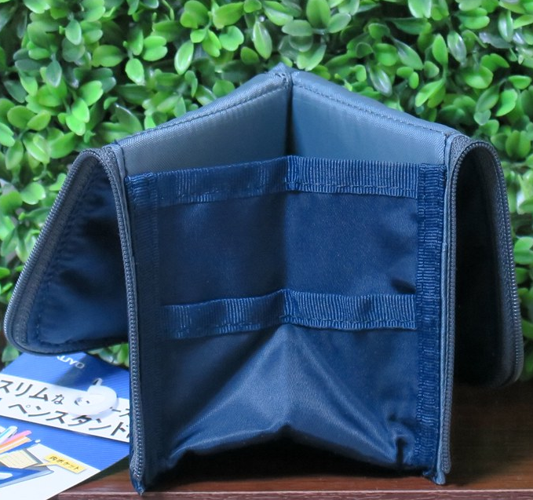

[Haptic imagery and high-involvement conditions]
The following is an image of an “aroma hand cream.”
Please imagine how you would feel if you touched or held the product.
After 30 s, you will automatically be taken to the next page.
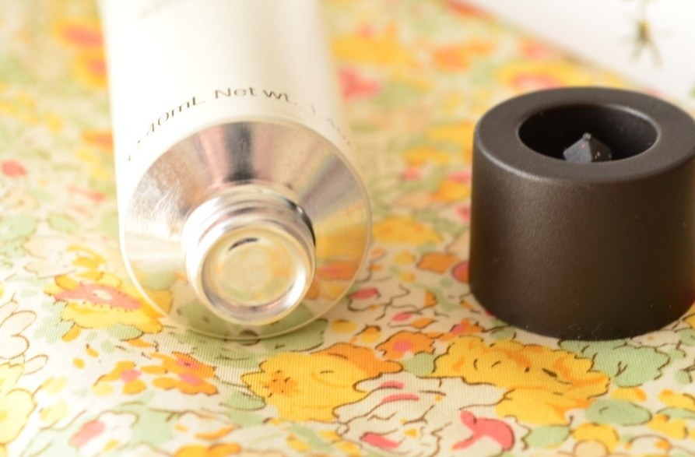

[No imagery and low involvement condition]

Below is an image of a “freestanding pen case.”
Please consider whether you will purchase the product.
After 30 seconds, you will automatically go to the next page.

――
[No imagery and high involvement condition]

The following is an image of an “aroma hand cream.”
Please consider whether you will purchase the product.
After 30 s, you will automatically go to the next page.

Please indicate how your thoughts apply to the following statement regarding the product you have just looked at.
[Participants answer questions on a 7-point Likert scale ranging from 1 (“strongly disagree” to 7 “strongly agree”). ]

- When evaluating the product, I felt as though I could move it.
- When evaluating the product, I had physical control over it.
- I feel like the product is mine.
- I feel a personal ownership of the product.
- I feel like I own the product.
- I want to purchase the product.
- I want the product.

