Supplementary Material – Detailed Methodology

Study Overview
The study comprised of two distinct elements. First, the reliability of the MSANT and SDST was assessed in a seated condition on three separate occasions (Part 1). This was due to the large variability in the way in which the assessment tools may be utilised in future projects. Second, within a sub-sample of the study population, the reliability of the MSANT and SDST was assessed during a 10-minute military-specific walking activity (6.5 km·h⁻¹; 1% gradient), on three separate occasions (Part 2). Whilst a matched study population, for this part of the study would have been optimal, given the time required for this portion of the study (a result of the necessity to reach a physiological steady-state before conducting the test, and the recovery period required between each walking bout to prevent the onset of fatigue), a sub-sample approach was instead chosen. For the subsample of the study population that completed Part 2, the familiarisation in Part 1 acted as the familiarisation for this part as well. For all study visits, participants were required to arrive in a fed and hydrated state having avoided caffeine for a minimum of three hours before their laboratory visit. Study visits were completed at approximately the same time of day (± 2 hours) to control for the potential effect of circadian rhythm on test performance.

Participants
Twenty-eight participants volunteered for Part 1 of the study (14 men, 14 women, age [mean ± SD] 27.3 ± 4.3 y) and 12 participants for Part 2 (6 men, 6 women, age 28.4 ± 3.5 y). The study sample size for part 1 was calculated using an a priori power calculation (G Power; version 3.1.9.4) as detailed by Prajapati, Dunne, & Armstrong (2010). A sample size, of 28 was identified, for the seated portion of the investigation, as the number required to identify a moderate effect size (f = 0.25), with a statistical power of 80%, and an alpha level of 0.05, based upon a correlation coefficient between repeated test performances of r = 0.5 (identified from initial pilot testing). This effect size was chosen as the smallest effect size of interest to military policymakers, based on data from both pilot testing and previous investigations utilising similar cognitive assessment tools (Eddy et al., 2015). The sub-sample population size was designed to represent the typical size (and therefore likely variation) of study populations within this research area (e.g. Bhattacharyya et al., 2017; Crowell et al., 1999; Eddy et al., 2015). On the participants’ first visit to the laboratory written consent was provided following a written and verbal brief of the study requirements and methodologies. Ethical approval was provided by the Institution’s Research Ethics Committee. All procedures were conducted in accordance with the declaration of Helsinki.

Cognitive Assessments
Design decisions were always made in favour of military relevance over ‘typical’ cognitive research norms. For example, stimuli in the SDST were not of equal spatial frequency, as employed in previous research (Kobus et al., 2010), but instead, were of individuals adopting realistic stances that would require specific responses, as used previously within the literature (Armstrong et al., 2022; Eddy et al., 2015; Nibbeling et al., 2014).

MSANT
The MSANT was developed to mimic aspects of coded military radio traffic, with stimuli comprising of letter pairs, described phonetically, using the International Radiotelephony Spelling Alphabet (International Civil Aviation Organization, 2019). Each letter within a pair was separated by 0.4 s, and each pair was separated by 2 s. After a random number of letter pairs (3-7 pairs), an auditory tone (0.25 s, 1000 Hz) was sounded and the participant was required to identify the pair of letters described two previous to the auditory tone (i.e. 2-back). The auditory tone occurred 1 s after the last pairing of that stimuli string. In line with previously employed n-back assessments, each test lasted approximately 5 minutes; depending on letter combinations. Each MSANT contained 100 letter stimuli (Kazemi et al., 2018) and required 10 responses.
Letter stimuli were generated using online speech generation software (www.fromtexttospeech.com) and compiled into a single audio track using an open-source digital audio editing software (Audacity® v2.3, Audacity®, USA). Speech generation variables were set to ‘British English’, male voice, and medium for the speech speed. All letter stimuli were randomly selected using an online random number generator (Research Randomiser; https://www.randomizer.org/). The letter ‘F’ was excluded due to the lack of clarity in generated audio stimuli. For both seated and walking conditions participants received the auditory information via headphones at a standardised volume. During the seated condition, participants recorded their answers, whilst during walking trials, participants were required to relay their answers verbally to be recorded on their behalf. Whilst this approach may have been less than optimal for action fidelity, due to a difference in response modes, as the study was not designed to compare walking and seated conditions, the practicalities of this approach made this approach preferential.

SDST
The SDST was designed to be a visual search and inhibition task similar to those tasks previously employed within the literature (Armstrong et al., 2022; Eddy et al., 2015; Kobus et al., 2010). The urban scene depicted a derelict warehouse (Figure 1), with 12 possible target locations (windows); comprising of 6 on the ground floor and 6 on the first floor. There were no stimuli on the gantry level. Using a calibration stick, the warehouse within the scene was measured to be 9.18 m high and 18.42 m in width. Windows containing the target stimuli were standardised, to a size of 1.60 m x 0.87m (555 x 300 pixels) and coloured using a dark grey (RGB 58,50,48) in order that they provided a uniform background for the target stimuli. At random time intervals (0.5 - 3 s), either a target (persons adopting a shooting stance) or non-target (persons with hands up above their head) would appear at a random window. For a target stimulus, a mouse click was required as quickly as possible (no locational movement required), whereas no response was required for a non-target. The two stimuli were not of the same spatial frequency due to this not being representative of real-world scenarios, however stimuli size was standardised. Participants were instructed to place equal importance on both response time and accuracy. For the SDST there was a 2:1 ratio between targets and non-targets, with two targets and one non-target appearing in each location during each SDST. The SDST was created and recorded using SuperLab 5 software (version 5.05; Cedrus®, San Pedro, USA), with response times recorded to the nearest millisecond for all target stimuli.
For both conditions, a gaming mouse (Logitech G203, Logitech, Lausanne, Switzerland) with 1 ms latency was employed. In the walking condition, the mouse was attached to the side of a replica SA80 rifle, of correct mass, with a mouse button adjacent to the trigger location. During the seated condition, the tests were displayed on a laptop screen (30.9 x 17.4 cm; Toshiba, Tokyo, Japan), whilst for the walking condition, the task was projected ~2.6 m in front of the individual walking on the treadmill (0.97 x 0.79 m). A marker was placed on the side of the treadmill, and participants were instructed to stay in line with it, so that the stimuli size was consistent for all participants. Again, whilst this approach may have been less than optimal, with respect to action fidelity, due to different response modes, as the study was not designed to compare walking and seated conditions, this approach was chosen principally due to the impracticalities of utilising physiological laboratories to collect seated data.

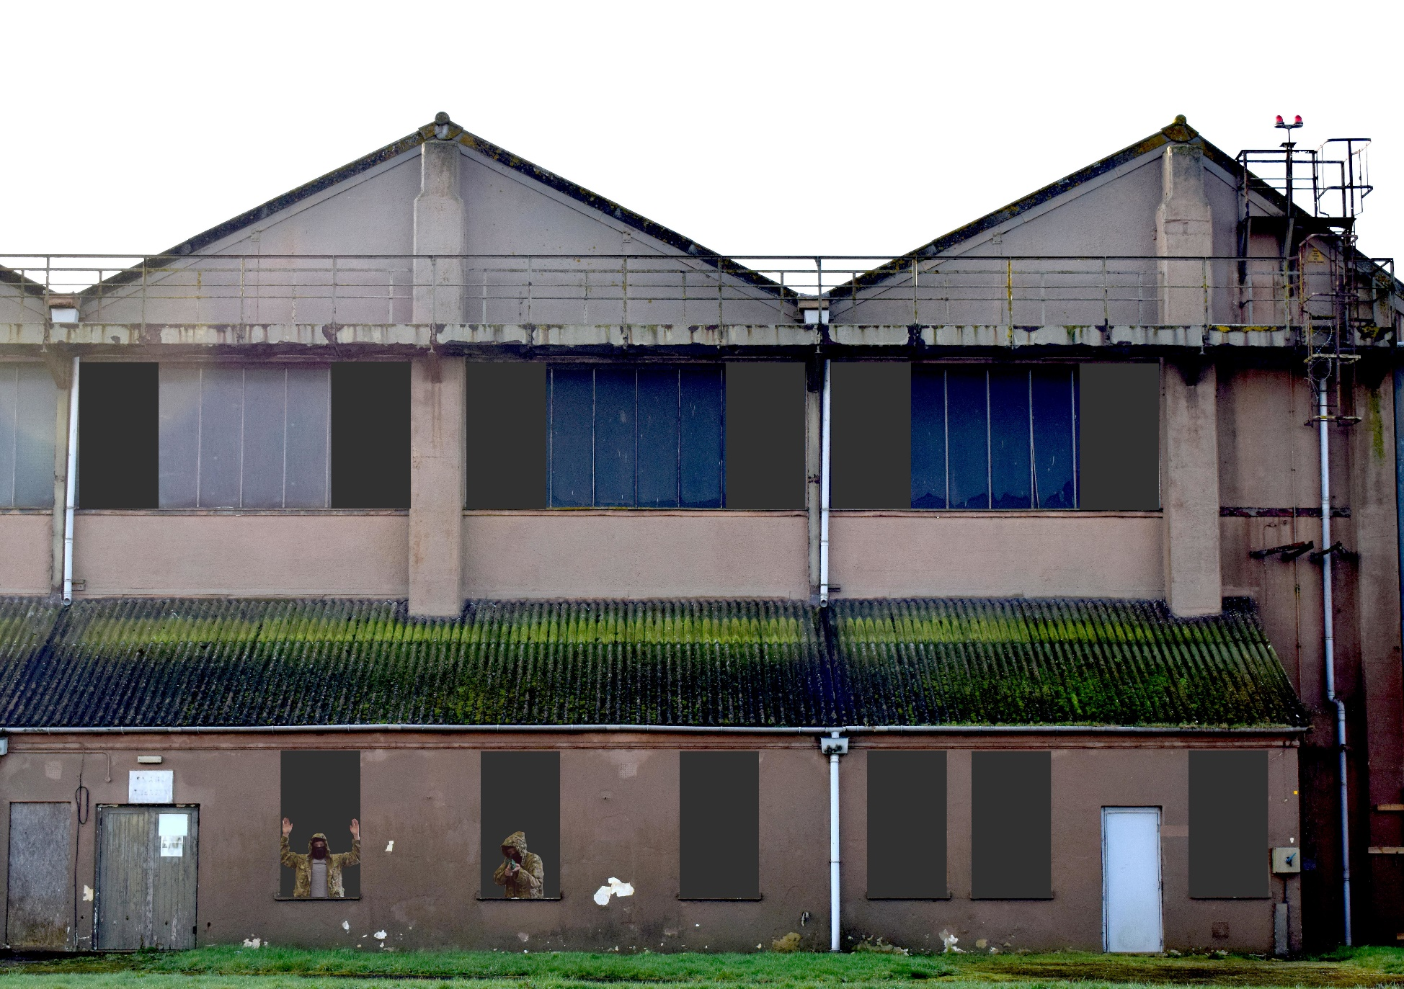
Figure 1. Example Shoot-/Don’t-Shoot Stimuli.

Seated Reliability of Military Specific Cognitive Assessments
Part 1 comprised of three laboratory visits. During the first visit, participants were familiarised (two full trial completions of each assessment) with the MSANT and SDST, in a randomised counterbalanced order. The number of familiarisation trials was based on initial pilot testing, and time expediency. For the second, and third visits, participants completed the MSANT and SDST in the same randomised counterbalanced order as they had during visit one. Trials were separated by a minimum of 24 hours.

Walking Reliability of Military Specific Cognitive Assessments
For part 2, a subsample of 12 participants completed three additional laboratory visits and completed the SDST and MSANT whilst walking on a treadmill. The MSANT and SDST were again completed in a randomised counterbalanced order. All tests were completed with 10 minutes of seated rest between trials to negate the influence of physical fatigue. To enable a physiological steady-state to occur, participants completed five minutes of walking before the commencement of the cognitive assessments. For all walking trials, participants walked on a motorised treadmill (6.5 km·h⁻¹, 1% gradient) based on the fastest load carriage walking speed within the literature (Blacker et al., 2013) and represents a typical ‘enemy contact’ speed (Armstrong, Ward, Lomax, Tipton, & House, 2019).

Analysis of Cognitive Assessment Parameters

MSANT
The number of correct responses and partially correct responses was collected and compared for each trial. A correct response was when both letters were correctly identified and in the correct order. A partial response was when an individual letter in a pair was identified, in the correct location (i.e. first or second letter), but the other letter given was incorrect. To give an additional level of fidelity and sensitivity between individuals, the parameter of total combined correct responses was calculated (Equation 1). Within this equation, a weighting was added to total correct responses to differentiate from partial correct responses and also highlight the importance of correct responses compared with partial correct responses within the context of military operations.
Total combined correct responses =
(3 x Total correct responses) + Partial correct responses (1)

SDST
The number of shoot correct, don’t-shoot correct, total correct (Equation 2), and response times was compared across trials. A response time greater than 1 second, was classified as a non-response. To determine whether changes in the aforementioned SDST parameters were operationally relevant the accuracy-speed trade-off ASTO) variable was calculated (Equation 3).
Total correct responses = (∑ shoot correct + ∑ don’t-shoot correct) (2)
ASTO = (Average response time) ÷ (Total correct responses) (3)

Statistical Analysis
Data were principally analysed using JASP (JASP, 2020; Version 0.14.1) and are presented as mean ± standard deviation unless otherwise stated. For comparative purposes, scores were converted to percentages. Data were assessed for normality using skewness and kurtosis ratios (Fallowfield et al., 2005), and sphericity; with the Greenhouse-Geisser correction applied if sphericity assumptions were violated. For normally distributed data, a one-way ANOVA was employed to identify whether a likely main effect of assessment time point (including familiarisation trials) was apparent. Effect sizes are presented as Omega squared (Ѡ²) (Levine & Hullett, 2002), with 0.01, 0.06, and 0.14 classed as small, medium and large, respectively (Field, 2013). Where F-statistics, p-values, and effect sizes, likely indicate an incompatibility with the null model, Holm-Bonferroni adjusted pairwise comparisons were made post-hoc. Whilst this approach was utilised to investigate incompatibility with the null model across assessment periods, a lack of incompatibility does not imply equity between time points; thus two one-sided tests were employed between trials 1, 2, and 3, to assess whether differences in scores between trials were at least as extreme as the smallest effect size of interest (Lakens et al., 2018). For non-parametric data a Wilcoxon Two One Sided Tests was conducted in R Studio (version 2021.09.1), and the TOSTR package (version 0.4.1). Based upon the a priori sample size calculation, d = 0.5 was employed as the smallest effect size of interest. To describe the typical variation in assessment parameters between trials, Limits of Agreement (LoA) ± 95% Confidence Intervals (CI), Standard Error of the Mean (SEM), and Smallest Detectable Change (SDC) values were calculated. The SEM was calculated by dividing the standard deviation of the difference between trials by $√2$ (Hopkins, 2000; Ludbrook, 2010). Using SEM the SDC was also calculated; SEM x 1.96 x $√2$ (van Kampen et al., 2013). For non-parametric data a Friedman’s test was employed with effect sizes presented using Kendall’s W. Where the combination of χ²-statistics, p-values, and effect sizes, indicate a likely incompatibility with the null model, post hoc pairwise comparisons were made using Conover’s test.

References
Armstrong, N., Smith, S., Risius, D., … D. D.-B. M., & 2022, U. (2022). Cognitive performance of military men and women during prolonged load carriage. BMJ Military Health.
Armstrong, N., Ward, A., Lomax, M., Tipton, M. J., & House, J. R. (2019). Wearing body armour and backpack loads increase the likelihood of expiratory flow limitation and respiratory muscle fatigue during marching. Ergonomics, 62(9), 1181–1192.
Bhattacharyya, D., Pal, M., Chatterjee, T., & Majumdar, D. (2017). Effect of load carriage and natural terrain conditions on cognitive performance in desert environments. Physiology & Behavior, 179, 253–261.
Blacker, S. ., Fallowfield, J. L., Bilzon, J. L. J., & Willems, M. E. T. (2013). Neuromuscular impairment following backpack load carriage. Journal of Human Kinetics, 37(1), 91–98.
Crowell, H. P., Krausman, A. S., Harper, W. H., Faughn, J. A., & Sharp, M. A. (1999). Cognitive and Physiological Performance of Soldiers While They Carry Loads Over Various Terrains. Army Research Laboratory, Aberdeen Proving Ground, MD.
Eddy, M. D., Hasselquist, L., Giles, G., Hayes, J. F., Howe, J., Rourke, J., Coyne, M., O’Donovan, M., Batty, J., & Brunyé, T. T. (2015). The effects of load carriage and physical fatigue on cognitive performance. PloS One, 10(7), e0130817.
Fallowfield, J. L., Hale, B. J., & Wilkinson, D. M. (2005). Using statistics in sport and exercise science research. Lotus Publishing.
Field, A. (2013). Discovering statistics using IBM SPSS statistics. sage.
Hopkins, W. G. (2000). Measures of reliability in sports medicine and science. Sports Medicine, 30(1), 1–15.
International Civil Aviation Organization. (2019). Alphabet - Radiotelephony (Vol. 2019). https://www.icao.int/Pages/AlphabetRadiotelephony.aspx
JASP. (2020). JASP (Version 0.14.1)[Computer software].
Kazemi, R., Motamedzade, M., Golmohammadi, R., Mokarami, H., Hemmatjo, R., & Heidarimoghadam, R. (2018). Field study of effects of night shifts on cognitive performance, salivary melatonin, and sleep. Safety and Health at Work, 9(2), 203–209.
Kobus, D. A., Brown, C. M., Wu, L., Robusto, K., & Bartlett, J. (2010). Cognitive Performance and Physiological Changes under Heavy Load Carriage. Pacific Science and Engineering Group Inc., San Diego, CA.
Lakens, D., Scheel, A. M., & Isager, P. M. (2018). Equivalence testing for psychological research: A tutorial. Advances in Methods and Practices in Psychological Science, 1(2), 259–269.
Levine, T. R., & Hullett, C. R. (2002). Eta squared, partial eta squared, and misreporting of effect size in communication research. Human Communication Research, 28(4), 612–625.
Ludbrook, J. (2010). Confidence in Altman-Bland plots: A critical review of the method of differences. Clinical and Experimental Pharmacology and Physiology, 37(2), 143–149.
Nibbeling, N., Oudejans, R. R. D., Ubink, E. M., & Daanen, H. A. M. (2014). The effects of anxiety and exercise-induced fatigue on shooting accuracy and cognitive performance in infantry soldiers. Ergonomics, 57(9), 1366–1379.
van Kampen, D. A., Willems, W. J., van Beers, L. W. A. H., Castelein, R. M., Scholtes, V. A. B., & Terwee, C. B. (2013). Determination and comparison of the smallest detectable change (SDC) and the minimal important change (MIC) of four-shoulder patient-reported outcome measures (PROMs). Journal of Orthopaedic Surgery and Research, 8(1), 40.

