Supplementary Materials

Using Network Analysis to Improve Understanding and Utility of the 10-item Autism-Spectrum Quotient (AQ10)

Lucy H Waldren, Lucy A Livingston, Florence Y N Leung, & Punit Shah

Figure S1

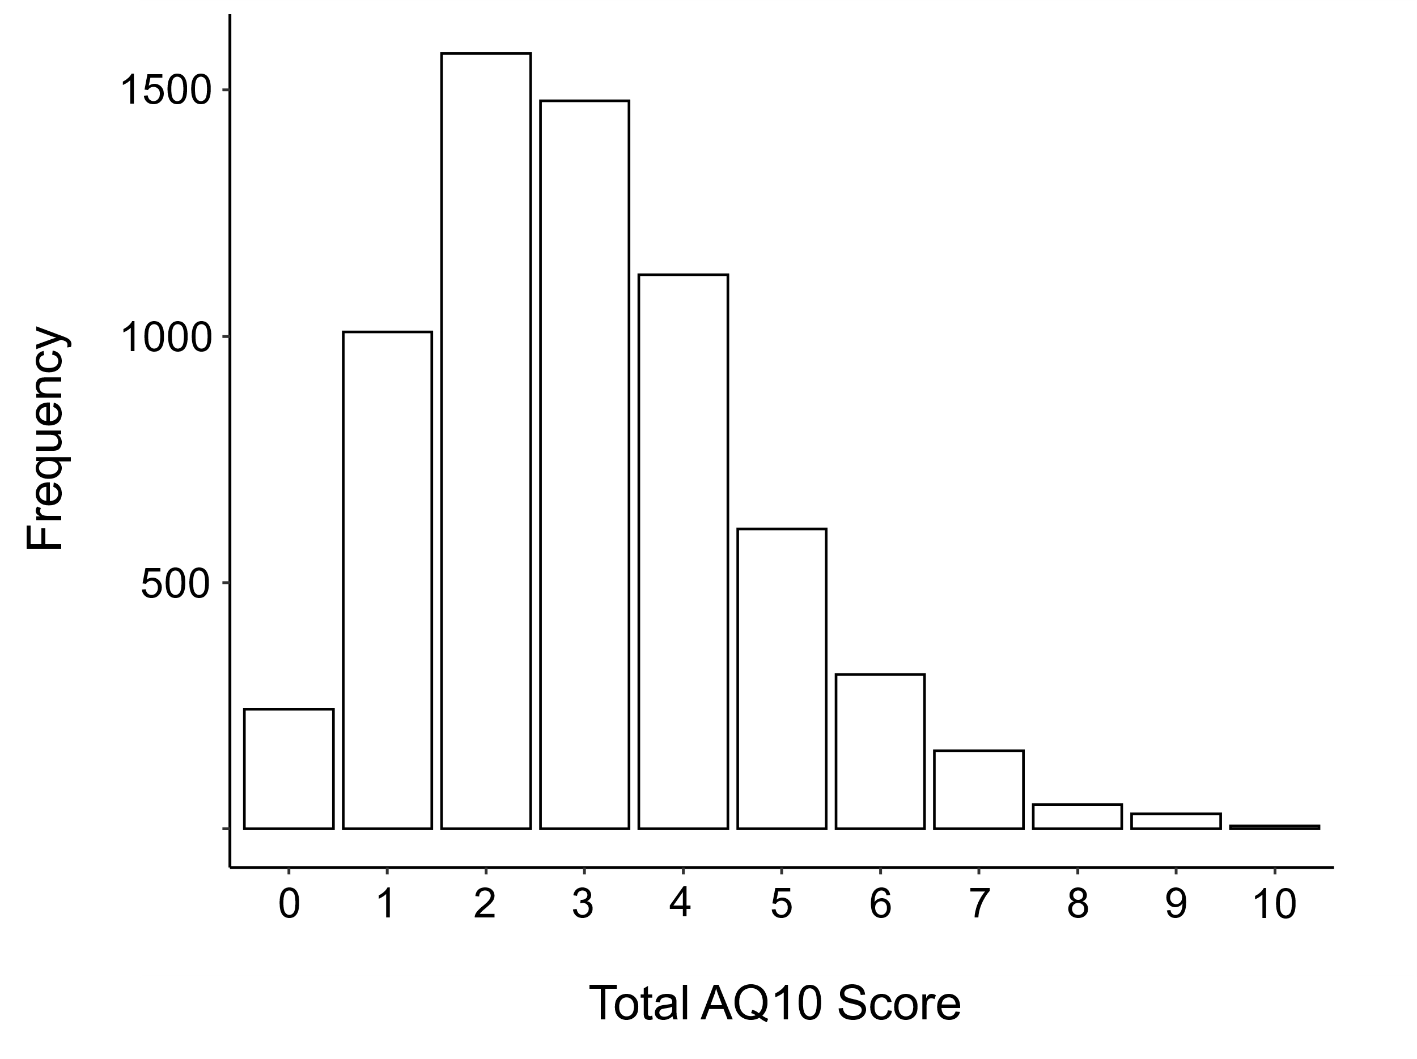

Note. Total AQ10 binary score distribution in a general population, non-clinical sample (N = 6595, see Gollwitzer et al., 2019 for further information).

Figure S2
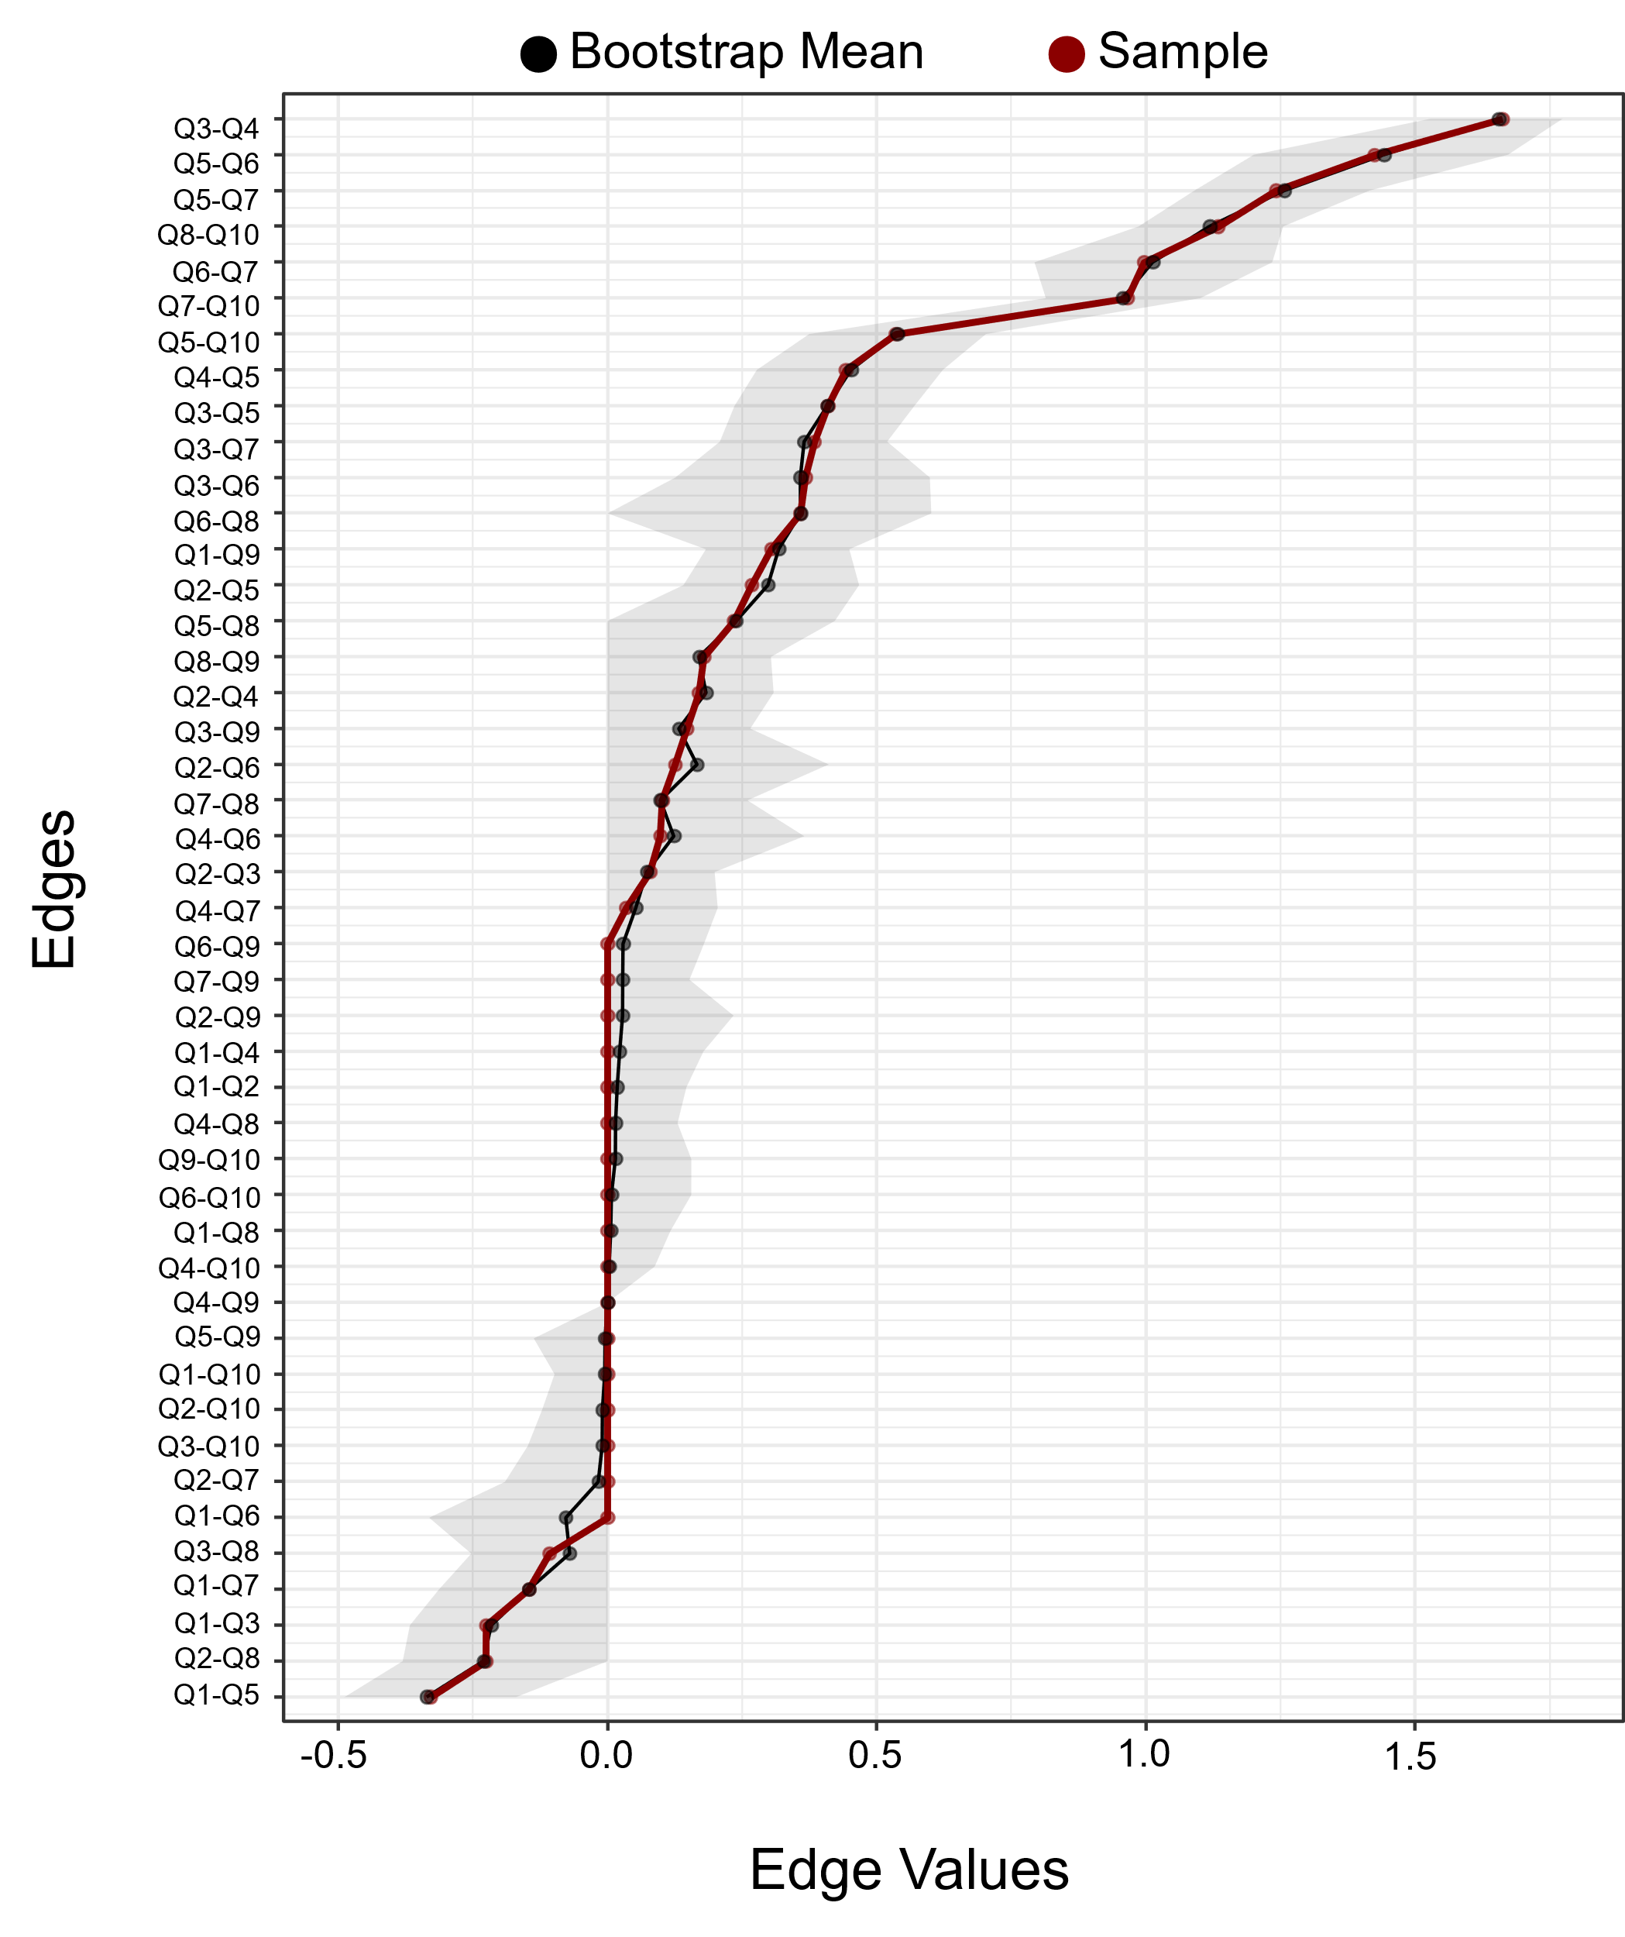

Note. Estimated edge weight accuracy assessed through non-parametric bootstrapping (1000 resamples). Sample (red) and bootstrapped (black) edge weights, and 95% confidence intervals (shaded area) are reported.

Table S1

Estimated Edge Weights

 | Item1 | Item2 | Item3 | Item4 | Item5 | Item6 | Item7 | Item8 | Item9 | Item10
Item1 | ---
Item2 | 0.00 | ---
Item3 | -0.23 | 0.08 | ---
Item4 | 0.00 | 0.17 | 1.66 | ---
Item5 | -0.33 | 0.27 | 0.41 | 0.44 | ---
Item6 | 0.00 | 0.13 | 0.37 | 0.10 | 1.42 | ---
Item7 | -0.15 | 0.00 | 0.38 | 0.03 | 1.24 | 1.00 | ---
Item8 | 0.00 | -0.23 | -0.11 | 0.00 | 0.23 | 0.36 | 0.10 | ---
Item9 | 0.30 | 0.00 | 0.15 | 0.00 | 0.00 | 0.00 | 0.00 | 0.18 | ---
Item10 | 0.00 | 0.00 | 0.00 | 0.00 | 0.54 | 0.00 | 0.97 | 1.13 | 0.00 | ---
Note. Logistic regression coefficients for each edge weight association. Only non-zero edges are in the final network.

Table S2
Edge 1 | Edge 2 | 95% CI
 |  | Lower | Upper
Item3–Item4 | Item5–Item6 | -0.48 | 0.05
Item3–Item4 | Item5–Item7 | -0.60 | -0.20
Item3–Item4 | Item6–Item7 | -0.91 | -0.39
Item3–Item4 | Item7–Item10 | -0.88 | -0.51
Item3–Item4 | Item8–Item10 | -0.72 | -0.36
Item5–Item6 | Item5–Item7 | -0.47 | 0.12
Item5–Item6 | Item6–Item7 | -0.79 | -0.06
Item5–Item6 | Item7–Item10 | -0.75 | -0.21
Item5–Item6 | Item8–Item10 | -0.60 | -0.04
Edge Weight Difference Test

Note. 95% bootstrapped confidence intervals comparing edge weight differences. Confidence intervals including 0 indicate no significant difference in edge weights.

Figure S3
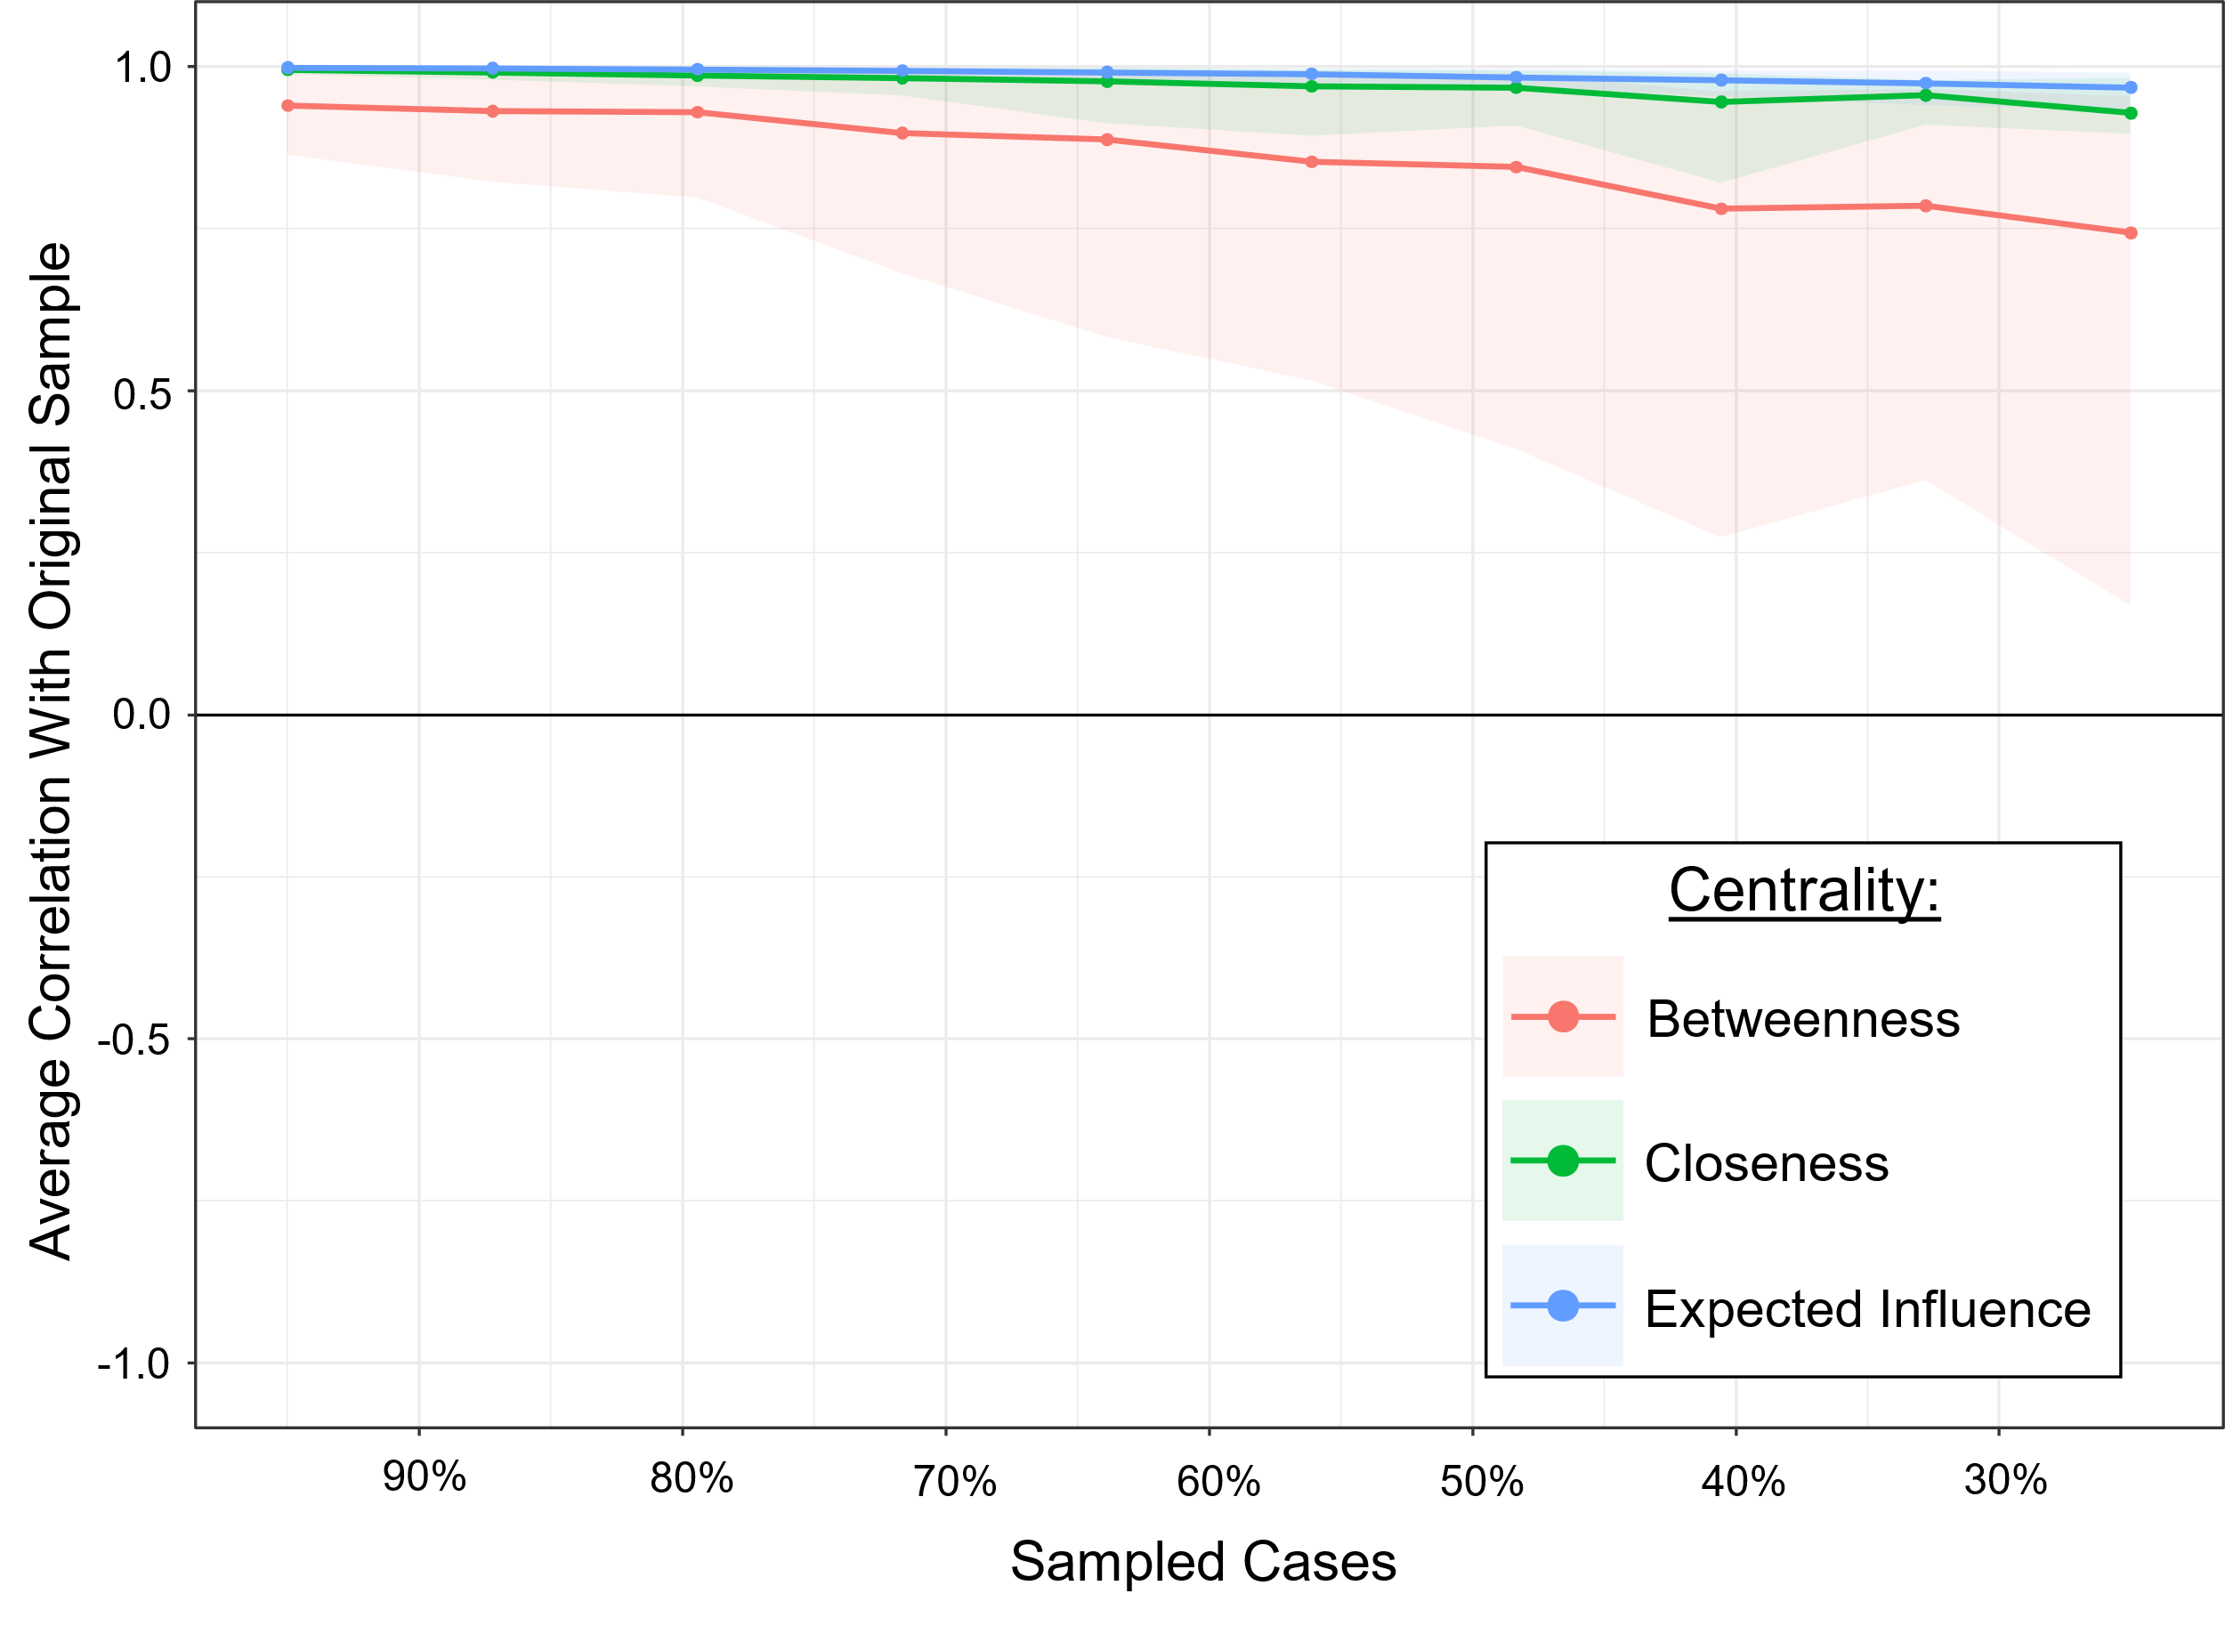

Note. Centrality stability assessed through case-drop bootstrapping (1000 resamples) to 20% of the original sample. The correlation of centrality scores with the original sample (line) and 95% confidence intervals (shaded area) are reported.

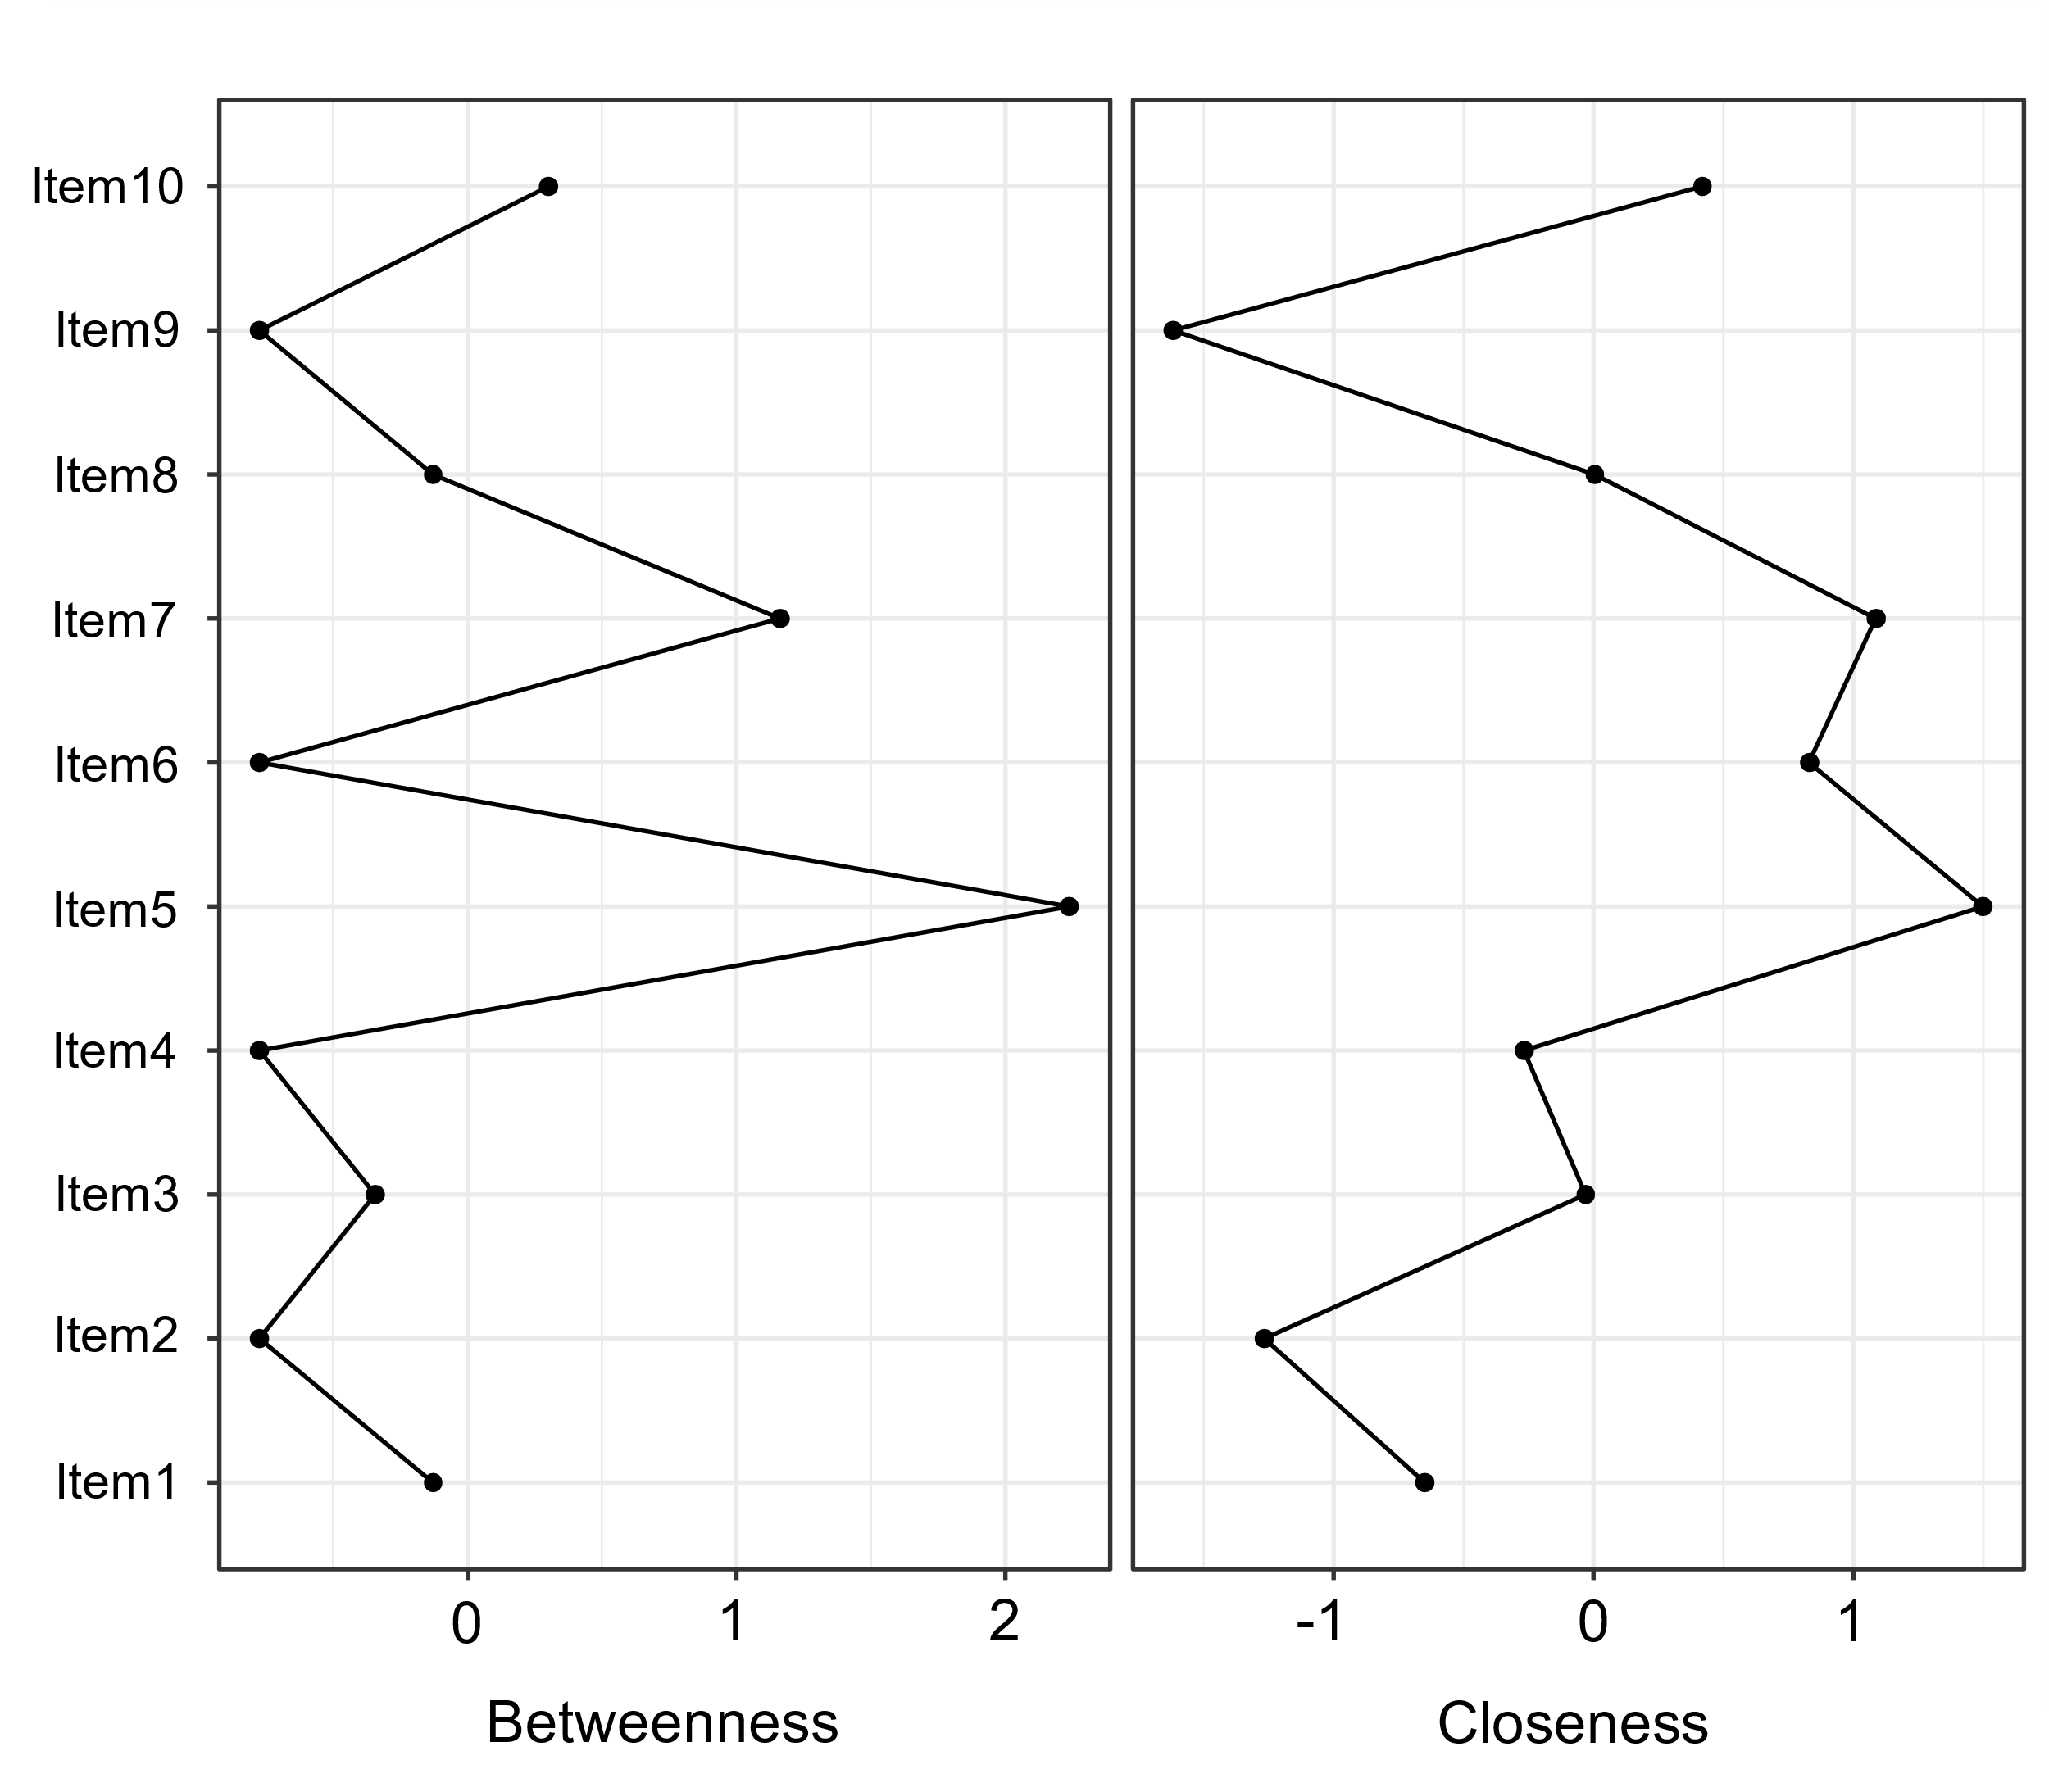
Figure S4

Note. Betweenness and Closeness centrality measures (z-score) for each AQ10 item.

Table S3
Centrality Values
 | Betweenness | Closeness | Expected Influence
Item1 | -0.13 | -0.65 | -1.67
Item2 | -0.77 | -1.27 | -1.13
Item3 | -0.34 | -0.03 | 0.39
Item4 | -0.77 | -0.27 | 0.19
Item5 | 2.24 | 1.50 | 1.39
Item6 | -0.77 | 0.83 | 0.82
Item7 | 1.16 | 1.09 | 0.96
Item8 | -0.13 | 0.00 | -0.30
Item9 | -0.77 | -1.62 | -0.99
Item10 | 0.30 | 0.42 | 0.34

Note. Betweenness, Closeness, and Expected Influence centrality values (z-score) for each AQ10 item.

