Supplementary file #1
SEM
Samples were fixed on a metal stub using double sided conductive carbon tape and a gold coating was applied to the top surface to avoid surface charging. The morphology was examined using a ZEISS ULTRA 55 at an operating voltage of 5kV at different magnifications.

Figure S1 SEM micrograph of unshocked mixture of amino acids (control) as listed in Table 1 (a) Sample1 (b) Sample 2 (c) Sample 3 (d) Sample 4, show micron size particles.

IR spectroscopy
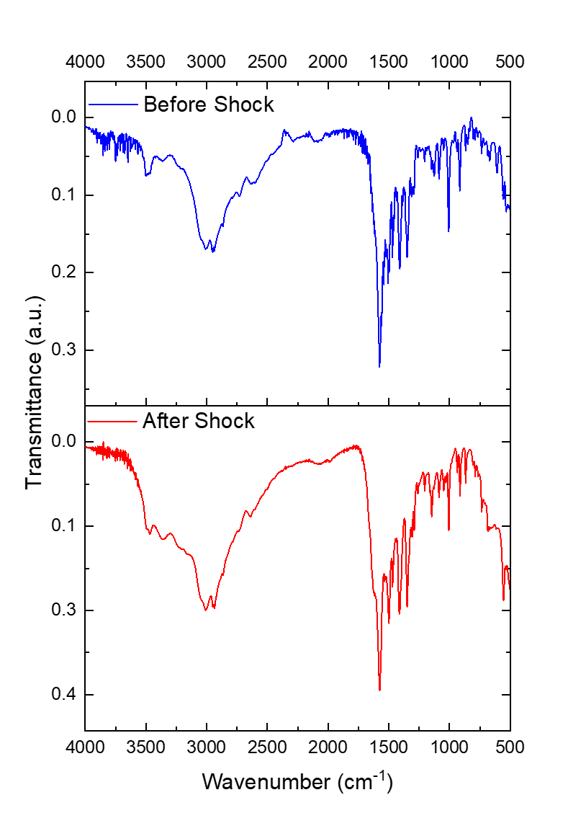
All reported FT-IR spectra were obtained with a Thermo Scientific Nicolet iS50 FTIR Spectrometer in ATR mode.
Figure S2 IR spectra of Sample 1 (mixture of four amino acids) before and after shock processing.

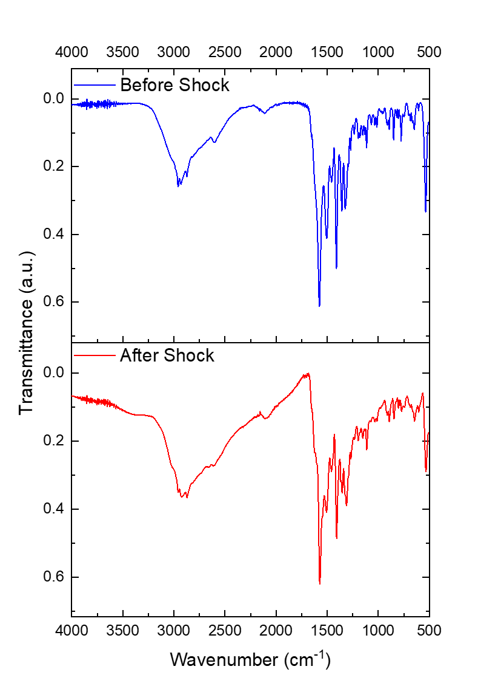
Figure S3 IR spectra of Sample 2 (mixture of eight amino acids) before and after shock processing.

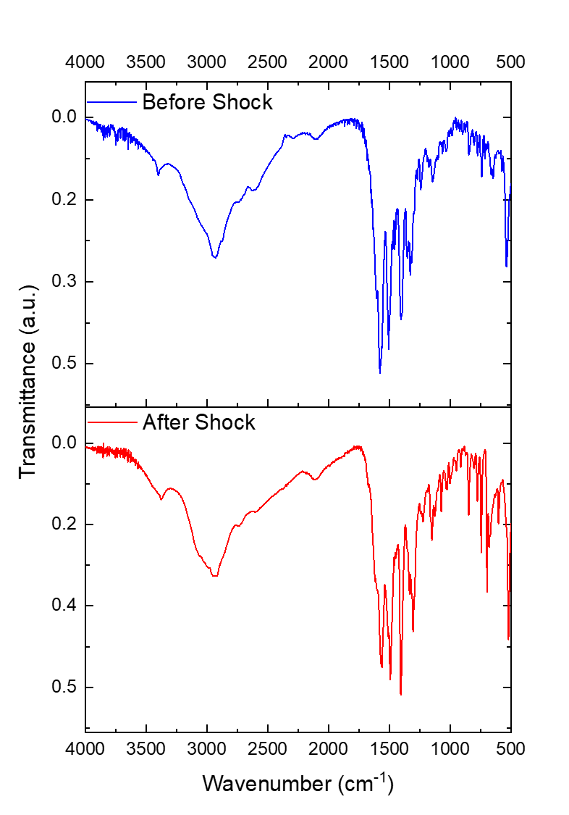
Figure S4 IR spectra of Sample 3 (mixture of seventeen amino acids) before and after shock processing.

Figure S5 IR spectra of Sample 4 (mixture of twenty amino acids) before and after shock processing.

