Experimental Results
Preparation burning may not improve short-term seed survival in an Amazonian savanna
Victor J. U. R. Chuma, Taires P. da Silva, Jéssica A. da Silva, Keison S. Cavalcante, Igor A. P. Sidônio, Adriano F. de Souza, Daniel S. S. Valentim, Silas Mochiutti, Darren Norris and Fernanda Michalski
Supplementary Material

S1 Study species
Açaí fruits (Euterpe oleracea – Mart. Arecaceae) and popcorn kernels (Zea mays L. – Poaceae) were used to compare seed removal and infestation among habitats.
A) Açaí fruits | B) Popcorn kernel
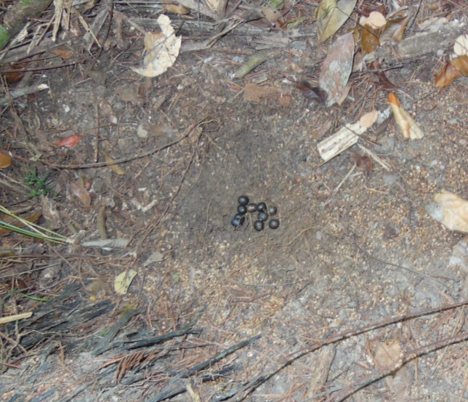 | 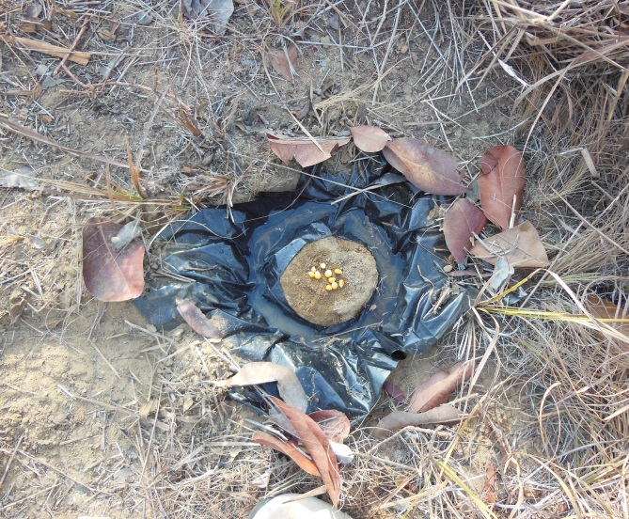
Figure S1. Study species used in experimental access treatments. A) açaí fruits in the riparian forest habitat and B) popcorn kernel in the unburned savanna habitat.

These species were selected as they represent examples of species with potential in both agroforestry and restoration activities. Popcorn kernels are not native but have been widely used in seed predation studies worldwide (Thompson et al., 1991), allowing cross-site comparisons. Popcorn kernels are also attractive on the ground for the majority of vertebrates and can be eaten in situ or carried on to be consumed by animals (Christianini and Galetti, 2007). Additionally, the eastern Amazonia has an increase demand of corn, with Amapá state producing 14,362 tons per year by February 2020 (IBGE, 2020). The palm (Euterpe oleracea) is native to riparian savanna forest and has also been planted for agroforestry and commercial production in irrigated Amazonian savanna areas (S. Mochiutti, Pers. Comm.). This fruit is also highly predated in tropical forests and have been considered a keystone palm in anthropogenic landscapes (Soares et al., 2015).

S2 Habitats: Representative photos characterizing the three different habitats where the seed/fruit removal experiment was conducted in the eastern Brazilian Amazon.
Unburned savanna | Unburned riparian savanna | Burned savanna
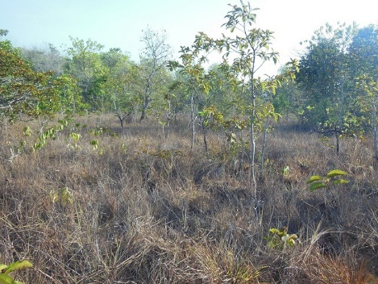 | 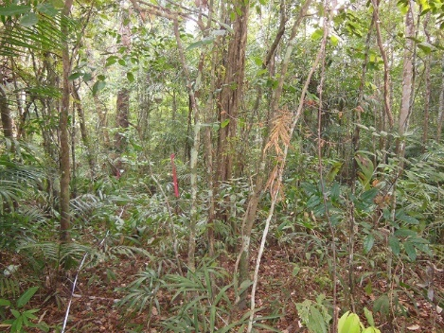 | 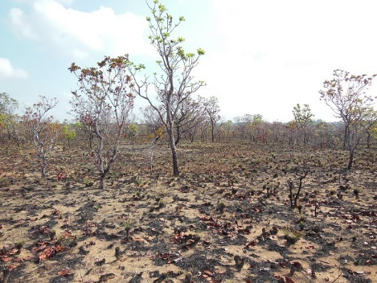
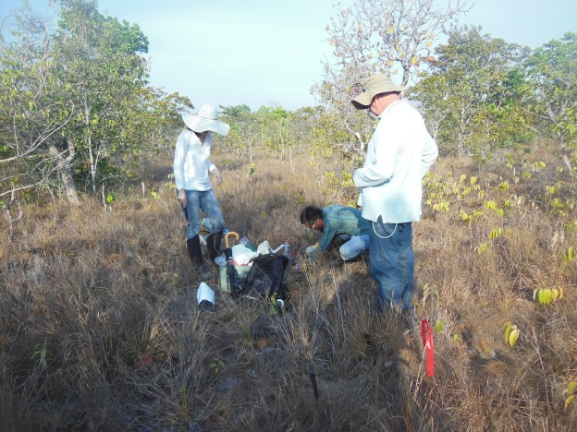 | 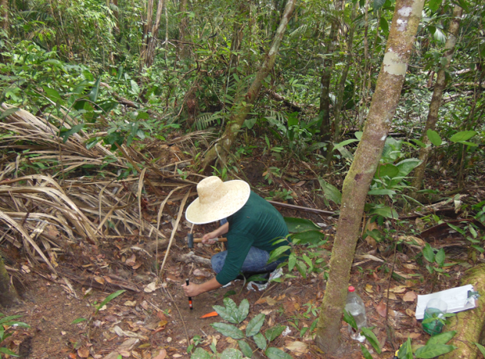 | 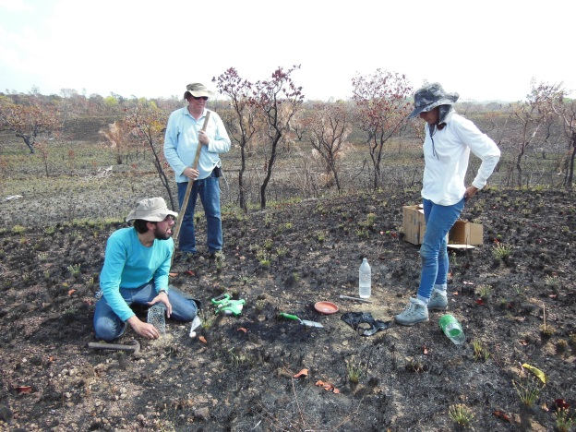

S3 Experimental setup
In order to identify seed removers experimental selective access treatments were adapted from previous studies (Christianini and Galetti, 2007; Norris and Michalski, 2010; Tasker et al., 2011) and placed in each experimental unit (Figure S3) as follows: (1) open treatment, with all seeds or fruits placed on the soil surface so that any bird, mammal or invertebrate could access. (2) Vertebrate access, ants and other invertebrates were excluded by a 2-3 cm circular moat around the seeds/fruits. (3) Invertebrate access, where vertebrates were excluded by covering the seeds/fruits with a protective wire tower (5 mm mesh, 15-20 cm high). The tower was secured flush to the ground with two tent pegs on opposite sides. In each experimental unit, the three treatments each contained 10 seeds or fruits separated by 1 m. To avoid confounding edge effects experimental units were placed along transects that were established at a fixed distance of 50 m from any nearest habitat edge.
Observations were conducted twice daily in the morning (from 08:00 to 10:00) and afternoon (15:00 to 17:00). In each observation, the number of seeds/fruits remaining in each treatment and unit, the number of infested seeds/fruits (when invertebrates infested the seeds internally), the presence of animals seen removing or eating seeds, and evidence of seed/fruit predation or any disturbance to the treatments were recorded.

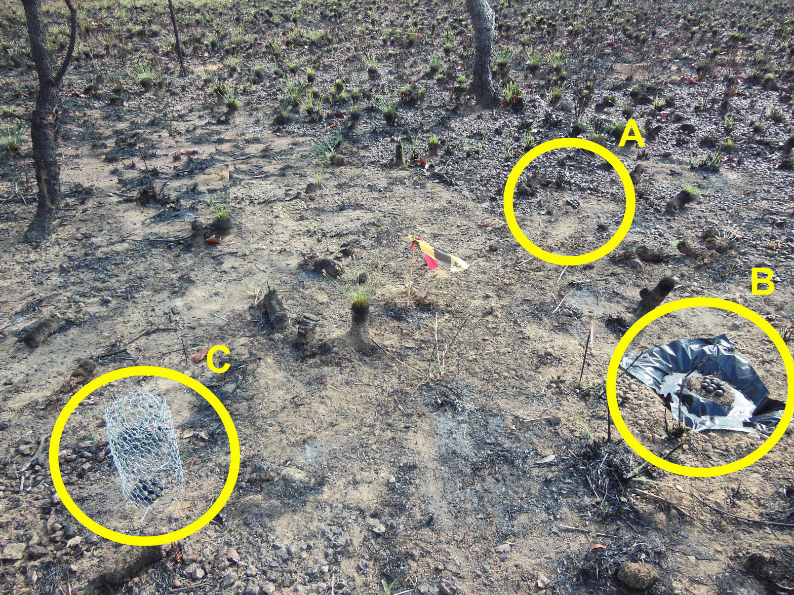
Figure S3. Overall arrangement of the seed/fruit removal experiment unit treatments, with a flag tape at the center and (A) open access, (B) vertebrate access and (C) invertebrate access treatments in an area of burned savanna habitat, eastern Brazilian Amazon.

References
Christianini, A. V., & Galetti, M. (2007). Spatial variation in post-dispersal seed removal in an Atlantic forest: Effects of habitat, location and guilds of seed predators. Acta Oecologica-International Journal of Ecology, 32(3), 328-336. doi:10.1016/j.actao.2007.06.004
IBGE. (2020). Levantamento Sistemático da Produção Agrícola. https://sidra.ibge.gov.br/tabela/6588. Retrieved March 2020 https://sidra.ibge.gov.br/tabela/6588
Norris, D., & Michalski, F. (2010). Implications of faecal removal by dung beetles for scat survey in a fragmented landscape of the Braziliam Amazon. Oryx, 44(3), 455-458. doi:10.1017/S0030605309990809
Soares, L. A. S. S., Faria, D., Velez-Garcia, F., Vieira, E. M., Talora, D. C., & Cazetta, E. (2015). Implications of habitat loss on seed predation and early recruitment of a keystone palm in anthropogenic landscapes in the Brazilian Atlantic rainforest. Plos One, 10(7), e0133540. doi:10.1371/journal.pone.0133540
Tasker, E. M., Denham, A. J., Taylor, J. E., & Strevens, T. C. (2011). Post-fire seed predation: Does distance to unburnt vegetation matter? Austral Ecology, 36(7), 755-766. doi:10.1111/j.1442-9993.2010.02214.x
Thompson, D. B., Brown, J. H., & Spencer, W. D. (1991). Indirect facilitation of granivorous birds by desert rodents: experimental evidence from foraging patterns. Ecology, 72, 852-863.

