Supplementary material for:
De Santiago, K., Palmer, T.A, Wetz, M.S. & Beseres Pollack, J. (2020) Response of macrobenthic communities to changes in water quality in a subtropical, microtidal estuary (Oso Bay, Texas). Experimental Results
Table S1. Mean abundances of taxa occurring at each station (n/m²)
Taxa | AG | OI | DG | AI | WP | YB | Mean
Ostracoda | 3115 | 212 | 1770 | 1109 | 147901 | 47 | 25693
Streblospio benedicti | 10184 | 1369 | 7328 | 22292 | 106 | 30376 | 11943
Capitella capitata | 861 | 330 | 1617 | 802 | 12 | 460 | 681
Nereididae | 496 | 0 | 920 | 590 | 177 | 118 | 384
Amphipoda | 35 | 83 | 649 | 378 | 260 | 673 | 346
Oligochaeta | 142 | 24 | 1027 | 71 | 555 | 0 | 303
Chironomidae larvae | 0 | 0 | 12 | 0 | 920 | 0 | 155
Bivalvia | 0 | 236 | 0 | 83 | 0 | 201 | 87
Scoloplos sp. | 0 | 319 | 0 | 106 | 0 | 71 | 83
Polydora sp. | 12 | 12 | 83 | 130 | 0 | 106 | 57
Mediomastus californiensis | 0 | 59 | 0 | 0 | 0 | 248 | 51
Brania sp. | 0 | 224 | 0 | 0 | 0 | 24 | 41
Hypereteone heteropoda | 0 | 12 | 12 | 0 | 0 | 189 | 35
Heteromastus filiformis | 0 | 12 | 0 | 0 | 0 | 201 | 35
Cumacea | 0 | 118 | 0 | 0 | 12 | 12 | 24
Prionospio heterobranchia | 0 | 0 | 0 | 0 | 0 | 94 | 16
Tanaidacea | 0 | 59 | 12 | 0 | 0 | 0 | 12
Gastropoda | 0 | 24 | 0 | 35 | 0 | 0 | 10
Hesionidae | 0 | 0 | 0 | 24 | 0 | 35 | 10
Capitella aciculata | 24 | 0 | 12 | 0 | 12 | 0 | 8
Isopoda | 12 | 12 | 0 | 0 | 12 | 12 | 8
Phyllodocidae | 0 | 24 | 0 | 0 | 0 | 24 | 8
Syllidae | 12 | 12 | 0 | 0 | 12 | 12 | 8
Callinectes sapidus | 0 | 0 | 12 | 0 | 12 | 0 | 4
Insecta larvae | 12 | 0 | 0 | 0 | 12 | 0 | 4
Mysida | 0 | 12 | 0 | 0 | 0 | 12 | 4
Nemertea | 12 | 0 | 0 | 0 | 0 | 12 | 4
Sphaerosyllis aciculata | 0 | 0 | 0 | 0 | 0 | 24 | 4
Arenicola cristata | 0 | 12 | 0 | 0 | 0 | 0 | 2
Bivalvia juvenile | 0 | 0 | 0 | 0 | 0 | 12 | 2
Cirriformia filigera | 0 | 12 | 0 | 0 | 0 | 0 | 2
Glycinde sp. | 0 | 12 | 0 | 0 | 0 | 0 | 2
Goniadidae | 0 | 12 | 0 | 0 | 0 | 0 | 2
Holothuroidea | 0 | 0 | 0 | 0 | 0 | 12 | 2
Larval teleost | 0 | 0 | 12 | 0 | 0 | 0 | 2
Lysidice spp. | 0 | 0 | 0 | 0 | 0 | 12 | 2
Decapoda larvae | 0 | 0 | 0 | 0 | 12 | 0 | 2
Palaemon sp. | 12 | 0 | 0 | 0 | 0 | 0 | 2
Sigambra tentaculata | 0 | 0 | 0 | 0 | 0 | 12 | 2
Sipuncula | 0 | 0 | 0 | 0 | 0 | 12 | 2
Total | 14928 | 3198 | 13465 | 25620 | 150013 | 33007 | 40039
Table S2. Mean (and standard deviation) of water quality and sediment variables at each station. DOC = Dissolved Organic Carbon, TDN = Total Dissolved Nitrogen, DON = Dissolved Organic Nitrogen
Medium | Variable | OI | AG | WP | DG | AI | YB
Water | Salinity | 36.3 | 9.8 | 7.0 | 25.0 | 30.8 | 40.7
 |  | (4.0) | (7.6) | (9.1) | (12.0) | (15.5) | (7.8)
 | Temperature | 22.7 | 23.6 | 25.1 | 22.8 | 22.3 | 23.9
 | (°C) | (6.0) | (5.4) | (4.7) | (6.1) | (6.9) | (6.3)
 | Dissolved Oxygen | 6.5 | 5.4 | 4.4 | 6.3 | 6.6 | 5.9
 | (mg/L) | (1.6) | (2.8) | (2.6) | (2.7) | (2.1) | (1.1)
 | pH | 8.2 | 8.3 | 7.4 | 8.3 | 8.3 | 8.2
 |  | (0.3) | (0.4) | (0.5) | (0.4) | (0.2) | (0.1)
 | Ammonia | 2.0 | 122.8 | 413.6 | 21.0 | 13.8 | 3.4
 | (µM/L) | (2.2) | (183.5) | (273.6) | (33.3) | (28.2) | (2.9)
 | Chlorophyll-a | 6.4 | 34.6 | 5.5 | 23.2 | 25.7 | 10.1
 | (µg/L) | (2.8) | (33.0) | (7.3) | (11.3) | (19.7) | (8.8)
 | DOC | 418.3 | 869.3 | 772.0 | 733.3 | 654.7 | 632.7
 | (µM/L) | (138.4) | (246.1) | (74.1) | (198.5) | (322.6) | (243.3)
 | DON | 31.3 | 81.2 | 96.2 | 60.4 | 51.7 | 46.7
 | (µM/L) | (10.9) | (51.6) | (57.9) | (18.7) | (27.9) | (17.2)
 | Nitrate+Nitrite | 1.6 | 160.0 | 456.7 | 16.4 | 12.6 | 7.4
 | (µM/L) | (4.2) | (161.0) | (339.0) | (20.4) | (19.7) | (18.8)
 | Nitrite | 0.3 | 17.4 | 18.1 | 4.4 | 3.7 | 0.6
 | (µM/L) | (0.6) | (13.1) | (11.1) | (7.1) | (6.3) | (0.9)
 | Orthophosphate | 0.4 | 28.2 | 47.5 | 7.5 | 5.0 | 1.6
 | (µM/L) | (0.2) | (21.5) | (23.9) | (5.3) | (4.6) | (2.5)
 | Silicate | 22.1 | 134.1 | 192.3 | 102.9 | 50.7 | 38.3
 | (µM/L) | (17.1) | (43.7) | (23.2) | (34.3) | (27.8) | (43.0)
 | TDN | 35.0 | 364.0 | 991.4 | 97.7 | 78.1 | 57.5
 | (µM/L) | (13.3) | (328.0) | (267.8) | (46.2) | (44.9) | (20.5)
Sediment | Clay | 0.2 | 18.6 | 15.6 | 55.6 | 27.5 | 18.4
 | (%) | (0.0) | (3.8) | (7.2) | (2.5) | (2.8) | (2.8)
 | Rubble | 2.4 | 10.6 | 0.9 | 1.4 | 1.3 | 8.1
 | (%) | (0.4) | (1.6) | (0.2) | (1.1) | (0.2) | (4.0)
 | Sand | 97.2 | 58.5 | 75.1 | 14.9 | 56.3 | 63.9
 | (%) | (0.4) | (5.7) | (12.1) | (2.8) | (3.8) | (8.3)
 | Silt | 0.3 | 12.3 | 8.6 | 28.3 | 15.0 | 9.8
 | (%) | (0.1) | (0.3) | (4.7) | (6.2) | (0.8) | (1.5)
 | Chlorophyll-a | 6.5 | 11.3 | 30.5 | 32.7 | 12.1 | 5.8
 | (mg/L) | (2.9) | (7.0) | (19.8) | (33.6) | (8.1) | (2.5)

Table S3. Correlations among water quality variables. Numbers for each correlation represent Pearson Correlation Coefficient (r), Prob > |r| (p) and number of observations (N). Values have not been adjusted for possible multiple testing error.
Variables | Chl-a | Sal | DO | pH | Temp | DOC | TDN | Ammonia | NO3+NO2 | Nitrite | DON | Silicate | OrthoP
Chlorophyll-a | 1 | 0.03682 | 0.14199 | 0.3885 | 0.1548 | 0.61801 | -0.17661 | -0.20787 | -0.16621 | 0.05734 | 0.26984 | 0.21835 | -0.08241
(µg/L) |  | 0.7691 | 0.2554 | 0.0013 | 0.2146 | <.0001 | 0.1593 | 0.094 | 0.1823 | 0.6474 | 0.0311 | 0.0782 | 0.5107
 | 66 | 66 | 66 | 66 | 66 | 65 | 65 | 66 | 66 | 66 | 64 | 66 | 66
Salinity | 0.03682 | 1 | 0.1394 | 0.36432 | 0.02254 | -0.12413 | -0.58795 | -0.46218 | -0.5301 | -0.5105 | -0.32768 | -0.615 | -0.5771
 | 0.7691 |  | 0.2297 | 0.0012 | 0.8467 | 0.3246 | <.0001 | <.0001 | <.0001 | <.0001 | 0.0082 | <.0001 | <.0001
 | 66 | 76 | 76 | 76 | 76 | 65 | 65 | 66 | 66 | 66 | 64 | 66 | 66
Dissolved Oxygen | 0.14199 | 0.1394 | 1 | 0.5995 | -0.32646 | -0.23126 | -0.32475 | -0.34055 | -0.21317 | -0.0897 | -0.30464 | -0.32083 | -0.35419
(mg/L) | 0.2554 | 0.2297 |  | <.0001 | 0.004 | 0.0638 | 0.0083 | 0.0051 | 0.0857 | 0.4738 | 0.0144 | 0.0086 | 0.0035
 | 66 | 76 | 76 | 76 | 76 | 65 | 65 | 66 | 66 | 66 | 64 | 66 | 66
pH | 0.3885 | 0.36432 | 0.5995 | 1 | -0.07139 | 0.00212 | -0.58255 | -0.54668 | -0.47265 | -0.26116 | -0.21196 | -0.41858 | -0.51089
 | 0.0013 | 0.0012 | <.0001 |  | 0.54 | 0.9866 | <.0001 | <.0001 | <.0001 | 0.0342 | 0.0927 | 0.0005 | <.0001
 | 66 | 76 | 76 | 76 | 76 | 65 | 65 | 66 | 66 | 66 | 64 | 66 | 66
Temperature | 0.1548 | 0.02254 | -0.32646 | -0.07139 | 1 | 0.4604 | 0.1065 | -0.01165 | 0.16339 | -0.09068 | 0.22105 | 0.28167 | 0.06717
(°C) | 0.2146 | 0.8467 | 0.004 | 0.54 |  | 0.0001 | 0.3985 | 0.926 | 0.1899 | 0.469 | 0.0792 | 0.022 | 0.592
 | 66 | 76 | 76 | 76 | 76 | 65 | 65 | 66 | 66 | 66 | 64 | 66 | 66
DOC | 0.61801 | -0.12413 | -0.23126 | 0.00212 | 0.4604 | 1 | 0.27401 | 0.20695 | 0.17578 | 0.29888 | 0.57414 | 0.61839 | 0.26567
(µM/L) | <.0001 | 0.3246 | 0.0638 | 0.9866 | 0.0001 |  | 0.0272 | 0.0981 | 0.1613 | 0.0156 | <.0001 | <.0001 | 0.0324
 | 65 | 65 | 65 | 65 | 65 | 65 | 65 | 65 | 65 | 65 | 64 | 65 | 65
TDN | -0.17661 | -0.58795 | -0.32475 | -0.58255 | 0.1065 | 0.27401 | 1 | 0.81928 | 0.84853 | 0.71952 | 0.63279 | 0.79773 | 0.80681
(µM/L) | 0.1593 | <.0001 | 0.0083 | <.0001 | 0.3985 | 0.0272 |  | <.0001 | <.0001 | <.0001 | <.0001 | <.0001 | <.0001
 | 65 | 65 | 65 | 65 | 65 | 65 | 65 | 65 | 65 | 65 | 64 | 65 | 65
Ammonia | -0.20787 | -0.46218 | -0.34055 | -0.54668 | -0.01165 | 0.20695 | 0.81928 | 1 | 0.40827 | 0.60677 | 0.48815 | 0.62403 | 0.52486
(µM/L) | 0.094 | <.0001 | 0.0051 | <.0001 | 0.926 | 0.0981 | <.0001 |  | 0.0007 | <.0001 | <.0001 | <.0001 | <.0001
 | 66 | 66 | 66 | 66 | 66 | 65 | 65 | 66 | 66 | 66 | 64 | 66 | 66
Nitrate+Nitrite | -0.16621 | -0.5301 | -0.21317 | -0.47265 | 0.16339 | 0.17578 | 0.84853 | 0.40827 | 1 | 0.58813 | 0.43954 | 0.68078 | 0.81865
(µM/L) | 0.1823 | <.0001 | 0.0857 | <.0001 | 0.1899 | 0.1613 | <.0001 | 0.0007 |  | <.0001 | 0.0003 | <.0001 | <.0001
 | 66 | 66 | 66 | 66 | 66 | 65 | 65 | 66 | 66 | 66 | 64 | 66 | 66
Nitrite | 0.05734 | -0.5105 | -0.0897 | -0.26116 | -0.09068 | 0.29888 | 0.71952 | 0.60677 | 0.58813 | 1 | 0.4409 | 0.63019 | 0.64532
(µM/L) | 0.6474 | <.0001 | 0.4738 | 0.0342 | 0.469 | 0.0156 | <.0001 | <.0001 | <.0001 |  | 0.0003 | <.0001 | <.0001
 | 66 | 66 | 66 | 66 | 66 | 65 | 65 | 66 | 66 | 66 | 64 | 66 | 66
DON | 0.26984 | -0.32768 | -0.30464 | -0.21196 | 0.22105 | 0.57414 | 0.63279 | 0.48815 | 0.43954 | 0.4409 | 1 | 0.64982 | 0.40933
(µM/L) | 0.0311 | 0.0082 | 0.0144 | 0.0927 | 0.0792 | <.0001 | <.0001 | <.0001 | 0.0003 | 0.0003 |  | <.0001 | 0.0008
 | 64 | 64 | 64 | 64 | 64 | 64 | 64 | 64 | 64 | 64 | 64 | 64 | 64
Silicate | 0.21835 | -0.615 | -0.32083 | -0.41858 | 0.28167 | 0.61839 | 0.79773 | 0.62403 | 0.68078 | 0.63019 | 0.64982 | 1 | 0.74113
(µM/L) | 0.0782 | <.0001 | 0.0086 | 0.0005 | 0.022 | <.0001 | <.0001 | <.0001 | <.0001 | <.0001 | <.0001 |  | <.0001
 | 66 | 66 | 66 | 66 | 66 | 65 | 65 | 66 | 66 | 66 | 64 | 66 | 66
Orthophosphate | -0.08241 | -0.5771 | -0.35419 | -0.51089 | 0.06717 | 0.26567 | 0.80681 | 0.52486 | 0.81865 | 0.64532 | 0.40933 | 0.74113 | 1
(µM/L) | 0.5107 | <.0001 | 0.0035 | <.0001 | 0.592 | 0.0324 | <.0001 | <.0001 | <.0001 | <.0001 | 0.0008 | <.0001
 | 66 | 66 | 66 | 66 | 66 | 65 | 65 | 66 | 66 | 66 | 64 | 66 | 66

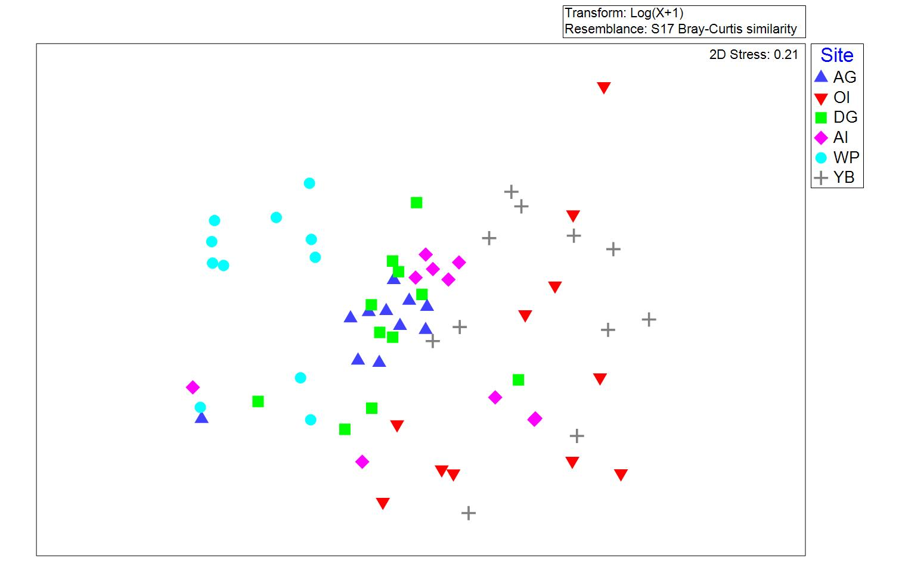
Figure S1. Non-metric multidimensional scaling plot of spatial variation in macrofaunal community composition for six stations sampled over 11 months.

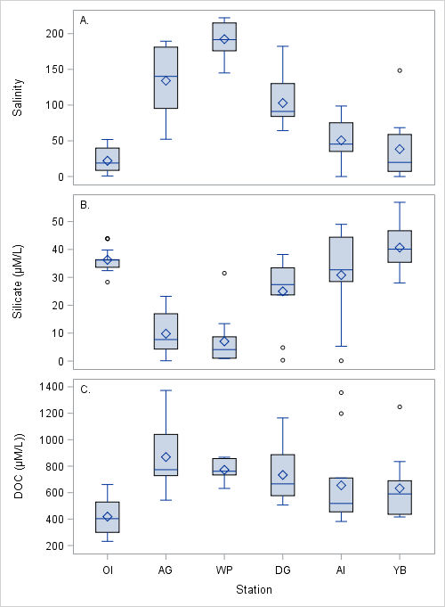
Figure S2. Concentrations of salinity (A), silicate (B) and dissolved organic carbon (C) at each station. Diamonds represent means. Circles represent outliers (>|1.5 IQR +/- 75th/25th percentiles|)

