Supplementary Materials
- Methodology addendum
- Dependent variables
- A - Fairness tailored arguments, B - Loyalty tailored arguments
- A - Openness tailored arguments, B - Contentiousness tailored arguments
- Non-tailored control arguments

- Methodology addendum
For both studies participants were recruited via social media and subsequently Prolific Academic.
Social media participants were entered into a prize draw for one £50 Amazon voucher upon study completion. They comprised 72% of the sample in each study; 287 in Study 1 (MFT) and 288 in Study 2 (personality).
Most of our social media recruitment traffic stemmed from two sub-reddit sites – r/brexit and r/ukpolitics – with 2,348 and 8,664 views, respectively. It is possible that these sites attract more Remain voting individuals especially when one factors in the propensity for younger people to have voted Remain. We did reach out to Leave based subreddits and organisations; however, we had no reply.
All participation was anonymous, voluntary, and informed consent was obtained.
Prolific recruitment was carried out post-hoc in order to satisfy quotas from a priori power calculations for the pair wise comparisons (but not the interactions in the ANOVAs). Participants recruited via Prolific Academic were compensated £1 for their participation. Budgetary constraints for each study meant only a further 111 participants could be recruited via Prolific for each study.
Given the budgetary constraints and the necessary quotas for each study, we decided to use Prolific to solely recruit Remain supporters. Prolific was used to bridge the gap between participant numbers at that time and the numbers necessary according to the power calculations.
The proposed studies with Leave supporters were dropped at this point due to a lack of confidence in recruiting sufficient participants.
- Dependent variables
Three dependent variables comprise the composite score used in the Two-Way Mixed ANOVA analysis. Below are the questions used in assessing each DV:
1. Credibility
“How credible is this argument?
Please consider credibility as distinct from support.”
2. Compellingness
“How compelling do you find this argument?”
3. Vote intention
“How likely is it that you would vote for a party espousing this argument?”

- (A) Fairness tailored arguments (B) Loyalty tailored arguments

Note key Moral Foundation theory words are highlighted in red here for illustration purposes, but these were not be highlighted for the participants.
Moral Foundations Theory – Fairness
Remain Study / Pro-Leave Arguments
- Immigration:
British workers are disproportionally and unfairly affected by unregulated EU immigration

Unbalanced immigration from the EU has caused unreasonable pressure on government services and thus on British people. The lack of regulation has led to many Eastern European workers unfairly undercutting British citizens seeking work, unjustly excluding British citizens from many types of employment. EU immigrants can also avail of British government services like social welfare and the NHS, often unfairly causing the tax-paying British citizen to be excluded from or delayed in receiving such services. The unbalanced nature of EU immigration also preferentially treats EU citizens and thus biases against other, perhaps more skilled, immigrants entering Britain. This prejudicing against non-EU citizens is not fair or justifiable and Britain can implement a fairer and more egalitarian system without the EU enforced favouritism.
No matter what one’s political preferences, it is unfair for EU citizens in Britain to receive preferential treatment over either British citizens or non-EU immigrants.

- Sovereignty
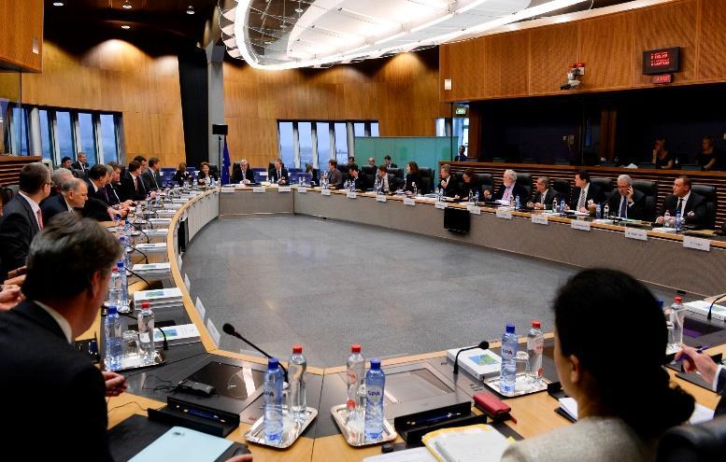
Unelected EU Commission Members have an unjust influence on British Citizens

It is unfair and unreasonable that EU Commission regulations can overrule British laws which only affect British citizens. This preferential treatment in favour of EU institutions means the British parliament is no longer entirely sovereign. Furthermore, British citizens are excluded from directly electing the Commission members. This system means the EU Commission can disproportionally influence the lives of British citizens. It is entirely fair for British people to want to have a direct influence on laws which affect them. It is also quite clearly unjust that British influence on the Commission is grossly unequal to the Commissions influence on Britain. For example between 2009 and 2014 British MEP’s voted against 485 EU proposals which regardless later became laws governing Britain. This current situation is unfair and undermines Britain’s sovereignty.
No matter what one’s political position, it is logical and fair for the British government to have the final say in matters which affect British citizens.

- Trade/Economy
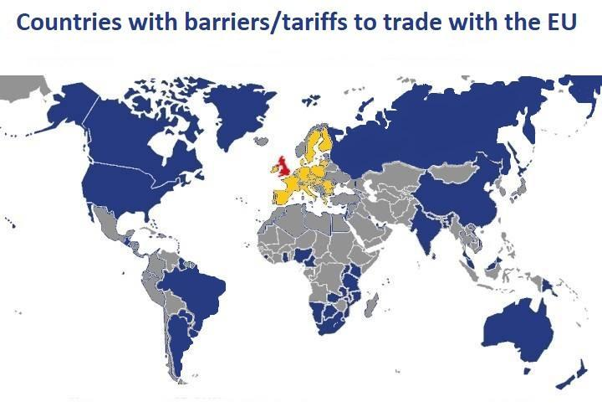
Discriminatory tariffs are unjustly imposed on trade from many countries (those in blue)

The EU’s policy of forced imposition of tariffs on goods and services discriminates against non-EU countries. These biased EU tariffs and policies exclude non-EU firms from fair competition and thus damage free trade within British markets. Protectionist economic policies, such as these unequal tariffs, also leave British individuals and families at an unfair disadvantage compared to many non-EU consumers. This is as the prejudicial treatment against non-EU countries requires British consumers to pay a tax on many non-EU goods. Major manufacturing nations such as China and Australia are excluded from this preferential treatment. Given our disproportionate importing of goods from China these unjust tariffs put the British consumer at an unfair disadvantage compared to their non-EU counterparts when purchasing these goods. Without these biased tariffs numerous products from non-EU countries would become easier and cheaper to buy for British consumers.
No matter what one’s political position, it is unfair for British consumers to be forced to pay unreasonably more for goods in comparison to other consumers.

Moral Foundations Theory – Loyalty
Remain Study / Pro-Leave Arguments
- Immigration
EU regulations mean British families are at a disadvantage in their own homeland

Many British communities and citizens have felt abandoned by government immigration policies in recent years. EU regulations on immigration do not allow governments to prioritise the needs of loyal and devoted members of British communities. As a result government policies have been disloyal to the ordinary British citizen by allowing all immigrants, even those who do not contribute, to avail of community and national services including the NHS. Although immigration can be positive for communities, the sheer scale of this immigration, caused by EU regulations, has led to services being overrun with patients, increasing the pressure on these vital national and community services. British governments have a patriotic duty to be loyal to the citizens who elect them. Acting primarily in the interest of devoted British families and communities is and ought to be the priority for all British governments.
No matter what one’s political position, one must agree that a government should remain loyal to the interests of those who elect them.
- Sovereignty
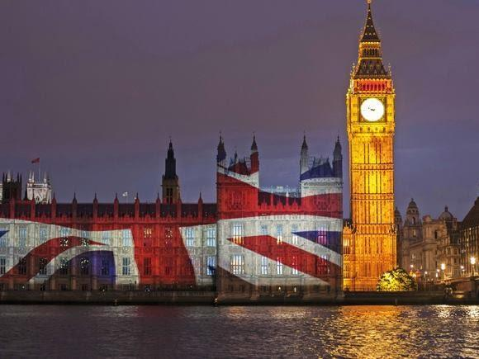
National laws should be implemented by and for British families and communities,
and not for the interests of foreign groups.

Due to the EU Commission being undemocratic and unaccountable to the British citizens, their members have no duty or loyalty to the collective British interest. Continuing to allow EU regulations to trump British law, as EU Commission laws do, is akin to deserting and betraying the national interest. Due to the influence of foreign EU states, decisions made by the EU will never be truly focused on our national interest. For example between 2009 and 2014, 485 laws which were opposed by MEP’s loyal to British interests, were nonetheless passed by the EU Commission. It is only right that these decisions which directly affect British citizens and the national interest should be made by those both loyal and accountable to the British people.
No matter what one’s political position, it is unpatriotic to allow laws created by those not loyal to British interests to take precedent over British laws.

- Trade/Economy
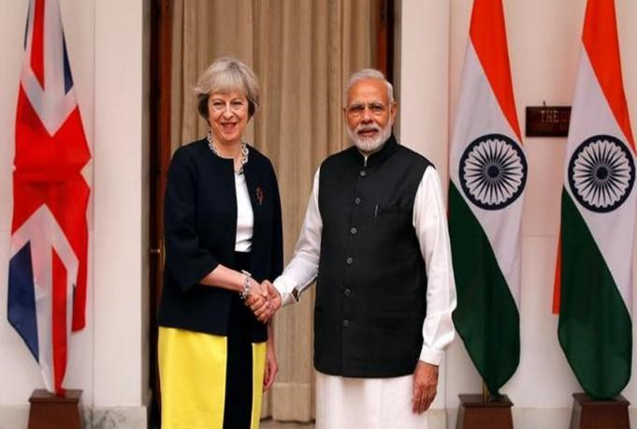
Historic Commonwealth allies have been deserted by recent EU trade policies

The introduction of tariffs on non-EU goods, forced on Britain by the EU, was an economic abandonment of British Commonwealth countries. Leaving the EU allows us to reconnect, economically and culturally, with our family of commonwealth members such as India; a country with which the EU failed to reach a trade deal. The GDP of the Commonwealth bloc now vastly exceeds the EU’s and so leaving affords Britain the opportunity to reconnect with a historically loyal and much larger economically prosperous bloc. A reunited Commonwealth could scrap the EU enforced tariffs which betrayed the economic interests of Commonwealth nations when introduced.
No matter what one’s political position, re-opening previously blocked trade networks with Britain’s historically loyal allies in the Commonwealth can only benefit the economy as a whole.

- (A) Openness tailored arguments (B) Contentiousness tailored arguments
Note key personality words and concepts are highlighted in blue here for illustration purposes, but these were not highlighted for the participants.
Personality – Openness
Remain Study / Pro-Leave Arguments
    - Immigration
Current immigration policies do not promote openness and diversity, people from EU countries are given opportunities that are closed to the rest of the world

The “immigration” debate opens up the philosophical question of the UK’s inability to control its’ own immigration laws.
This debate need not promote narrow-mindedness or reduce the opportunity for diversity, instead the focus should be on whether we consider the government’s inability to regulate its own border controls as an infringement on our freedom of expression. We should have the ability to consider a variety of ideas about immigration which would promote creative and adventurous policy-making. At the moment the potential for these original ideas is stifled by shallow EU bureaucracy.
The current concerns over UK immigration policy are not a minority perspective. A 2015 YouGov poll indicated that 75% of people in the UK take issue with the current immigration system. For example, the current system disproportionately disadvantages non-EU immigrants compared to those from the EU. It is therefore time for a new and innovative approach to immigration that values fairness and diversity and would increase multiculturalism and openness rather than stifling them.
Irrespective of political preference, the concerns over immigration laws need to be addressed. The current system does not represent real openness as it unreasonably disadvantages people from some countries over others.
    - Sovereignty
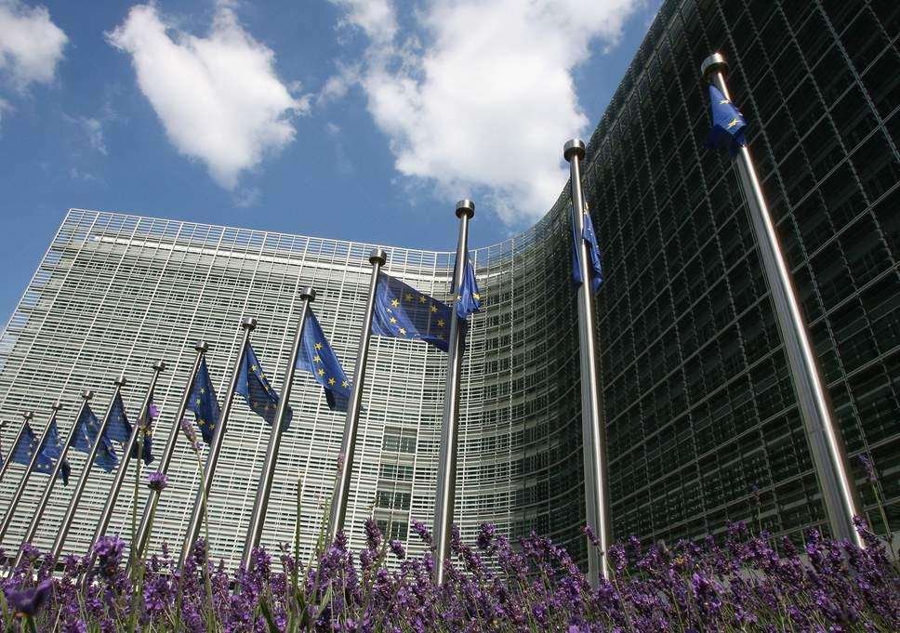
The EU bureaucracy is creating a homogeneous state which threatens our cultural diversity

As part of the EU the British parliament has had its powers drained, with government having to cede control over many of its’ own affairs.
The bureaucratic philosophy of one-size-fits-all is morally questionable. Not only does it breed homogeneity, but it does so at the expense of diversity with legislation being implemented irrespective of cultural idiosyncrasies. The political and cultural diversity of Europe should be celebrated; however, we risk losing the heterogeneity of experiences and practices that stem from countries individual freedom of thought.
To put this sentiment in perspective, in a five-year period between 2009-2014, British MEPs voted against 576 EU proposals, yet 485 were still passed and became law. This shallow approach only serves the narrow interests of the EU. The UK government is no doubt more attentive to the sensitivities and broad interests of British people; yet, without sovereignty our interests are being closed off.
Regardless of one’s political standpoint, the current bureaucratic and single-state governance that the EU represents is smothering individual cultural expression and contravenes everyone’s openness. We ought to advocate a system of governance that creates progressive policies which enhance our opportunities rather than stifling our experiences through homogeneous policy-making.

    - Economy
A strong economy stems from the innovation and variety of interests that diversity brings

The EU’s economy is shrinking relative to other countries around world. The EU’s GDP now sits behind other major economic blocs including the US, China and the Commonwealth, and as a member of the EU Britain is not free to create resourceful agreements with this surging global market.
It is logical for the UK to diversify its economic strategy to include these prosperous markets. In doing so it would maintain an economic relationship with the EU but we would also open ourselves up to a range of commercial opportunities by varying our economic trade agreements. Not only does our current arrangement damage our economic growth but it stifles our opportunity for new and innovative socio-cultural experiences. Moreover, the new opportunities that would result from leaving the EU would create a market for original and innovate ideas, allowing us the opportunity to evolve rather than focusing on narrow interests. Therefore, not only does it make logical economic sense to leave the EU but remaining in it could harm the UK’s economy and overall opportunity for growth.
The EU also harms small business with over-officious red-tape. This has a seriously negative effect on small business owners and threatens the diversity and inventiveness of open-minded individuals. We should be supporting the adventurousness and ingenuity of these business owners, not hampering their opportunities with closed-minded bureaucracy.
Overall, we should be optimistic about leaving the EU. Leaving will place us in a more prosperous economic position where we will be unrestricted to implement creative and adventurous economic policy that will pioneer a range of new and beneficial experiences and opportunities.

Personality – Conscientiousness
Remain Study / Pro-Leave Arguments
    - Immigration
Our current immigration policy is chaotic, we need a more orderly system that benefits everyone

Being able to systematically regulate the influx of people entering one’s country should be an essential component of a country’s government. However, our immigration policy is unsystematically imposed on us by the EU and is creating considerable disorder.
We currently have a record number of over 2 million EU workers in our country and this is having a negative impact on our job-market. The wages of hard-working, but low-skilled employees are being undercut by low-skilled immigrant workers. We are failing to dutifully support the integrity of low-skilled British employees and this is creating disorder in the job market and straining our welfare system. This is not to suggest we want to “close the border” to hard-working immigrants but that we need a better system.
It is time for a more systematic approach to immigration. A more meticulous system - with a greater level of organisation - could be achieved by adopting a scheme which is carefully tailored to the needs of everyone involved. This will allow us to plan and structure immigration more efficiently by matching immigrants’ skill sets with suitable job vacancies – preserving jobs, boosting the economy and benefiting high-skilled and hard-working immigrants.
Putting one’s political agenda aside, it is evident that the current immigration policy is not dependable and is creating disorder. Supporting the call for a more orderly immigration policy is not based on impulsive racist or xenophobic beliefs. Instead it is about our desire to create a more reasonable policy that takes into the consideration our obligations to one another.

    - Sovereignty
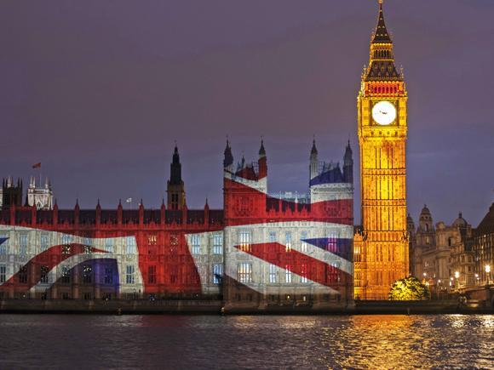
We should strive for well-planned laws created by our coherent and accountable British government

Europe is a large continent made up of many countries with divergent and contrasting socio-political agendas. This variety makes legislating and coordinating across the EU particularly complex and disorderly.
The implementation of laws is an important task that impacts on all of us. Given the practical effects of these laws we ought to make sure this task is carried out efficiently but also that the resulting laws have been deliberated over and are generally dependable. However, we now have very little influence on EU decision-making. For example, between 2009-2014 our British MEPs voted against 576 EU proposals, yet 485 were still passed and became law. As part of the EU we are being systematically marginalised while laws are being irresponsibly forced upon us. This is clearly not an organised or dependable approach to governance.
A result the gradual process of implementing laws in conjunction with the diverging growth of individual countries means that much of EU legislation is inconsistent and incoherent. This creates disorder as there is a lack of clarity at the operational level which unnecessarily complicates the implementation of these laws. Not only is this system inefficient and poorly planned but it also restricts the development of integrated national policies.
The one-size-fits all approach of the EU is disorganised and impractical. Leaving the EU and attaining sovereignty would allow us to create a more efficient and dependable system which is carefully tailored to our needs. This represents a more responsible form of governance which takes seriously our responsibilities to one another.

    - Economy
The EU is a broken and inefficient system, our economy would benefit from responsible trade agreements with non-EU countries

From an economic perspective the EU is highly disorganised and chaotic. While many of the countries within the EU are economically stagnant or facing a recession, our economy is faring well and is propping up Europe’s overall economic figures – the EU is benefiting and we are suffering from our hard-working ethos.
Not only is the EU economically undependable its’ GDP now sits behind other major economic blocs including the US, China and the Commonwealth; yet, as a member of the EU we are unable to make resourceful trade agreements with these states. The easy-going attitude of much of Europe does not fit with our hard-working, self-disciplined and dependable nature and we should not have to suffer the negative economic consequences of this imbalance.
The economy of UK affects all of us and so we have an obligation to one another to take this matter seriously. The attempt by the EU to align the economies of its’ member states by forcing them to follow the same rules is creating considerable disorder, as evident with the dramatic fluctuations in value of the Euro. Similarly, the overly complex and unsystematic EU fiscal policies were partly responsible for the failure to efficiently deal with the Eurozone crisis which resulted in huge bailouts of EU member states such as Ireland and Greece.
Our current economic situation with the EU is undependable and so remaining a part of this would be irresponsible. Outside the EU we will have the opportunity to carefully construct practical and systematic trade deals with non-EU countries that will reward our industrious economy, rather than being vulnerable to the impulsive fluctuations of the EU member state’s chaotic economic situation.
- Non-tailored control arguments
Moral Foundation Theory
Remain Study – Control Argument
    - Young People
Young people may actually benefit from increased places in top universities
Leaving the EU has drastic negative consequences for young people, particularly for students. Given the price of tuition fees in Britain currently many young British people are choosing to study abroad. Being an EU nation offers these British students the chance to study in EU nations for a fraction of the price that they would pay at home. In this way more young people can afford to go to university as a result of Britain’s membership of the EU. These tuition fees rise substantially for non-EU students and thus would price-out many young people. British students wishing to pursue further study and research also benefit from access to numerous and substantial EU grants. The avenues for British students, both in initially being able to go to university as well as in pursuing their academic interests further into postgraduate study, will be substantially reduced upon leaving the EU.

Personality
Remain Study – Control Argument
    - Young People
Leaving the EU increases the opportunity for better work and wages for young apprentices
Leaving the EU could have significantly positive benefits for young people.
A likely outcome of leaving the EU is that companies will no longer be able to freely higher EU graduates. Indeed, many employers have already announced that they would decrease their recruitment of EU graduates in the event of a leave vote, reducing the competition for graduate positions.
Leaving the EU also has benefits for non-graduates. At present, the number of tradesmen across the country is rising. This has reduced wages and made it harder for apprentices to get on the career ladder. However, in the event of leaving the EU competition is likely to decrease, providing young workers more opportunities in the job market.
Finally, it is also likely that leaving the EU will make it easier for young people to get on the housing ladder. Rising house prices are partly caused by migration which will likely be reduced upon leaving. This should help young people attain houses at affordable prices as demand is reduced.
Irrespective of political preference, leaving the EU could represent a positive advancement for young people. The potential increase in job availability in conjunction with more affordable housing could transform the lives of young people for the better.

