Supplemental Materials of Measurement of Attitudes towards Autistic people

Materials

Societal Attitudes towards autism scale (Flood et al., 2013)
People with autism should not engage in romantic relationships.
People with autism should have the opportunity to go to university.
People with autism should not have children.
People with autism should be institutionalised for their safety and others.
If a facility to treat people with autism opened in my community, I would consider moving out.
Individuals with autism are incapable of living on their own.
I would be afraid to be around a person with autism.
A person with autism is an emotional burden to his/her family.
I would be comfortable sitting next to a person with autism in the same class.
A person with autism is a financial burden to his/her family.
People with autism should be encouraged to marry a person with autism.
People with autism are incapable of forming relationships and expressing affection.
Children with autism should be fully integrated into mainstream classes.
I would be uncomfortable hugging a person with autism.
People with autism cannot understand other people’s feelings.
Students with autism who are mainstreamed into regular classrooms are a distraction to students without autism in that classroom.
[Responses were given on a 4-point scale ranging from 1 (strongly disagree) to 4 (strongly agree)]

Other attitudes towards autism scales
[Thermometer attitude item, adapted from Haddock et al. (1993)]
“Please provide a number between 0 and 100 to indicate your overall evaluation of a typical autistic person” [slider-measure response from 0 (extremely unfavourable) to 100 (extremely favourable)]
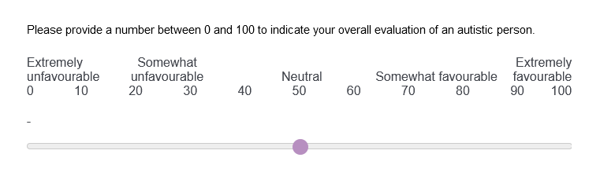
[Measure adapted from Armitage et al. (1999)]
"I see autistic people in general as..."
[Responses were given on four bipolar scales ranging from -3 (bad, unfavourable, negative, unsatisfactory) to 3 (good, favourable, positive, satisfactory)]
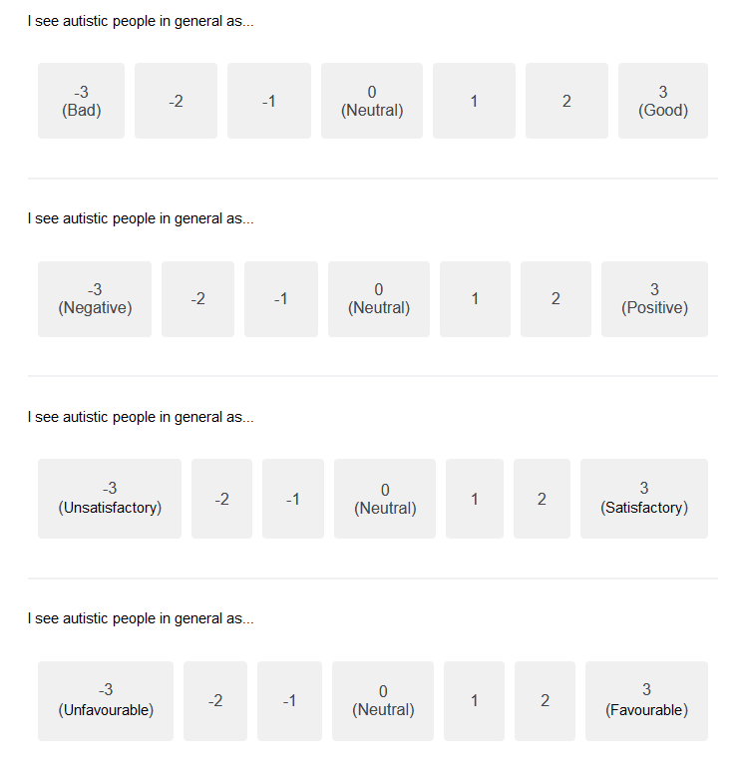

Behaviour intention item, adapted from Flood et al. (2013)
“Would you be interested in having your name and email provided to a local community organization that utilizes students to work with individuals with autism for potential contact in the Spring regarding volunteering?”
[Responses were given on a 7-point scale ranging from 1 (certainly not) to 7 (most certainly)]

Results

Confirmatory Factor Analysis
Our data:
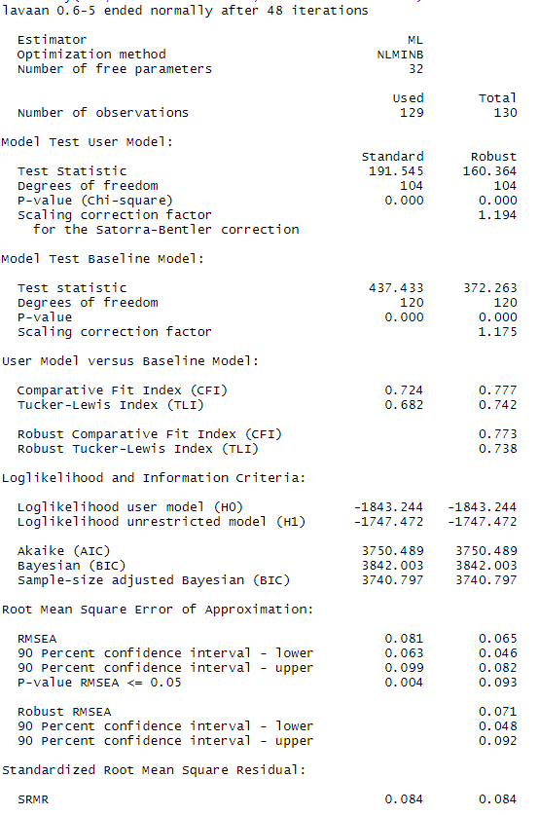

Flood et al. (2013) data (n = 475):
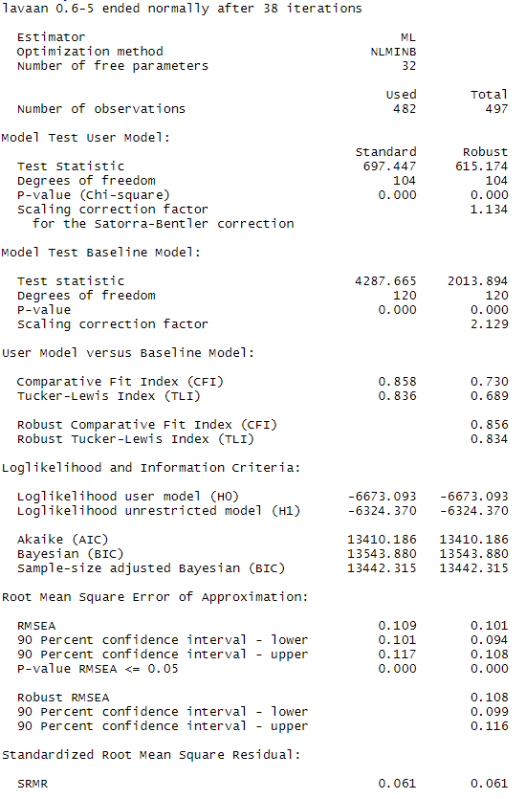
Armitage et al.’s 4-item measure
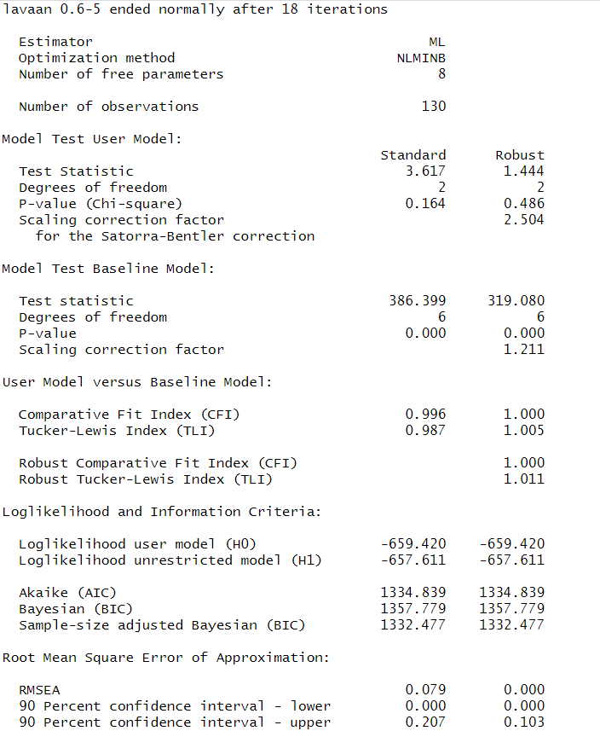

Exploratory Factor Analyses
Our data: The EFA suggests 3 factors (see screenshot below). We acknowledge that our sample size might be too small to be very confident in the results of the CFA and EFA. However, the pattern of findings we obtained from the CFA and EFA with our data are in line with the CFA and EFA from the Flood et al. (2013) data (n = 475): Both suggests that the SATAS is not unidimensional.
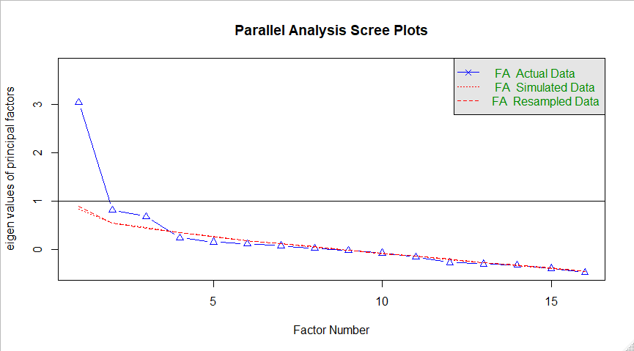
Loadings:
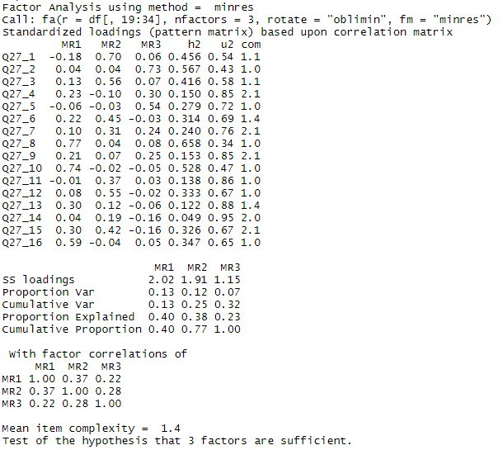
Flood et al. (2013) data: The EFA suggests 4 factors
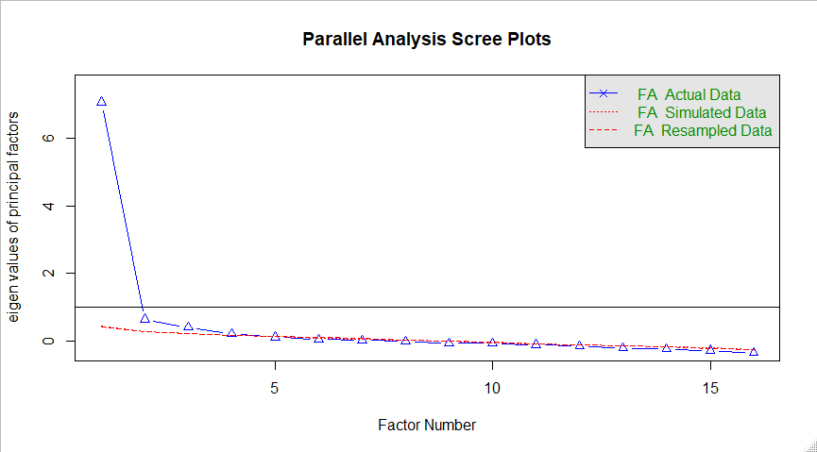
Loadings:
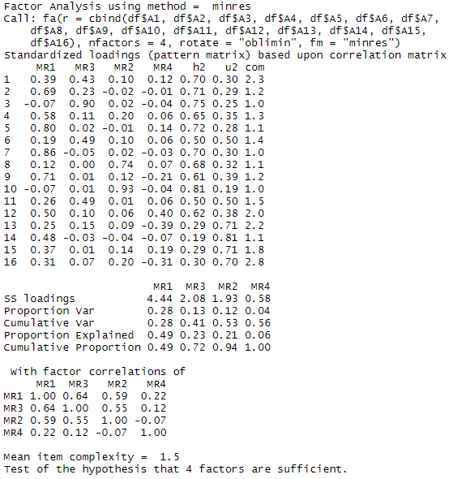

We thank Betsy Morgan for sharing the data.

