Supplementary Material

Table S1: Bayesian factor Pearson correlation analysis for fear and trust
Variables | ATAI fear | ATAI acceptance | ATAI single trust item | Trust towards AI product | Trust in humans (NEO-PI-R)
ATAI fear | -
BF₁₀ | inf
p
ATAI acceptance | r=-0.398 | -
BF₁₀ | 151.349
p | <0.001
ATAI single trust item | r=-0.401 | r=0.925 | -
BF₁₀ | 169.976 | 3.06E+35
p | <0.001 | <0.001
Trust towards Ai product | r=-0.397 | r=0.698 | r=0.746 | -
BF₁₀ | 2.520 | 3.56E+11 | 1.98E+14
p | =0.009 | <0.001 | <0.001
Trust in humans (NEO-PI-R) | r=0.068 | r=0.041 | r=-0.013 | r=0.059 | -
BF₁₀ | 0.102 | 0.090 | 0.084 | 0.097
p | =0.525 | =0.701 | =0.903 | =0.577
BF; Bayesian factor, * BF₁₀ > 10, ** BF₁₀ > 30, *** BF₁₀ > 100

Figure S1: Pearson correlation analysis for trust in eight AI product and humans(two-tailed tested). E; Exponent (10^{x})

Figure S2: Re-computation of ICA two data sets. A) demonstrates the significant component estimated from 82 subjects (subjects used in the previous work [31]). B) shows the significant component derived from all 90 subjects. C) shows a comparative test of the component loading coefficients from 82 and 90 subjects respectively.

Table S2: Statistical t-test between 82 and 90 subjects using their loading coefficients
VARIABLES | 82_subjects | 90_subjects
Mean | -0.018 | 5.680E-09
Variance | 0.982 | 1.00
Observations | 82 | 90
Pooled variance | 0.991
Hypothesized mean difference | 0
Df | 170
T stat | -0.124
P(t<=t) one-tail | 0.450
T critical one-tail | 1.653
P(t<=t) two-tail | 0.901
T critical two-tail | 1.974

Table S3: Table showing all four components as estimated by the ICA-SBM
Component number | Maps | Results from the regression analysis revealed the following associations with trust in humans (p<0.05)
1 | 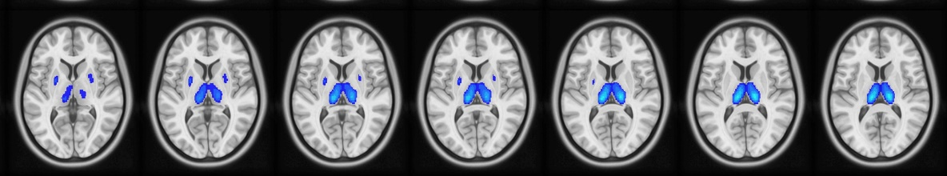 | Significant
2 | 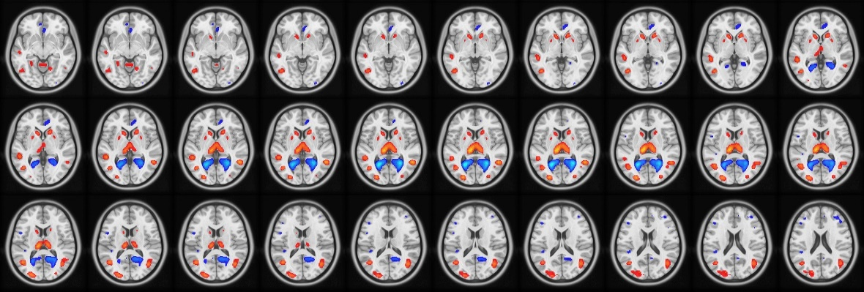 | Not significant
3 | 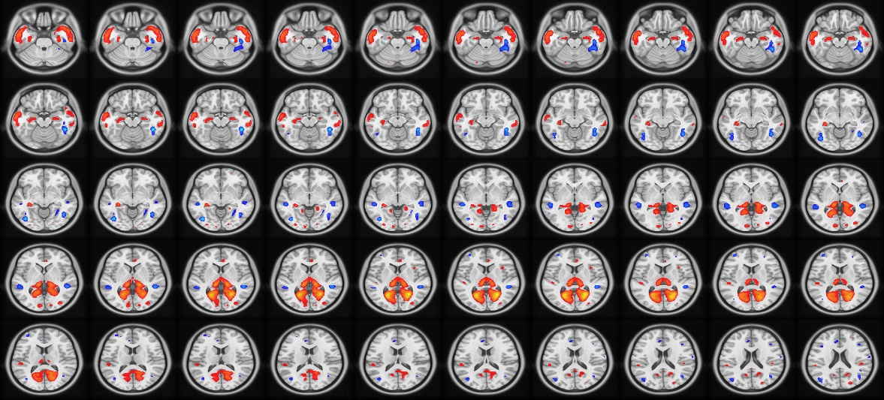 | Not significant
4 | 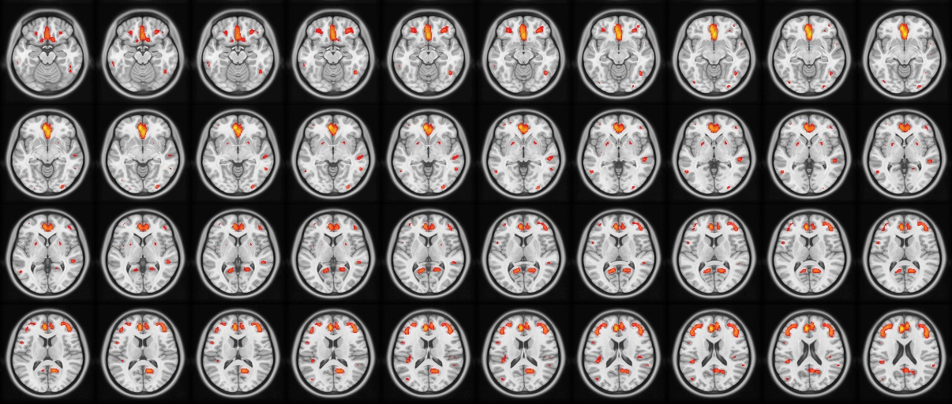 | Not significant

