Supplemental Table 1. Within-Subjects Outlier Removal Procedure Results.
 | Arrow | Social | Unpleasant | Pleasant
Number of Total Trials Removed | 98 | 127 | 77 | 91
Number of Participants Affected | 58 | 71 | 49 | 56
Average Trials per Participant Removed | 1.69 | 1.79 | 1.57 | 1.63
Maximum Number of Trials Removed from a Single Participant | 5 | 7 | 4 | 5

Supplemental Table 2. Descriptive Statistics of the Errors Made.
Task | Unit | No Errors | M | SD | Min | Max
Arrow (N = 91) | 1 | 3 | 4.68 | 3.04 | 1 | 17
 | 2 | 1 | 6.24 | 3.26 | 1 | 17
 | 3 | 0 | 6.52 | 3.21 | 1 | 15
 | 4 | 3 | 7.42 | 3.68 | 2 | 19
 | 5 | 1 | 7.44 | 3.29 | 1 | 16
 | All | 0 | 31.76 | 12.06 | 5 | 65
Social (N = 93) | 1 | 0 | 7.52 | 3.02 | 2 | 15
 | 2 | 0 | 8.26 | 3.11 | 2 | 19
 | 3 | 1 | 8.13 | 2.79 | 3 | 16
 | 4 | 0 | 8.60 | 3.39 | 2 | 18
 | 5 | 0 | 8.48 | 3.43 | 1 | 18
 | All | 0 | 40.90 | 11.56 | 10 | 73
Unpleasant (N = 91) | 1 | 0 | 8.75 | 4.80 | 1 | 24
 | 2 | 1 | 9.38 | 3.88 | 1 | 17
 | 3 | 0 | 8.88 | 3.49 | 1 | 17
 | 4 | 0 | 9.16 | 3.89 | 1 | 18
 | 5 | 1 | 8.66 | 3.28 | 1 | 17
 | All | 0 | 44.63 | 15.33 | 7 | 70
Pleasant (N = 89) | 1 | 1 | 7.31 | 3.88 | 1 | 19
 | 2 | 1 | 8.01 | 3.41 | 1 | 15
 | 3 | 1 | 8.56 | 3.57 | 1 | 18
 | 4 | 0 | 8.92 | 4.18 | 1 | 19
 | 5 | 0 | 8.45 | 3.39 | 2 | 16
 | All | 0 | 40.98 | 13.25 | 7 | 71
Notes. N = Sample Size; No Errors = Number of participants who did not make any error in the Unit. M = Mean; SD = Standard deviation; Min = Minimum value; Max = Maximum value.

Supplemental Table 3. Descriptive Statistics of the Error-Related Negativity Variables.
Task | Unit | N | M (µV) | SD | Min | Max | Skew | Kurtosis
Arrow | 1 | 88 | -7.02 | 7.07 | -30.26 | 8.71 | -0.30 | 0.80
 | 2 | 90 | -6.57 | 7.44 | -28.43 | 12.80 | -0.04 | 0.39
 | 3 | 91 | -5.53 | 6.98 | -27.46 | 15.97 | -0.12 | 0.82
 | 4 | 88 | -6.02 | 5.99 | -21.05 | 8.17 | -0.25 | 0.34
 | 5 | 89 | -5.75 | 6.29 | -28.00 | 12.54 | -0.27 | 1.19
 | All | 91 | -5.88 | 4.96 | -21.68 | 5.78 | -0.64 | 0.97
Social | 1 | 91 | -6.12 | 5.15 | -24.70 | 5.66 | -0.76 | 1.10
 | 2 | 93 | -5.38 | 5.59 | -27.91 | 5.83 | -0.77 | 1.48
 | 3 | 90 | -5.80 | 4.63 | -19.58 | 9.21 | -0.30 | 1.07
 | 4 | 91 | -5.53 | 5.24 | -16.89 | 7.16 | 0.08 | -0.33
 | 5 | 91 | -5.70 | 5.19 | -21.28 | 8.58 | -0.27 | 0.53
 | All | 92 | -5.60 | 3.85 | -21.16 | 3.96 | -0.79 | 1.91
Unpleasant | 1 | 90 | -7.39 | 5.07 | -19.29 | 4.12 | 0.15 | -0.48
 | 2 | 88 | -7.65 | 6.03 | -26.01 | 8.24 | -0.43 | 0.51
 | 3 | 89 | -6.63 | 6.01 | -21.71 | 10.49 | -0.28 | -0.05
 | 4 | 89 | -6.50 | 6.30 | -25.46 | 18.56 | 0.94 | 4.16
 | 5 | 87 | -8.15 | 5.12 | -19.97 | 5.48 | 0.05 | -0.29
 | All | 89 | -7.39 | 3.85 | -16.85 | 2.89 | -0.31 | 0.22
Pleasant | 1 | 87 | -6.79 | 6.03 | -24.48 | 4.47 | -0.67 | 0.29
 | 2 | 87 | -8.75 | 5.29 | -35.02 | 3.11 | -1.37 | 5.54
 | 3 | 85 | -8.91 | 6.77 | -33.75 | 3.04 | -1.16 | 1.99
 | 4 | 88 | -8.58 | 6.38 | -24.25 | 7.99 | -0.28 | 0.00
 | 5 | 87 | -7.16 | 5.37 | -21.70 | 7.07 | -0.20 | -0.05
 | All | 88 | -7.95 | 4.06 | -22.97 | -0.50 | -0.79 | 0.95
Notes. N = Sample Size; M = Mean; µV = microvolts; SD = Standard deviation; Min = Minimum value; Max = Maximum value.

Supplemental Table 4. Correlations of Units and Grand Averages Within Each Task.
Arrow |  | Unit 1 | Unit 2 | Unit 3 | Unit 4 | Unit 5
 | Unit 2 | 0.41
 | Unit 3 | 0.45 | 0.47
 | Unit 4 | 0.52 | 0.42 | 0.56
 | Unit 5 | 0.40 | 0.31 | 0.41 | 0.45
 | Grand Average | 0.72 | 0.69 | 0.72 | 0.80 | 0.70
Social |  | Unit 1 | Unit 2 | Unit 3 | Unit 4 | Unit 5
 | Unit 2 | 0.53
 | Unit 3 | 0.25 | 0.35
 | Unit 4 | 0.27 | 0.36 | 0.40
 | Unit 5 | 0.26 | 0.33 | 0.30 | 0.24
 | Grand Average | 0.69 | 0.79 | 0.67 | 0.68 | 0.59
Unpleasant |  | Unit 1 | Unit 2 | Unit 3 | Unit 4 | Unit 5
 | Unit 2 | 0.42
 | Unit 3 | 0.22 | 0.37
 | Unit 4 | 0.30 | 0.32 | 0.34
 | Unit 5 | 0.22 | 0.48 | 0.32 | 0.36
 | Grand Average | 0.56 | 0.78 | 0.67 | 0.65 | 0.67
Pleasant |  | Unit 1 | Unit 2 | Unit 3 | Unit 4 | Unit 5
 | Unit 2 | 0.43
 | Unit 3 | 0.16 | 0.35
 | Unit 4 | 0.39 | 0.29 | 0.39
 | Unit 5 | 0.17 | 0.25 | 0.24 | 0.53
 | Grand Average | 0.61 | 0.68 | 0.62 | 0.78 | 0.69

Supplemental Table 5. Standardized Factor Loadings of Units Onto Latent Task Construct for Each Task.
Unit | Arrow | Social | Unpleasant | Pleasant (2) | Pleasant (4)
1 | 0.648 | 0.642 | 0.506 | 0.402 | 0.515
2 | 0.594 | 0.742 | 0.739 |  | 0.803
3 | 0.728 | 0.598 | 0.531 | 0.427 | 0.508
4 | 0.752 | 0.600 | 0.549 | 0.960
5 | 0.589 | 0.463 | 0.646 | 0.567 | 0.411

Supplemental Table 6. Descriptive Statistics of the International Personality Item Pool-NEO and Personality Inventory for DSM-5 Traits.
Model | Domain | Facet | N | M | SD | Min. | Max. | Skew | Kurtosis
IPIP-NEO | Neuroticism | N1 | 93 | 3.61 | 0.84 | 1.00 | 5.00 | -0.84 | 0.92
 |  | N2 | 93 | 2.79 | 0.97 | 1.00 | 5.00 | -0.03 | -0.56
 |  | N3 | 93 | 2.88 | 1.07 | 1.00 | 5.00 | 0.14 | -0.91
 |  | N4 | 93 | 2.86 | 0.66 | 1.25 | 4.25 | -0.16 | -0.44
 |  | N5 | 93 | 3.19 | 0.76 | 1.25 | 5.00 | 0.02 | -0.55
 |  | N6 | 93 | 2.74 | 0.70 | 1.00 | 4.25 | -0.15 | -0.76
 | Extraversion | E1 | 93 | 3.58 | 0.82 | 1.00 | 5.00 | -0.48 | 0.10
 |  | E2 | 93 | 2.97 | 1.14 | 1.00 | 5.00 | -0.13 | -1.24
 |  | E3 | 93 | 3.34 | 0.86 | 1.25 | 5.00 | -0.07 | -0.72
 |  | E4 | 93 | 3.35 | 0.70 | 1.50 | 5.00 | -0.13 | -0.03
 |  | E5 | 93 | 3.66 | 0.75 | 1.75 | 5.00 | -0.45 | -0.18
 |  | E6 | 93 | 3.79 | 0.78 | 1.75 | 5.00 | -0.54 | -0.41
 | Openness to Experience | O1 | 93 | 3.89 | 0.86 | 1.50 | 5.00 | -0.59 | -0.36
 |  | O2 | 93 | 3.67 | 0.85 | 1.75 | 5.00 | -0.45 | -0.50
 |  | O3 | 93 | 3.70 | 0.87 | 1.25 | 5.00 | -0.31 | -0.52
 |  | O4 | 93 | 2.88 | 0.83 | 1.25 | 5.00 | 0.34 | -0.12
 |  | O5 | 93 | 3.70 | 0.85 | 2.00 | 5.00 | -0.15 | -1.00
 |  | O6 | 93 | 2.88 | 0.97 | 1.00 | 5.00 | 0.09 | -0.38
 | Agreeableness | A1 | 93 | 3.44 | 0.78 | 1.75 | 4.75 | -0.34 | -0.91
 |  | A2 | 93 | 3.68 | 0.60 | 2.25 | 5.00 | -0.08 | -0.43
 |  | A3 | 93 | 4.34 | 0.50 | 3.00 | 5.00 | -0.64 | -0.08
 |  | A4 | 93 | 4.00 | 0.79 | 2.00 | 5.00 | -0.49 | -0.69
 |  | A5 | 93 | 3.43 | 0.88 | 1.50 | 5.00 | 0.00 | -0.62
 |  | A6 | 93 | 4.00 | 0.66 | 2.25 | 5.00 | -0.25 | -0.64
 | Conscientiousness | C1 | 93 | 3.82 | 0.55 | 2.25 | 5.00 | -0.44 | 0.30
 |  | C2 | 93 | 3.35 | 0.86 | 1.25 | 5.00 | -0.19 | -0.61
 |  | C3 | 93 | 4.15 | 0.54 | 2.50 | 5.00 | -0.54 | 0.12
 |  | C4 | 93 | 3.92 | 0.70 | 1.25 | 5.00 | -0.74 | 1.05
 |  | C5 | 93 | 2.74 | 0.98 | 1.00 | 4.75 | -0.04 | -1.08
 |  | C6 | 93 | 3.06 | 0.93 | 1.00 | 5.00 | -0.31 | -0.44
Model | Domain | Facet | N | M | SD | Min. | Max. | Skew | Kurtosis
PID-5 | Negative Affectivity | Anxiousness | 93 | 1.91 | 0.72 | 0.00 | 3.00 | -0.54 | -0.37
 |  | Emotional Lability | 93 | 1.22 | 0.78 | 0.00 | 2.75 | 0.10 | -0.89
 |  | Hostility | 93 | 0.84 | 0.75 | 0.00 | 2.75 | 0.72 | -0.32
 |  | Perseveration | 93 | 1.32 | 0.62 | 0.00 | 3.00 | 0.24 | -0.64
 |  | Restricted Affectivity | 93 | 4.03 | 0.79 | 2.00 | 5.00 | -0.69 | -0.37
 |  | Separation Insecurity | 93 | 1.56 | 0.74 | 0.00 | 3.00 | -0.11 | -0.54
 |  | Submissiveness | 93 | 1.63 | 0.59 | 0.25 | 3.00 | -0.14 | -0.34
 | Detachment | Anhedonia | 93 | 0.80 | 0.69 | 0.00 | 2.75 | 0.81 | 0.04
 |  | Depressivity | 93 | 0.61 | 0.71 | 0.00 | 2.75 | 1.08 | 0.13
 |  | Intimacy Avoidance | 93 | 0.74 | 0.67 | 0.00 | 3.00 | 0.95 | 0.60
 |  | Suspiciousness | 93 | 0.85 | 0.55 | 0.00 | 2.25 | 0.54 | -0.37
 |  | Withdrawal | 93 | 0.80 | 0.64 | 0.00 | 2.50 | 0.64 | -0.22
 | Psychoticism | Eccentricity | 93 | 1.51 | 0.92 | 0.00 | 3.00 | -0.09 | -1.12
 |  | Perceptual Dysregulation | 93 | 0.61 | 0.59 | 0.00 | 2.25 | 0.74 | -0.25
 |  | Unusual Beliefs Experiences | 93 | 0.88 | 0.70 | 0.00 | 2.50 | 0.30 | -1.01
 | Antagonism | Attention Seeking | 93 | 1.29 | 0.83 | 0.00 | 3.00 | 0.18 | -0.96
 |  | Callousness | 93 | 0.27 | 0.43 | 0.00 | 1.75 | 1.72 | 2.28
 |  | Deceitfulness | 93 | 0.73 | 0.56 | 0.00 | 2.25 | 0.66 | -0.38
 |  | Grandiosity | 93 | 0.35 | 0.48 | 0.00 | 2.25 | 1.54 | 2.09
 |  | Manipulativeness | 93 | 0.86 | 0.63 | 0.00 | 2.50 | 0.69 | -0.29
 | Disinhibition | Distractibility | 93 | 1.79 | 0.74 | 0.25 | 3.00 | -0.04 | -1.00
 |  | Impulsivity | 93 | 1.09 | 0.74 | 0.00 | 3.00 | 0.57 | -0.35
 |  | Irresponsibility | 93 | 0.48 | 0.51 | 0.00 | 2.75 | 1.45 | 3.23
 |  | Rigid Perfectionism | 93 | 3.77 | 0.72 | 2.25 | 5.00 | -0.09 | -1.00
 |  | Risk Taking | 93 | 0.98 | 0.76 | 0.00 | 3.00 | 0.66 | -0.24
Notes. N = Sample Size; M = Mean; SD = Standard deviation; Min = Minimum value; Max = Maximum value; IPIP-NEO = International Personality Item Pool-NEO; PID-5 = Personality Inventory for DSM-5.

Supplemental Table 7. Correlations of Estimated Latent Five-Factor Model and Personality Inventory for DSM-5 Domain Traits.
Measure |  | IPIP-NEO |  |  |  |  | PID-5
 | Domain (Dropped Facet) | N | E (3) | O (4) | A (3 & 5) | C (5) | NA (Res.) | DE (Wit.) | PS | AN (Gra.)
IPIP-NEO | E (3) | -0.35
 | O (4) | 0.02 | 0.11
 | A (3 & 5) | -0.14 | 0.01 | 0.28
 | C (5) | -0.23 | 0.29 | 0.16 | 0.36
PID-5 | NA (Res.) | 0.74 | -0.20 | 0.00 | -0.23 | -0.38
 | DE (Wit.) | 0.52 | -0.53 | 0.04 | -0.18 | -0.46 | 0.49
 | Psychoticism | 0.05 | 0.01 | 0.24 | -0.27 | -0.25 | 0.18 | 0.22
 | AN (Gra.) | 0.18 | -0.03 | -0.14 | -0.68 | -0.46 | 0.35 | 0.22 | 0.45
 | DI (Dis.) | -0.13 | 0.21 | 0.15 | -0.23 | -0.35 | 0.03 | 0.12 | 0.60 | 0.40
Notes. IPIP-NEO = International Personality Item Pool-NEO; PID-5 = Personality Inventory for DSM-5; N = Neuroticism; E = Extraversion; O = Openness to Experience; A = Agreeableness; C = Conscientiousness; NA = Negative Affectivity; Res. = Restricted Affectivity; DE = Detachment; Wit. = Withdrawal; AN = Antagonism; Gra. = Grandiosity; PS = Psychoticism; DI = Disinhibition; Dis = Distractibility; Underline = |r| > .30; Bold = |r| > .50.

Supplemental Table 8. Correlations of Estimated Latent Task Error-Related Negativity Amplitudes from Second-Order Confirmatory Factor Analyses with Estimated Latent Five-Factor Model and Personality Inventory for DSM-5 Domain Traits.
 |  | Second-Order CFA
Model | Domain | Arrow | Social | Unpleasant | Pleasant
IPIP-NEO | Neuroticism | 0.06 | 0.01 | -0.05 | -0.03
 | Extraversion | 0.03 | -0.06 | 0.00 | -0.02
 | Openness | -0.11 | -0.03 | -0.02 | 0.01
 | Agreeableness | -0.14 | -0.06 | -0.16 | -0.06
 | Conscientiousness | -0.10 | -0.03 | -0.01 | -0.06
PID-5 | Negative Affectivity | 0.01 | -0.07 | -0.09 | -0.10
 | Detachment (-E) | -0.15 | -0.03 | -0.04 | -0.02
 | Psychoticism | 0.03 | 0.05 | 0.13 | 0.09
 | Antagonism (-A) | 0.10 | 0.02 | 0.11 | 0.05
 | Disinhibition (-C) | 0.09 | -0.01 | 0.04 | 0.04
Notes. CFA = Confirmatory factor analysis; IPIP-NEO = International Personality Item Pool-NEO; PID-5 = Personality Inventory for DSM-5; -E = Opposite of Extraversion; -A = Opposite of Agreeableness; -C = Opposite of Conscientiousness; Bold = Hypothesized relations; Underline = |r| > .10.

Supplemental Table 9. Personality Profile Similarities of Estimated Latent Task Error-Related Negativity Amplitudes from Second-Order Confirmatory Factor Analyses.
 |  |  | Second-Order CFA |  |  |  |  |  | Second-Order CFA
 |  |  | Arrow | Social | Unpleasant | Pleasant |  |  | Arrow | Social | Unpleasant | Pleasant
Using IPIP-NEO Domains | Single Task CFA | Arrow | 1.00 | 0.43 | 0.37 | 0.17 | Second-Order CFA | Social | 0.40
 |  | Social | -0.08 | 0.79 | -0.27 | -0.14 |  | Unpleasant | 0.44 | 0.28
 |  | Unpleasant | 0.29 | 0.12 | 0.98 | 0.48 |  | Pleasant | 0.20 | 0.28 | 0.48
 |  | Pleasant | -0.47 | 0.01 | 0.13 | 0.77 |  | General | 0.68 | 0.66 | 0.79 | 0.73
Using PID-5 Domains |  | Arrow | 0.97 | 0.24 | 0.38 | 0.23 |  | Social | 0.42
 |  | Social | -0.42 | 0.47 | 0.35 | 0.31 |  | Unpleasant | 0.55 | 0.99
 |  | Unpleasant | 0.56 | 0.97 | 0.99 | 0.97 |  | Pleasant | 0.43 | 0.97 | 0.96
 |  | Pleasant | -0.20 | 0.73 | 0.63 | 0.77 |  | General | 0.58 | 0.98 | 0.99 | 0.98

Notes. CFA = Confirmatory factor analysis; IPIP-NEO = International Personality Item Pool-NEO; PID-5 = Personality Inventory for DSM-5; Underline = |r| > .30; Bold = |r| > .50; Top four rows used correlations with IPIP-NEO domains to calculate the similarity. Bottom four rows used correlations with PID-5 domains to calculate the similarity.

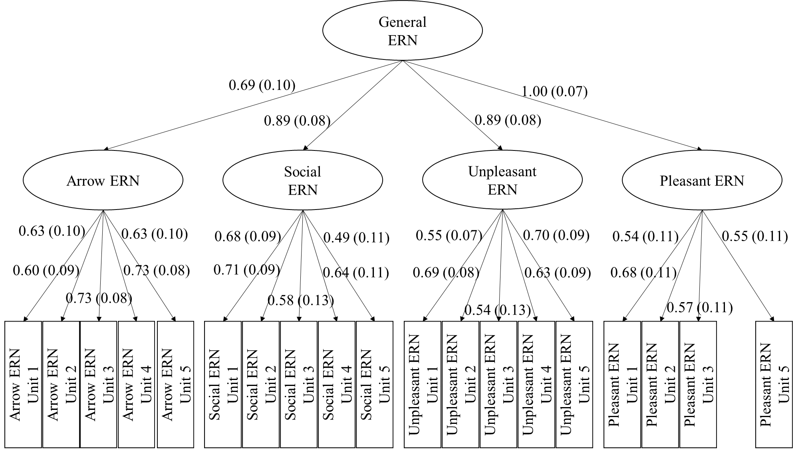
Supplemental Figure 1. The final second-order confirmatory factor analysis model with standardized factor loadings (Standard errors in parentheses).

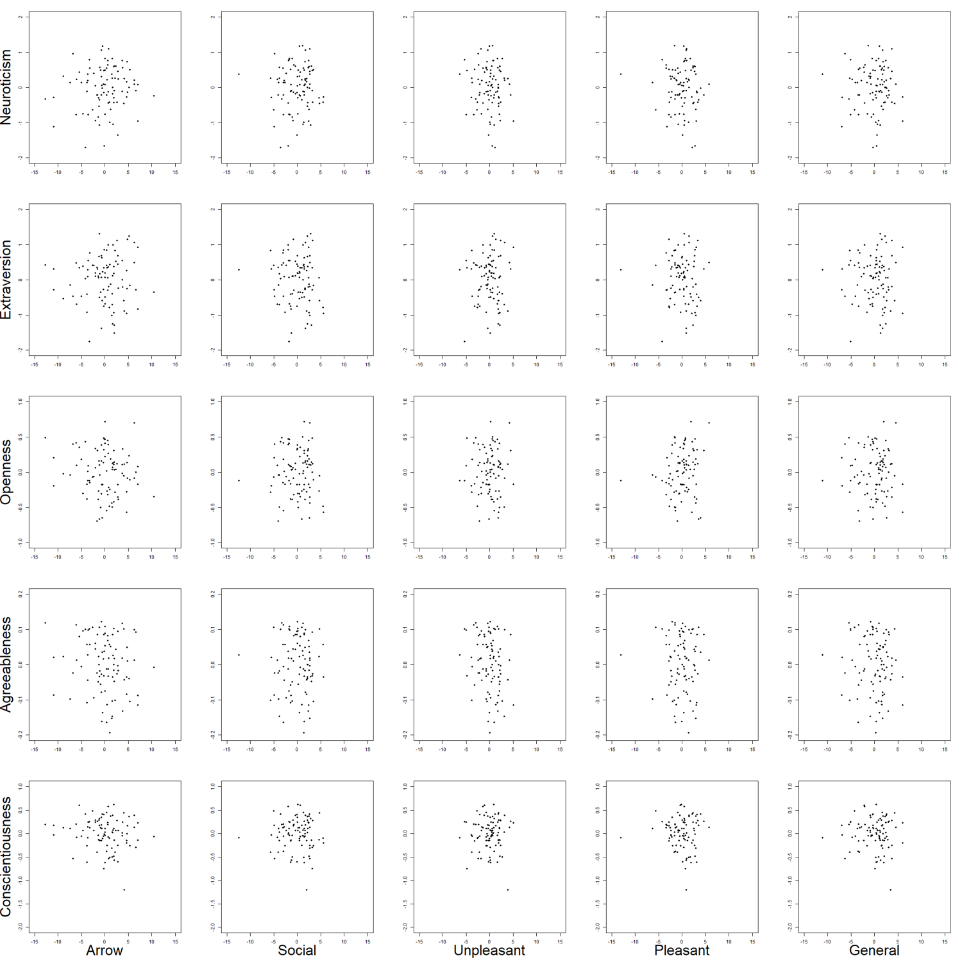

Supplemental Figure 2. Scatter Plot Between Estimated Latent Error-Related Negativity Amplitudes with Estimated General International Personality Item Pool-NEO Domain Traits. See Table 3 for the correlation values.

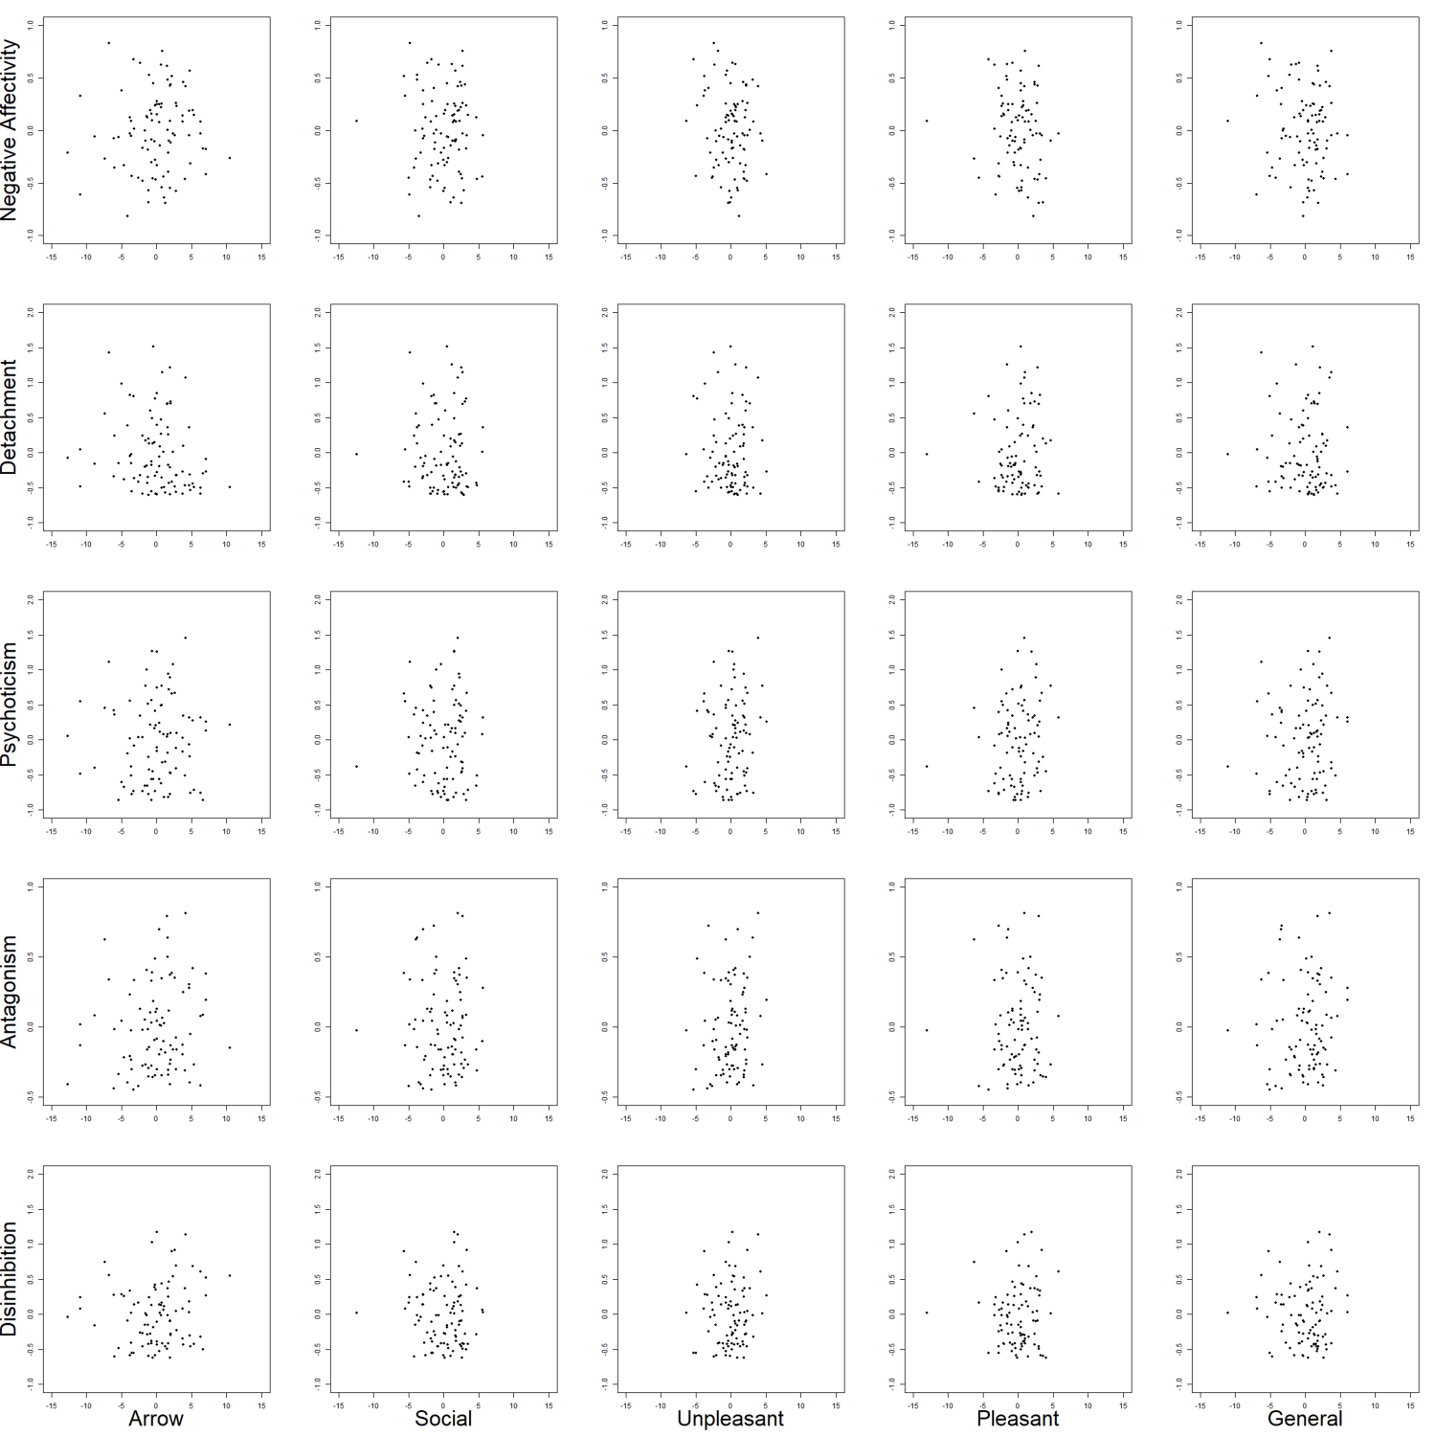

Supplemental Figure 3. Scatter Plot Between Estimated Latent Error-Related Negativity Amplitudes with Estimated Maladaptive Five-Factor Model Domain Traits. See Table 3 for the correlation values.

