Supplementary Material

Tab. S1: Overview on the results of previous and current JORT-studies
Study | Perkins et al., 2009 | Perkins et al., 2013 | Lippold et al., 20xx
sample | 30 males | 20 males  20 females | 27 females  23 males
drug and dosage | - Placebo  - 10 mg citalopram  - 1 mg lorazepam | - Placebo  - 1 mg lorazepam  - 2 mg lorazepam | - Placebo  - 0.5 mg lorazepam  - 1 mg lorazepam
questionnaires | - Fear Survey Schedule (FSS; Wolpe and Lang, 1977)  - Trait Scale; Spielberger State-Trait Anxiety Inventory (STAI-T, Spielberger et al., 1983) | - FSS  - STAI-T  - Eysenck Personality Questionnaire – Revised (Eysenck & Eysenck, 1991) | - FSS  - STAI-T
main results | - lorazepam modulated RAI: lorazepam reduced RAI in participants scoring in the lower half of the sample on FSS social fear  - no effect of lorazepam on FI  - citalopram neither showed an effect on RAI nor on FI | - RAI was affected by lorazepam but the effect was modulated by personality  - 2 mg lorazepam reduced RAI in low scorers on trait anxiety and increased RAI in high scorers  - personality had no differential effects in the placebo and 1 mg lorazepam conditions  - Lorazepam increased FI in the participants with low scores on FSS tissue damage in a dose-dependent manner, whereas FI was decreased in participants with high FSS tissue damage scores in a dose-dependent manner | - main effect of 0.5 mg lorazepam on RAI  - no significant difference between 1 mg lorazepam and placebo

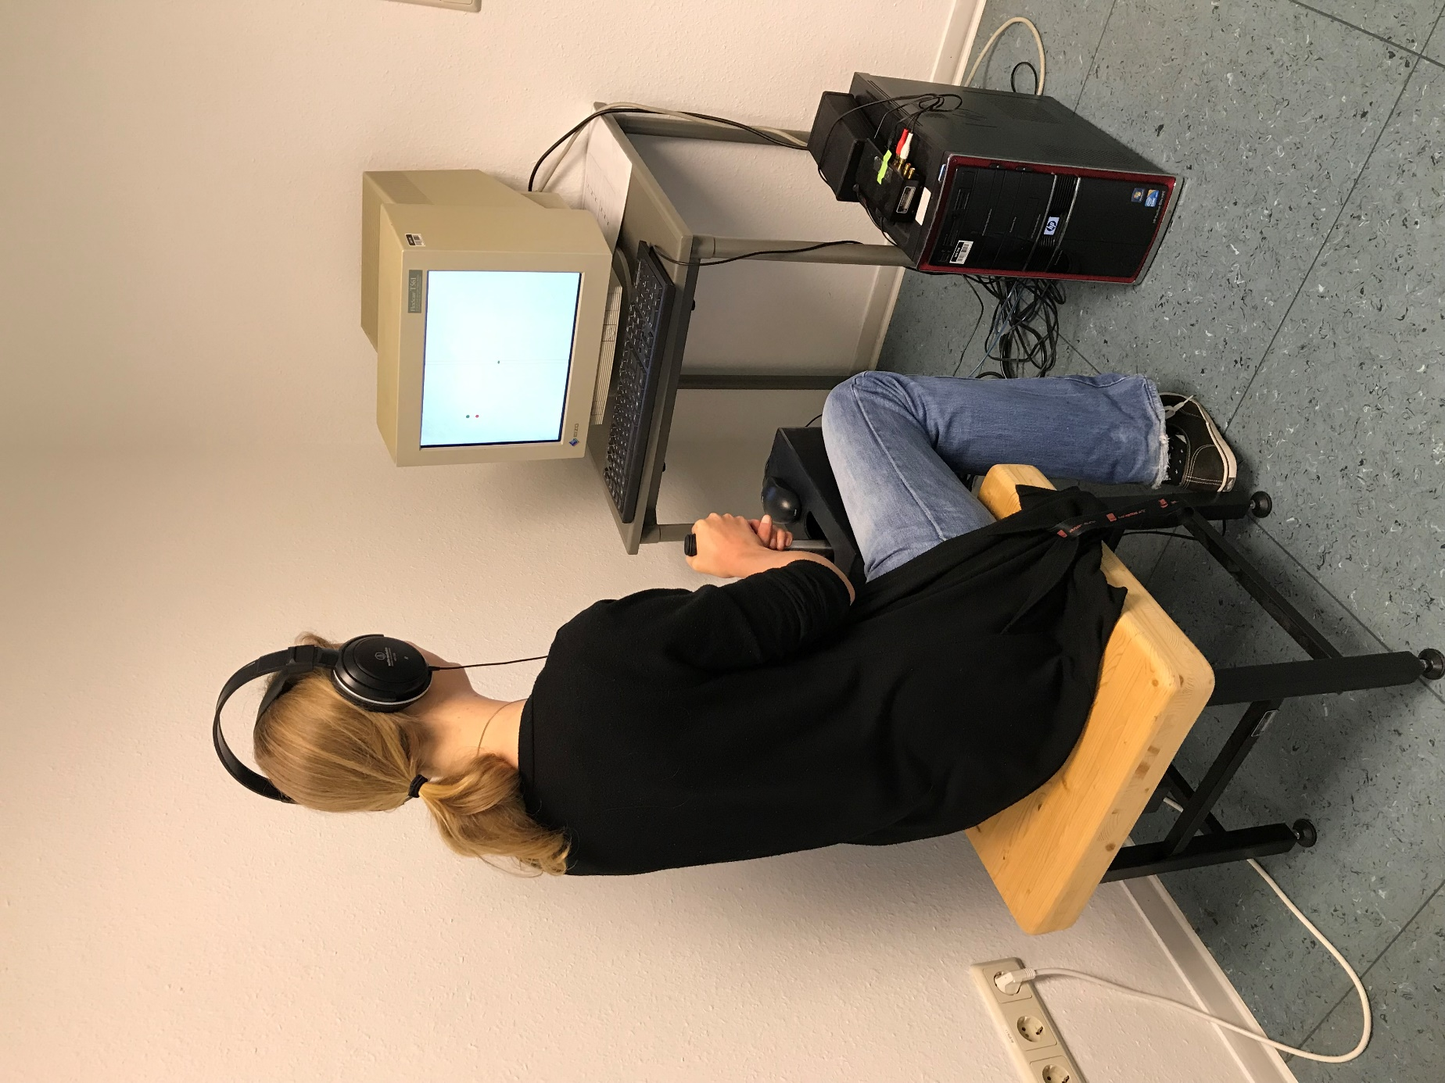
Fig. S1: JORT-apparatus in the laboratory

