Figures in Communal breeding by women is associated with lower investment from husbands
Qiao-Qiao He, Jun-Wen Rui, Li Zhang, Yi Tao, Jia-Jia Wu, Ruth Mace, Ting Ji
2022-10-07

Introduction
This R Markdown document was generated using RStudio. It shows the code of our gee models and figures 2-5.

Packages used
library(tidyverse)
library(wesanderson)
library(dplyr)
library(ggplot2)
library(geepack)
library(gridExtra)
library(aod)
library(data.table)
library(geepack)

Figure 2
##fig 2
##
## plot correlations between predictors
##
# get upper triangle of the correlation matrix
# (source: http://www.sthda.com/english/wiki/ggplot2-quick-correlation-matrix-heatmap-r-software-and-data-visualization) see Thomas et al 2016
get_upper_tri <- function(cormat){
cormat[lower.tri(cormat)]<- NA
return(cormat)
}
d = FarmVM1msb %>%
select(PhelpedMe,breedingF0712, BF, PChdinHH, pAvgR,Age )
cor_vars = c("Husband helped?","Reproducing women","Reproductive-age women","Husband's children",
"Relatedness", "Age")
# calculate correlations and p-values
cormats = d %>%
as.matrix(.) %>%
Hmisc::rcorr(.,type = "spearman")
# format p-values
cormat.p = cormats$P %>%
round(., 2) %>%
get_upper_tri(.) %>%
reshape2::melt(.)
# format correlations and merge with p-values
cormat = cormats$r %>%
round(., 2) %>%
get_upper_tri(.) %>%
reshape2::melt(.) %>%
rename(r = value) %>%
left_join(cormat.p, by=c("Var1", "Var2")) %>%
rename(p = value)
# rename variables
cormat$Var1 = factor(cormat$Var1)
levels(cormat$Var1) = cor_vars
cormat$Var2 = factor(cormat$Var2)
levels(cormat$Var2) = cor_vars
ggplot(data = cormat, aes(Var2, Var1, fill = p)) +
geom_tile(colour = "white") +
geom_text(aes(label = r), size=3) +
scale_fill_gradient2(low = "red", high = "blue", mid = "white", na.value="grey75",
midpoint = 0.05, limit = c(0, 0.1), space = "Lab",
name="P-value") +
theme_minimal() +
theme(axis.text.x = element_text(angle = 45, vjust = 1,
size = 11, hjust = 1)) +
coord_fixed() +
xlab("") +
ylab("")
# point out where p < 0.01 (rather than show it as p = 0)
cormat$p = as.character(cormat$p)
cormat$p = ifelse(cormat$p == "0", "< 0.01", cormat$p)
cormat
## Warning: Removed 15 rows containing missing values (geom_text).
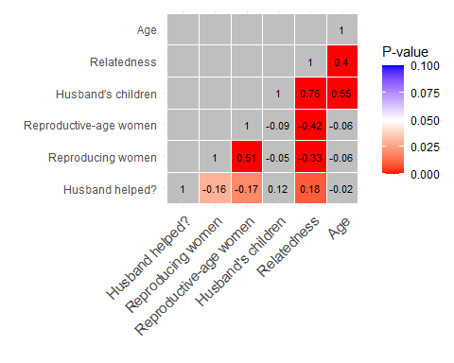

Figure 3
#data explore and fig 3
#wilcox test
wilcox.test(FarmVM1msb$BF~FarmVM1msb$PhelpedMe)
wilcox.test(FarmVM1msb$breedingF0712~FarmVM1msb$PhelpedMe)
wilcox.test(FarmVM1msb$pAvgR~FarmVM1msb$PhelpedMe)
wilcox.test(FarmVM1msb$BFPartner~FarmVM1msb$PhelpedMe)
#fig 3
# breeding female (not reproductive-age women)
opar <- par(no.readonly=TRUE)
par(mfrow=c(1,3))
boxplot (FarmVM1msb$BF ~ FarmVM1msb$PhelpedMe, title= "",
#ylim = c(0, 8),
ylab = "Reproductive-age women in my household",
xlab = "Husband helped my household")
boxplot (FarmVM1msb$breedingF0712 ~ FarmVM1msb$PhelpedMe,
#ylim = c(0, 5),
ylab = "Breeding females in my household",
xlab = "Husband helped my household")
boxplot (FarmVM1msb$pAvgR ~ FarmVM1msb$PhelpedMe,
#ylim = c(0, 0.5),
ylab = "Average relatedness of spouse to my household",
xlab = "Husband helped my household")
par(opar)
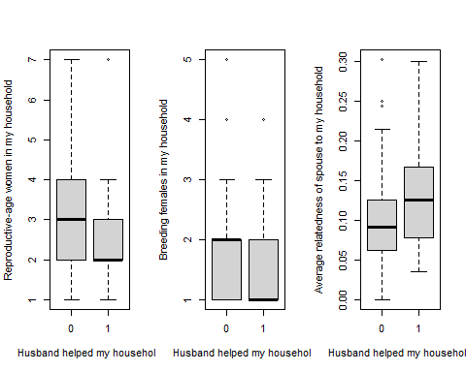

GEE models and Figures 4-5
####men help wife's household
###GEE
Farmgee.sig<-geeglm (PhelpedMe ~breedingF0712#reproducing women
,id=HH,
family="binomial",
data =subset(FarmVM1msb), #only reproducing women (with dependant) included
corstr="exchangeable", scale.fix=T)
summary (Farmgee.sig)
exp(coef(Farmgee.sig, full=T))
Farmgee.sigraw<-geeglm (PhelpedMe ~BF #reproducitve-age women
,id=HH,
family="binomial",
data = subset(FarmVM1msb), #only reproducing women (with dependant) included
corstr="exchangeable", scale.fix=T)
summary (Farmgee.sigraw)
exp(coef(Farmgee.sigraw, full=T))
####fig 4
############################################################################
## Function to calculate 95% CIs for GEE models
## adapted from: https://danieljhocking.wordpress.com/2012/07/25/plotting-95-confidence-bands-in-r/ (see Thomas et al. 2016)
##
m.terms = terms(Farmgee.sig)
predict_gee = function(m, m.terms, new.data)
{
mm.geeEX = model.matrix(m.terms, new.data) # use the full model to create the design matrix, since can't run terms() on an averaged model
new.data$PhelpedMe = mm.geeEX %*% coef(m)
tvar1.gee = diag(mm.geeEX %*% tcrossprod(aod::vcov(m), mm.geeEX))
new.data = data.frame(
new.data
, tlo = new.data$PhelpedMe - 2*sqrt(tvar1.gee)
, thi = new.data$PhelpedMe + 2*sqrt(tvar1.gee)
)
# keep log odds
# new.data$PhelpedMe_logodds = new.data$PhelpedMe
# new.data$tlo_logodds = new.data$tlo
# new.data$thi_logodds = new.data$thi
# transform log odds to probabilities
new.data$PhelpedMe = as.numeric(plogis(new.data$PhelpedMe))
new.data$tlo = plogis(new.data$tlo)
new.data$thi = plogis(new.data$thi)
return(new.data)
}
##
## to make the plots look pretty
##
plot_style = theme_bw() +
#eliminates baground, gridlines, and chart border
theme(
plot.background = element_blank()
,panel.grid.major = element_blank()
,panel.grid.minor = element_blank()
,panel.background = element_blank()
,axis.text=element_text(size=12)
,axis.title=element_text(size=12)
) +
theme(legend.position="bottom", legend.title=element_blank()) # legends at the bottom, with no titles
## reproducing women
##
library(aod)
new.data = expand.grid(breedingF0712=seq(from=1, to=5, length.out = 5),
breedingF0712.c = c(0, mean(FarmVM1msb$breedingF0712), max(FarmVM1msb$breedingF0712)),
# set these predictors to their means
PhelpedMe=0)
new.data = predict_gee(Farmgee.sig, m.terms, new.data)
new.data$breedingF0712.c = factor(new.data$breedingF0712.c)
levels(new.data$breedingF0712.c) = c("None", "Mean", "Five")
plt.breedingf = new.data %>%
#filter(Ego.VillageID==1) %>%
ggplot(aes(x=as.factor(breedingF0712), y=PhelpedMe)) +
geom_point(size=2) +
geom_errorbar(aes(ymax=thi, ymin=tlo), width=.2, size=.3) +
xlab("Number of reproducing women per household") +
ylab("Probability of farm help") +
ylim(0,0.55)+
plot_style
plt.breedingf
###reproductive-age women
############################################################################
## Function to calculate 95% CIs for GEE models
## adapted from: https://danieljhocking.wordpress.com/2012/07/25/plotting-95-confidence-bands-in-r/
##
m.terms1 = terms(Farmgee.sigraw)
predict_gee = function(m1, m.terms1, new.data1)
{
mm.geeEX1 = model.matrix(m.terms1, new.data1) # use the full model to create the design matrix, since can't run terms() on an averaged model
new.data1$PhelpedMe = mm.geeEX1 %*% coef(m1)
tvar1.gee1 = diag(mm.geeEX1 %*% tcrossprod(aod::vcov(m1), mm.geeEX1))
new.data1 = data.frame(
new.data1
, tlo = new.data1$PhelpedMe - 2*sqrt(tvar1.gee1)
, thi = new.data1$PhelpedMe + 2*sqrt(tvar1.gee1)
)
new.data1$PhelpedMe = as.numeric(plogis(new.data1$PhelpedMe))
new.data1$tlo = plogis(new.data1$tlo)
new.data1$thi = plogis(new.data1$thi)
return(new.data1)
}
new.data1 = expand.grid(BF=seq(from=1, to=7, length.out = 7),
BF.c = c(0, mean(FarmVM1msb$BF), max(FarmVM1msb$BF)),
# set these predictors to their means
PhelpedMe=0)
# set response to zero for now
new.data1 = predict_gee(Farmgee.sigraw, m.terms1, new.data1)
plt.RAW = new.data1 %>%
ggplot(aes(x=as.factor(BF), y=PhelpedMe)) +
geom_point(size=2) +
geom_errorbar(aes(ymax=thi, ymin=tlo), width=.2, size=.3) +
xlab("Number of reproductive-age women per household") +
ylab("") +
ylim(0,0.55)+
plot_style
plt.RAW
##
## Save the plots
##
# first give them titles
plt.breedingf = plt.breedingf + ggtitle("A")
plt.RAW = plt.RAW + ggtitle("B")
png(filename = file.path( "fig 4.png"), height=10, width=22.5, units = "cm", res=300) #all women
grid.arrange(plt.breedingf, plt.RAW,
ncol=2, nrow=1)
dev.off()
pdf(file = file.path( "fig 4.pdf"), height=4, width=9) #all women
grid.arrange(plt.breedingf, plt.RAW,
ncol=2, nrow=1)
dev.off()
#########################################################################################
#men help natal
duomosuo0_ownerH<-read.table("C:/Users/heqq/Documents/duomosuo0_ownerH.csv",sep = ",",header = TRUE)
###GEE
Farm_DML3.11 <- geeglm (AsOwner ~ Age+
RAW
,id=MC.H2012,
family="binomial", corstr="exchangeable", scale.fix=T,
data = subset(duomosuo0_ownerH, !is.na(RAW)))
summary (Farm_DML3.11)
exp(coef(Farm_DML3.11, full=T))
Farm_DML4.11 <- geeglm (AsOwner ~ Age+
BW
,id=MC.H2012,
family="binomial", corstr="exchangeable", scale.fix=T,
data = subset(duomosuo0_ownerH, !is.na(BW)))
summary (Farm_DML4.11)
exp(coef(Farm_DML4.11, full=T))
##fig 5
############################################################################
## Function to calculate 95% CIs for GEE models
## adapted from: https://danieljhocking.wordpress.com/2012/07/25/plotting-95-confidence-bands-in-r/
##
m.terms = terms(Farm_DML4.11)
predict_gee = function(m, m.terms, new.data)
{
mm.geeEX = model.matrix(m.terms, new.data) # use the full model to create the design matrix, since can't run terms() on an averaged model
new.data$AsOwner = mm.geeEX %*% coef(m)
tvar1.gee = diag(mm.geeEX %*% tcrossprod(aod::vcov(m), mm.geeEX))
new.data = data.frame(
new.data
, tlo = new.data$AsOwner - 2*sqrt(tvar1.gee)
, thi = new.data$AsOwner + 2*sqrt(tvar1.gee)
)
new.data$AsOwner = as.numeric(plogis(new.data$AsOwner))
new.data$tlo = plogis(new.data$tlo)
new.data$thi = plogis(new.data$thi)
return(new.data)
}
##
## to make the plots look pretty
##
plot_style = theme_bw() +
#eliminates baground, gridlines, and chart border
theme(
plot.background = element_blank()
,panel.grid.major = element_blank()
,panel.grid.minor = element_blank()
,panel.background = element_blank()
,axis.text=element_text(size=12)
,axis.title=element_text(size=12)
) +
theme(legend.position="bottom", legend.title=element_blank()) # legends at the bottom, with no titles
## reproducing women
##
library(aod)
new.data = expand.grid(BW=seq(from=0, to=4, length.out = 5),
BW.c = c(0, mean(duomosuo0_ownerH$BW), max(duomosuo0_ownerH$BW)),
# set these predictors to their means
Age =mean(duomosuo0_ownerH$Age),
# set response to zero for now
AsOwner=0)
new.data = predict_gee(Farm_DML4.11, m.terms, new.data)
#new.data$BW.c = factor(new.data$BW.c)
#levels(new.data$BW.c) = c("None", "Mean", "Five")
plt.breedingf1 = new.data %>%
#filter(Ego.VillageID==1) %>%
ggplot(aes(x=as.factor(BW), y=AsOwner)) +
geom_point(size=2) +
geom_errorbar(aes(ymax=thi, ymin=tlo), width=.2, size=.3) +
xlab("Number of reproducing women per household") +
ylab("Probability of farm help") +
ylim(0,0.8)+
plot_style
plt.breedingf1
###reproductive-age women
############################################################################
## Function to calculate 95% CIs for GEE models
## adapted from: https://danieljhocking.wordpress.com/2012/07/25/plotting-95-confidence-bands-in-r/
##
m.terms1 = terms(Farm_DML3.11)
predict_gee = function(m1, m.terms1, new.data1)
{
mm.geeEX1 = model.matrix(m.terms1, new.data1) # use the full model to create the design matrix, since can't run terms() on an averaged model
new.data1$AsOwner = mm.geeEX1 %*% coef(m1)
tvar1.gee1 = diag(mm.geeEX1 %*% tcrossprod(aod::vcov(m1), mm.geeEX1))
new.data1 = data.frame(
new.data1
, tlo = new.data1$AsOwner - 2*sqrt(tvar1.gee1)
, thi = new.data1$AsOwner + 2*sqrt(tvar1.gee1)
)
new.data1$AsOwner = as.numeric(plogis(new.data1$AsOwner))
new.data1$tlo = plogis(new.data1$tlo)
new.data1$thi = plogis(new.data1$thi)
return(new.data1)
}
library(aod)
new.data1 = expand.grid(RAW=seq(from=0, to=9, length.out = 10),
RAW.c = c(0, mean(duomosuo0_ownerH$RAW), max(duomosuo0_ownerH$RAW)),
# set these predictors to their means
Age =mean(duomosuo0_ownerH$Age),
# set response to zero for now
AsOwner=0)
new.data1 = predict_gee(Farm_DML3.11, m.terms1, new.data1)
plt.RAW1 = new.data1 %>%
ggplot(aes(x=as.factor(RAW), y=AsOwner)) +
geom_point(size=2) +
geom_errorbar(aes(ymax=thi, ymin=tlo), width=.2, size=.3) +
xlab("Number of reproductive-age women per household") +
ylab("") +
ylim(0,0.8)+
plot_style
plt.RAW1
##
## Save the plots
##
# first give them titles
plt.breedingf1 = plt.breedingf1 + ggtitle("A")
plt.RAW1 = plt.RAW1 + ggtitle("B")
png(filename = file.path( "fig 5.png"), height=10, width=22.5, units = "cm", res=300)
grid.arrange(plt.breedingf1, plt.RAW1,
ncol=2, nrow=1)
dev.off()
pdf(file = file.path( "fig 5.pdf"), height=4, width=9)
grid.arrange(plt.breedingf1, plt.RAW1,
ncol=2, nrow=1)
dev.off()

Figure 4
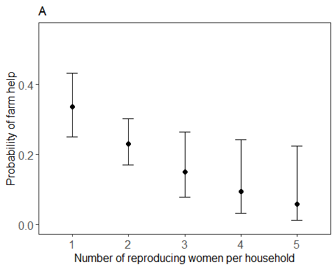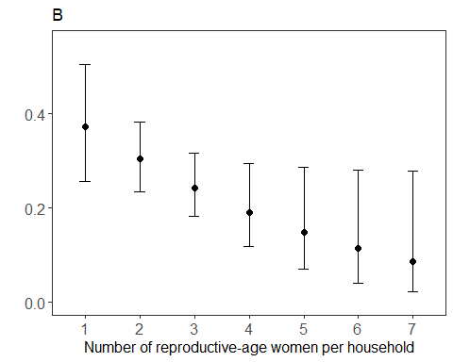

Figure 5
