Supplementary Materials for
Deep ancestry of collapsing networks of nomadic hunter-gatherers in Borneo
J. Stephen Lansing∗, Guy S. Jacobs∗, Sean S. Downey, Peter K. Norquest, Murray P. Cox, Steven L. Kuhn, John H. Miller, Herawati Sudoyo, John H. Miller,
Safarina G. Malik, Pradiptajati Kusuma∗†

∗These authors contributed equally to this work
†Corresponding author. Email: pradiptajati.kusuma@gmail.com

This PDF includes:

Supplementary Text Supplementary Figs. S1 to S7 Supplementary Tables S1 to S5
Linguistic data (Swadesh wordlists) are available at Figshare: (https://figshare.com/s/e6107567f0ef4a42bf27)

Supplementary Text

Supplementary Methods and Results on Linguistics

Note: The language data used in this analysis is available in Figshare: https://doi.org/10.6084/m9.figshare.12466001

When examining the two Basa Latala word lists, it is clear that the same form has been elicited, but with morphological differences. For example, the word for ‘to say’ was given as [luwai] in the first ses- sion, but as [paluwai] in the second – in this case, a verbal prefix [pa-] was included as part of the latter form (compare, for example, ‘to rub’ [parerit] and ‘to float’ [paliho] which also include this prefix). In other cases, there is variation in a single segment. The words for ‘child’, for example, were elicited as [majaN] and [bajaN], respectively. This is very likely the same form which is pronounced slightly differently by the two different consultants; in other cases, the difference may result from a transcription error, where certain phonemes are very similar to each other in terms of perception. A good example of this is the word for ‘to know’, which in the first session was recorded as [lakopan], and in the second as [parakopan] (also with the verbal prefix [pa-]), where the phonemes [l] and [r] are difficult to distinguish from each other perceptually. While there may be some question about the fact that there is only 70% agreement between the items elicited in the two sessions, this is actually not abnormal in this kind of situation where there may be more than one word which is used to express a particular concept. Slaska
[1] reports the following in a study in which English was used as the prompt language and Swadesh list data were collected from bilingual French and Polish speakers:

In fact, out of the total 207 meanings, there were only 64 in French, and 48 in Polish, for which all the speakers agreed on the word which they provided [...] In both the French and the Polish studies, around a quarter of the meanings yielded 5 or more different lexemes: the exact figures are 46/207 (22%) for French, and 59/207 (29%) for Polish. Furthermore, it is noteworthy that there were 15 meanings for which fewer than half of the French sample (i.e. fewer than 20 speakers) agreed on any one particular lexeme; for Polish, the number of such meanings reached 21. [1]

During our sessions, there were also a few cases where one lexical item was offered for more than one semantically-related prompt. For example, in the first session [pasa gata] is used for both ’all’ and ’you (pl)’; in another case, [pali kaban] was given for ’many’ in the first session, but was given for ’we’ in the second session. This kind of variation is normal for a natural language (and probably more so for a song language which is not used in everyday communication and is used in a more restricted context), and explains some of the discrepancies between the lists generated by our two elicitation sessions.

Supplementary Figures

- 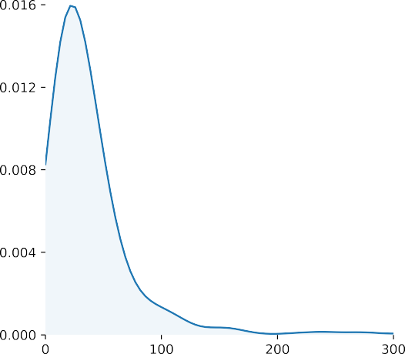B.
Movements < 250m Movements 250m
600

500
Total consecutive nights

400
300
200

100

2000 4000 6000 8000 10000 12000 14000
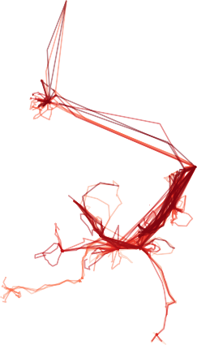Distance travelled (m)
D.
300
15
0
0
0.2 0 5 10
Distance (km)
0
Count
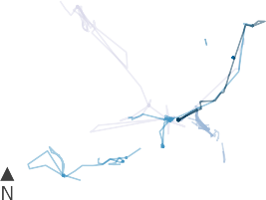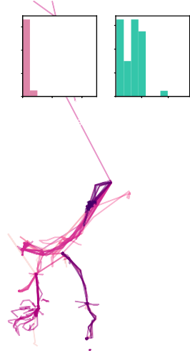
C.
E.

Fig. S1. Mobility analysis based on GPS readings. A) Distribution of GPS location errors, based on the difference between simultaneous (<1min time difference) GPS readings from two devices carried by the same individual. B) Distribution of distances between consecutive night-time GPS locations, based on 713 consecutive nights from the 25 individuals included in the March and/or June 2019 data collections. GPS tracks recorded over three four-week periods, from C) October 2018 (5 individuals),
D) March 2019 (15 individuals) and E) June 2019 (17 individuals). Long straight lines are journeys by motorised canoe, or, for one data point leading to the north in June 2019, by road. A total of 27 individuals were included in this analysis, contributing 37 tracks. The distribution of distances between camp locations on consecutive nights is shown as an inset in (D) and (E) (left, moves <250m; right,
moves ≥250m).

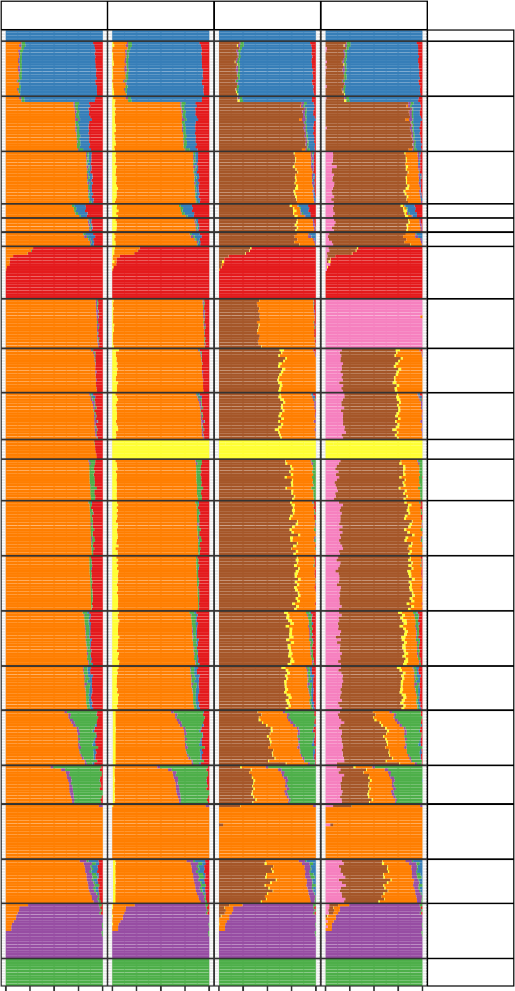
5
6
7
8
Mbuti

Brahmin
EastIndian
Vietnamese

Cambodian Dai Han

Jehai
Mentawai
Murut
Dusun
PunanBatu Lebbo
Samihim
Maanyan
Ngaju
Banjar
BajauKDR
NMaluku
Kankanaey
Filipino
Aeta

PNGHigh

Fig. S2. Admixture plot from K=5 to K=8. The "Punan Batu component" in the admixture plot first appears at K=7.

0.6
Murut
2.48
2.13

3.04
2.46
Dusun

5.59
3.68
PunanBatu

2.88
2.41
Lebbo

0.4

0.2

0.0
Density

0.6
Samihim
2.56
2.15
Maanyan
2.88
2.35
Ngaju
2.16
1.85
Banjar
2
1.73

0.4

0.2

0.0

0.0

2.5

5.0

7.5

10.00.0

2.5

5.0

7.5

10.00.0

2.5

5.0

7.5

10.00.0

2.5

5.0

7.5

10.0

IBD length (cM)

Fig. S3. Individual IBD chunk length distributions of Borneo populations. The mean (blue) and median (red) chunk length indicated.

800

600

400
MB

200

0

Fig. S4. Total runs of homozygosity (ROH) in the Punan Batu and comparison populations. ROH is highest among the Punan Batu, but also elevated for other traditional hunter-gatherers (Jehai, Aeta) relative to agriculturalist groups.

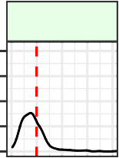0.100
Murut
24.78
Dusun
PunanBatu
Lebbo
Samihim
Maanyan
Ngaju
0.075
Dusun
0.050
0.025
0.000
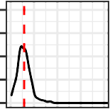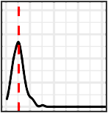0.100
14.46
13.3
1
PunanBatu
0.075
0.050
0.025
0.000
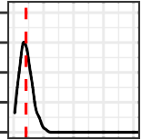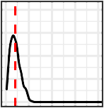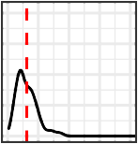0.100
10.37
10.3
1
15.5
5
0.075
Lebbo
0.050
0.025
0.000
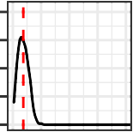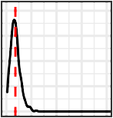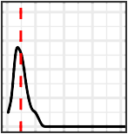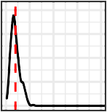0.100
9.23
7
9.0
12.0
3
9
9.9
Samihim
density
0.075
0.050
0.025
0.000
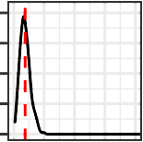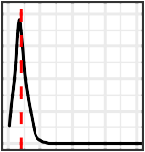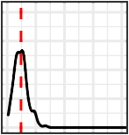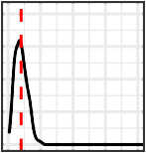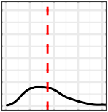0.100
9.27
10
12.0
5
10.0
1
43.2
2
Maanyan
0.075
0.050
0.025
0.000
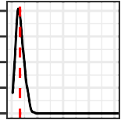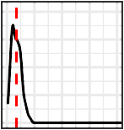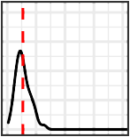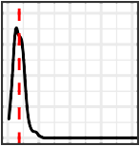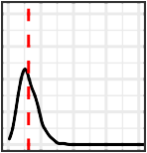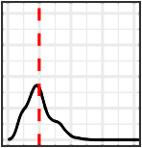0.100
8.1
6
8.6
13.6
1
8
9.1
15.6
3
24.8
1
0.075
Ngaju
0.050
0.025
0.000
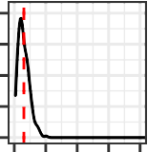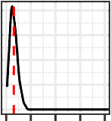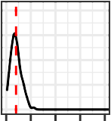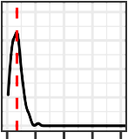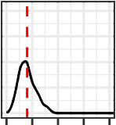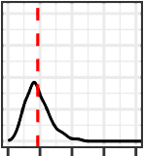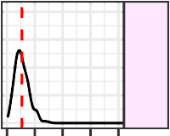0.100
7.6
2
7.7
9
9.9
2
8.6
20.1
1
23.2
3
13.45
0.075
Banjar
0.050
0.025
0.000
0 2550751000 2550751000 2550751000 2550751000 2550751000 2550751000 255075100

Total inter−pop pairwise IBD length (cM)

Fig. S5. Identity By Descent (IBD) genetic sharing between individuals from different population pairs. The Punan Batu show limited IBD sharing with other populations from Borneo. (Green: Popula- tions located in Northeast Borneo; Magenta: Populations located in South/Southeast Borneo)

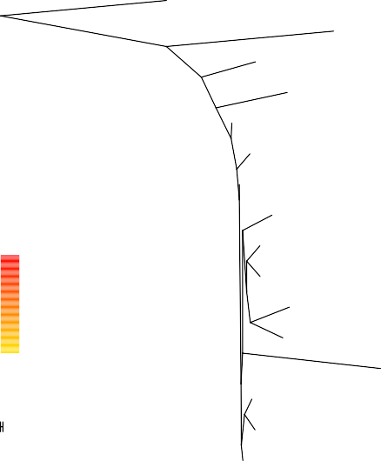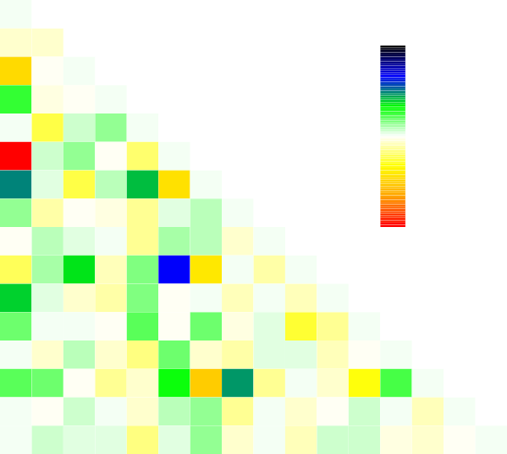A
MbutiPygmy
PNGHigh
Aeta

Jehai

Cambodian Han
Banjar

Lebbo
Migration
weight
0.5
Murut

Dusun
Kankanaey Mentawai
0
Samihim

Maanyan
10 s.e.
Ngaju
49.6 SE
−49.6 SE
Aeta

Banjar Cambodian
Dusun

Han Jehai
Kankanaey

Lebbo Maanyan
MbutiPygmy

Mentawai

Murut

Ngaju

PunanBatuSajau PNGHigh

0.00 0.02 0.04 0.06 0.08 0.10

PunanBatuSajau

Samihim
Aeta
Banjar
Cambodian
Dusun
Han
Jehai
Lebbo
Maanyan
MbutiPygmy
Mentawai
Murut
Ngaju
PNGHigh
Samihim

Drift parameter
Kankanaey
PunanBatuSajau

B

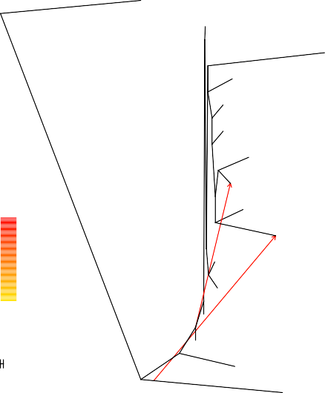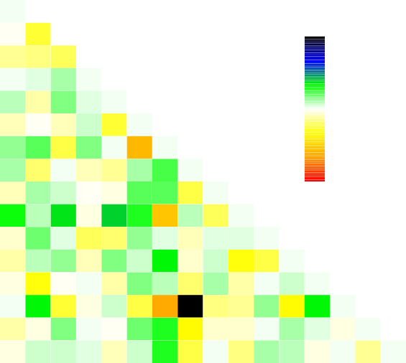Aeta
MbutiPygmy
Ngaju
Lebbo

Murut Dusun
Kankanaey

Han
Migration
weight
0.5
Mentawai

Aeta
Samihim Maanyan
0
Banjar

Cambodian

Jehai
10 s.e.
PNGHigh
18.1 SE
−18.1 SE

PunanBatuSajau

Banjar Cambodian

Dusun

Han Jehai
Kankanaey

Lebbo Maanyan
MbutiPygmy

Mentawai Murut
Ngaju

PNGHigh

PunanBatuSajau

Samihim
Aeta
Banjar
Cambodian
Dusun
Han
Jehai
Kankanaey
Lebbo
Maanyan
MbutiPygmy
Mentawai
Murut
Ngaju
PNGHigh
PunanBatuSajau
Samihim

0.00 0.02 0.04 0.06 0.08 0.10

Drift parameter

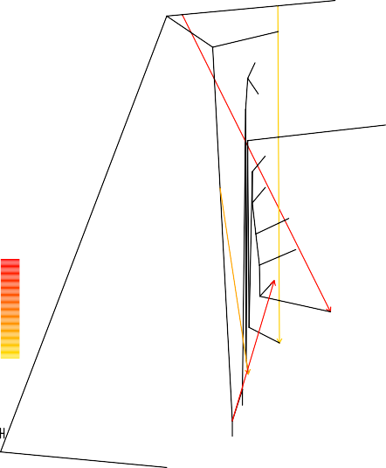
C
Jehai Samihim

PNGHigh

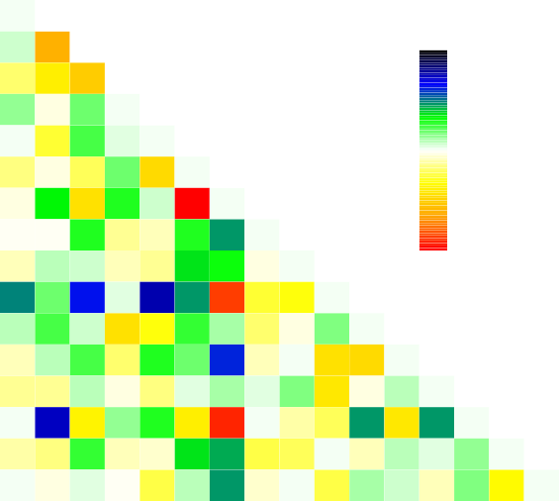Aeta Banjar Cambodian
10.1 SE
−10.1 SE

Maanyan Dusun

PunanBatuSajau

Han

Migration weight
0.5

Murut Dusun
Mentawai Kankanaey
Han

Jehai Kankanaey Lebbo Maanyan MbutiPygmy Mentawai

Aeta Murut

0
Ngaju

Lebbo

Ngaju PNGHigh

10 s.e.

MbutiPygmy
Banjar Cambodian
PunanBatuSajau

Samihim
Aeta
Banjar
Dusun
Han
Jehai
Lebbo
Murut
Ngaju

0.00 0.02 0.04 0.06 0.08 0.10
Cambodian
Kankanaey
Maanyan
MbutiPygmy
Mentawai
PNGHigh
PunanBatuSajau
Samihim
Drift parameter

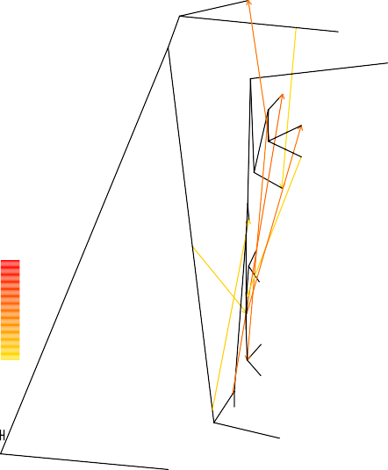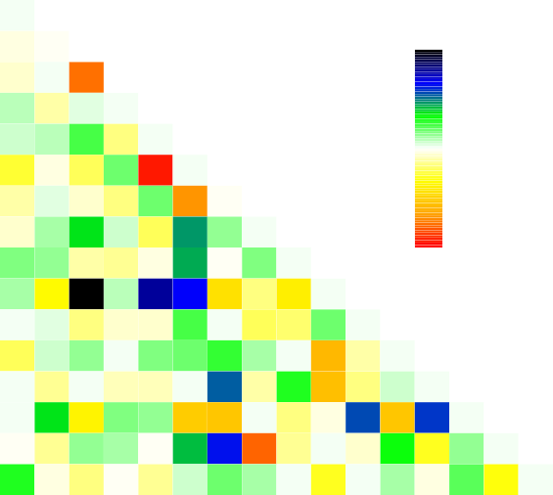D
Aeta
PNGHigh
Han

Mentawai Kankanaey
Lebbo
Ngaju
Migration
weight
Samihim
1
Maanyan

Banjar

Dusun
0
Murut

Cambodian

Jehai
10 s.e.
MbutiPygmy
7.6 SE
−7.6 SE
Aeta

PunanBatuSajau

Banjar Cambodian

Dusun

Han Jehai
Kankanaey

Lebbo Maanyan
MbutiPygmy

Mentawai Murut
Ngaju

PNGHigh PunanBatuSajau
Samihim
Aeta
Banjar
Dusun
Han
Jehai
Lebbo
Murut
Ngaju

0.00 0.02 0.04 0.06 0.08 0.10
Drift parameter
Cambodian
Kankanaey
Maanyan
MbutiPygmy
Mentawai
PNGHigh
PunanBatuSajau
Samihim

Fig. S6. Treemix analyses involving Punan Batu and other populations in ISEA and MSEA. The Punan Batu appears to outgroup the Kankanaey-Mentawai cluster, and do not receive admixture nodes from MSEA-related ancestry.

Axis 2
−0.3−0.2−0.1
0.0
0.1

- 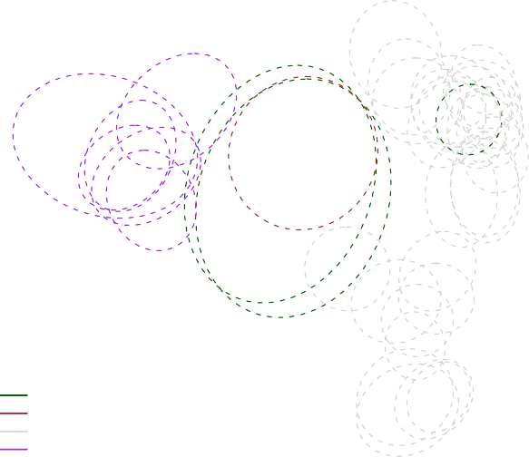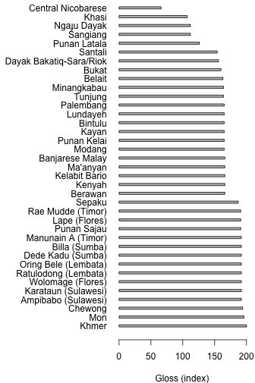Multidimensional scaling analysis 95% Confidence Ellipses
●
●
●
●
●
●
●
- ●Pu●nan Sajau
● ●
●
● ●
●
●
●
- Sangiang
●
●
- Latala #2
  - Latala #1
●
● ●
●
●
●
●
●
●

●
Latala
Sangiang Austronesian Austroasiatic
● ●
●
A.
0.2
0.3

−0.4−0.3−0.2−0.1 0.0 0.1 0.2

Axis 1

Fig. S7. Additional linguistic analyses. A) Data presence plot showing the total number of glosses for each language included in the linguistic analysis. B) Bootstrap analysis of Swadesh word lists. Language word lists are re-sampled by gloss with replacement and mean pairwise distances between languages are calculated (n=10,000). Classical multidimensional scaling and Procrustes rotation is used to estimate the primary axes of variation.

Supplementary Tables

Table S1. List of populations

Population | Region | No of Inds | Source
Mbuti | Africa | 4 | Li et al. 2008
Brahmin | India | 20 | Mörseburg et al. 2016
East Indian | India | 20 | Tätte et al. 2019
Japanese | East Asia | 5 | Li et al. 2008
Han | East Asia | 5 | Li et al. 2008
Vietnamese | Mainland Southeast Asia | 19 | Mörseburg et al. 2016
Cambodian | Mainland Southeast Asia | 5 | Li et al. 2008
Dai | Mainland Southeast Asia | 5 | Li et al. 2008
Jehai | Mainland Southeast Asia | 19 | Aghakhanian et al. 2015
Mentawai | West Island Southeast Asia | 18 | New Data
Murut | West Island Southeast Asia (Borneo) | 16 | Mörseburg et al. 2016
Dusun | West Island Southeast Asia (Borneo) | 17 | Mörseburg et al. 2016
Punan Batu | West Island Southeast Asia (Borneo) | 11 | New Data
Lebbo | West Island Southeast Asia (Borneo) | 15 | Mörseburg et al. 2016
Maanyan | West Island Southeast Asia (Borneo) | 20 | Kusuma et al. 2016
Samihim | West Island Southeast Asia (Borneo) | 20 | Kusuma et al. 2017
Ngaju | West Island Southeast Asia (Borneo) | 20 | Kusuma et al. 2016
Banjar | West Island Southeast Asia (Borneo) | 16 | Kusuma et al. 2016
BajauKDR | East Island Southeast Asia | 20 | Mörseburg et al. 2016
Bugis | East Island Southeast Asia | 20 | Kusuma et al. 2017
Mandar | East Island Southeast Asia | 20 | Kusuma et al. 2017
N. Maluku | East Island Southeast Asia | 14 | Kusuma et al. 2017
Sumba | East Island Southeast Asia | 20 | Cox et al. 2016
Kankanaey | Philippines | 20 | Mörseburg et al. 2016
Filipino | Philippines | 16 | Mörseburg et al. 2016
Aeta | Philippines | 20 | Migliano et al. 2013
Batak | Philippines | 20 | Migliano et al. 2013
Mappi | New Guinea | 5 | New Data
PNG Highland | New Guinea | 10 | Li et al. 2008

Table S2. Swadesh glosses used in linguistic analysis. (n=200)

I | thin | tail | to know | to tie | mountain
you (singular) | woman | feather | to think | to sew | red
he | man (adult male) | hair | to smell | to count | green
we | man (human being) | head | to fear | to say | yellow
you (plural) | child | ear | to sleep | to sing | white
they | wife | eye | to live | to play | black
this | husband | nose | to die | to float | night
that | mother | mouth | to kill | to flow | day
here | father | tooth | to fight | to freeze | year
there | animal | tongue (organ) | to hunt | to swell | warm
who | fish | fingernail | to hit | sun | cold
what | bird | foot | to cut | moon | full
where | dog | leg | to split | star | new
when | louse | knee | to stab | water | old
how | snake | hand | to scratch | rain | good
not | worm | wing | to dig | river | bad
all | tree | belly | to swim | lake | rotten
many | forest | guts | to fly | sea | dirty
some | stick | neck | to walk | salt | straight
few | fruit | back | to come | stone | round
ot her | seed | breast | to lie (as in a bed) | sand | sharp (as a knife)
one | leaf | heart | to sit | dust | dull (as a knife)
two | root | liver | to stand | earth | smooth
three | bark (of a tree) | to drink | to turn (intransitive) | cloud | wet
four | flower | to eat | to fall | fog | dry
five | grass | to bite | to give | sky | correct
big | rope | to suck | to hold | wind | near
long | skin | to spit | to squeeze | snow | far
wide | meat | to vomit | to rub | ice | right
thick | blood | to blow | to wash | smoke | left
heavy | bone | to breathe | to wipe | fire
small | fat (noun) | to laugh | to pull | ash
short | egg | to see | to push | to burn
narrow | horn | to hear | to throw | road

Table S3. Manual cognate count.

 | Austronesian | Austroasiatic | Sangiang | Basa Latala
Austronesian | -
Austroasiatic | 0 | -
Sangiang | 6 | 0 | -
Basa Latala | 3 | 0 | 0 | -

Supplementary Diet Information

Dietary information for 15 Punan Batu individuals (self-reported regularity of major consumed foods) was recorded by staff of the Eijkman Institute for Molecular Biology during a medical clinic at the Datuk’s trading post on the Sajau River in October 2018.

Frequency | Rice traded | Rice grown | Wild tubers | Wild meat
Daily | 0.93 | 0 | 0.53 | 0.8
Weekly | 0.07 | 0 | 0.33 | 0.13
Infrequently | 0 | 0 | 0.13 | 0
Unknown frequency | 0 | 0 | 0 | 0.07

Table S 4: Punan Batu self-reported regularity of major consumed foods. Daily indicates that a food is consumed at least once a day; weekly indicates that a food is consumed less than once a day but more than once a week; infrequently indicates that a food is consumed less than once a week; consumed indicates that the frequency of consumption was not reported by the interviewee.

Frequency | Rice traded | Rice grown | Wild tubers | Wild meat
Punan Batu | 0.93 | 0 | 0.53 | 0.8
Punan Tubu (Close) | 0.07 | 0.98 | 0 | 0.63
Punan Tubu (Remote) | 0 | 1 | 0 | 0.49

Table S 5: Daily consumption of different foods among the Punan Batu and Punan Tubu communities living near town and remotely. We compare information on rice sources and wild tuber sources with the broader category ‘starchy goods’ reported in Reyes-Garcia et al 2019, which includes both of these foods. Frequency of consumption at least once a day reported in each case; Punan Tubu totals calculated based on frequency * source (Tables 3 and 4 of Reyes-Garcia et al 2019)[2].

References

- N. Slaska, Transactions of the Philological Society 103, 221 (2005).

- V. Reyes-Garcia, et al., Food Security 11, 109 (2019).

