Table S1: Kendall’s correlations between ill-being, well-being, sociosexuality, mate value, and intrasexual competition
 |  | SOI desire | SOI behavior | SOI attitude | SOI total | Depression | Happiness | Life satisfaction | Intrasexual competition | Mate value
Age | τ | -.044 | .126 | .006 | .025 | -.128 | .077 | .054 | -.054 | .029
 | p | .071 | ≤.001 | .794 | .282 | ≤.001 | ≤.001 | .010 | .027 | .214
SOI desire | τ | - | .285 | .359 | .555 | .199 | -.114 | -.072 | .167 | .015
 | p | - | ≤.001 | ≤.001 | ≤.001 | ≤.001 | ≤.001 | .003 | ≤.001 | .534
SOI behavior | τ |  | - | .380 | .547 | .005 | -.029 | -.030 | .060 | .079
 | p |  | - | ≤.001 | ≤.001 | .852 | .243 | .213 | .015 | .001
SOI attitude | τ |  |  | - | .742 | .021 | -.039 | -.033 | .026 | .027
 | p |  |  | - | ≤.001 | .389 | .106 | .165 | .291 | .270
Global SOI | τ |  |  |  | - | .053 | -.069 | -.053 | .093 | .039
 | p |  |  |  | - | .028 | .003 | .025 | ≤.001 | .106
Depression | τ |  |  |  |  | - | -.466 | -.367 | .135 | -.243
 | p |  |  |  |  | - | ≤.001 | ≤.001 | ≤.001 | ≤.001
Happiness | τ |  |  |  |  |  | - | .425 | -.123 | .306
 | p |  |  |  |  |  | - | ≤.001 | ≤.001 | ≤.001
Life satisfaction | τ |  |  |  |  |  |  | - | -.050 | .255
 | p |  |  |  |  |  |  | - | .037 | ≤.001
Intrasexual competition | τ |  |  |  |  |  |  |  | - | -.046
 | p |  |  |  |  |  |  |  | - | .055
Note: statistically significant values in bold (p ≤ .05)

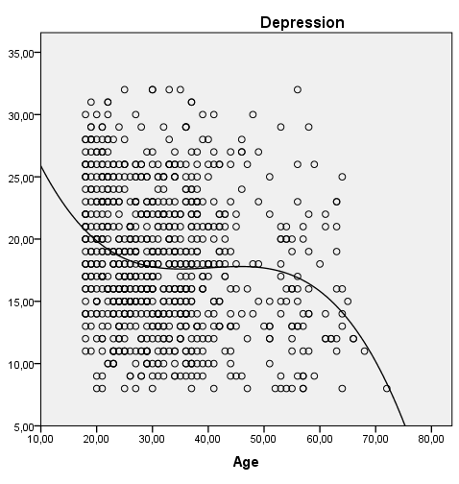
Figure S1: Graphic of the best curve estimation between age and depression
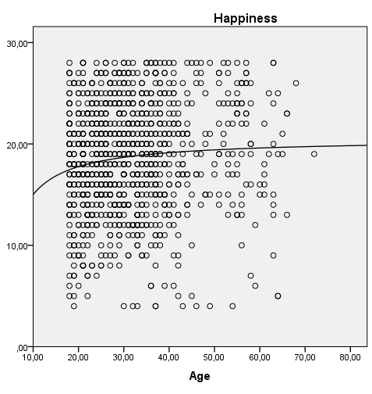

Figure S2: Graphic of the best curve estimation between age and happiness
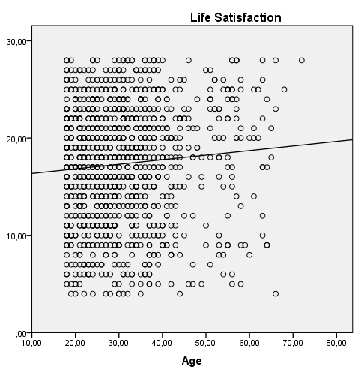

Figure S3: Graphic of the best curve estimation between age and life satisfaction

