- Online Appendix
5.1 Further details on interventions

5.1.1 Project introduction
The Operations Director of the centre introduced the project to employees in a centre-wide “town hall” meeting. The following information was presented in a slide that was part of the “COVID-19 planning” section:
- We are conscious of the physical mental health effects of Covid-19 as well as people’s changing expectations of applied measures.
- We have been getting advice from colleagues in behavioural economics (UoB) [University of Birmingham] who specialise in how we balance different risks, some of which relate to our health.
- They are working on some ideas as to how we can help you remain healthy through sustaining the right behaviours as circumstances evolve. – In this way we hope to use their expertise to develop best practice in staying Covid-safe.

5.1.2 Questionnaires
The incentivised social norms questions in the initial questionnaire asked participants to rate the moral appropriateness of different actions on a six-point scale from ”Very morally appropriate” to ”Very morally inappropriate”. The actions were:
- A colleague does not keep a distance of 2 metres from other co-workers regularly.
- A colleague ignores the one-way system to get from one place to another regularly.
- A colleague does not use hand sanitisers regularly when entering the building or before lunch breaks.
- A colleague ignores the social distance guidelines around toilet breaks.
- A group of colleagues congregates for their lunch break in a common area.
- A colleague does not clean up workspaces and common areas appropriately after use.
- A colleague takes the shortcut between the wax injection and the furnace hall exit after making sure that there is no one else around.
- A colleague takes the shortcut between the wax injection and the furnace hall exit making sure to stay away from others as much as possible.
We introduced the incentive system by telling them that “in this part of the survey you have the chance to win a shopping voucher worth £20”. Then, we gave more details: “After the study, we will randomly select one of the actions we describe to you. For this situation, we will find out which response was selected by the most people answering the survey. If you give the same response as that most frequently given by other people, then you will enter the prize draw. Among all people in the prize draw we will pick three random winners who can win a shopping voucher worth £20.”

The non-incentivised social norms elicitation questions were as follows. First, we elicited how reasonable it would be to break the guidelines under three situations:
- it means it takes an extra five minutes to walk to the coffee area?
- it means it takes 20 percent longer to finish work-related tasks?
- it means not taking the shortest route to an emergency exit during an emergency?
Second, we asked them to rate the following items as in the incentivised case according to: ”how important do you personally think they are” on a five point scale from ”Not at all important” to ”Extremely important”.
- Always keeping a distance of 2 metres from co-workers.
- Using the one-way / priority system to get from one place to another.
- Using hand sanitisers regularly.
- Following your workplace COVID guidelines during toilet breaks.
- Keeping distance during lunch breaks.
- Cleaning up workspaces and common areas after using them.
In the pledge intervention, all employees received an email invitation to “follow your personalised link to sign our pledge to comply with the COVID19 guidance at the HTRC”. The pledge document gave a very brief outline of the three most important guidelines to prevent COVID at the organisation. Additional text indicated that ”by signing this form, I promise that I will follow all the above measures at all times”.
The messenger intervention involved participants being invited to enter a competition to design the best illustration of the phrase ”Protecting everyone”. They could submit their entry by email to the research team. They were informed that the best entry would win a £50 shopping voucher. The winning entry consisted of a collage of photographs of childrens’ stuffed toys wearing facemasks.

5.1.3 Email communications
Recruitment email for pledge intervention
Please follow your personalised link to sign our pledge to comply with the COVID-19 guidance at HTRC. This activity earns points towards the charitable donation, boosts your own chances of getting to decide which charity receives the money, and should only take a couple of minutes.
Best wishes,
The research team

Pledge form
NB: The form had the logos of the University of Birmingham and the HTRC on the header.
PLEDGE FORM FOR COMPLIANCE WITH COVID-19 GUIDELINES AT WORK
To protect our staff, associates, contractors and visitors from the risks of exposure to and onwards transmission of COVID-19, a number of control measures have been implemented in the Centre.
These measures include:
- Keep to the one-way system: We have implemented a one-way/priority system throughout the site.
- Maintain social distancing: Keep a minimum of 2m gap between you and your colleagues, except where there is a mitigation because it is for a very short time, i.e. if you are passing behind or to the side of someone.
- Hygiene: Wash your hands frequently and do not touch eyes, nose or mouth unless you are sure they are clean. Cough into tissues and dispose of them in bins.
By signing this form, I promise that I will follow all the above measures at all times.
Date at the time of signing appeared here.
“Sign here” signature box appeared here.

Recruitment email for messenger intervention
Hello,
As part of our efforts to help you comply with the COVID-19 guidelines at HTRC, we are running a picture contest. We would like you to illustrate this message: “Protecting Everyone”.

The best illustration will win a shopping voucher worth £50.
The winning entry will be featured prominently around the HTRC and will be circulated by email. The remaining entries will also be on display.
As well as the £50 prize for the winning entry, every submission will earn money for the charitable donation, and will improve your personal chance of choosing the charity to receive the money.

In the first questionnaire, you told us what you would say if you needed to convince someone to comply with the safety guidance. Your answers revealed that you care about keeping everyone at HTRC safe, and by doing so, reducing the risk of transmission to everybody else beyond the Centre. You feel that there are a lot of uncertainties surrounding COVID-19 but it is important to protect each other. The sentence that you’ll be illustrating (“Protecting Everyone”) is designed to capture the concerns you voiced. The theme of this contest, protecting everyone, encapsulates these thoughts.
Guidelines for entry

- Submit a PDF or an image file (A4 or larger). Your illustration could be a photo, a drawing, or any other visual format - get creative!
- You can enter individually and/or as part of a team. We’d be delighted if you got your friends and family involved.
- You can submit as many entries as you like.
- Email your entries to d.arroyoscalvera@bham.ac.uk. Please, include HTRC CONTEST as the subject line.
- Entries received up to noon on Thursday, 17th of September will be included in the competition.
Best wishes,
Danae Arroyos-Calvera (on behalf of the research team)
Lecturer in Economics
University of Birmingham

5.2 COVID-19 Pandemic Developments during Study Period
Figure 3 displays the evolution of several indicators of COVID severity during the study period. Panel 1 shows the relative stringency of government regulation (scale 0-100), which fluctuated only mildly during the twelve weeks of the study. Similarly, Panel 3 shows data for Google Search Trends for the term COVID-19 again indicating only relatively small swings in public interest in COVID-19. Looking at confirmed COVID cases both nationally (United Kingdom) and locally (West Midlands) shows that cases remained fairly stable for the first 9 weeks of the study period but then started to rise, roughly doubling, for the last week of the study period. The first day when we elicited the daily check-in questionnaires was the 27th of July 2020.

Fig. 3: COVID Severity Indicators during our Study
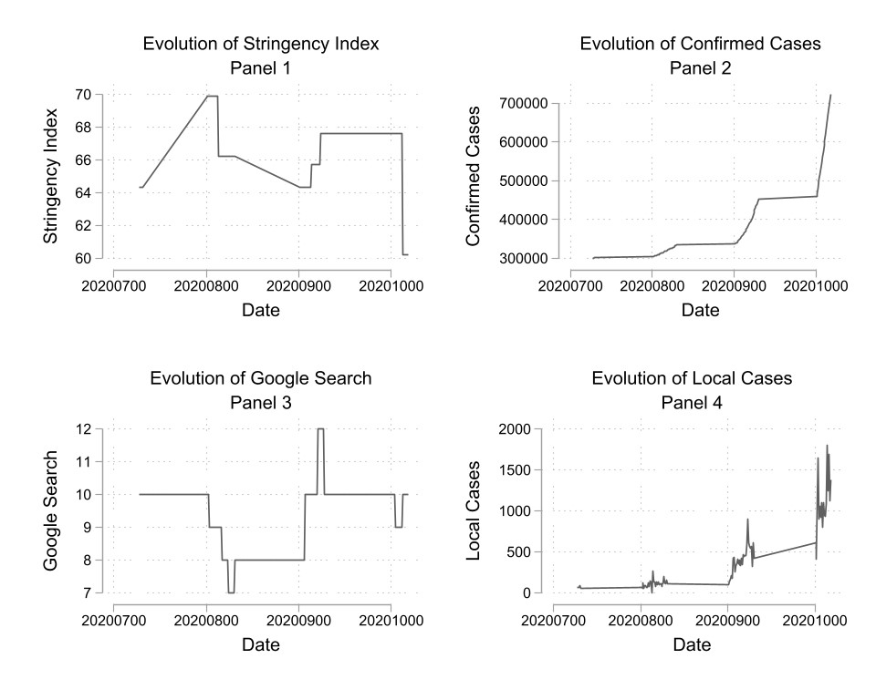
This figure displays the development of several COVID-19 Severity indicators during the study period. Data sources: Panel 1 (Hale et al., 2021); Panel 2 (Hale et al., 2021); Panel 3
Google Trends Search Term COVID 19; Panel 4 https://coronavirus.data.gov.uk/

5.3 Timeline
Fig. 4: Timeline of study
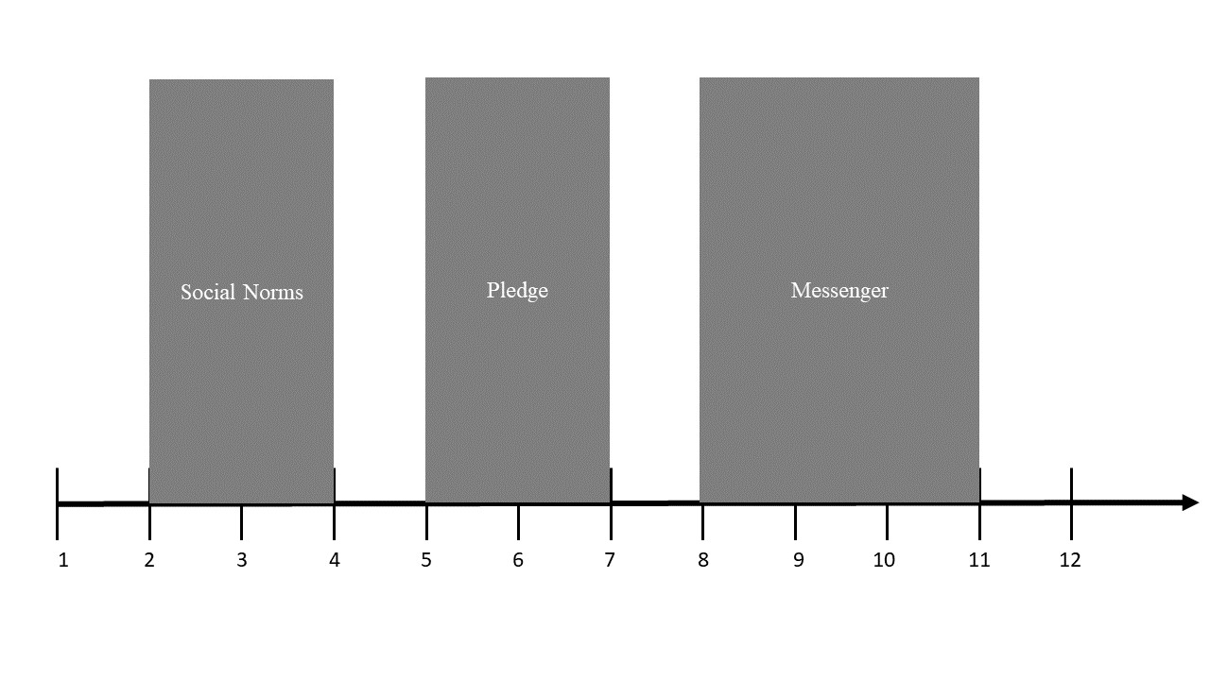
This figure displays the progression of the study. Shaded areas indicate the weeks in which interventions took place. The remaining weeks are fallow weeks.

5.4 Robustness to COVID-19 Pandemic Developments
Table 6: Effects of interventions
 | (1) | (2) | (3) | (4)
 | Own | Others | Own | Others
Norms Week 1 | 0.233∗∗ | 0.157 | 0.239∗∗ | 0.131
 | (2.46) | (1.61) | (2.45) | (1.32)
Norms Week 2 | 0.0681 | 0.182 | 0.0713 | 0.172
 | (0.66) | (1.28) | (0.68) | (1.18)
Pledge Week 1 | 0.167 | 0.132 | 0.143 | 0.109
 | (1.25) | (0.84) | (1.08) | (0.68)
Pledge Week 2 | -0.0844 | 0.119 | -0.101 | 0.0993
 | (-0.50) | (0.68) | (-0.59) | (0.56)
Messenger Week 1 | -0.313 | 0.0964 | -0.347 | 0.0754
 | (-1.28) | (0.61) | (-1.40) | (0.48)
Messenger Week 2 | -0.240 | 0.360∗∗ | -0.276 | 0.333∗∗
 | (-0.76) | (2.56) | (-0.87) | (2.37)
Messenger Week 3 | -0.389 | 0.150 | -0.433 | 0.112
 | (-1.20) | (0.74) | (-1.32) | (0.55)
Fallow Week 4 | 0.0794 | 0.0337 | 0.0750 | 0.0341
 | (0.61) | (0.21) | (0.56) | (0.21)
Fallow Week 7 | -0.111 | 0.263∗∗∗ | -0.129 | 0.244∗∗
 | (-0.83) | (2.69) | (-0.96) | (2.47)
Fallow Week 11 | -0.554 | 0.0832 | -0.670 | 0.0286
 | (-1.07) | (0.28) | (-1.28) | (0.10)
Fallow Week 12 | -0.837 | 0.0946 | -0.980 | 0.0491
 | (-1.36) | (0.23) | (-1.60) | (0.12)
Google COVID Trends | 0.0908∗ | -0.0314 | 0.0833 | -0.0355
 | (1.72) | (-0.67) | (1.61) | (-0.72)
Local COVID Cases | -0.000259∗ | -0.000235 | -0.000234 | -0.000243
 | (-1.65) | (-1.54) | (-1.46) | (-1.56)
Government Stringency | -0.00471 | -0.0113 | -0.00315 | -0.00777
 | (-0.27) | (-0.61) | (-0.18) | (-0.41)
National COVID Cases | 0.00000309 | 0.000000671 | 0.00000343 | 0.000000843
 | (1.40) | (0.47) | (1.52) | (0.59)
Constant | -1.519 | 0.680 | -1.012 | 1.240
 | (-0.77) | (0.43) | (-0.52) | (0.77)
Observations | 1047 | 1032 | 1047 | 1032
Adjusted R² | 0.0059 | 0.0143 | 0.5491 | 0.5365
Prob Chi2 | 0.0064 | 0.0723 | 0.001 | 0.001
t statistics in parentheses
∗ p < 0.10, ∗∗ p < 0.05, ∗∗∗ p < 0.01, ∗∗∗∗ p < 0.001
5.5 Hand sanitiser usage regression analysis
The following regression models use standardised hand sanitiser usage (in grams) as the dependent variable and compare it across interventions and fallow weeks.

Table 7: Effects On Interventions
 | (1) | (2) | (3) | (4)
 | DailyUse | DailyUse | DailyUse | DailyUse
Social Norms | 0.421 | 0.342 | 0.590 | 1.861*
 | (1.11) | (0.29) | (1.53) | (1.91)
Fallow Week 1 | 0.972∗ | 1.195 | 1.121∗∗ | 1.493
 | (2.03) | (0.39) | (2.26) | (0.46)
Pledge | 0.640 | 1.008 | 0.806 | 2.758
 | (1.21) | (0.72) | (1.43) | (1.70)
Fallow Week 2 | -0.261 | -3.754 | -0.303 | -2.431
 | (-0.36) | (-0.75) | (-0.40) | (-0.57)
Messenger | -0.460 | 1.100 | -0.600 | 2.759
 | (-0.52) | (0.85) | (-0.64) | (2.38)
Fallow Week 3 | -0.553 | -5.554 | -0.804 | -5.107
 | (-0.51) | (-1.52) | (-0.68) | (-1.40)
Day | 0.0457 | 0.00630 | 0.0608∗ | 0.481***
 | (1.45) | (0.03) | (1.76) | (2.92)
Norms  ∗Day |  | 0.0369 |  | -0.418∗∗
 |  | (0.15) |  | (-2.15)
Fallow1  ∗Day |  | 0.0147 |  | -0.347
 |  | (0.05) |  | (-1.17)
Pledge  ∗Day |  | 0.0137 |  | -0.453∗∗
 |  | (0.06) |  | (-2.37)
Fallow2  ∗Day |  | 0.187 |  | -0.272
 |  | (0.61) |  | (-1.09)
Messenger∗  Day |  | -0.0168 |  | -0.490∗∗∗
 |  | (-0.08) |  | (-2.91)
Fallow3  ∗Day |  | 0.167 |  | -0.275
 |  | (0.70) |  | (-1.43)
Lag of Daily Usage |  |  | -0.0963 | -0.147
 |  |  | (-1.15) | (-1.45)
Constant | -1.106∗∗∗ | -1.008 | -1.431
 | (-3.45) | (-1.24) | (-4.13) | (-5.16)
Observations | 41 | 41 | 40 | 40
R2 | 0.307 | 0.248 | 0.325 | 0.329
F | 3.483 | 2.902 | 3.521 | 4.248
t statistics in parentheses. Robust standard errors.
∗ p < 0.10, ∗∗ p < 0.05, ∗∗∗ p < 0.01, ∗∗∗∗ p < 0.001

