Contents
This Online Supplementary file contains a total of 4 Appendices

- Appendix A: Details on method for measuring loss aversion

- Appendix B: Additional results

- Appendix C: Robustness checks for selective drop-out

- Appendix D: Full transcript of experimental instructions

Appendix A: Method for measuring loss aversion
In the non-parametric method, estimating loss aversion requires a reference-point (denoted $RP$) which separates outcomes in the task into gains and losses. In this study the reference point was 0 euro, i.e., status quo, and outcomes were denoted as compared to this reference point (i.e., +€20 and €-20). Furthermore, the method requires specifying an amount $G.$The gauge outcome $G$ was set to €100. As can be seen in the demo task, the method was operationalised with 3 choice lists to elicit indifferences. Providing a full formal rationale for the method would be beyond the scope of this paper, but Table A1 gives an example.

 | General notation | Goal | Example
Indifference 1:  Mixed prospect | $G$_{0.5}$L$ ~ RP | Eliciting $L$ | $100$_{0.5}$-70$ ~ 0
Indifference 2:  Certainty equivalence – gains | $G$_{0.5}$r$ ~ $x_{1}^{+}$ | Eliciting $x_{1}^{+}$ | $100$_{0.5}$0$ $\sim 40$
Indifference 3:  Certainty equivalence - losses | $L$_{0.5}$r$ ~ $x_{1}^{-}$ | Eliciting $x_{1}^{-}$ | $-70$_{0.5}$0$ $\sim -20$
Köbberling and Wakker (2005) | $$λ=\frac{x_{1}^{+}}{-x_{1}^{-}}$$ | Loss aversion coefficient | $$λ=\frac{40}{-\left(-20\right)}=2$$
Table A1. Indifferences elicited in the non-parametric method, where $x_{0.5}y$ denotes a gamble yielding $x$ with probability 0.5 and $y$ otherwise and the example indifferences yield a loss aversion coefficient of $λ=2$.

Appendix B: Additional results
This Appendix contains a set of additional results, not presented in the main text, including:
- Kaplan-Meier survival curves for the experiment
- Mean sliders completed, stratified by conditions and incentive type
- Regression analyses controlling for demographics
- Regression analyses demonstrating the (lack of) effect of economic preferences on persistence and earning.

B1. Survival-analysis
As the figures presented closely represent survival analysis, additional Kaplan-Meier survival curves were estimated. A Mantel-Heanszel test indicated no significant difference between the two conditions (p=.20), which is also observable by the crossing lines in figure 6.
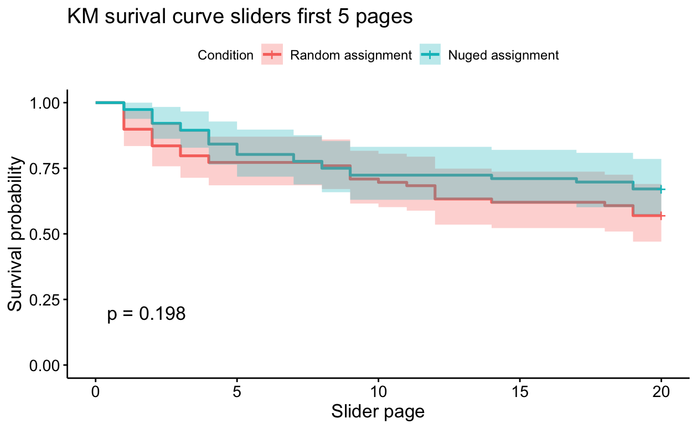
Figure B1: Kaplan-Meier survival curve
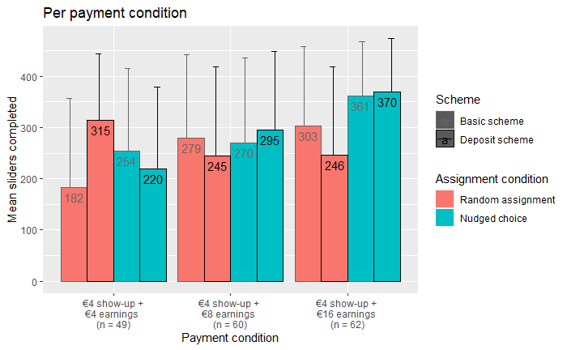
Figure B2 : Sliders completed per payment condition
 |  | Model 0 |  | Model 1 |  | Model 2 |  | Model 3 |  | Model 4 |  | Model 5
Sample |  | Both arms |  | Both arms |  | Only random |  | Only nudged |  | Only deposit-based |  | Only reward-based
Persistence |  | β | p-value | β | p-value | β | p-value | β | p-value | β | p-value | β | p-value
 | Intercept | 187.7 | .005 | 119.2 | .082 | 119.0 | .251 | 297.9 | .041 | 220.1 | .040 | 62.0 | .511
 | Nudged assignment |  |  | 37.7 | .213 |  |  |  |  | 53.7 | .198 | 32.2 | .314
 | Payment condition €12 |  |  | 41.7 | .160 | 48.3 | .278 | 31.1 | .465 | -15.7 | .796 | 54.4 | .163
 | Payment condition €20 |  |  | 86.1 | .004 | 63.0 | .156 | 114.0 | .008 | 10.6 | .853 | 117.9 | .002
 | Deposit scheme |  |  |  |  | 7.1 | .846 | 7.3 | .839
 | Gender (ref. male) | 52.2 | .031 | 56.6 | .018 | 72.9 | .039 | 30.0 | .364 | 39.6 | .305 | 63.3 | .047
 | Income | -6.3 | .225 | -5.3 | .319 | -7.6 | .293 | 1.6 | .859 | -4.0 | .641 | -4.4 | .584
 | Educational level | 6.2 | .543 | 5.1 | .614 | 3.3 | .817 | 0.6 | .969 | -0.1 | .994 | 10.5 | .478
Earnings | Intercept | 922.6 | .001 | 273.1 | .202 | 243.4 | .467 | 776.8 | .003 | 377.8 | .364 | 186.4 | .392
 | Nudged assignment |  |  | 156.3 | .042 |  |  |  |  | 283.5 | .086 | 67.6 | .359
 | Payment condition €12 |  |  | 282.2 | .003 | 312.5 | .032 | 306.5 | .008 | 217.1 | .364 | 328.3 | .000
 | Payment condition €20 |  |  | 1006.3 | .000 | 902.2 | .000 | 1248.5 | .000 | 888.7 | .000 | 1122.8 | .000
 | Deposit scheme |  |  |  |  | -197.8 | .095 | -74.1 | .440
 | Gender (ref. male) | 60.7 | .540 | 137.4 | .066 | 225.7 | .048 | 2.2 | .980 | 111.1 | .464 | 149.5 | .042
 | Income | -17.8 | .406 | -22.9 | .169 | -20.9 | .373 | 19.4 | .4 | -15.2 | .651 | -10.2 | .0577
 | Educational level | 22.2 | .599 | 24.1 | .447 | 26.1 | .577 | -37.7 | .362 | -3.2 | .956 | 36.4 | .288
Table B1. Linear regression analysis results with persistence and total earnings as independent variables and including personal characteristics
Model0: Effect of personal characteristics persistence and earnings
Model1: Effect of choice on persistence and earnings corrected for personal characteristics
Model2: Effect of deposit incentives on persistence and earnings when it is not a choice corrected for personal characteristics
Model3: Effect of deposit incentives on persistence and earnings when it is a choice corrected for personal characteristics
Model 4: Effect of choice on persistence and earnings among those who have a deposit-based incentive scheme corrected for personal characteristics
Model 5: Effect of choice on persistence and earnings among those who have a reward-based incentive scheme corrected for personal characteristics

 |  | Model 0 |  | Model 1 |  | Model 2 |  | Model 3 |  | Model 4 |  | Model 5
Sample |  | Both arms |  | Both arms |  | Only random |  | Only nudged |  | Only deposit-based |  | Only reward-based
Persistence |  | β | p-value | β | p-value | β | p-value | β | p-value | β | p-value | β | p-value
 | Intercept | 334.3 | .000 | 277.1 | .000 | 288.7 | .000 | 260.0 | .001 | 316.3 | .000 | 224.6 | .002
 | Nudged assignment |  |  | 20.3 | .399 |  |  |  |  | 49.4 | .214 | 1.3 | .969
 | Payment condition €12 |  |  | 46.6 | .126 | 28.7 | .545 | 65.8 | .125 | 8.8 | .869 | 58.9 | .139
 | Payment condition €20 |  |  | 72.1 | .017 | 27.8 | .693 | 128.2 | .003 | 26.4 | .608 | 94.1 | .019
 | Deposit scheme |  |  |  |  | 2.4 | .971 | 25.1 | .551
 | Demand for commitment (ref. willing to commit) | 015.5 | .526 | -10.3 | .677 | -10.8 | .779 | -3.3 | .933 | -18.2 | .691 | 14.3 | .684
 | Loss aversion | -2.1 | .382 | -2.6 | .289 | -1.7 | .595 | -3.1 | .480 | -2.8 | .307 | -0.9 | .851
 | Kirby score | -342.2 | .446 | -379.8 | .394 | 423.7 | .646 | -732.9 | .149 | -636.9 | .279 | -10.6 | .989
Earnings | Intercept | 1198.5 | .000 | 567.1 | .000 | 570.7 | .028 | 735.2 | .000 | 572.9 | .045 | 510.9 | .002
 | Nudged assignment |  |  | 129.1 | .080 |  |  |  |  | 280.0 | .073 | 13.6 | .864
 | Payment condition €12 |  |  | 351.4 | .000 | 356.0 | .028 | 389.6 | .000 | 275.3 | .190 | 376.0 | .000
 | Payment condition €20 |  |  | 1064.4 | .000 | 902.2 | .000 | 1285.4 | .000 | 985.5 | .000 | 1114.6 | .000
 | Deposit scheme |  |  |  |  | -123.2 | .342 | 4.6 | .963
 | Demand for commitment (ref. willing to commit) | -32.6 | .754 | 25.3 | .737 | 67.7 | .599 | -40.4 | .659 | 11.9 | .947 | 70.4 | .389
 | Loss aversion | -5.2 | .613 | -12.2 | .089 | -7.4 | .480 | -11.3 | .267 | -14.0 | .198 | 2.0 | .863
 | Kirby score | -769.6 | .688 | -905.4 | .504 | 2284.0 | .471 | -2312.6 | .052 | -2039.4 | .374 | 74.4 | .967
Table B2. Linear regression analysis results with persistence and total earnings as independent variables and including loss aversion, discounting and demand for commitment (i.e. economic characteristics
Model0: Effect of economic characteristics persistence and earnings
Model1: Effect of choice on persistence and earnings corrected for economic characteristics
Model2: Effect of deposit incentives on persistence and earnings when it is not a choice corrected for economic characteristics
Model3: Effect of deposit incentives on persistence and earnings when it is a choice corrected for economic characteristics
Model 4: Effect of choice on persistence and earnings among those who have a deposit-based incentive scheme corrected for economic characteristics
Model 5: Effect of choice on persistence and earnings among those who have a reward-based incentive scheme corrected for economic characteristics
Predictor | B | SE | t | p
(Intercept) | 298.7 | 50.6 | 5.9 | 0.000
Demand for commitment | -23.6 | 24.7 | -1.0 | 0.341
Loss aversion ( | -2.4 | 2.6 | -0.9 | 0.352
Proportion of LL choices | 40.3 | 60.0 | 0.7 | 0.503
Table B3 The lack of association between the number of sliders completed and economic preferences

Predictor | B | SE | t | p
(Intercept) | 1067.5 | 205.6 | 5.2 | 0.000
Demand for commitment | -56.9 | 100.6 | -0.6 | 0.573
Loss aversion ( | -6.2 | 10.4 | -0.6 | 0.555
Proportion of LL choices | 201.5 | 243.8 | 0.8 | 0.410
Table B4 The lack of association between earning and economic preferences

Appendix C. Robustness checks for selective drop-out
Figure 1 shows that only very few respondents completed the experiment that were in the low payment condition and had chosen or were randomized to deposit-based incentives. In this Appendix we ran a set of test to demonstrate the robustness of our results to this selective drop-out effect. In particular, we report the following:

  - A set of analyses that compare the characteristics of the respondents that showed up for the second session with low-paying deposit-based incentives to two groups. First, we compare these respondents to respondents with low-paying deposit-based incentives that dropped out of the experiment between session T0 and T1. Second, seeing as with so few observations the power of these tests may be low, we contrast the low-payment deposit-based incentives respondents to the remaining respondents that showed up for session T1. The characteristics of all 3 groups are found in Table C1. It appears that any potential selection occurs at T0, as only 20 out of 67 (30%) low payment participants are within the deposit arm. In both other payment conditions the distribution between lumpsum and deposit is approximately even. Nonetheless, there are no significant differences between those 20 participants and all other respondents that showed up for session T1.
  - The regression analyses reported in Table 3 were defined to take low payment as the reference-case. As such, some of the estimated fixed effects could be biased if there is selective drop-out. As such, we also reprint Table 3 with the medium payment condition as a reference-case, here shown as Table C2. Comparing Table 3 and Table C2 no major differences are observed.

 | Low-paying deposit respondents at TO (n=20) | Low-paying deposit respondents at T1 (n=11) | Dropped out low-paying deposit respondents  (n=9) | All other respondents that showed up for session T1  (n=160)
Sex – n (%)
Male | 7 (35) | 3 (27) | 4 (44) | 77 (48)
Female | 13 (65) | 8 (73) | 5 (56) | 83 (52)
Age – n (%)
18-20 | 8 (40) | 4 (36) | 4 (44) | 56 (35)
21-23 | 7 (35) | 4 (36) | 3 (33) | 65 (41)
24+ | 5 (25) | 3 (27) | 2 (22) | 39 (24)
Demand for commitment
Yes | 15 (75) | 9 (82) | 6 (67) | 103 (64)
No | 5 (25) | 2 (18) | 3 (33) | 57 (36)
Loss aversion
Mean (SD) | 5.41 (3.99) | 4.89 (3.51) | 6.05 (4.63) | 6.14 (18.9)
Discounting: Proportion of LL*
Mean (SD) | 0.51 (0.15) | 0.53 (0.10) | 0.48 (0.20) | 0.56 (0.21)
Discounting: K-parameter
Mean (SD) | 0.017 (0.025) | 0.009 (0.009) | 0.025 (0.035) | 0.018 (0.034)

Table C1. Drop-out and characteristics per payment condition.

 |  | Model 1 |  | Model 2 |  | Model 3 |  | Model 4 |  | Model 5
Sample |  | Both arms |  | Only random |  | Only nudged |  | Only deposit-based |  | Only reward-based
Persistence |  | β | p-value | β | p-value | β | p-value | β | p-value | β | p-value
 | Intercept | 249.6 | .000 | 263.6 | .000 | 278.4 | .000 | 237.9 | .000 | 255.7 | .000
 | Nudged assignment | 48.4 | .044 |  |  |  |  | 63.8 | .097 | 42.7 | .174
 | Payment condition €8* | -36.9 | .219 | -40.6 | .369 | -30.0 | .474 | 33.6 | .549 | -58.2 | .126
 | Payment condition €20* | 42.0 | .137 | 7.6 | .856 | 82.5 | .031 | 35.1 | .439 | 55.1 | .168
 | Deposit-based incentives |  |  | -0.2 | .997 | 9.3 | .789
Earnings | Intercept | 792.0 | .000 | 953.9 | .000 | 940.6 | .000 | 651.3 | .011 | 907.3 | .000
 | Nudged assignment | 189.6 | .011 |  |  |  |  | 312.1 | .039 | 94.5 | .195
 | Payment condition €8* | -270.5 | .004 | 291.1 | .048 | -307.4 | .007 | -158.6 | .470 | -337.1 | .000
 | Payment condition €20* | 723.3 | .000 | 564.9 | .000 | 929.4 | .000 | 698.4 | .000 | 775.3 | .000
 | Deposit-based scheme |  |  | -214.9 | .069 | -54.7 | .555
Table C2. Effect of incentives on effort when reference level is Payment Condition €12
Model0: Effect of personal characteristics persistence and earnings
Model1: Effect of choice on persistence and earnings corrected for personal characteristics
Model2: Effect of deposit incentives on persistence and earnings when it is not a choice corrected for personal characteristics
Model3: Effect of deposit incentives on persistence and earnings when it is a choice corrected for personal characteristics
Model 4: Effect of choice on persistence and earnings among those who have a deposit-based incentive scheme corrected for personal characteristics
Model 5: Effect of choice on persistence and earnings among those who have a reward-based incentive scheme corrected for personal characteristics

Appendix D. Full transcript of instructions

D1. Participant recruitment message
‘Dear #fname#,
We would like to invite you to participate at in an Online Econlab experiment on the effect of financial incentives. In particular, we are interested in how different incentives might influence your persistence on a tedious task. At this stage, we are searching for 80 respondents to pilot this experiment with, so our recruitment is organized in a first-come first-served basis. After 80 people have taken part, the survey is closed automatically, and you will no longer be able to take part.
Before reading on, please note that we are only recruiting respondents with a Dutch bank account. Payment will be facilitated through you sending us payment requests (e.g. via Tikkie or your own bank’s alternative), which are only available through Dutch bank accounts. Note that this is mandatory, you will not be paid through any other route.
The experiment consists of two sessions. In the first session, which last 15 minutes and starts immediately when you click the link in this e-mail, we will collect some information about you and your preferences as well as form you of the incentives you can earn. You will be invited for the second session exactly one week later, in which you will complete the tedious task. This second session will last for approximately 30 minutes.
By taking part in this experiment, you can earn money through persistence on a tedious task. The exact amount of money you earn will differ between people (depending on which condition you are in) as well as on how persistent you are. You could earn up to 20 euro, but note that if you don’t spend any effort in the second session (or don’t complete the second session at all) you will not earn anything. We expect that most respondents will earn approximately 10 euro for these two sessions combined.
More information will be provided in the first session of the experiment. If you are interested in taking part, have a Dutch bank account, AND are willing to be paid through sending us payment requests (via Tikkie or alternative services), please go to the following link:
#link#

D2. Informed consent form
Many thanks for showing interest in our study. Before you continue we would like to explain you what the experiment is about, and ask you to provide informed consent. Please read this information carefully.
Goal and set-up of the experiment
The aim of the experiment is to investigate the effect of different schemes of small payments on effort and persistence in a tedious task. The experiment consists of two sessions spread out a week apart. The duration of both sessions combined will last roughly 45 minutes.

Week 1: Baseline questionnaires and information about the payment schemes, possibility to earn show-up fee
Week 2: Tedious task completion, possibility to earn rewards through task completion
Potential risks and discomfort.
There are no physical, legal or economic risks associated with your participation in this study. You are free to refuse answering any question as well as quit your participation at any time.
Compensation for the experiment
As we are interested in the effect of payments on effort, the exact amount you will earn is not yet clear, but you can expect that you can earn up to €${e://Field/totalamount} in 45 minutes.
Please note the following important messages regarding your compensation.
1. A Dutch bank account is required for payments, as payments will be transferred through Tikkie or payment requests facilitated by other Dutch online banking apps.
2. Under some conditions, if you end the task prematurely you will not receive payment.
3. Next week, in order for us to easily and quickly pay you, you will be creating a Tikkie/alternative payment request link and entering it into Qualtrics. This will be sent to us, including your a record of your earning in the experiment such that we can check it. More information will follow next week.
Privacy
Your privacy is protected by all means. This means that no personal information will be published or sold to third parties. All research data is only used academic purposes (i.e. writing and publishing academic research), and will only be shared with other academic personnel. Research data is stored for 20 years and may be reused for academic research projects besides this study. This study was approved by the Erasmus School of Economics' internal review board.
Voluntary
Your participation is completely voluntary, meaning that you can end your participation at all times, as well as refuse the use of your research data (without having to provide a reason). If you decide to end your participation early, the data collected so far will be used. If you have any additional questions or complaints, please feel free to contact the researchers: <removed for anonymity>
If you would like more information about your rights as participant, see: <removed for anonymity>
D3. Demographics
Age: What is your age (in years)? Answering categories: <18, 18-28 in discrete years, >28
Sex: What is your sex? Answering categories: Male, female, other
Income: What is your estimated yearly income in Euro? If you're note sure, please make an educated guess. Note this includes income from all sources: e.g. student grants, paid work, and/or financial support from family members: Answering categories: <5.000 euro, 5000-7499, 7500-14999, 15000-29999, 30000-44999, 45000-59999, 60000-79999, 80000-99999, >100000, don’t want to share
What is your highest level of education (including ongoing education)? Answering categories (excluding examples): Primary education, Secondary education, Tertiary education, Bachelor’s or equivalent, Master’s or equivalent, Doctoral or equivalent
Demand for commitment: Imagine you have made plans to invest some amount of effort on a task you would normally not enjoy much, but has benefits in the future, for example: exercising, doing taxes, going to the doctor/dentist.

To make sure you actually stick to your plan next week, you are offered to pay a small deposit. That is, you can pay €5 that you will receive back in full if you indeed stick to your plan (i.e. go exercise, do the taxes, visit the doctor), but is lost if you forget or postpone. Would you do this?
Answering categories: Yes, absolutely; Yes, probably; I’m not sure; No, probably not; No absolutely not.

D4. Loss aversion
Practice task:
We are also interested in your preferences for different types of gambles. Please imagine that these lotteries would be played out and paid out today.
Please complete the following list of choices between gambles.
In the first row, you will choose option B, because you will always be better off in B. As you move down the list, option B becomes less attractive. In some row, you will probably choose option A. If so, you will also choose option A in all rows below that one, because in these option B is even less attractive. Similarly, if you choose option B in a given row, you will also choose option B in all rows above that one. The computer accounts for this by selecting all rows above the point in which you selected option B, and all points above where you selected option A.
If this is unclear, you can practice with the choice list below:
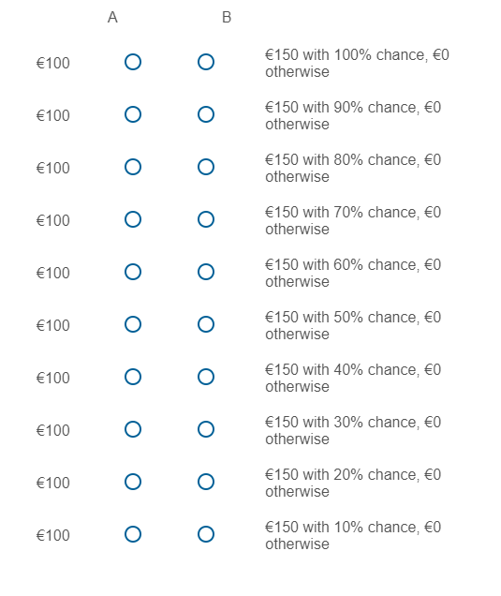
Figure D1. Practice choice list for loss aversion elicitation
 | General notation | Goal | Example
Indifference 1:  Mixed prospect | $G$_{0.5}$L$ ~ RP | Eliciting $L$ | $100$_{0.5}$-70$ ~ 0

Please fill out the list with choices about monetary gambles below
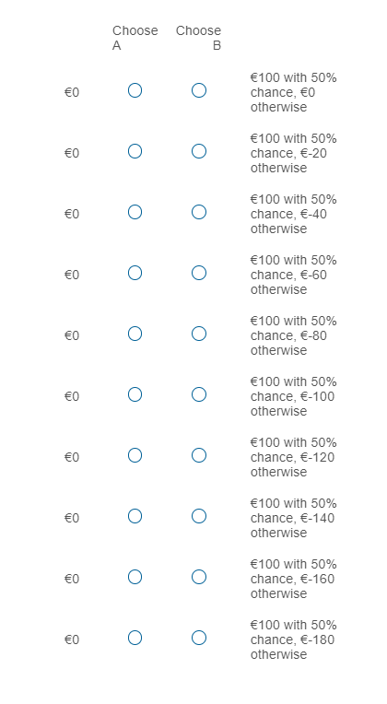
Figure D2. Choice list for loss aversion elicitation: indifference 1
 | General notation | Goal | Example
Indifference 2:  Certainty equivalence – gains | $G$_{0.5}$r$ ~ $x_{1}^{+}$ | Eliciting $x_{1}^{+}$ | $100$_{0.5}$0$ $\sim 40$
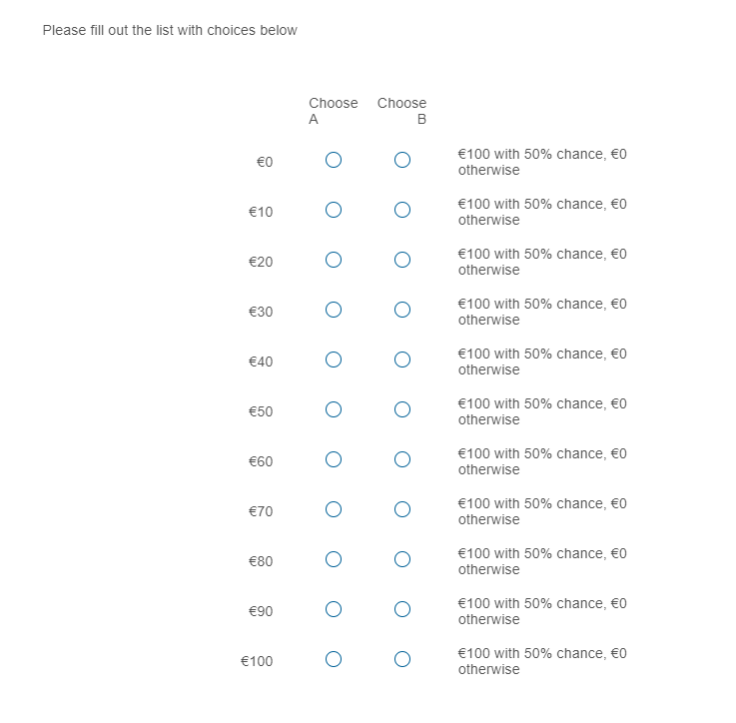
Figure D3. Choice list for loss aversion elicitation: indifference 2

 | General notation | Goal | Example
Indifference 3:  Certainty equivalence - losses | $L$_{0.5}$r$ ~ $x_{1}^{-}$ | Eliciting $x_{1}^{-}$ | $-70$_{0.5}$0$ $\sim -20$

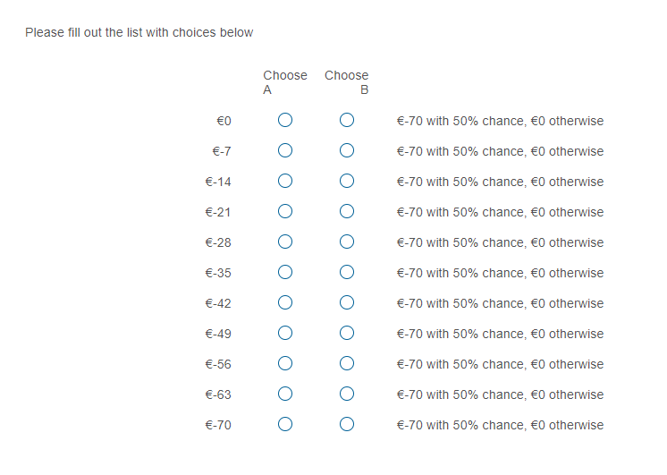
Figure D4. Choice list for loss aversion elicitation: indifference 3

D5. Discounting
Monetary choice questionnaire
We are interested in your preferences for monetary amounts at different points in time. For each of the next 27 choices, please indicate which reward you would prefer: the smaller reward today, or the larger reward in the specified number of days.
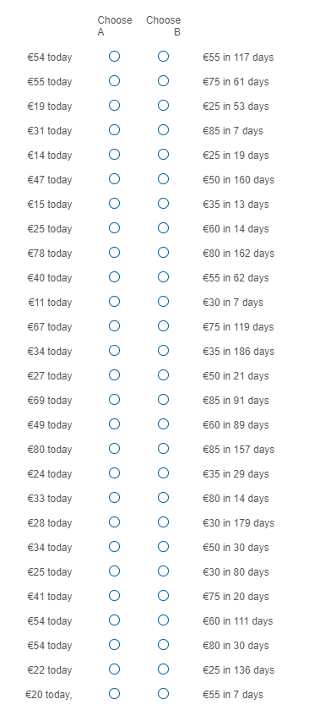
Figure D5. Monetary choice questionnaire used for eliciting discounting
D6. Instructions slider task

As you were informed of earlier, this experiment consists of two sessions. You have almost completed the first session, and the next session takes place next week. Before this session ends we want to provide you some additional information about the procedure and goal of next week's session.

Our main interest is studying the influence small payments have on effort and persistence on tedious tasks. Next week, therefore, you will be asked to work on a tedious task and earn money with that task. All the money you earn with the task is paid out one week after the second session (i.e. 2 weeks from now) Before we move on, we would like to show you how the task works. If you click '->' you will see a page with 10 sliders, which you have to set from 0 to 25. Next week, you will be paid for each slider you set to 25.
Please continue to the next page to try this out.
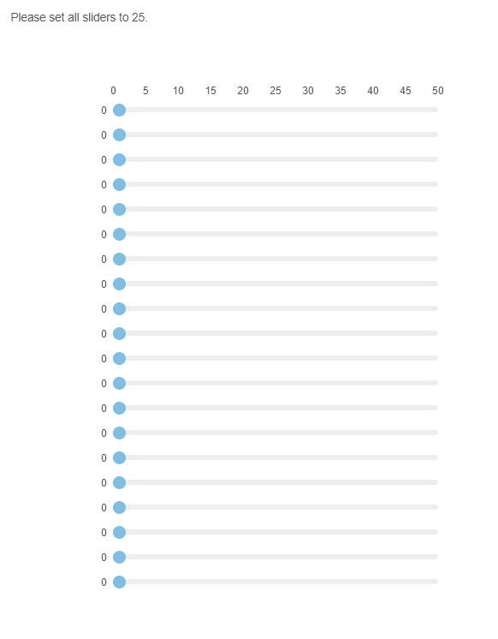

D7. Instructions incentives and earnings (amounts depended on the payment condition)

Please note that by completing this session you have earned €4, that will be be paid out to you after next week's session.

To investigate the influence of small payments on effort and persistence, we use two different payment schemes, which you can choose from. These payment schemes will allow you to earn additional money above the €4 you earned so far, but you will have to work on the slider task you just practiced. Each page with sliders has 20 sliders on it. Next week, you have the opportunity to work on 400 sliders (in other words, 20 pages with sliders). Each completed slider is worth money, which you will receive one week after you have invested the time on working on the slider (i.e. 2 weeks for now). You don't have to complete all 20 pages, in fact you can work as long as you want (or until the task is finished). This means, after each page you can choose to complete another page or quit the experiment. Of course, you earn the most money by completely finishing the slider task (completing all 400 sliders). Your can earn money for your effort based on the basic scheme or the deposit scheme.

Basic scheme
You are paid for €0.20 for a full page of sliders set to 25. If you don't complete a page, or don't set the slider to exactly 25, you will not be paid for that slider. If you complete no sliders at all, you will be paid the €4 you already earned directly, but nothing else. If you complete all sliders, you will earn €4 in two weeks (so €8.00 in total for both sessions) on top of the €4 you already earned today.

Deposit scheme
Because the task is tedious, you might lose motivation and quit early. In order to motivate you to complete all task, in the deposit scheme, we will treat the €4 you earned today as a deposit. This means that rather than earning €4 next week, you will not earn anything next week. Instead, your earned €4 will be paid out as part of the reward for the sliders as follows:

You are paid for €0.40 for a full page of sliders set to 25. If you don't complete a page, or don't set the slider to exactly 25, you will not be paid for that slider. If you complete no sliders at all, you earn nothing for this experiment (meaning you lost your deposit). If you complete all sliders, you will earn €8.00.

D8. Nudged assignment condition specific instruction
Choosing between the two schemes
In both the basic and deposit scheme you have the opportunity to earn the same amount of money for persistent effort on a tedious task. The deposit scheme may help to keep you motivated, however, because you are not only earning ''extra' money, but also earning back money you made earlier. If you don't complete all tasks, however, you might lose money.

You have the opportunity to choose between the two schemes, and you are free to choose whichever you prefer. However, based on the monetary choices and questionnaires you filled in earlier, we have preselected the scheme we think will help best to motivate you. Whether you follow our recommendation or not is your choice.

D9. Random assignment condition specific instruction:
You were assigned (randomly) to the basic/deposit scheme.

D10. Final information

You have almost finished part 1 of the survey. Next week you will receive an e-mail with an invitation for the second part of the survey on this e-mail address: . Furthermore, please write down your random ID (10010), which is used to check your choices and earning next week. A screenshot also works.

D11. Try it yourself?
We prepared a version of the online experiment that can be tested here (https://tinyurl.com/436z7nzd).

