Participants
All raw data, analysis code, preregistration, and more information can be found online on the project’s OSF repository available at https://osf.io/k8dmg/. In total, we collected data from 2,305 participants. Of those, five participants abandoned the study before completing it, and two data sets were removed due to the same participant completing the task twice, with a remaining 2,298 participants finishing the experiment. Of those, 20 participants typed in fewer than two captchas correctly, and did not proceed to the roulette stage. All analyses are based on the 2,278 participants who solved two or more captchas correctly and proceeded to the roulette stage.
There were three experimental conditions: Participants could be randomly allocated to the a) “control” group with no gambling message present, b) “message” condition, in which the “take time to think” message (Figure S1) was visible on the screen, or c) “message+” condition with “take time to think” additionally displayed prominently as a popup prior to the game of online roulette (Figure S4).
Figure S 1. Take Time To Think logo

Experimental design
A screenshot of the main roulette game (in the “message” or “message+” experimental condition) is shown in Figure S2, and screen captures of all pages are available online (https://osf.io/k8dmg/). Data collection occurred over 31/03 – 05/04/2022.
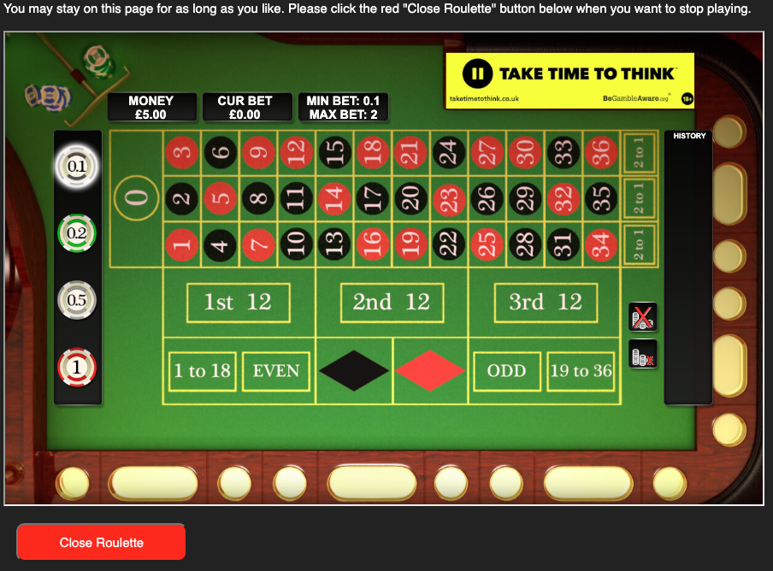
Figure S 2. Screenshot of the roulette task (message condition).
A total of N=2,305 participants started the task by reading the consent form in which they were informed that high performance on the captcha task would yield “a bonus that can optionally be used to bet on a roulette game.” After giving consent, participants then proceeded to the captchas page, which consisted of ten captchas that had to be transcribed by the participant (Figure S 3 shows examples).
Participants (N=20) who typed in fewer than two correct captchas were immediately moved to the final thank-you page which ended the task and paid £2.50. Participants who typed in two or more correct captchas were awarded a bonus of £5.00, which they could play in a roulette game, in the next phase of the experiment. Five participants were excluded from further analyses due to abandoning the task before completing it, and two datasets were excluded from a participant who completed the task twice due to an error, for a total sample of N=2,278 used for analysis.
Figure S 3. Examples of four captchas. Each participant was asked to type ten captchas, selected from the complete set of 18 available.
The roulette phase started with a page with instructions on how to play the roulette game. The full instructions are available online in osf (https://osf.io/mq6gj/). Participants were told that they could play as often or as little as they liked. The instructions page also included information on how to place bets and operate the game. After reading the instructions, participants could then proceed to the roulette game itself on the next page.
Figure S 4. Pop-up message in the experimental condition Message+. Participants needed to click on the “X” to close the message and proceed.
Gambling message presence was manipulated between participants, with messages shown both on the instructions page and overlaid in the top-right corner of the roulette game. In the message+ condition, participants were also shown a pop-up message (in addition to the banner) before the beginning of the roulette game (Figure S4). This message needed to be dismissed by the participant, before the roulette was shown (Figure S2).
Twenty-five percent (N=579) of participants left the roulette without placing any bets, thereby keeping their entire £5 bonus. Participants could play as many spins of the roulette as they wanted, by betting between £0.10 and £2 per spin, using one or more betting chips of different values (£0.1, £0.2, £0.5, £1). The game was a realistic version of roulette, allowing individuals to place diverse types of bets, such as bets on a single number, red/black, odds/evens, highs/lows, and more complicated bets such as splits (two numbers), streets (three numbers), corners (four numbers), columns, and others. The winning number was randomly generated by the server at each spin.
Participants were allowed to play roulette for as long as they wanted, with the exception that any participant who managed to reach a balance of zero (lost everything) or more than £120 would be moved on from the roulette game (no one reached the upper limit; the maximum balance reached was £79.40). Participants could proceed by clicking the "close roulette" button. Participants who closed the roulette by accident were given a chance to reopen the roulette; otherwise, after closing the roulette they could continue to the Gamcare page.
The next page of the task was based closely on the current homepage for gamcare.org.uk, the UK’s main provider for gambling support, and contained information on the four main Gamcare services: phone advice, live web-based chat, a group chatroom, and an online forum (Figure S5). Participants were given the option to have a new browser tab open to the Gamcare homepage upon task completion, so as to provide participants with easy access to help resources, but without interfering with the remainder of the task. The click on the button at this page was recorded and analysed.
After indicating their selection, participants were show the final page with demographics questions (age, gender), and the eight-question PGSI questionnaire. Once all the questions had been answered, participants were shown the thank-you page which ended the task. Participants who passed the captchas and played the roulette game were paid £2.50 plus whatever bonus they had when they closed the roulette (average bonus: £4.91, median=£5.00, range: [£0, £79.40]). If participants had clicked “Yes” on the Gamcare page, an additional tab was opened at the end of the task redirected to the Gamcare homepage.

Figure S 5. Gamcare page. In order to proceed, participants had to click one of the two buttons at the bottom of the screen.

ZOIBR model specification
The ZOIBR model was parameterised as follows with four distributional parameters g, e, μ, and ϕ. The main focus are the first three distributional parameters g, e, and μ.
g: probability to gamble at all (i.e., probability of proportion bet being greater than 0). Thus, 1 - g is the zero-inflation probability. g is restricted to be in (0, 1).
e: conditional probability to gamble everything (i.e., conditional probability of proportion bet being equal to one, if one gambles). e is the conditional one probability and is restricted to be in (0, 1).
μ (mu): mean proportion gambled if participants gamble, but do not gamble everything (i.e., mean of beta regression model). μ is restricted to be in (0, 1).
ϕ (phi): precision of the beta regression model. ϕ is restricted to be in (0, Infinity].

Thus, the likelihood, L, for the data, y, would be
L(y) = (1 - g), if y = 0,
L(y) = g * e, if y = 1,
L(y) = g * (1 - e) * Beta(y | a, b), if y is not 0 or 1,
where Beta(y | a, b) corresponds to the beta distribution for y with parameters
a = μ * ϕ,
b = (1 - μ) * ϕ.

All models were estimated on the linear (i.e., unconstrained) scale using the generalised linear model formulation with 𝜂 = X𝜷, where 𝜂 is the prediction on the linear scale, X the model matrix, and 𝜷 the parameter vector. The prediction on the transformed scale (i.e., the scale in the likelihood formulation given above) is then obtained via a link function h, such that θ = h⁻¹(𝜂), where θ = {g, e, μ, ϕ}. For the three parameters on the unit range, g, e, and μ, h is the logit function. For ϕ, h is the log function.
In terms of the model matrix X, all models were parameterised using treatment coding such that the control condition without gambling message was the reference condition and represented by the intercept. Each message condition (message and message+) was represented by one additional coefficient. In case a model also contained interactions, this coding was maintained and more coefficients added. For all models, this coding was applied equally to the three main parameters g, e, and μ. Furthermore, we only estimated one ϕ per model (i.e., ϕ did not differ across conditions).
Our main interest was a possible effect of the gambling messages on proportion bet. To test this hypothesis we performed the following steps: Based on the posterior distributions of the model parameters 𝜷, we calculated the posterior distribution of the predicted value 𝜂 for each condition (no-message control, message, and message+) and each distributional model parameter g, e, μ. Then, we applied the inverse link function h⁻¹ to obtain the posterior distribution of the predictions per distributional parameter and condition on the transformed scale (i.e., the unit range from 0 to 1). From these, we obtained the by-condition posterior distribution of proportion bet (i.e., the posterior distribution on the response scaled), Pr_{bet}, using the formula Pr_{bet} = (g × e) + (g × (1 – e) × μ). From these posterior distributions we calculated the difference posterior distributions of the two message conditions from the no-message control condition which we use to test the central hypothesis.
In terms of priors, we only specified priors for ϕ, a location-scale t-distributions with 3 df, location = 0, and scale = 2.5. We did not specify any priors for the other model parameters.
The brms code for the model can be found in the following RMarkdown document: https://osf.io/kv5u3/
An a-priori power analysis was performed for the proportion bet outcome. This analysis compared two groups each with N = 500. The model parameters were based on the ZOIBR model parameters estimated in a previous study (Newall et al., 2022), and additionally manipulated the true difference in proportion bet between the two groups from 0% to 10% in increments of 1%. Each difference was simulated and analysed in 10,000 synthetic samples. For each synthetic sample the distributional parameter responsible for the difference was randomly determined, one possibility was that the difference in proportion bet was coming from a mixture of parameters. The code for the simulation (plus results data) are available on Github: https://github.com/singmann/proportion_bet_sensitivity
Results are shown in Figure S6. The power analysis showed a 79% probability of detecting a difference in proportion bet of 6 percentage points, and an 88% probability of detecting a difference in proportion bet of 7 percentage points. The analysis also showed that the proportion bet model was well calibrated; in the absence of an effect the Bayesian 95% CI excluded 0 in 4.8% (95% Binomial CI [4.4% to 5.3%]) of cases.
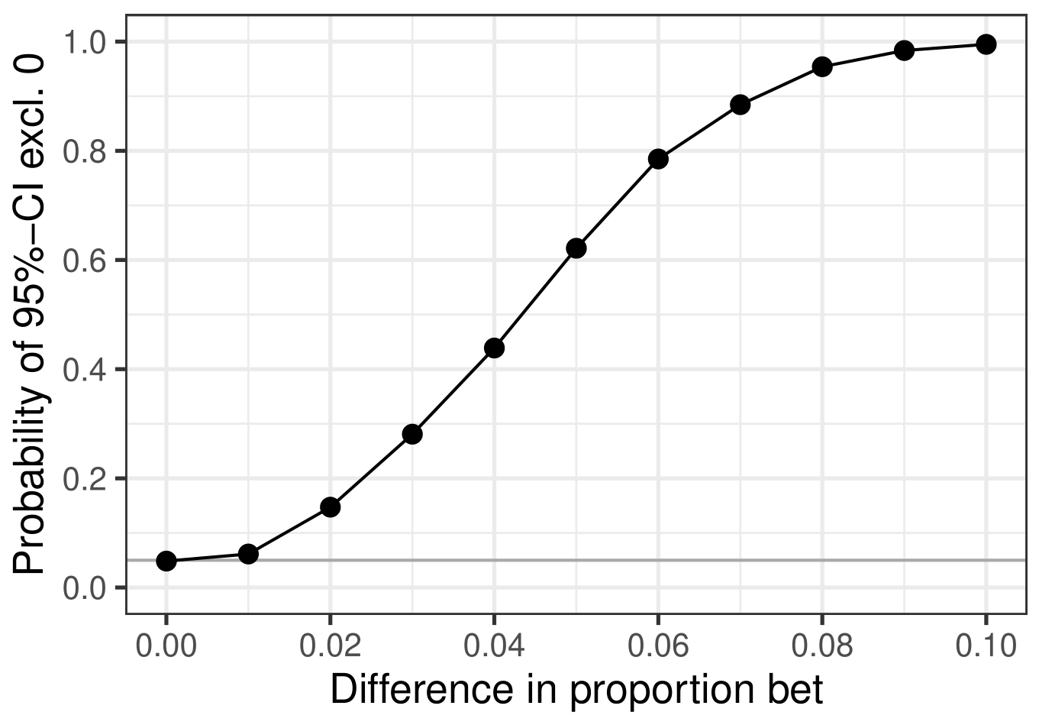
Figure S 6. Results from a priori power analysis on proportion bet. The x-axis shows the simulated (i.e., true) difference in proportion bet and the y-axis the probability to observe a 95% Bayesian CI that does not include 0. Binomial CIs are also drawn, but so narrow that they are smaller than the point used to indicate the probability.

Descriptive Adequacy of ZOIBR Model for Proportion Bet
We assess the descriptive adequacy of the ZOIBR model in two different ways. Firstly, we compare the actual distribution of proportion bet with synthetic distributions of proportion bet generated from the fitted model, the so-called called posterior predictive distribution. This analysis is performed across all gambling conditions. Secondly, we compare the observed means of proportion bet per condition with the estimated (or predicted) means of proportion bet per condition. The latter is based on the posterior distribution of proportion bet also used for testing the main hypothesis. Both comparisons show strong agreement between model and data indicating a high degree of descriptive adequacy for the ZOIBR model.
Figure S7 compares the actual distribution of responses on the dependent variable proportion bet with the posterior predictive distribution – simulated data based on the estimated ZOIBR model. The actual data is shown in the top left panel whereas random draws from the posterior predictive distribution are shown in the remaining eleven panels. As can be seen, the model is well able to capture both aspects of the distribution of the dependent variable: the peaks at zero and one, and the unimodal distribution of the remaining responses.
Figure S8 (left panel) compares the observed mean proportion bet per condition (as blue diamonds) with the ZOIBR estimated mean proportion bets (grey density estimates and black lines/points). The right panel compares the observed mean differences with the ZOIBR estimated mean differences. In both cases we can see that the model estimates are very similar to the observed values.
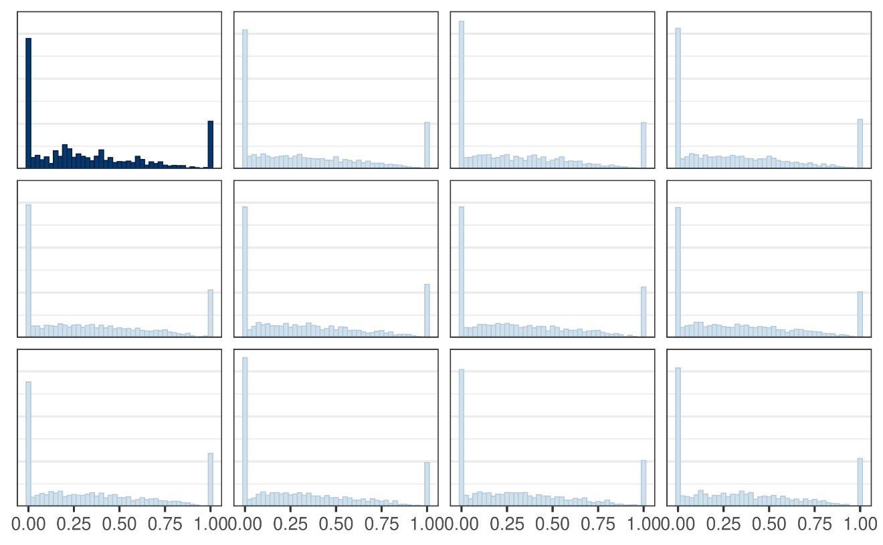
Figure S 7. Comparison of the empirical distribution of proportion bet with posterior predictive distribution (i.e., synthetic proportion bet data generated from the estimated model). The panel in the upper left with bars in dark blue shows the distribution of the actual data whereas the eleven remaining panels show one random draw from the posterior predictive distribution. The posterior predictive distribution is very similar to the observed distribution.
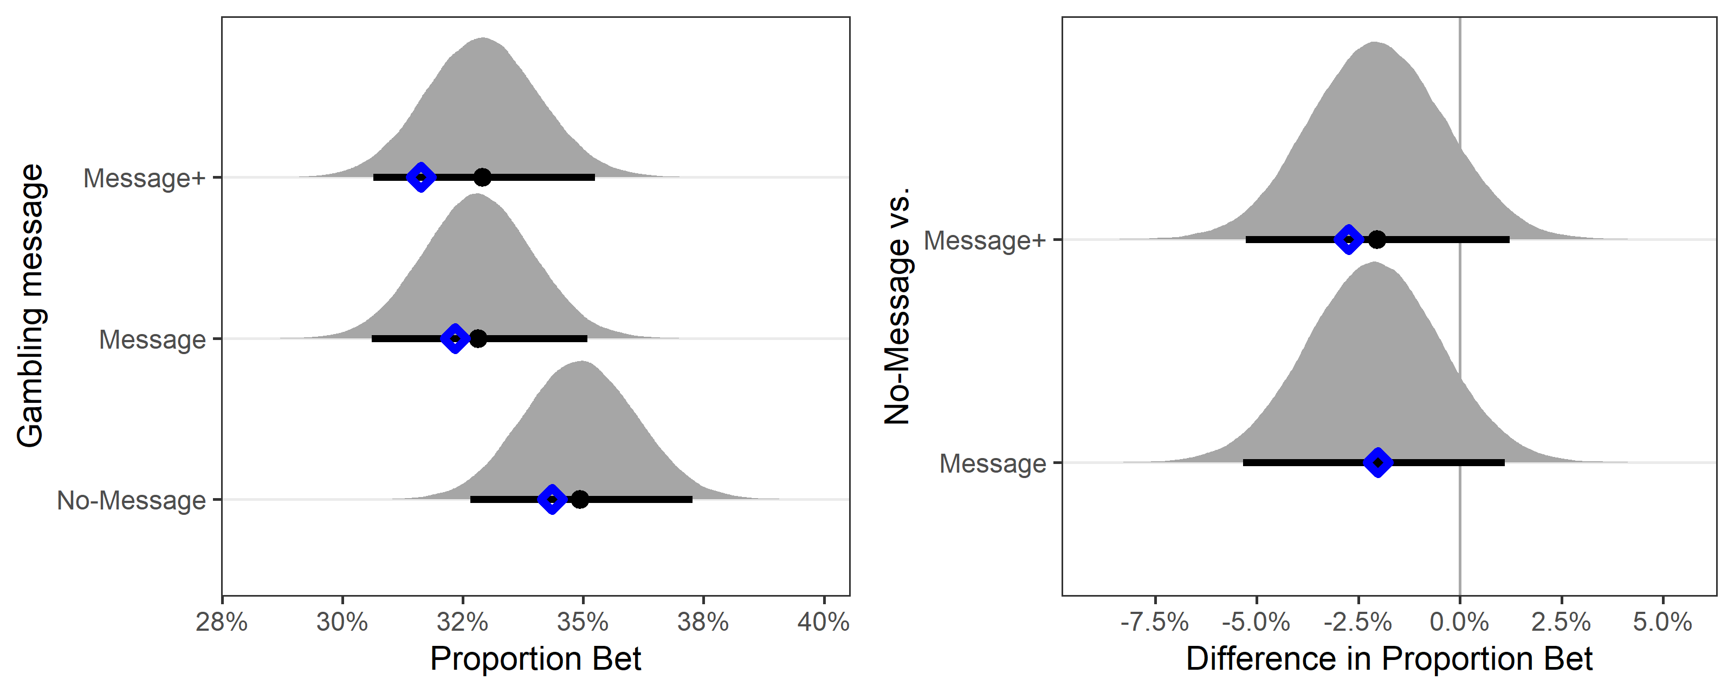
Figure S 8. Zero-One-Inflated beta regression model estimates for proportion bet across conditions and corresponding observed means. The left panel shows mean proportion bet across the three message conditions, the right panel shows the estimated mean differences between the no-message condition with the two message conditions (negative values indicate less gambling in the message conditions and positive values indicate more gambling in the message conditions). In each panel, the grey area shows the full posterior distribution in terms of a density estimate, the black dot shows the posterior mean, and the horizontal black line shows the 95% credibility interval (CI). The blue triangle shows the observed mean (left panel) or observed mean difference (right panel). When the black dot is not visible it is because it overlaps with the blue dot (it is behind it).
Taken together, the ZOIBR model does not only produce synthetic data that looks like the actual data, it can also adequately describe the observed mean proportion bet values across condition.

Individual Distributional ZOIBR Parameters for Proportion Bet
We can also look at the individual distributional ZOIBR parameters (Table S1), which can reveal in more detail any differences between conditions across the three different processes captured by the model (Table S2).
Means | Proportion Bet | g: prob. to gamble at all | e: cond. prob to gamble everything | μ: cond. mean prop gambled
No message | 0.349  [0.327, 0.373] | 0.754  [0.723, 0.784] | 0.121  [0.094, 0.148] | 0.390  [0.369, 0.410]
Message | 0.328  [0.306, 0.351] | 0.734  [0.703, 0.764] | 0.128  [0.102, 0.156] | 0.366  [0.347, 0.386]
Message+ | 0.329  [0.306, 0.352] | 0.751  [0.719, 0.781] | 0.117  [0.091, 0.144] | 0.364  [0.344, 0.384]
Table S1. ZOIBR Model estimates for both proportion bet and for each of the three main distributional ZOIBR model parameters.
Differences | Proportion Bet | g: prob. to gamble at all | e: cond. prob to gamble everything | μ: cond. mean prop gambled
Message – No message | -0.021  [-0.053, 0.011] | -0.020  [-0.063, 0.023] | 0.007  [-0.031, 0.045] | -0.024  [-0.051, 0.004]
Message+ – No message | -0.020  [-0.053, 0.012] | -0.003  [-0.046, 0.041] | -0.004  [-0.042, 0.034] | -0.026  [-0.054, 0.002]
Table S 2. ZOIBR Model estimate differences in comparison to no message condition, for both proportion bet and for each of the three main distributional ZOIBR model parameters.

Pre-registered secondary analysis: PGSI covariates on proportion bet
The same model as the main confirmatory analysis was run, but this time including PGSI as a covariate. This approach allowed us to assess if the main findings would be replicated when adjusting for individual differences in the PGSI scores. This analysis was conducted twice, with and without interactions between the messages and the index. In the first analysis, only the main effects of PGSI was included (mean-centered), in addition to the experimental conditions. The second analysis also included the two-way interaction between PGSI and the messages.
Both models showed the same patterns for the influence of the safer gambling messages as reported in the main analysis, without the covariates (Table S3): there was no credible effect of the messages on gambling behavior.

Predictors | Main model  Estimate (SD)  [95% CI] | Main Effect Model  Estimate (SD)  [95% CI] | Interaction Model  Estimate (SD)  [95% CI]
Coefficients for “probability to gamble at all” (g)
Intercept | 1.12 (0.08)  [0.96, 1.29] | 1.14 (0.08)  [0.97, 1.30] | 1.13 (0.09)  [0.96, 1.30]
Message | -0.11 (0.12)  [-0.33, 0.12] | -0.10 (0.12)  [-0.33, 0.13] | -0.08 (0.12)  [-0.31, 0.15]
Message+ | -0.01 (0.12)  [-0.25, 0.22] | -0.02 (0.12)  [-0.26, 0.22] | 0.00 (0.12)  [-0.24, 0.24]
PGSI |  | 0.07 (0.02)  [0.04, 0.10] | 0.04 (0.02)  [-0.01, 0.09]
Message : PGSI |  |  | 0.05 (0.04)  [-0.03, 0.12]
Message+ : PGSI |  |  | 0.05 (0.04)  [-0.03, 0.12]
Coefficients for “conditional probability to gamble everything” (e)
Intercept | -1.99 (0.13)  [-2.25, -1.74] | -2.04 (0.13)  [-2.30, -1.79] | -2.02 (0.13)  [-2.29, -1.79]
Message | 0.07 (0.18)  [-0.29, 0.42] | 0.06 (0.18)  [-0.29, 0.42] | 0.03 (0.19)  [-0.33, 0.40]
Message+ | -0.04 (0.19)  [-0.41, 0.32] | -0.04 (0.19)  [-0.41, 0.32] | -0.09 (0.19)  [-0.47, 0.29]
PGSI |  | 0.09 (0.02)  [0.06, 0.12] | 0.06 (0.03)  [0.0, 0.12]
Message : PGSI |  |  | 0.03 (0.04)  [-0.05, 0.10]
Message+ : PGSI |  |  | 0.04 (0.04)  [-0.04, 0.12]
Coefficients for beta regression model (μ and ϕ), or “proportion bet”
Intercept | -0.45 (0.04)  [-0.53, -0.36] | -0.45 (0.04)  [-0.54, -0.37] | -0.45 (0.04)  [-0.54, -0.37]
Message | -0.10 (0.06)  [-0.22, 0.02] | -0.10 (0.06)  [-0.22, 0.02] | -0.10 (0.06)  [-0.22, 0.02]
Message+ | -0.11 (0.06)  [-0.23, 0.01] | -0.11 (0.06)  [-0.23, 0.01] | -0.11 (0.06)  [-0.23, 0.01]
PGSI |  | 0.02 (0.01)  [0.01, 0.03] | 0.00 (0.01)  [-0.03, 0.02]
Message : PGSI |  |  | 0.02 (0.02)  [-0.01, 0.05]
Message+ : PGSI |  |  | 0.05 (0.02)  [0.02, 0.08]
Phi (ϕ) | 1.18 (0.03)  [1.11, 1.24] | 1.18 (0.03)  [1.12, 1.25] | 1.19 (0.03)  [1.12, 1.25]
Table S 3. Regression coefficients of the preregistered ZOIBR models of proportion bet.
Note: Standard deviation of the posterior, the Bayesian equivalent of the standard error, in brackets. Estimates are given on the linear scale (i.e., without applying the link function). CI gives the 95% Bayesian credibility interval. PGSI are mean-centered. The intercept corresponds to the mean of the no-message condition and all coefficients are in relation to this mean (i.e., the models use treatment coding). For example, “Message” is the difference from the no-message condition for the message condition, and “PGSI” refers to the relationship between PGSI and the corresponding ZOIBR parameter in the no message condition. “:” indicates an interaction.

Bernoulli Model for Help-Seeking via Gamcare Button
Participants' responses on the Gamcare page were treated as a binary variable with a value of 1 if a participant clicked on any of the Gamcare links and 0 if the participant did not click on the Gamcare link. We analysed this data with a Bernoulli model using a logistic link function (this model only has one distributional parameter for the mean probability). The only prior was for the intercept, a location-scale t-distributions with 3 df, location = 0, and scale = 2.5. We used the same regression-modelling strategy as for the ZOIBR model to analyse this data. We used treatment contrasts and the no-message control condition as the baseline and estimated separate condition effects for each of the two message conditions.
The analysis of the model was similar to the ZOIBR model. Based on the posterior distributions of the model estimates we estimated the by-condition posterior distribution on the response (i.e., probability) scale. From these we calculated the difference distributions (also on the response scale) of the two message conditions from the no-message control condition which were used for the main statistical test.
To assess the descriptive adequacy of the model, we compared the observed mean rate with which participants clicked on the Gamcare page with the model estimated mean rates as well as the observed and estimated differences in mean rates across conditions. Both of these comparisons can be seen in Figure S9 and show a perfect agreement between observed and model estimated values. Hence, the model provides a perfect account of the observed data. (Given the simplicity of model and data, a posterior predictive plot was not necessary for these data.)
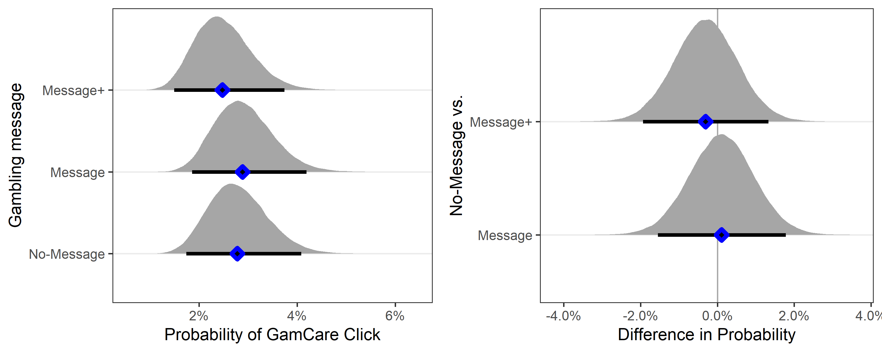
Figure S 9. Bernoulli model estimates (in black and grey) and corresponding observed means (as blue diamonds) for the rates of help-seeking behaviour via the Gamcare button across conditions. The left panel shows by-condition means which participants open the Gamcare link per condition, the right panel shows the differences of the no-message condition. See Figure S7 for more details.

Shifted Lognormal Model for Speed of Play
For speed of play, we analysed the distribution of participants' betting times. To allow participants to familiarise themselves with the task, we discarded participants' first bet in this analysis. The analysis of betting times thus only included participants that made at least two bets at the roulette and only considered the betting times from bets two and onward. In addition, to prevent this analysis from being affected by unusually long betting times, we will excluded all observations with a betting time larger than 120 seconds. There were total of 13,590 bets. After removing the first bet of each participant, 11,891 bets remained. Of those, 29 (0.24%) bets took longer than 120 seconds. Following our pre-registration, we removed these betting times from analysis.
The analysis of betting times used a shifted lognormal model with three distributional parameters, log-mean, log-SD, and non-decision time (ndt; also shift-parameter). For log-mean and ndt we modelled the parameter on the unconstrained (real) line. For log-SD we used a log link. The model included fixed-effects for condition for both distributional parameters, log-mean and log-SD (i.e., the model will be hetereoscedastic and allow different log-SDs for each condition). As for all models, we used treatment coding for the effect of condition with the no-message condition as baseline. The model also included random-intercepts for participants for the log-mean (to avoid misunderstandings, this is the only model with random-effects terms, the other models only contained fixed-effects).
In terms of priors, we included priors for all fixed-effects intercepts (for log-mean, log-SD, and the non-decision time parameter). For the log-mean it was a location-scale t-distributions with 3 df, location = 1.8, and scale = 2.5. For log-SD it was a location-scale t-distributions with 3 df, location = 0, and scale = 2.5. For the non-decision time it was a uniform distribution between 0 and the minimum betting time. For the random-effects, the prior on the standard deviation of the individual deviations was a zero-truncated location-scale t-distributions with 3 df, location = 0, and scale = 2.5.
To test differences in mean betting times across gambling conditions we used a similar approach as for the other models. We first obtained the by-gambling-condition posterior distribution of the three distributional parameters (for ndt, the posteriors were the same for each gambling condition). For log-SD this required the application of the inverse link function. From these, we calculated the by-condition posterior distributions of estimated (or predicted) mean betting time as
mean = ndt + exp(m + sigma^2/2), where ndt is the non-decision time, m is the log-mean, and sigma the log-SD.
Based on these posterior distributions, we calculated the difference distributions which we used to test the hypothesis of differences in mean betting times across conditions.
To assess the empirical adequacy of the shifted lognormal model for describing the distribution of betting times, we considered both the posterior predictive distribution as well as the estimated and observed mean speed of play. Figure S10 compares the actual distribution of responses on the dependent variable speed of play with the posterior predictive distribution. The actual data is shown in the top left panel whereas random draws from the posterior predictive distribution are shown in the remaining eleven panels. As can be seen, the model is able to adequately reproduce the shape of the observed data. Figure S11 compares the observed and estimated mean betting times across conditions (left panel) as well as differences in mean betting times across conditions (right panel). In all cases, the observed mean is within the 95% credibility interval of the estimated mean, indicating an adequate account of the data. Taken together, both the posterior predictive distribution as well as the observed versus estimated mean betting times indicate that the shifted lognormal model provided an adequate account of participants’ betting times.
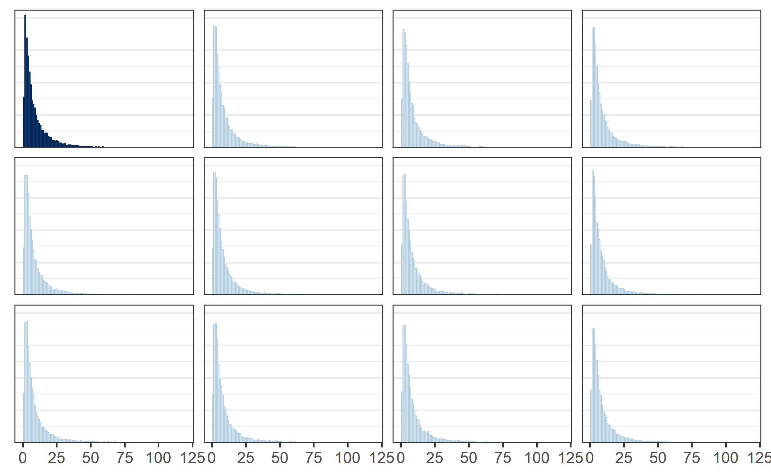
Figure S 10. Comparison of the empirical distribution of speed of play with posterior predictive distribution (i.e., synthetic speed of play data generated from the estimated model). The panel in the upper left with bars in dark blue shows the distribution of the actual data whereas the eleven remaining panels show one random draw from the posterior predictive distribution.
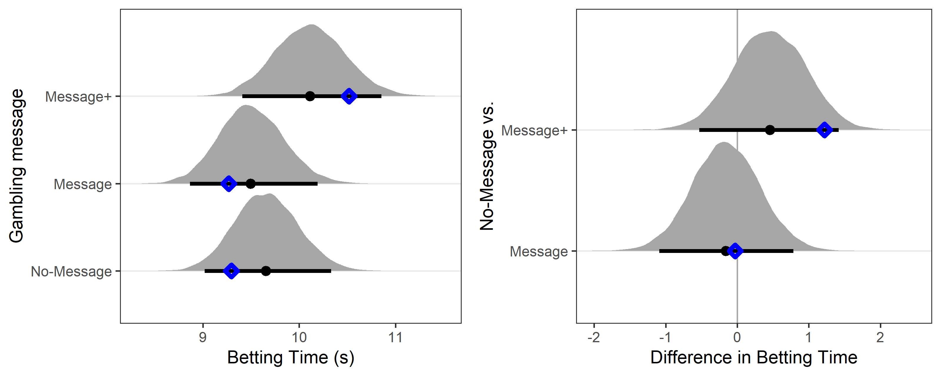
Figure S 11. Shifted log-normal model estimates (grey areas and black lines/symbols) and observed values (blue diamonds) for participants’ mean betting times (excluding the very first bet) across conditions. The left panel shows the posterior distribution of the estimated mean betting times, the right panel shows the posterior difference distributions for the differences from the no-message condition.

Negative binomial model for total number of spins
For the analysis of the total number of spins, we only considered participants who bet at least once. We analysed the total number of spins with a negative binomial (a type of generalised form of the Poisson distribution) model with a lower bound of 1 (i.e., truncated at 1). The model has two distributional parameters, the strictly positive mean parameter, which we modelled using a log link, and the strictly positive shape parameter, which we modelled using an identity link (i.e., no link function). We used treatment contrasts allowing condition specific effects for the mean parameter (as before, with the no-message control condition as the baseline).
In terms of priors, we included priors for both intercepts. For the mean parameter (intercept only), the prior was a location-scale t-distributions with 3 df, location = 1.4, and scale = 2.5. For the shape parameter, the prior was a Gamma(0.01, 0.01) distribution.
Based on the posterior distributions of the model parameters, we then obtained the by-condition posterior distribution of the mean parameter (after applying the inverse link function, so on the parameter scale) and the shape parameter (which were the same for each condition). From these posteriors, we then calculated the posterior of the estimated mean on the response scale (i.e., the total number of spins after excluding all participants with only one spin) using the formula
mean = mu / (1 – F(1 | mu, shape)),
where mu is the mean parameter of the truncated negative binomial distribution, shape is the shape parameter of the truncated negative binomial distribution, and F(1 | mu, shape) is the cumulative density function of the negative binomial model with parameters mu and shape evaluated at 1. For an explanation of this formula, see the explanation in the analysis document on GitHub. From these posteriors, we calculated the difference distribution of the two message conditions from the no-message control condition.
To assess the empirical adequacy of the truncated negative binomial model for describing the distribution of (truncated) number of spins, we considered both the posterior predictive distribution as well as the estimated and observed mean speed of play. Figure S12 compares the actual distribution of responses on the dependent variable total number of spins with the posterior predictive distribution. The actual data is shown in the top left panel whereas random draws from the posterior predictive distribution are shown in the remaining eleven panels. Overall, the distribution of the synthetic data looks similar to the distribution of the actual data, but there are also some differences. The synthetic data has a larger peak at 1 and at the same time less mass at values smaller than 1. Figure S13 compares the observed and estimated mean numbers of spins per condition (left panel) and the differences in mean number of spins per condition (right panel). It is clear that estimated and mean values perfectly match it other. Taken together, the truncated negative binomial model provides an adequate account of the observed distribution of number of spins.

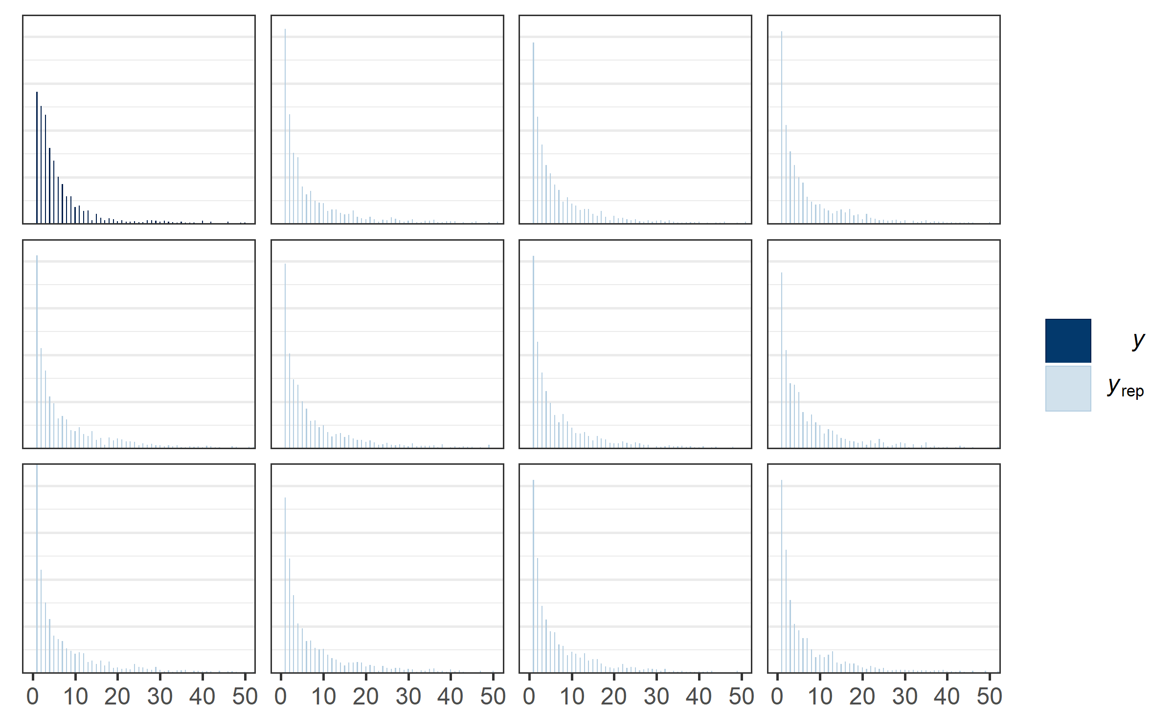
Figure S 12. Comparison of the empirical distribution of total number of spins with posterior predictive distribution (i.e., synthetic proportion bet data generated from the estimated model), zoomed in on numbers of spins between 1 and 50. The panel in the upper left with bars in dark blue shows the distribution of the actual data whereas the eleven remaining panels show one random draw from the posterior predictive distribution. The posterior predictive distribution is very similar to the observed distribution.
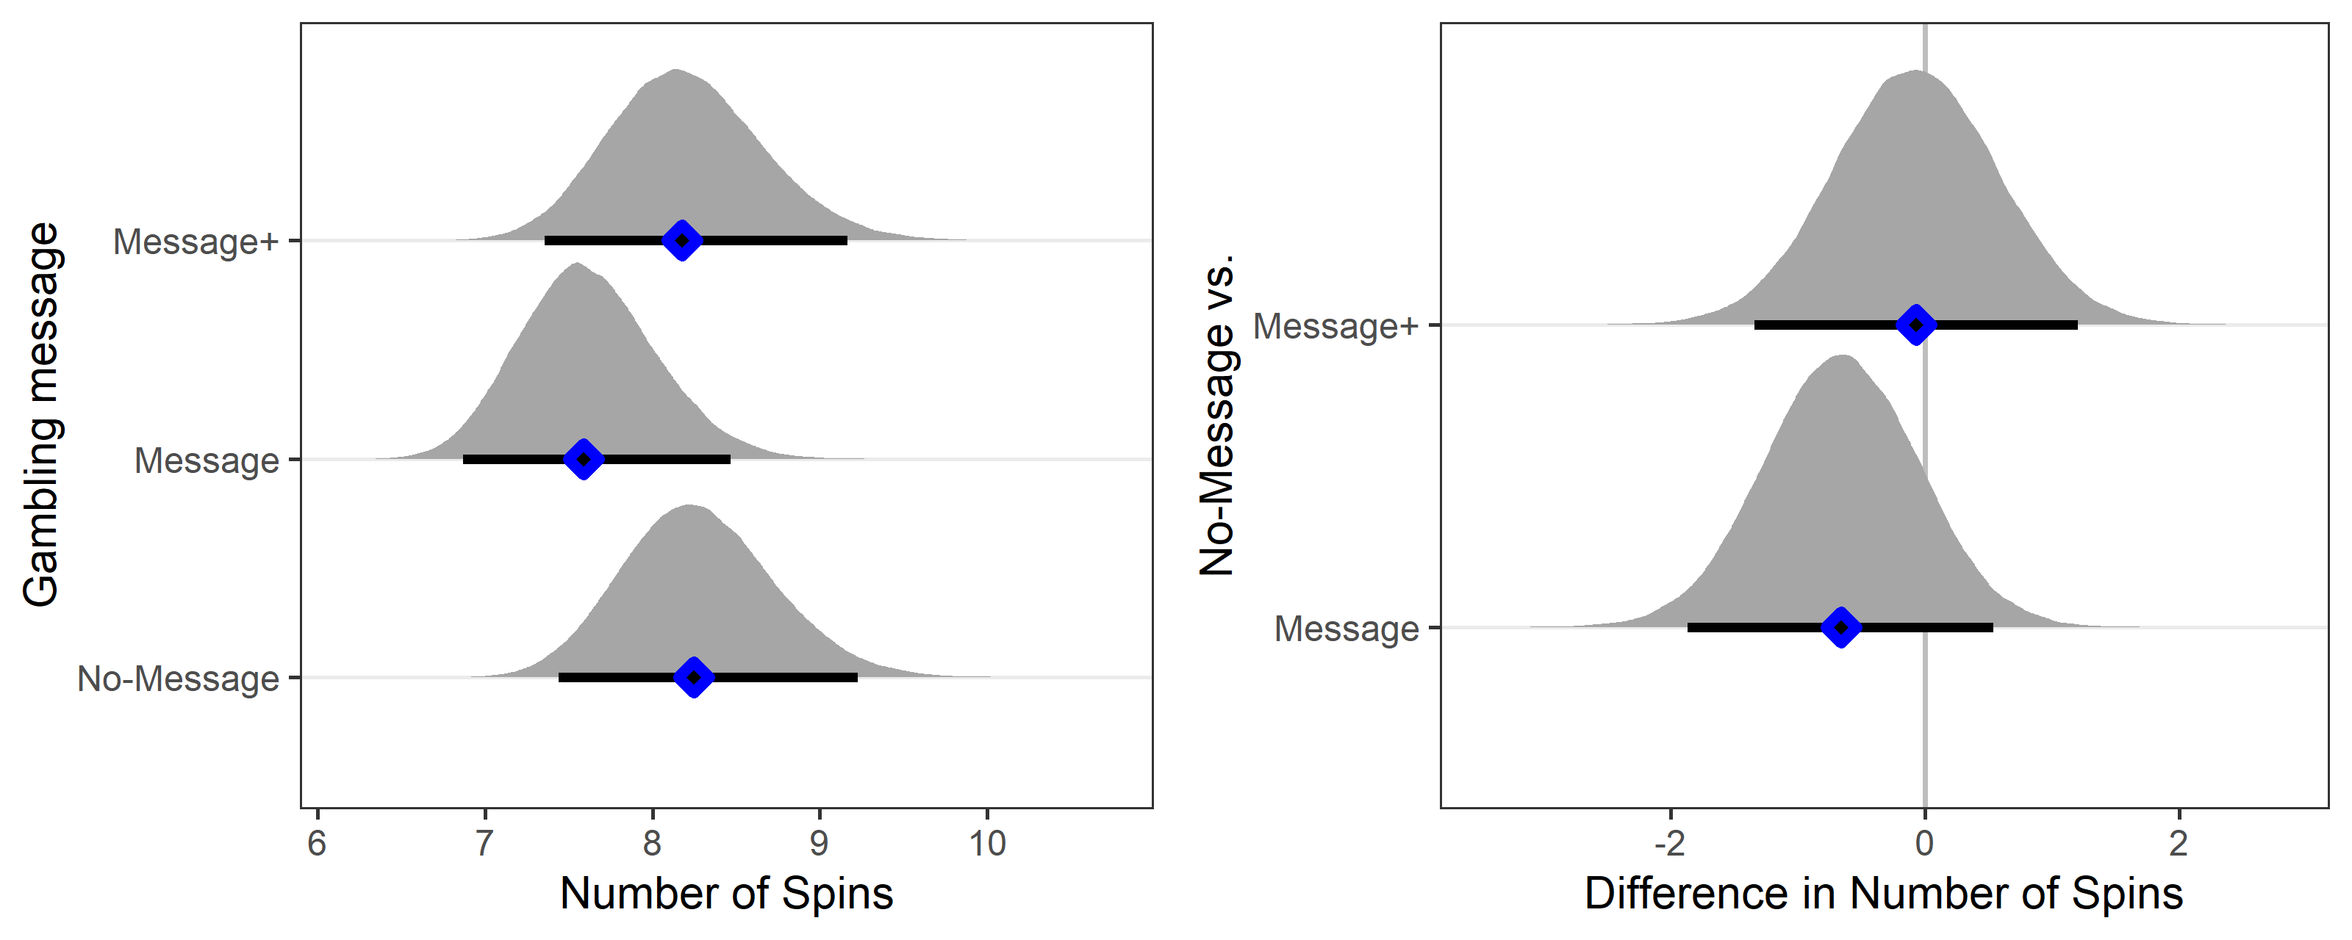
Figure S 13. Truncated negative binomial model estimates (grey density and black lines/symbols) and observed values for number of spins (after excluding participants with 0 spins). The left panel shows the posterior distribution of the estimated mean number of spins, the right panel shows the posterior difference distributions for the differences from the no-message condition.

