Supplement A - Demographics
Table S1. Demographic characteristics of the sample
 | Control group | AQ | AQV | AQR | AQVR | Overall
 | (N=894) | (N=892) | (N=894) | (N=927) | (N=893) | (N=4500)
Age
Mean (SD) | 47.5 (17.0) | 46.9 (16.5) | 47.6 (16.6) | 47.8 (16.7) | 47.8 (16.8) | 47.5 (16.7)
Gender
Female | 448 (50.1%) | 459 (51.5%) | 464 (51.9%) | 489 (52.8%) | 440 (49.3%) | 2300 (51.1%)
Male | 446 (49.9%) | 433 (48.5%) | 430 (48.1%) | 438 (47.2%) | 453 (50.7%) | 2200 (48.9%)
BMI
Mean (SD) | 26.0 (6.04) | 26.2 (6.22) | 26.4 (6.49) | 25.9 (6.27) | 25.9 (5.65) | 26.1 (6.14)
Missing | 17 (1.9%) | 25 (2.8%) | 31 (3.5%) | 39 (4.2%) | 30 (3.4%) | 142 (3.2%)
Education
Low | 302 (33.8%) | 325 (36.4%) | 335 (37.5%) | 326 (35.2%) | 344 (38.5%) | 1632 (36.3%)
Medium | 201 (22.5%) | 200 (22.4%) | 195 (21.8%) | 202 (21.8%) | 189 (21.2%) | 987 (21.9%)
High | 391 (43.7%) | 367 (41.1%) | 364 (40.7%) | 399 (43.0%) | 360 (40.3%) | 1881 (41.8%)
Region
East Anglia | 102 (11.4%) | 96 (10.8%) | 91 (10.2%) | 107 (11.5%) | 93 (10.4%) | 489 (10.9%)
East Midlands | 71 (7.9%) | 84 (9.4%) | 72 (8.1%) | 81 (8.7%) | 86 (9.6%) | 394 (8.8%)
London | 133 (14.9%) | 135 (15.1%) | 147 (16.4%) | 148 (16.0%) | 143 (16.0%) | 706 (15.7%)
North East | 44 (4.9%) | 43 (4.8%) | 47 (5.3%) | 35 (3.8%) | 53 (5.9%) | 222 (4.9%)
North West | 121 (13.5%) | 112 (12.6%) | 113 (12.6%) | 120 (12.9%) | 117 (13.1%) | 583 (13.0%)
South East | 162 (18.1%) | 134 (15.0%) | 150 (16.8%) | 150 (16.2%) | 129 (14.4%) | 725 (16.1%)
South West | 90 (10.1%) | 92 (10.3%) | 100 (11.2%) | 94 (10.1%) | 89 (10.0%) | 465 (10.3%)
West Midlands | 90 (10.1%) | 92 (10.3%) | 95 (10.6%) | 109 (11.8%) | 87 (9.7%) | 473 (10.5%)
Yorkshire and the Humber | 81 (9.1%) | 104 (11.7%) | 79 (8.8%) | 83 (9.0%) | 96 (10.8%) | 443 (9.8%)
Note. A = Assert, Q = Quantify, V = Visualise, R = Re-express

Supplement B - Interventions
Control group
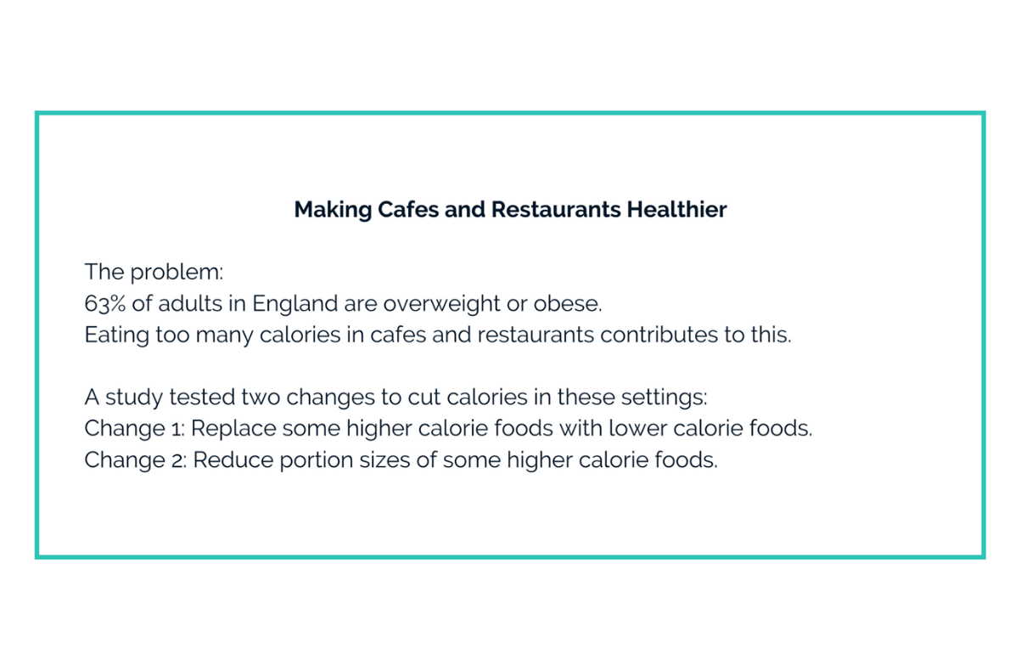
Assert and Quantify group
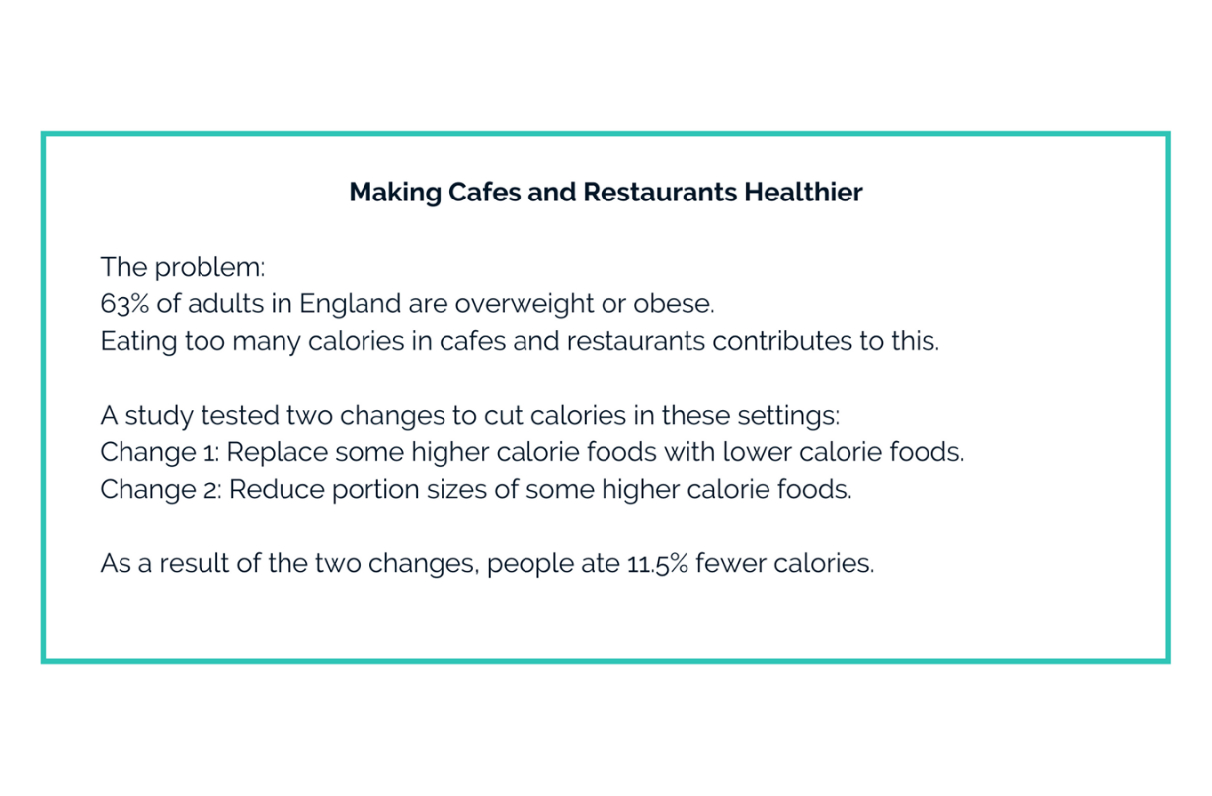

Assert, Quantify, and Visualise group
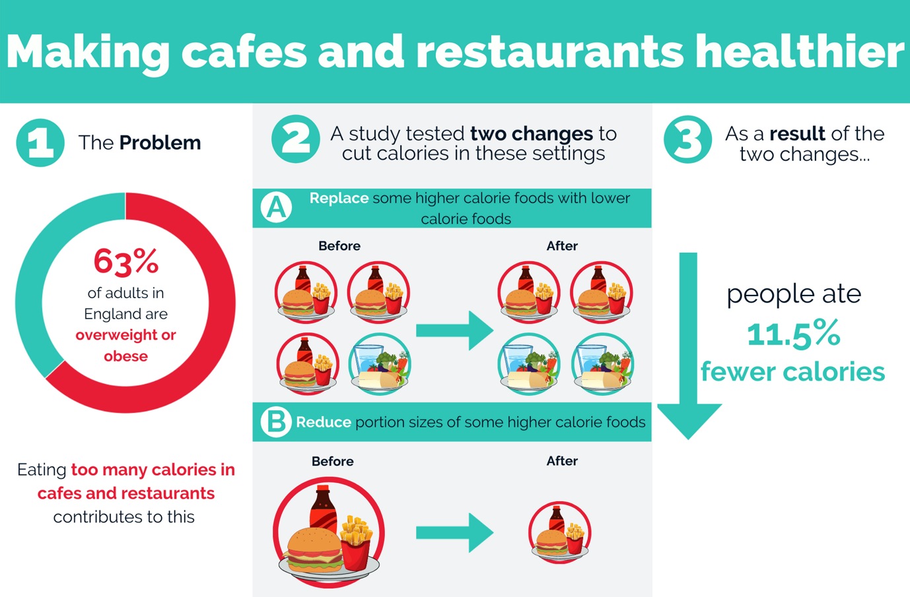

Assert, Quantify, and Re-express
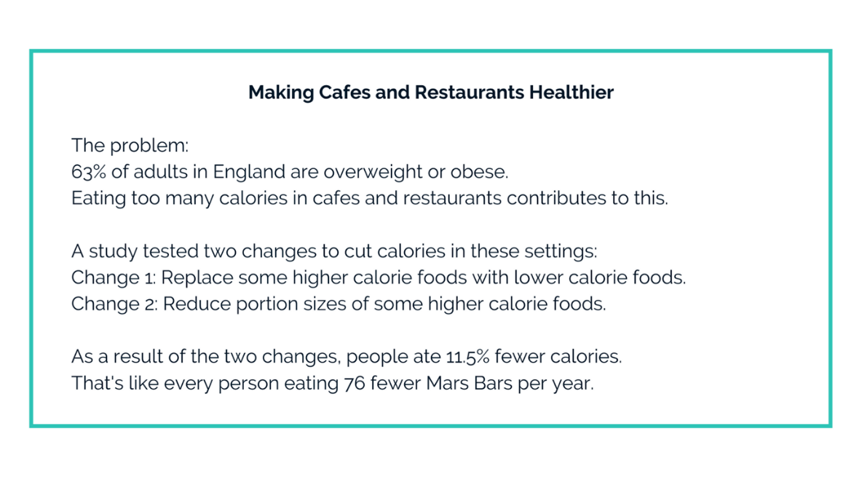

Assert, Quantify, Visualise, and Re-express
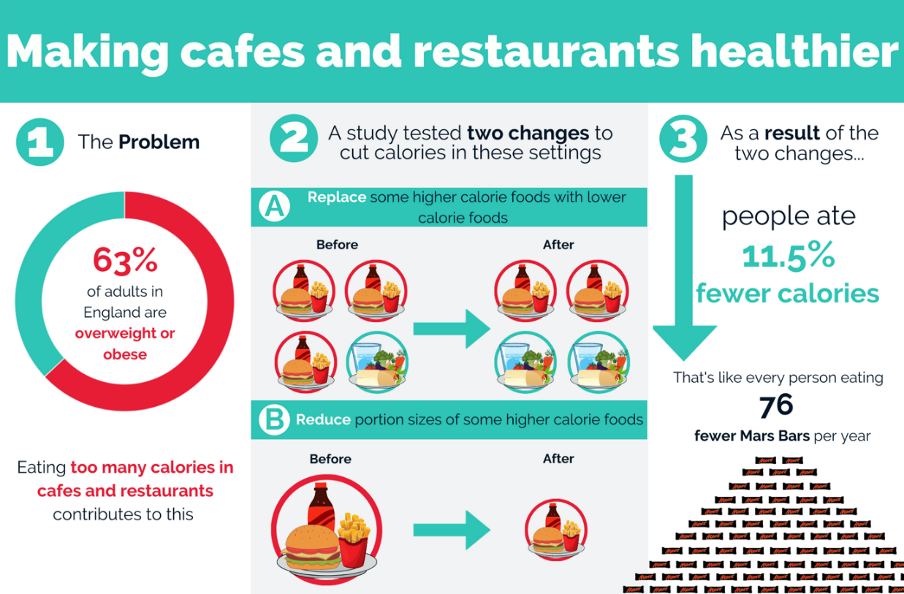

Supplement C – Full questionnaire

[All instructions are in square brackets and should not appear in the final questionnaire]
[Perceived effectiveness: both]
The following questions are about your views on the two different changes that have been proposed. Please indicate whether you agree or disagree with each statement
[Randomly order questions 1a and 1b]
 | 1. Making this change in cafes and restaurants will reduce the number of calories that people eat:
a) Reducing the portion size of some higher calorie foods | Strongly agree | Agree | Somewhat agree | Neither agree not disagree | Somewhat disagree | Disagree | Strongly disagree
b) Replacing some higher calorie foods with lower calorie foods | Strongly agree | Agree | Somewhat agree | Neither agree not disagree | Somewhat disagree | Disagree | Strongly disagree
c) Making both of these changes | Strongly agree | Agree | Somewhat agree | Neither agree not disagree | Somewhat disagree | Disagree | Strongly disagree

[Randomly order questions 2a and 2b]
 | 2. England’s problem with eating too many calories can be helped by:
a) Reducing the portion size of some higher calorie foods in cafes and restaurants | Strongly agree | Agree | Somewhat agree | Neither agree nor disagree | Somewhat disagree | Disagree | Strongly disagree
b) Replacing some higher calorie foods with lower calorie foods in cafés and restaurants | Strongly agree | Agree | Somewhat agree | Neither agree nor disagree | Somewhat disagree | Disagree | Strongly disagree
c) Making both of these changes | Strongly agree | Agree | Somewhat agree | Neither agree nor disagree | Somewhat disagree | Disagree | Strongly disagree

[Acceptability]
The next few questions are about your views on implementing the changes in cafes and restaurants. Please indicate whether you support or oppose each change.
[Randomly order questions 3a and 3b]
 | 3. Do you support or oppose the following changes in cafes and restaurants:
a) Reducing the portion size of some higher calorie foods | Strongly support | Support | Somewhat support | Neither support nor oppose | Somewhat oppose | oppose | Strongly oppose
b) Replacing some higher calorie foods with lower calorie foods | Strongly support | Support | Somewhat support | Neither support nor oppose | Somewhat oppose | oppose | Strongly oppose
c) Making both of these changes | Strongly support | Support | Somewhat support | Neither support nor oppose | Somewhat oppose | oppose | Strongly oppose

[Subjective comprehension]
The next two questions are about the information that you received about the two changes that were proposed for cafes and restaurants. Please indicate whether you agree or disagree with each statement.
[Randomly order questions 10 and 11]
- I found the information about the two changes to be clear
  - Strongly agree
  - Agree
  - Agree a little
  - Neither agree nor disagree
  - Disagree a little
  - Disagree
  - Strongly disagree

- I found the information about the two changes easy to understand
- Strongly agree
- Agree
- Agree a little
- Neither agree nor disagree
- Disagree a little
- Disagree
- Strongly disagree

[Attention check]
- Please select the number 4 from the list below
- 1
- 4
- 9
- 12

[Recall]
The next questions are to test whether you remember the information that you received about the two changes that were proposed in cafes and restaurants

- Below are seven changes that could be made in cafes and restaurants. Select two of these to show which were described at the beginning of this survey [randomise order of response options]
  - Placing fruit and vegetables close to customers
  - Reducing the size of plates
  - Replacing higher calorie foods with lower calorie foods
  - Calorie labelling on foods
  - Reducing the portion size of foods
  - Health warning labels on foods
  - Decreasing the price of healthier foods

- What was the effect of the two changes that were described?
- Increased calories purchased 1-10%
- Increased calories purchased 10-20%
- Increased calories purchased 20-30%
- No effect on calories purchased
- Decreased calories purchased 1-10%
- Decreased calories purchased 10-20%
- Decreased calories purchased 20-30%

[Height and weight for BMI]
- What is your current height?
[drop down menu]

- What is your current weight?
[drop down menu]

[Numeracy]
- Which of the following numbers represents the biggest risk of getting a disease? [randomise order of response options]
- 1 in 100 risk of getting a disease
- 1 in 1,000 risk of getting a disease
- 1 in 10 risk of getting a disease

- Do you know what a Mars Bar is?
- Yes
- No

Supplement D – Sensitivity analyses
The following section provides the results for the sensitivity analyses to compare whether the main results change following the removal of outliers (defined as any value ± 3 standard deviations from the median). Tables S1-S5 show that all results and conclusions are robust to the presence of outliers.
Table S1. Effect of communicating evidence on perceived effectiveness with and without outliers
 | Perceived effectiveness of Availability + Size |  |  | Perceived effectiveness of Availability + Size with outliers removed
Predictors | Estimates | CI | p | Estimates | CI | p
(Intercept) | 5.49 | 5.40 – 5.58 | <0.001 | 5.61 | 5.53 – 5.69 | <0.001
Control group | Reference |  |  | Reference
Evidence group | 0.19 | 0.09 – 0.29 | <0.001 | 0.15 | 0.06 – 0.23 | 0.001
Observations | 4500 |  |  | 4422
Note. Both results are significant, in the same direction, and with similar sized estimates.

Table S2. Effect of communicating evidence on acceptability with and without outliers

 | Acceptability of Availability + Size |  |  | Acceptability of Availability + Size with outliers removed
Predictors | Estimates | CI | p | Estimates | CI | p
(Intercept) | 5.24 | 5.14 – 5.34 | <0.001 | 5.44 | 5.35 – 5.53 | <0.001
Control group | Reference |  |  | Reference
Evidence group | 0.12 | 0.01 – 0.24 | 0.034 | 0.07 | -0.04 – 0.17 | 0.206
Observations | 4500 |  |  | 4343
Note. Both results are non-significant (at adjusted α = .006) and with similar sized estimates.

Table S3. Effect of visualising and re-expressing evidence on perceived effectiveness with and without outliers
 | Perceived effectiveness of Availability + Size |  |  | Perceived effectiveness of Availability + Size with outliers removed
Predictors | Estimates | CI | p | Estimates | CI | p
(Intercept) | 5.68 | 5.61 – 5.76 | <0.001 | 5.77 | 5.70 – 5.84 | <0.001
Text only | Reference |  |  | Reference
Visualise | 0.02 | -0.06 – 0.11 | 0.605 | 0.01 | -0.07 – 0.09 | 0.797
No re-expression | Reference |  |  | Reference
Re-expression | -0.03 | -0.11 – 0.06 | 0.507 | -0.05 | -0.13 – 0.03 | 0.211
Observations | 3606 |  |  | 3551
Note. Both visualisation results are non-significant with similar sized estimates. Both re-expression results are non-significant with similar sized estimates.

Table S4. Effect of visualising and re-expressing evidence on acceptability with and without outliers

 | Acceptability of Availability + Size |  |  | Acceptability of Availability + Size with outliers removed
Predictors | Estimates | CI | p | Estimates | CI | p
(Intercept) | 5.31 | 5.23 – 5.40 | <0.001 | 5.49 | 5.41 – 5.57 | <0.001
Text only | Reference |  |  | Reference
Visualise | 0.08 | -0.02 – 0.18 | 0.121 | 0.05 | -0.04 – 0.14 | 0.239
No re-expression | Reference |  |  | Reference
Re-expression | 0.02 | -0.08 – 0.12 | 0.674 | -0.02 | -0.11 – 0.07 | 0.711
Observations | 3606 |  |  | 3490
Note. Both visualisation results are non-significant with similar sized estimates. Both re-expression results are non-significant with similar sized estimates.

Table S5. Effect of visualising and re-expressing evidence on subjective comprehension with and without outliers

 | Subjective comprehension |  |  | Subjective comprehension with and without outliers
Predictors | Estimates | CI | p | Estimates | CI | p
(Intercept) | 6.13 | 6.07 – 6.19 | <0.001 | 6.15 | 6.09 – 6.20 | <0.001
Text only | Reference |  |  | Reference
Visualise | -0.11 | -0.18 – -0.05 | 0.001 | -0.09 | -0.15 – -0.03 | 0.006
No re-expression | Reference |  |  | Reference
Re-expression | 0.01 | -0.06 – 0.08 | 0.814 | 0.02 | -0.05 – 0.08 | 0.578
Observations | 3606 |  |  | 3578
Note. Both visualisation results are significant, in the same direction, and with similar sized estimates. Both re-expression results are non-significant with similar sized estimates.

Supplement E – Additional results

The following section provides the results for secondary analysis in which the outcomes including perceived effectiveness and acceptability of the Size and Availability policies individually.
Communicating evidence of policy effectiveness
Communicating evidence of Availability plus Size effectiveness (four evidence groups combined vs control group) increased the belief Size policy alone, B = 0.20, 95% CIs [0.11 to 0.30], p < 0.001, d = 0.15, yet there was no evidence that this changed perceptions of the effectiveness of the Availability policy alone, B = 0.09, 95% CIs [-0.01 to 0.18], p = 0.066, d = 0.07. This was supported by a Bayesian analysis, BF = 0.23, which provide moderate evidence in favour in the null hypothesis.
There was no evidence that communicating evidence of the effectiveness of the two interventions combined increased acceptability of the Availability policy, B = 0.08, 95% CIs [-0.03 to 0.19], p = 0.141, d = 0.06, BF = 0.12, or Size policy, B = 0.05, 95% CIs [-0.07 to 0.16], p = 0.437, d = 0.03, BF = 0.07. Bayes factors suggest there is anecdotal evidence, moderate evidence, and strong evidence for the null hypothesis, respectively.
Visualising evidence of policy effectiveness
There was no evidence that visualising evidence of policy effectiveness changed perceptions of the effectiveness of the Availability policy, B = 0.00, 95% CIs [-0.08 to 0.08], p = 0.995, d = 0.00, BF = 0.04 or the Size policy, B = 0.04, 95% CIs [-0.04 to 0.13], p = 0.323, d = 0.03, BF = 0.06. The Bayesian analyses suggest there is strong evidence in favour of the null hypothesis for both policies.
There was also no evidence that visualising evidence of policy effectiveness changed acceptability of the Availability policy, B = 0.08, 95% CIs [-0.02 to 0.17], p = 0.119, d = 0.05, BF = .13 or the Size policy, B = 0.08, 95% CIs [-0.02 to 0.18], p = 0.135, d = 0.05, BF = .11. The Bayesian analyses suggest there is moderate evidence in favour of the null hypothesis for both policies.
Re-expressing evidence of policy effectiveness
There was no evidence that re-expressing the evidence of policy effectiveness changed perceptions of the effectiveness of the Availability policy, B = 0.01, 95% CIs -0.07 to 0.09], p = 0.846, d = 0.01, BF = .04, or Size policy, B = 0.01, 95% CIs [-0.08 to 0.09], p = 0.900, d = 0.00, BF = .04. The Bayesian analyses suggest there is strong evidence in favour of the null hypothesis for both policies.
There was also no evidence that re-expressing the evidence of policy effectiveness changed acceptability of the effectiveness of the Availability alone, B = 0.01, 95% CIs [-0.09 to 0.10], p = 0.873, d = 0.01, BF = .04, or Size alone, B = -0.01, 95% CIs [-0.12 to 0.09], p = 0.802, d = -0.01, BF = .04. The Bayesian analyses suggest there is strong evidence in favour of the null hypothesis for both policies.

Supplement F – Support for policies among the control group

Table S6. Support and opposition of each policy for the control group only.
Variable | Count | Percentage | 95% Confidence intervals
Acceptability of Size
Oppose | 135 | 15% | 13%, 18%
Neither support nor oppose | 98 | 11% | 9%, 13%
Support | 661 | 74% | 71%, 77%
Acceptability of Availability
Oppose | 104 | 12% | 10%, 14%
Neither support nor oppose | 90 | 10% | 8%, 12%
Support | 700 | 78% | 75%, 81%
Acceptability of Availability plus Size
Oppose | 132 | 15% | 13%, 17%
Neither support nor oppose | 122 | 14% | 12%, 16%
Support | 640 | 72% | 69%, 74%
Note. These may not match the sum of the sub-categories in Figure 1 due to rounding.

Supplement G – Qualitative analyses
Out of the 4500 participants recruited into the study, 249 (6%) left comments in the open text response box (after removing comments such as “no comment” or “N/A”).

Thematic analysis
Four main themes were identified from manual content analysis of participants’ free-text comments:
- Effectiveness (i.e. whether the size and availability interventions were perceived capable of reducing levels of obesity, and why).
- Acceptability (i.e. whether the size and availability interventions were supported or opposed, and why).
- Presentation of information (i.e. whether the information presented during the study was accurate and well-presented).
- Other solutions for obesity (i.e. approaches to reducing obesity levels that participants deemed more effective and/or acceptable).
Additional subthemes were identified for each theme. More information about each theme and subtheme can be found in Table S7.

Valence of comments
An analysis of the comment valence suggested that 14% of comments were positive towards the interventions, 47% were negative, and 38% were neutral/mixed. A breakdown of valence by intervention group can be found in Table S8. This is further broken down by theme in tables S9-S12.

Table S7. Themes identified in free-text comments
Theme | Subtheme | Description | Examples
Theme 1: Effectiveness | The interventions would be effective | Participants believed that the size/ availability interventions would be effective at reducing obesity. | “These interventions, which are simple to implement, make a significant difference to the total calories that are consumed when eating out. This would lead to a major health gain for obese individuals.” (participant 3469, intervention 5)
 | The interventions would be ineffective | Participants believed that the size/ availability interventions would be ineffective at reducing obesity, and may even backfire to make the situation worse. | “I think encouraging healthier eating is the way forward as surely if portion sizes are reduced then people will just order more, which would be even worse for them.” (participant 535, intervention 5)
 | Additional considerations are necessary for the interventions to be effective | Participants believed that the size/ availability interventions had potential, but that more thought should be put into how they could be implemented effectively in practice. | “reucing [sic] portions is helpful but some people would just buy more regardless of price. A lot of foods have empty calories and people feel the need to fill up more just to gain the required nutrition so it isnt [sic] only about reducing the calories, they must also improve the nutrititional [sic] contents.” (participant 942, intervention 3)
Theme 2: Acceptability | Generally supportive | Participants commented that they would like to see the interventions implemented. | “I look forward to hopefully seeing these new changes in cafes and restaurants in the future” (participant 713, intervention 4)
 | Generally opposed | Participants commented that they would not like to see the interventions implemented. | “Hope this proposal is abandoned” (participant 235, intervention 3)
 | Acceptability contingent on how the interventions are implemented | Participants were open to the interventions, but only if they would be implemented in particular ways. | “the only way this can happen is if prices drop too” (participant 2873, intervention 1)
 | The interventions are not targeted enough | Participants felt that broadly targeting cafes and restaurants for intervention was unnecessary, as not everyone who eats in a café or restaurant needs to reduce their calorie intake. | “why penalise normal weight people because overweight people eat too much” (participant 192; control group)
 | The interventions would ruin the treat of eating out | Participants felt that eating out should be a treat, and that the interventions would ruin the enjoyment in eating out. | “you assume that everybody eats out a lot I very rarely do, so eating out for me is a real treat, and\I [sic] don't think about the calories in food just if i [sic] like it or not” (2396; control group)
 | Opposed to feeling controlled by the interventions | Participants felt that the interventions removed their agency and individual choice, and treated them as if they could not make decisions for themselves. They disliked this, and felt that individuals should be able to make their own choices about what they eat. | “It is up to the individual to look after his health. I am utterly fed up with the Nanny state we are living in where other people feel the need to think for us. If I want to eat food that is considered less good for, that is my choice and nobody elses [sic].” (participant 3226; assert, quantify, and re-express)
 | Belief that interventions would not be implemented fairly | Participants did not trust that the interventions would be implemented fairly. Some believed that companies may use the interventions to exploit customers. | “It's all well and good reducing portion sizes and whilst I agree that it is the right thing to do, having been in the catering trade I know full well that the prices will not reflect the reductions, ie, prices will remain the same or rise. As a person who is fortunate enough to earn a very good living that is not going to affect me, but as usual, those at the lower end of the pay scale or unemployed will be getting less and paying more. I do not think that this is fair, no matter why.” (participant 141; assert, quantify, visualise, and re-express)
Theme 3: Presentation of information | Positive view of information presented: content | Participants commented favourably on the content of the information presented during the study. | “I think that it is important to judge the equivalent calorie reduction based on hypothetical Mars bar consumption, which provides greater insight on the benefits of eating more responsibly.” (participant 3595; assert, quantify, visualise, and re-express)
 | Negative view of information presented: form | Participants commented unfavourably on the form of the information presented during the study, particularly the visualisation. | “I thought the original info and graphics were too complicated , [sic] taking time to read it all and digest it”. (Participant 773; assert, quantify, visualise, and re-express)
 | Negative view of information presented: content | Participants either disagreed with information that had been given to them in the study materials, or felt that useful information was missing from the study materials. | “very optimistic science and farcical to blame the problems on cafes and restaurants” (Participant 1569; assert, quantify, and visualise)
Theme 4: Other solutions for obesity | Education/ information campaigns | Participants believed that the reduce and replace interventions would not work or were not acceptable, and that a better approach would be to educate and inform people about how to be healthy. | “I don’t believe that people can or should be forced to change their eating habits. The only way to change eating habits so they are “healthier” is by education and information/labelling.” (participant 1395; control group)
 | Financial intervention | Participants believed that the reduce and replace interventions would not work or were not acceptable, and that a better approach would be to intervene financially, either to make healthy eating cheaper, or unhealthy eating more expensive. | “I personally consider education or increased taxes (and thus increased prices) on unhealthy food to be a better approach to reducing obesity than reducing portion sizes (people will order more portions / go somewhere with larger portions) or swapping (people will ignore advice to swap).” (participant 4328; assert, quantify, visualise, and re-express)
 | Restrict sales | Participant believed that the reduce and replace interventions would not work or were not acceptable, and that a better approach would be to ban the sales of certain products that contribute to overweight and obesity. | “banning the sale of cola and the like to under 18s would be more effective” (participant 842; assert, quantify, and re-express)
 | Design environments conducive to better health | Participants believed that the reduce and replace interventions would not work or were not acceptable, and that a better approach would be to prioritise health in urban design and in plans to improve quality of life. | “I don't agree that cutting the amount of calories or portion sizes in cafes etc is the right way to go about it, offering people the chance to have a better quality of life in general would natural ly [sic] increase their motivation to eat healthier, e.g.. help people to reduce stress or improve their income more easily.” (participant 1287; assert and quantify)
 | Medical/ scientific intervention | Participants believed that the reduce and replace interventions would not work or were not acceptable, and that a better approach would be to solve the problem through medical interventions. | “If doctors/scientists really want to help obesity they should just come up with a pill that stops you gaining weight, and another to make you lose weight if you're already overweight.” (Participant 1711; assert, quantify, visualise, and re-express)
 | Physical activity | Participants believed that the reduce and replace interventions would not work or were not acceptable, and that a better approach would be to focus on physical activity interventions. | “EXERCISE WILL MAKE MORE DIFFERENCE TO naTIONS [sic] HEALTH THAN CHANGES TO FOOD INTAKE” (Participant 4171; assert, quantify, and re-express)

Table S8. Percentage (number) of valence code type by intervention group

 | Control group | Assert and quantify | Assert, quantify, and visualise | Assert, quantify, and re-express | Assert, quantify, visualise, and re-express | Total
Positive | 13 (7) | 20 (9) | 7 (4) | 12 (6) | 22 (10) | 14 (36)
Negative | 50 (27) | 51 (23) | 49 (27) | 45 (22) | 41 (19) | 47 (118)
Neutral/mixed | 37 (20) | 29 (13) | 44 (24) | 43 (21) | 37 (17) | 38 (95)

Table S9: Percentage (number) of valence code type by intervention group – Theme 1 (Effectiveness)
 | Control group | Assert and quantify | Assert, quantify, and visualise | Assert, quantify, and re-express | Assert, quantify, visualise, and re-express | Total
Positive | 4 (1) | 18 (4) | 0 (0) | 6 (1) | 5 (1) | 9 (7)
Negative | 56 (14) | 41 (9) | 61 (11) | 35 (6) | 57 (12) | 65 (50)
Neutral/mixed | 40 (10) | 41 (9) | 39 (7) | 59 (10) | 38 (8) | 43 (44)

Table S10: Percentage (number) of valence code type by intervention group – Theme 2 (Acceptability)
 | Control group | Assert and quantify | Assert, quantify, and visualise | Assert, quantify, and re-express | Assert, quantify, visualise, and re-express | Total
Positive | 19 (6) | 23 (6) | 11 (4) | 18 (5) | 27 (6) | 19 (27)
Negative | 58 (18) | 54 (14) | 50 (19) | 43 (12) | 32 (7) | 48 (70)
Neutral/mixed | 23 (7) | 23 (6) | 39 (15) | 39 (11) | 41 (9) | 33 (48)

Table S11: Percentage (number) of valence code type by intervention group – Theme 3 (Presentation of information)
 | Control group | Assert and quantify | Assert, quantify, and visualise | Assert, quantify, and re-express | Assert, quantify, visualise, and re-express | Total
Positive | 0 (0) | 0 (0) | 0 (0) | 0 (0) | 50 (3) | 13 (3)
Negative | 33 (1) | 75 (3) | 33 (2) | 100 (4) | 33 (2) | 52 (12)
Neutral/mixed | 66 (2) | 25 (1) | 66 (4) | 0 (0) | 17 (1) | 35 (8)

Table S12: Percentage (number) of valence code type by intervention group – Theme 4 (Other solutions for obesity)
 | Control group | Assert and quantify | Assert, quantify, and visualise | Assert, quantify, and re-express | Assert, quantify, visualise, and re-express | Total
Positive | 0 (0) | 0 (0) | 0 (0) | 0 (0) | 0 (0) | 0 (0)
Negative | 100 (6) | 100 (5) | 71 (5) | 63 (5) | 100 (3) | 83 (24)
Neutral/mixed | 0 (0) | 0 (0) | 29 (2) | 38 (3) | 0 (0) | 17 (5)

