Can Vaccination Intentions Against COVID-19 be Nudged?
Supplementary Materials

Table of Contents
Summary information of the studies 3
Study 1 3
The text of the full study 3
Summary of the experiment 3
Full study in Hebrew 4
Additional Results Study 1 13
Table S1-1. Characteristics of Participants 13
Distribution of Choices 13
Figure S1-1. Distribution of Choices Study 1 13
Results for the Restricted Sample (excluding manipulation check “failures”) 14
Figure S1-2. Social norm experiment in Israel, Restricted Sample (excluding attention check failures) 14
Table S1-2. Additional Tests Main Effects Full Sample 14
Table S1-3. Regression Analysis Main Effects Full Sample 15
Figure S1-3. Equivalence test for the difference between the control and the nudge groups 16
Figure S1-4. Equivalence test for the difference between the nudge and the nudge + transparency groups 16
Figure S1-5. Equivalence test for the difference between the control and the nudge + transparency groups 16
Experiment 1- Potential Moderating Effects 17
Gender 17
Conspiracy theories 17
Compliance 17
Risk perception 18
Trust in the government 18
Political views 19
Figure S1-6. Combined Moderating Effects Results 19
Study 2 20
The text of the full study 20
Additional Results Study 2 29
Table S2-1. Characteristics of Participants 29
Distribution of Choices 29
Figure S2-1. Distribution of Choices in the Control Group 29
Death Saliency Nudge 30
Results for the Restricted Sample (excluding manipulation check “failures”) 30
Figure S2-2. Death Saliency Nudge Restricted Sample (excluding manipulation check failures) 30
Additional Tests 30
Table S2-2. Additional Tests Main Effects Full Sample Death Saliency Nudge 30
Table S2-3. Regression Analysis Main Effects Full Sample Death Saliency Nudge 31
Figure S2-3. Equivalence test for the difference between the control and the nudge groups (Death Saliency Nudge) 32
Figure S2-4. Equivalence test for the difference between the nudge and the nudge + transparency groups (Death Saliency Nudge) 32
Figure S2-5. Equivalence test for the difference between the control and the nudge + transparency groups (Death Saliency Nudge) 32
Symptoms Saliency Nudge 33
Results for the Restricted Sample (excluding manipulation check “failures”) 33
Figure S2-6. Symptoms Saliency Nudge Restricted Sample (excluding manipulation check failures) 33
Additional Tests 33
Table S2-4. Additional Tests Main Effects Full Sample Symptoms Saliency Nudge 33
Table S2-5. Regression Analysis Main Effects Full Sample Symptoms Saliency Nudge 34
Figure S2-7. Equivalence test for the difference between the control and the nudge groups (Symptoms Saliency Nudge) 35
Figure S2-8. Equivalence test for the difference between the nudge and the nudge + transparency groups (Symptoms Saliency Nudge) 35
Figure S2-9. Equivalence test for the difference between the control and the nudge + transparency groups (Symptoms Saliency Nudge) 35
Experiment 2- Potential Moderating Effects (Both Saliency Nudges) 36
Gender 36
Conspiracy theories 36
Risk perception 36
Political ideology 36
Figure S2-10. Combined Moderating Effects Results 37
Bibliography 38

Summary information of the studies
Study | Country/sample | Period | Tested nudges | N
1 | Israel | October 11-18, 2020 | Descriptive social norm | N=1,121  (3 experimental groups)
2 | UK | January 8-16, 2021 | 1. Death from COVID-19 Saliency  2. Symptoms of COVID-19 Saliency | N=1,308  (5 experimental groups)

Study 1

The text of the full study
First, we present the summary of the study in English. Next, we present the full text of the study in its original language (Hebrew). It should be noted that aside from the main experimental intervention text, which is presented here, and the manipulation check question which has been presented in the main text, all the other questions are identical to Study 2, therefore, we do not translate it to English. Even though the researchers had access to the data during its collection, the data in both studies was analysed after the collection process was complete. There are no pilot studies to report.

Summary of the experiment
Consent form
Survey questions of the larger study, including: (reported) compliance behaviour with anti-COVID-19 rules, support for measures, risk perception, belief in COVID-19 related conspiracy theories, trust in government, political ideology.
Q1: If a vaccine for COVID-19 was available, I would get vaccine against the virus (5=strongly agree; 4=agree; 3=neither agree or disagree; 2=disagree; 1=strongly disagree).

Control | Social norm | Social norm + transparency
No additional information | In a recent anonymous survey on a representative sample of the Israeli population the vast majority of people stated they would get a COVID-19 vaccine if it was available (The research was published in: Dror et al. European journal of epidemiology 35, no. 8 (2020): 775-779.) | In a recent anonymous survey on a representative sample of the Israeli population the vast majority of people stated they would get a COVID-19 vaccine if it was available (The research was published in: Dror et al. European journal of epidemiology 35, no. 8 (2020): 775-779.)  The goal of presenting information on the study regarding the intentions of other people to get vaccination is to increase your willingness to get a COVID-19 vaccination, since vaccination can protect you and others against COVID-19. The reason those findings are presented to you is the knowledge from behavioral studies that people are strongly influenced by the actions and believes of other people.
Q2: [For those who chose 2 or 1 in Q1]: For the following statement, please choose the option which best describes your view.
I prefer not to get vaccinated against COVID-19 because…
(you may indicate more than one reason)
- I am worried about the side effects
- I don’t think it will be effective
- I am not enough at risk from COVID-19
- I am against vaccines in general
- I don’t have the time
- If majority of people intend to vaccinate, then I will be protected from the virus
- Another reason [open]
Demographics

Full study in Hebrew

Start of Block: Consent form
טופס הסכמה השתתפות במחקר
מטרת המחקר
מטרת המחקר הינה ללמוד על תפיסותך ולהבין את דעותיך לגבי מגיפת הקורונה. המחקר נערך על ידי חוקרים מאוניברסיטת ארסמוס רוטרדם, הולנד (Erasmus University Rotterdam) - ד"ר אלנה קנטורוביץ-רזניצ׳נקו (reznichenko@law.eur.nl), ואוניברסיטת ליידן, הולנד (Leiden University) - ד"ר ירוסלב קנטורוביץ (j.j.kantorowicz@fgga.leidenuniv.nl). המחקר אושר על ידי ועדת האתיקה של אוניברסיטת קנט (בבריטניה) וכן על ידי ועדת האתיקה של אוניברסיטת ארסמוס ברוטרדם (הולנד).
מי יכול להשתתף?
יכולים להשתתף במחקר כל מי שהם מעל גיל 18.
מה כולל המחקר?
אורך המחקר הינו כ10 דקות. במסגרת זמן זה נשאל אותך שאלות על דעותיך והתנהגותך. אין כאן תשובות נכונות או לא נכונות, אנו מעוניינים רק בדעותיך הכנות.
האם יש סיכונים או אי-נוחות?
השתתפותך אינה כרוכה בשום סיכון פיזי, משפטי או כלכלי. את/ה לא מחוייב/ת לענות על שאלות שאין ברצונך לענות עליהן. את/ה משתתף/ת במחקר זה מרצונך החופשי ויכול/ה להפסיק בכל שלב.
התשובות שלך חסויות!
כל תשובותיך יטופלו בסודיות. מידע אישי לגביך לא יפורסם בשום צורה, ולא יהיה ניתן לקשר בין התשובות שלך לזהות שלך. כל פרסום הנובע מעבודה זו ידווח רק על ממצאים כוללנים או על דוגמאות אנונימיות לחלוטין שלא מאפשרות לזהות אותך, כך שכל תשובה שלך תישאר אנונימית לחלוטין. מידע שיאסף במחקר זה, ישמר במאגר נתונים מוגן ומקוונן באוניברסיטה וע״י החוקרים. המידע ישמר למשך 10 שנים.
התשובות האנונימיות שלך ישמשו את החוקרים, אך צוות המחקר עשוי גם לשתף חוקרים אחרים בתשובותיך האנונימיות, או לעשותם זמינים במאגר נתונים מקוון. במידת הצורך המידע האנונימי ישותף עם גורמים נוספים לצרכים כגון שמירה על יושרה מדעית.
השתתפות מרצון חופשי
ההשתתפות במחקר זה הינה התנדבותית לחלוטין. גם אחרי שתסכים/י להשתתף ותתחיל/י את המחקר, יש באפשרותך לעצור בכל עת ומכל סיבה. יש לך את הזכות למשוך את הנתונים שלך בכל עת לפני שהנתונים שלך כלולים בניתוח המחקרי (כשבוע לאחר תחילת איסוף הנתונים), ללא השלכות שליליות. אם תחליט/י למשוך את הנתונים שלך לאחר שהם נכללו בניתוח המחקרי, עדיין ניתן להשתמש בהם בצורתם האנונימית ומשיכתם אינה שוללת את חוקיות הניתוח המחקרי שכבר בוצע.
במקרה וברצונך למשוך את נתוניך או שיש לך שאלות לגבי המחקר, אנא צור/צרי קשר עם החוקרת הראשית ד"ר אלנה קנטורוביץ-רזניצ׳נקו (reznichenko@law.eur.nl). אם יש לך שאלות ספציפיות לגבי השימוש בנתוני המחקר, ניתן גם לפנות לרכז המידע של האוניברסיטה fg@eur.nl. כמו כן, במקרה של תלונות ניתן לפנות ל Dutch Data Protection Authority. בנוסף, יש לך זכות להגיש בקשה לקבל גישה, לשנות, או למחוק את נתוניך. יש לך אפשרות לעשות זאת ע״י מילוי טופס בElectronic Service Desk שניתן למצוא באתר הבא: https://www.eur.nl/disclaimer/privacy-statement.
גמול
קבלת הגמול עבור השתתפותך במחקר זה הינה לפי ההסכם בינך לבין חברת הסקר.
הסכמת השתתפות
אני מאשר/ת שקראתי והבנתי את דף המידע הנוכחי בנוגע למחקר. הייתה לי הזדמנות לשקול את המידע, בצורה מספקת. ניתנה לי ההזמנות לשאול שאלות. אני משתתף/ת במחקר זה מרצוני החופשי, ושום לחץ ישיר או בלתי ישיר לא הופעלו עליי לצורך השתתפותי. ברור לי כי יש ביכולתי להפסיק את השתתפותי בכל רגע נתון, ללא צורך בסיבה, וכן כי אני לא חייב/ת לענות על שאלה אם אין ברצוני לעשות זאת.
אני מבין/ה ומסכים/ה שהנתונים שלי יטופלו בסודיות וכל פרסום הנובע ממחקר זה ידווח רק בהתייחס לנתונים שאינם מזהים אותי. עם זאת, התגובות הלא-מזוהות שלי עשויות להיות משותפות עם חוקרים אחרים ו/או להיות זמינות במאגרי נתונים מקוונים. הסכמה זו חלה גם על מידע לגבי בריאותי/עמדותי הפוליטיות או האידיאולוגיות.
כמו כן, אני מסכים/ה שהנתונים שלי ישמרו וישמשו לצרכים אקדמיים ולצורך מחקר עתידי.
האם ברצונך לקחת חלק במחקר זה? consent
- (4) כן, אני רוצה לקחת חלק במחקר
- (5) לא, אני לא רוצה לקחת חלק במחקר

End of Block: Consent form

Start of Block: Compliance (1) distance
אנא ענה/י באופן מדויק ככל שתוכל/י:
בימי מגיפת הקורונה (COVID-19) אני ...
compl_dist
מסכים/ה בהחלט | לא מסכים/ה ולא מתנגד/ת | מתנגד/ת בהחלט

10 | 9 | 8 | 7 | 6 | 5 | 4 | 3 | 2 | 1 | 0

() נשאר/ת בבית ככל האפשר
() מבקר/ת חברים, משפחה או עמיתים מחוץ לביתי
() מצמצם/ת למינימום ביקור בחנויות מכולת
() שומר/ת על מרחק פיזי מכל האנשים האחרים מחוץ לבית שלי
() נמנע/ת מלחיצות ידיים עם אנשים מחוץ לבית שלי

End of Block: Compliance (1) distance

Start of Block: Compliance (2) hygiene and more

אנא ענה/י באופן מדויק ככל שתוכל/י:
בימי מגיפת הקורונה (COVID-19) אני ...
compl_hyg
מסכים/ה בהחלט | לא מסכים/ה ולא מתנגד/ת | מתנגד/ת בהחלט

10 | 9 | 8 | 7 | 6 | 5 | 4 | 3 | 2 | 1 | 0

() שוטף/ת ידיים (עם סבון) בצורה יסודית יותר מהרגיל
() מחטא/ה חפצים המשמשים אותי לעתים קרובות, כגון טלפונים ניידים ומפתחות
() מתעטש/ת ומשתעל/ת לתוך המרפק
() עוטה מסיכת פה ואף בכל יציאה מהבית
() איני נכנס/ת למקום ציבורי כל שהוא בעת מחלת חום או בעת הופעת תסמינים נשימתיים

End of Block: Compliance (2) hygiene and more

Start of Block: Attention check

אנא אשר/י כי את/ה קורא/ת שאלה זו על ידי הזזת הסמן לקצה בו מופיעה התשובה 0 attention
מסכים/ה בהחלט | לא מסכים/ה ולא מתנגד/ת | מתנגד/ת בהחלט

10 | 9 | 8 | 7 | 6 | 5 | 4 | 3 | 2 | 1 | 0

() .

Start of Block: Risk perception

אנא ענה/י על השאלות הבאות בצורה מדויקת ככל האפשר risk_perc
100% = ודאי | 0% = בלתי אפשרי

100 | 90 | 80 | 70 | 60 | 50 | 40 | 30 | 20 | 10 | 0

() עד ליום 30 באפריל 2021: מה הסיכוי לדעתך שאת/ה תידבק/י בנגיף הקורונה?
() עד 30 באפריל 2021: עד כמה את/ה סבור/ה שהאדם הממוצע בישראל יידבק בנגיף הקורונה ?

End of Block: Risk perception

Start of Block: Political ideology

בסך הכל, מה יהיה התיאור הטוב ביותר של השקפותיך הפוליטיות? political_ideol
נוטה מאוד לימין | מרכז | נוטה מאוד לשמאל

10 | 9 | 8 | 7 | 6 | 5 | 4 | 3 | 2 | 1 | 0

() .

End of Block: Political ideology

Start of Block: Conspiracy theories

עבור כל אחת מההצהרות הבאות, אנא בחר/י את התשובה המתארת בצורה הטובה ביותר אם את/ה מסכים/ה או מתנגד/ת. consp_theor
מסכים/ה בהחלט | לא מסכים/ה ולא מתנגד/ת | מתנגד/ת בהחלט

10 | 9 | 8 | 7 | 6 | 5 | 4 | 3 | 2 | 1 | 0

() נגיף הקורונה הוא נשק ביולוגי שהונדס על ידי מדענים
() נגיף הקורונה הוא קונספירציה שנועדה לשלול את זכויות האזרח לתמיד ולהקים משטר אוטוריטרי
() נגיף הקורונה הוא מתיחה שהומצאה על ידי קבוצת בעלי עניין לטובת רווחים כספיים.
() נגיף הקורונה נוצר כמסווה להתרסקות הכלכלית העולמית הקרבה

End of Block: Conspiracy theories

Start of Block: Trust

עבור כל אחת מההצהרות הבאות, אנא בחר/י את התשובה המתארת בצורה הטובה ביותר אם את/ה מסכים/ה או לא מסכים/ה. trust
מסכים בהחלט | לא מסכים ולא מתנגד | מתנגד בהחלט

10 | 9 | 8 | 7 | 6 | 5 | 4 | 3 | 2 | 1 | 0

() באופן כללי, אני סומך/ת על ממשלת ישראל.
() ממשלת ישראל מתמודדת היטב עם מגיפת הקורונה.
() יש לנקוט באמצעים דרסטיים כדי לעצור את מגיפת הקורונה, גם אם זה כולל הגבלה של חירויות הפרט וזכויותיו.

End of Block: Trust

Start of Block: support

אנא ענה/י באופן מדויק ככל שתוכל/י:
בימי מגיפת הקורונה (COVID-19) אני ... support_polic
מסכים/ה בהחלט | לא מסכים/ה ולא מתנגד/ת | מתנגד/ת בהחלט

10 | 9 | 8 | 7 | 6 | 5 | 4 | 3 | 2 | 1 | 0

() בעד סגירת כל בתי הספר והאוניברסיטאות
() בעד סגירת כל הברים והמסעדות
() בעד סגירת כל הפארקים והגנים הציבוריים
() בעד איסור על כל המפגשים הציבוריים שבהם אנשים רבים נאספים במקום אחד (ספורט ותרבות)
() בעד איסור על כל נסיעה לא נחוצה

End of Block: support

Start of Block: Experiment control

exper_cont
עבור ההצהרה ההבאה, אנא בחר/י את התשובה המתארת בצורה הטובה ביותר את עמדתך.
אם היה חיסון לנגיף הקורונה, הייתי מסכים/ה להתחסן מפני הנגיף
- (1) מתנגד/ת לחלוטין
- (2) מתנגד/ת
- (3) לא מסכים/ה ולא מתנגד/ת
- (4) מסכים/ה
- (5) מסכים/ה בהחלט

End of Block: Experiment control

Start of Block: Experimental nudge

עבור ההצהרה ההבאה, אנא בחר/י את התשובה המתארת בצורה הטובה ביותר את עמדתך.
אם היה חיסון לנגיף הקורונה, הייתי מסכים/ה להתחסן מפני הנגיף
- (1) מתנגד/ת לחלוטין
- (2) מתנגד/ת
- (3) לא מסכים/ה ולא מתנגד/ת
- (4) מסכים/ה
- (5) מסכים/ה בהחלט

במחקר אנונימי שנערך לאחרונה על מדגם מייצג של האוכלוסייה הכללית בארץ נמצא כי הרוב המכריע של המשתתפים היו מסכימים להתחסן בפני הנגיף אם היה חיסון לנגיף הקורונה (המחקר פורסם ב: Dror et al. 2020. European Journal of Epidemiology 35.8: 775-779).

n_manip
אנא ענה/י על השאלה הבאה:
בשאלה הקודמת הוצג בפניך מידע נוסף על מחקר אחר שנערך לאחרונה לגבי שיעור האנשים בארץ שהיה מסכים להתחסן בפני נגיף הקורונה אם היה חיסון כזה. לפי המידע שהוצג בפניך, מה היה שיעור המשתתפים שהביעו הסכמה? manip_check_n
- (1) כמחצית מהמשתתפים באותו מחקר
- (2) רוב מכריע של המשתתפים באותו מחקר
- (3) פחות ממחצית המשתתפים באותו מחקר

End of Block: Experimental nudge

Start of Block: Experiment nudge+transp
עבור ההצהרה ההבאה, אנא בחר/י את התשובה המתארת בצורה הטובה ביותר את עמדתך.
אם היה חיסון לנגיף הקורונה, הייתי מסכים/ה להתחסן מפני הנגיף
- (1) מתנגד/ת לחלוטין
- (2) מתנגד/ת
- (3) לא מסכים/ה ולא מתנגד/ת
- (4) מסכים/ה
- (5) מסכים/ה בהחלט

במחקר אנונימי שנערך לאחרונה על מדגם מייצג של האוכלוסייה הכללית בארץ נמצא כי הרוב המכריע של המשתתפים היו מסכימים להתחסן בפני הנגיף אם היה חיסון לנגיף הקורונה (המחקר פורסם ב: Dror et al. 2020. European Journal of Epidemiology 35.8: 775-779).
מטרת הצגת המידע על המחקר בנוגע לכוונותיהם של אנשים אחרים להתחסן היא להגביר את נכונותך לקבל חיסון נגד נגיף הקורונה, מכיוון שחיסון יכול להגן עליך ועל אחרים מפני קורונה. הסיבה שתוצאות מחקר זה מוצגות לך הינה הידע ממחקרים התנהגותיים המדגימים כי אנשים מושפעים מאוד ממעשיהם ואמונותיהם של אנשים אחרים.

nt_manip
אנא ענה/י על השאלה הבאה:
בשאלה הקודמת הוצג בפניך מידע נוסף על מחקר אחר שנערך לאחרונה לגבי שיעור האנשים בארץ שהיה מסכים להתחסן בפני נגיף הקורונה אם היה חיסון כזה. לפי המידע שהוצג בפניך, מה היה שיעור המשתתפים שהביעו הסכמה? manip_check_nt
- (1) כמחצית מהמשתתפים באותו מחקר
- (2) רוב מכריע של המשתתפים באותו מחקר
- (3) פחות ממחצית המשתתפים באותו מחקר

End of Block: Experiment nudge+transp

Start of Block: Experiment: reasons not to vaccinate

עבור ההצהרה ההבאה, אנא בחר/י את התשובה המתארת בצורה הטובה ביותר את עמדתך.
אני מעדיף/ה לא להתחסן נגד נגיף הקורונה כי...
(ניתן לציין יותר מסיבה אחת) reas_no_vacc
- (1) אני מודאג/ת מתופעות הלוואי
- (2) אני לא חושב/ת שהחיסון יהיה יעיל
- (3) אני לא בקבוצת הסיכון לנגיף הקורונה
- (4) אני נגד חיסונים באופן כללי
- (5) אין לי זמן
- (6) אם רוב האנשים יחוסנו, אני אהיה מוגן מהנגיף
- (7) סיבה אחרת

אם ציינת ״סיבה אחרת״ אנא ציין/י מהי

End of Block: Experiment: reasons not to vaccinate

Start of Block: Medical information

האם אובחנת כחיובי לנגיף הקורונה (ללא סיפטומים)? כלומר, האם עכשיו או בעבר אובחנת רפואית כנושא נגיף הקורונה? corona_pos
- (1) לא
- (2) כן

האם אובחנת כחולה בנגיף הקורונה (עם סימפטומים)? כלומר, האם עכשיו או בעבר אובחנת רפואית כחולה במחלה? corona_ill
- (1) לא
- (2) כן

האם מישהו שאת/ה מכיר/ה היטב (חבר, בן זוג, משפחה, עמית וכו') אובחן כנושא נגיף הקורונה (ללא סימפטומים)? corona_pos_oth
- (1) לא
- (2) כן

האם מישהו שאת/ה מכיר/ה היטב (חבר, בן זוג, משפחה, עמית וכו') אובחן כחולה בקורונה (עם סימפטומים)? corona_ill_oth
- (1) לא
- (2) כן

End of Block: Medical information

Start of Block: Demographics
gender
מה המגדר שלך?
- (1) זכר
- (2) נקבה
- (3) אחר

age
בן כמה את/ה?
relat_status
מהו המצב המשפחתי הנוכחי שלך?
- (1) רווק/ה
- (2) במערכת יחסים
- (3) נשוי/נשואה
- (4) גרוש/ה
- (5) אלמן/ה

Employ
איך היית מתאר/ת את מצבך התעסוקתי כרגע ?
- (1) מועסק/ת במשרה מלאה
- (2) מועסק/ת במשרה חלקית
- (3) מובטל/ת או מחפש/ת עבודה
- (4) סטודנט/ית
- (5) גמלאי/ת
- (6) אחר

Educ
מה רמת ההשכלה שלך?
- (1) בית ספר
- (2) עתודאי/ת
- (3) תואר ראשון
- (4) תואר שני
- (5) דוקטורט
- (6) אחר

Relig

הגדרה עצמית של מידת דתיות. אנא בחר/י מה שהכי מאפיין אותך.
אני מחשיב/ה את עצמי...
- (1) חילוני/ת
- (2) מסורתי/ת
- (3) דתי/ה
- (4) חרדי/ת

End of Block: Demographics

Start of Block: Debriefing
open
אם יש לך הערות או הארות לגבי מחקר זה, אנו נודה לך אם תוכל/י לרשום אותם פה.

תודה על השתתפותך !
מטרת מחקר זה הינה ללמוד על הדעות והחוויות של הציבור הישראלי בנוגע למגפת הקורונה.
אם לאחר השתתפותך במחקר הינך חש/ה דאגה או חוסר-שקט, ניתן לקבל תמיכה נפשית על ידי פנייה למוקד ער"ן באמצעות חיוג למספר 1201.
אם יש לך שאלות נוספות בנוגע למחקר זה אנא פנה/י לחוקרת האחראית ד"ר אלנה קנטורוביץ-רזניצ׳נקו (reznichenko@law.eur.nl).
End of Block: Debriefing

Additional Results Study 1

Table S1-1. Characteristics of Participants
 | % Female | Average age | % highly educated | N
Control | 48.9 | 43.5 | 47.6 | 374
Nudge | 52.0 | 42.1 | 52.8 | 373
Nudge + transparency | 45.2 | 44 | 46.3 | 374

Distribution of Choices

Figure S1-1. Distribution of Choices Study 1
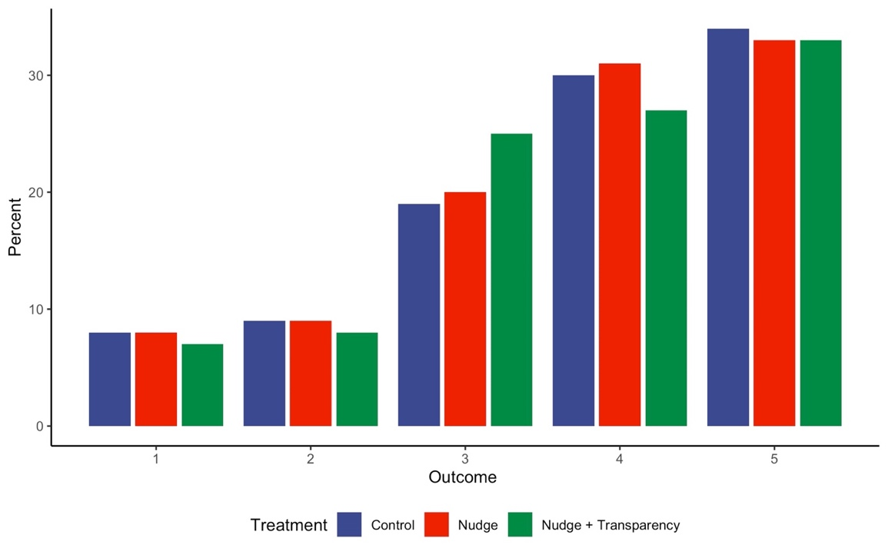

Results for the Restricted Sample (excluding manipulation check “failures”)

Figure S1-2. Social norm experiment in Israel, Restricted Sample (excluding attention check failures)
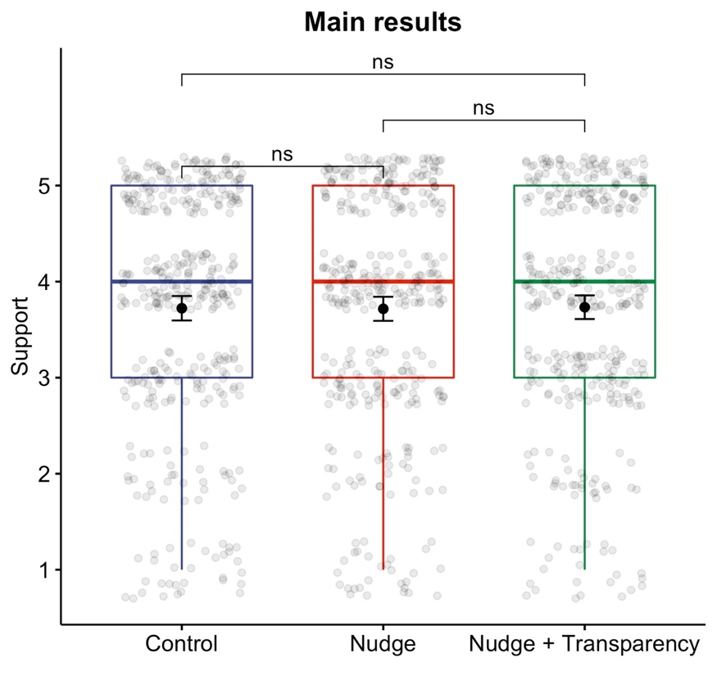

Table S1-2. Additional Tests Main Effects Full Sample
 | Control  vs  Nudge | Nudge  vs  Nudge + Transparency | Control  vs  Nudge + Transparency
Mann-Whitney-Wilcoxon test | W = 70044  p-value = 0.9178 | W = 70079  p-value = 0.9082 | W = 70518  p-value = 0.8386
Fisher’s Exact test | p-value = 0.979 | p-value = 0.6333 | p-value = 0.4601

Table S1-3. Regression Analysis Main Effects Full Sample
 | Regression Table
 |  | Dependent variable: Intention to vaccinate
 |  | OLS |  |  | Cumulative link
 |  | (1) | (2) |  | (3) | (4)
Nudge |  | 0.005 | 0.008 |  | -0.013 | -0.005
 |  | (0.089) | (0.089) |  | (0.132) | (0.133)
Nudge + Transparency |  | 0.005 | -0.011 |  | -0.028 | -0.040
 |  | (0.089) | (0.089) |  | (0.132) | (0.133)
Male |  |  | 0.392*** |  |  | 0.615***
 |  |  | (0.072) |  |  | (0.110)
Age |  |  | 0.003 |  |  | 0.004
 |  |  | (0.002) |  |  | (0.003)
Lower educated |  |  | -0.214** |  |  | -0.299**
 |  |  | (0.074) |  |  | (0.111)
Constant |  | 3.722*** | 3.508***
 |  | (0.063) | (0.138)
Observations |  | 1,121 | 1,110 |  | 1,121 | 1,110
R² |  | 0.00000 | 0.034
Adjusted R² |  | -0.002 | 0.030
Log Likelihood |  |  |  |  | -1,635.673 | -1,601.383
Note: Standard errors in parentheses. *p**p***p<0.001

Figure S1-3. Equivalence test for the difference between the control and the nudge groups

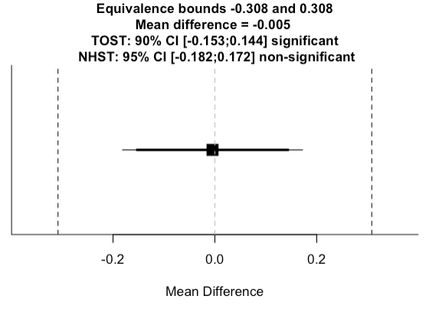

Figure S1-4. Equivalence test for the difference between the nudge and the nudge + transparency groups
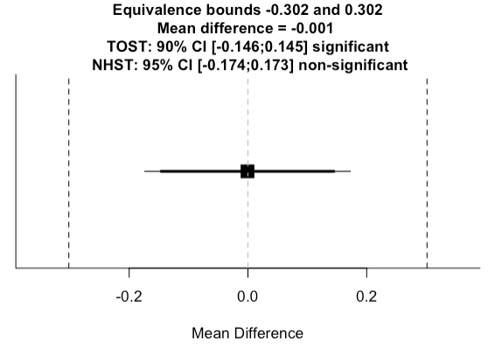

Figure S1-5. Equivalence test for the difference between the control and the nudge + transparency groups

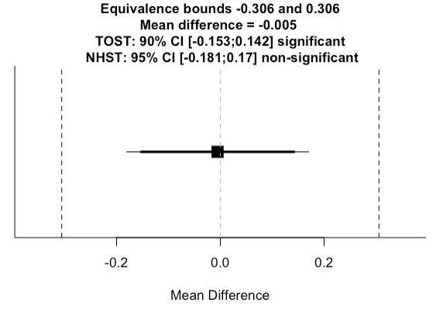

Experiment 1- Potential Moderating Effects

Aside from the main effects, we also examined the determinants of being influenced by a social norm nudge in the context of a vaccine against COVID-19. The following sections present a brief theoretical support for each hypothesis and the combined results are presented in a combined Figure S1-6 at the end of these sections.

Gender
First, a few studies have demonstrated that male participants are more responsive to social norm nudges than female respondents (Croson et al., 2010; Kantorowicz-Reznicehnko & Kantorowicz 2021). Relying on these results we predict that male participants will be more likely to increase their willingness to get vaccination against COVID-19 following the presentation of the descriptive social norm, as compared to female participants.
Interestingly, our results demonstrate that female participants in general are less willing to vaccinate against COVID-19 than male participants. However, for both groups neither the social norm, nor the transparent social norm nudge had an effect on reported intentions to vaccinate (Figure S1-6). Therefore, we see that the lack of effectiveness of the social norm nudge is not necessarily the result of simply an already high level of willingness to vaccinate.

Conspiracy theories
In our study, we also measure to what extent people believe in COVID-19 related conspiracy theories. It is reasonable to assume that people who believe to a larger extent in conspiracy theories are in general more susceptible to follow misinformation. For example, such people might be more prone to also believe in conspiracy theories with respect to the developed vaccine, which will reduce their willingness to vaccinate (Jolley & Douglas 2014). Therefore, we predict that participants who believe in conspiracy theories to a larger extent will also be less willing to receive vaccination, even when nudged to do so by a descriptive social norm as compared to participants who believe in conspiracy theories to a lesser extent.
For belief in conspiracy theories, participants indicated their level of agreement with different conspiracy theory statements on a scale from 0-10 (with 10 being “strongly agree” and 0 = ”strongly disagree”). The statements suggested for example, that the pandemic is a hoax, or a bioweapon (the exact questions in English can be found in the full text of Study 2 below). For our analysis, we divided the participants into two groups. All participants who rated their level of agreement above 5 for at least one of the three statements, were defined as believing in conspiracy theories (“Yes”). The rest were treated as not believing in conspiracy theories (“No”). As expected, participants who do not believe in conspiracy theories have significantly higher intentions to vaccinate as compared to participants who believe in such theories. However, neither of the groups was affected by social norm nudges (nor by the transparent social norm nudge) (Figure S1-6).

Compliance
Compliance with anti-COVID-19 rules related to keeping distance and maintaining personal hygiene, as well as support for anti COVID-19 public policies, such as closing public places were expected to be correlated with the intention to vaccinate. Vaccination is another method to manage the infection rates and reduce the number of deaths and sicknesses from COVID-19. People who tend to comply to a larger extent and support policies might also be more willing to follow a behaviour expressed by others. Therefore, we predicted that a stronger compliance with the rules, and support of anti-corona measures, will be associated with a more willingness to follow the direction of the nudge with respect to the intention to be vaccinated.
We measured people’s (self-reported) level of compliance with COVID-19 related rules such as keeping distance, avoiding public places, washing hands, etc. on a scale of 0-10 (0=”strongly disagree” to the statement that “I comply”; 10=”strongly agree”). To create the compliance sub-groups we divided participants into two groups. Those who indicated level of agreement five and above (on a scale of 0-10) were considered as compliant/supporting. We looked at the average level of agreement of all the statements together in each of the categories (compliance with distance; compliance hygiene; policy support).
It seems that contrary to our prediction, the differences between the two groups (compliant/supporting versus non-compliant/supporting) are small or even non existing. This refers to the control group, as well as the nudge groups. However, with respect to supporting public policies, the gap in the willingness to vaccinate when nudged with a transparent social norm, is growing between the two groups. The supporters of the policies have stronger intention to vaccinate than those who do not support when they are subject to a transparent social norm nudge. Nevertheless, when looking within the groups, also here we see that the social norm, and the transparent social norm nudge do not affect participants’ willingness to vaccinate (Figure S1-6).

Risk perception
Since the purpose of a vaccine against COVID-19 is to reduce the risk of infection, people who perceive a higher risk of getting infected with COVID-19 virus (to self or others) are also expected to follow the behavior of others and receive vaccination. Therefore, we predicted that the positive effect of presenting a descriptive social norm on the willingness to accept a vaccine against COVID-19 will be stronger as the perceived risk of infection (to self or others) is becoming higher.
For people’s risk perception we asked their perceived likelihood of getting infected with coronavirus in the next 12 months. We presented the same question asking the perceived probability that someone they know would get infected (on a scale 0%-100%).
We used the average score for the two risk perception questions (to self and to others) and divided the participants into two group – those who rated the risk above 50% and those who rated it 50% or bellow. We find no support for our prediction. There are even no differences in the control group, thus suggesting that contrary to our expectation, perceived risk does not play a significant role in people’s willingness to vaccinate (Figure S1-6).

Trust in the government
Finally, given the centrality of self-compliance with different rules and public policies in order to manage this health crisis, trust in the government is very important. Therefore, we predicted that people who are more trustful of the government (and its management capacity) will be more willing to follow others in accepting a vaccine. We measured people’s level of trust in the government and the government’s performance in managing the crisis (on a scale 0-10, where 0=strongly disagree and 10=strongly agree). We have divided the groups into two – those who have higher trust in the government and its performance (above 5) and those who have low levels of trust (5 and below). We do not find differences between the groups. Not only that the nudge has no effect on either of the groups, but they seem also not to differ in the base line (control group) (Figure S1-6).

Political views
There are some tentative indications that political ideology or views might also be relevant for people’s intention to vaccination. Therefore, we also measured whether people with different ideological stances (as measures on a scale between 0=very leaning to the left and 10=very leaning to the right) also differ in their level of intention to vaccinate, and/or their responsiveness to the nudge.
Not only that those participants with different political ideology did not differ in their vaccination intentions in the base line group, but also the nudge had the same (lack of) effect on both groups (Figure S1-6).

Figure S1-6. Combined Moderating Effects Results
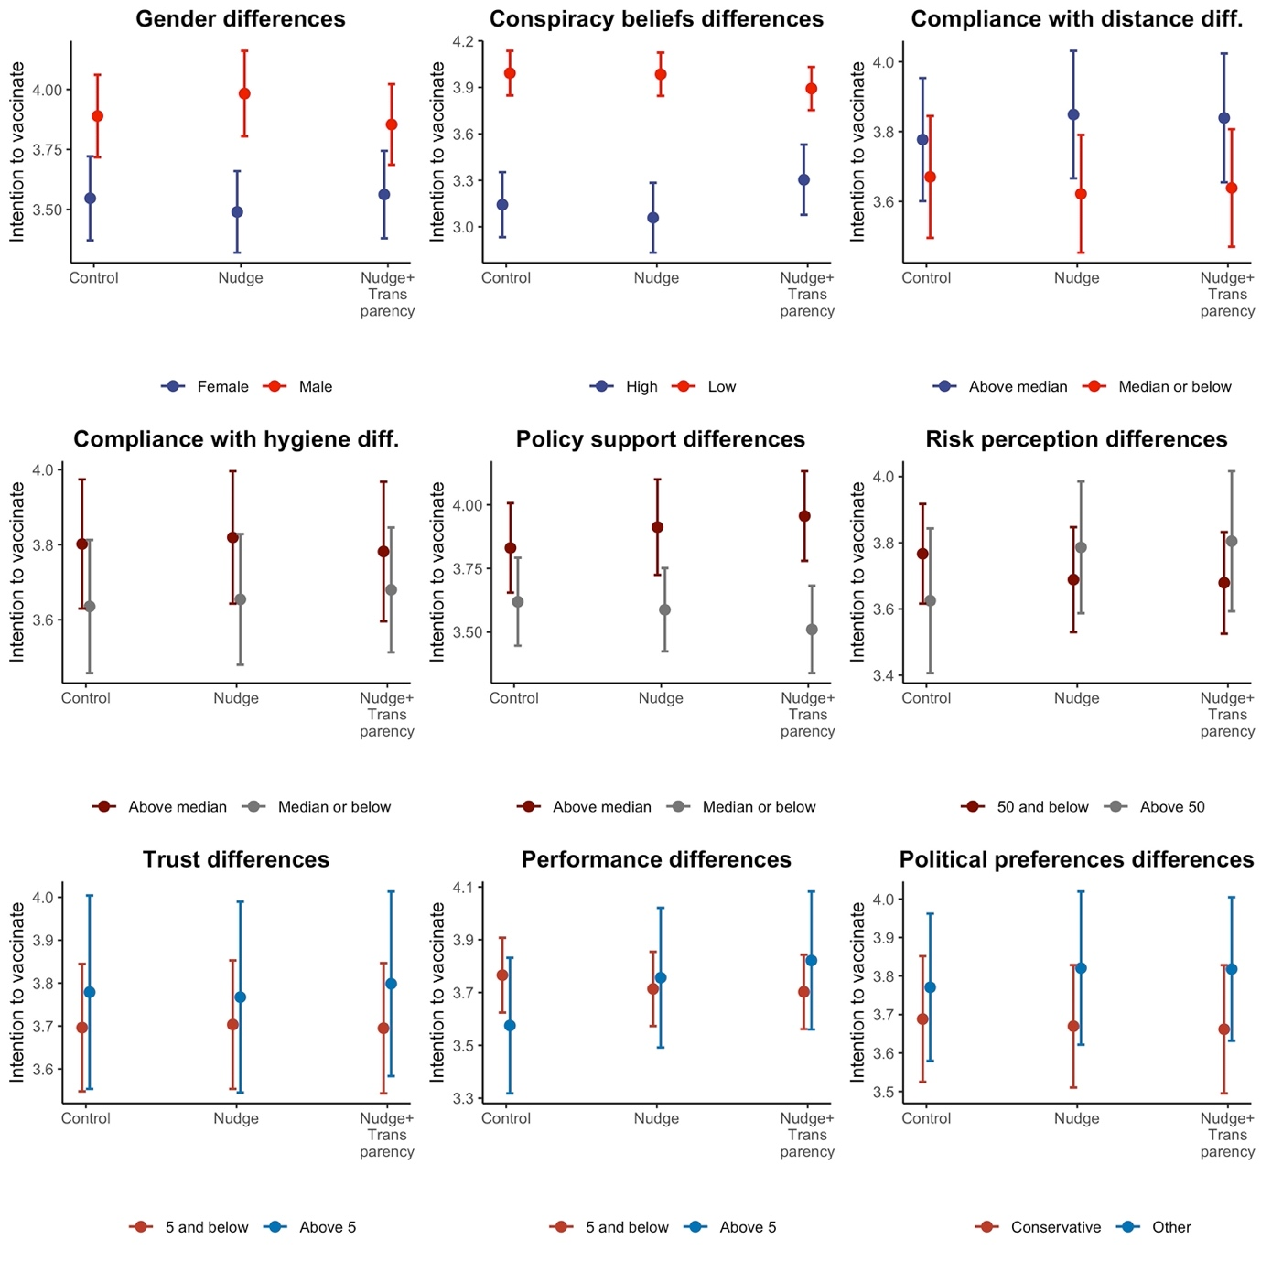

Study 2

The text of the full study

Start of Block: consent_form

consent_form Consent form
Objective of the Study
The aim of this study is to examine people’s attitudes towards a vaccine against COVID-19. This study is conducted by researchers from Erasmus University Rotterdam (Dr. Elena Kantorowicz-Reznichenko, reznichenko@law.eur.nl and Liam Wells wells@law.eur.nl), and Leiden University (Dr. Jaroslaw Kantorowicz, j.j.kantorowicz@fgga.leidenuniv.nl), The Netherlands. The study has been approved by the Erasmus School of Law Research Ethics Review Committee, approval number: 20-08.
Eligibility Requirements:
You are welcome to take part in the study if you are over 18.
What you will need to do and time commitment:
The study will take around 10 minutes. You will be asked to answer different questions related to the COVID-19 pandemic. There are no right or wrong answers here, we are only interested in your honest opinions.
Potential Risks and Inconveniences
There are no physical, legal or economic risks associated with your participation in this study. You don't need to answer any questions which you don't want to answer. You are taking part on a voluntary basis and can stop whenever you want to.
Confidentiality of Information:
Your answers are anonymous. Any responses you provide will be treated confidentially. Confidential information or personal data relating to you will not be publicized in any way; no one will be able to trace this information/data back to you.
We will render data anonymous or use pseudonyms in publications. The pseudonymized data sheet which will be made or collected for the purpose of this study will be stored in a safe location at the Erasmus University Rotterdam and on the researchers' secured (encrypted) data carriers. The research data will be retained for a period of 10 years. The data will be rendered anonymous by the end of this period so that it can no longer be traced back to anyone.
Any publication resulting from this work will report only aggregated findings or fully anonymized examples that will not identify you. Your anonymous responses may be used by the research team, shared with other researchers, or made available in an online data repository. If necessary, the stored anonymized research data will be made available to persons outside the research group (e.g. to monitor scientific integrity).
Voluntary Basis
Participation in this study is completely voluntary. As a participant, you can pull out of the study at any time or, without stating reasons, withdraw your permission for the use of your information in the study at any time before your data was included in the analysis, without any adverse consequence for you. Please note that if you withdraw your data after it has been analyzed, it can still be used in its fully anonymized form in further analyzes, and it also does not negate the legality of the analysis already performed. Do you wish to pull out of the study, or do you have any questions and/or complaints? If so, please contact the research leader (Dr. Elena Kantorowicz-Reznichenko, reznichenko@law.eur.nl).
This study will be carried out by the Erasmus University Rotterdam. If you have any specific questions regarding the handling of personal data, you can also submit these to EUR's Data Protection Officer by sending an email to fg@eur.nl. You also have the right to lodge a complaint with the Dutch Data Protection Authority.
Finally, you have the right to submit a request to access, change, delete or modify your data. You can do so by going to https://www.eur.nl/disclaimer/privacy-statement and submitting your request via the link of the Electronic Service Desk.
Reimbursement
You will be reimbursed by the survey firm based on your agreement with them as appreciation for taking part in this study.
By signing this Consent Form, I confirm the following:
I confirm that I have read and understand the information sheet for the above study. I have had the opportunity to consider the information, ask questions and have had these answered satisfactorily.
I am taking part in this study voluntarily. I am not under any explicit or implicit pressure to take part in this study. It is clear to me that I can pull out of the study at any time, without stating reasons. I don't have to answer a question if I don't want to.
I hereby consent to having the data collected during the study and processed in the manner stated above. This consent therefore also applies to processing data regarding my health/ political views/ or ideological convictions.
I hereby consent to having my research data stored and used for educational purposes and for future research.
- Yes, I consent to take part in this study (1)
- No, I do not consent to take part in this stydy (2)

End of Block: consent_form

Start of Block: Risk perception

risk_perc Please indicate your estimated likelihood for the following events:
 | 0% | 100%

 | 0 | 10 | 20 | 30 | 40 | 50 | 60 | 70 | 80 | 90 | 100

How likely do you think it is that you will get infected by the Coronavirus (Covid-19)? ()
How likely do you think it is that the average person in your country will get infected by the Coronavirus (Covid-19)? ()

End of Block: Risk perception

Start of Block: Conspiracy theories

consp_theor Please select the answer that best describes whether you agree or disagree.
 | Strongly disagree | Strongly agree

 | 0 | 1 | 2 | 3 | 4 | 5 | 6 | 7 | 8 | 9 | 10

The coronavirus (COVID-19) is a bioweapon engineered by scientists. ()
The coronavirus (COVID-19) is a conspiracy to take away citizen’s rights for good and establish an authoritarian government. ()
The coronavirus (COVID-19) is a hoax invented by interest groups for financial gains. ()
The coronavirus (COVID-19) was created as a cover up for the impending global economic crash ()
The vaccine against coronavirus (COVID-19) is a cover up for a plan to implant trackable microchips. ()

End of Block: Conspiracy theories

Start of Block: Political ideology

polit_ideo
Overall, how would you describe yourself in terms of political ideology?
 | Extremely liberal/left-leaning | Center | Extremely conservative/right-leaning

 | 0 | 1 | 2 | 3 | 4 | 5 | 6 | 7 | 8 | 9 | 10

()

End of Block: Political ideology

Start of Block: Attention check

atten_check Please confirm that you have read this question by moving the bar all the way to the left, providing the value 0 as your answer.
 | Bad | Neither good nor bad | Good

 | 0 | 1 | 2 | 3 | 4 | 5 | 6 | 7 | 8 | 9 | 10

. ()

End of Block: Attention check

Start of Block: control

control_main Please indicate to which extent you agree with the following statement:
When a vaccine against COVID-19 is offered in my country, I will get vaccinated.
- strongly disagree (1)
- disagree (2)
- neither agree nor disagree (3)
- agree (4)
- strongly agree (5)

End of Block: control

Start of Block: treatment 2a saliency death description

sal_dd_text
Please read the text and answer the questions on the following screens (you may proceed to the following screen after 15 seconds).
The problem with the COVID-19 pandemic does not lie only in the number of deaths, but the way people experience this death. The following text is a real testimony of a doctor who is treating COVID-19 patients:
“It’s called acute respiratory distress syndrome, ARDS. That means the lungs are filled with fluid.
In my experience, this severity of ARDS is usually more typical of someone who has a near drowning experience. I’ve never seen a microorganism or an infectious process cause such acute damage to the lungs so rapidly. That was what really shocked me.
It first struck me how different it was when I saw my first coronavirus patient go bad. Watching this relatively young guy, gasping for air, pink frothy secretions coming out of his tube and out of his mouth. The ventilator should have been doing the work of breathing but he was still gasping for air, moving his mouth, moving his body, struggling. We had to restrain him. With all the coronavirus patients, we’ve had to restrain them. They really hyperventilate, really struggle to breathe.
[The coronavirus patients] are essentially drowning in their own blood and fluids because their lungs are so full."

sal_dd_main Please indicate to which extent you agree with the following statement:
When a vaccine against COVID-19 is offered in my country, I will get vaccinated.
- strongly disagree (1)
- disagree (2)
- neither agree nor disagree (3)
- agree (4)
- strongly agree (5)

manip_check_dd Prior to answering the question about your intentions to get vaccinated, you have been asked to read a text. Please choose from the list below what was the text about:
- Testimony of COVID-19 patients about their experience (1)
- Testimony of a doctor who is treating COVID-19 patients (2)
- Testimony of relatives of COVID-19 patients about their (the patients') experience (3)

End of Block: treatment 2a saliency death description

Start of Block: treatment 2b saliency death description_transparency

sal_dd_tr_text_text Please read the text and answer the questions on the following screens (you may proceed to the following screen after 15 seconds).
The problem in this pandemic does not lie only in the number of deaths, but the way people experience this death. The following text is a real testimony of a doctor who is treating COVID-19 patients:
“It’s called acute respiratory distress syndrome, ARDS. That means the lungs are filled with fluid.
In my experience, this severity of ARDS is usually more typical of someone who has a near drowning experience. I’ve never seen a microorganism or an infectious process cause such acute damage to the lungs so rapidly. That was what really shocked me.
It first struck me how different it was when I saw my first coronavirus patient go bad. Watching this relatively young guy, gasping for air, pink frothy secretions coming out of his tube and out of his mouth. The ventilator should have been doing the work of breathing but he was still gasping for air, moving his mouth, moving his body, struggling. We had to restrain him. With all the coronavirus patients, we’ve had to restrain them. They really hyperventilate, really struggle to breathe.
[The coronavirus patients] are essentially drowning in their own blood and fluids because their lungs are so full."

sal_dd_tr_tr Please note, the information you have received in the previous screen was a genuine factual report made by a doctor treating COVID-19 patients. It is meant to make the death experience from COVID-19 more salient. The reason for presenting the information in this way is the knowledge from behavioral studies that such framing can promote certain health related choices. The goal of presenting the information in such a way is to increase your willingness to get a COVID-19 vaccination, since vaccination can protect you and others against COVID-19.

sal_dd_tr_text_main
Please indicate to which extent you agree with the following statement:
When a vaccine against COVID-19 is offered in my country, I will get vaccinated.
- strongly disagree (1)
- disagree (2)
- neither agree nor disagree (3)
- agree (4)
- strongly agree (5)

manip_check_ddt Prior to answering the question about your intentions to get vaccinated, you have been asked to read a text. Please choose from the list below what was the text about:
- Testimony of COVID-19 patients about their experience (1)
- Testimony of a doctor who is treating COVID-19 patients (2)
- Testimony of relatives of COVID-19 patients about their (the patients') experience (3)

End of Block: treatment 2b saliency death description_transparency

Start of Block: treatment 3a saliency symptoms

sal_ds_text
Please read the text and answer the questions on the following screens (you may proceed to the following screen in 10 seconds).
The problem in this pandemic does not lie only in the number of deaths, but the way people experience this disease.
Research published in the leading scientific journal in the world reports that “[t]he list of lingering maladies from COVID-19 is longer and more varied than most doctors could have imagined. Ongoing problems include fatigue, a racing heartbeat, shortness of breath, achy joints, foggy thinking, a persistent loss of sense of smell, and damage to the heart, lungs, kidneys, and brain.” It can take months before recovery.

sal_ds_main Please indicate to which extent you agree with the following statement:
When a vaccine against COVID-19 is offered in my country, I will get vaccinated.
- strongly disagree (1)
- disagree (2)
- neither agree nor disagree (3)
- agree (4)
- strongly agree (5)

manip_check_sd Prior to answering the question about your intentions to get vaccinated, you have been asked to read a text. Please choose from the list below what was the text about:
- Description of COVID-19 infection rates (1)
- Description of COVID-19 symptoms (2)
- Description of COVID-19 vaccinations (3)

End of Block: treatment 3a saliency symptoms

Start of Block: treatment 3b saliency symptoms transparency

sal_ds_tr_text Please read the text and answer the questions on the following screens (you may proceed to the following screen in 10 seconds).
The problem in this pandemic does not lie only in the number of deaths, but the way people experience this disease.
Research published in the leading scientific journal in the world reports that “[t]he list of lingering maladies from COVID-19 is longer and more varied than most doctors could have imagined. Ongoing problems include fatigue, a racing heartbeat, shortness of breath, achy joints, foggy thinking, a persistent loss of sense of smell, and damage to the heart, lungs, kidneys, and brain.” It can take months before recovery.

sal_ds_tr_tr Please note, the information you have received in the previous screen was taken from a real article published in a world leading scientific journal. It was meant to make the experience of COVID-19 disease more salient through the presentation of actual symptoms. The reason for presenting the information in this way is the knowledge from behavioral studies that such framing can promote certain health related choices. The goal of presenting the information in such a way is to increase your willingness to get a COVID-19 vaccination, since vaccination can protect you and others against COVID-19.

sal_ds_tr_main Please indicate to which extent you agree with the following statement:
When a vaccine against COVID-19 is offered in my country, I will get vaccinated.
- strongly disagree (1)
- disagree (2)
- neither agree nor disagree (3)
- agree (4)
- strongly agree (5)

manip_check_sdt Prior to answering the question about your intentions to get vaccinated, you have been asked to read a text. Please choose from the list below what was the text about:
- Description of COVID-19 infection rates (1)
- Description of COVID-19 symptoms (2)
- Description of COVID-19 vaccinations (3)

End of Block: treatment 3b saliency symptoms transparency

Start of Block: Reasons not to vaccinate
reas_no_vacc For the following statement, please choose the option which best describes your view.
I prefer not to get vaccinated against COVID-19 because…
(you may indicate more than one reason)
- I am worried about the side effects (1)
- I don’t think it will be effective (2)
- I am not enough at risk from COVID-19 (3)
- I am against vaccines in general (4)
- I don’t have the time (5)
- If majority of people intend to vaccinate, then I will be protected from the virus (6)
- Other reason (7)

other_reason If you have chosen "other reason" please indicate here which reason:
________________________________________________________________

End of Block: Reasons not to vaccinate

Start of Block: Demographics

gender What is your gender
- Female (1)
- Male (2)
- Other (3)

age What is your age?
- 18-28 (1)
- 29-38 (2)
- 39-48 (3)
- 49-58 (4)
- 59-68 (5)
- 69-78 (6)
- 79-88 (7)

marital What is your marital status
- Single (1)
- Married (2)
- In a relationship (3)
- Divorced (4)
- Widow (5)

children How many children do you have?
________________________________________________________________

education What is your level of education?
- Primary school (6)
- Secondary school (1)
- Bachelor (2)
- Master (3)
- PhD (4)
- Other (5)

employment What is your employment status?
- Employed (1)
- Unemployed (2)
- Student (3)
- Retired (4)

covid-19_self Have you tested positive (now or earlier) for the Coronavirus (COVID-19)?
- YES (1)
- NO (2)

covid-19_else
Has anyone you know well (friend, partner, family, colleague etc.) tested positive for the Coronavirus (COVID-19)?
- YES (1)
- NO (2)
End of Block: Demographics

Additional Results Study 2

Table S2-1. Characteristics of Participants
 | % Female | % highly educated | N
Control | 51.7 | 35.7 | 263
Saliency death | 49.2 | 31.4 | 261
Saliency death + transparency | 49.4 | 34.0 | 259
Saliency symptoms | 52.5 | 26.1 | 263
Saliency symptoms + transparency | 54.2 | 30.9 | 262

Distribution of Choices

Figure S2-1. Distribution of Choices in the Control Group
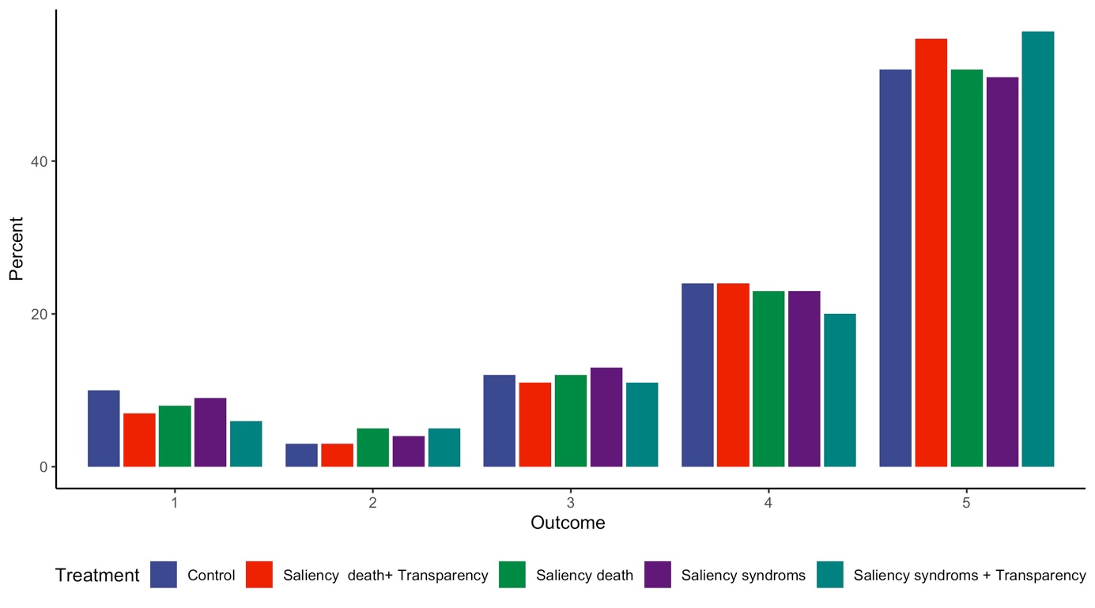

Death Saliency Nudge

Results for the Restricted Sample (excluding manipulation check “failures”)

Figure S2-2. Death Saliency Nudge Restricted Sample (excluding manipulation check failures)
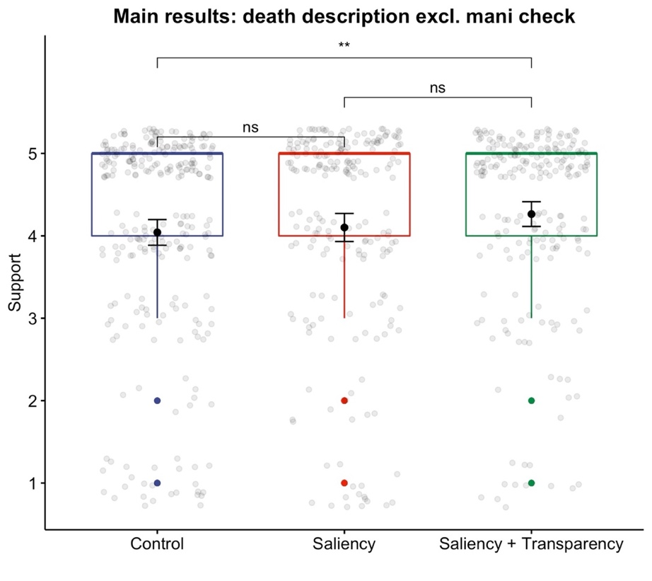

Additional Tests

Table S2-2. Additional Tests Main Effects Full Sample Death Saliency Nudge
 | Control  vs  Nudge | Nudge  vs  Nudge + Transparency | Control  vs  Nudge + Transparency
Mann-Whitney-Wilcoxon test | W = 34377  p-value = 0.9725 | W = 31967  p-value = 0.2408 | W = 32284  p-value = 0.2587
Fisher’s Exact test | p-value = 0.7098 | p-value = 0.6461 | p-value = 0.7098

Table S2-3. Regression Analysis Main Effects Full Sample Death Saliency Nudge
 | Regression Table
 |  | Dependent variable: Intention to vaccinate
 |  | OLS |  |  |  | Cumulative link
 |  | (1) | (2) |  |  | (3) | (4)
Saliency |  | 0.004 | 0.012 |  |  | -0.006 | -0.026
 |  | (0.108) | (0.108) |  |  | (0.165) | (0.171)
Saliency + Transparency |  | 0.144 | 0.118 |  |  | 0.188 | 0.150
 |  | (0.108) | (0.108) |  |  | (0.166) | (0.173)
Male |  |  | -0.065 |  |  |  | -0.090
 |  |  | (0.090) |  |  |  | (0.143)
Above median age |  |  | 0.495*** |  |  |  | 0.898***
 |  |  | (0.103) |  |  |  | (0.171)§
Lower educated |  |  | -0.137 |  |  |  | -0.153
 |  |  | (0.102) |  |  |  | (0.159)
Constant |  | 4.042*** | 4.003***
 |  | (0.076) | (0.102)
Observations |  | 783 | 742 |  |  | 783 | 742
R² |  | 0.003 | 0.033
Adjusted R² |  | 0.0003 | 0.026
Log Likelihood |  |  |  |  |  | -983.281 | -916.422
Note: |  |  |  | *p**p***p<0.001

Figure S2-3. Equivalence test for the difference between the control and the nudge groups (Death Saliency Nudge)
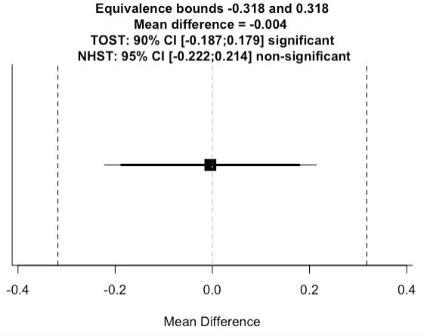

Figure S2-4. Equivalence test for the difference between the nudge and the nudge + transparency groups (Death Saliency Nudge)
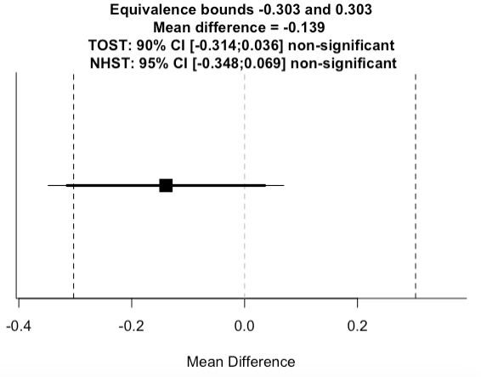

Figure S2-5. Equivalence test for the difference between the control and the nudge + transparency groups (Death Saliency Nudge)
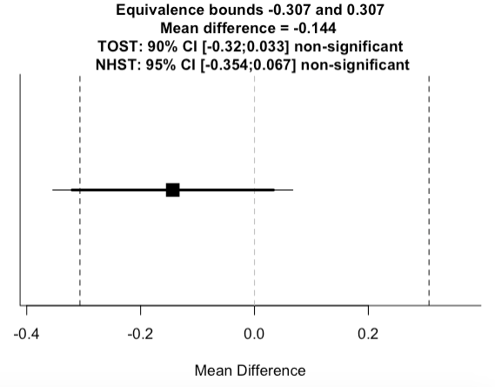

Symptoms Saliency Nudge

Results for the Restricted Sample (excluding manipulation check “failures”)

Figure S2-6. Symptoms Saliency Nudge Restricted Sample (excluding manipulation check failures)

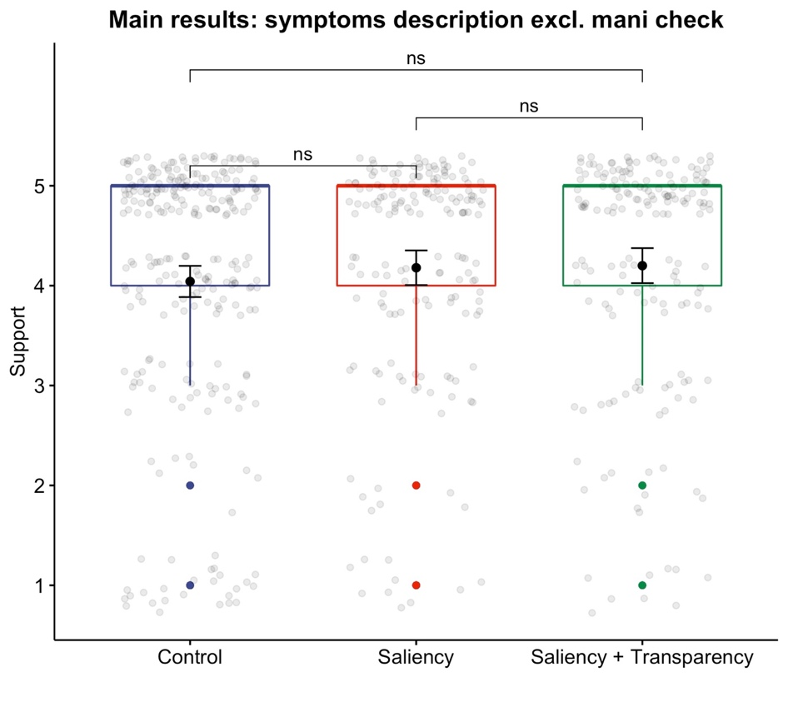

Additional Tests

Table S2-4. Additional Tests Main Effects Full Sample Symptoms Saliency Nudge
 | Control  vs  Nudge | Nudge  vs  Nudge + Transparency | Control  vs  Nudge + Transparency
Mann-Whitney-Wilcoxon test | W = 34772  p-value = 0.9072 | W = 32364  p-value = 0.1867 | W = 32541  p-value = 0.2261
Fisher’s Exact test | p-value = 0.9355 | p-value = 0.5501 | p-value = 0.2854

Table S2-5. Regression Analysis Main Effects Full Sample Symptoms Saliency Nudge
 | Regression Table
 |  |  | Dependent variable: Intention to vaccinate
 |  | OLS |  |  |  | Cumulative link
 |  | (1) |  | (2) |  | (3) | (4)
Saliency |  | -0.004 |  | 0.004 |  | -0.019 | 0.002
 |  | (0.109) |  | (0.110) |  | (0.164) | (0.171)
Saliency + Transparency |  | 0.122 |  | 0.130 |  | 0.202 | 0.230
 |  | (0.109) |  | (0.111) |  | (0.167) | (0.174)
Male |  |  |  | 0.059 |  |  | 0.179
 |  |  |  | (0.091) |  |  | (0.143)
Above median age |  |  |  | 0.310** |  |  | 0.751***
 |  |  |  | (0.103) |  |  | (0.169)
Lower educated |  |  |  | -0.060 |  |  | -0.093
 |  |  |  | (0.106) |  |  | (0.162)
Constant |  | 4.042*** |  | 3.963***
 |  | (0.077) |  | (0.105)
Observations |  | 788 |  | 745 |  | 788 | 745
R² |  | 0.002 |  | 0.016
Adjusted R² |  | -0.0004 |  | 0.010
Log Likelihood |  |  |  |  |  | -993.268 | -916.644
Note: |  |  | *p**p***p<0.001

Figure S2-7. Equivalence test for the difference between the control and the nudge groups (Symptoms Saliency Nudge)

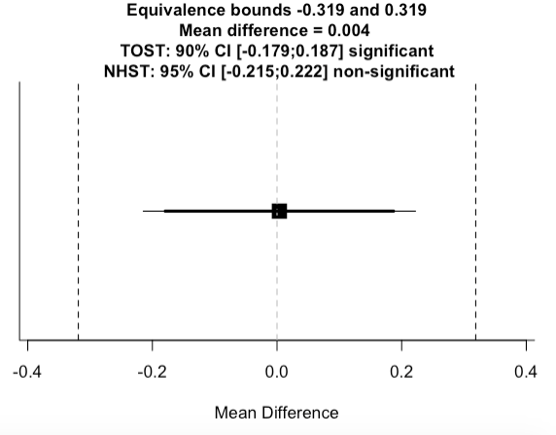

Figure S2-8. Equivalence test for the difference between the nudge and the nudge + transparency groups (Symptoms Saliency Nudge)

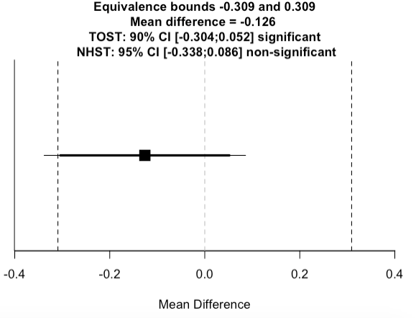

Figure S2-9. Equivalence test for the difference between the control and the nudge + transparency groups (Symptoms Saliency Nudge)

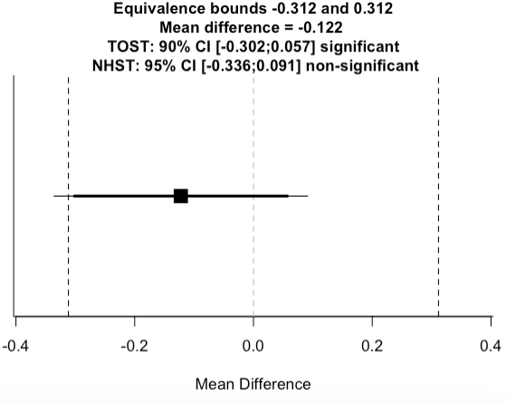

Experiment 2- Potential Moderating Effects (Both Saliency Nudges)

Gender
First, relying on the finding we have cited for Study 1 (Croson et al., 2010; Kantorowicz-Reznicehnko & Kantorowicz 2021), we have decided to examine whether women might differ from men in their susceptibility to the influence of nudges. If the results concerning social norms can be informative with respect to a saliency nudge, then we predict that male participants will be more likely to increase their willingness to get vaccination against COVID-19 following the presentation of salient information on the death as a result of COVID-19, or the symptoms it causes, as compared to female participants.
As can be seen in Figure S2-10, in contrst to the Iseari results, female and male participants do not differ from each other in their intention to vaccinate (looking at the control group). Both groups do not seem to have been affected by the saliency nudges.

Conspiracy theories
It is reasonable to assume that people who believe to a larger extent in conspiracy theories are in general more susceptible to follow misinformation. For example, such people might be more prone to also believe in conspiracy theories with respect to the developed vaccine, which will reduce their willingness to vaccinate (Jolley & Douglas 2014). Therefore, we predicted that participants who believe in conspiracy theories to a larger extent will be less willing to receive vaccination, even when nudged to do so by a saliency nudge as compared to participants who believe in conspiracy theories to a lesser extent.
We performed the analysis as in Study 1 (people who had higher agreement with at least one conspiracy theory, were considered as believing in conspiracy theories). Figure S2-10 presents the results for both the experiments. As expected, people who tend to believe in conspiracy theories have significantly lower intentions to vaccinate, whether nudged or not. However, withing the groups, the saliency nudge, as well as the transparent form of that nudge, have no effect on people’s choices.

Risk perception
Second, since the purpose of a vaccine against COVID-19 is to reduce the risk of infection, people who perceive a higher risk of getting infected with COVID-19 virus (to self or others) are also expected to follow more the nudge and receive vaccination. Therefore, we predicted that the positive effect of the nudges on the willingness to accept a vaccine against COVID-19 will be stronger as the perceived risk of infection (to self or others) is becoming higher.
As figure S2-10 demonstrates, higher risk perception also leads to higher intention to vaccinate. However, risk perception has no moderating effect on the effectiveness of the nudges.

Political ideology
Some early surveys suggest that conservative people are less willing to vaccinate than liberal. Therefore, we predicted that conservative participants will be less influenced by the nudges in their expressed willingness to receive a vaccination against COVID-19.
As Figure S2-10 demonstrates, participants with different political ideology did not vary in their level of intention to vaccinate, nor in their susceptibility to the effect of the nudges.

Figure S2-10. Combined Moderating Effects Results

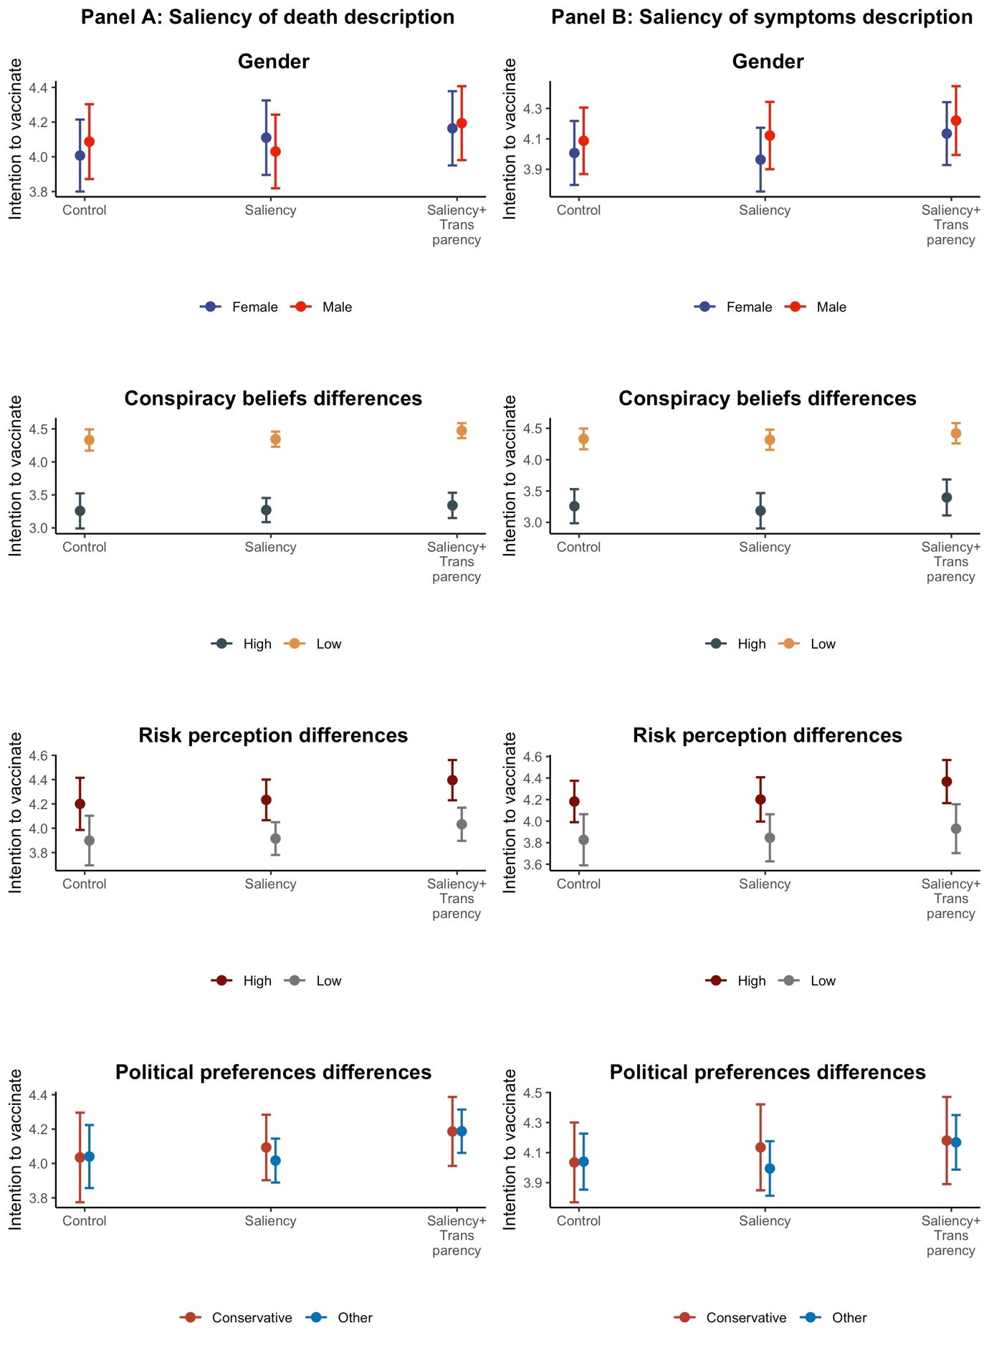

Bibliography
Croson, Rachel, and Simon Gächter. "The science of experimental economics." Journal of Economic Behavior & Organization 73, no. 1 (2010): 122-131.
Jolley, Daniel, and Karen M. Douglas. "The effects of anti-vaccine conspiracy theories on vaccination intentions." PloS one 9, no. 2 (2014): e89177.
Kantorowicz‐Reznichenko, Elena, and Jaroslaw Kantorowicz. "To follow or not to follow the herd? Transparency and social norm nudges." Kyklos 74, no. 3 (2021): 362-377.

The main question and the follow up reasons were inspired by a survey conducted by the World Economic Forum, available at https://www.weforum.org/agenda/2020/09/covid-19-coronavirus-vaccine-opinion-survey/.
https://thehill.com/policy/healthcare/530127-republicans-four-times-more-likely-than-democrats-not-to-get-covid-19.
https://thehill.com/policy/healthcare/530127-republicans-four-times-more-likely-than-democrats-not-to-get-covid-19.

