Appendices

Appendix A: Control Letter in the German Original Version (English Translation below)
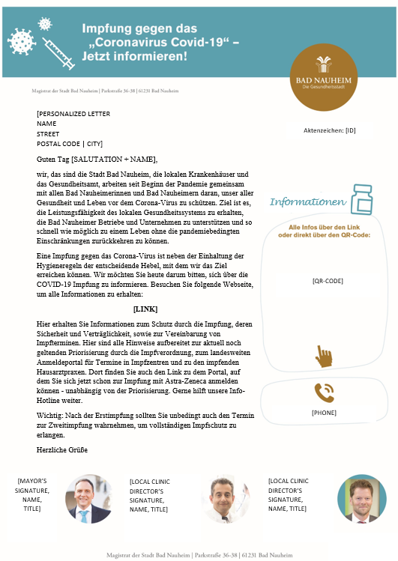

Appendix B: Treatment Letter in the German Original Version (changes to control letter marked by underlining; English Translation below)
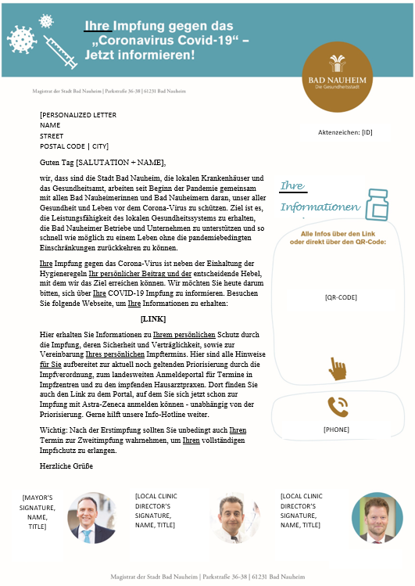

Appendix C: English Translation of the Letter (Textual amendments of the treatment marked by underlining)
Headline: Your vaccination against the “Coronavirus Covid-19” – Inform now!
Side bar: Your information: All Info via the link or directly via the QR code: [code], [phone]
Dear [SALUTATION + NAME],
we, that is the municipality of Bad Nauheim, the local hospitals and the health authority, have been working together with all Bad Nauheim residents since the beginning of the pandemic to protect all of our health and lives from the coronavirus. The goal is to maintain the capacities of the local health care system, to support Bad Nauheim's businesses and enterprises, and to return to a life without the pandemic-related limitations as soon as possible.
Your vaccination against the coronavirus, in addition to adherence to hygiene rules, is your personal contribution and the critical lever we can use to achieve the goal. Today, we are asking you to learn about your COVID-19 vaccination. Visit the following website to get your information: [LINK]
Here you will find information about your personal protection through vaccination, its safety and tolerability, and how to schedule your personal vaccination appointment. Here are all the instructions prepared for you on the prioritization by vaccination regulation that is currently still in effect, on the nationwide registration portal for appointments at vaccination centers, and on the general practitioners who vaccinate. There you will also find the link to the portal where you can already register for vaccination with Astra-Zeneca - regardless of prioritization. Our information hotline will be happy to help.
Important: After the first vaccination, you should definitely also keep your appointment for the second vaccination in order to obtain your full vaccination protection.
Best regards

Appendix D: Correlation Table
Correlations matrix
 | 1 | 2 | 3 | 4 | 5 | 6 | 7 | 8 | 9
(1) Gender
(2) Age | -0.08**
(3) Marital Status | -0.04** | 0.23**
(4) Type of Residence | 0.02** | -0.05** | 0.02**
(5) PhD | 0.06** | 0.06** | 0.04** | 0.04**
(6) Failed Mailing | 0.02** | -0.05** | -0.09** | -0.02** | -0.01
(7) Clicks (1 Week) | 0.03** | -0.06** | 0.01 | 0.02** | 0.00 | -0.03**
(8) Clicks (4 Weeks) | 0.04** | -0.07** | 0.00 | 0.02** | 0.00 | -0.04** | 0.93**
(9) Google Analytics (1 Week) | 0.02** | -0.06** | 0.01 | 0.01* | -0.01 | -0.03** | 0.83** | 0.78**
(10) Google Analytics (4 Weeks) | 0.02** | -0.07** | 0.00 | 0.01 | -0.01 | -0.03** | 0.78** | 0.83** | 0.94**
***p < 0.001; **p < 0.01; *p < 0.05.

Appendix E: Linear Probability Models for Google Analytics
 | Clicks Google Analytics (1 Week) |  | Clicks Google Analytics (4 Weeks)
 | Model 1 | Model 2 | Model 3 | Model 4
Psychological Ownership | .019 (.003)  p < .0001 | .017 (.003)  p < .0001 | .021 (.003)  p < .0001 | .018 (.003)  p < .0001
Age |  | -.001 (.000)  p < .0001 |  | -.001 (.000)  p < .0001
Main Residence |  | .009 (.008)  p = .2535 |  | .009 (.009)  p = .2984
Married |  | .018 (.010)  p = .0813 |  | .020 (.010)  p = .0593
Registered civil partnership |  | -.052 (.011)  p = .0061 |  | -.056 (.012)  p = .0056
Single |  | -.005 (.010)  p = .6316 |  | .002 (.011)  p = .8526
Divorced |  | -.004 (.011)  p = .7302 |  | -.001 (.011)  p = .9119
Widowed |  | -.006 (.011)  p = .5518 |  | -.003 (.011)  p = .8149
Marriage cancelled |  | -.051 (.013)  p = .1609 |  | -.054 (.014)  p = .1569
Registered civil partnership cancelled |  | -.054 (.011)  p = .0036 |  | -.058 (.011)  p = .0030
Registered life partner died |  | -.041 (.015)  p = .0674 |  | -.044 (.014)  p = .0517
PhD |  | -.014 (.008)  p = .0871 |  | -.012 (.009)  p = .1882
Gender (Male) |  | .006 (.003)  p = .0439 |  | .006 (.003)  p = .0333
Delivery failed |  | -.056 (.004)  p < .0001 |  | -.065 (.004)  p < .0001
Address Cluster Size |  | -.000 (.000)  p = .3512 |  | -.000 (.000)  p = .7452
Intercept | .047 (.002)  p < .0001 | .080 (.011)  p < .0001 | .053 (.002)  p < .0001 | .091 (.011)  p < .0001
R² | .002 | .009 | .002 | .010
Adj. R² | .002 | .009 | .002 | .009
Observations | 27,306 | 27,300 | 27,306 | 27,300
RMSE | .231 | .230 | .244 | .243
Clusters | 6,442 | 6,442 | 6,442 | 6,442
Linear Probability Model with Clustered Standard Errors

Appendix F: Treatment Effects for Google Analytics
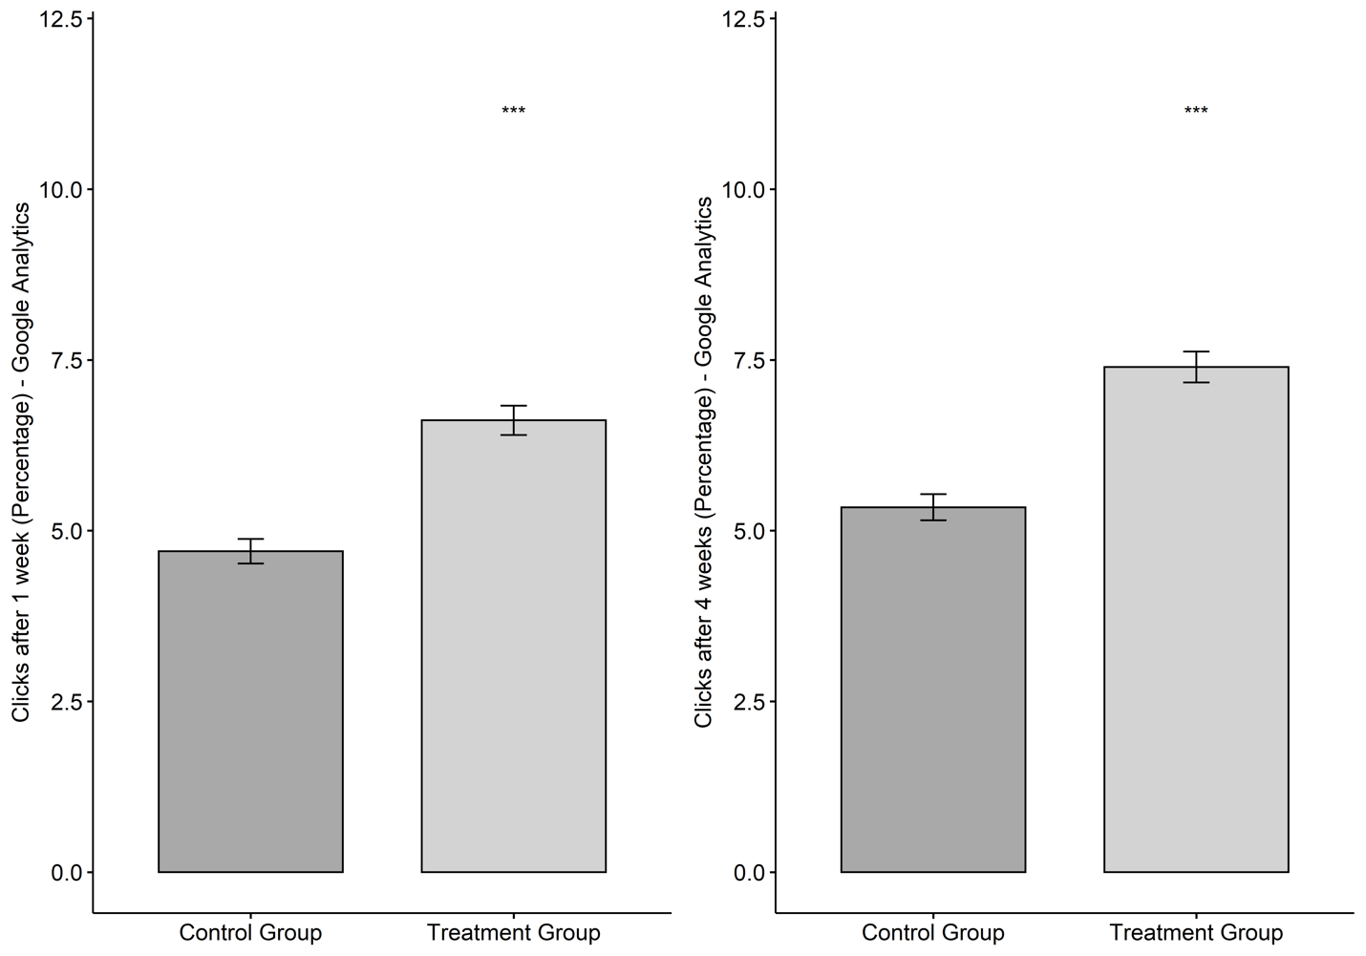
Note: ***p < 0.0001

