The impact on nudge acceptability judgments of framing and consultation of the targeted population

- APPENDICES -
Ismaël Rafaï^{1,2,*} Arthur Ribaillier²
Dorian Jullien^{3,2}

* Corresponding author, ismael.rafai@gmail.com
¹ CEE-M, Univ. Montpellier, CNRS, INRAE, Institut Agro, Montpellier, France.
² Université Côte d’Azur, CNRS, GREDEG
³ Centre d’Economie de la Sorbonne, Université Paris I - Panthéon Sorbonne

Appendix 1: Nudge scenarios
Scenario 1: default option in coffee-vending machine

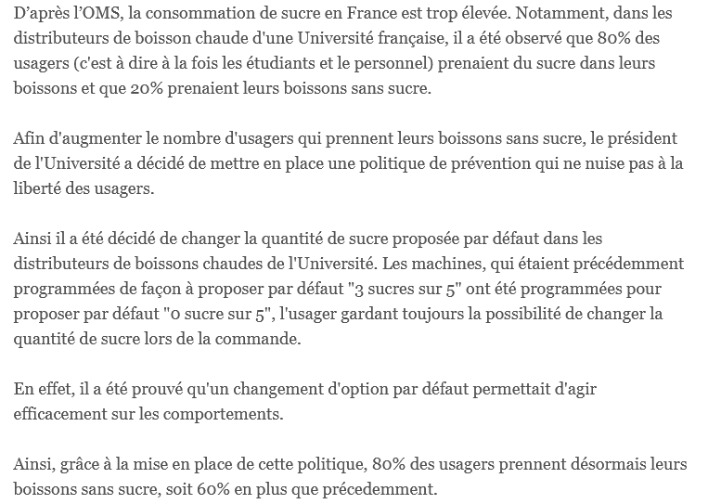
Figure A1: Screenshot of the Coffee scenario (frame ++ and no consultation treatments).
Note: Original scenario is in French. Can be translated in English as follows. “According to WHO, sugar consumption is excessive in France. In a French University, it has been observed that 80% of the users of a coffee-vending machine put sugar in their drinks and 20% of users do not put sugar in their drinks. To [fame + +: increase the number of users taking their drink without sugar / frame - -: decrease the number of users taking their drink with sugar], the president of the University has decided [consultation=1: following the proposal of the users representative council] to implement a default option prevention policy that does not limit the freedom of users. It has been decided to change the default sugar quantity in the University coffee-vending machines. The machines were programmed to offer a quantity of “3 out of 5” sugar doses and have now been programmed to offer a quantity of “0 out of 5”. The user remains free to change the sugar quantity. It has been proven that changing the default option has an impact on behaviour. Consequently, because of this policy, [frame + +: 80% of users do not take any sugar in their drink, that is 60% more than before / frame - -: 20% of users take sugar in their drink, which is 60% less than before].”

Scenario 2: hotel
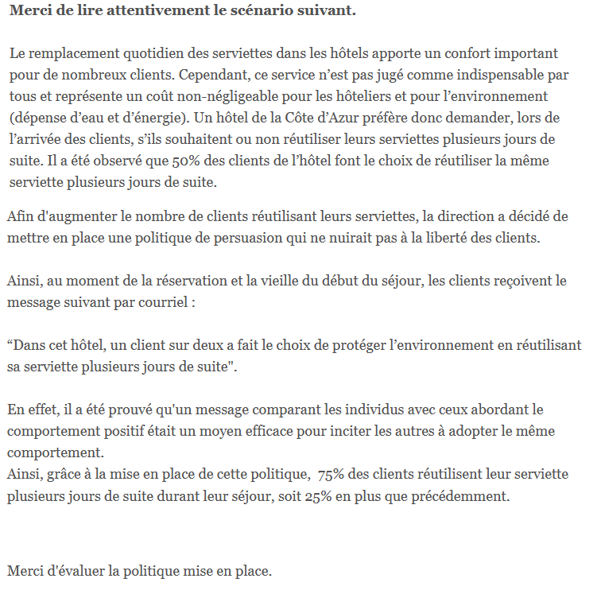
Figure A2: Screenshot of the hotel scenario (frame ++ and no consultation treatments).
Note: Original scenario is in French. Can be translated in English as follows. “The daily replacement of towels in hotels is an added comfort for many customers. However, this service is not considered essential by most of them and represents a significant cost for hoteliers and for the environment (expenditure of water and energy). A hotel on the French Riviera therefore prefers to ask customers, when they arrive, whether or not they agree to reuse their towels for several days in a row. It has been observed that 50% of hotel guests choose to reuse the same towel several days in a row. In order to [fame + +: increase the number of clients reusing their towels / fame - -: decrease the number of clients not reusing their towels] the management has decided to introduce [consultation=1: after discussion with former clients] a policy of persuasion that would not interfere with the freedom of clients. Thus, at the time of booking and the day before the start of their stay, customers receive the following message by email; “In this hotel, one in two customers have chosen to protect the environment by reusing their towels for several days in a row.” This was decided because it has been proven that social comparison is an effective way to change behaviour. Thanks to the implementation of this policy, [fame + +: 75% of customers reuse their towel for several days in a row during their stay, this is 25% more than before / fame - -: 25% of customers do not reuse their towel for several days in a row during their stay, this is 25% less than before.]”

Scenario 3: Election
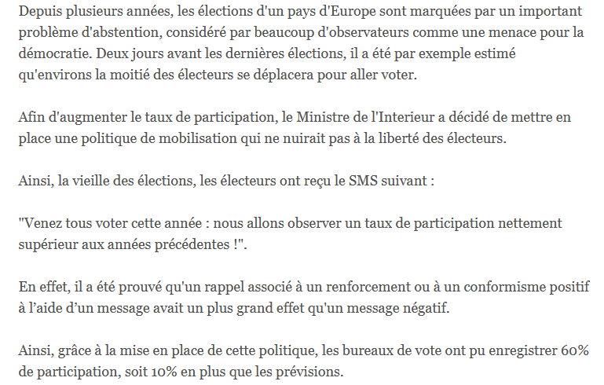
Figure A3: Screenshot of the election scenario (frame ++ and no consultation treatments).
Note: Original scenario is in French. Can be translated in English as follows. “For several years now, elections in a European country have been marked by a significant abstention problem, considered by many observers as a threat to democracy. Two days before the last election, for example, it was estimated that only around half of eligible voters intended to go vote. In order [fame + +: to increase the participation rate / fame - -: to decrease the abstention rate], the Minister of Interior has decided [consultation = 1: after consultation with citizen representatives], to introduce a policy of mobilization that would not limit the freedom of voters. Thus, on the day before the elections, voters received the following SMS: “Come and vote this year: we are expecting to see a much higher turnout than in previous years!” This type of reminder combined with a message expressing a positive social reinforcement or conformism has been shown to have a greater effect than a negative message. Thus, thanks to the implementation of this policy, the polling stations registered [fame + +: 60% participation, this is 10% more than forecasts / fame - -: 40% abstention, this is 10% less than the forecasts.]”

Scenario 4: Wasted time at work
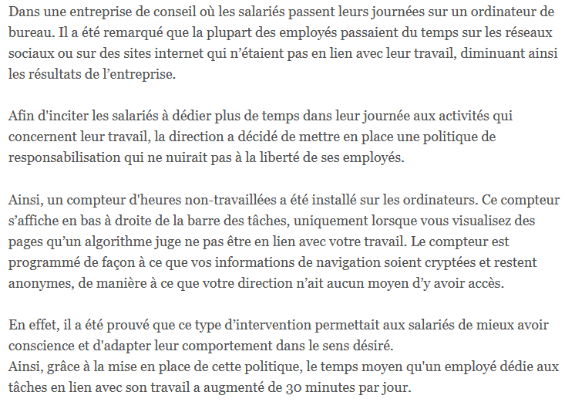
Figure A4: Screenshot of the company scenario (frame ++ and no consultation treatments).
Note: Original scenario is in French. Can be translated in English as follows. “In a consulting company where employees spend their days at a desktop computer, it was noticed that most of the employees spent time on social media or on websites that were not related to their work, thus diminishing the company’s productivity. In order to encourage its employees to dedicate [fame + +: more time in the day to work-related activities / fame - -: less time in the day to non-work-related activities] the management has decided [consultation = 1: on the advice of the works council] to introduce a policy of accountability which would not affect the freedom of its employees. Thus, a non-work time tracker was installed on their computer screens. This time tracker appears at the bottom right of the taskbar when they are viewing pages that an algorithm deems unrelated to their work. The tracker is programmed to keep browsing information encrypted and anonymous, so that management has no way of accessing it. This was implemented because it has been proven that this type of intervention allows employees to be more aware of their behaviour and adapt it in the desired direction. Thus, thanks to the implementation of this policy, work time dedicated [fame + +: to work-related activities increased by 30 minutes per day / fame - -: to non-work-related activities decreased by 30 minutes per day.]”

Appendix 2: Acceptability Scale
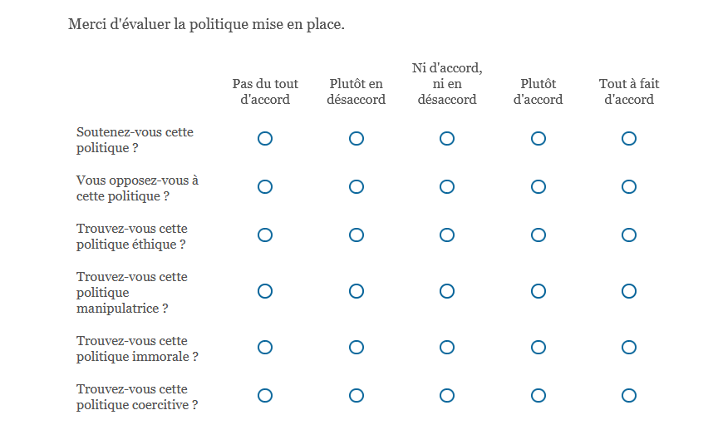
Figure A5: Screenshot of the acceptability scale (in French)
Appendix 3: Correlation between the acceptability indexes of the scenarios.
The Pearson correlation coefficients between the acceptability indexes are all positive (r between 0.216 and 0.362) and statistically significant (at least at the 1% level), except the acceptability index of the company scenario which is significantly correlated only with the hotel scenario (r = 0.362, p<0.001) and correlated at the 10% level with the coffee scenario (r = 0.129, p=0.092).
 | Election | Company | Hotel
Coffee | 0.216 ** | 0.129 · | 0.358 ***
Hotel | 0.242 ** | 0.362 ***
Company | 0.057
Table A1: Correlation between the acceptability of the different scenarios.
Note: Pearson’s correlation test. ***: p<0.001, **: p<0.01; *: p<0.05; · p<0.1

