**Online Appendix**

**Appendix for Default options: A powerful behavioral tool to increase COVID-19 contact tracing app acceptance in Latin America?**

**Contents**

1. **Technical aspects of contact tracing apps**
2. **Survey Details**
3. **Sample**
4. **Descriptive Analysis of Basic App**
5. **Determinants of acceptance per regime**
6. **Additional Results**
7. **Instrument (Spanish)**

**A Technical aspects of contact tracing apps**

In order to cope with the pandemic, as well as manage the reopening of their economies, countries around the globe have relied on technological tools in mobile phones for contact tracing, such as Bluetooth Low Energy (BLE). Such technology can be used to detect and inform users when they have been in close-range physical contact with individuals who have been tested positive for COVID-19 (and have informed their condition on the system). As such, it facilitates contact tracing between participating devices while allowing for the protection of private data (Troncoso et al. 2020, Bay et al. 2020, DP-3T Project 2020).One of the first countries to implement digital proximity contact tracing has been Singapore in March 2020, with its TraceTogether mobile app that exchanges short-distance Bluetooth signals between cellphones to detect other users in close proximity. Following the release of TraceTogether, other countries have followed (Bay et al. 2020). In April 2020 Apple and Google announced a joined effort to enable the use of Bluetooth technology to help reduce the spread of the virus with user privacy and security central to their design. Such efforts included launching application programming interfaces (APIs) that enable interoperability between Android and iOS devices using apps from public health authorities and that users can download via the app stores, and operating system-level technology to assist in enabling contact tracing. The version used in Singapore for example required that a user of the application have the application active in order to track contacts, while the newer version developed by Apple and Google can work in the background and across operating systems.

Testing, contact tracing and quarantine/isolation were and continue to be key strategies to contain the spread of an infectious disease for which vaccination is not (widely) available. Testing finds new cases that can be put into quarantine; contact tracing allows the early detection and isolation of contacts before they transmit the infection even further (Salathé et al. 2020). Contact tracing can also help identify potential hotspots of transmission under a centralized model (under a decentralized model, such as the one using DP-3T protocol, cellphone-based contact tracing does not veal when and where the contact happened and therefore it is not possible to identify hotspots). Traditional person-based contact tracing requires trained individuals that can “…record data about contacts, to monitor them over time and to communicate with other contact tracers across geographical areas securely and confidentially” (Salathé et al. 2020, p.2). A person-based contact also requires intensive human labor and depends on correct recall from those interviewed: contact tracers must communicate with contacts of positive cases, ask about symptoms, provide support and assess circumstances (Salathé et al. 2020). Relying only on manual contact tracing might be infeasible to control the spread of the virus given both high rates of transmission and its elevated cost. For example, Wymant et al. (2021) showed in the UK that the mean number of contacts reached through contact tracing apps with exposure notification was 4.4 per COVID-19 positive case, compared to 1.8 for manual tracing. Using digital proximity contact tracing as the one described above has the main benefits of demanding less information than manual tracing (therefore, assuming low interpersonal trust translates into a lower willingness to share personal data, contact tracing apps should be more acceptable than manual tracing in low trust environments), being limited to physical proximity only, of not relying of individual recall, of allowing an immediate alert and of not requiring human inputs for contact identification (Salathé et al. 2020). The user needs, on the other hand, to have a smartphone with the Bluetooth option on, as well as the obligation to report its own COVID-19 positive case on the system.

**B Survey Details**

**B.1 Survey Timeframe**

The data collection process overall started on July 29th 2020 and finished on September 27th 2020. See Table B.1 shows timeframes per country.

Table B.1. Data collection process timeframe, by country (2020)

|  |  |  |  |  |  |  |
| --- | --- | --- | --- | --- | --- | --- |
| Country | Started | Finished | COVID-19 cases* | | COVID-19 deaths* | |
| Started | Finished | Started | Finished |
| Chile | July 29th | August 20th | 1,868.9 | 2,069.0 | 49.6 | 56.1 |
| Uruguay | July 29th | August 22nd** | 35.2 | 44.1 | 1.0 | 1.2 |
| Paraguay | July 30th | August 18th | 69.1 | 143.9 | 0.7 | 2.1 |
| Peru | July 30th | August 15th** | 1,232.5 | 1,648.5 | 57.9 | 80.8 |
| Ecuador | August 4th | August 28th | 550.4 | 689.5 | 33.2 | 37.2 |
| El Salvador | August 6th | August 23rd | 289.2 | 380.8 | 7.9 | 10.3 |
| Honduras | August 7th** | September 5th** | 469.5 | 665.0 | 14.8 | 20.8 |
| Costa Rica | August 8th** | September 26th** | 461.3 | 1,427.4 | 4.7 | 16.4 |
| Panama | August 9th | September 27th** | 1,754.2 | 2,603.5 | 38.6 | 55.1 |
| Mexico | August 31st | September 8th | 467.0 | 499.7 | 50.3 | 53.1 |

* Cases and deaths per 100,000 inhabitants

** August 10, 2020, August 24, 2020

Source: Inter-American Development Bank, Social Protection and Health Division (SPH) calculations based on European CDC data.

**B.2 Survey Design**

The survey included eight modules on questions regarding technology usage, trust, behavior, and COVID-19, as well as basic socio demographic indicators. The order of the modules is: Basic Individual Characteristics (Module 1), Basic Household Characteristics (Module 2), General Technology Usage (Module 3), Trust and COVID-19 (Module 4), Administrative Procedures (Module 5), Technology and COVID-19 (Module 6 – hypothetical app), Data Privacy (Module 7), Behavior (Module 8). Table B.2 shows the structure of the survey.

Table B.2 Structure of the Survey

|  |  |
| --- | --- |
| Module 1: Basic Individual Characteristics | Age  Gender  Education |
| Module 2: Basic Household Characteristics | Household composition |
| Module 3: General Technology Usage | Smartphone usage  Smartphone activities |
| Module 4: Trust and COVID-19 | Interpersonal trust  Trust in government  Trust information COVID-19  Support quarantine strategies |
| Module 5: Administrative Procedures | Type of administrative procedures before and after COVID-19  Restrictions to in-person services |
| Module 6: Technology and COVID-19 | Acceptance of contact tracing apps  Reasons to accept/not accept  Acceptance w/ conditionalities |
| Module 7: Data Privacy | Knowledge about personal data regulation  Control over personal data |
| Module 8: Behavior | Preventive behavior observance |

Specifically in Module 6, the first questions in the module were:

* **OPT-IN:** If there is or there was an application of the national government that you would need to download (but that would not consume data or credit) that lets you know if you have any symptoms of coronavirus and tells you what to do, would you surely install it on your phone, would you probably install it, or not install it?
* **OPT-OUT:** If there is or was a national government application that would be installed automatically with the possibility of uninstalling whenever you want (but that would not consume data or credit) that lets you know if you have any symptoms of coronavirus and tells you what to do, would you surely uninstall it in your phone probably or not uninstall it?

The survey then asks

* **OPT-IN:** If this app would also alert you if you were in contact for more than 15 minutes with someone infected with coronavirus as well as notify the people who were in close contact with you, without identifying any names (neither your nor that of other people) would you surely install it on your phone, would you probably install it, or not install it?
* **OPT-OUT:** If this app would also alert you if you were in contact for more than 15 minutes with someone infected with coronavirus as well as notify the people who were in close contact with you, without identifying any names (neither your nor that of other people) would you surely uninstall it in your phone probably or not uninstall it?

For the complete instrument, please see section G (in Spanish, the original language)

**C Sample**

**C.1 Recruitment**

Three data collection firms were hired to carry out the survey. One firm oversaw Mexico, one Chile, Uruguay, Paraguay and Peru and another one Ecuador, El Salvador, Honduras, Costa Rica and Panama.

In Chile, a sample frame of telephone numbers of each company present in the country was generated, according to their market share based on statistics from the Telecommunications Undersecretariat, and then proceeded with a Random Digit Dialing system, with fixed numbers and cell phones. Random numbers were generated based on the block of first fixed digits that each company must assign to the telephone numbers of its users.15,859 attempts were made for a total number of 1,004 complete surveys. In Paraguay, the prefixes enabled for each cell phone company, which are 4 (Tigo, Personal, Claro and Vox) were used as a reference. Each company has an unequal number of prefixes, as well as market share differentials. The data of the market share of each company was taken to generate a stratified sample that considers that weight over the total (within each sample stratum – company- the sample was distributed equally according to available prefixes. 17,789 attempts were made for a total number of 1,021 complete surveys. In Peru, a sampling frame was built from the numbering series of the mobile services of the Ministry of Transport and Communications (MTC). In the country there are four providers of cell phone lines: Movistar, Claro, Entel and Bitel. The series of MTC numbers correspond to all providers and contain the same number of digits as cell phone numbers (9 digits). The first five have a header function and the last four can be numbered from "0000" to "10000". In order to have a valid sampling frame, the randomly selected numbers go through an IVR (Interactive Voice Response). The sample frame is representative of the mobile lines market and includes both old and new users, to the extent that numbers of all the headends by operator are included. 98,610 attempts were made for a total number of 1,009 complete surveys. In Uruguay, the data collection company has a sample frame of telephone numbers of the three mobile telephone companies that operate in the country, considering the prefixes used by each one. Subsequently, a Random Digit Dialing system was used to verify the existence or not of the number, and those numbers that correspond to an existing telephone number were kept. 22,000 attempts were made for a total number of 1,012 complete surveys. In Honduras, Costa Rica and El Salvador the data collection company already had a database of numbers previously compiled for market research. The average response rate to achieve a sample of 1,000 individuals per country was 8.2, 4.5 and 28.4, respectively (in El Salvador, the sample was of 997). In Panama the data collection company counted with a digital phone book and numbers were randomly selected through Random Digital Dialing with an average response rate of 14.2 to achieve a sample of 1,000 individuals. In Ecuador, with data from local telephone directories and Synergie's own databases collected from studies from previous years, 1,000 individuals were surveyed (response rate of approximately 60 percent).

Finally, in Mexico the data collection firm first prepared the sampling frame using the National Numbering Plan (PNN), whose administration and use of national numbering is attributed to the Federal Telecommunications Institute (IFT). In this Plan there are 617,567,770 possible total numbers that the different fixed or mobile telephone service providers in Mexico can distribute among their users, whether or not they have yet been assigned for use to a particular user. In this plan there are two main components: the national long-distance code (lada) and the serial number, which corresponds to the numbers with which a specific number starts. Among these components, six of the ten digits that make up the total number of digits required to dial a telephone number in the country are identified. For each of the combined components of lada and series, four random numbers were generated, resulting in 504,896 unique numbers. For these, an automatic dialing program (Blaster) was used to identify 101,902 telephone numbers, which were randomly divided into 12 samples for a total sample of 1,214 individuals using the Bassols-Batalla regionalization to meet the sample stratification criterion by geographic division.

**C.2 Final Sample**

In Table C.1 we show the descriptive statistics for the sample used in our analysis. On average, respondents are 39 years old, and live in a household with four members. There is a fair gender distribution with 49.9 percent of respondents being females. In terms of education, 41 percent have not graduated high school, almost 38 percent have a high school degree and the rest have a complete university degree or more. Almost 50 percent of the households live with a child younger than 12 years old, and a resident over 60 years old lives in almost 35 percent of the households. We test that the difference in means across the two groups is not significant, finding that there seems not to be any significant difference in baseline characteristics. In terms of primary smartphone activities, Table C.1 shows almost 80 percent of this sample say they use their smartphones to send and receive instant messages (like WhatsApp) every day, 67 percent say they use it for social media (Facebook, Instagram or Twitter), but only 4 percent of users do financial transactions (online shopping or pay utilities online) every day. There is no difference in smartphone activities across treatment groups. These results validate our identification strategy, given that the results that we might see in probability of acceptance of these apps will not be biased by differences in smartphone activities. Trust, both interpersonal and citizen trust in government, is a key dimension when analyzing potential acceptability of contact tracing apps with exposure notifications. Interpersonal trust is key as all models of contact tracing app with exposure notifications depend on users to voluntarily notify a positive diagnosis and share their relevant location and contact data, thus requiring users to trust that others will do so, and that other users will not intentionally report false positives, to believe in the app’s utility. In existing applications the government needs to authorize people to report themselves as positive, thus controlling for this risk. On this front, the Latin American countries covered by this survey present a challenging backdrop – few people report having high trust in government or in other citizens. On the aggregate for our sample of smartphone users, 38 percent claim not to trust the government at all. Moreover, over 80 percent of respondents believe that rather than always being able to trust the majority of people, you can never be careful enough in your interaction with others. These perceptions are balanced across experimental groups. Finally, given the potential connection between overall concern about data protection and willingness to use a contact tracing app with exposure notification as highlighted by previous studies, we also analyze questions regarding how much in control people think they are of their personal data, and the potential risk of sharing it. More than 75 percent think that sharing their personal data has more risks than benefits. Moreover, 44 percent say claim to have control of their personal data– but an overwhelming majority of individuals in the region state they do not know what private companies or the government do with their personal data – 58 percent and 69 percent, respectively. These opinions are also balanced across experimental groups (note that in our estimations, we aggregate the values for “Yes” and “Some” in the same category, versus “No” so difference in means across the two groups and is not significant even for the questions related to sharing and control of personal data. Nevertheless, the fact that this module was asked right after the experimental hypothetical app one, means that issues with data privacy might not be properly controlled for by adding these variables to the analysis. We repeated the main analysis with and without those controls, and results hold (not shown)).

Table C.1. Descriptive statistics for smartphone users

|  |  |  |  |  |  |
| --- | --- | --- | --- | --- | --- |
| Variable | Options | Total | Regime | | p-value |
| Opt-In | Opt-out |  |
| Basic Socio Economic Characteristics | | | | | |
| Age | Mean | 39.07 | 39.08 | 39.05 | 0.81 |
| SD | 14.75 | 14.63 | 14.87 |
| Gender (%) | Female | 0.5 | 0.5 | 0.5 | 0.87 |
| Educational level (% composition)* | Less than high school | 0.41 | 0.41 | 0.41 | 0.43 |
| High school | 0.38 | 0.38 | 0.38 | 0.76 |
| More than high school | 0.2 | 0.2 | 0.2 | 0.83 |
| Household characteristics | Size: mean | 4.14 | 4.1 | 4.18 | 0.1 |
| Size: SD | 1.98 | 1.95 | 2 |
| Members >60 y.o. (%) | 0.34 | 0.35 | 0.33 | 0.43 |
| Members <12 y.o. (%) | 0.49 | 0.48 | 0.5 | 0.2 |
| Online Activities | | | | | |
| Social Networks (Facebook, Instagram, Twitter)* | Every day | 0.67 | 0.68 | 0.67 | 0.668 |
| Some days | 0.23 | 0.23 | 0.23 | 0.79 |
| Never | 0.09 | 0.08 | 0.1 | 0.745 |
| Instant Messages (WhatsApp)* | Every day | 0.79 | 0.8 | 0.78 | 0.634 |
| Some days | 0.18 | 0.18 | 0.19 | 0.991 |
| Never | 0.03 | 0.02 | 0.03 | 0.146 |
| Online shopping or pay utilities online* | Every day | 0.04 | 0.04 | 0.04 | 0.706 |
| Some days | 0.31 | 0.32 | 0.3 | 0.207 |
| Never | 0.64 | 0.64 | 0.65 | 0.265 |
| Trust | | | | | |
| With which phrase do you identify more? | You can trust the majority of people | 0.17 | 0.17 | 0.17 | 0.946 |
| You can never be careful enough in your interactions with others | 0.81 | 0.81 | 0.81 | 0.715 |
| How much do you trust the government? | A lot | 0.16 | 0.16 | 0.16 | 0.57 |
| Some | 0.44 | 0.45 | 0.44 | 0.99 |
| Nothing | 0.38 | 0.38 | 0.38 | 0.612 |
| Data Privacy Concerns | | | | | |
| Do you think sharing your personal data has more benefits than risks or more risks than benefits? | More benefits | 0.1 | 0.1 | 0.1 | 0.044 |
| More risks | 0.77 | 0.77 | 0.77 | 0.446 |
| Depends | 0.11 | 0.1 | 0.12 | 0.174 |
| Do you think you have control over your personal data? | Yes | 0.44 | 0.43 | 0.44 | 0.036 |
| Some | 0.3 | 0.32 | 0.28 | 0.016 |
| No | 0.25 | 0.24 | 0.27 | 0.739 |
| Do you know what private companies do with your personal data? | Yes | 0.18 | 0.17 | 0.19 | 0.258 |
| Some | 0.22 | 0.23 | 0.22 | 0.946 |
| No | 0.58 | 0.58 | 0.57 | 0.586 |
| Do you know what the government do with your personal data? | Yes | 0.12 | 0.11 | 0.12 | 0.386 |
| Some | 0.17 | 0.17 | 0.17 | 0.391 |
| No | 0.69 | 0.69 | 0.69 | 0.795 |
| N |  | 7,966 | 3,976 | 3,991 |  |

Note: * differences due to NA/NR

Table C.2 presents a description of trust in information related to COVID-19 coming from different sources. Note that such questions were asked *before* the experimental module regarding the hypothetical app, and therefore should not have been influenced by it. There are no differences by treatment arm.

Table C.2. Trust for smartphone users

|  |  |  |  |  |  |
| --- | --- | --- | --- | --- | --- |
| Variable | Options | Total | Regime | | p-value |
| Opt-In | Opt-out |  |
| Thinking about the information your receive about COVID-19, how much do you trust it if it comes from…? | | | |  |  |
| President | A lot | 0.24 | 0.24 | 0.24 | 0.416 |
| Some | 0.47 | 0.47 | 0.47 | 0.706 |
| Nothing | 0.26 | 0.26 | 0.26 | 0.842 |
| Do not receive any | 0.02 | 0.02 | 0.02 | 0.803 |
| Local authority | A lot | 0.14 | 0.13 | 0.14 | 0.559 |
| Some | 0.44 | 0.45 | 0.44 | 0.846 |
| Nothing | 0.29 | 0.29 | 0.29 | 0.723 |
| Do not receive any | 0.12 | 0.11 | 0.12 | 0.896 |
| Media (newspaper, radio, TC) | A lot | 0.21 | 0.21 | 0.21 | 0.957 |
| Some | 0.59 | 0.59 | 0.59 | 0.445 |
| Nothing | 0.17 | 0.17 | 0.17 | 0.759 |
| Do not receive any | 0.01 | 0.01 | 0.02 | 0.082 |
| Social media (Twitter, Facebook, etc) | A lot | 0.10 | 0.09 | 0.10 | 0.766 |
| Some | 0.54 | 0.54 | 0.53 | 0.609 |
| Nothing | 0.31 | 0.31 | 0.30 | 0.517 |
| Do not receive any | 0.05 | 0.05 | 0.05 | 0.844 |
| World Health Organization | A lot | 0.33 | 0.33 | 0.33 | 0.699 |
| Some | 0.50 | 0.50 | 0.50 | 0.468 |
| Nothing | 0.13 | 0.13 | 0.14 | 0.343 |
| Do not receive any | 0.03 | 0.03 | 0.02 | 0.071 |
| Health Ministry | A lot | 0.30 | 0.28 | 0.31 | 0.473 |
| Some | 0.49 | 0.51 | 0.47 | 0.712 |
| Nothing | 0.18 | 0.18 | 0.18 | 0.572 |
| Do not receive any | 0.02 | 0.02 | 0.02 | 0.766 |
| N |  | 7,966 | 3,976 | 3,991 |  |

**C.3 Sample Robustness**

To be sure of the validity of our sample, we present in Table C.3 the results of the Latinobarometro 2018 wave. Note that while in our sample a higher share of individuals are smartphone users (73 percent versus 45 percent), both the socioeconomic composition as well as variables such as trust, social network usage and privacy concern are similar between the Latinobarometro sample and the sample of smartphone users we use for our analysis.

Table C.3 Descriptive statistics, Latinobarometro (2018)

|  |  |  |  |
| --- | --- | --- | --- |
| Variable | Option | Mean | SD |
| Age |  | 40.81 | 2.776 |
| Gender | Female | 0.520 | 0.0156 |
| Education level (% composition) | Primary | 0.396 | 0.167 |
| Secondary | 0.393 | 0.103 |
| Tertiary | 0.210 | 0.0950 |
| Usage of Social Media (%that mentions it) | Facebook | 0.600 | 0.100 |
| Twitter | 0.120 | 0.0507 |
| Whatsapp | 0.640 | 0.127 |
| No Social Networks | 0.285 | 0.108 |
| Trust in Government (%) | A lot | 0.0580 | 0.0318 |
| Some | 0.164 | 0.0762 |
| Little | 0.319 | 0.0708 |
| Nothing | 0.434 | 0.123 |
| Trust others (%) |  | 0.141 | 0.0447 |
| "The use of private information on the Internet for commercial purposes represents a violation of a basic human right" (%) | Agrees a lot | 0.150 | 0.0646 |
| Agrees some | 0.463 | 0.0795 |
| Agrees a little | 0.232 | 0.0530 |
| Does not agree | 0.0446 | 0.0247 |
| Smartphone user (%) |  | 0.452 | 0.115 |

Source: Latinobarometro (2018)

**D Descriptive Analysis of Basic App**

We show in Figure D.1 and D.2 the acceptance for the basic app – with no exposure notification. Results are similar than with the app with exposure notifications.

Figure D.1. Opt-in vs. Opt-out, basic app

*(a) Opt-in (b) Opt-out*

Note: Figure D.1 shows the acceptance rates of the basic app (with no exposure notification). In the extreme options, 52 percent of the sample in the opt-in option claim to for sure install or have already installed the app, while 65 percent in the opt-out option say they will for sure not uninstall or have already installed the same app; for not installing/ uninstalling the app those figures are 19 percent and 15 percent, respectively. Finally, while 28 percent of individuals claim they would probably install the app, 15 percent claim they would probably uninstall it.

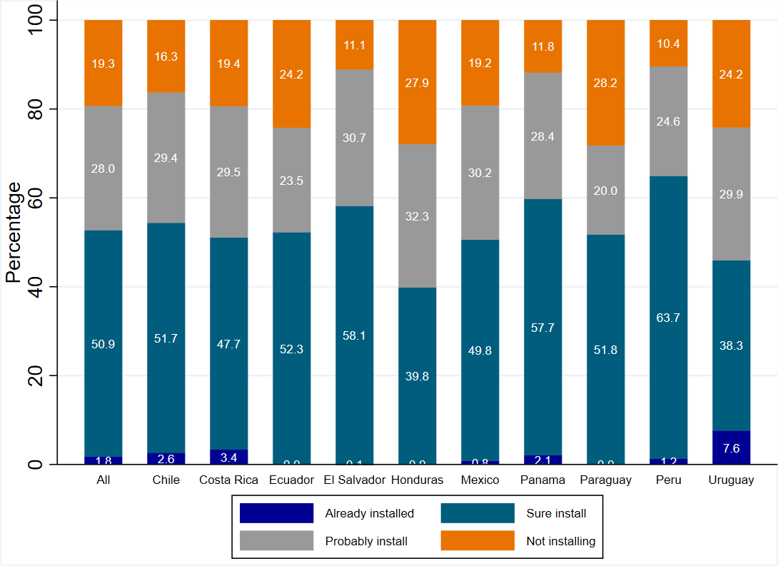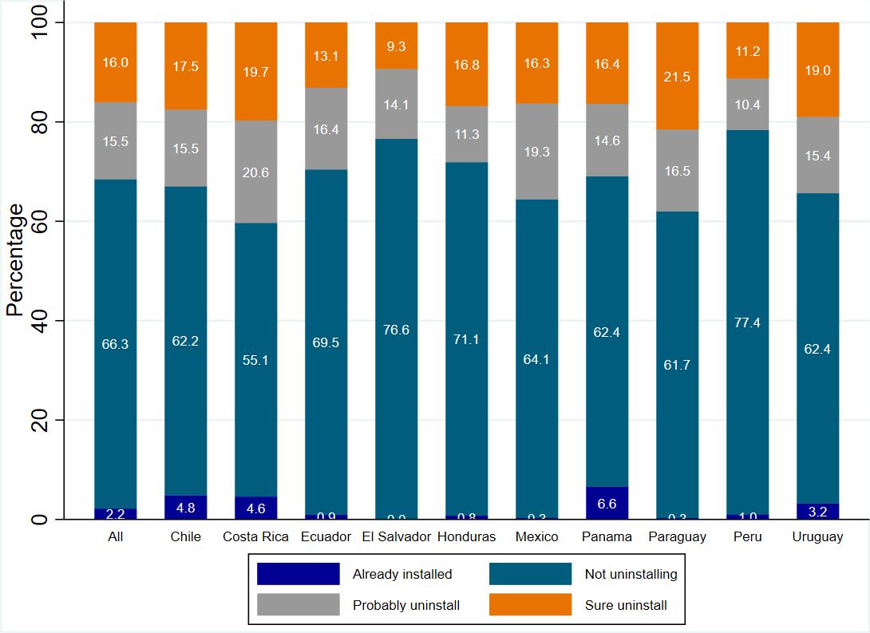

Figure D.2 Difference in acceptance of each regime between basic app and exposure notification



Note: Figure D.2 looks at the differences in acceptance of each regime between the basic app and the exposure notification feature. It can be seen that while the increase observed between both is significant for the opt-out option, it is not for the opt-in.

**E Determinants of acceptance per regime**

Figure E.1 shows the determinants of acceptance per regime. It can be seen that in the case of voluntary installment using the smartphone for social media or online shopping, trusting the government and believing the benefits of sharing data outweighs its costs significantly increases acceptance, while having less than high school education reduces it compared to those who are more educated. In the case of the opt-out regime the only significant determinant is believing the benefits of sharing data outweighs its costs significantly increases acceptance.

Figure E.2 shows the distribution of reasons respondents declared for their choice. Among the main ones behind the intention to install/ not uninstall the app are staying informed and knowing the level of risk of being infected. In terms of intention not to accept the app, for the opt-in case the main reasons are believing not to benefit from the application (25 percent), not believing in the promises of anonymity (17 percent) and not thinking it will help to stop the pandemic (14 percent). Trust issues like not wanting the government to have access to location or thinking the government could have control over people or technical reasons like not having enough space on the phone or not knowing how to install the app appear later in the list (average 7 percent each). In terms of intention not to uninstall the app, for the opt-out case the main reasons are the same as in the opt-in case (figures are 21, 15 and 14 percent, respectively). Trust issues like not wanting the government to have access to location, thinking the government could have control over people or believing their phone could be in danger appear to be more of a concern in this case (above 9 percent each). The same is true for technical reasons like not having space on their phone, though a lower share of respondents claim not to know how to uninstall the app. Overall, for those not willing to accept the app, the main reasons seem to be the same across regimes and related to epidemiological and promise of anonymity concerns. Nevertheless, technical or trust issues appear to be more of a concern for those in the opt-out option.

Finally, Figure E.3 shows the difference in acceptance of each regime between contact tracing app with exposure notification and extra features / different implementing institutions. As it can be seen, for each regime, having COVID-19 or having a family member that has tested positive for COVID-19 significantly increases the self-reported intention to install (not uninstall) the app. When compared to the national government, all the other potential designers (local governments, an international company, a phone company and the WHO) significantly decrease intention to accept the app for each regime

Figure E.1. Determinants of acceptance per regime



Note: In the case of opt-in the dependent variable is an indicator variable taking the value 1 if a respondent answered “Already have the app of the country”, “Definitely Install”, and 0 for “Probably Install” or “Definitely not install”. In the case of opt-out the dependent variable is an indicator variable taking the value 1 if a respondent answered “Already have the app of the country”, “Definitely not uninstall”, and 0 for “Definitely uninstall” or “Probably uninstall”. We use a Linear Probability Model. Lines represent 95% confidence intervals calculated with heteroskedasticity-robust standard errors. Population weights used. Marginal effects displayed (a coefficient of 0.1 implies a respondent who chose this option is 10 percentage points more likely to state they would use the phone relative to the base category). Base categories: 61 years old or more, more than high school; men; no children under 12 at home; no seniors at home. Includes country FE.

Figure E.2 Reasons for install/ not uninstall and not install/uninstall exposure notifications apps

1. Install App (b) Not Uninstall App

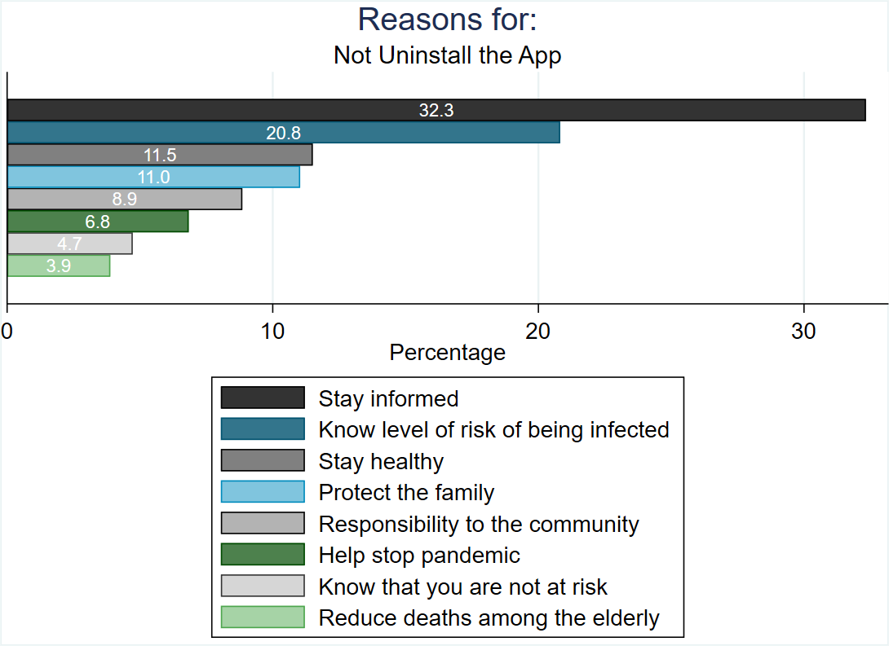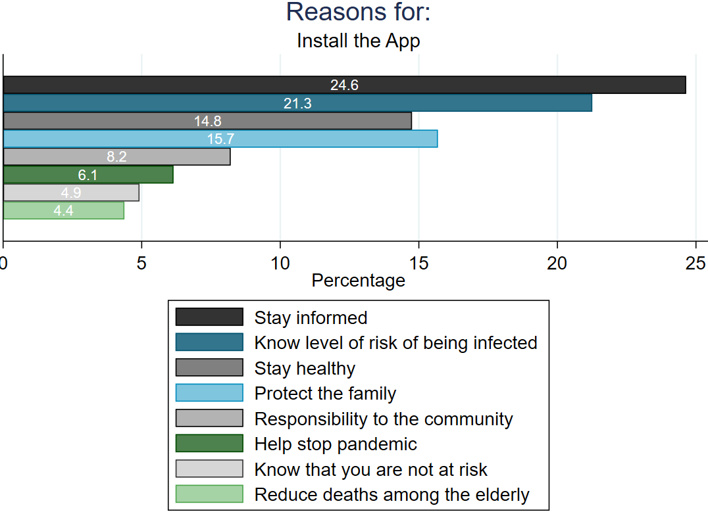

(c) Not Install App (d) Uninstall App

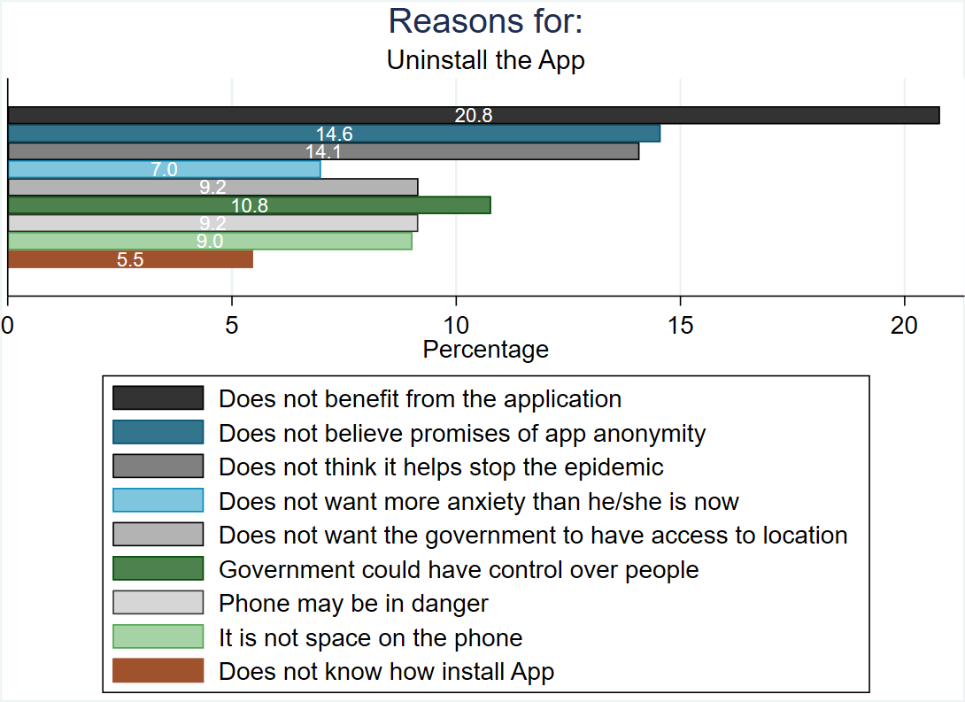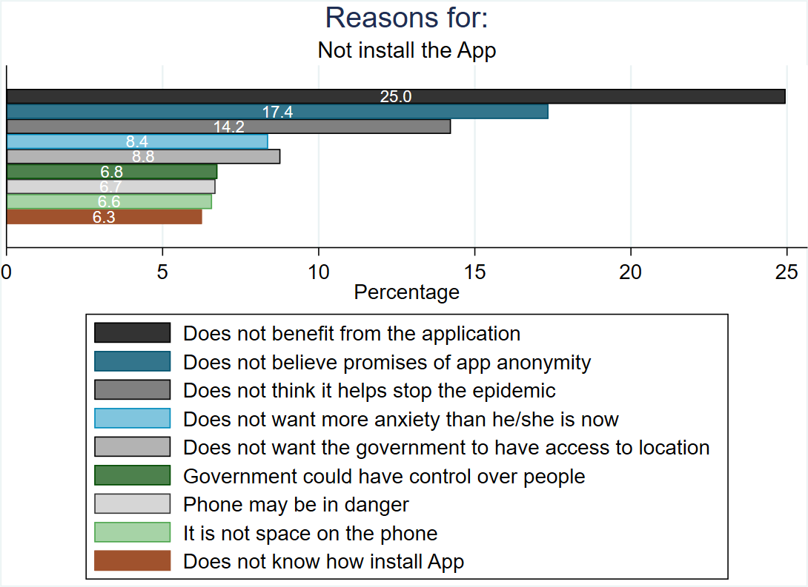

*Figure E.3. Difference in acceptance of each regime between contact tracing app with exposure notification and* *extra features / different implementing institutions*

**

Note: Figure E.3 looks at the differences in acceptance of each regime between the basic contact tracing app with exposure notifications and different features or conditions for acceptance as well as different implementing institutions (rather than the national government). It shows both the difference in means, as well as the 95 percent confidence interval.

**F Additional Results**

**F.1 Main results**

Table F.1 shows the point estimates of the main results

Table F.1 Main results

|  |  |  |  |  |  |  |  |
| --- | --- | --- | --- | --- | --- | --- | --- |
|  | (1) | (2) | (3) | (5) | (6) | (7) | (8) |
|  | |  | | Conditions | | Implementing Institutions | |
|  | Contact Tracing w/ exposure notification | COVID-19 Positive | COVID-19 Family | Local Gov. | Intl. Comp. | Phone Comp. | WHO |
|  |  |  |  |  |  |  |  |
| Opt-Out | 0.216*** | 0.161*** | 0.160*** | 0.223*** | 0.184*** | 0.216*** | 0.211*** |
|  | (0.0147) | (0.0137) | (0.0138) | (0.0152) | (0.0153) | (0.0147) | (0.0146) |
|  |  |  |  |  |  |  |  |
| 18-30 years old | 0.0165 | 0.0469 | 0.0352 | -0.0369 | 0.155*** | -0.00831 | 0.141*** |
|  | (0.0321) | (0.0314) | (0.0309) | (0.0328) | (0.0321) | (0.0303) | (0.0310) |
|  |  |  |  |  |  |  |  |
| 31-40 years old | 0.000985 | 0.0183 | 0.00749 | -0.0208 | 0.0930*** | -0.00105 | 0.0583* |
|  | (0.0339) | (0.0337) | (0.0334) | (0.0345) | (0.0339) | (0.0318) | (0.0328) |
|  |  |  |  |  |  |  |  |
| 41-50 years old | -0.00517 | 0.00707 | 0.00430 | -0.00814 | 0.0899*** | 0.0311 | 0.0626* |
|  | (0.0337) | (0.0331) | (0.0324) | (0.0345) | (0.0338) | (0.0327) | (0.0327) |
|  |  |  |  |  |  |  |  |
| 51-60 years old | 0.00716 | 0.0101 | -0.00303 | 0.0163 | 0.0805** | 0.00955 | 0.0682* |
|  | (0.0362) | (0.0354) | (0.0360) | (0.0383) | (0.0380) | (0.0365) | (0.0354) |
|  |  |  |  |  |  |  |  |
| Women | 0.0265* | 0.000589 | -0.00397 | 0.0241 | -0.0357** | 0.0115 | 0.0591*** |
|  | (0.0151) | (0.0142) | (0.0143) | (0.0156) | (0.0157) | (0.0151) | (0.0150) |
|  |  |  |  |  |  |  |  |
| Less than HS | -0.0571*** | -0.0597*** | -0.0300 | 0.00395 | -0.0758*** | -0.0165 | 0.0391* |
|  | (0.0203) | (0.0187) | (0.0190) | (0.0210) | (0.0213) | (0.0205) | (0.0201) |
|  |  |  |  |  |  |  |  |
| HS | -0.0314** | -0.0239* | -0.0211 | -0.00828 | -0.0432*** | -0.0362** | -0.00885 |
|  | (0.0155) | (0.0141) | (0.0143) | (0.0163) | (0.0165) | (0.0160) | (0.0159) |
|  |  |  |  |  |  |  |  |
| Child | 0.0240 | -0.00291 | 0.000888 | 0.0177 | -0.0217 | 0.0138 | 0.00422 |
|  | (0.0158) | (0.0152) | (0.0152) | (0.0162) | (0.0164) | (0.0159) | (0.0159) |
|  |  |  |  |  |  |  |  |
| Senior | 0.00951 | -0.000831 | -0.00381 | -0.0121 | 0.00241 | -0.0259 | 0.0120 |
|  | (0.0175) | (0.0165) | (0.0170) | (0.0181) | (0.0182) | (0.0170) | (0.0173) |
|  |  |  |  |  |  |  |  |
| Social Network Usage | 0.0747** | 0.0575* | 0.0690** | 0.0271 | 0.0581* | 0.0525 | -0.00793 |
|  | (0.0306) | (0.0315) | (0.0318) | (0.0299) | (0.0322) | (0.0321) | (0.0302) |
|  |  |  |  |  |  |  |  |
| Instant Messaging Usage | -0.0420 | -0.0585 | 0.0109 | -0.00218 | -0.0713 | -0.0448 | 0.00283 |
|  | (0.0520) | (0.0458) | (0.0516) | (0.0485) | (0.0546) | (0.0523) | (0.0500) |
|  |  |  |  |  |  |  |  |
| Online Shopping | 0.0464*** | 0.0331** | 0.0277** | 0.0375** | 0.0654*** | 0.0257 | 0.0403*** |
|  | (0.0154) | (0.0138) | (0.0139) | (0.0163) | (0.0164) | (0.0157) | (0.0155) |
|  |  |  |  |  |  |  |  |
| Trust Gov. | 0.0513*** | 0.0639*** | 0.0524*** | 0.0437** | 0.00556 | 0.0258 | 0.103*** |
|  | (0.0170) | (0.0163) | (0.0167) | (0.0177) | (0.0177) | (0.0169) | (0.0170) |
|  |  |  |  |  |  |  |  |
| Trust others | -0.0245 | -0.0313* | -0.0279 | -0.00229 | -0.0375* | -0.00259 | -0.00479 |
|  | (0.0190) | (0.0184) | (0.0184) | (0.0201) | (0.0195) | (0.0192) | (0.0190) |
|  |  |  |  |  |  |  |  |
| Benefit Share Data | 0.0773*** | 0.0786*** | 0.0766*** | 0.118*** | 0.107*** | 0.0948*** | 0.0919*** |
|  | (0.0178) | (0.0163) | (0.0164) | (0.0190) | (0.0195) | (0.0190) | (0.0177) |
|  |  |  |  |  |  |  |  |
| Control Personal Data | 0.0255 | 0.0303* | 0.0398** | 0.0583*** | 0.0545*** | 0.0552*** | 0.0780*** |
|  | (0.0182) | (0.0159) | (0.0160) | (0.0179) | (0.0186) | (0.0176) | (0.0176) |
|  |  |  |  |  |  |  |  |
| Knowledge Gov. Data | -0.0219 | -0.0276 | -0.0413** | 0.00502 | -0.00230 | -0.00148 | 0.0175 |
|  | (0.0171) | (0.0168) | (0.0169) | (0.0175) | (0.0181) | (0.0179) | (0.0170) |
|  |  |  |  |  |  |  |  |
| Observations | 7387 | 7377 | 7386 | 7353 | 7328 | 7331 | 7382 |
| P-value of the difference in the point estimate of “Opt-out” between (1) and each column |  | 0.0001 | 0.0001 | 0.6865 | 0.0668 | 0.9746 | 0.7800 |
|  |  |  |  |  |  |  |  |
| Note: Standard errors in parentheses;  Regressions include country FE | | | | | | | |
| "* p<0.10 | ** p<0.05 | *** p<0.01" |  |  |  |  |  |

**F.2 Results with alternative sample**

Claiming to have the official app of the country was a spontaneous answer, and that is why we decided to keep it in the main analysis and mix it to those who self-report an intention to download or not remove the app. However, in Table F.2 we perform the analysis excluding those who already downloaded the official apps of their country and find similar results.

Table F.2. Main results (excluding those who already downloaded the official apps of their country)

|  |  |  |  |  |  |  |  |
| --- | --- | --- | --- | --- | --- | --- | --- |
|  | (1) | (2) | (3) | (5) | (6) | (7) | (8) |
|  | |  | | Conditions | | Implementing Institutions | |
|  | Contact Tracing w/ exposure notification | COVID-19 Positive | COVID-19 Family | Local Gov. | Intl. Comp. | Phone Comp. | WHO |
|  |  |  |  |  |  |  |  |
| Opt-Out | 0.219*** | 0.166*** | 0.165*** | 0.225*** | 0.188*** | 0.219*** | 0.215*** |
|  | (0.0149) | (0.0137) | (0.0138) | (0.0153) | (0.0154) | (0.0148) | (0.0147) |
|  |  |  |  |  |  |  |  |
| 18-30 years old | 0.0210 | 0.0557* | 0.0432 | -0.0315 | 0.167*** | 0.000382 | 0.148*** |
|  | (0.0326) | (0.0320) | (0.0314) | (0.0331) | (0.0322) | (0.0305) | (0.0313) |
|  |  |  |  |  |  |  |  |
| 31-40 years old | 0.00831 | 0.0209 | 0.0104 | -0.0227 | 0.0980*** | -0.000307 | 0.0590* |
|  | (0.0344) | (0.0342) | (0.0339) | (0.0348) | (0.0341) | (0.0319) | (0.0331) |
|  |  |  |  |  |  |  |  |
| 41-50 years old | -0.00233 | 0.0104 | 0.00751 | -0.00972 | 0.0931*** | 0.0285 | 0.0628* |
|  | (0.0344) | (0.0337) | (0.0331) | (0.0349) | (0.0340) | (0.0329) | (0.0331) |
|  |  |  |  |  |  |  |  |
| 51-60 years old | 0.0137 | 0.0158 | 0.00291 | 0.0186 | 0.0880** | 0.0144 | 0.0713** |
|  | (0.0368) | (0.0360) | (0.0366) | (0.0388) | (0.0382) | (0.0368) | (0.0358) |
|  |  |  |  |  |  |  |  |
| Women | 0.0311** | 0.00479 | 0.000117 | 0.0294* | -0.0327** | 0.0130 | 0.0603*** |
|  | (0.0153) | (0.0143) | (0.0144) | (0.0157) | (0.0158) | (0.0151) | (0.0151) |
|  |  |  |  |  |  |  |  |
| Less than HS | -0.0583*** | -0.0603*** | -0.0299 | 0.00213 | -0.0776*** | -0.0178 | 0.0434** |
|  | (0.0206) | (0.0189) | (0.0192) | (0.0213) | (0.0215) | (0.0206) | (0.0203) |
|  |  |  |  |  |  |  |  |
| HS | -0.0328** | -0.0255* | -0.0224 | -0.0109 | -0.0464*** | -0.0385** | -0.00720 |
|  | (0.0157) | (0.0143) | (0.0144) | (0.0165) | (0.0166) | (0.0161) | (0.0160) |
|  |  |  |  |  |  |  |  |
| Child | 0.0228 | -0.00237 | 0.00267 | 0.0207 | -0.0177 | 0.0170 | 0.00715 |
|  | (0.0160) | (0.0153) | (0.0153) | (0.0164) | (0.0165) | (0.0161) | (0.0160) |
|  |  |  |  |  |  |  |  |
| Senior | 0.00845 | -0.00226 | -0.00451 | -0.0130 | 0.00130 | -0.0266 | 0.00875 |
|  | (0.0177) | (0.0166) | (0.0171) | (0.0183) | (0.0183) | (0.0171) | (0.0174) |
|  |  |  |  |  |  |  |  |
| Social Network Usage | 0.0673** | 0.0541* | 0.0650** | 0.0222 | 0.0551* | 0.0496 | -0.00893 |
|  | (0.0306) | (0.0317) | (0.0320) | (0.0299) | (0.0321) | (0.0320) | (0.0303) |
|  |  |  |  |  |  |  |  |
| Instant Messaging Usage | -0.0283 | -0.0475 | 0.0225 | -0.00897 | -0.0825 | -0.0517 | -0.00414 |
|  | (0.0514) | (0.0459) | (0.0515) | (0.0490) | (0.0546) | (0.0530) | (0.0507) |
|  |  |  |  |  |  |  |  |
| Online Shopping | 0.0445*** | 0.0277** | 0.0232* | 0.0331** | 0.0628*** | 0.0246 | 0.0395** |
|  | (0.0156) | (0.0139) | (0.0140) | (0.0165) | (0.0165) | (0.0157) | (0.0156) |
|  |  |  |  |  |  |  |  |
| Trust Gov. | 0.0535*** | 0.0582*** | 0.0469*** | 0.0387** | -0.000985 | 0.0203 | 0.0997*** |
|  | (0.0172) | (0.0162) | (0.0165) | (0.0178) | (0.0178) | (0.0170) | (0.0170) |
|  |  |  |  |  |  |  |  |
| Trust others | -0.0258 | -0.0357* | -0.0325* | -0.00207 | -0.0302 | 0.000853 | -0.00519 |
|  | (0.0191) | (0.0186) | (0.0187) | (0.0204) | (0.0197) | (0.0194) | (0.0192) |
|  |  |  |  |  |  |  |  |
| Benefit Share Data | 0.0719*** | 0.0788*** | 0.0757*** | 0.119*** | 0.108*** | 0.0975*** | 0.0914*** |
|  | (0.0182) | (0.0166) | (0.0168) | (0.0193) | (0.0199) | (0.0193) | (0.0179) |
|  |  |  |  |  |  |  |  |
| Control Personal Data | 0.0270 | 0.0337** | 0.0434*** | 0.0599*** | 0.0556*** | 0.0571*** | 0.0780*** |
|  | (0.0183) | (0.0161) | (0.0162) | (0.0181) | (0.0188) | (0.0178) | (0.0179) |
|  |  |  |  |  |  |  |  |
| Knowledge Gov. Data | -0.0198 | -0.0289* | -0.0418** | 0.00725 | -0.00340 | -0.00164 | 0.0138 |
|  | (0.0173) | (0.0170) | (0.0171) | (0.0177) | (0.0183) | (0.0180) | (0.0171) |
|  |  |  |  |  |  |  |  |
| Observations | 7250 | 7242 | 7251 | 7219 | 7198 | 7209 | 7250 |
|  |  |  |  |  |  |  |  |
| Note: Standard errors in parentheses.  Regressions include country FE | | | | | | | |
| "* p<0.10 | ** p<0.05 | ***p<0.01" |  |  |  |  |  |
|  |  |  |  |  |  |  |  |

**F.3. Heterogeneous effects**

Table F.3, column (1) shows the results of our estimations divided by South America on the one hand, and Central America and Mexico on the other. The intention to accept the app increases by 20.2 percentage points in the case of an opt-out regime compared to an opt-in in Central America and Mexico. In South America, we see the same figure (the interaction effect between an opt-out regime and being in South America is not statistically significant different from zero) – though overall we see acceptance of contact tracing apps overall being higher in that part of the continent. Column (2) in the same table shows the results of our estimations by countries that during the period of the survey had over 30 COVID-19 deaths per 100,000 inhabitants (high COVID-19 incidence), and those with les (low COVID-19 incidence). There seems to be no differences: the intention to accept the app increases by 21.5 percentage points in the case of an opt-out regime compared to an opt-in with the interaction effect not being significant, suggesting that the severity of the pandemic does not affect this behavior. This goes in line with studies that show how local incidence of COVID-19 does not seem to have an impact in explaining objective metrics of social distancing or support for COVID-19 policies (Freira et al. 2020; Gollwitzer et al. 2020; Clinton et al. 2020). Table F.3, column (3) shows the intention to accept the app increases by 24.21 percentage points in the case of an opt-out regime compared to an opt-in for respondents who claim to never trust the government. For those who do (“a lot” or “some”) such figure gets reduced by 4.05 percentage points. Therefore, there is some indication then that default option could be more effective for those who do not trust the government – even though, as expected, for those respondents who claim to trust the government, acceptance increases by 7.14 percentage points across regimes. Column (4) of Table F.3 shows that there is no difference in the intention to accept the app between those who claim not to have control over their personal data, and those who think they do (at least some) as the interaction effect is not significant. In both cases, the intention to accept the app increases by 19 percentage points in the case of an opt-out regime compared to an opt-in. Given that the previous issues of trust and data sharing concerns are self-reported perceptions (and also that the data question was asked *after* the contact tracing app with exposure notification module which might introducing some bias), we show the results of our estimations by those who use their phones to make financial transactions (do online shopping or payments), and those who do not. The assumption is that reporting using phones regularly to make transaction is a better proxy for actual behavior related to data privacy concerns. As it can be seen in column (5) of Table F.3, the probability of acceptance of the app increases by 24.9 percentage points in the case of an opt-out regime compared to an opt-in for respondents who claim to never have used their phones in the previous week to make financial transactions. For those who did, such figure is reduced by 9.12 percentage points (and, as expected, for those respondents who use their phones every day or some days to do online shopping, acceptance increases by 9.16 percentage points across regimes). We can thus extrapolate that it is more effective for those who, probably, are not comfortable with having bank or credit card information to make payments through their phone – in other words, those who by their actions show not feel comfortable sharing personal data compared to those who do.

Table F.3 Heterogeneous results

|  |  |  |  |  |  |
| --- | --- | --- | --- | --- | --- |
|  | (1) | (2) | (3) | (4) | (5) |
|  | Region | COVID-19 Incidence | Trust in Government | Control Personal Data | Online Financial Transactions |
|  |  |  |  |  |  |
| Opt-Out | 0.202*** | 0.215*** | 0.241*** | 0.190*** | 0.249*** |
|  | (0.0148) | (0.0155) | (0.0173) | (0.0212) | (0.0136) |
|  |  |  |  |  |  |
| South | 0.0257* |  |  |  |  |
|  | (0.0155) |  |  |  |  |
|  |  |  |  |  |  |
| **Opt-Out x South** | **0.0305** |  |  |  |  |
|  | **(0.0216)** |  |  |  |  |
|  |  |  |  |  |  |
| High COVID-19 Incidence |  | 0.0115 |  |  |  |
|  |  | (0.0155) |  |  |  |
|  |  |  |  |  |  |
| **Opt-Out x High COVID-19 Incidence** |  | **0.00185** |  |  |  |
|  |  | **(0.0216)** |  |  |  |
|  |  |  |  |  |  |
| Trust Gov. | 0.0706*** | 0.0679*** | 0.0714*** | 0.0513*** | 0.0518*** |
|  | (0.0112) | (0.0113) | (0.0164) | (0.0121) | (0.0121) |
|  |  |  |  |  |  |
| **Opt-Out x Trust Gov.** |  |  | **-0.0405\*** |  |  |
|  |  |  | **(0.0221)** |  |  |
|  |  |  |  |  |  |
| Control Personal Data | 0.0223* | 0.0175 | 0.0261** | 0.00713 | 0.0261** |
|  | (0.0126) | (0.0126) | (0.0129) | (0.0184) | (0.0129) |
|  |  |  |  |  |  |
| **Opt-Out x Control Personal Data** |  |  |  | **0.0346** |  |
|  |  |  |  | **(0.0247)** |  |
|  |  |  |  |  |  |
| Online Shopping | 0.0528*** | 0.0533*** | 0.0463*** | 0.0463*** | 0.0916*** |
|  | (0.0120) | (0.0120) | (0.0124) | (0.0124) | (0.0166) |
|  |  |  |  |  |  |
| **Opt-Out x Online Shopping** |  |  |  |  | **-0.0912\*\*\*** |
|  |  |  |  |  | **(0.0224)** |
|  |  |  |  |  |  |
| Constant | 0.403*** | 0.410*** | 0.432*** | 0.461*** | 0.427*** |
|  | (0.0455) | (0.0458) | (0.0495) | (0.0500) | (0.0490) |
|  |  |  |  |  |  |
| Observations | 7387 | 7387 | 7387 | 7387 | 7387 |
| Controls | YES | YES | YES | YES | YES |
| Country FE | NO | NO | YES | YES | YES |
|  |  |  |  |  |  |
| Standard errors in parentheses |  |  |  |  |  |
| ="* p<0.10 | ** p<0.05 | *** p<0.01" |  |  |  |

**F.4 Robustness Tests**

As a robustness test, we run the same analysis but changed the outcome. After the questions related to the contact tracing app with exposure notification, we also asked three questions related to the handling of the pandemic. Particularly:

*1. Do you think that the benefits the government can give by gathering personal data overweight the potential risks during a pandemic?*

*2. Do you think that it is necessary for the government to track the movement of all of us as a way to limit social contact to limit the spread of the virus?*

*3. Do you think the government should fine individuals that are COVID-19 positive and do not allow the geo-localization of their cellphones?*

As can be seen in Figure F.1, there are not significant differences in the previous perception of the pandemic between those respondents who were asked about an opt-in contact tracing app with exposure notification and those for whom the regime was opt-out. In other words, and as expected, the only variable that seems to be affected by the difference in regimes is the acceptance probability but not any other perception regarding data usage or perception about the government tracking of citizens.

Figure F.1 Alternative outcomes



Note: The dependent variable is an indicator variable taking the value 1 if a respondent answered “Yes”, and 0 for “No”. We use a Linear Probability Model. Lines represent 95% confidence intervals calculated with heteroskedasticity-robust standard errors. Population weights used. Marginal effects displayed (a coefficient of 0.1 implies a respondent who chose this option is 10 percentage points more likely to state they would use the phone relative to the base category). Base categories: 61 years old or more, more than high school; men; no children under 12 at home; no seniors at home. Includes country FE.

**G Instrument (Spanish)**

**Buenas tardes, mi nombre es ____________ y trabajo para FIRMA, una empresa que hace estudios de opinión pública.**

**Estamos haciendo una encuesta, en el marco de un estudio internacional sobre la emergencia en salud a causa del coronavirus y las herramientas para disminuir el contagio, entre ellas el uso de tecnología. La encuesta dura alrededor de 15 minutos. Sus respuestas son voluntarias y estrictamente confidenciales**. **¿Accede a participar?**

**P0. VERSION CUESTIONARIO**

**1. CUESTIONARIO 1**

**2. CUESTIONARIO 2**

**3. CUESTIONARIO 3**

**4. CUESTIONARIO 4**

**P1. ¿Cuántos años tiene usted?**

________________________________

**P2. (ANOTAR GENERO POR REGISTRO DE VOZ o preguntar si hay dudas)**

1. Hombre
2. Mujer

**P3. ¿Cuál es el nivel educativo mas alto que alcanzó? (respuesta abierta, encuestador anota opción más cercana**. Como referencia: Primaria = entre 6 y 11 años; Secundaria = entre 12 y 18 años)

* 1. No fue a la escuela
  2. Primaria incompleta
  3. Primaria completa
  4. Secundaria incompleta
  5. Secundaria completa
  6. Universitario/terciario incompleto
  7. Universitario/terciario completa
  8. Posgrado incompleto
  9. Posgrado completo

99. Ns/Nr

**Modulo 2: Hogar**

**P4. Incluido usted, ¿cuántas personas residen en el hogar?**

________________________________

**P5. Sin contarse usted, ¿Hay mayores de 60 años en el hogar?**

1. Sí
2. No

99. NS/NR

**P6. ¿Hay menores de 12 años en el hogar?**

1. Sí
2. No

99. NS/NR

**Modulo 3: Uso de Tecnología**

**P7. ¿Utilizó en la última semana un teléfono inteligente, conocido también como “Smartphone”?**

1. Sí
2. No

99. NS/NR

**P8. (P7 =1) La semana pasada, ¿cuántas veces realizó las siguientes actividades con su celular o en internet de cualquier forma? ¿todos los días, algunos días, o nunca realizó? Ns/Nr=99. (Lea las alternativas y marque una respuesta para cada ítem).**

|  |  |  |  |  |
| --- | --- | --- | --- | --- |
| **Actividad** | **1 –**  **Todos los días** | **2 – Algunos días** | **3 - Nunca** | **99 – Ns/Nr** |
| P8_1 Uso de redes sociales (Facebook, Instagram, Twitter, etc.) |  |  |  |  |
| P8_2 Uso de mensajería instantánea (WhatsApp, iMessage, Messenger, etc.) |  |  |  |  |
| P8_3 Hacer compras o pagar servicios online |  |  |  |  |

**Modulo 4: Confianza y Coronavirus**

**P9. De las siguientes dos frases, ¿con cuál se identifica más? (i) se puede confiar en la mayoría de las personas; o (ii) uno nunca es lo suficientemente cuidadoso en el trato con los demás**

1. Se puede confiar en la mayoría de las personas

2. Uno nunca es lo suficientemente cuidadoso en el trato con los demás

99. NS/NR

**P10. ¿Cuánta confianza tiene usted en el gobierno? ¿Mucha, algo, o nada?**

1. Mucha

2. Algo

3. Nada

99. NS/NR

**P11. Pensando en la información que recibe sobre el coronavirus, ¿usted tiene mucha confianza en la información que da el presidente, algo, o ninguna confianza? ¿Y en…?**

|  |  |  |  |  |  |
| --- | --- | --- | --- | --- | --- |
| **Institución** | **1-Mucha** | **2-Algo** | **3-Ninguna** | **77. No recibe** | **99-Ns/Nr** |
| P11_1 Presidente |  |  |  |  |  |
| P11_2 (AUTORIDAD LOCAL/Gobernador, Intendente) |  |  |  |  |  |
| P11_3 Medios de comunicación (diarios, radio, televisión) |  |  |  |  |  |
| P11_4 Posteos en redes sociales (Twitter, Facebook, etc.) |  |  |  |  |  |
| P11_5 Organización Mundial de la Salud |  |  |  |  |  |
| P11_6 Ministro de Salud |  |  |  |  |  |

**P12A. (P0=1 O 2) Las personas con coronavirus deben aislarse para no contagiar y mantenerse en cuarentena. Para corroborar que todos los enfermos se mantengan en cuarentena, ¿Usted apoya o no apoya que autoridades del gobierno…?**

|  |  |  |  |
| --- | --- | --- | --- |
| **Normas de monitoreo** | **1-Apoya** | **2-No apoya** | **99-Ns/Nr** |
| P12A_1 Llamen por teléfono todos los días a las personas con coronavirus |  |  |  |
| P12A_2 Visiten todos los días a las personas con coronavirus |  |  |  |
| P12A_3 Les pongan pulseras electrónicas a las personas con coronavirus |  |  |  |
| P12A_4 Rastreen dónde están los enfermos con el teléfono celular (vía sistema de GPS) |  |  |  |
| P12A_5 Pongan un guardia en la puerta del lugar donde está el enfermo |  |  |  |

**P12b. (P0=3 O 4) Las personas con coronavirus deben aislarse para no contagiar y mantenerse en cuarentena. Si usted fuese un caso positivo de coronavirus, ¿Usted apoya o no apoya que para corroborar que usted se mantenga en cuarentena autoridades del gobierno…?**

|  |  |  |  |
| --- | --- | --- | --- |
| **Normas de monitoreo** | **1-Apoya** | **2-No apoya** | **99-Ns/Nr** |
| P12C_1 Llamen por teléfono todos los días a las personas con coronavirus |  |  |  |
| P12C_2 Visiten todos los días a las personas con coronavirus |  |  |  |
| P12C_3 Les pongan pulseras electrónicas a las personas con coronavirus |  |  |  |
| P12C_4 Rastreen dónde están los enfermos con el teléfono celular (vía sistema de GPS) |  |  |  |
| P12C_5 Pongan un guardia en la puerta del lugar donde está el enfermo |  |  |  |

**Modulo 5: Trámites**

**P13. Entre enero y marzo, antes de que hubiera restricciones al movimiento (llamado “cuarentena” en algunos lugares), ¿hizo algún trámite con una institución de gobierno, como renovar documento de identidad, licencia de conducir, acceder a seguro de desempleo, o cualquier otro trámite? Puede ser para su vida personal o para su trabajo, y por cualquier canal de atención (en persona, en línea, etc.).**

1. Sí
2. No

99. NS/NR

**P14. (P13=1) ¿Qué tipo de trámite fue? Si hizo más de uno, queremos saber sobre el último trámite que hizo. (respuesta abierta, encuestador anota opción más cercana)**

1. Solicitar o renovar un documento de identidad o registro civil
2. Acceder a un programa social, o tramitar seguro de desempleo
3. Acceder a un servicio de educación o salud
4. Registrar, comprar o vender una propiedad inmueble
5. Abrir o cerrar una empresa, u otro trámite empresarial
6. Pagar impuestos, pagar seguro médico, pagar o cobrar una pensión/mesada pública por jubilación
7. Hacer una denuncia de un crimen
8. Solicitar un permiso de conducir u otro trámite de transporte
9. Un trámite de justicia (por ejemplo, consulta a mi juicio)
10. Otro (ANOTAR)

**P15. (P13=1) Para el mismo trámite que nos acaba de señalar, ¿Fue personalmente a una oficina pública, hizo el trámite por internet, hizo el trámite por teléfono, o empezó el trámite por internet o por teléfono y lo terminó personalmente?**

1. Todo presencial / en la oficina pública
2. Una parte por teléfono y otra en la oficina
3. Una parte en línea y otra en la oficina
4. Todo por teléfono
5. Todo en línea

99. NS/NR

**P16. Durante el periodo de mayores restricciones al movimiento (llamado “cuarentena” en algunos lugares), ¿hizo algún trámite con una institución de gobierno, como renovar documento de identidad, licencia de conducir, acceder a seguro de desempleo, o cualquier otro trámite? Puede ser para su vida personal o para su trabajo, y por cualquier canal de atención (en persona, en línea, etc.).**

1. Sí
2. No

99. NS/NR

**P17. (P16=1) Si hizo más de un trámite durante el periodo de mayores restricciones al movimiento, queremos saber sobre el trámite más reciente. ¿Qué tipo de trámite fue? (respuesta abierta, encuestador anota opción más cercana)**

1. Solicitar o renovar un documento de identidad o registro civil
2. Acceder a un programa social, tramitar seguro de desempleo
3. Acceder a un servicio de educación o salud
4. Registrar, comprar o vender una propiedad inmueble
5. Abrir o cerrar una empresa, u otro trámite empresarial
6. Pagar impuestos, pagar seguro médico, pagar o cobrar una pensión/mesada pública por jubilación
7. Hacer una denuncia de un crimen
8. Solicitar un permiso de conducir u otro trámite de transporte
9. Un trámite de justicia (por ejemplo, consulta a mi juicio)
10. Otro (ANOTAR)

**P18. (P16=1) ¿Fue personalmente a una oficina pública, hizo el trámite por internet, hizo el trámite por teléfono, o empezó el trámite por internet y lo terminó personalmente?**

1. Todo presencial / la oficina pública
2. Una parte por teléfono y otra en la oficina
3. Una parte en línea y otra en la oficina
4. Todo por teléfono
5. Todo en línea

99. NS/NR

**P19. (P18=1, 2 o 3) ¿Considera usted que se respetaron las normas de distanciamiento social y seguridad sanitaria en su visita a la oficina prestadora?**

1. Sí

2. No

99. NS/NR

**P20. Durante el periodo de cuarentena más restrictiva, ¿hubo algún trámite oficial que hubiera querido hacer pero que no pudo? (para su vida personal o para su trabajo)**

1. Sí

2. No

99. NS/NR

**P21. (P20=1) Pensando en el trámite MAS IMPORTANTE que no pudo hacer, ¿Qué tipo de trámite fue?** (respuesta abierta, encuestador anota opción más cercana)

1. Solicitar o renovar un documento de identidad o registro civil
2. Acceder a un programa social, tramitar seguro de desempleo
3. Acceder a un servicio de educación o salud
4. Registrar, comprar o vender una propiedad inmueble
5. Abrir o cerrar una empresa, u otro trámite empresarial
6. Pagar impuestos, pagar seguro médico, pagar o cobrar una pensión/mesada pública por jubilación
7. Hacer una denuncia de un crimen
8. Solicitar un permiso de conducir u otro trámite de transporte
9. Un trámite de justicia (por ejemplo, consulta a mi juicio)
10. Otro (ANOTAR)

**P22. (P20=1) ¿Por qué no lo pudo hacer?** (respuesta abierta, encuestador anota opción más cercana)

1. La oficina que presta el trámite estaba abierta, pero no quise ir en persona
2. No atendían el teléfono, mucha espera para que atendieran
3. Se cerró la oficina pública donde se presta y no estaba disponible en línea
4. El trámite que buscaba estaba disponible en línea, pero no lo pude completar (porque no tenía un computador o dispositivo, el trámite no se pudo hacer o no se completó).
5. Otra razón (ANOTAR)

**Modulo 6: Tecnología y coronavirus**

SOLO LOS QUE TIENEN TELEFONO INTELIGENTE

**P23A. (PO=1 O 3) (P7=1) Si existe o hubiera una aplicación del gobierno nacional que usted necesitaría descargar (pero que no le consumiría datos ni saldo) que le permite saber si tiene algún síntoma de coronavirus y le diga qué hacer, ¿seguramente la instalaría en su teléfono, probablemente la instalaría, o no la instalaría?**

1. (Espontánea) Ya instaló/tiene la oficial del país

2. Seguro la instalaría

3. Probablemente la instalaría

4. No la instalaría

99. NS/NR

**P23B. (P0=2 O 4) (P7=1) Si existe o hubiera una aplicación del gobierno nacional que se instalaría automáticamente con posibilidad de desinstalar cuando desee (pero que no le consumiría datos ni saldo) que le permite saber si tiene algún síntoma de coronavirus y le diga qué hacer, ¿seguramente la desinstalaría en su teléfono, probablemente, o no la desinstalaría?**

1. (Espontánea) Ya instaló/tiene la oficial del país

2. Seguro la desinstalaría

3. Probablemente la desinstalaría

4. No la desinstalaría

99. NS/NR

**P24A. (P0=1 O 3) (P7=1) Si esa aplicación también le alertara si usted estuvo en contacto por más de 15 minutos con una persona infectada de coronavirus y le notificara a las personas que estuvieron en contacto cercano con usted, sin identificar ningún nombre, ni el suyo ni el de las otras personas, ¿seguramente la instalaría en su teléfono, probablemente la instalaría, o no la instalaría?**

1. (Espontánea) Ya instaló/tiene la oficial del país

2. Seguro la instalaría

3. Probablemente la instalaría

4. No la instalaría

99. NS/NR

**P24B. (P0=2 O 4) (P7=1) Si esa aplicación también le alertara si usted estuvo en contacto por más de 15 minutos con una persona infectada de coronavirus y le notificara a las personas que estuvieron en contacto cercano con usted, sin identificar ningún nombre, ni el suyo ni el de las otras personas, ¿seguramente la desinstalaría en su teléfono, probablemente la desinstalaría, o no la desinstalaría?**

1. (Espontánea) Ya instaló/tiene la oficial del país

2. Seguro la desinstalaría

3. Probablemente la desinstalaría

4. No la desinstalaría

99. NS/NR

**P25A. (P0=1 O 3)** (P23A=1, 2, o 3 o P24A=1, 2 o 3-LA INSTALÓ O LA INSTALARIA) **¿Cuáles serían las principales razones para instalar la aplicación?** (Sin leer las alternativas, marque lo que dice la gente) OPCION MULTIPLE

P25A_1 Saber mi nivel de riesgo de estar infectado

P25A_2 Mantenerme saludable

P25A_3 Proteger a mi familia

P25A_4 Mantenerme informado

P25A_5 Paz mental de saber que no estoy en riesgo

P25A_6 Responsabilidad ante la comunidad

P25A_7 Reducir el número de fallecimientos entre la gente mayor

P25A_8 Puede ayudar a detener la pandemia

P25A_9 Otro: _______

**P25B. (P0=2 O 4)**  (P23B=1 o 4 o P24B=1 o 4 LA INSTALÓ O NO LA DESINSTALARÍA) **¿Cuáles serían las principales razones para NO desinstalar la aplicación?** (Sin leer las alternativas, marque lo que dice la gente) OPCION MULTIPLE

P25B_1 Saber mi nivel de riesgo de estar infectado

P25B_2 Mantenerme saludable

P25B_3 Proteger a mi familia

P25B_4 Mantenerme informado

P25B_5 Paz mental de saber que no estoy en riesgo

P25B_6 Responsabilidad ante la comunidad

P25B_7 Reducir el número de fallecimientos entre la gente mayor

P25B_8 Puede ayudar a detener la pandemia

P25B_9 Otro: _______

**P26A. (P0=1 O 3)**  (P23=4, 99 y P24=4, 99 NO LA INSTALARIA O NO SABE**) ¿Cuáles son las principales razones para NO instalar la aplicación?** (Sin leer las alternativas, marque lo que dice la gente) OPCION MULTIPLE

P26A_1 No creo que ayude a detener la epidemia

P26A_2 No sé instalar aplicaciones

P26A_3 Sería muy complicado / no tengo espacio para instalarlo en mi teléfono

P26A_4 No creo beneficiarme de la aplicación

P26A_5 Me preocupa que mi teléfono pueda estar en peligro

P26A_6 Me preocupa que el gobierno utilice la aplicación como una excusa para tener más control sobre la ciudadanía una vez pase la pandemia

P26A_7 No quiero estar más ansioso de lo que ya estoy ahora

P26A_8 No quiero que el gobierno tenga acceso a mi locación

P26A_9 No creo en las promesas de anonimatos de las aplicaciones

P26A_10 Otro: _______

**P26B. (P0=2 O 4)** (P23B=2, 3 o 99 y P24B=2, 3 o 99 LA DESINSTALARIA O NO SABE) **¿Cuáles son las principales razones para desinstalar la aplicación?** (Sin leer las alternativas, marque lo que dice la gente) OPCION MULTIPLE

P26B_1 No creo que ayude a detener la epidemia

P26B_2 No sé desinstalar aplicaciones

P26B_3 Sería muy complicado / no tengo espacio para instalarlo en mi teléfono

P26B_4 No creo beneficiarme de la aplicación

P26B_5 Me preocupa que mi teléfono pueda estar en peligro

P26B_6 Me preocupa que el gobierno utilice la aplicación como una excusa para tener más control sobre la ciudadanía una vez pase la pandemia

P26B_7 No quiero estar más ansioso de lo que ya estoy ahora

P26B_8 No quiero que el gobierno tenga acceso a mi locación

P26B_9 No creo en las promesas de anonimatos de las aplicaciones

P26B_10 Otro: _______

**P27A. (P0=1 O 3)** P7=1 **¿Ud. seguro** **instalaría, probablemente instalaría o no instalaría la aplicación en su teléfono si…?**

|  |  |  |  |  |
| --- | --- | --- | --- | --- |
| **Ítem** | **1. Seguro instalaría** | **2. Probablemente instalaría** | **3. No instalaría** | **99. NS/NR** |
| P27A_1 Si usted fuese un caso positivo de coronavirus |  |  |  |  |
| P27A_2 Si alguien de su familia se encontrara infectado |  |  |  |  |
| P27A_3 Si la aplicación le permitiera obtener beneficios como descuentos en tiendas |  |  |  |  |

**P27B. (P0=2 O 4)** P7=1 **¿Ud. seguro desinstalaría, probablemente desinstalaría o no desinstalaría la aplicación en su teléfono si…?**

|  |  |  |  |  |
| --- | --- | --- | --- | --- |
| **Ítem** | **1. Seguro desinstalaría** | **2. Probablemente desinstalaría** | **3. No desinstalaría** | **99. NS/NR** |
| P27B_1 Si usted fuese un caso positivo de coronavirus |  |  |  |  |
| P27B_2 Si alguien de su familia se encontrara infectado |  |  |  |  |
| P27B_3 Si la aplicación le permitiera obtener beneficios como descuentos en tiendas |  |  |  |  |

**P28A.** **(P0=1 O 3)** P7=1 **Si en lugar de ser diseñada por el gobierno nacional la aplicación fuera diseñada por el gobierno local, ¿usted seguramente la instalaría, probablemente la instalaría o no la instalaría? ¿Y si fuera diseñada por…?**

|  |  |  |  |  |
| --- | --- | --- | --- | --- |
| **Institución** | **1. Seguro instalaría** | **2. Probablemente instalaría** | **3. No instalaría** | **99. NS/NR** |
| P28A_1 El gobierno local |  |  |  |  |
| P28A_2 Una compañía tecnológica internacional (Apple, Google, etc.) |  |  |  |  |
| P28A_3 Una compañía telefónica |  |  |  |  |
| P28A_4 La Organización Mundial de la Salud |  |  |  |  |

**P28B**. **(P0=2 O 4)** P7=1 **Si en lugar de ser diseñada por el gobierno nacional la aplicación fuera diseñada por el gobierno local, ¿usted seguramente la desinstalaría, probablemente la desinstalaría o no la desinstalaría? ¿Y si fuera diseñada por…?**

|  |  |  |  |  |
| --- | --- | --- | --- | --- |
| **Institución** | **1. Seguro desinstalaría** | **2. Probablemente desinstalaría** | **3. No desinstalaría** | **99. NS/NR** |
| P28B_1 El gobierno local |  |  |  |  |
| P28B_2 Una compañía tecnológica internacional (Apple, Google, etc.) |  |  |  |  |
| P28B_3 Una compañía telefónica |  |  |  |  |
| P28B_4 La Organización Mundial de la Salud |  |  |  |  |

**Modulo 7: confianza, tecnología y coronavirus**

**TODOS**

Ahora vamos a hacerle una serie de preguntas sobre la privacidad y protección de sus datos personales. Por datos personales, entendemos la información confidencial, como por ejemplo su historia clínica.

**P29. De acuerdo con lo que usted sabe o escuchó, ¿sus datos personales legalmente pueden ser utilizados por el gobierno en casos de emergencia?**

1. Sí

2. No

99. NS/NR

**P30. Si considera que hubo un mal uso de sus datos personales, ¿dónde lo denunciaría? (NO MENCIONAR OPCIONES DE RESPUESTA-LA OPCION 1. ES ESPECIFICA A CADA PAIS Y LAS DEMAS PARA TODOS)**

1. **Chile:** Consejo para la Transparencia

**Paraguay:** Cualquier ministerio / la oficina de acceso a la información pública dentro de cualquier ministerio

**Perú:** Autoridad Nacional de Protección de Datos Personales

**Uruguay:** Unidad Reguladora y de Control de Datos Personales / AGESIC / organismo de gobierno electrónico

1. defensor del pueblo/defensoría del pueblo/ombudsperson
2. fiscalía/ministerio de justicia
3. agencia de protección del consumidor, defensa del consumidor
4. agencia de acceso a la información
5. en la policía
6. en un banco u otra institución privada
7. no hay en dónde / no se puede
8. No sabe dónde
9. otro (ANOTAR)

99. NR

**P31. ¿Le parece que compartir sus datos personales tiene más beneficios que riesgos o más riesgos que beneficios?**

1. Más beneficios

2. Más riesgos

3. Depende con quién

99. NS/NR

**P32. ¿Ud. considera que tiene control sobre sus datos personales?**

1. Sí

2. Más o menos

3. No

99. NS/NR

**P33. ¿Usted sabe qué hacen las empresas con sus datos personales?**

1. Sí

2. Más o menos

3. No

99. NS/NR

**P34. ¿Usted sabe qué hace el gobierno con sus datos personales?**

1. Sí

2. Más o menos

3. No

99. NS/NR

**P35. ¿Qué es lo que más le preocupa sobre el uso que puedan hacer otros de sus datos personales?** (Respuesta abierta – encuestador anota respuesta más cercana)

1. Robo de identidad
2. Venta a un tercero
3. Uso para discriminación de parte de alguna entidad de gobierno
4. Uso para discriminación de parte de una empresa privada
5. Mercadeo no deseado
6. Estafas, robo de datos de tarjeta/cuenta bancaria
7. No me preocupa compartir mis datos personales
8. Invasión de la privacidad
9. Otro (ABIERTO, ANOTAR)

**P36. ¿Piensa que…?** (LEER CADA FRASE Y ANOTAR RESPUESTA)

|  |  |  |  |
| --- | --- | --- | --- |
| Frase | 1-  Sí | 2-  No | 99-  Ns/Nr |
| P36_1 **Los beneficios que el gobierno puede proporcionar al recopilar mis datos y el de otras personas superan los riesgos potenciales en épocas de pandemia?** |  |  |  |
| P36_2 **Para limitar la propagación del Covid 19 es imprescindible que el gobierno pueda rastrear los movimientos de todos nosotros para asegurarse que la gente limite el contacto social?** |  |  |  |
| P36_3 **El gobierno debería multar a las personas que son coronavirus positivo y no permiten la geo localización de sus celulares?** |  |  |  |

**Modulo 8: Comportamiento**

**P37. ¿Ud. ha escuchado sobre aplicaciones en su teléfono o sitios de web que le permitan reportar sus síntomas, sin ver un doctor, por ejemplo (EN URUGUAY coronavirus.uy)?**

1. Sí

2. No

**P38A. (P0=1 O 2)¿Cumple usted las recomendaciones de las autoridades de PAIS para prevenir el contagio del coronavirus?** (Lea las alternativas y marque una opción)

1. No cumplo ninguna
2. Cumplo alguna recomendación, alguna vez
3. Cumplo la mitad de las cosas que recomiendan, o la mitad de las veces
4. Cumplo la mayoría de las recomendaciones, la mayoría de las veces
5. Cumplo todas las recomendaciones, siempre

99. NS/NR

**P38B. (P0=3 O 4 ¿Cuánto MEJOR que usted cumplen el resto de los nacionalidad las recomendaciones de las autoridades de PAIS para prevenir el contagio del coronavirus? (Lea las alternativas y marque una opción)**

1. No cumplen ninguna mejor que yo
2. Cumplen alguna recomendación, alguna vez mejor que yo
3. Cumplen la mitad de las cosas que recomiendan, o la mitad de las veces mejor que yo
4. Cumplen la mayoría de las recomendaciones, la mayoría de las veces mejor que yo
5. Cumplen todas las recomendaciones, siempre mejor que yo

99. NS/NR

**P39. En la semana pasada, ¿usted salió de su hogar alguna vez?**

1. Sí
2. No

**P39A. (P0=1 O 2) y P39=1En la semana pasada, ¿ Con cuánta frecuencia cumplió con las siguientes recomendaciones? ¿Siempre, algunas veces, o nunca?**

|  |  |  |  |  |  |
| --- | --- | --- | --- | --- | --- |
| **Comportamiento** | **1**  **Siempre** | **2**  **Algunas veces** | **3**  **Nunca** | **98**  **No salió, No corresponde** | **99**  **Ns/**  **Nr** |
| **P39A_1** Tapabocas en la vía pública |  |  |  |  |  |
| **P39A_2** Tapabocas dentro de establecimientos (banco, supermercado, etc.) |  |  |  |  |  |
| **P39A_3** Tapabocas en su lugar de trabajo |  |  |  |  |  |
| **P39A_4** Lavarse las manos al volver a su hogar |  |  |  |  |  |
| **P39A_5** Alcohol en gel dentro de establecimientos (banco, comercio) |  |  |  |  |  |
| **P39A_6** Codo/antebrazo al toser/estornudar |  |  |  |  |  |

**P39B. (P0=3 O 4) y P39=1 En la semana pasada, ¿ Con cuánta MÁS frecuencia que usted cumplieron el resto de los nacionalidad con las siguientes recomendaciones? ¿Siempre, algunas veces, o nunca?**

|  |  |  |  |  |  |
| --- | --- | --- | --- | --- | --- |
| **Comportamiento** | **1**  **Siempre** | **2**  **Algunas veces** | **3**  **Nunca** | **98**  **No salió, No corresponde** | **99**  **Ns/**  **Nr** |
| **P39B_1** Tapabocas en la vía pública |  |  |  |  |  |
| **P39B_2** Tapabocas dentro de establecimientos (banco, supermercado, etc.) |  |  |  |  |  |
| **P39B_3** Tapabocas en su lugar de trabajo |  |  |  |  |  |
| **P39B_4** Lavarse las manos al volver a su hogar |  |  |  |  |  |
| **P39B_5** Alcohol en gel dentro de establecimientos (banco, comercio) |  |  |  |  |  |
| **P39B_6** Codo/antebrazo al toser/estornudar |  |  |  |  |  |

**P40A. (P0=1 O 2) De acuerdo a su percepción, ¿usted se preocupa por mantener la distancia de 2 metros en…? ¿Siempre, algunas veces, o nunca?**

|  |  |  |  |  |  |
| --- | --- | --- | --- | --- | --- |
| **Lugar** | **1**  **Siempre** | **2**  **Algunas veces** | **3**  **Nunca** | **98**  **No salió, no corresponde** | **99**  **NS/NR** |
| P40A_1 La vía pública |  |  |  |  |  |
| P40A_2 La feria / el mercado |  |  |  |  |  |
| P40A_3 Un local cerrado (supermercado, banco, etc.) |  |  |  |  |  |
| P40A_4 El parque |  |  |  |  |  |
| P40A_5 El centro de salud |  |  |  |  |  |
| P40A_6 El transporte público |  |  |  |  |  |

**P40B. (P0=3 O 4) De acuerdo a su percepción, ¿con cuánta MÁS frecuencia que usted se preocupan el resto de los nacionalidad por mantener la distancia de 2 metros en…? ¿Siempre, algunas veces, o nunca?**

|  |  |  |  |  |  |
| --- | --- | --- | --- | --- | --- |
| **Lugar** | **1**  **Siempre** | **2**  **Algunas veces** | **3**  **Nunca** | **98**  **No salió, no corresponde** | **99**  **NS/NR** |
| P40B_1 La vía pública |  |  |  |  |  |
| P40B_2 La feria / el mercado |  |  |  |  |  |
| P40B_3 Un local cerrado (supermercado, banco, etc.) |  |  |  |  |  |
| P40B_4 El parque |  |  |  |  |  |
| P40B_5 El centro de salud |  |  |  |  |  |
| P40B_6 El transporte público |  |  |  |  |  |

**P41. ¿Piensa que hasta que se desarrolle una vacuna las clases presenciales deberían estar prohibidas…**

|  |  |  |  |
| --- | --- | --- | --- |
| **Frase** | **1-Sí** | **2-**  **No** | **99-**  **Ns/Nr** |
| P41_1 para niños entre 0-5 años? |  |  |  |
| P41_2 para niños entre 6-12 años? |  |  |  |

AGRADECER Y FINALIZAR

P42. COMENTARIOS (ANOTA ENCUESTADOR CUALQUIER DUDA, AGREGADO QUE QUIERA REALIZAR A LA ENCUESTA)

P43. ENCUESTADOR